

Deal With Stress
09.05.2017
─
🔀 AnalysisⓇ
Analysis Team
Unilever de Argentina S.A.
Alf. H. Bouchard 4191
(B1605BNA)

Overview
What is stress ?
Stress is your body's way of responding to any kind of demand. It can be caused by both good and bad experiences. When people feel stressed by something going on around them, their bodies react by releasing chemicals into the blood. These chemicals give people more energy and strength, which can be a good thing if their stress is caused by physical danger. But this can also be a bad thing, if their stress is in response to something emotional and there is no outlet for this extra energy and strength. This class will discuss different causes of stress, how stress affects you, the difference between 'good' or 'positive' stress and 'bad' or 'negative' stress, and some common facts about how stress affects people today.

We generally use the word "stress" when we feel that everything seems to have become too much - we are overloaded and wonder whether we really can cope with the pressures placed upon us.

When are stressed the following happens:
- Blood pressure rises
- Breathing becomes more rapid
- Digestive system slows down
- Heart rate (pulse) rises
- Immune system goes down
- Muscles become tense
- We do not sleep (heightened state of alertness)

How we respond to stress affects {in our health
- We do not all interpret each situation in the same way.
- Because of this, we do not all call on the same resources for each situation
- We do not all have the same resources and skills.

Some of the effects of stress on you

Possible effects of stress on your body:
- A tendency to sweat
- Back pain
- Chest pain
- Childhood obesity
- Cramps or muscle spasms
- Fainting spells
- Headache
- Hart diseases
- Hypertension (high blood pressure )
- Loss of libido
- Lower immunity against diseases
- Muscular aches
- Nail biting
- Nervous twitches
- Pins and needles
- Sleeping difficulties
- Stomach upset

Possible effects of stress on your thoughts and feelings:
- Anger
- Anxiety
- Burnout
- Depression
- Feeling of insecurity
- Forgetfulness
- Irritability
- Problem concentrating
- Restlessness
- Sadness
- Fatigue

Possible effects of stress on your behavior:
- Eating too much
- Eating too little
- Food cravings
- Sudden angry outbursts
- Drug abuse
- Alcohol abuse
- Higher tobacco consumption
- Social withdrawal
- Frequent crying
- Relationship problems

The most common causes of stress are:
Stressed at work?. A study conducted by the charity Mind suggested found that 34% of people considered their jobs to be very stressful.

- Bereavement
- Family problems
- Financial matters
- Illness
- Job issues
- Lack of time
- Moving home
- Relationships (including divorce)
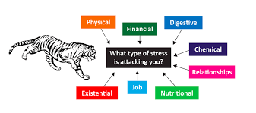

The following are also common causes of stress:
- Abortion
- Becoming a mother or a father
- Conflicts in the workplace
- Driving in bad traffic
- Fear of crime
- Losing your job
- Miscarriage
- Noisy neighbors
- Overcrowding
- Pollution
- Pregnancy
- Retirement
- Too much noise
- Uncertainty (awaiting laboratory test results, academic exam results, job interview results, etc)

How to deal with stress
There are three broad methods you can follow to treat stress, they include self-help, self management, and medication.
Self help for treating stress
Exercise
exercise has been proven to have a beneficial effect on a person's mental and physical state. For many people exercise is an extremely effective stress buster.
Division of labor
try to delegate your responsibilities at work, or share them. If you make yourself indispensable the likelihood of your feeling highly stressed is significantly greater.
Assertiveness
don't say yes to everything. If you can't do something well, or if something is not your responsibility, try to seek ways of not agreeing to do them.
Alcohol and drugs
alcohol and drugs will not help you manage your stress better. Either stop consuming them completely, or cut down.

Caffeine
if your consumption of coffee and other drinks which contain caffeine is high, cut down.
Nutrition
eat plenty of fruit and vegetables. Make sure you have a healthy and balanced diet.
Time
make sure you set aside some time each day just for yourself. Use that time to organize your life, relax, and pursue your own interests.
Breathing
there are some effective breathing techniques which will slow down your system and help you relax.
Talk
talk to you family, friends, work colleagues and your boss. Express your thoughts and worries.
Seek professional help
if the stress is affecting the way you function; go and see your doctor. Heightened stress for prolonged periods can be bad for your physical and mental health.
Relaxation techniques
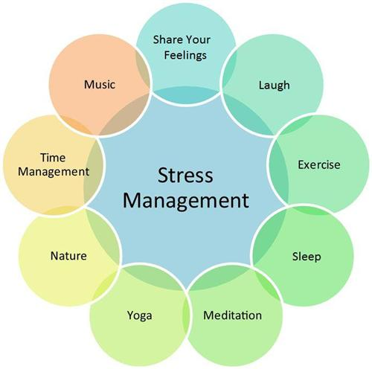
meditation, massage, or yoga have been known to greatly help people with stress.

Best way to manage your stress :
The best way to manage your stress is to learn healthy coping strategies . Your stress is to learn healthy coping strategies. You can start practicing these tips right away. Try one or two until you find a few that work for you. Practice these techniques until they become habits you can also use this coping strategies from to see how you respond to stress.

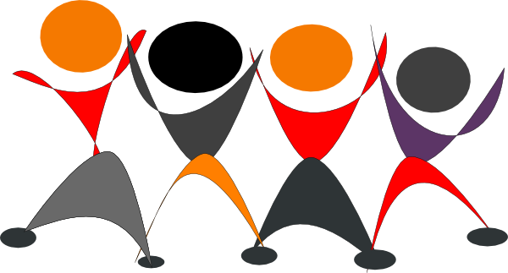

Thank You

