MONGODB IN-CLASS EXERCISE_01

1) Create a Database called music.
> use music
>db
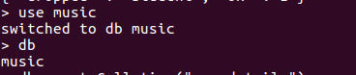

2) Create a collection called songdetails.
> db.createColletion("songdetails")
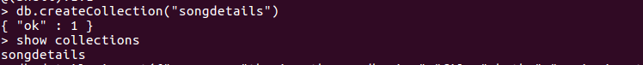

3) Create the above 5 song documents.
> db.songDetails.insert({"songName":"thaniye thannandhaniye","film":"rhythm","musicDirector":"AR Rahman","singer":"shankar mahadhevan"})
WriteResult({ "nInserted" : 1 })
> db.songDetails.insert({"songName":"evano oruvan","film":"alaipayudhe","musicDirector":"AR Rahman","singer":"swarnalatha"})
WriteResult({ "nInserted" : 1 })
> db.songDetails.insert({"songName":"Roja poondhottam","film":"kannukkul nilavu","musicDirector":"ilayaraja","singer":"unni krishnan"})
WriteResult({ "nInserted" : 1 })
> db.songDetails.insert({"songName":"vennilave vennilave","film":"minsara kanavu","musicDirector":"AR Rahman","singer":"Hariharan"})
WriteResult({ "nInserted" : 1 })
> db.songDetails.insert({"songName":"sollamal thottu sellum","film":"Dheena","musicDirector":"Yuvana shankar raja","singer":"Hariharan"})
WriteResult({ "nInserted" : 1 })

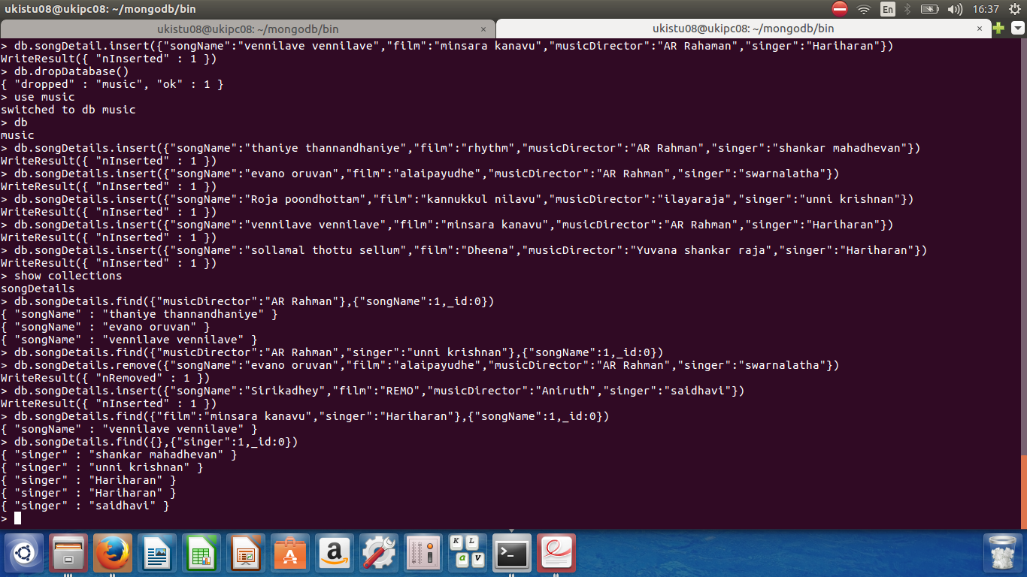

4) List all documents created.
> db.songDetails.find()
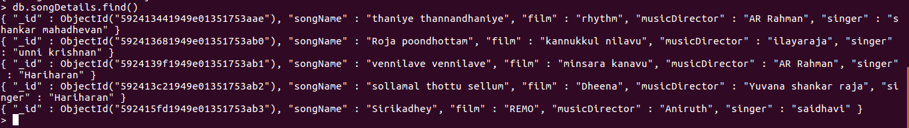

5) List A.R.Rahman’s songs.
> db.songDetails.find({"musicDirector":"AR Rahman"},{"songName":1,_id:0})

6) List A.R.Rahman’s songs sung by Unnikrishnan.
> db.songDetails.find({"musicDirector":"AR Rahman","singer":"unni krishnan"},{"songName":1,_id:0})

7) Delete the song which you don’t like.
> db.songDetails.remove({"songName":"evano oruvan","film":"alaipayudhe","musicDirector":"AR Rahman","singer":"swarnalatha"})

8) Add new song which is your favourite.
> db.songDetails.insert
({"songName":"Sirikadhey","film":"REMO","musicDirector":"Aniruth","singer":"saidhavi"})

9) List Songs sung by Hariharan from Minsara kanavu film.
> db.songDetails.find({"film":"minsara kanavu","singer":"Hariharan"},{"songName":1,_id:0})

10)List out the singers’ names in your document.
> db.songDetails.find({},{"singer":1,_id:0})

