Assignment 3: Using Databases

In this assignment, you will run basic SQL queries to query and update store, product, and employee information.

Attempt this assignment yourself, then when you feel either **Lost** or **Successful**, watch this walkthrough video and correct any mistakes you might have made: <https://bit.ly/DB1-A3>

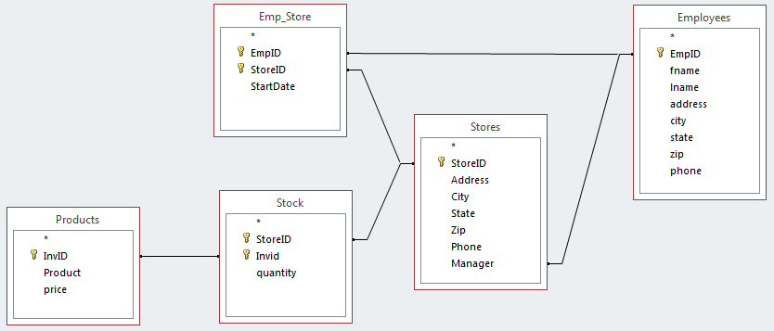

For each question, provide the SQL query and a screenshot of the results (unless otherwise noted) in a word document.

WRITE THE SQL QUERIES BY HAND! I realize it is possible to do most of this using the graphical “QBE” tool within Access – the SQL it creates is slightly different than the examples I gave you, so it will be obvious if you do this.

**DO YOUR OWN WORK** – I am fine with you all discussing the assignment with one another, but you should each individually type and run the SQL statements and **do your own screenshots and create your own document**.

You can find more SQL tutorials online, for example: <http://www.w3schools.com/sql/>

* Put your name in the header section of the word file
* Name your file lastname_a3.docx (i.e. grimes_a3.docx)

**As an example I will do number 1 for you!**

1. **Select all attributes for all employees and order them alphabetically by last name:**

SELECT * FROM Employees ORDER BY lname

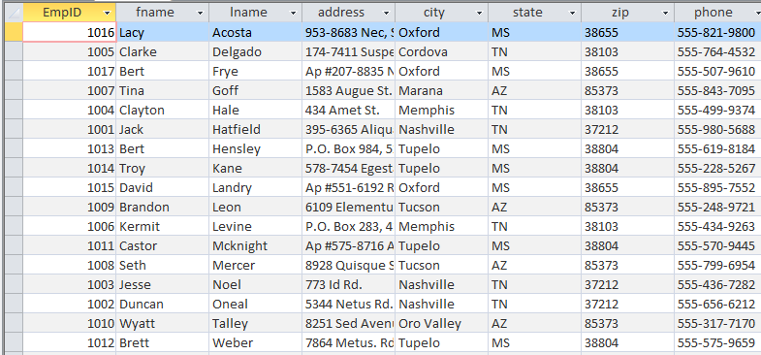

1. **Select the first name, last name, city, state and phone number for all employees living in Mississippi (MS)**
2. **For each store, display the store’s address, city, state, zip, the manager’s first and last name, and manger’s phone number**
3. **Display the names and prices of products with a price over $40, ordered so that the most expensive item is at the top and the least expensive item is at the bottom**
4. **Display the inventory for the Memphis store. Display the city, product, price and quantity. List each item alphabetically with the price and quantity in stock. If you cannot get the entire list in one screenshot that is OK – just take a screenshot that shows the first 10 items.**
5. **Display the name and price of all product with the word “water” anywhere in the product name.**
6. **Add a new employee with the following information (No Screenshot needed)**

Employee ID: 9999  
Name: Molly Smith

Address: 125 Timber Lane  
City: Oxford  
State: MS  
Zip: 38655  
Phone: 662-555-3245

1. **Associate the employee created in #7 with the Tucson store. Start date is 3/23/2019. (No Screenshot needed)**
2. **You are changing management styles! Make the employee you created in #7 the manager for all stores in Mississippi (MS) – do this using one SQL command (No Screenshot needed)**
3. **For each store, display the address, city, state, zip, manager’s first and last name, and manger’s phone number (Do this AFTER steps 7-9)**