Homework 4: Functional Dependencies

Attempt this assignment yourself, then when you feel either Lost or Successful, watch this walkthrough video and correct any mistakes you might have made: <https://bit.ly/DB1-A4>

In each of the three following problems, you will be given a relation (R) and set of functional dependencies (F). For each relation you should:

1. Draw the dependency diagram (you may use software such as PowerPoint, excel, paint, etc., or you can draw it by hand and take a picture)
2. Identify the candidate key(s) using either the synthesis or decomposition method
3. Determine if the relation is in 2NF
4. Briefly (i.e. one sentence) describe why the relation is or is not in 2NF
5. Transform the relation to 2NF and list the FDs and candidate keys for each relation
6. Determine if the relation resulting from step e is in 3NF
7. Briefly (i.e. one sentence) describe why the relation is or is not in 3NF
8. Transform the relation to 3NF and list the FDs and candidate keys for each relation

It is possible that some relations may already be in 2NF or 3NF. In that case no transformation is necessary in steps e or h.

You have three problems. For all three you may use either the synthesis or decomposition method, HOWEVER, you must use each method **at least once**. If you use the same method all three times you will not receive credit for your candidate keys on the third attempt.

You can assume that all relations are already in at least first normal form (1NF) – otherwise they would not be relations at all!

**Tips**:

In Word you can make a pretty right arrow by typing two dashes and a greater than sign --> 🡪

If you hand draw and take pictures of your dependency diagrams, you can “crop” the image by selecting the picture, then clicking the “Format” tab (under the Picture Tools ribbon) and selecting the “Crop” option.

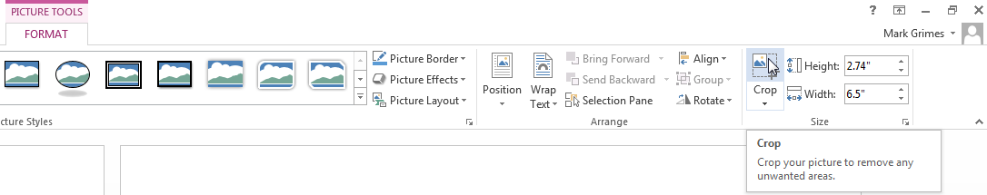

1. Given the relation R(A, B, C, D, E, G) and the function dependencies

* FD1: A🡪 B
* FD2: E 🡪 D
* FD3: {E,G} 🡪 {A, C}

1a. Draw the dependency diagram for this relation

1b. Identify all candidate keys using either the synthesis **OR** decomposition method. Show each step.

Candidate key(s):

1c. Is the relation in 2NF? _____

1d. Why or why not?

1e. Write the relation(s) in 2NF here, the FDs, and candidate keys for each relation. If already in 2NF, just write the relation:

1f. Are the relation(s) you provided in question 1e in 3NF? ______

1g. Why or why not?

1h. Write the relation(s) in 3NF here, the FDs, and candidate keys for each relation. If already in 3NF, just write the relation(s):

2. Given the relation R(A, B, C, D, E, F, G) and the function dependencies

* FD1: E 🡪 {C,G}
* FD2: {F,G} 🡪 {A,B,E}
* FD3: {B,C} 🡪 D

**Note: You will have to infer two additional FDs that are in F+ before transforming from 2NF to 3NF**

2a. Draw the dependency diagram for this relation

2b. Identify all candidate keys using either the synthesis **OR** decomposition method. Show each step.

Candidate key(s):

2c. Is the relation in 2NF? _____

2d. Why or why not?

2e. Write the relation(s) in 2NF here, the FDs, and candidate keys for each relation. If already in 2NF, just write the relation:

2f. Are the relation(s) you provided in question 2e in 3NF? ______

2g. Why or why not?

2h. Write the relation(s) in 3NF here, the FDs, and candidate keys for each relation. If already in 3NF, just write the relation(s):

3. Given the relation R(artist, album, year, length, genre, date, concert_venue, city, state, capacity) and the function dependencies

* FD1: artist 🡪 genre
* FD2: {artist, album} 🡪 {year, length}
* FD3: {date, concert_venue} 🡪 artist
* FD4: {artist, date} 🡪 concert_venue
* FD5: concert_venue 🡪 {city, state, capacity}

Note: It may be easiest to replace the names of the attributes with letters (A, B, C, …) when doing the synthesis or decomposition like we have done in class. If you do this, then:

* Indicate what letter is assigned to what attribute.
* Show your candidate keys in steps b, e, and h using the NAMES of the attributes, not the letters

3a. Draw the dependency diagram for this relation

3b. Identify all candidate keys using either the synthesis **OR** decomposition method. Show each step.

Candidate key(s):

3c. Is the relation in 2NF? _____

3d. Why or why not?

3e. Write the relation(s) in 2NF here, the FDs, and candidate keys for each relation. If already in 2NF, just write the relation:

3f. Are the relation(s) you provided in question 3e in 3NF? ______

3g. Why or why not?

3h. Write the relation(s) in 3NF here, the FDs, and candidate keys for each relation. If already in 3NF, just write the relation(s):