
KAUNAS UNIVERSITY OF TECHNOLOGY

Farhana Khanom Fariha

T170B151 Fundamentals of Digital and Microprocessor Systems

Project report

Variant No 28

ERBu-4

Kaunas, 2026

Objective:

To design an STM32F401RETx microcontroller system that reads vibration sensor data every Ts = 15 s, stores it in EEPROM with an RTC timestamp, and displays the last measurement on an LCD. The system must log data for N = 0.5 days.

Task parameters- Variant 28
Parameter | Value | Description
Ts | 15 s | Sampling Period
N | 0.5 days | Data Logging duration= 12 hours
K | 1 | Number of sensors
Q | Vibration | Measured quantity
Data count | 2880 | N _ 24 _ 3600 / Ts = 0.5 _ 24 _ 3600 / 15

Components Used:

The following hardware components were selected to implement the Vibration Data Logger system according to Variant 28 requirements:
- 5 Model Buttons: DTSM-6
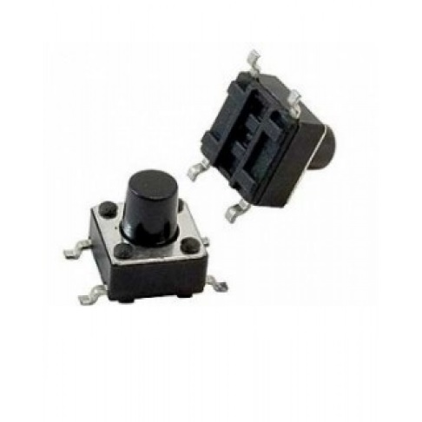
- EEPROM Model: AT24C256

- STM32F401RE
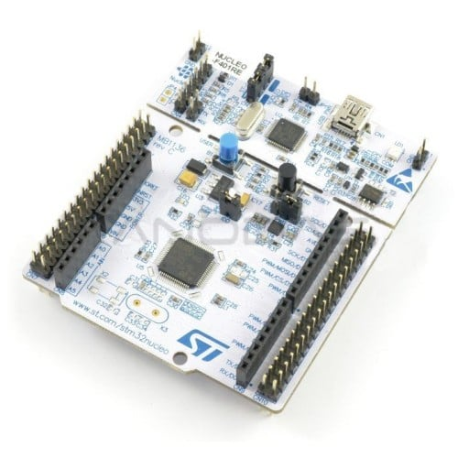
- Accelerometer Model: MPU6050
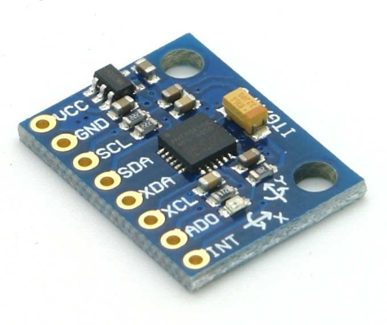

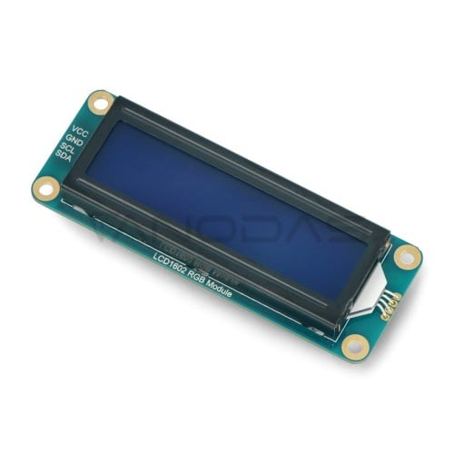
- Display Model: LCD1602 + PCF8574 I2C interface
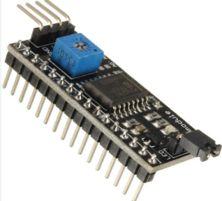

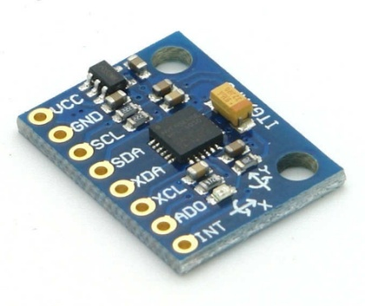

SENSOR DESCRIPTION

Name: Accelerometer
Model: MPU6050
Type: 3-axis digital Accelerometer.
Measurement Range: ±2g, ±4g, ±8g, ±16g (configurable).
Resolution: Up to 13-bit (4 mg/LSB at ±16g).
Interfaces: I²C and SPI.
Supply Voltage: 2.0–3.6 V (typically 3.3 V).

Features:
- Free-fall, motion, and inactivity detection;
- Built-in interrupt support;
- FIFO buffer to reduce microcontroller workload.
Applications: Smartphones, pedometers, image stabilization systems, wearable devices, etc.

Project scheme:

The project uses one MPU6050 accelerometer sensor connected to the STM32F401RE microcontroller via I2C interface.
The system measures vibration level every 15 seconds and displays the latest value on LCD1602 display.
The measured data is stored in EEPROM memory together with timestamps.
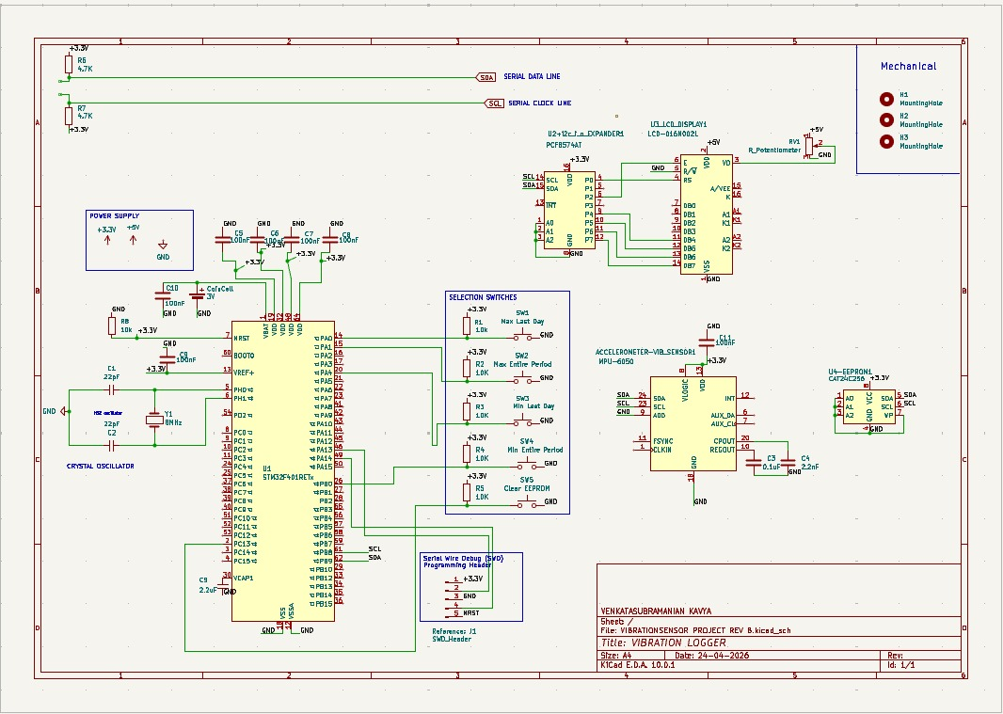
Figure 1: Electrical Schematic Diagram of Vibration Data Logger - Variant 28

Block Diagram
Figure 2 shows the structural block diagram of the Vibration Data Logger system for out project. The STM32F401RETx microcontroller acts as the central unit, interfacing with all peripheral devices via I2C, SPI, and GPIO protocols.
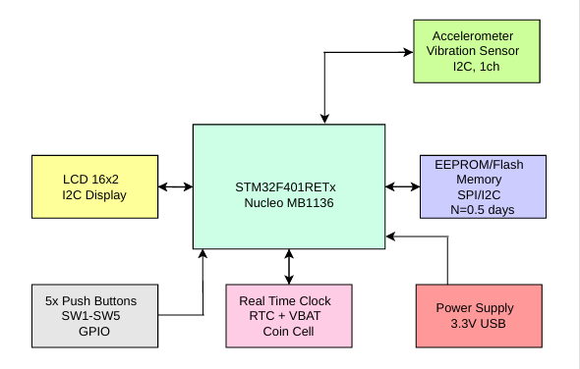
Figure 2: Block Diagram of Vibration Data Logger - Variant 28

The system operates as follows: the accelerometer sends vibration data to the MCU via I2C every Ts = 15 s. The MCU requests the current timestamp from the RTC and stores both values in EEPROM memory. The last measurement is displayed on the LCD 16x2. Five push buttons connected to GPIO pins allow the user to start/stop logging. The entire system is powered by a 3.3V USB supply, with a coin cell providing backup power to the RTC.

Microcontroller Pin Configuration
The microcontroller pin configuration was done in STM32CubeMX. Figure 3 shows the STM32F401RETx pinout with assigned peripherals for Variant 28.
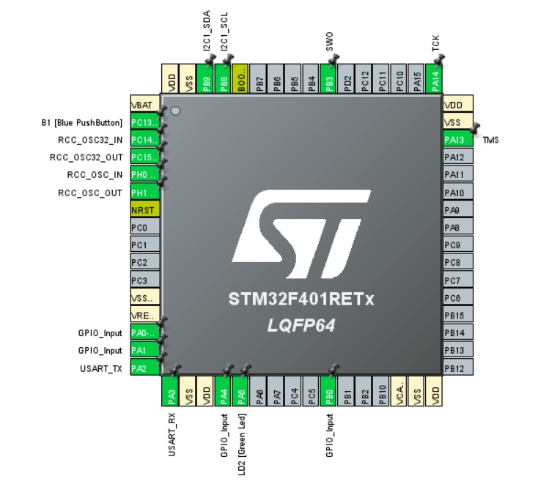
Figure 3: STM32F401RETx Pin Configuration for Vibration Data Logger - Variant 28

The five push buttons are connected to the microcontroller as follows:
S1 → PA0
S2 → PA1
S3 → PA4
S4 → PB0
S5 → PC13
All pins are configured as GPIO inputs with internal pull-up resistors.

Program Code:
The program for the Vibration Data Logger was developed in STM32CubeIDE using HAL libraries. The code implements Variant 28 requirements: sampling period Ts = 15 s, data logging for N = 0.5 days, and storage of 2880 records in EEPROM. The main program structure is shown below.
/* USER CODE BEGIN Header */
/**
******************************************************************************
* @file : main.c
* @brief : Final Project - Vibration Logger
******************************************************************************
*/
/* USER CODE END Header */
/* Includes ------------------------------------------------------------------*/
#include "main.h"

/* Private includes ----------------------------------------------------------*/
/* USER CODE BEGIN Includes */
#include "lcd_i2c.h"
#include <stdio.h>
#include <stdlib.h>
#include <string.h>
/* USER CODE END Includes */

/* Private typedef -----------------------------------------------------------*/
/* USER CODE BEGIN PTD */

/* USER CODE END PTD */

/* Private define ------------------------------------------------------------*/
/* USER CODE BEGIN PD */

/* MPU6050 */
#define MPU6050_ADDR (0x68 << 1)
#define MPU6050_PWR_MGMT_1 0x6B
#define MPU6050_ACCEL_XOUT_H 0x3B

/* EEPROM AT24C256 */
#define EEPROM_ADDR (0x50 << 1)

/* Case 28 parameters */
#define SAMPLE_PERIOD_MS 15000UL
#define MAX_RECORDS 2880

/* EEPROM memory map */
#define META_MAGIC_ADDR 0x0000
#define META_COUNT_ADDR 0x0002
#define META_INDEX_ADDR 0x0004
#define DATA_START_ADDR 0x0010
#define EEPROM_MAGIC 0xA55A
#define RECORD_SIZE 8

/* Buttons */
#define BTN_PRESSED GPIO_PIN_RESET

#define S1_GPIO_Port GPIOA
#define S1_Pin GPIO_PIN_0

#define S2_GPIO_Port GPIOA
#define S2_Pin GPIO_PIN_1

#define S3_GPIO_Port GPIOA
#define S3_Pin GPIO_PIN_4

#define S4_GPIO_Port GPIOB
#define S4_Pin GPIO_PIN_0

#define S5_GPIO_Port GPIOC
#define S5_Pin GPIO_PIN_13

/* USER CODE END PD */

/* Private macro -------------------------------------------------------------*/
/* USER CODE BEGIN PM */

/* USER CODE END PM */

/* Private variables ---------------------------------------------------------*/
I2C_HandleTypeDef hi2c1;

UART_HandleTypeDef huart2;

/* USER CODE BEGIN PV */

uint16_t sampleCount = 0;
uint16_t writeIndex = 0;
uint32_t lastSampleTick = 0;

int16_t prev_ax = 0;
int16_t prev_ay = 0;
int16_t prev_az = 0;

/* USER CODE END PV */

/* Private function prototypes -----------------------------------------------*/
void SystemClock_Config(void);
static void MX_GPIO_Init(void);
static void MX_I2C1_Init(void);
static void MX_USART2_UART_Init(void);
/* USER CODE BEGIN PFP */

HAL_StatusTypeDef MPU6050_Init(void);
HAL_StatusTypeDef MPU6050_Read_Accel(int16_t *ax, int16_t *ay, int16_t *az);

HAL_StatusTypeDef EEPROM_WriteBytes(uint16_t memAddr, uint8_t *data, uint16_t size);
HAL_StatusTypeDef EEPROM_ReadBytes(uint16_t memAddr, uint8_t *data, uint16_t size);
void EEPROM_WriteUInt16(uint16_t memAddr, uint16_t value);
uint16_t EEPROM_ReadUInt16(uint16_t memAddr);
void EEPROM_WriteUInt32(uint16_t memAddr, uint32_t value);
uint32_t EEPROM_ReadUInt32(uint16_t memAddr);

void Data_Init(void);
void Data_Clear(void);
void Data_SaveRecord(uint32_t timestamp, uint32_t vibration);
void Data_ReadRecord(uint16_t index, uint32_t *timestamp, uint32_t *vibration);

uint32_t Read_Vibration(void);
void LCD_ShowMessage(char *line1, char *line2);
void LCD_ShowMain(uint32_t vibration);
void Show_Max_LastDay(void);
void Show_Max_All(void);
void Show_Min_LastDay(void);
void Show_Min_All(void);
void Handle_Buttons(void);

/* USER CODE END PFP */

/* Private user code ---------------------------------------------------------*/
/* USER CODE BEGIN 0 */

HAL_StatusTypeDef MPU6050_Init(void)
{
uint8_t data = 0x00;

return HAL_I2C_Mem_Write(
&hi2c1,
MPU6050_ADDR,
MPU6050_PWR_MGMT_1,
I2C_MEMADD_SIZE_8BIT,
&data,
1,
100
);
}

HAL_StatusTypeDef MPU6050_Read_Accel(int16_t *ax, int16_t *ay, int16_t *az)
{
uint8_t rawData[6];

HAL_StatusTypeDef status = HAL_I2C_Mem_Read(
&hi2c1,
MPU6050_ADDR,
MPU6050_ACCEL_XOUT_H,
I2C_MEMADD_SIZE_8BIT,
rawData,
6,
100
);

if (status != HAL_OK)
{
return status;
}

*ax = (int16_t)((rawData[0] << 8) | rawData[1]);
*ay = (int16_t)((rawData[2] << 8) | rawData[3]);
*az = (int16_t)((rawData[4] << 8) | rawData[5]);

return HAL_OK;
}

HAL_StatusTypeDef EEPROM_WriteBytes(uint16_t memAddr, uint8_t *data, uint16_t size)
{
HAL_StatusTypeDef status;

status = HAL_I2C_Mem_Write(
&hi2c1,
EEPROM_ADDR,
memAddr,
I2C_MEMADD_SIZE_16BIT,
data,
size,
100
);

HAL_Delay(10);

return status;
}

HAL_StatusTypeDef EEPROM_ReadBytes(uint16_t memAddr, uint8_t *data, uint16_t size)
{
return HAL_I2C_Mem_Read(
&hi2c1,
EEPROM_ADDR,
memAddr,
I2C_MEMADD_SIZE_16BIT,
data,
size,
100
);
}

void EEPROM_WriteUInt16(uint16_t memAddr, uint16_t value)
{
uint8_t data[2];

data[0] = (value >> 8) & 0xFF;
data[1] = value & 0xFF;

EEPROM_WriteBytes(memAddr, data, 2);
}

uint16_t EEPROM_ReadUInt16(uint16_t memAddr)
{
uint8_t data[2];

EEPROM_ReadBytes(memAddr, data, 2);

return ((uint16_t)data[0] << 8) | data[1];
}

void EEPROM_WriteUInt32(uint16_t memAddr, uint32_t value)
{
uint8_t data[4];

data[0] = (value >> 24) & 0xFF;
data[1] = (value >> 16) & 0xFF;
data[2] = (value >> 8) & 0xFF;
data[3] = value & 0xFF;

EEPROM_WriteBytes(memAddr, data, 4);
}

uint32_t EEPROM_ReadUInt32(uint16_t memAddr)
{
uint8_t data[4];

EEPROM_ReadBytes(memAddr, data, 4);

return ((uint32_t)data[0] << 24) |
((uint32_t)data[1] << 16) |
((uint32_t)data[2] << 8) |
data[3];
}

void Data_Init(void)
{
uint16_t magic = EEPROM_ReadUInt16(META_MAGIC_ADDR);

if (magic != EEPROM_MAGIC)
{
Data_Clear();
}
else
{
sampleCount = EEPROM_ReadUInt16(META_COUNT_ADDR);
writeIndex = EEPROM_ReadUInt16(META_INDEX_ADDR);

if (sampleCount > MAX_RECORDS)
{
sampleCount = 0;
}

if (writeIndex >= MAX_RECORDS)
{
writeIndex = 0;
}
}
}

void Data_Clear(void)
{
sampleCount = 0;
writeIndex = 0;

EEPROM_WriteUInt16(META_MAGIC_ADDR, EEPROM_MAGIC);
EEPROM_WriteUInt16(META_COUNT_ADDR, sampleCount);
EEPROM_WriteUInt16(META_INDEX_ADDR, writeIndex);
}

void Data_SaveRecord(uint32_t timestamp, uint32_t vibration)
{
uint16_t addr = DATA_START_ADDR + (writeIndex * RECORD_SIZE);

EEPROM_WriteUInt32(addr, timestamp);
EEPROM_WriteUInt32(addr + 4, vibration);

writeIndex++;

if (writeIndex >= MAX_RECORDS)
{
writeIndex = 0;
}

if (sampleCount < MAX_RECORDS)
{
sampleCount++;
}

EEPROM_WriteUInt16(META_COUNT_ADDR, sampleCount);
EEPROM_WriteUInt16(META_INDEX_ADDR, writeIndex);
}

void Data_ReadRecord(uint16_t index, uint32_t *timestamp, uint32_t *vibration)
{
uint16_t addr = DATA_START_ADDR + (index * RECORD_SIZE);

*timestamp = EEPROM_ReadUInt32(addr);
*vibration = EEPROM_ReadUInt32(addr + 4);
}

uint32_t Read_Vibration(void)
{
int16_t ax, ay, az;

if (MPU6050_Read_Accel(&ax, &ay, &az) != HAL_OK)
{
return 0;
}

uint32_t vibration =
labs((int32_t)ax - (int32_t)prev_ax) +
labs((int32_t)ay - (int32_t)prev_ay) +
labs((int32_t)az - (int32_t)prev_az);

prev_ax = ax;
prev_ay = ay;
prev_az = az;

return vibration;
}

void LCD_ShowMessage(char *line1, char *line2)
{
lcd_put_cur(0, 0);
lcd_send_string(" ");

lcd_put_cur(1, 0);
lcd_send_string(" ");

lcd_put_cur(0, 0);
lcd_send_string(line1);

lcd_put_cur(1, 0);
lcd_send_string(line2);
}

void LCD_ShowMain(uint32_t vibration)
{
char line2[17];

snprintf(line2, sizeof(line2), "V:%lu C:%u", vibration, sampleCount);

lcd_put_cur(0, 0);
lcd_send_string("Vibration Logger");

lcd_put_cur(1, 0);
lcd_send_string(" ");

lcd_put_cur(1, 0);
lcd_send_string(line2);
}

void Show_Max_LastDay(void)
{
uint32_t timestamp;
uint32_t vibration;
uint32_t currentTime = HAL_GetTick() / 1000;
uint32_t maxVal = 0;
uint8_t found = 0;
char line2[17];

for (uint16_t i = 0; i < sampleCount; i++)
{
Data_ReadRecord(i, &timestamp, &vibration);

if ((currentTime - timestamp) <= 86400UL)
{
if (!found || vibration > maxVal)
{
maxVal = vibration;
found = 1;
}
}
}

if (found)
{
snprintf(line2, sizeof(line2), "%lu", maxVal);
LCD_ShowMessage("Max last day:", line2);
}
else
{
LCD_ShowMessage("Max last day:", "No data");
}

HAL_Delay(2000);
}

void Show_Max_All(void)
{
uint32_t timestamp;
uint32_t vibration;
uint32_t maxVal = 0;
uint8_t found = 0;
char line2[17];

for (uint16_t i = 0; i < sampleCount; i++)
{
Data_ReadRecord(i, &timestamp, &vibration);

if (!found || vibration > maxVal)
{
maxVal = vibration;
found = 1;
}
}

if (found)
{
snprintf(line2, sizeof(line2), "%lu", maxVal);
LCD_ShowMessage("Max all:", line2);
}
else
{
LCD_ShowMessage("Max all:", "No data");
}

HAL_Delay(2000);
}

void Show_Min_LastDay(void)
{
uint32_t timestamp;
uint32_t vibration;
uint32_t currentTime = HAL_GetTick() / 1000;
uint32_t minVal = 0;
uint8_t found = 0;
char line2[17];

for (uint16_t i = 0; i < sampleCount; i++)
{
Data_ReadRecord(i, &timestamp, &vibration);

if ((currentTime - timestamp) <= 86400UL)
{
if (!found || vibration < minVal)
{
minVal = vibration;
found = 1;
}
}
}

if (found)
{
snprintf(line2, sizeof(line2), "%lu", minVal);
LCD_ShowMessage("Min last day:", line2);
}
else
{
LCD_ShowMessage("Min last day:", "No data");
}

HAL_Delay(2000);
}

void Show_Min_All(void)
{
uint32_t timestamp;
uint32_t vibration;
uint32_t minVal = 0;
uint8_t found = 0;
char line2[17];

for (uint16_t i = 0; i < sampleCount; i++)
{
Data_ReadRecord(i, &timestamp, &vibration);

if (!found || vibration < minVal)
{
minVal = vibration;
found = 1;
}
}

if (found)
{
snprintf(line2, sizeof(line2), "%lu", minVal);
LCD_ShowMessage("Min all:", line2);
}
else
{
LCD_ShowMessage("Min all:", "No data");
}

HAL_Delay(2000);
}

void Handle_Buttons(void)
{
if (HAL_GPIO_ReadPin(S1_GPIO_Port, S1_Pin) == BTN_PRESSED)
{
HAL_Delay(30);

if (HAL_GPIO_ReadPin(S1_GPIO_Port, S1_Pin) == BTN_PRESSED)
{
Show_Max_LastDay();

while (HAL_GPIO_ReadPin(S1_GPIO_Port, S1_Pin) == BTN_PRESSED)
{
}
}
}

if (HAL_GPIO_ReadPin(S2_GPIO_Port, S2_Pin) == BTN_PRESSED)
{
HAL_Delay(30);

if (HAL_GPIO_ReadPin(S2_GPIO_Port, S2_Pin) == BTN_PRESSED)
{
Show_Max_All();

while (HAL_GPIO_ReadPin(S2_GPIO_Port, S2_Pin) == BTN_PRESSED)
{
}
}
}

if (HAL_GPIO_ReadPin(S3_GPIO_Port, S3_Pin) == BTN_PRESSED)
{
HAL_Delay(30);

if (HAL_GPIO_ReadPin(S3_GPIO_Port, S3_Pin) == BTN_PRESSED)
{
Show_Min_LastDay();

while (HAL_GPIO_ReadPin(S3_GPIO_Port, S3_Pin) == BTN_PRESSED)
{
}
}
}

if (HAL_GPIO_ReadPin(S4_GPIO_Port, S4_Pin) == BTN_PRESSED)
{
HAL_Delay(30);

if (HAL_GPIO_ReadPin(S4_GPIO_Port, S4_Pin) == BTN_PRESSED)
{
Show_Min_All();

while (HAL_GPIO_ReadPin(S4_GPIO_Port, S4_Pin) == BTN_PRESSED)
{
}
}
}

if (HAL_GPIO_ReadPin(S5_GPIO_Port, S5_Pin) == BTN_PRESSED)
{
HAL_Delay(30);

if (HAL_GPIO_ReadPin(S5_GPIO_Port, S5_Pin) == BTN_PRESSED)
{
Data_Clear();
LCD_ShowMessage("EEPROM cleared", "Data deleted");
HAL_Delay(2000);

while (HAL_GPIO_ReadPin(S5_GPIO_Port, S5_Pin) == BTN_PRESSED)
{
}
}
}
}

/* USER CODE END 0 */

/**
* @brief The application entry point.
* @retval int
*/
int main(void)
{

/* USER CODE BEGIN 1 */

/* USER CODE END 1 */

/* MCU Configuration--------------------------------------------------------*/

/* Reset of all peripherals, Initializes the Flash interface and the Systick. */
HAL_Init();

/* USER CODE BEGIN Init */

/* USER CODE END Init */

/* Configure the system clock */
SystemClock_Config();

/* USER CODE BEGIN SysInit */

/* USER CODE END SysInit */

/* Initialize all configured peripherals */
MX_GPIO_Init();
MX_I2C1_Init();
MX_USART2_UART_Init();
/* USER CODE BEGIN 2 */

lcd_init();
HAL_Delay(500);
lcd_clear();

LCD_ShowMessage("System start", "Please wait");
HAL_Delay(1000);

if (MPU6050_Init() != HAL_OK)
{
LCD_ShowMessage("MPU Error", "Check wiring");

while (1)
{
HAL_GPIO_TogglePin(LD2_GPIO_Port, LD2_Pin);
HAL_Delay(200);
}
}

int16_t ax, ay, az;

if (MPU6050_Read_Accel(&ax, &ay, &az) == HAL_OK)
{
prev_ax = ax;
prev_ay = ay;
prev_az = az;
}

Data_Init();

LCD_ShowMessage("System ready", "Logging start");
HAL_Delay(1000);

lastSampleTick = HAL_GetTick();

/* USER CODE END 2 */

/* Infinite loop */
/* USER CODE BEGIN WHILE */
while (1)
{
Handle_Buttons();

if ((HAL_GetTick() - lastSampleTick) >= SAMPLE_PERIOD_MS)
{
uint32_t timestamp = HAL_GetTick() / 1000;
uint32_t vibration = Read_Vibration();

Data_SaveRecord(timestamp, vibration);
LCD_ShowMain(vibration);

lastSampleTick = HAL_GetTick();
}

HAL_GPIO_TogglePin(LD2_GPIO_Port, LD2_Pin);
HAL_Delay(100);
/* USER CODE END WHILE */

/* USER CODE BEGIN 3 */
}
/* USER CODE END 3 */
}

/**
* @brief System Clock Configuration
* @retval None
*/
void SystemClock_Config(void)
{
RCC_OscInitTypeDef RCC_OscInitStruct = {0};
RCC_ClkInitTypeDef RCC_ClkInitStruct = {0};

/** Configure the main internal regulator output voltage
*/
__HAL_RCC_PWR_CLK_ENABLE();
__HAL_PWR_VOLTAGESCALING_CONFIG(PWR_REGULATOR_VOLTAGE_SCALE2);

/** Initializes the RCC Oscillators according to the specified parameters
* in the RCC_OscInitTypeDef structure.
*/
RCC_OscInitStruct.OscillatorType = RCC_OSCILLATORTYPE_HSI;
RCC_OscInitStruct.HSIState = RCC_HSI_ON;
RCC_OscInitStruct.HSICalibrationValue = RCC_HSICALIBRATION_DEFAULT;
RCC_OscInitStruct.PLL.PLLState = RCC_PLL_ON;
RCC_OscInitStruct.PLL.PLLSource = RCC_PLLSOURCE_HSI;
RCC_OscInitStruct.PLL.PLLM = 16;
RCC_OscInitStruct.PLL.PLLN = 336;
RCC_OscInitStruct.PLL.PLLP = RCC_PLLP_DIV4;
RCC_OscInitStruct.PLL.PLLQ = 7;
if (HAL_RCC_OscConfig(&RCC_OscInitStruct) != HAL_OK)
{
Error_Handler();
}

/** Initializes the CPU, AHB and APB buses clocks
*/
RCC_ClkInitStruct.ClockType = RCC_CLOCKTYPE_HCLK|RCC_CLOCKTYPE_SYSCLK
|RCC_CLOCKTYPE_PCLK1|RCC_CLOCKTYPE_PCLK2;
RCC_ClkInitStruct.SYSCLKSource = RCC_SYSCLKSOURCE_PLLCLK;
RCC_ClkInitStruct.AHBCLKDivider = RCC_SYSCLK_DIV1;
RCC_ClkInitStruct.APB1CLKDivider = RCC_HCLK_DIV2;
RCC_ClkInitStruct.APB2CLKDivider = RCC_HCLK_DIV1;

if (HAL_RCC_ClockConfig(&RCC_ClkInitStruct, FLASH_LATENCY_2) != HAL_OK)
{
Error_Handler();
}
}

/**
* @brief I2C1 Initialization Function
* @param None
* @retval None
*/
static void MX_I2C1_Init(void)
{

/* USER CODE BEGIN I2C1_Init 0 */

/* USER CODE END I2C1_Init 0 */

/* USER CODE BEGIN I2C1_Init 1 */

/* USER CODE END I2C1_Init 1 */
hi2c1.Instance = I2C1;
hi2c1.Init.ClockSpeed = 100000;
hi2c1.Init.DutyCycle = I2C_DUTYCYCLE_2;
hi2c1.Init.OwnAddress1 = 0;
hi2c1.Init.AddressingMode = I2C_ADDRESSINGMODE_7BIT;
hi2c1.Init.DualAddressMode = I2C_DUALADDRESS_DISABLE;
hi2c1.Init.OwnAddress2 = 0;
hi2c1.Init.GeneralCallMode = I2C_GENERALCALL_DISABLE;
hi2c1.Init.NoStretchMode = I2C_NOSTRETCH_DISABLE;
if (HAL_I2C_Init(&hi2c1) != HAL_OK)
{
Error_Handler();
}
/* USER CODE BEGIN I2C1_Init 2 */

/* USER CODE END I2C1_Init 2 */

}

/**
* @brief USART2 Initialization Function
* @param None
* @retval None
*/
static void MX_USART2_UART_Init(void)
{

/* USER CODE BEGIN USART2_Init 0 */

/* USER CODE END USART2_Init 0 */

/* USER CODE BEGIN USART2_Init 1 */

/* USER CODE END USART2_Init 1 */
huart2.Instance = USART2;
huart2.Init.BaudRate = 115200;
huart2.Init.WordLength = UART_WORDLENGTH_8B;
huart2.Init.StopBits = UART_STOPBITS_1;
huart2.Init.Parity = UART_PARITY_NONE;
huart2.Init.Mode = UART_MODE_TX_RX;
huart2.Init.HwFlowCtl = UART_HWCONTROL_NONE;
huart2.Init.OverSampling = UART_OVERSAMPLING_16;
if (HAL_UART_Init(&huart2) != HAL_OK)
{
Error_Handler();
}
/* USER CODE BEGIN USART2_Init 2 */

/* USER CODE END USART2_Init 2 */

}

/**
* @brief GPIO Initialization Function
* @param None
* @retval None
*/
static void MX_GPIO_Init(void)
{
GPIO_InitTypeDef GPIO_InitStruct = {0};
/* USER CODE BEGIN MX_GPIO_Init_1 */

/* USER CODE END MX_GPIO_Init_1 */

/* GPIO Ports Clock Enable */
__HAL_RCC_GPIOC_CLK_ENABLE();
__HAL_RCC_GPIOH_CLK_ENABLE();
__HAL_RCC_GPIOA_CLK_ENABLE();
__HAL_RCC_GPIOB_CLK_ENABLE();

/*Configure GPIO pin Output Level */
HAL_GPIO_WritePin(LD2_GPIO_Port, LD2_Pin, GPIO_PIN_RESET);

/*Configure GPIO pin : B1_Pin */
GPIO_InitStruct.Pin = B1_Pin;
GPIO_InitStruct.Mode = GPIO_MODE_IT_FALLING;
GPIO_InitStruct.Pull = GPIO_PULLUP;
HAL_GPIO_Init(B1_GPIO_Port, &GPIO_InitStruct);

/*Configure GPIO pins : PA0 PA1 PA4 */
GPIO_InitStruct.Pin = GPIO_PIN_0|GPIO_PIN_1|GPIO_PIN_4;
GPIO_InitStruct.Mode = GPIO_MODE_INPUT;
GPIO_InitStruct.Pull = GPIO_PULLUP;
HAL_GPIO_Init(GPIOA, &GPIO_InitStruct);

/*Configure GPIO pin : LD2_Pin */
GPIO_InitStruct.Pin = LD2_Pin;
GPIO_InitStruct.Mode = GPIO_MODE_OUTPUT_PP;
GPIO_InitStruct.Pull = GPIO_NOPULL;
GPIO_InitStruct.Speed = GPIO_SPEED_FREQ_LOW;
HAL_GPIO_Init(LD2_GPIO_Port, &GPIO_InitStruct);

/*Configure GPIO pin : PB0 */
GPIO_InitStruct.Pin = GPIO_PIN_0;
GPIO_InitStruct.Mode = GPIO_MODE_INPUT;
GPIO_InitStruct.Pull = GPIO_PULLUP;
HAL_GPIO_Init(GPIOB, &GPIO_InitStruct);

/* USER CODE BEGIN MX_GPIO_Init_2 */

/* USER CODE END MX_GPIO_Init_2 */
}

/* USER CODE BEGIN 4 */

/* USER CODE END 4 */

/**
* @brief This function is executed in case of error occurrence.
* @retval None
*/
void Error_Handler(void)
{
/* USER CODE BEGIN Error_Handler_Debug */
/* User can add his own implementation to report the HAL error return state */
__disable_irq();
while (1)
{
}
/* USER CODE END Error_Handler_Debug */
}
#ifdef USE_FULL_ASSERT
/**
* @brief Reports the name of the source file and the source line number
* where the assert_param error has occurred.
* @param file: pointer to the source file name
* @param line: assert_param error line source number
* @retval None
*/
void assert_failed(uint8_t *file, uint32_t line)
{
/* USER CODE BEGIN 6 */

/* USER CODE END 6 */
}
#endif /* USE_FULL_ASSERT */

The program initializes MPU6050 accelerometer and AT24C256 EEPROM via I2C1. Every 15000 ms the system reads acceleration data, calculates vibration as the change from previous values, and saves the timestamp + vibration value to EEPROM. Five buttons connected to PA0, PA1, PA4, PB0, PC13 allow viewing max/min values and clearing EEPROM. The circular buffer overwrites old data after 2880 records.

Conclusion
The vibration data logger based on STM32F401RETx was successfully designed and implemented according to Variant 28 requirements. The system performs data acquisition every Ts = 15 s for a total duration of N = 0.5 days, storing 2880 measurements in AT24C256 EEPROM. The I2C interface enabled efficient connection of the MPU6050 accelerometer, RTC, LCD display, and EEPROM using minimal microcontroller pins. The developed program accurately reads vibration data, adds timestamps, saves records to memory, and provides user interface functionality through five push buttons for viewing current and statistical values.

