**MINOR-1 PROJECT**

**SYNOPSIS on**

**MENDELEEV’S MARVEL**

Submitted By:

|  |  |  |
| --- | --- | --- |
| **Name** | **Roll No** | **Branch** |
| Shahan Ali | R2142211305 | CSE GG |
| Mridul Pratap Singh | R2142211483 | CSE GG |
| Priyanshu Raj | R2142211450 | CSE GG |
| Ahzam Khan | R2141211273 | CSE GG |

**Under the guidance of**

**Alind Sir**



School of Computer Science

**UNIVERSITY OF PETROLEUM AND ENERGY STUDIES**

**Dehradun-248007 2023 24**

**Approved By**

Alind Sir

**Project Guide Department Head**



Table of Contents

1. **Project Title**
2. **Abstract**
3. **Introduction**
4. **Literature Review**
5. **Problem Statement**
6. **Objective**
7. **Methodology**
8. **System Requirements**
9. **Schedule (Pert Chart)**

**10.User Case Diagram**

**11.References**

**School of Computer Science**

University of Petroleum & Energy Studies, Dehradun

**Synopsis Report (2023-24)**

1. **Project Title**

# Mendeleev Marvels

# 2- Abstract

Mendeleev Marvels take us on a journey through the fundamental forces and elements that shape our world. These captivating adventures delve into the awe-inspiring realms of earth, air, fire, and water, revealing their intrinsic beauty and power. Whether it's exploring the serene depths of the ocean, witnessing the mesmerizing dance of flames, feeling the gentle caress of a breeze, or standing in the presence of towering mountains, elemental excursions connect us with the natural world in profound ways. These experiences remind us of our interconnectedness with the environment and the importance of preserving these elemental wonders for future generations to cherish and protect. In this project we are demonstrating a foundation structure and exploring the periodic table with a very interesting and interactive way and making it fun for an amateur to learn of the different aspects of the elements.

# 3- Introduction-

Chemistry, with its intricacies and elements, has long been a subject of both fascination and challenge for students. The periodic table, a cornerstone of chemical science, provides the fundamental framework upon which the properties and behaviors of these elements are understood. However, the task of memorizing the order of elements on this table has often proven to be a formidable hurdle in the educational journey of aspiring scientists.

In recognition of this challenge, the "Mendeleev Marvels” project emerges as a solution that marries education and entertainment. Our project sets out to create an interactive game that leverages the power of gamification to make learning the periodic table an engaging and enjoyable experience. By combining the structured beauty of scientific knowledge with the dynamic interactivity of gaming, Mendeleev Marvels aims to revolutionize the way students approach and conquer the periodic table.

In this endeavor, we draw inspiration from existing research in the field of science education, which highlights the potential of gamified learning experiences to enhance comprehension and retention of complex concepts. However, Mendeleev Marvels stands apart by directly addressing the specific challenge of element ordering within the periodic table, a challenge that has persisted in science education.

This document provides an overview of the Mendeleev Marvels project, including its objectives, methodology, and schedule. It also delves into relevant literature, offering insights from previous research that inform our approach. Through this project, we aspire not only to facilitate a deeper understanding of the periodic table but also to instill a sense of excitement and curiosity about the world of chemistry.

As we embark on this elemental journey, we aim to create an educational tool that not only meets the academic needs of students but also ignites their passion for the periodic table and the captivating realm of science.

The technology we are going to use for this particular project are OpenGL, object-oriented programming, data structure and algorithms.

# 4- Literature Review

In the field of science education, several studies have explored the effectiveness of gamification in enhancing learning outcomes. Research by Smith et al. (2018) demonstrated that educational games can significantly improve students' retention of complex scientific concepts. Moreover, Johnson's work (2017) highlights the positive impact of interactive periodic table applications in aiding students' comprehension of element ordering. While these studies offer valuable insights, none directly address our project's goal of creating an interactive game that combines both learning and entertainment aspects.

# Problem Statement

Memorizing the order of elements on the periodic table is a common challenge for students of chemistry. Traditional methods often involve rote memorization, which can be tedious and less effective in promoting long-term retention. To address this issue, the "Mendeleev Marvels" project will create an interactive game that leverages the power of gamification to make learning the periodic table more engaging and effective.

# 6- Objectives

The Mendeleev Marvels Project has several key objectives:

1- Develop an Interactive Learning Tool: Create an interactive and engaging educational game that assists users in learning the order of elements on the periodic table.

2- Promote Gamified Learning: Leverage gamification techniques to make the process of learning element ordering enjoyable, motivating users to actively participate in the learning process.

3- Enhance Retention and Comprehension: Improve users' retention and comprehension of the periodic table by providing a visual and interactive learning experience that goes beyond traditional rote memorization.

4- Utilize OpenGL for Graphics: Implement graphics and visuals using OpenGL to create an immersive and visually appealing environment that captures the attention of users.

5- Efficient Data Structure Usage: Employ efficient data structures to manage and organize the elements of the periodic table, ensuring smooth and optimized gameplay.

# 7- Methodology

Assessed the effectiveness of "Mendeleev's Marvel" in facilitating users' understanding of the periodic table. We will have Collected data on player progress and learning outcomes for analysis.

The project will utilize OpenGL for graphics rendering and data structures for efficient element management. Game development will follow a phased approach, including asset creation, game logic implementation, user interface design, and periodic table data integration. Data structures like arrays or linked lists will be employed to organize and represent elements based on their properties. OpenGL will enable the creation of visually appealing game elements, providing an immersive user experience.

# 8- System Requirements (Software/Hardware)

* Hardware Interface:
  + 64 bits processor architecture supported by windows.
  + Minimum RAM requirement for proper functioning is 4 GB.
  + Required input as well as output devices.
  + Required sufficient Graphic card for image processing.
* Software Interface:
  + This system is developed in OpenGL.
  + C++ compiler.

# Schedule (Pert Chart)

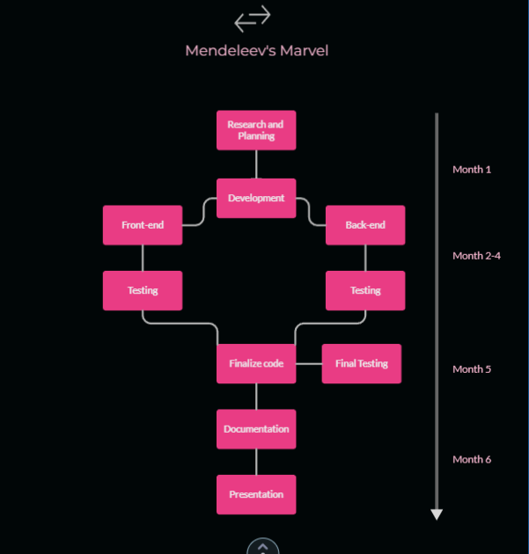

**11-User Case Diagram**

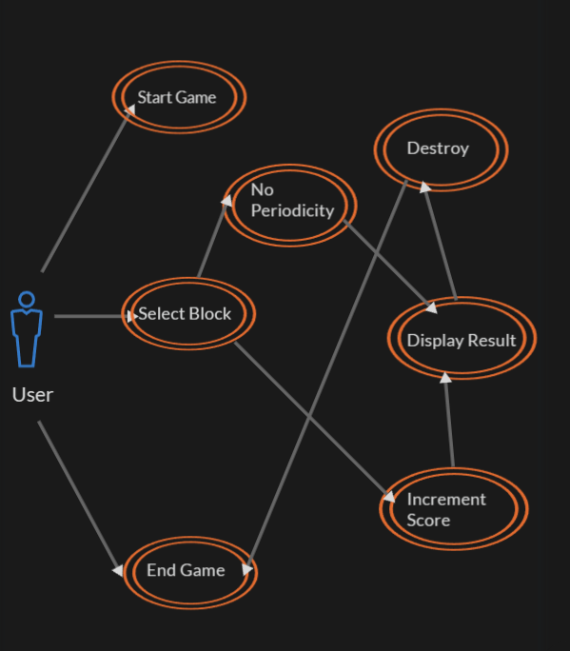

# References

<https://www.geeksforgeeks.org/tag/opengl/>  
<https://pubchem.ncbi.nlm.nih.gov/periodic-table/>

<https://stackoverflow.com/questions/595131/robust-and-flexible-3d-data-structure>

<https://github.com/topics/opengl-project>

<https://learnopengl.com/Getting-started/OpenGL>