**MINOR-2 PROJECT**

**SYNOPSIS on**

**SHOOT’N SHIELD**

Submitted By:

|  |  |  |
| --- | --- | --- |
| **Name** | **Roll No** | **Branch** |
| Shahan Ali | R2142211305 | CSE GG |

**Under the guidance of**

**Alind Sir**



School of Computer Science

**UNIVERSITY OF PETROLEUM AND ENERGY STUDIES**

**Dehradun-248007 2024 25**

**Approved By**

Alind Sir

**Project Guide Department Head**



Table of Contents

1. **Project Title**
2. **Abstract**
3. **Introduction**
4. **Literature Review**
5. **Problem Statement**
6. **Objective**
7. **Methodology**
8. **System Requirements**
9. **Schedule (Pert Chart)**

**10.References**

**School of Computer Science**

University of Petroleum & Energy Studies, Dehradun

**Synopsis Report (2024-25)**

1. **Project Title**

# Shoot’n Shield

# 2- Abstract

# In the realm of digital entertainment, 2D games continue to captivate players with their simplicity, charm, and timeless appeal. This project endeavors to create a dynamic and engaging 2D game experience centered around fast-paced shooting action and randomized enemy encounters. The game challenges players to test their reflexes and strategic prowess as they navigate through increasingly challenging levels, fending off hordes of enemies while striving to achieve the highest score possible.

# Drawing inspiration from classic arcade shooters and modern indie game trends, the project aims to deliver a polished and immersive gaming experience that resonates with both casual players and seasoned enthusiasts alike. By leveraging procedural generation techniques, each playthrough offers a unique and unpredictable gameplay experience, ensuring replayability and longevity.

# 3- Introduction-

The 2D game project aims to address the aforementioned issues by providing an engaging and dynamic gaming experience through the implementation of randomized enemy generation and interactive shooting mechanics. The game offers players the opportunity to test their reflexes and strategic thinking in a fast-paced environment where each playthrough presents unique challenges.

# 4- Literature Review

* Endless Game Design: This is a popular genre in the field of game design while most of the indie games are created in the genre, but the first one was the Doodle Jump in April 2009 and thus we got so many popular games like subway surfers and even the dinosaur game on google chrome. So, our game’s main genre is endless shooter which is the sub part of endless game design where the player needs to shoot.
* Shooting Game: Shooting game got popular with games like call of duty, counter strike etc, the popularity of the genre made it easier for gamers to know the choice of the audience and so we made different varieties of shooting based game, one of the variety which may be not that popular but is used in our game is 2-D sprite visual based shooting.
* Unity Game Development: It may not be an open source but there were research papers on it like “Unity Game Development Engine: A Technical Survey” Where it is shown how unity works and how one must use it. There were books on unity such as Unity in Action by Joe Hocking and Learning c# by Developing Games With Unity by Harrison Ferrone. The paper and books are used as reference to create the game and will be taken as reference and learning for further game development in the project.

# 5- Problem Statement

# Lack of Engaging 2D Games: Traditional 2D games often lack dynamic elements that keep players engaged over time.

# Absence of Randomized Challenges: Many 2D games rely on pre-defined levels or patterns, leading to repetitive gameplay experiences.

# Limited Player Interaction: Players may feel detached from the game due to a lack of meaningful interaction and variability in gameplay mechanics.

# 6- Objectives

The Shoot’n Shield Project has several key objectives:

* 1- Develop Engaging Gameplay Mechanics: Design and implement intuitive and addictive gameplay mechanics that allow players to keep on playing the endless game.
  + Variety of enemies, obstacles throughout the game will help us achieve engagement in the game
  + The intuitivity of the gameplay will be achieved through endless gameplay.
* 2- Enhance Player Progression and score: The game that incentivizes player to continue playing and improving their performance.
  + Player progression is achieved showing final result in the end of the game.
* 3- Unity graphics and C# functionality: Use graphics based on sprites because of 2-D game and the functionality is by default fixed in unity as C# so used it for all the programmed based exercise.

# 7- Methodology

# Developing Engaging Gameplay Mechanics by constantly generated enemies with different powers and giving them different weapons to attack the player and the engagement will be achieved through endlessness of the game, as per the game goes on. The level will increase constantly and so the difficulty. The script in the unity will be written in such a way to achieve the objective of engagement and intuitive game.

# The main point of the game is to have an addictive play which can be achieved by different types of enemies generated and the player powerups, the sprites will be taken with different scripts to be generation time of a particular time period. And the enemies generation will be pre defined to be given at a fixed time period as the game goes on.

# 8- System Requirements (Software/Hardware)

* Hardware Interface:
  + 64 bits processor architecture supported by windows.
  + Minimum RAM requirement for proper functioning is 4 GB.
  + Required input as well as output devices.
  + Required sufficient Graphic card for rendering the game.
* Software Interface:
  + This system is developed in Unity.

# 9-Schedule (Pert Chart)

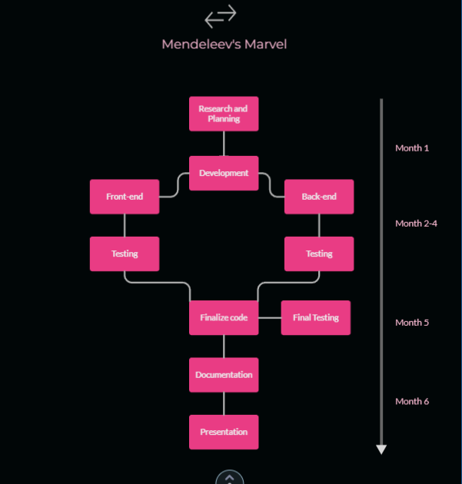

# References

https://unity.com/  
https://assetstore.unity.com/  
https://www.geeksforgeeks.org/unity-books-for-game-development/  
https://unity.com/solutions/indie-innovation  
https://flylib.com/books/en/2.208.1.86/1/  
https://unity.com/open-projects  
https://en.wikipedia.org/wiki/Unity_(game_engine)