Parameter recovery: classic_qval_and_eval, p50 environment, sanity_n20_highbeta

Design
We simulated 20 agents performing 150 trials of a 3-armed bandit (all arms offered every trial; p(win) = 0.5 for every arm on every trial). Agent-level parameters were drawn from alpha_rl = inv_logit(N(0.00, 1.50)), beta_rl = exp(N(1.00, 0.50)), alpha_per = inv_logit(N(0.00, 1.50)), beta_per = N(0.00, 1.50). The hierarchical classic_qval_and_eval model was fitted with 4 chains of 500 warmup and 500 sampling iterations (8.2 min).

Convergence
Divergent transitions: 0. Group-level max Rhat = 1.014, min bulk ESS = 267. Subject-level max Rhat = 1.016, min bulk ESS = 383.

Agent-level recovery
param | pearson_r | bias | ols_slope | coverage_90 | median_post_sd | spread_ratio_sd
alpha_rl | 0.97 | 0.05 | 0.92 | 0.85 | 0.10 | 0.95
beta_rl | 0.83 | -0.32 | 0.79 | 0.90 | 0.75 | 0.96
alpha_per | 0.55 | -0.18 | 0.51 | 1.00 | 0.36 | 0.93
beta_per | 0.73 | 0.71 | 0.38 | 1.00 | 1.41 | 0.52
For every pair of parameters: the correlation of recovery errors across agents (error_cor) and the within-agent correlation across posterior draws (mean and median over agents).
pair | error_cor | posterior_cor_mean | posterior_cor_median
alpha_rl_beta_rl | -0.36 | -0.46 | -0.62
alpha_rl_alpha_per | 0.08 | -0.02 | -0.02
alpha_rl_beta_per | -0.48 | 0.09 | 0.08
beta_rl_alpha_per | 0.00 | 0.04 | 0.02
beta_rl_beta_per | -0.15 | -0.08 | -0.09
alpha_per_beta_per | -0.41 | -0.16 | -0.19

Population-level recovery
variable | true_value | post_median | q5 | q95 | covered_90
alpha_rl_pop | 0.50 | 0.59 | 0.39 | 0.77 | true
beta_rl_pop | 2.72 | 3.03 | 2.23 | 4.03 | true
alpha_per_pop | 0.50 | 0.23 | 0.01 | 0.87 | true
beta_per_pop | 0.00 | 0.70 | -0.49 | 1.82 | true
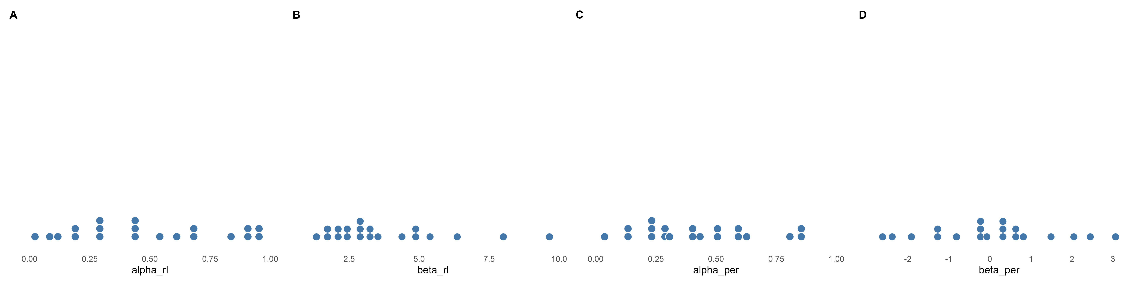
Figure 1. True agent-level parameters drawn from the generating population (one dot per agent).
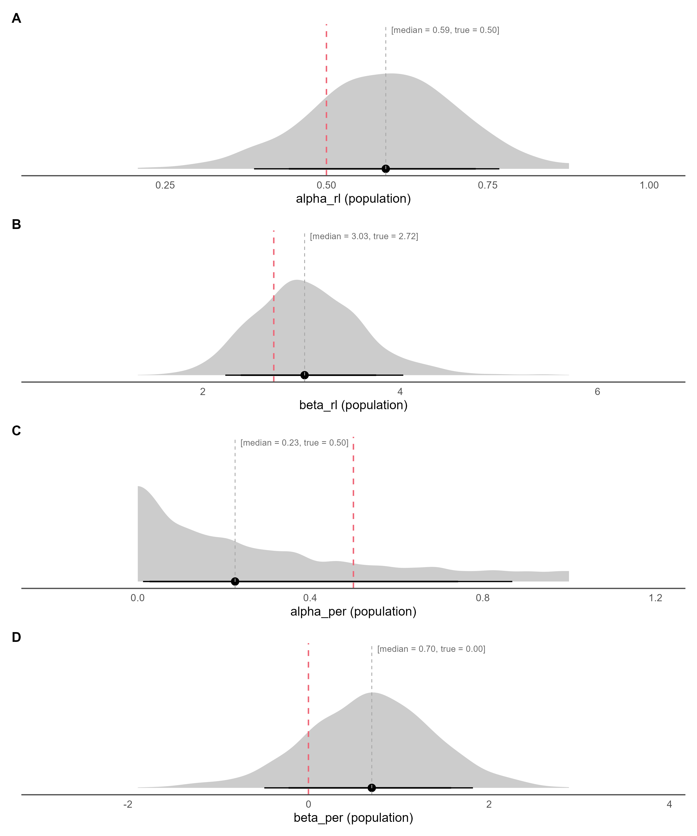
Figure 2. Posterior densities of the population-level parameters (link(mu)) on the natural scale, with median and 80% / 90% credible intervals; the dashed red line marks the true generating value.
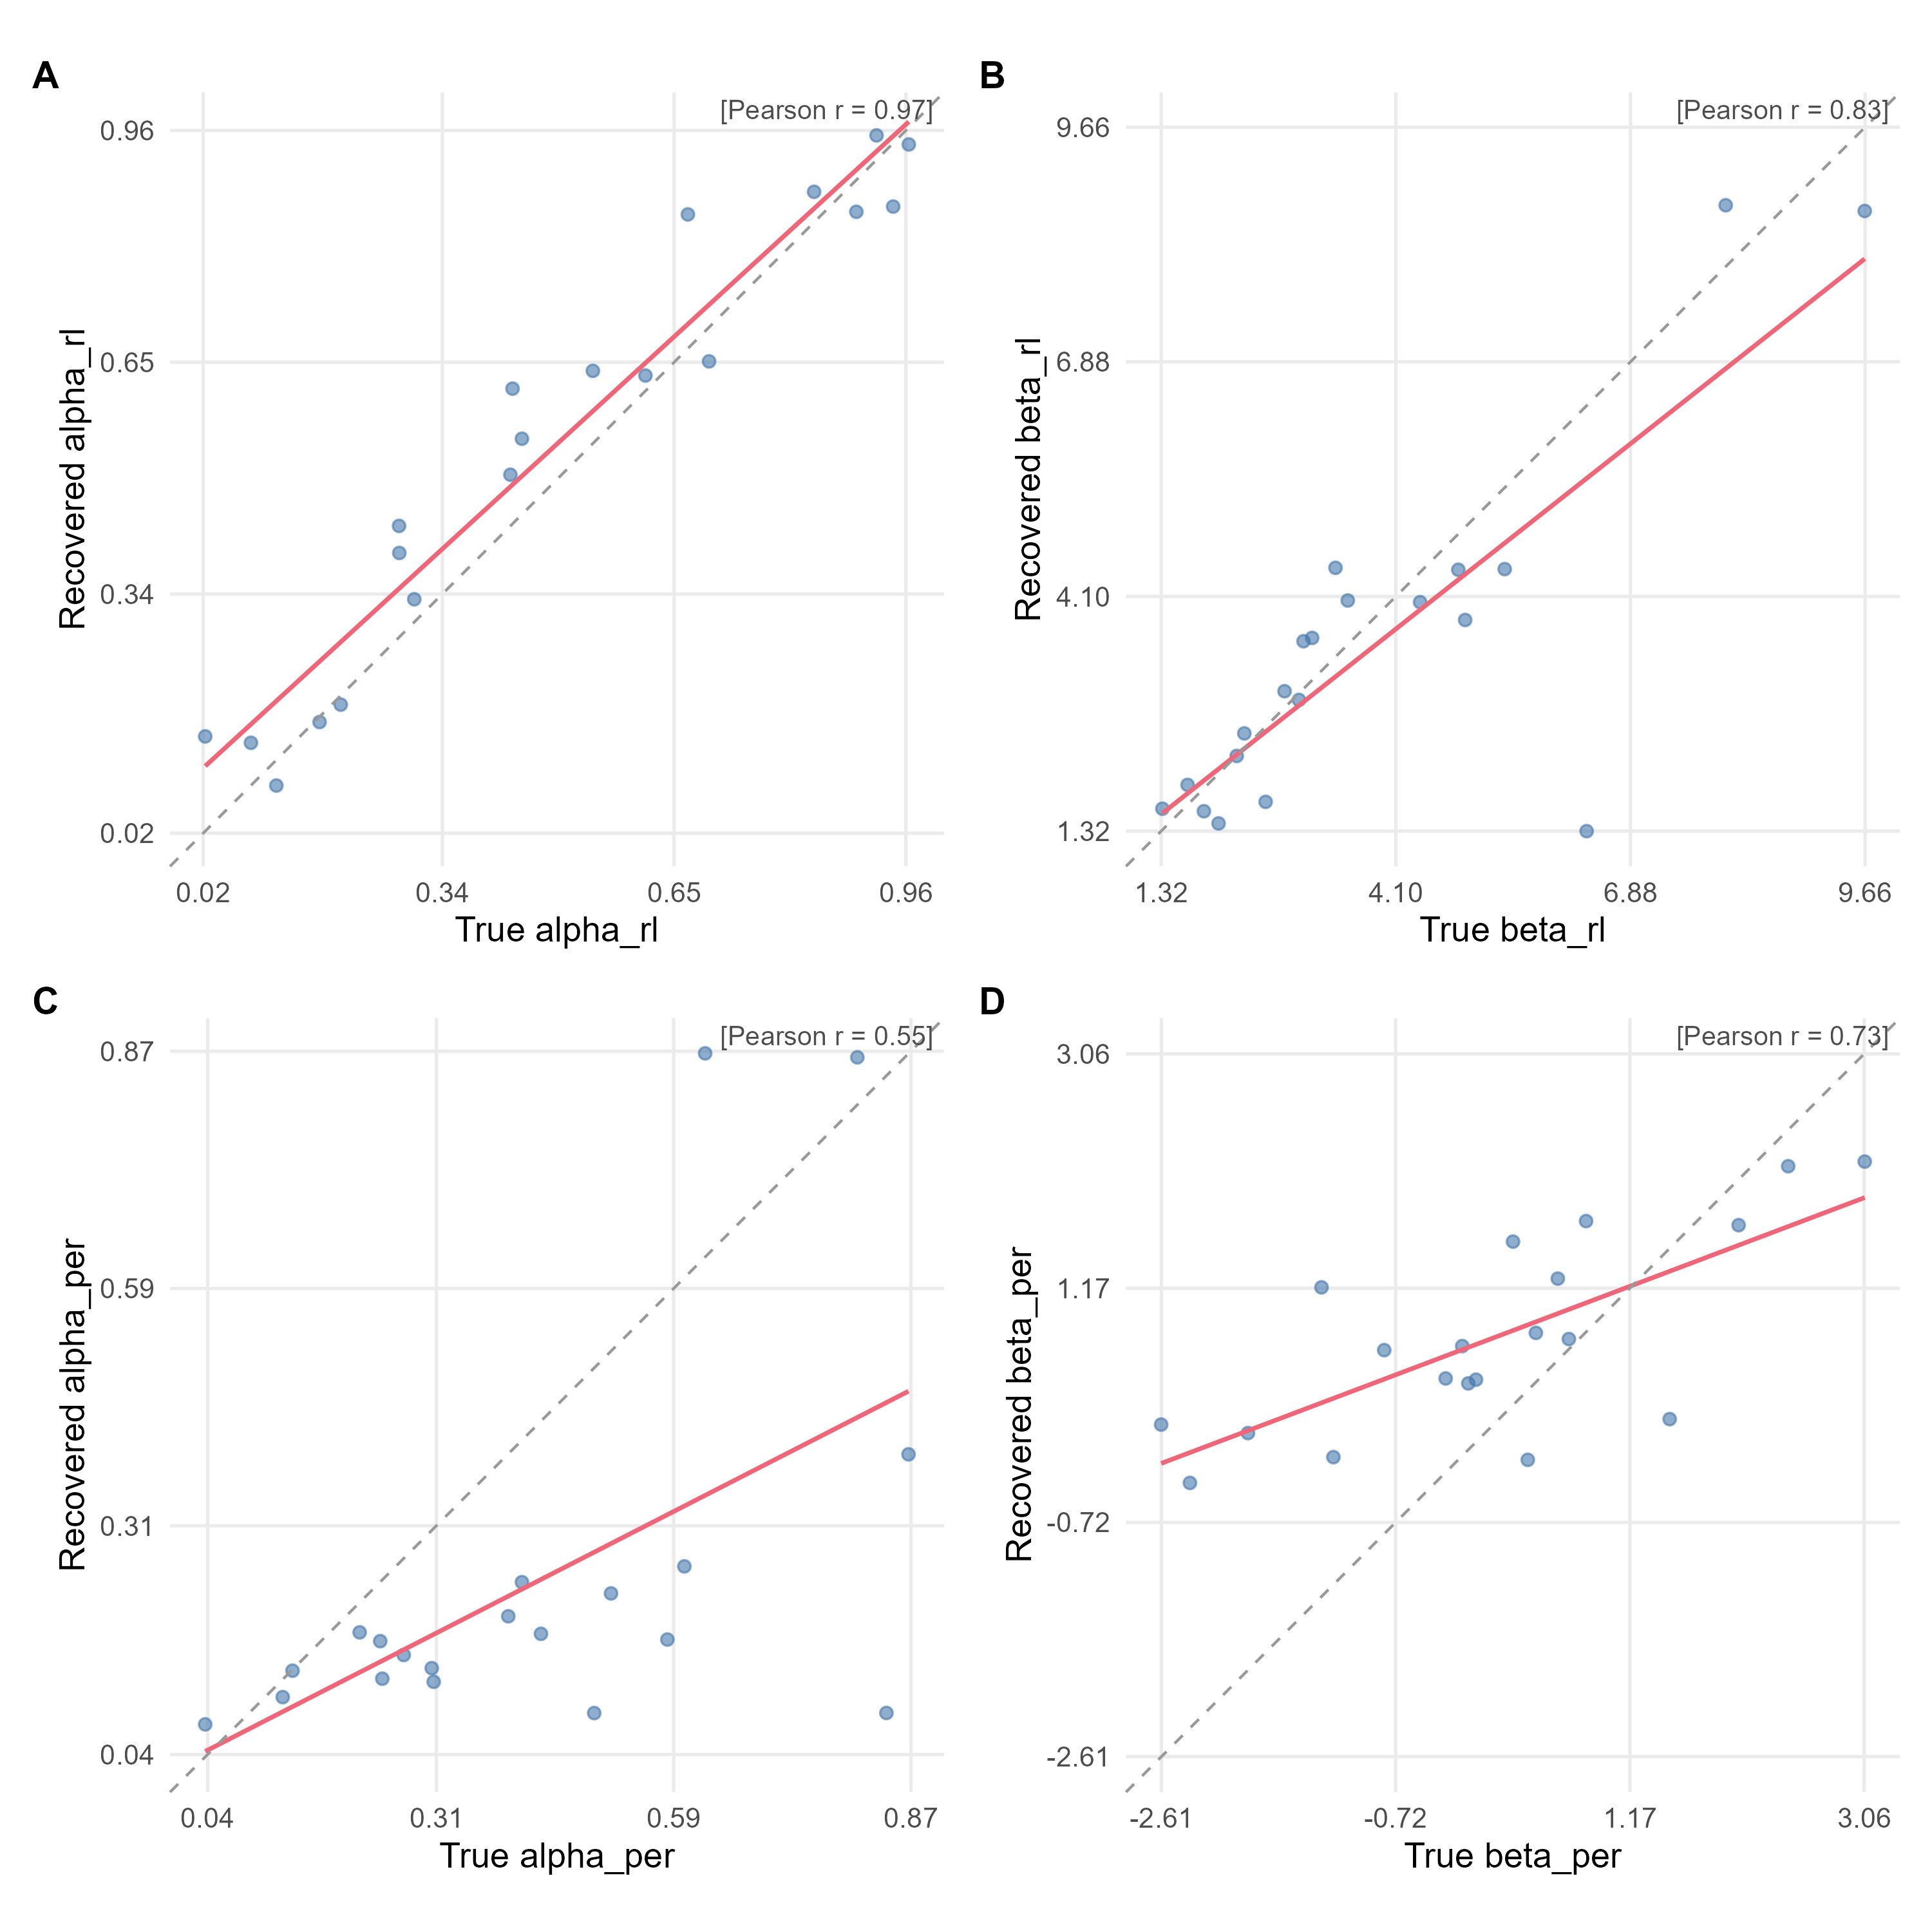
Figure 3. True versus recovered (posterior median) agent-level parameters. The red line is the OLS fit, the dashed grey line is the identity line, and r is Pearson's correlation.
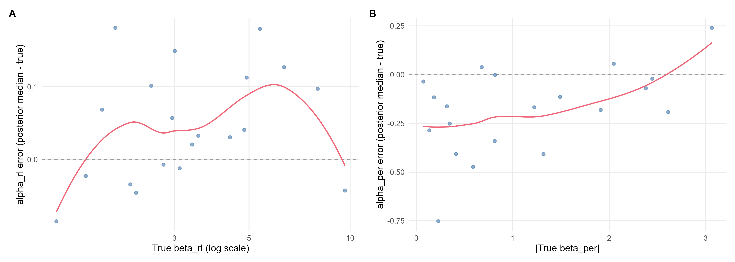
Figure 4. alpha_rl recovery error (posterior median minus true value) against the true beta_rl; alpha_per recovery error (posterior median minus true value) against the true absolute beta_per (log scale for exp-linked parameters). The red line is a loess smoother and the dashed grey line marks zero error.

