Parameter recovery: classic_qval_and_perseveration, p50 environment, sanity_n20

Design
We simulated 20 agents performing 150 trials of a 3-armed bandit (all arms offered every trial; p(win) = 0.5 for every arm on every trial). Agent-level parameters were drawn from alpha = inv_logit(N(0.00, 1.50)), beta = exp(N(1.00, 0.50)), kappa = N(0.00, 0.50). The hierarchical classic_qval_and_perseveration model was fitted with 4 chains of 500 warmup and 500 sampling iterations (5.0 min).

Convergence
Divergent transitions: 0. Group-level max Rhat = 1.008, min bulk ESS = 374. Subject-level max Rhat = 1.006, min bulk ESS = 955.

Agent-level recovery
param | pearson_r | bias | ols_slope | coverage_90 | median_post_sd | spread_ratio_sd
alpha | 0.95 | -0.03 | 1.04 | 0.90 | 0.08 | 1.09
beta | 0.85 | 0.25 | 0.87 | 0.95 | 1.12 | 1.01
kappa | 0.93 | -0.08 | 0.64 | 0.85 | 0.18 | 0.69
For every pair of parameters: the correlation of recovery errors across agents (error_cor) and the within-agent correlation across posterior draws (mean and median over agents).
pair | error_cor | posterior_cor_mean | posterior_cor_median
alpha_beta | -0.53 | -0.44 | -0.57
alpha_kappa | -0.20 | 0.01 | 0.00
beta_kappa | -0.16 | -0.22 | -0.24

Population-level recovery
variable | true_value | post_median | q5 | q95 | covered_90
alpha_pop | 0.50 | 0.47 | 0.28 | 0.68 | true
beta_pop | 2.72 | 3.62 | 2.59 | 4.79 | true
kappa_pop | 0.00 | -0.21 | -0.38 | -0.06 | false
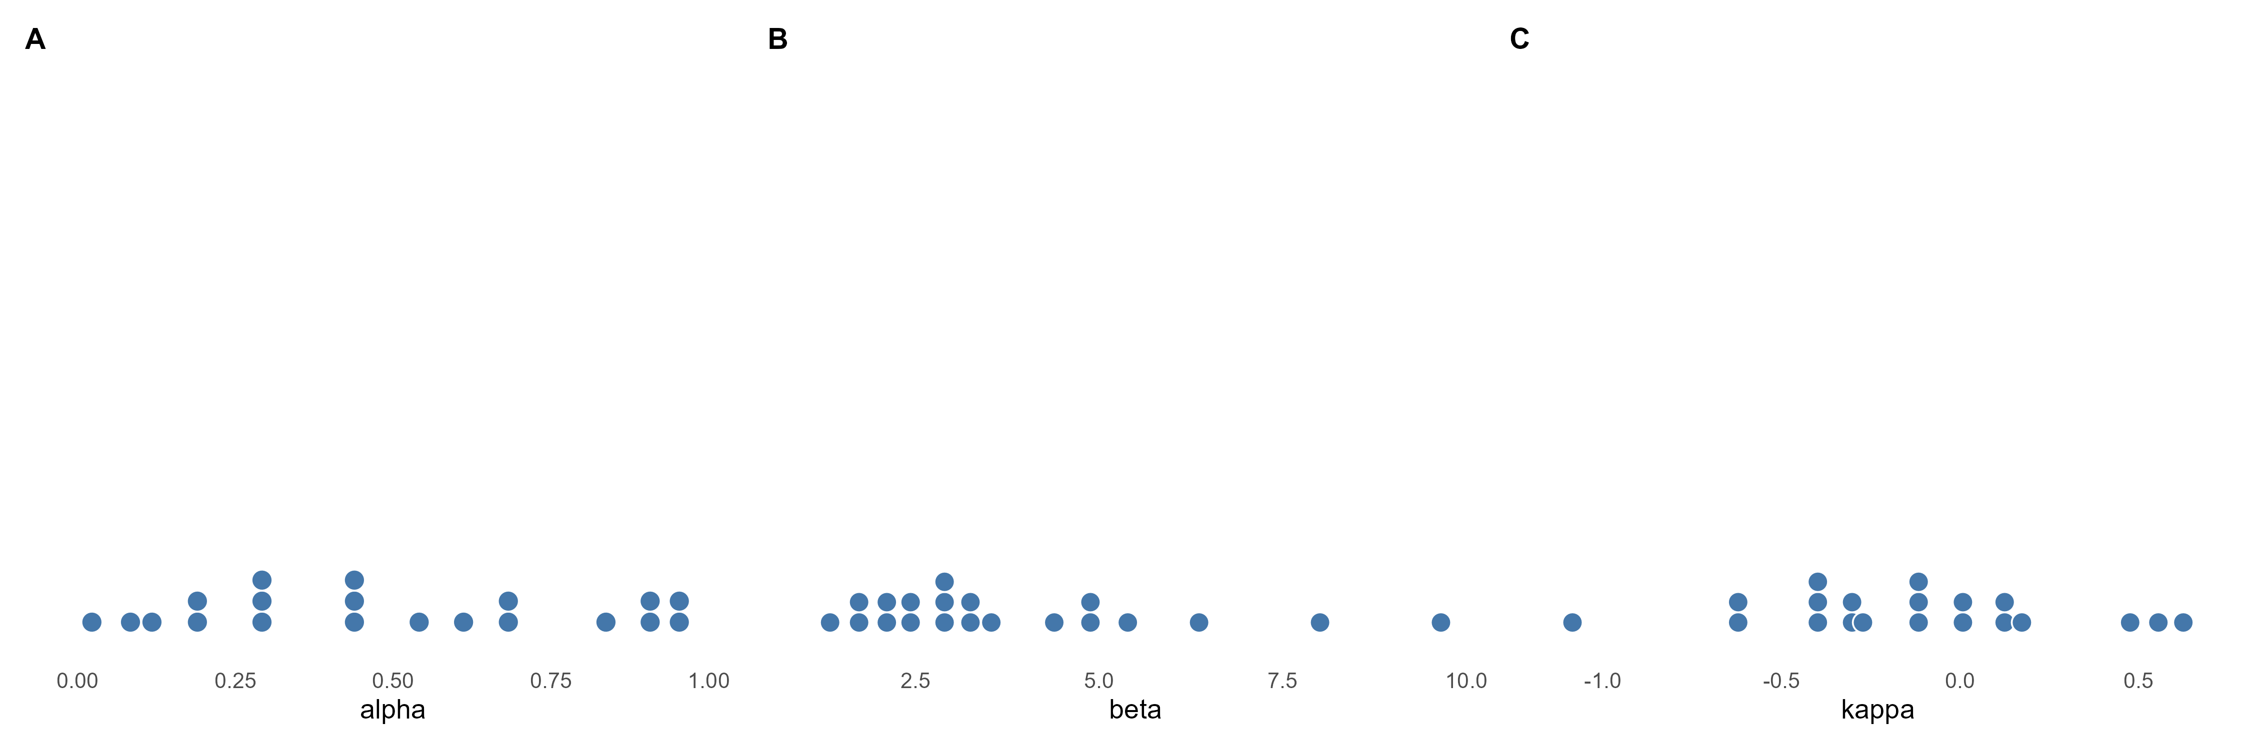
Figure 1. True agent-level parameters drawn from the generating population (one dot per agent).
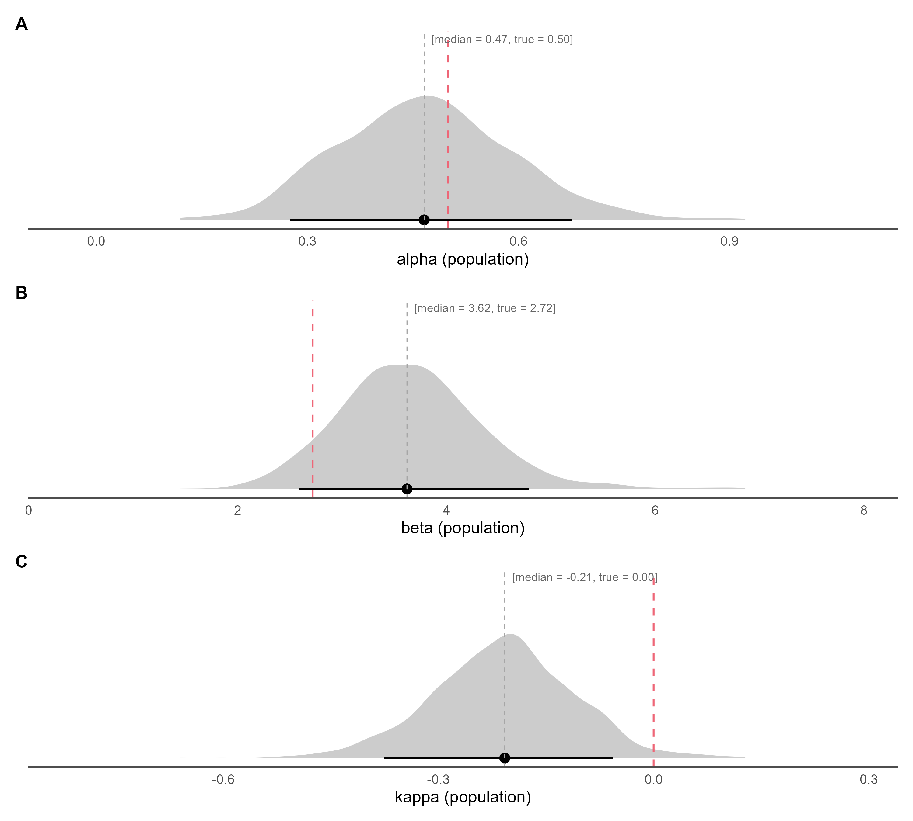
Figure 2. Posterior densities of the population-level parameters (link(mu)) on the natural scale, with median and 80% / 90% credible intervals; the dashed red line marks the true generating value.
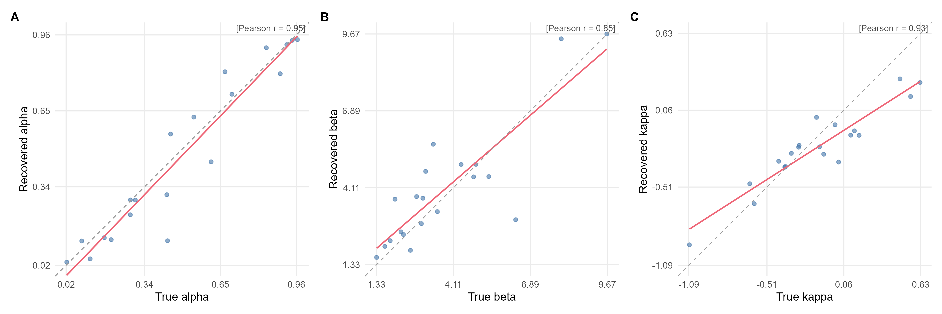
Figure 3. True versus recovered (posterior median) agent-level parameters. The red line is the OLS fit, the dashed grey line is the identity line, and r is Pearson's correlation.
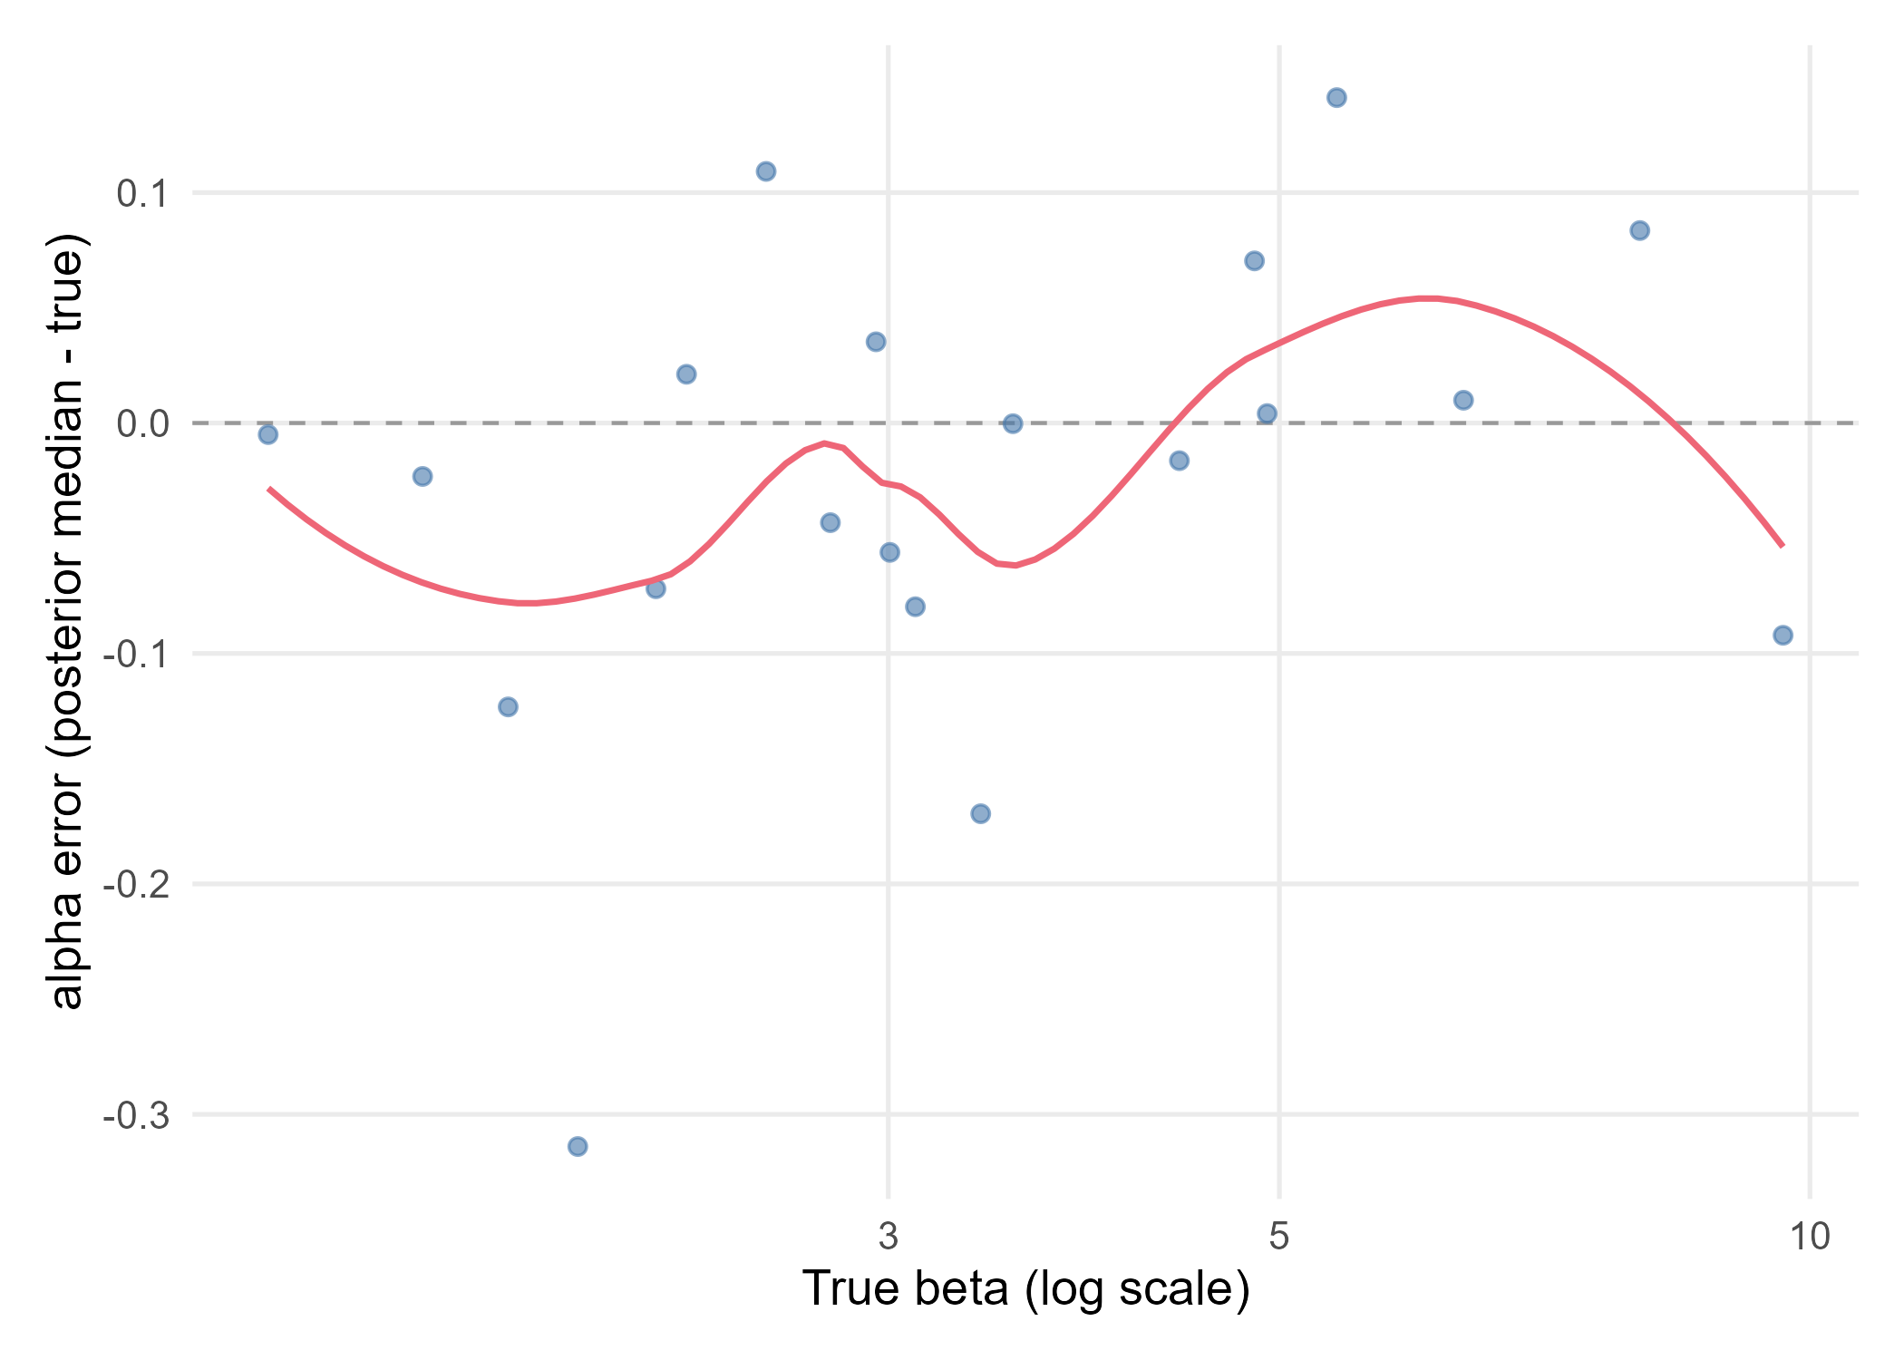
Figure 4. alpha recovery error (posterior median minus true value) against the true beta (log scale for exp-linked parameters). The red line is a loess smoother and the dashed grey line marks zero error.

