Parameter recovery: classic_qval, p50 environment, sanity_n20_highbeta

Design
We simulated 20 agents performing 150 trials of a 3-armed bandit (all arms offered every trial; p(win) = 0.5 for every arm on every trial). Agent-level parameters were drawn from alpha = inv_logit(N(0.00, 1.50)) and beta = exp(N(1.00, 0.50)); alpha was logistically transformed onto the unit interval and beta exponentiated to stay positive. The hierarchical classic_qval model was fitted with 4 chains of 500 warmup and 500 sampling iterations (1.2 min).

Convergence
Divergent transitions: 0. Group-level max Rhat = 1.005, min bulk ESS = 527. Subject-level max Rhat = 1.007, min bulk ESS = 872.

Agent-level recovery
param | pearson_r | bias | ols_slope | coverage_90 | median_post_sd | spread_ratio_sd
alpha | 0.97 | 0.01 | 0.93 | 0.95 | 0.09 | 0.96
beta | 0.85 | -0.26 | 0.79 | 0.90 | 0.75 | 0.94
Correlation of alpha and beta recovery errors across agents: r = -0.42. Mean within-agent posterior correlation of alpha and beta: -0.46.

Population-level recovery
variable | true_value | post_median | q5 | q95 | covered_90
alpha_pop | 0.50 | 0.53 | 0.34 | 0.72 | true
beta_pop | 2.72 | 3.07 | 2.30 | 4.06 | true
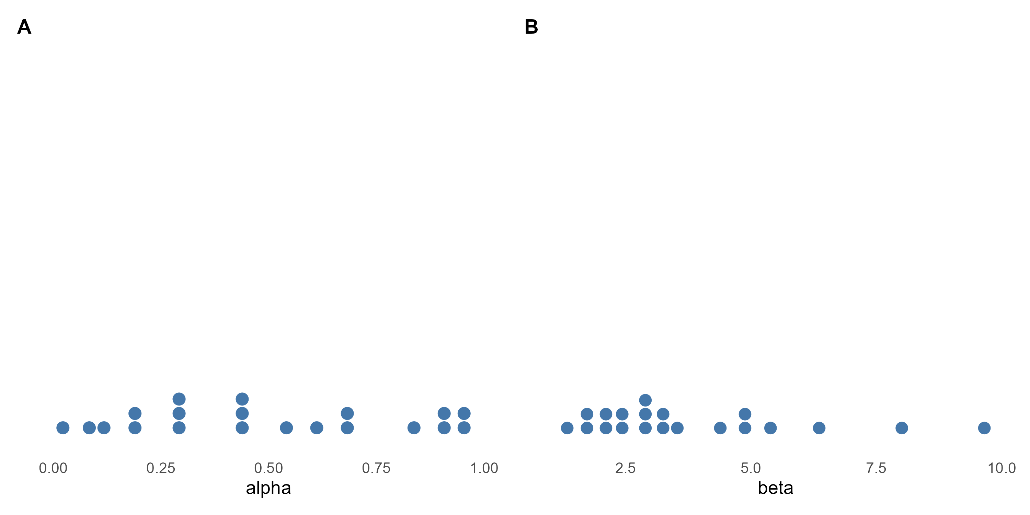
Figure 1. True agent-level alpha and beta drawn from the generating population (one dot per agent).
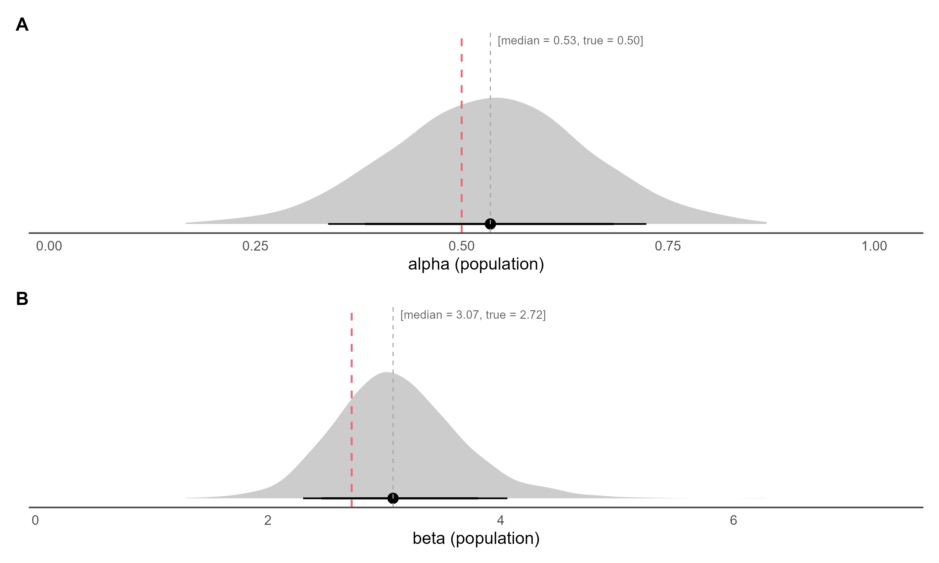
Figure 2. Posterior densities of the population-level alpha (inv_logit(mu_alpha)) and beta (exp(mu_beta)) on the natural scale, with median and 80% / 90% credible intervals; the dashed red line marks the true generating value.
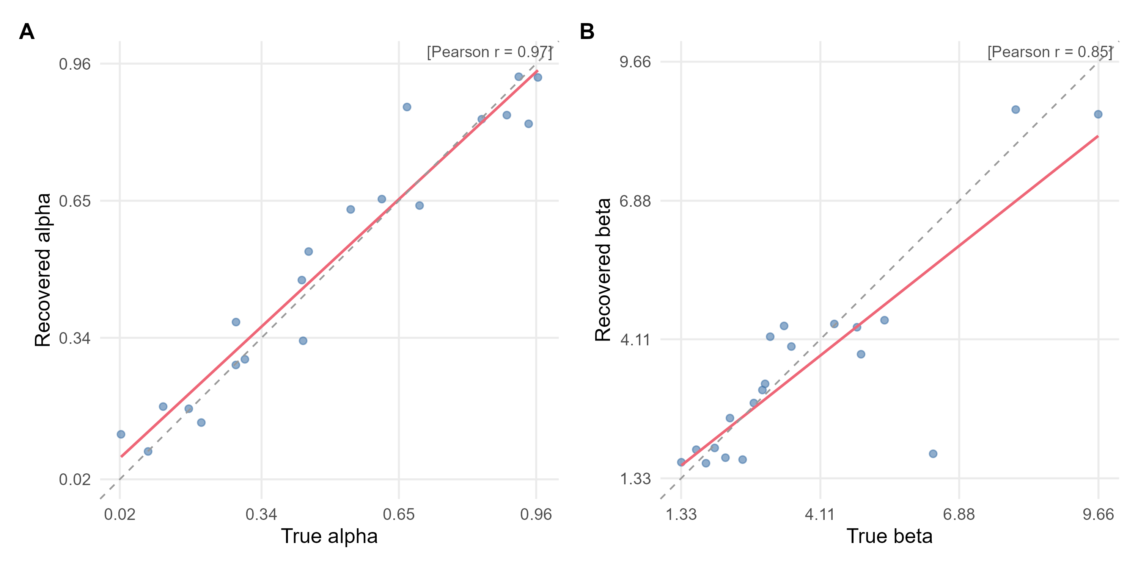
Figure 3. True versus recovered (posterior median) agent-level parameters. The red line is the OLS fit, the dashed grey line is the identity line, and r is Pearson's correlation.
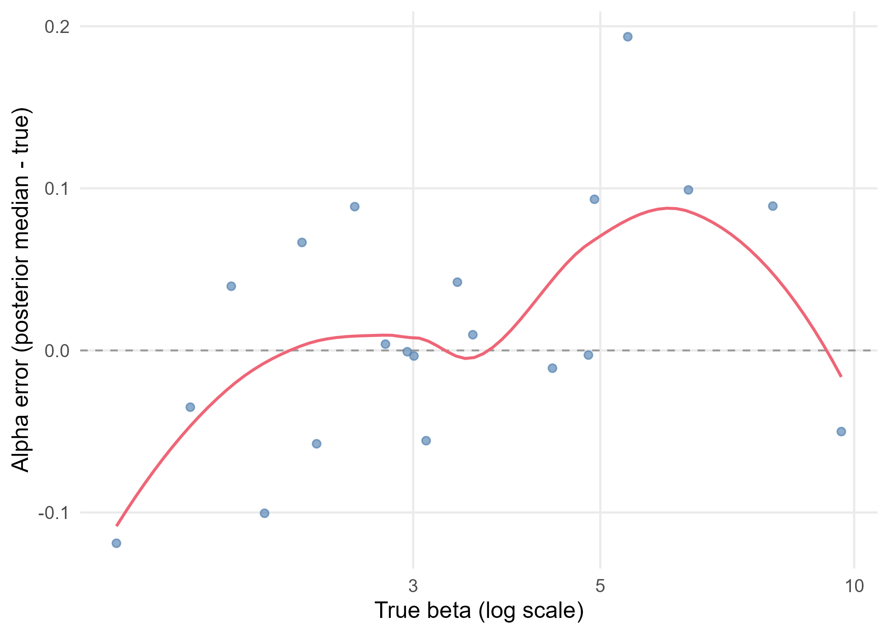
Figure 4. Alpha recovery error (posterior median minus true value) against the true beta, log scale. The red line is a loess smoother and the dashed grey line marks zero error.

