Parameter recovery: classic_qval, randomwalk environment, n35

Design
We simulated 35 agents performing 150 trials of a 3-armed bandit (all arms offered every trial; p(win) per arm follows a Gaussian random walk, SD 0.05, clamped to [0, 1], starting at U(0, 1)). Agent-level parameters were drawn from alpha = inv_logit(N(0.00, 0.85)) and beta = exp(N(-0.25, 0.75)); alpha was logistically transformed onto the unit interval and beta exponentiated to stay positive. The hierarchical classic_qval model was fitted with 4 chains of 2000 warmup and 2000 sampling iterations (4.0 min).

Convergence
Divergent transitions: 0. Group-level max Rhat = 1.003, min bulk ESS = 1566. Subject-level max Rhat = 1.001, min bulk ESS = 5135.

Agent-level recovery
param | pearson_r | bias | ols_slope | coverage_90 | median_post_sd | spread_ratio_sd
alpha | 0.63 | 0.04 | 0.31 | 0.94 | 0.16 | 0.5
beta | 0.98 | -0.05 | 0.98 | 0.97 | 0.26 | 1.0
Correlation of alpha and beta recovery errors across agents: r = -0.31. Mean within-agent posterior correlation of alpha and beta: -0.29.

Population-level recovery
variable | true_value | post_median | q5 | q95 | covered_90
mu_alpha | 0.00 | 0.16 | -0.28 | 0.63 | TRUE
mu_beta | -0.25 | -0.15 | -0.47 | 0.12 | TRUE
sigma_alpha | 0.85 | 0.87 | 0.44 | 1.50 | TRUE
sigma_beta | 0.75 | 0.91 | 0.70 | 1.21 | TRUE
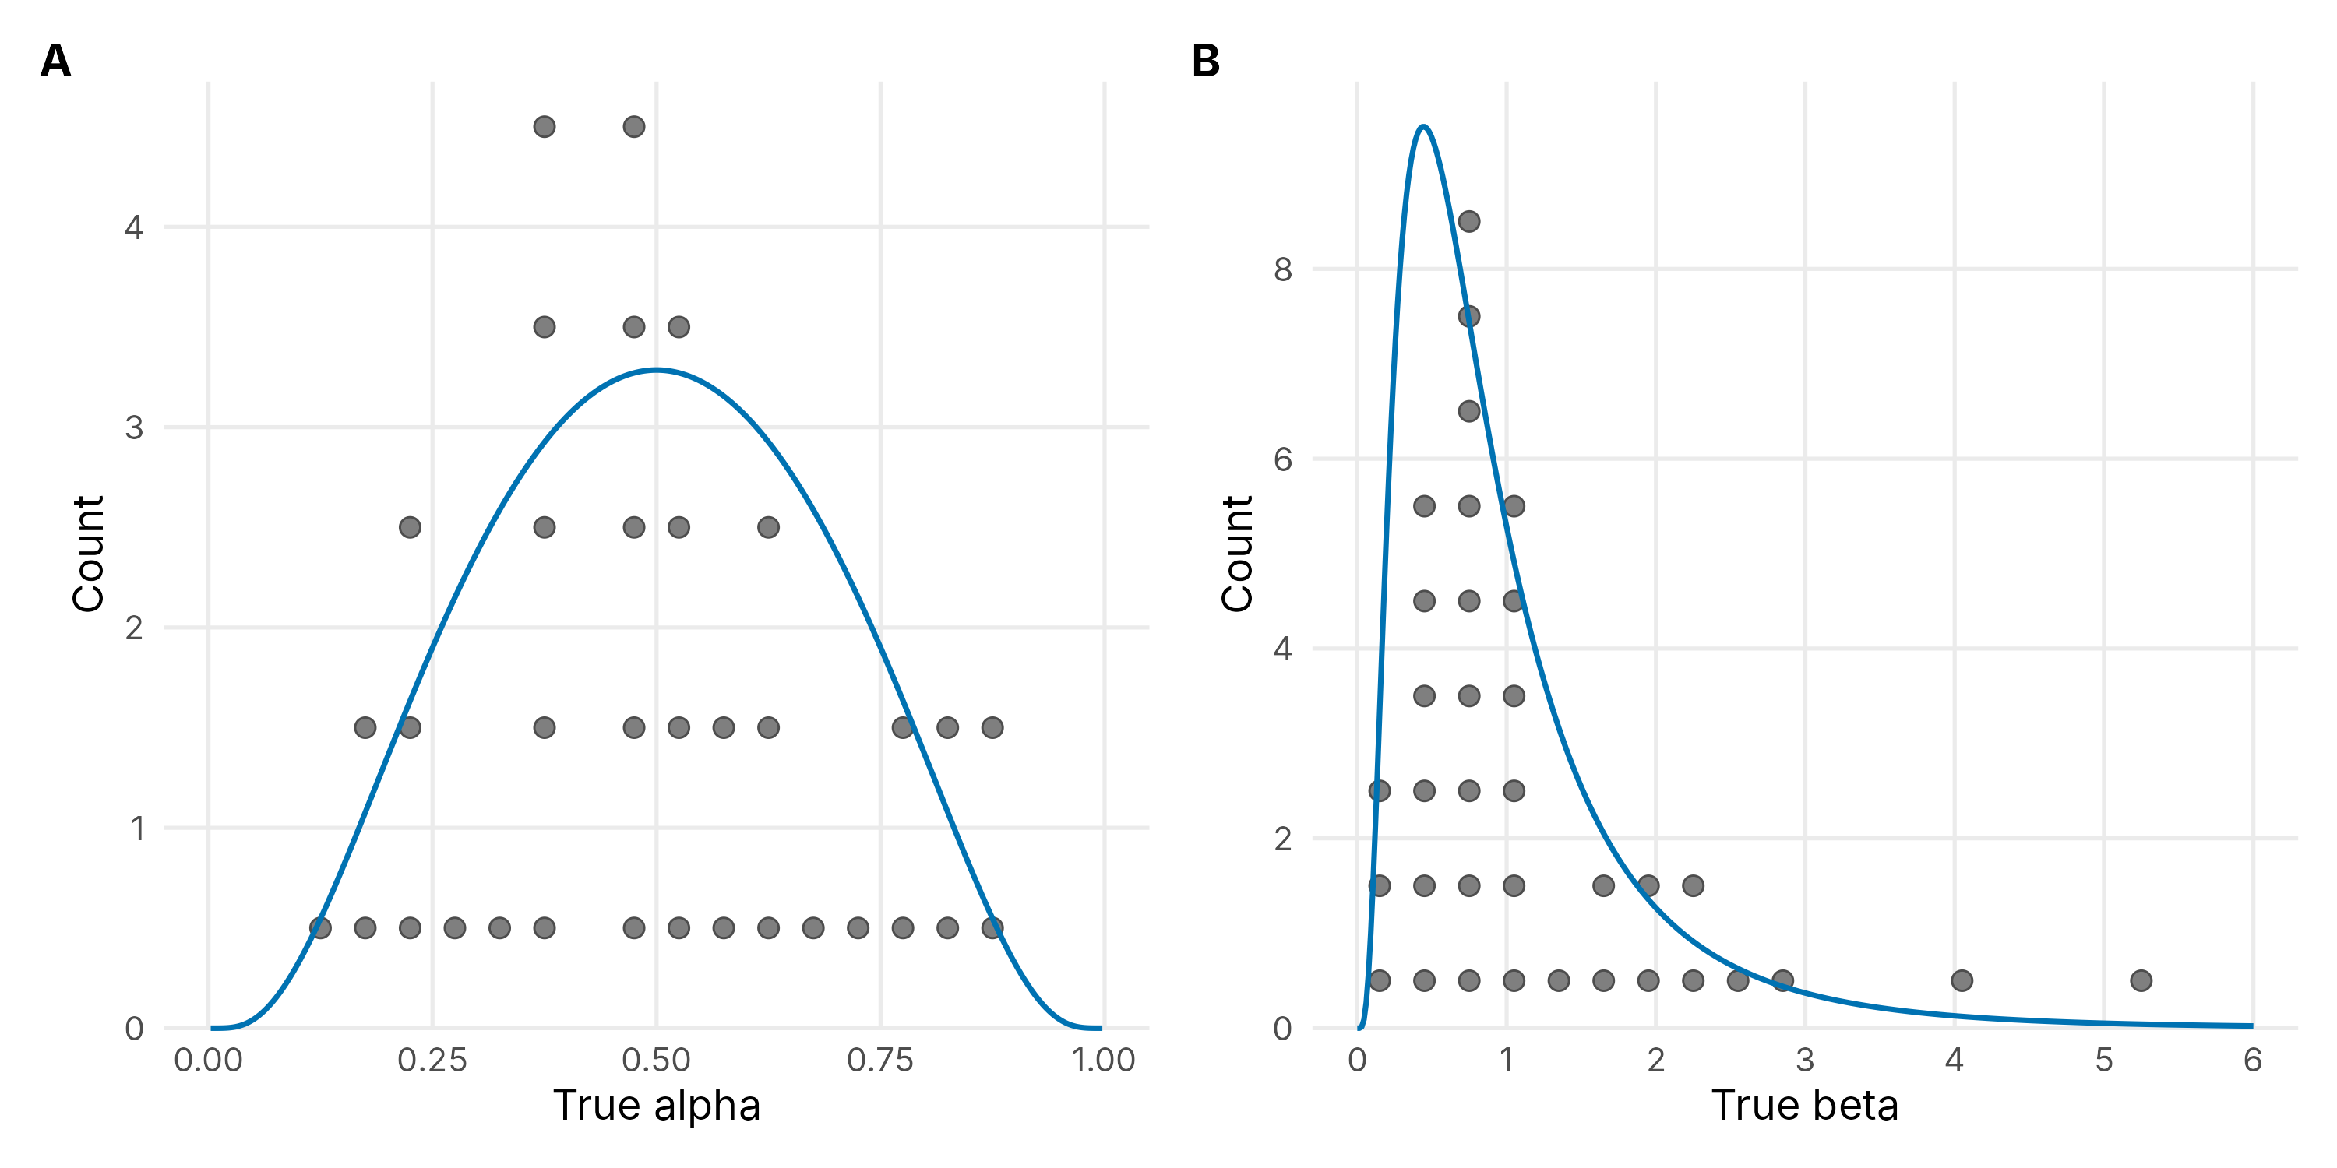
Figure 1. True agent-level alpha and beta drawn from the generating population (dots), with the generating density overlaid (blue line).
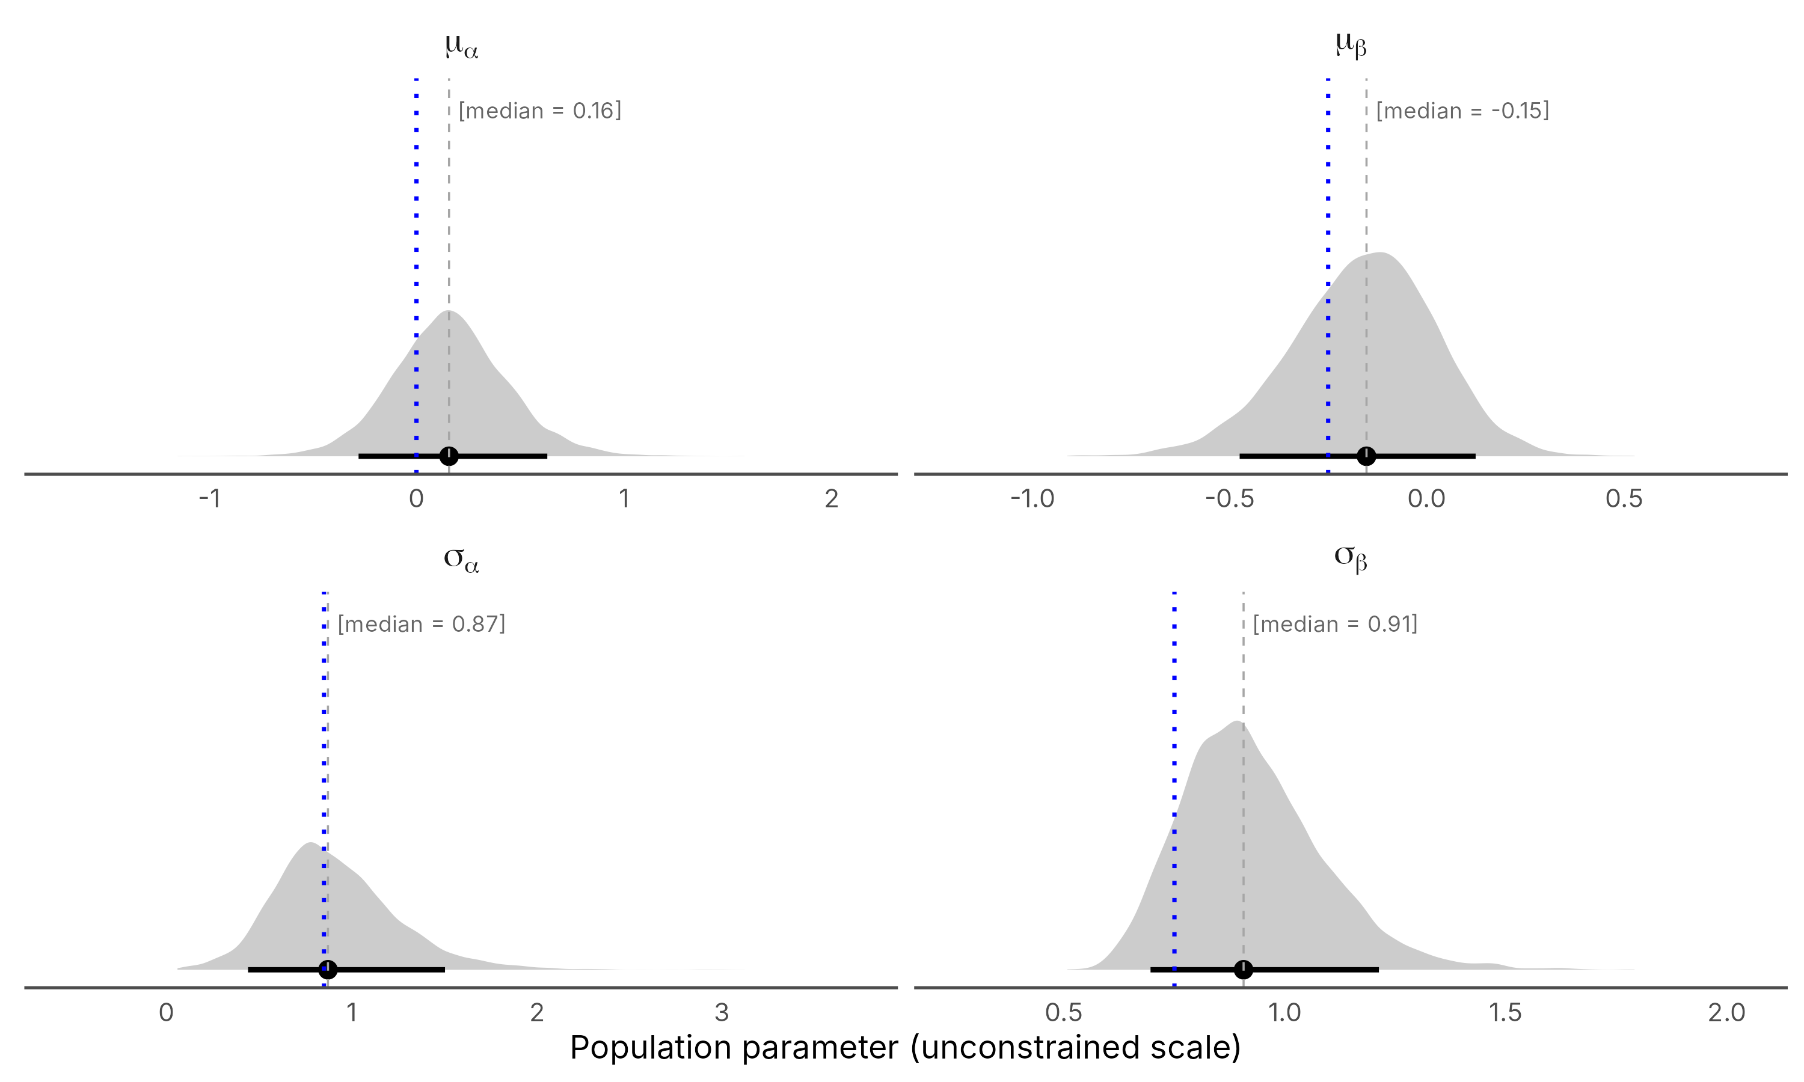
Figure 2. Posterior densities of the population location (mu) and scale (sigma) parameters on the unconstrained scale, with median and 90% credible interval; the dotted blue line marks the true generating value.
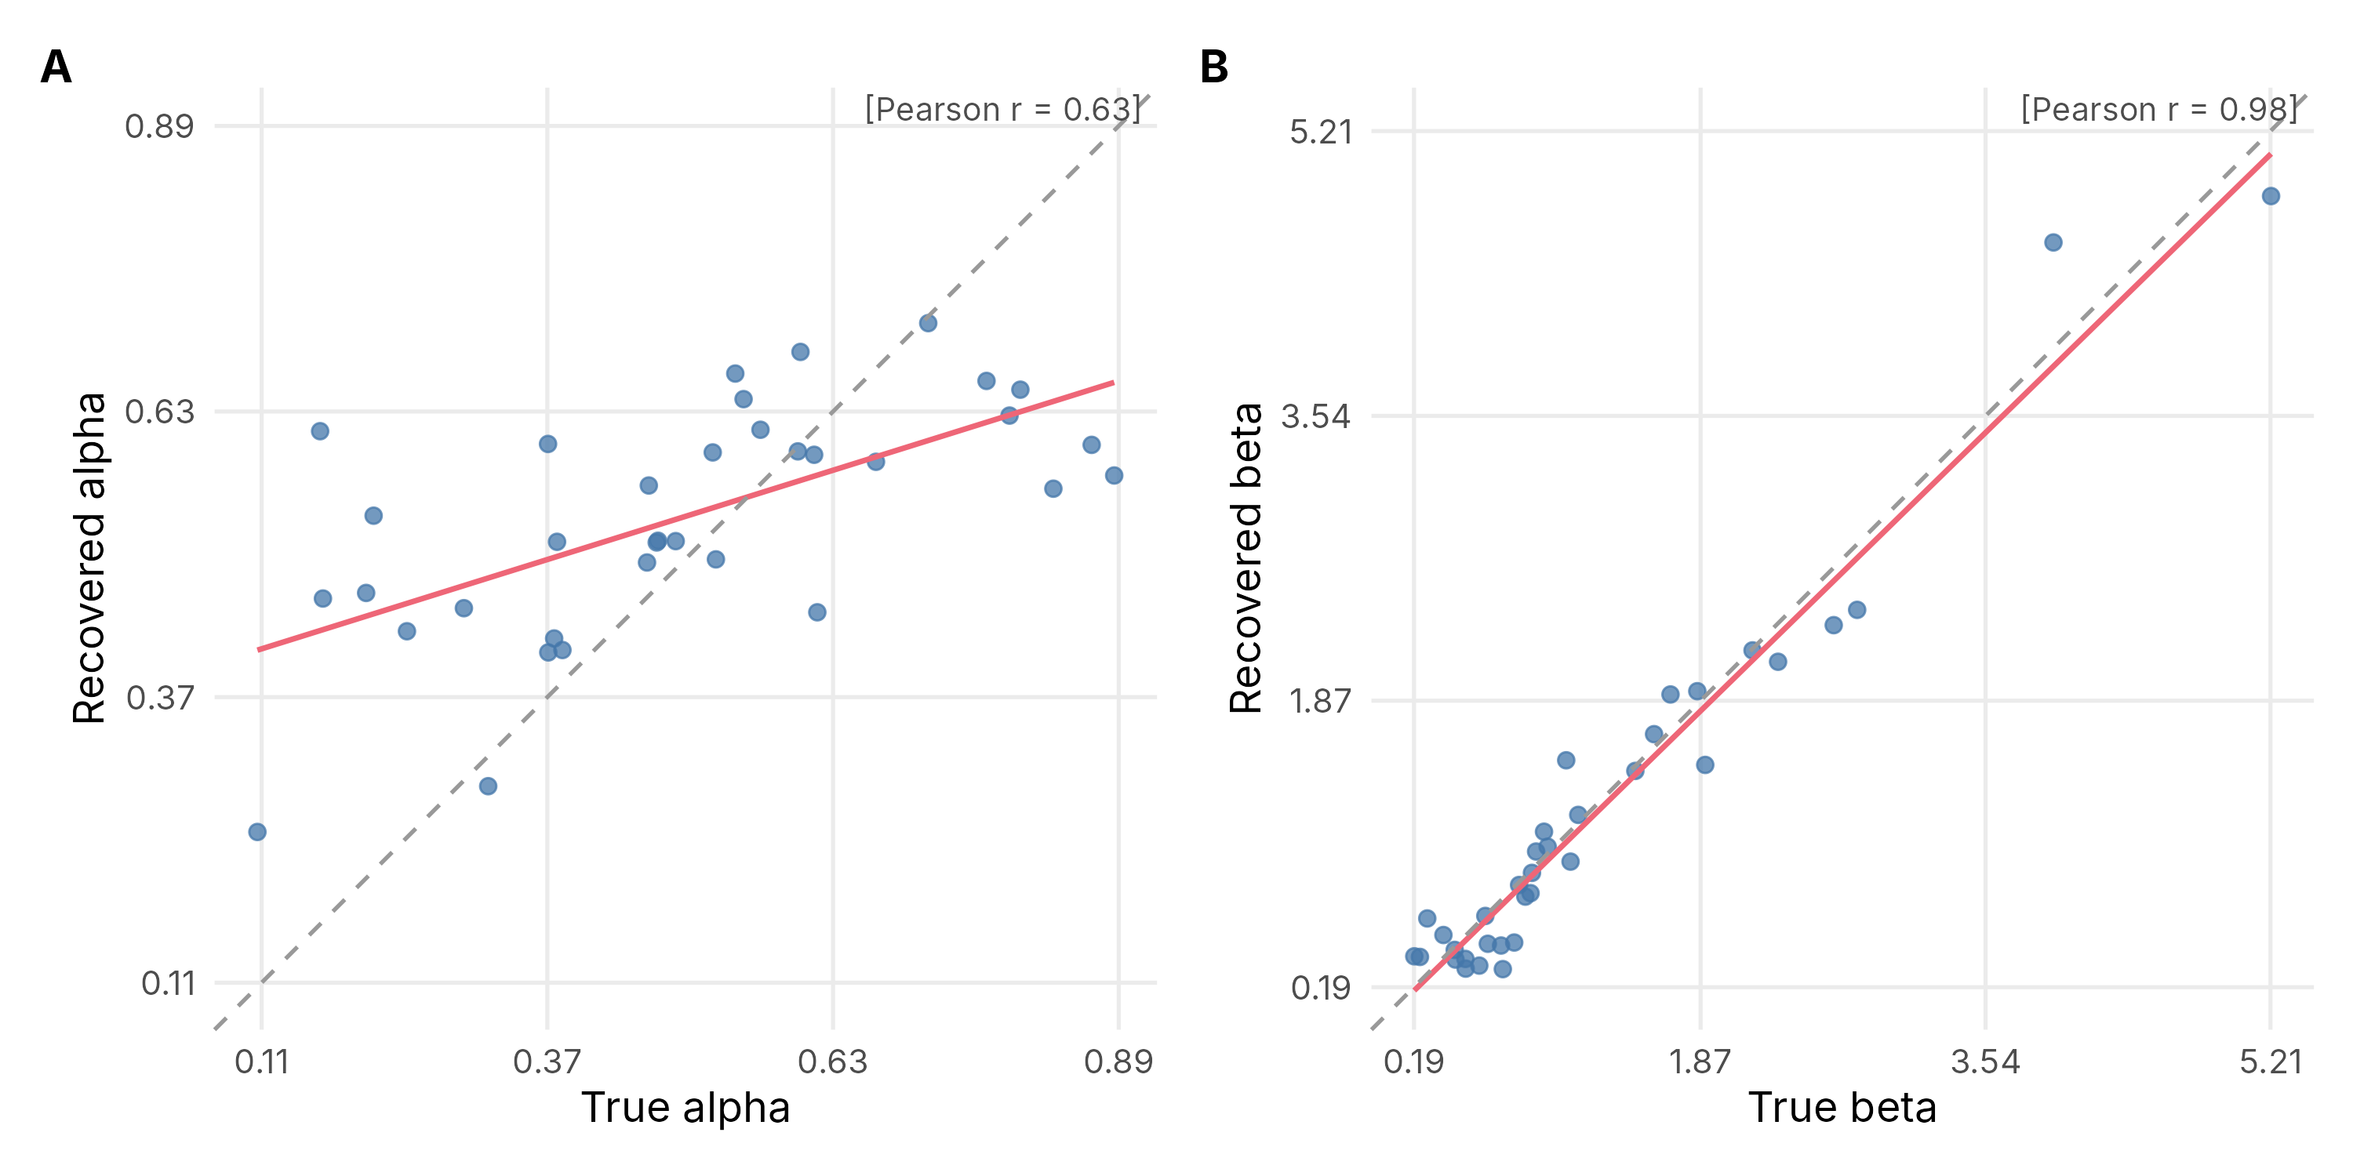
Figure 3. True versus recovered (posterior median) agent-level parameters. The red line is the OLS fit, the dashed grey line is the identity line, and r is Pearson's correlation.

