Parameter recovery: classic_qval_and_perseveration, p50 environment, n200

Design
We simulated 200 agents performing 150 trials of a 3-armed bandit (all arms offered every trial; p(win) = 0.5 for every arm on every trial). Agent-level parameters were drawn from alpha = inv_logit(N(0.00, 1.50)), beta = exp(N(1.00, 0.50)), kappa = N(0.00, 0.50). The hierarchical classic_qval_and_perseveration model was fitted with 4 chains of 2000 warmup and 3000 sampling iterations (555.9 min).

Convergence
Divergent transitions: 0. Group-level max Rhat = 1.001, min bulk ESS = 2343. Subject-level max Rhat = 1.002, min bulk ESS = 7811.

Agent-level recovery
param | pearson_r | bias | ols_slope | coverage_90 | median_post_sd | spread_ratio_sd
alpha | 0.94 | -0.01 | 0.87 | 0.92 | 0.10 | 0.93
beta | 0.91 | -0.13 | 0.77 | 0.93 | 0.69 | 0.85
kappa | 0.91 | -0.01 | 0.79 | 0.90 | 0.18 | 0.87
For every pair of parameters: the correlation of recovery errors across agents (error_cor) and the within-agent correlation across posterior draws (mean and median over agents).
pair | error_cor | posterior_cor_mean | posterior_cor_median
alpha_beta | -0.44 | -0.53 | -0.58
alpha_kappa | -0.01 | -0.02 | -0.03
beta_kappa | -0.12 | -0.21 | -0.22

Population-level recovery
variable | true_value | post_median | q5 | q95 | covered_90
alpha_pop | 0.50 | 0.50 | 0.45 | 0.55 | true
beta_pop | 2.72 | 2.69 | 2.48 | 2.90 | true
kappa_pop | 0.00 | -0.06 | -0.11 | 0.00 | true
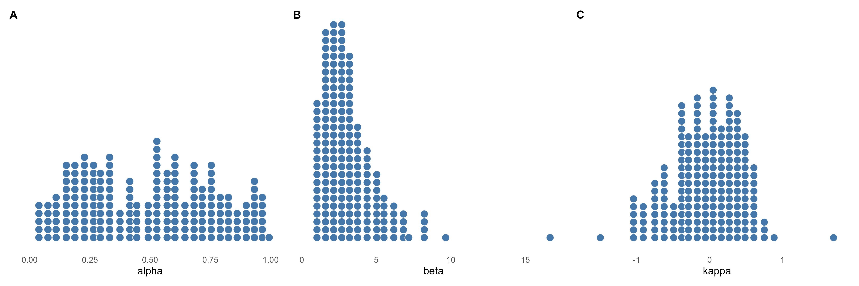
Figure 1. True agent-level parameters drawn from the generating population (one dot per agent).
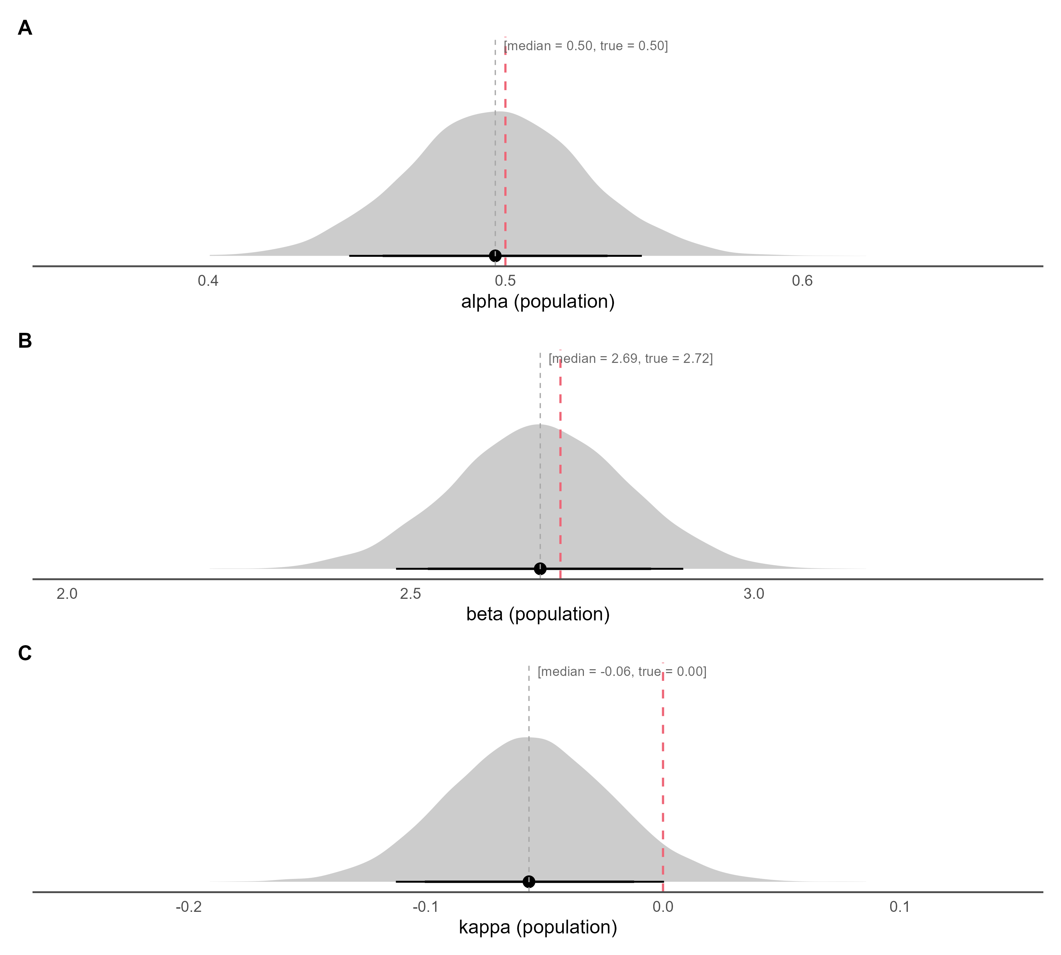
Figure 2. Posterior densities of the population-level parameters (link(mu)) on the natural scale, with median and 80% / 90% credible intervals; the dashed red line marks the true generating value.
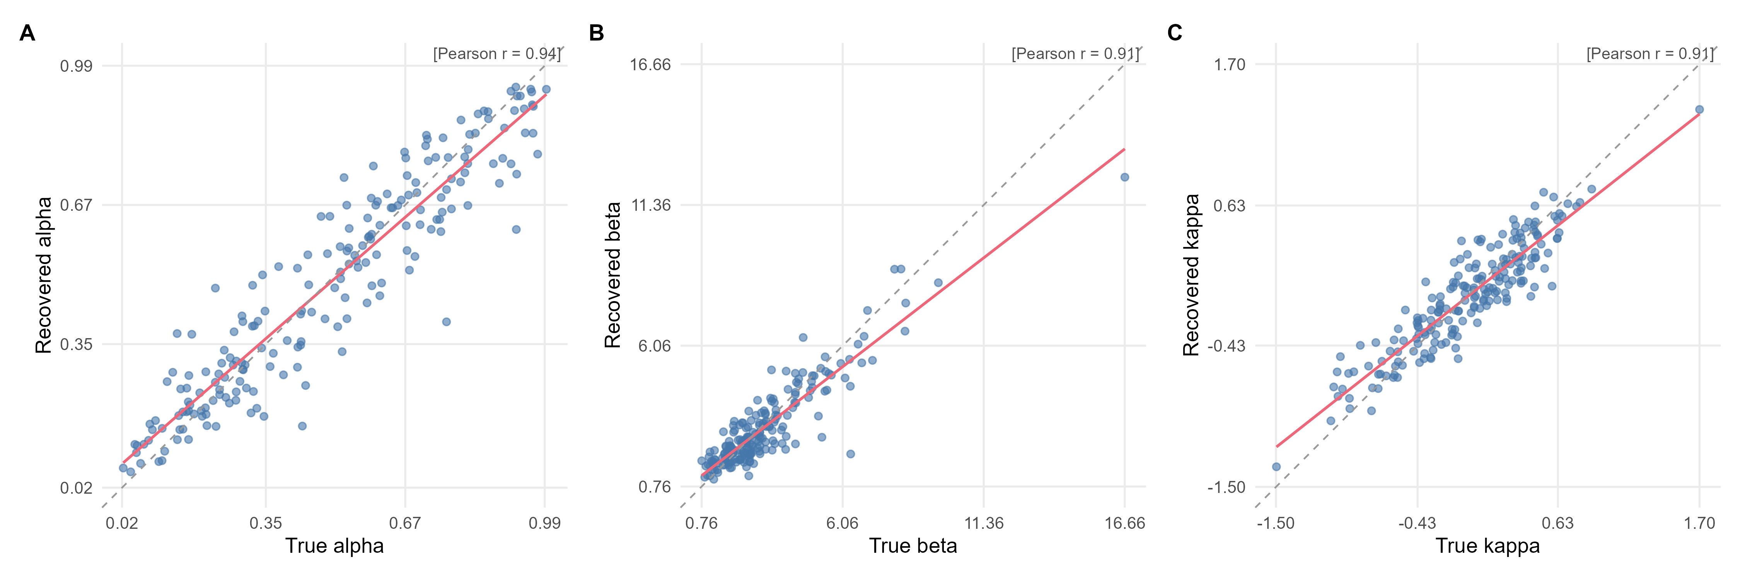
Figure 3. True versus recovered (posterior median) agent-level parameters. The red line is the OLS fit, the dashed grey line is the identity line, and r is Pearson's correlation.
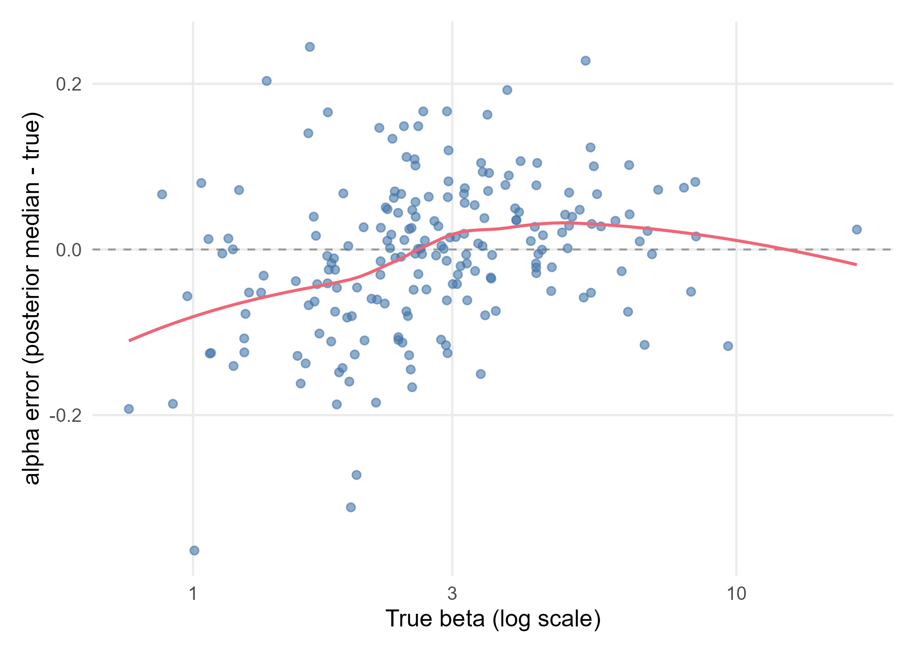
Figure 4. alpha recovery error (posterior median minus true value) against the true beta (log scale for exp-linked parameters). The red line is a loess smoother and the dashed grey line marks zero error.

