Parameter recovery: qval_and_decay_eval, p50 environment, sanity_n20_betaper_sd3

Design
We simulated 20 agents performing 150 trials of a 3-armed bandit (all arms offered every trial; p(win) = 0.5 for every arm on every trial). Agent-level parameters were drawn from alpha_rl = inv_logit(N(0.00, 1.50)), beta_rl = exp(N(1.00, 0.50)), alpha_per = inv_logit(N(0.00, 1.50)), beta_per = N(0.00, 3.00). The hierarchical qval_and_decay_eval model was fitted with 4 chains of 500 warmup and 500 sampling iterations (10.7 min).

Convergence
Divergent transitions: 0. Group-level max Rhat = 1.009, min bulk ESS = 222. Subject-level max Rhat = 1.008, min bulk ESS = 352.

Agent-level recovery
param | pearson_r | bias | ols_slope | coverage_90 | median_post_sd | spread_ratio_sd
alpha_rl | 0.86 | 0.07 | 0.79 | 1.00 | 0.12 | 0.92
beta_rl | 0.89 | -0.19 | 1.03 | 0.90 | 1.17 | 1.16
alpha_per | 0.56 | -0.10 | 0.46 | 0.90 | 0.18 | 0.82
beta_per | 0.98 | 0.06 | 0.97 | 0.95 | 1.18 | 0.99
For every pair of parameters: the correlation of recovery errors across agents (error_cor) and the within-agent correlation across posterior draws (mean and median over agents).
pair | error_cor | posterior_cor_mean | posterior_cor_median
alpha_rl_beta_rl | -0.38 | -0.43 | -0.46
alpha_rl_alpha_per | 0.10 | 0.06 | 0.07
alpha_rl_beta_per | 0.21 | 0.17 | 0.15
beta_rl_alpha_per | -0.30 | -0.08 | -0.06
beta_rl_beta_per | -0.32 | -0.19 | -0.18
alpha_per_beta_per | 0.43 | 0.12 | 0.15

Population-level recovery
variable | true_value | post_median | q5 | q95 | covered_90
alpha_rl_pop | 0.50 | 0.59 | 0.37 | 0.80 | true
beta_rl_pop | 2.72 | 3.06 | 2.10 | 4.35 | true
alpha_per_pop | 0.50 | 0.30 | 0.10 | 0.48 | false
beta_per_pop | 0.00 | 0.19 | -1.04 | 1.46 | true
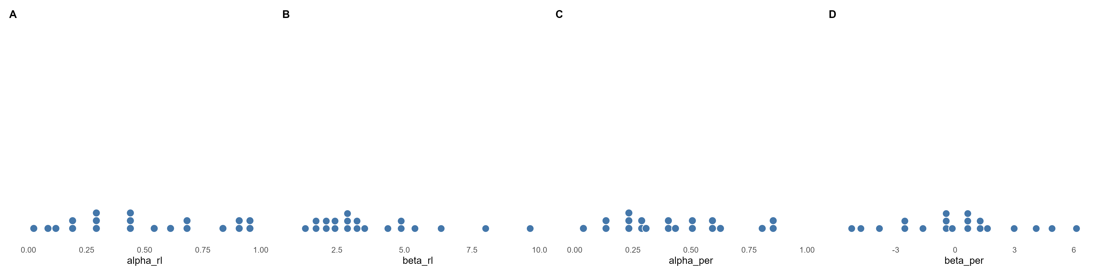
Figure 1. True agent-level parameters drawn from the generating population (one dot per agent).
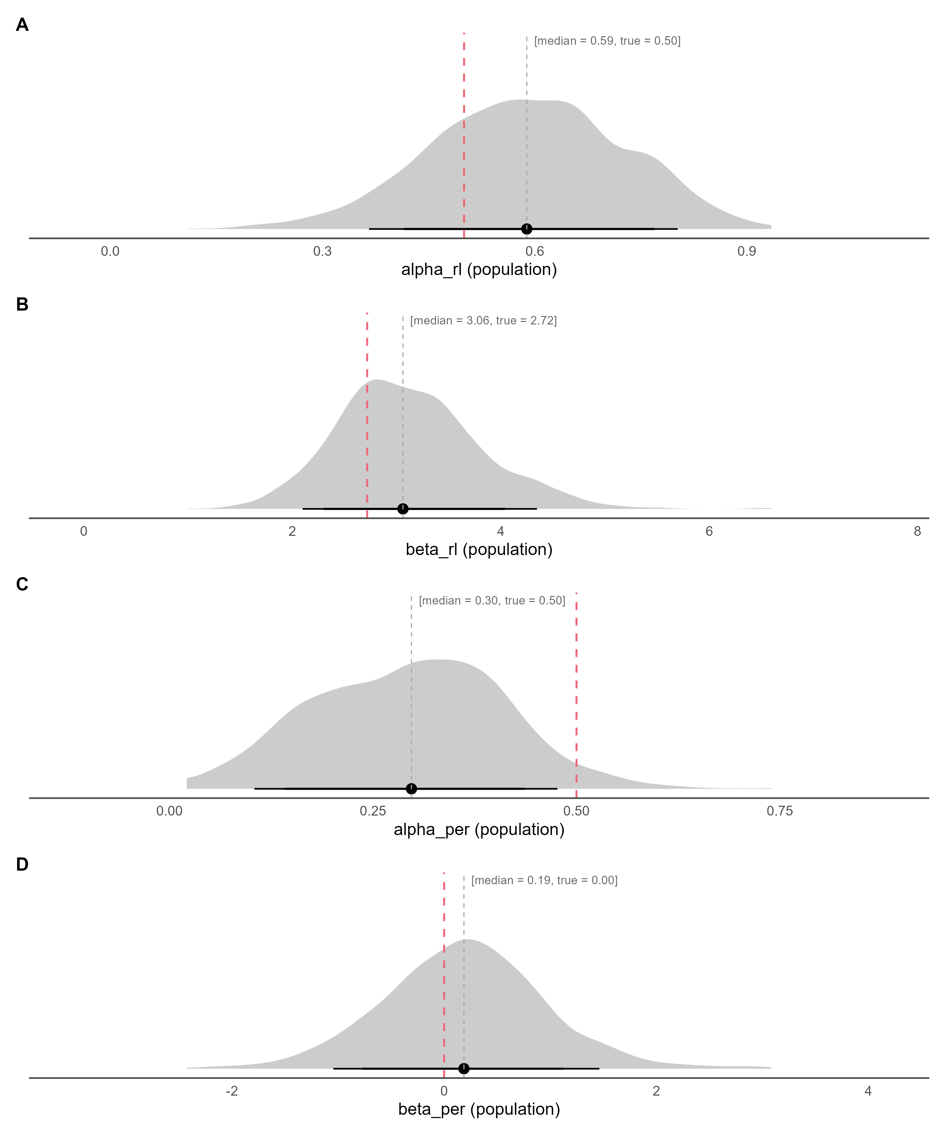
Figure 2. Posterior densities of the population-level parameters (link(mu)) on the natural scale, with median and 80% / 90% credible intervals; the dashed red line marks the true generating value.
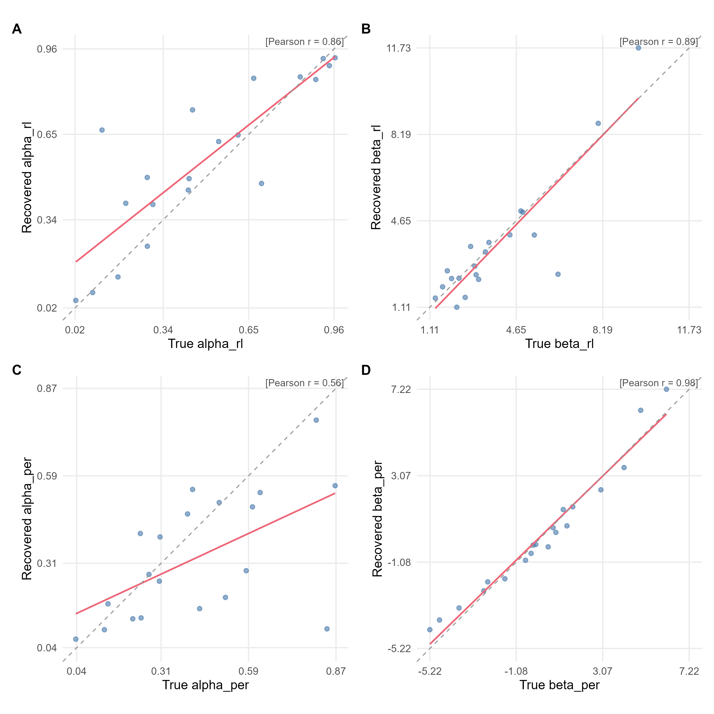
Figure 3. True versus recovered (posterior median) agent-level parameters. The red line is the OLS fit, the dashed grey line is the identity line, and r is Pearson's correlation.
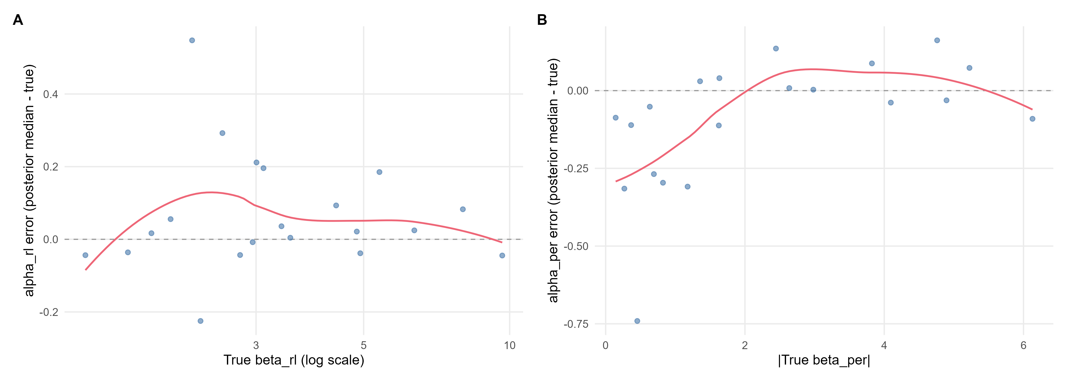
Figure 4. alpha_rl recovery error (posterior median minus true value) against the true beta_rl; alpha_per recovery error (posterior median minus true value) against the true absolute beta_per (log scale for exp-linked parameters). The red line is a loess smoother and the dashed grey line marks zero error.

