Parameter recovery: qval_and_decay_eval, p50 environment, n200_betaper_sd3

Design
We simulated 200 agents performing 150 trials of a 3-armed bandit (all arms offered every trial; p(win) = 0.5 for every arm on every trial). Agent-level parameters were drawn from alpha_rl = inv_logit(N(0.00, 1.50)), beta_rl = exp(N(1.00, 0.50)), alpha_per = inv_logit(N(0.00, 1.50)), beta_per = N(0.00, 3.00). The hierarchical qval_and_decay_eval model was fitted with 4 chains of 2000 warmup and 3000 sampling iterations (331.4 min).

Convergence
Divergent transitions: 0. Group-level max Rhat = 1.002, min bulk ESS = 907. Subject-level max Rhat = 1.002, min bulk ESS = 5104.

Agent-level recovery
param | pearson_r | bias | ols_slope | coverage_90 | median_post_sd | spread_ratio_sd
alpha_rl | 0.86 | 0.00 | 0.75 | 0.93 | 0.11 | 0.87
beta_rl | 0.77 | -0.14 | 0.55 | 0.88 | 0.81 | 0.72
alpha_per | 0.71 | -0.01 | 0.57 | 0.88 | 0.15 | 0.81
beta_per | 0.97 | -0.05 | 0.93 | 0.90 | 0.59 | 0.96
For every pair of parameters: the correlation of recovery errors across agents (error_cor) and the within-agent correlation across posterior draws (mean and median over agents).
pair | error_cor | posterior_cor_mean | posterior_cor_median
alpha_rl_beta_rl | -0.35 | -0.49 | -0.57
alpha_rl_alpha_per | 0.10 | 0.04 | 0.02
alpha_rl_beta_per | 0.17 | 0.16 | 0.12
beta_rl_alpha_per | -0.12 | -0.06 | -0.04
beta_rl_beta_per | -0.13 | -0.25 | -0.28
alpha_per_beta_per | 0.15 | 0.10 | -0.01

Population-level recovery
variable | true_value | post_median | q5 | q95 | covered_90
alpha_rl_pop | 0.50 | 0.50 | 0.45 | 0.55 | true
beta_rl_pop | 2.72 | 2.75 | 2.54 | 2.98 | true
alpha_per_pop | 0.50 | 0.47 | 0.42 | 0.53 | true
beta_per_pop | 0.00 | 0.12 | -0.23 | 0.45 | true
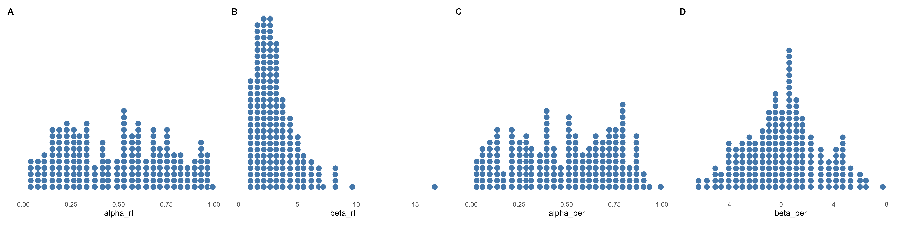
Figure 1. True agent-level parameters drawn from the generating population (one dot per agent).
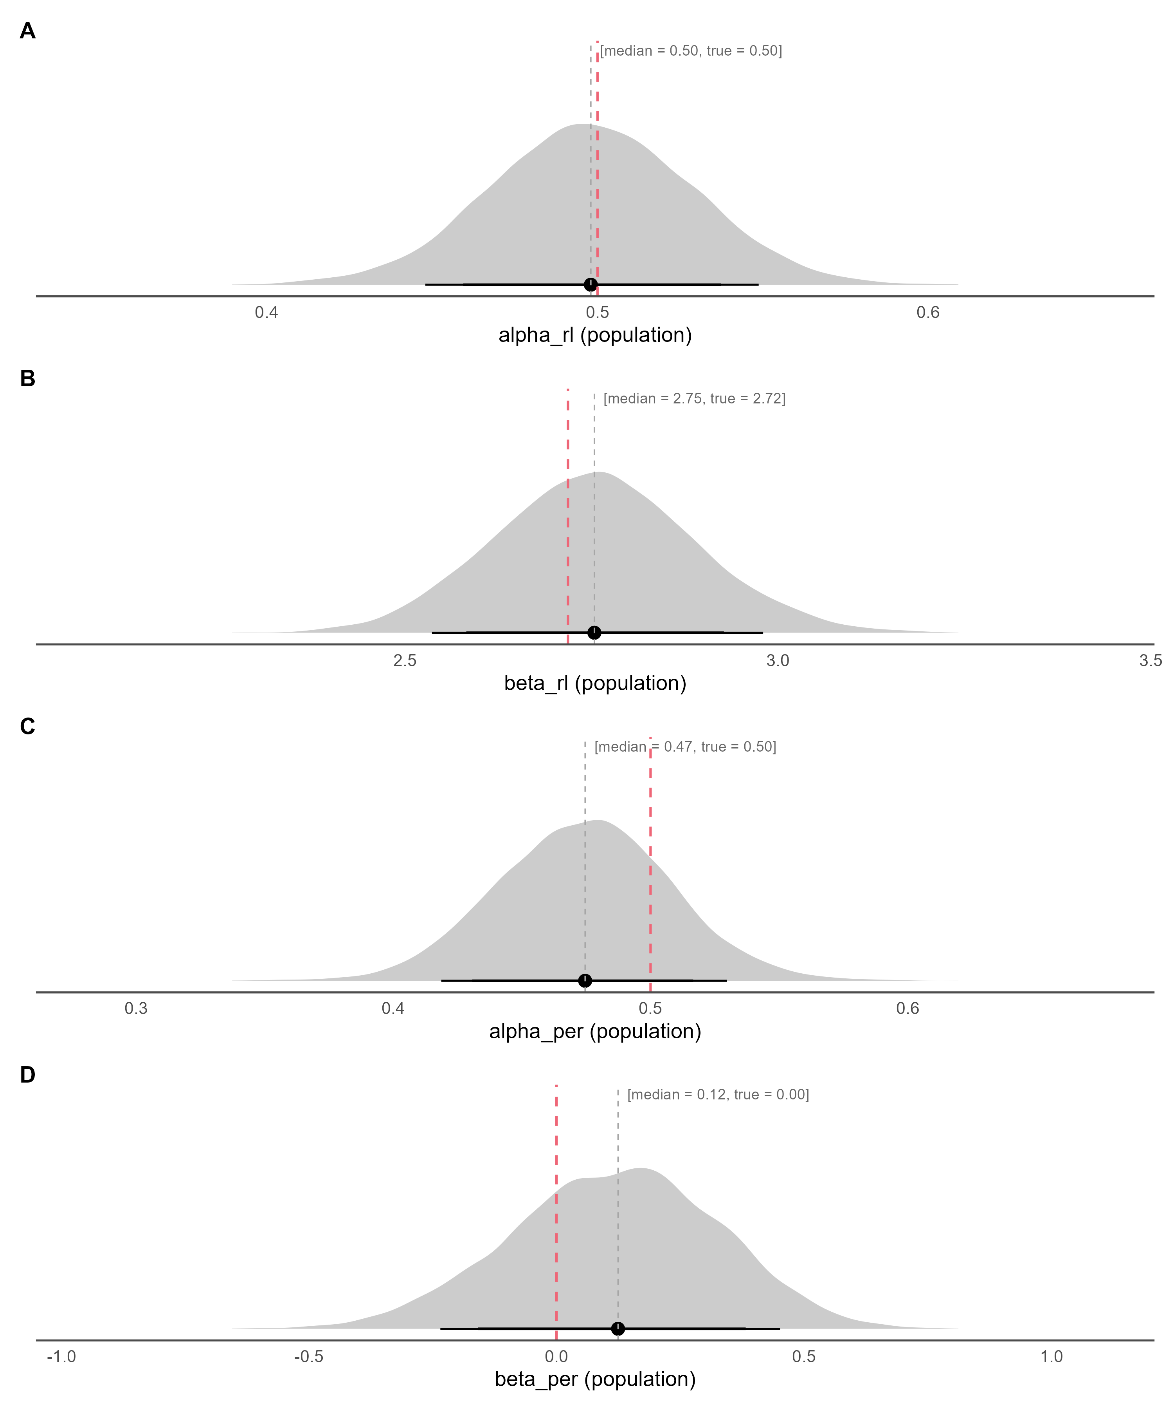
Figure 2. Posterior densities of the population-level parameters (link(mu)) on the natural scale, with median and 80% / 90% credible intervals; the dashed red line marks the true generating value.
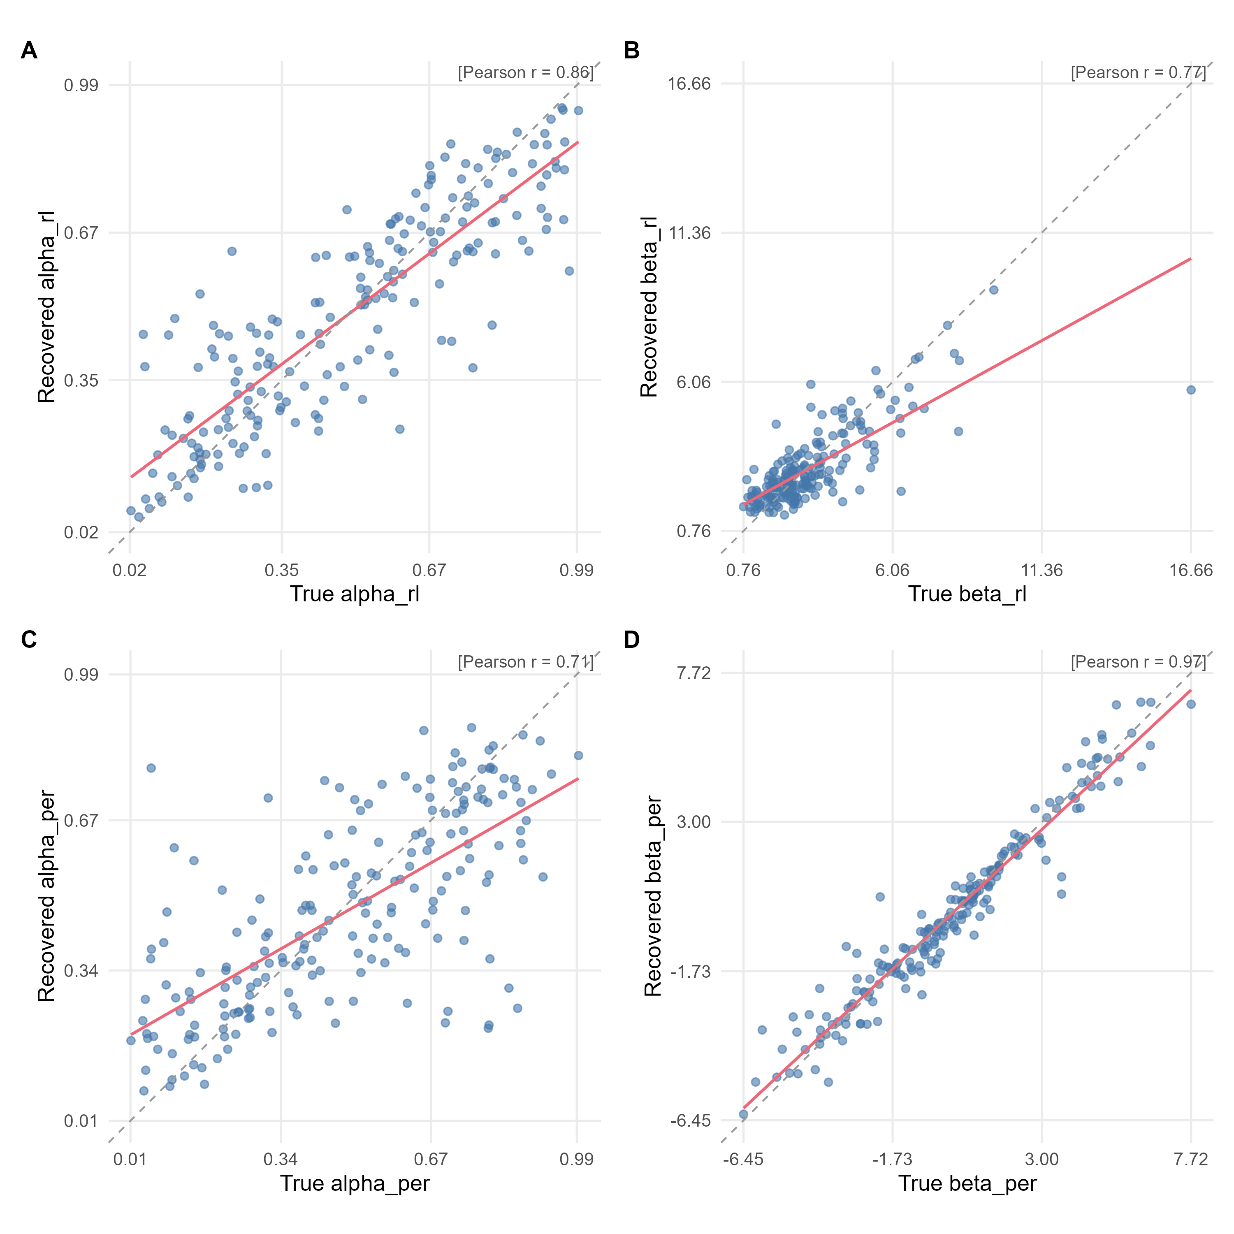
Figure 3. True versus recovered (posterior median) agent-level parameters. The red line is the OLS fit, the dashed grey line is the identity line, and r is Pearson's correlation.
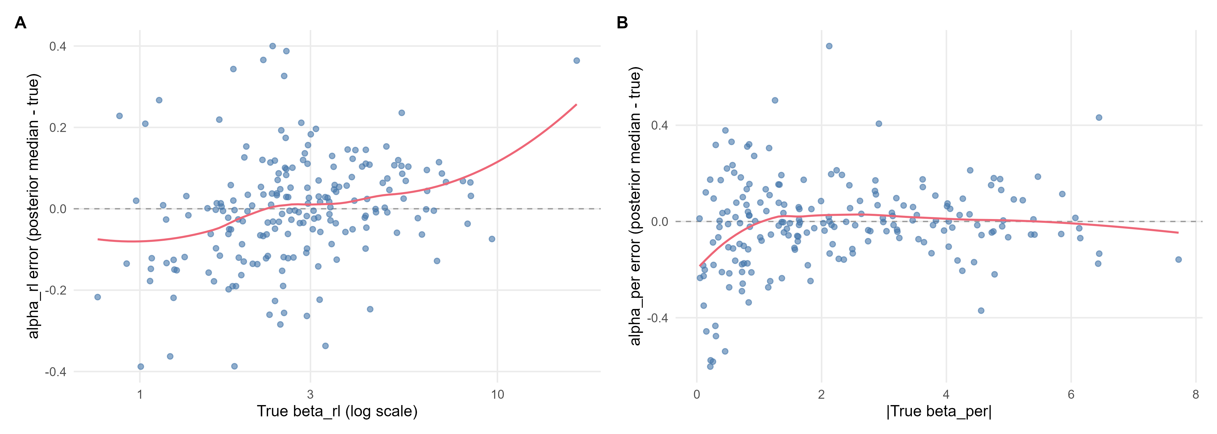
Figure 4. alpha_rl recovery error (posterior median minus true value) against the true beta_rl; alpha_per recovery error (posterior median minus true value) against the true absolute beta_per (log scale for exp-linked parameters). The red line is a loess smoother and the dashed grey line marks zero error.

