Parameter recovery: classic_qval, randomwalk environment, sanity_n20_highbeta

Design
We simulated 20 agents performing 150 trials of a 3-armed bandit (all arms offered every trial; p(win) per arm follows a Gaussian random walk, SD 0.05, clamped to [0, 1], starting at U(0, 1)). Agent-level parameters were drawn from alpha = inv_logit(N(0.00, 1.50)) and beta = exp(N(1.00, 0.50)); alpha was logistically transformed onto the unit interval and beta exponentiated to stay positive. The hierarchical classic_qval model was fitted with 4 chains of 500 warmup and 500 sampling iterations (0.7 min).

Convergence
Divergent transitions: 0. Group-level max Rhat = 1.013, min bulk ESS = 374. Subject-level max Rhat = 1.010, min bulk ESS = 1741.

Agent-level recovery
param | pearson_r | bias | ols_slope | coverage_90 | median_post_sd | spread_ratio_sd
alpha | 0.91 | 0.02 | 0.83 | 0.9 | 0.08 | 0.92
beta | 0.94 | -0.33 | 0.70 | 0.8 | 0.43 | 0.75
Correlation of alpha and beta recovery errors across agents: r = -0.16. Mean within-agent posterior correlation of alpha and beta: -0.40.

Population-level recovery
variable | true_value | post_median | q5 | q95 | covered_90
alpha_pop | 0.50 | 0.52 | 0.36 | 0.70 | true
beta_pop | 2.72 | 3.12 | 2.55 | 3.86 | true
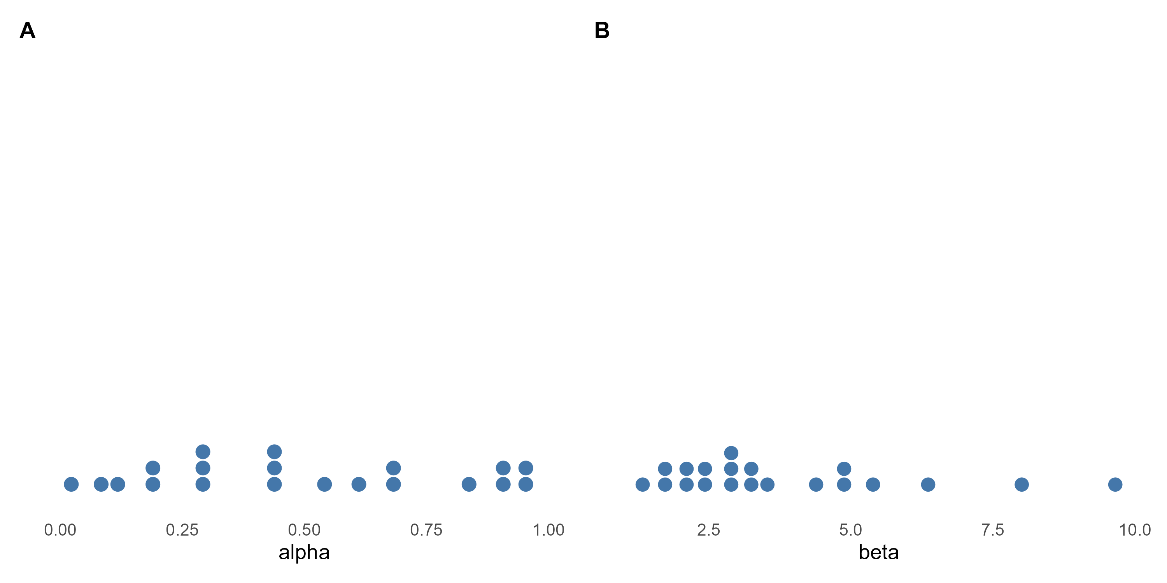
Figure 1. True agent-level alpha and beta drawn from the generating population (one dot per agent).
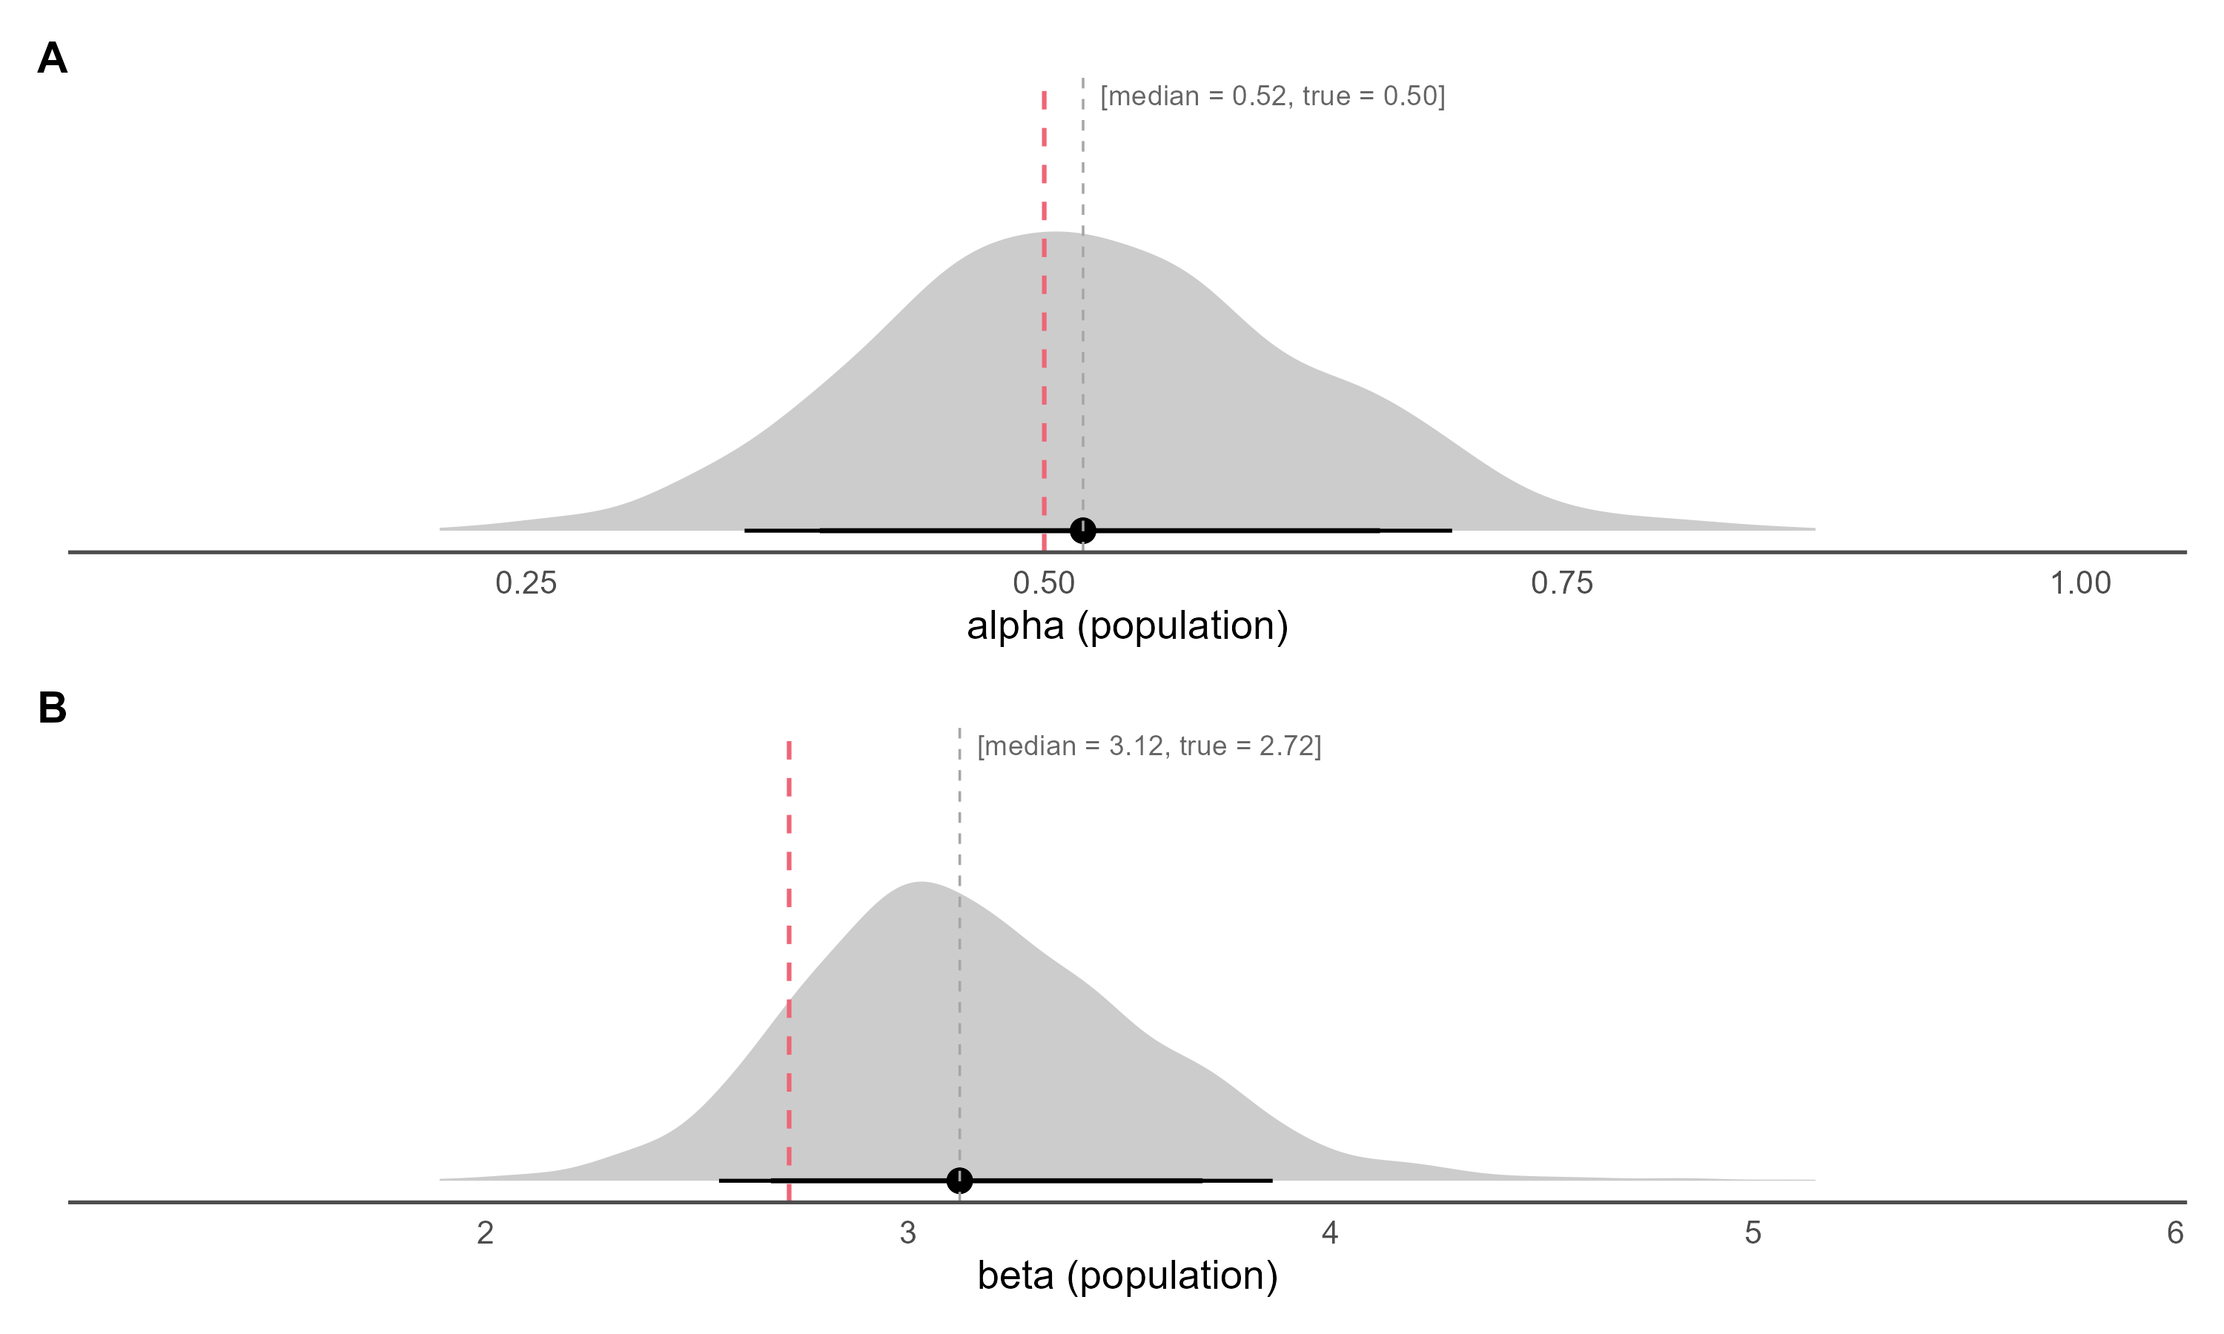
Figure 2. Posterior densities of the population-level alpha (inv_logit(mu_alpha)) and beta (exp(mu_beta)) on the natural scale, with median and 80% / 90% credible intervals; the dashed red line marks the true generating value.
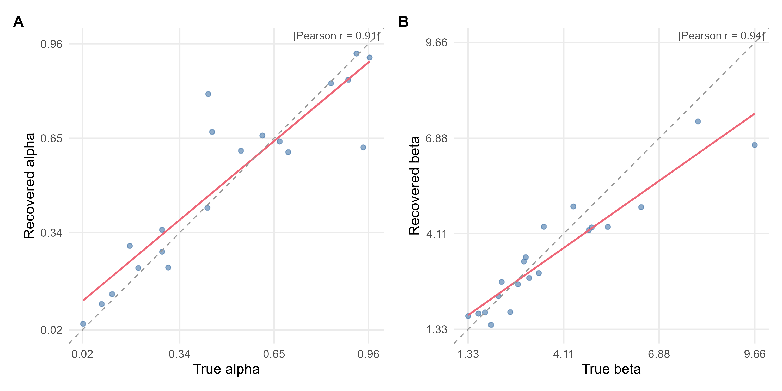
Figure 3. True versus recovered (posterior median) agent-level parameters. The red line is the OLS fit, the dashed grey line is the identity line, and r is Pearson's correlation.
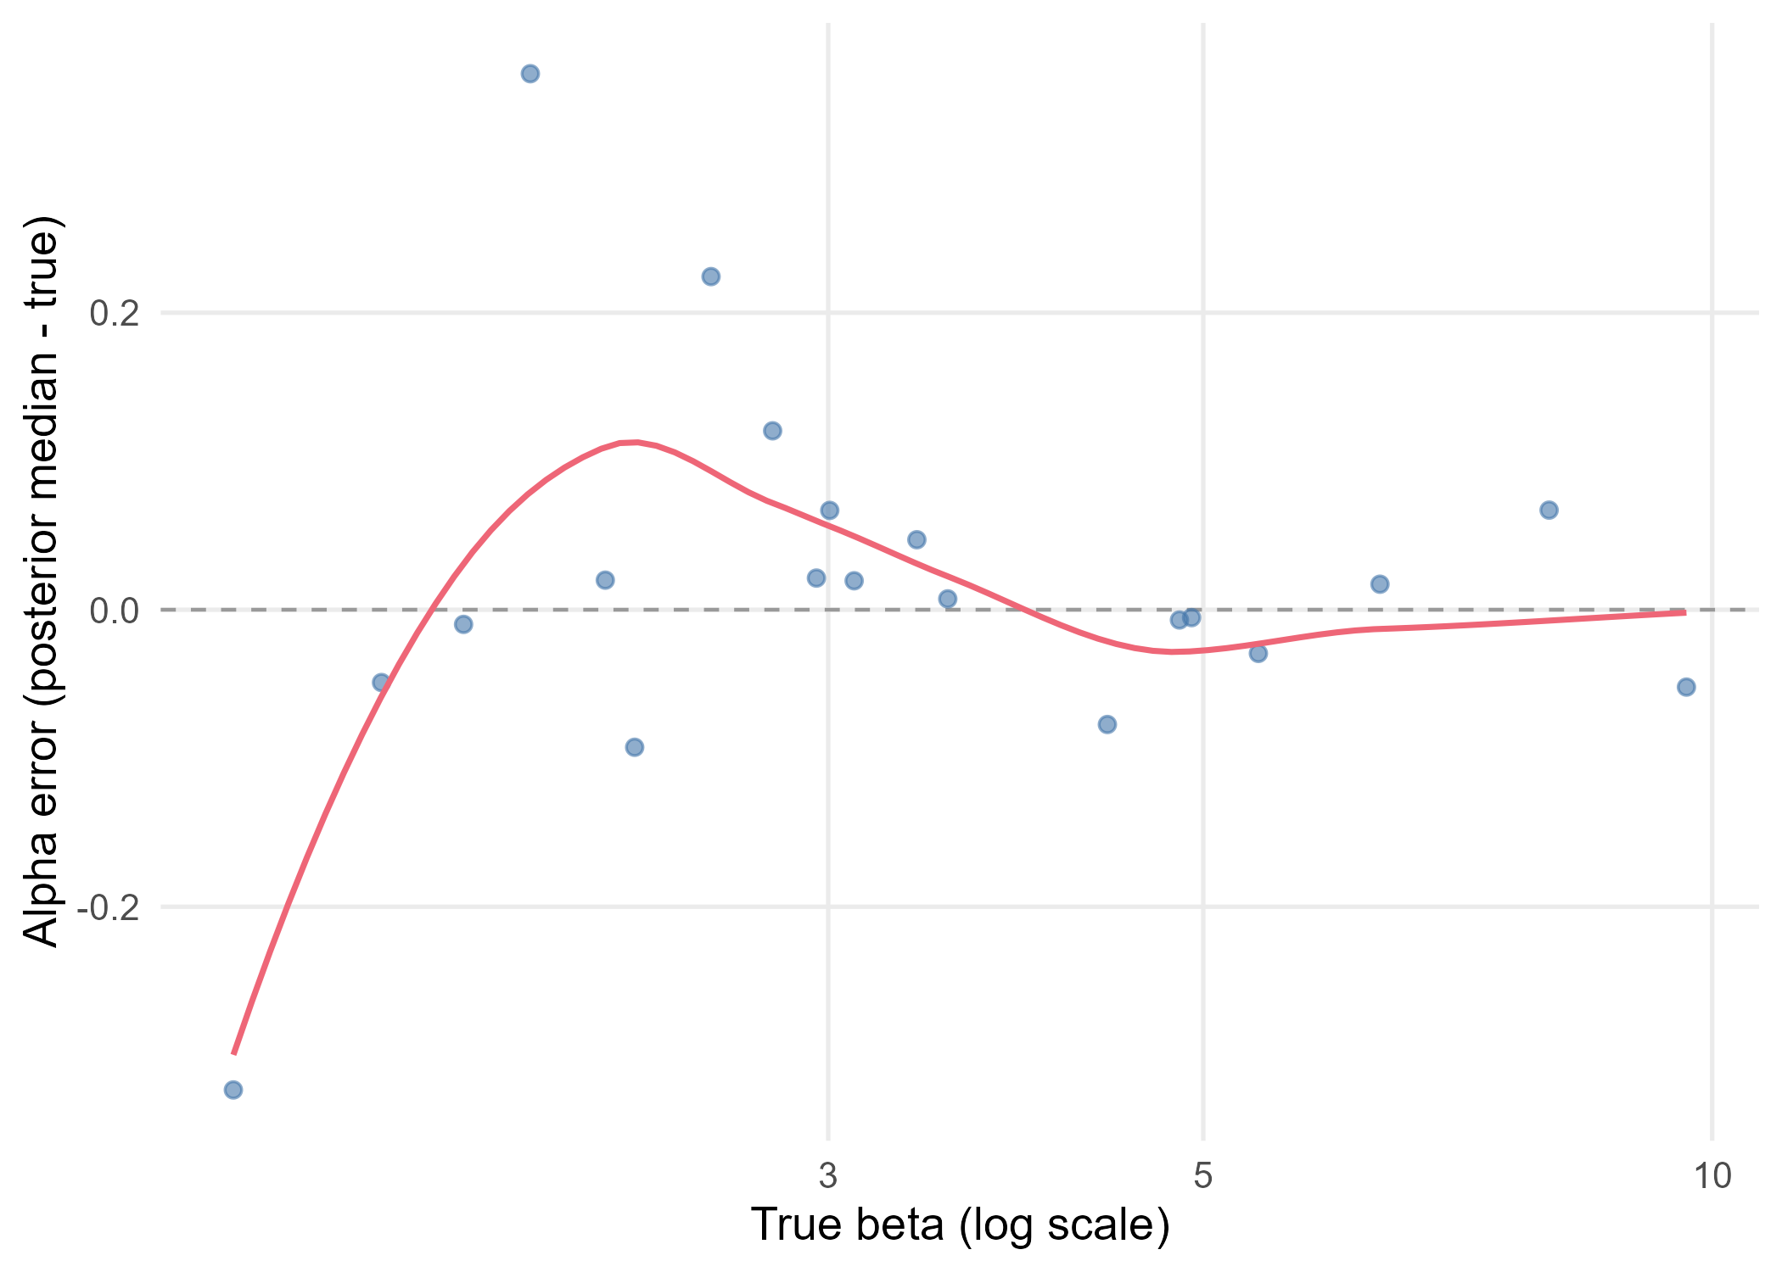
Figure 4. Alpha recovery error (posterior median minus true value) against the true beta, log scale. The red line is a loess smoother and the dashed grey line marks zero error.

