Parameter recovery: classic_qval_unbounded_beta, randomwalk environment, n200_walk3021

Design
We simulated 200 agents performing 150 trials of a 3-armed bandit (all arms offered every trial; p(win) per arm follows a Gaussian random walk, SD 0.05, clamped to [0, 1], starting at U(0, 1)). Agent-level parameters were drawn from alpha = inv_logit(N(0.00, 1.50)) and beta = N(3.00, 1.50); alpha was logistically transformed onto the unit interval; beta stayed on the natural scale (identity link, unbounded, so beta <= 0 is possible). The hierarchical classic_qval_unbounded_beta model was fitted with 4 chains of 2000 warmup and 3000 sampling iterations (72.6 min).

Convergence
Divergent transitions: 0. Group-level max Rhat = 1.002, min bulk ESS = 1447. Subject-level max Rhat = 1.002, min bulk ESS = 5083.

Agent-level recovery
param | pearson_r | bias | ols_slope | coverage_90 | median_post_sd | spread_ratio_sd
alpha | 0.9 | -0.01 | 0.87 | 0.88 | 0.09 | 0.96
beta | 0.9 | -0.06 | 0.77 | 0.86 | 0.55 | 0.86
Correlation of alpha and beta recovery errors across agents: r = -0.57. Mean within-agent posterior correlation of alpha and beta: -0.51.

Population-level recovery
variable | true_value | post_median | q5 | q95 | covered_90
alpha_pop | 0.5 | 0.49 | 0.44 | 0.54 | true
beta_pop | 3.0 | 3.01 | 2.82 | 3.20 | true
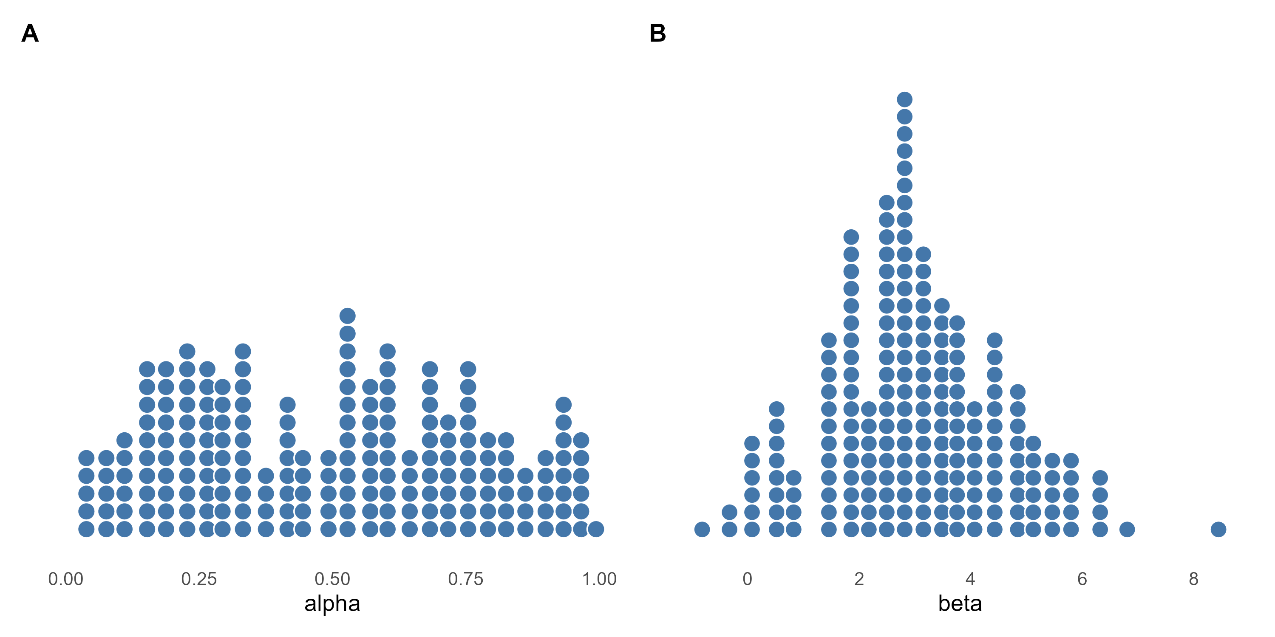
Figure 1. True agent-level alpha and beta drawn from the generating population (one dot per agent).
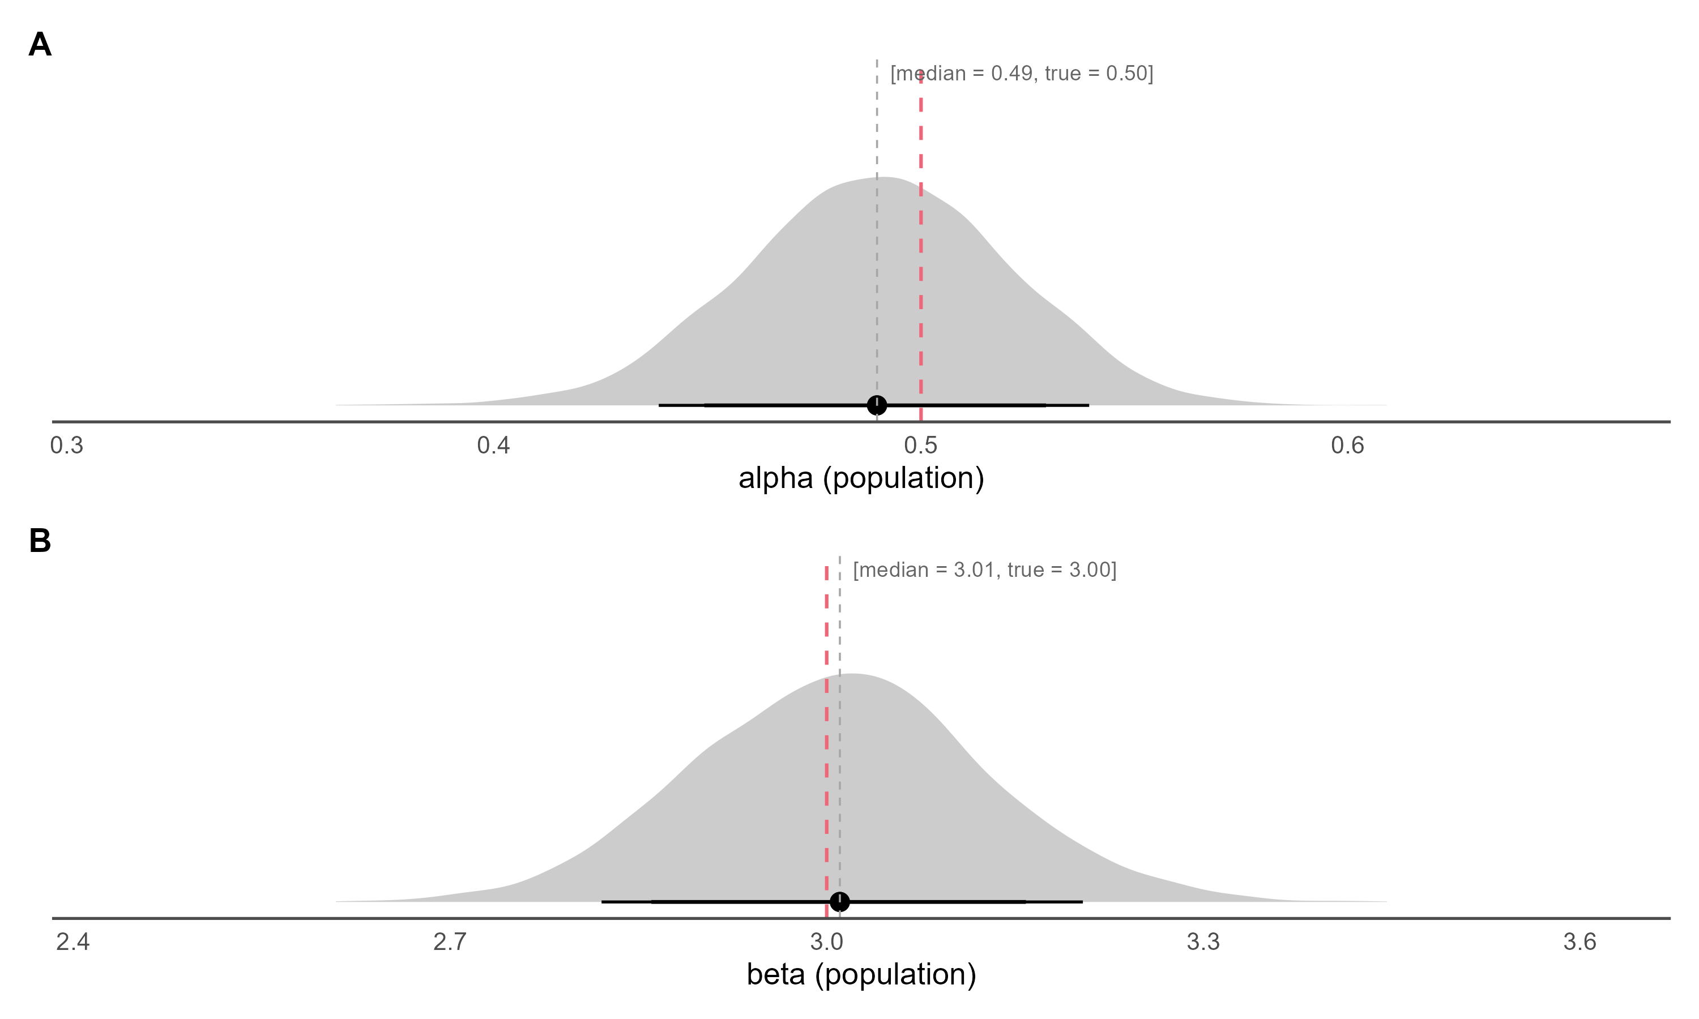
Figure 2. Posterior densities of the population-level alpha (inv_logit(mu_alpha)) and beta (mu_beta, identity link) on the natural scale, with median and 80% / 90% credible intervals; the dashed red line marks the true generating value.
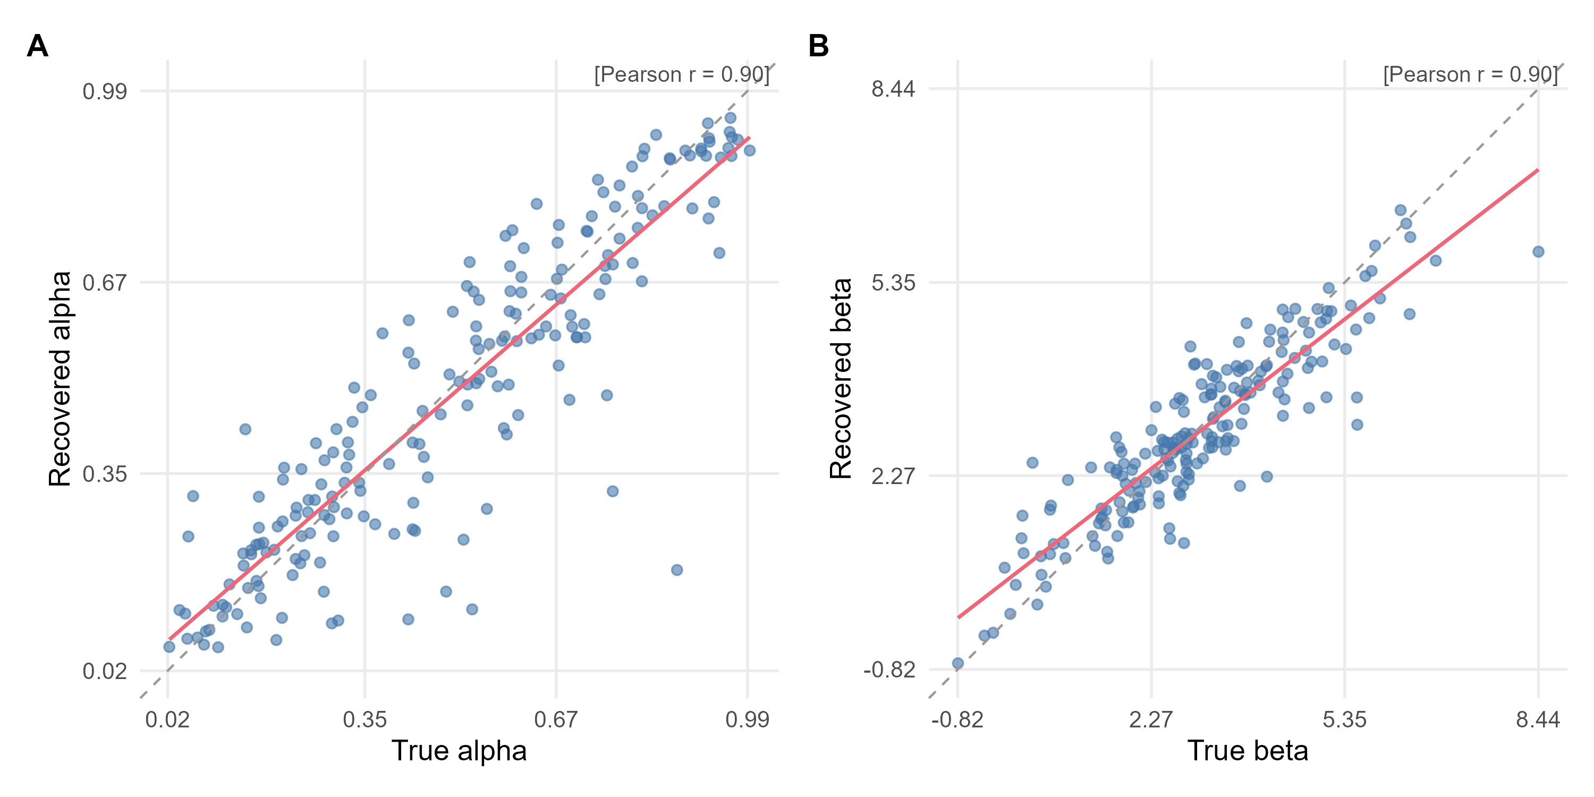
Figure 3. True versus recovered (posterior median) agent-level parameters. The red line is the OLS fit, the dashed grey line is the identity line, and r is Pearson's correlation.
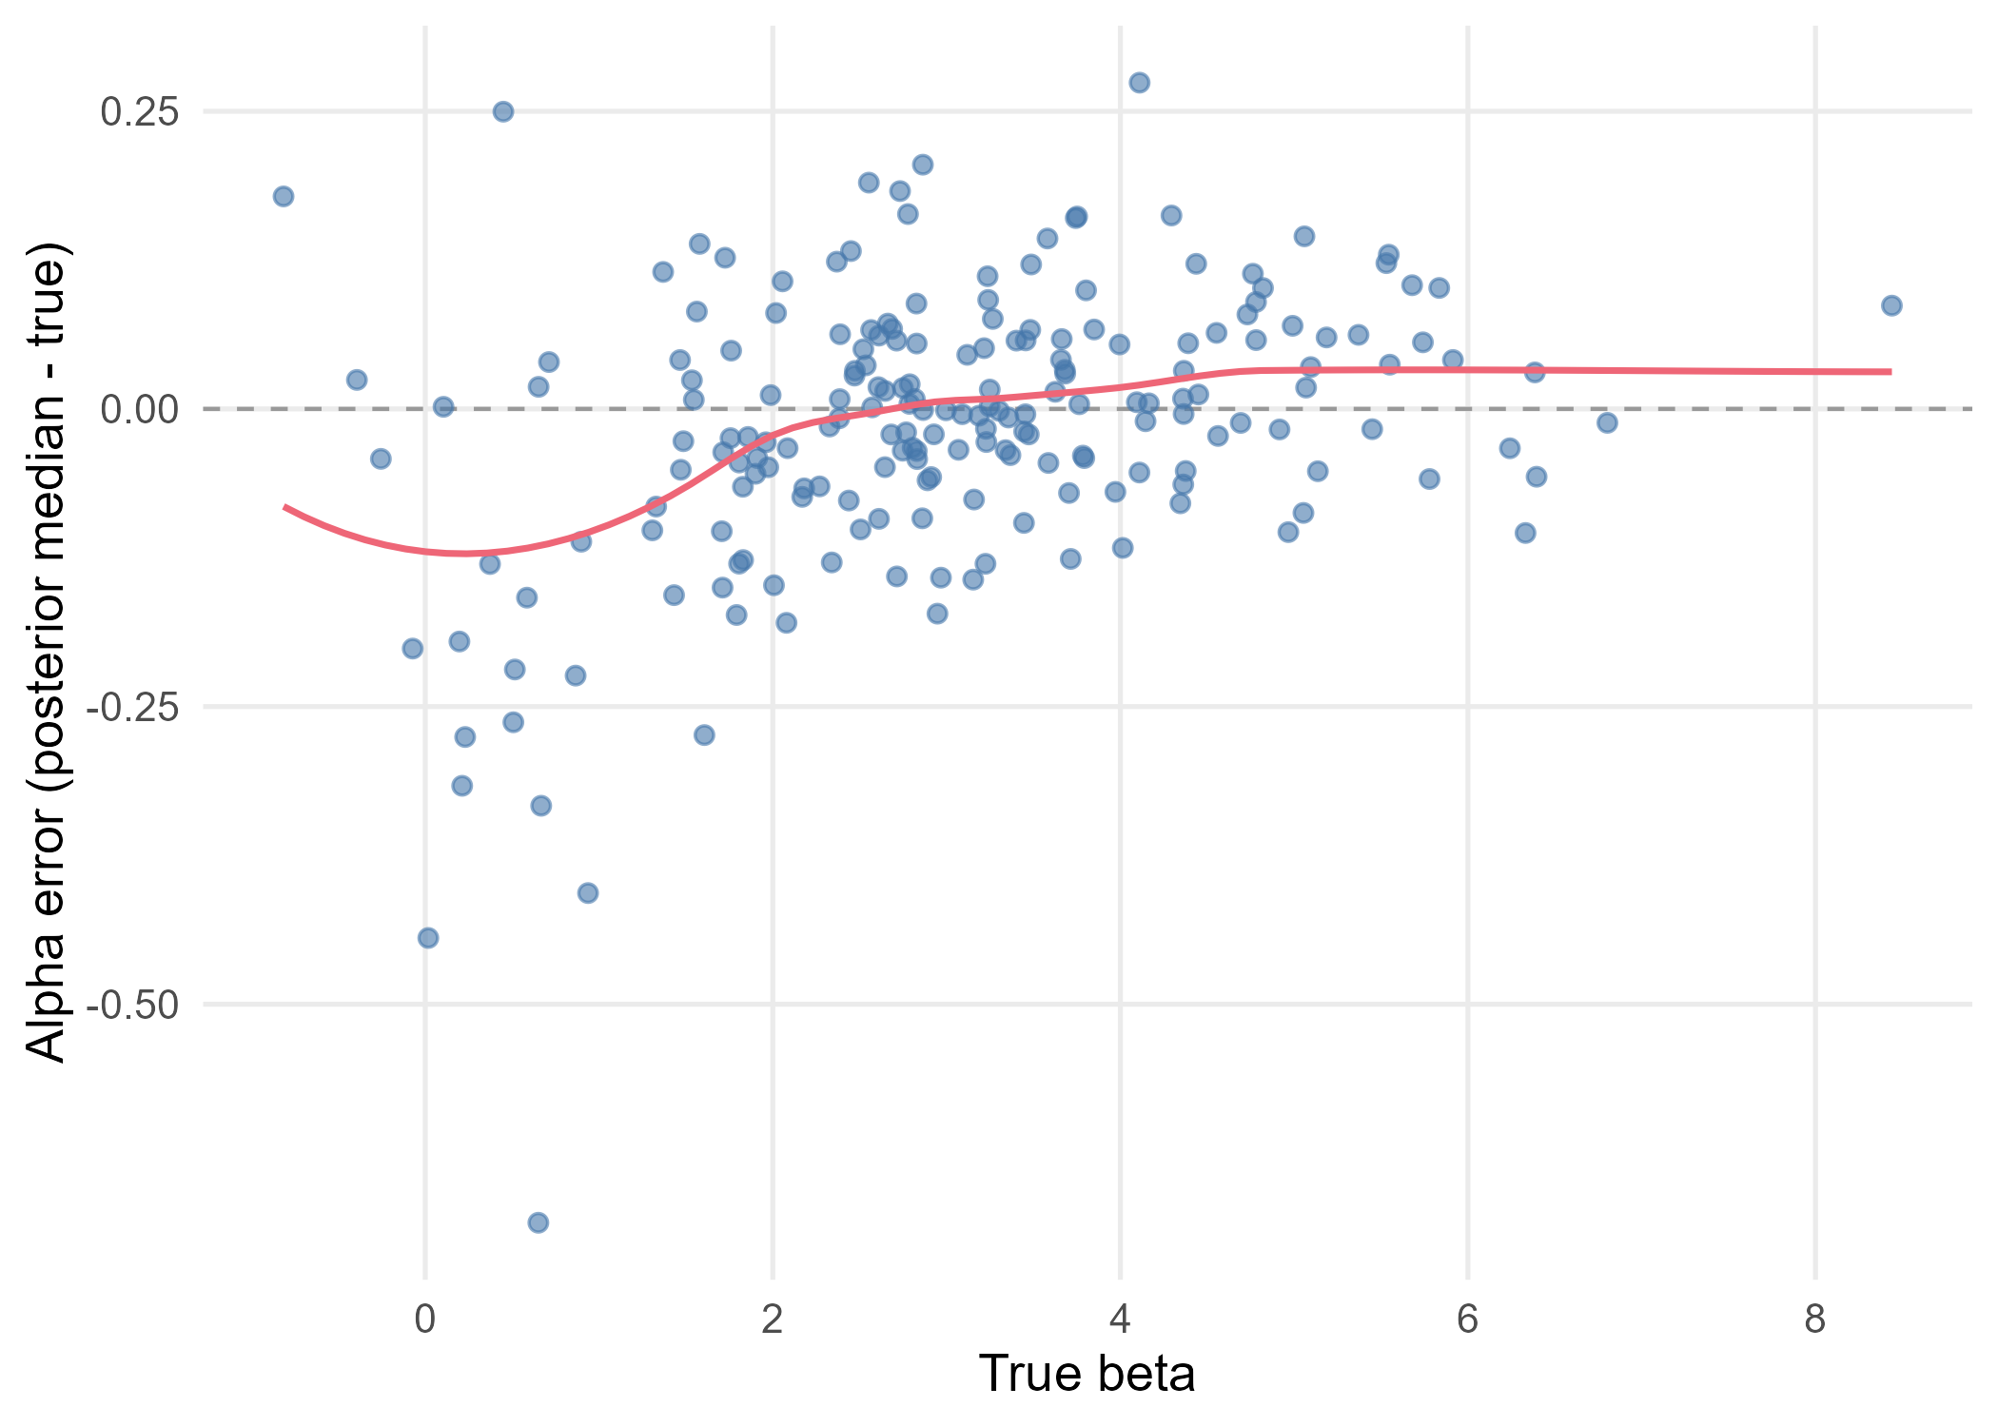
Figure 4. Alpha recovery error (posterior median minus true value) against the true beta. The red line is a loess smoother and the dashed grey line marks zero error.

