**Base**: earth, sun, gravity, newton

**Target**: electrons, nucleus, electricity, faraday

What I expected?

* earth 🡪 electrons
* sun 🡪 nucleus
* gravity 🡪 electricity
* newton 🡪 faraday

- Earth revolve around the sun like electrons revolve around the nucleus

- Newton discovered gravity like faraday discovered electricity

- Earth create gravity like electrons create electricity.

- Earth and sun have gravity field like nucleus and electrons have electricity field.

**Results**:

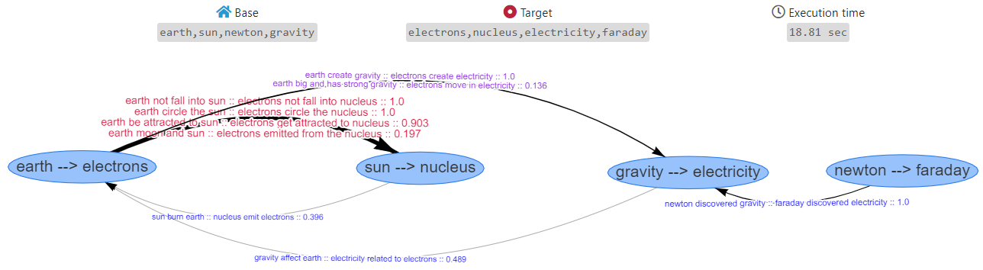

Figure 1

After removing *faraday*, I expected newton will be without a map.

The suggest is *humans*:

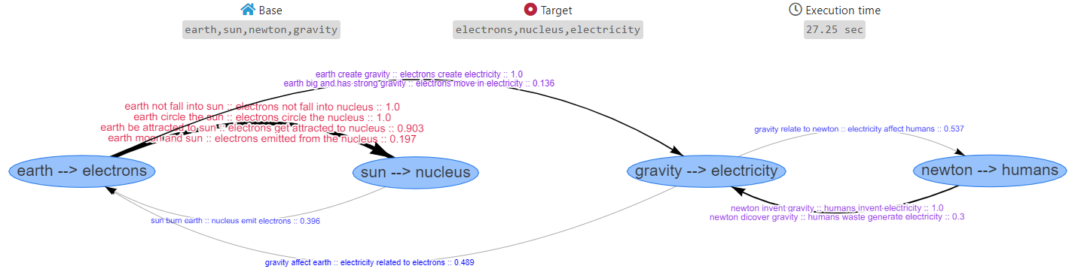

Figure 2

More information about the single mapping between *gravity:newton*, *electricity:humans*



Figure 3

The following figure is related to the second row (with score of 1.3).

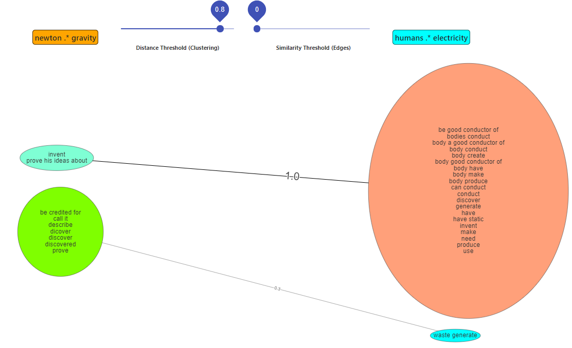

Figure 4

Compared to single mapping between *gravity:newton*, *electricity:faraday*



Figure 5

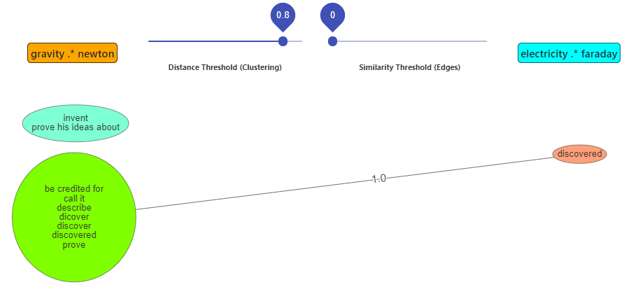

Figure 6

Now, I tried to remove *sun* from the base.

I expected that the sun will be without a map, but…

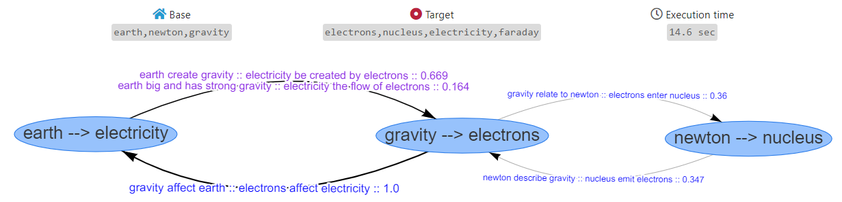

Figure 7

If we look into the single relation of *earth:gravity, electricity:electrons*:

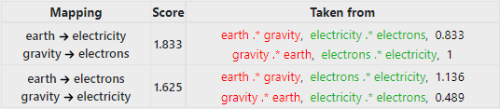

Figure 8

For the first mapping (the wrong one, with score of 1.833):

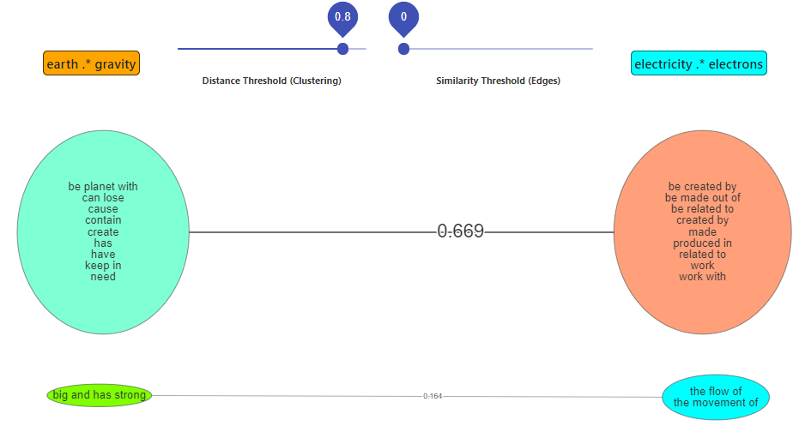

Figure 9

And the second direction:

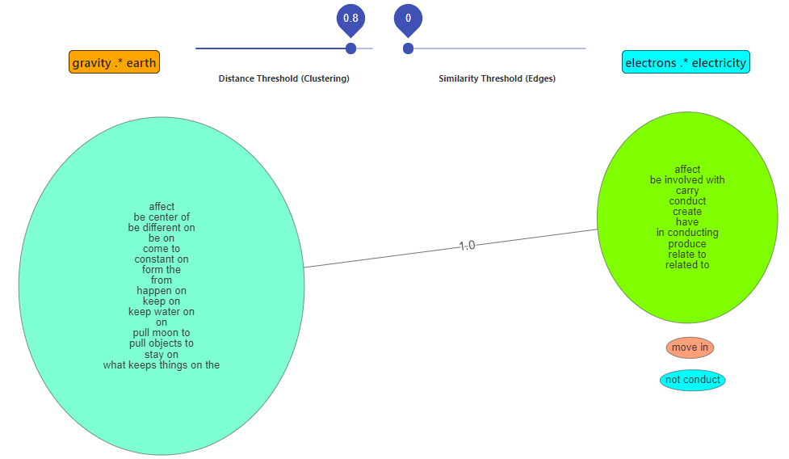

Figure 10

And the correct mapping (with score of 1.625):

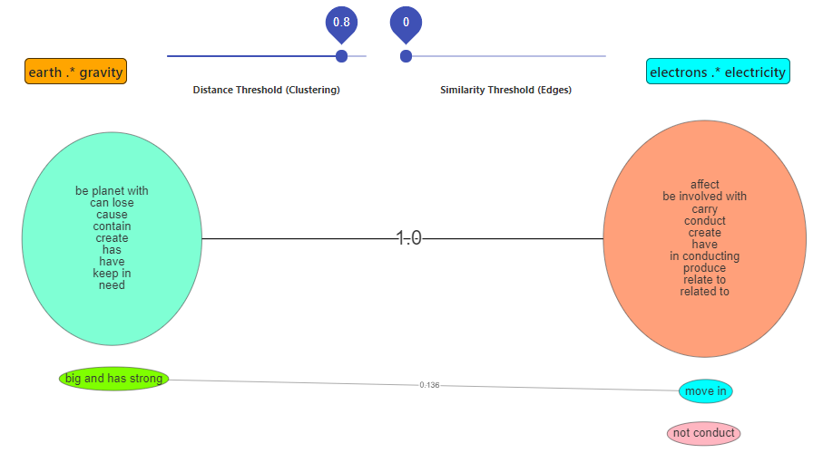

Figure 11

And the second direction:

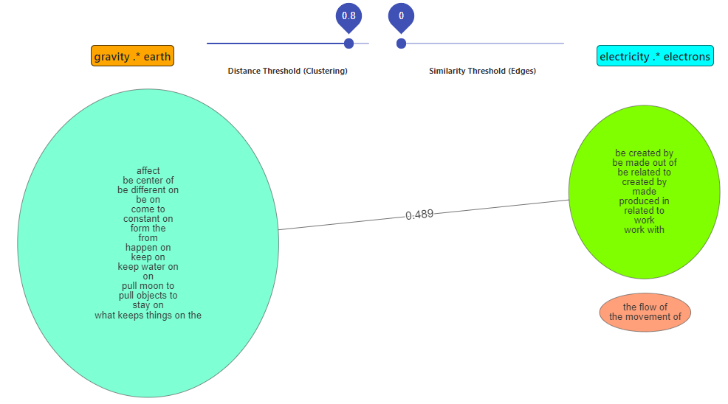

Figure 12

So, the greedy algorithm chooses in the first iteration the 'bad' mapping, so in the second iteration the mapping also wasn't so good.

It found (in the second iteration) that *gravity:electrons, newton:nucleus* give score of 0.707.

In total this is: 1.833 + 0.707 = 2.54.

In contrast, if it was taken the good one in the first iteration, with the score of 1.625, it will find a better mapping in the second iteration.

It was found *gravity:newton, electricity:faraday* which give score of 1.

In total: 1.625 + 1 = 2.625

=> the greedy algorithm was failed.

**Base**: thoughts, brain, neurons

**Target**: astronaut, space, black hole

What I expected?

* thoughts 🡪 astronaut
* brain 🡪 space
* neurons 🡪 black hole

- thoughts travel in the brain like astronauts floats in space.

- neurons are in the brain like black hole are exist the space.

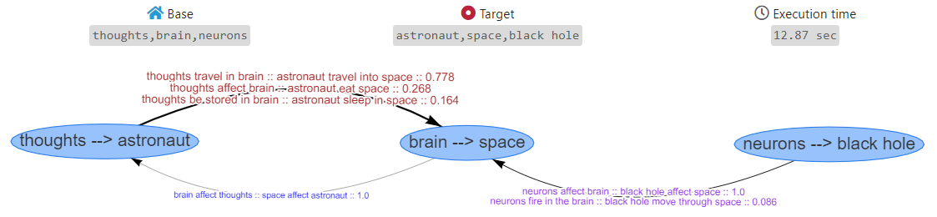

Figure

The relation between *neurons:brain, black hole:space*

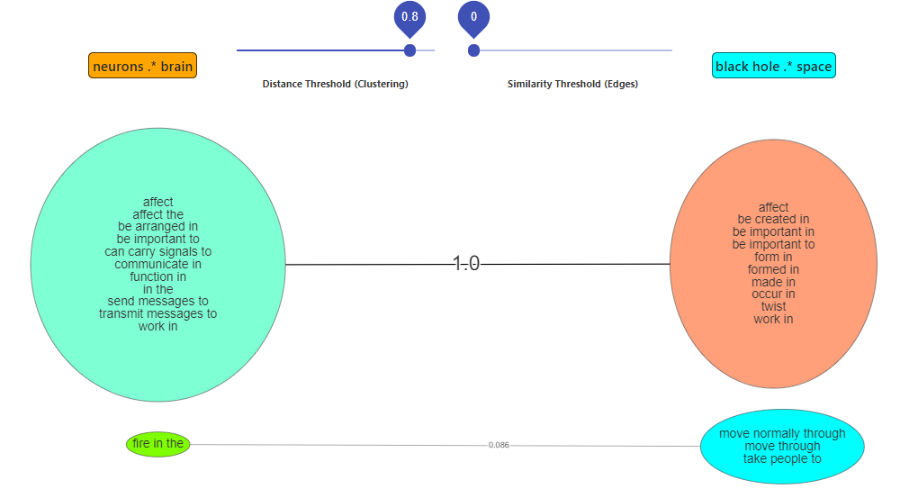

Figure

I tried to replace stars with block hole, and I found another issue with the greedy algorithm.

The problem is that it maps thoughts to start and neurons to astronaut:

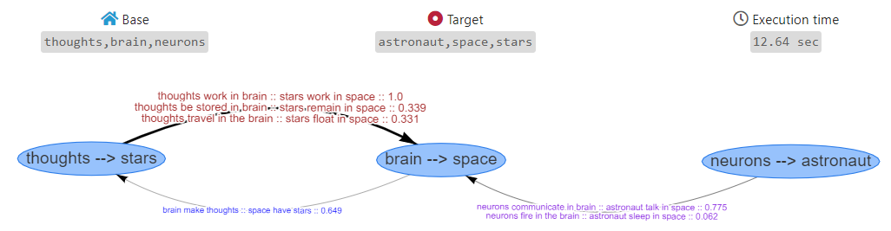

Figure

The total score here is: 2.319 + 0.837 = 3.156

If it was chosen in the first iteration the correct one (thoughts🡪astronaut, brain🡪space), it was achieved 2.21 points for the first iteration but 1.735 in the second iteration!! so the total is 3.945.

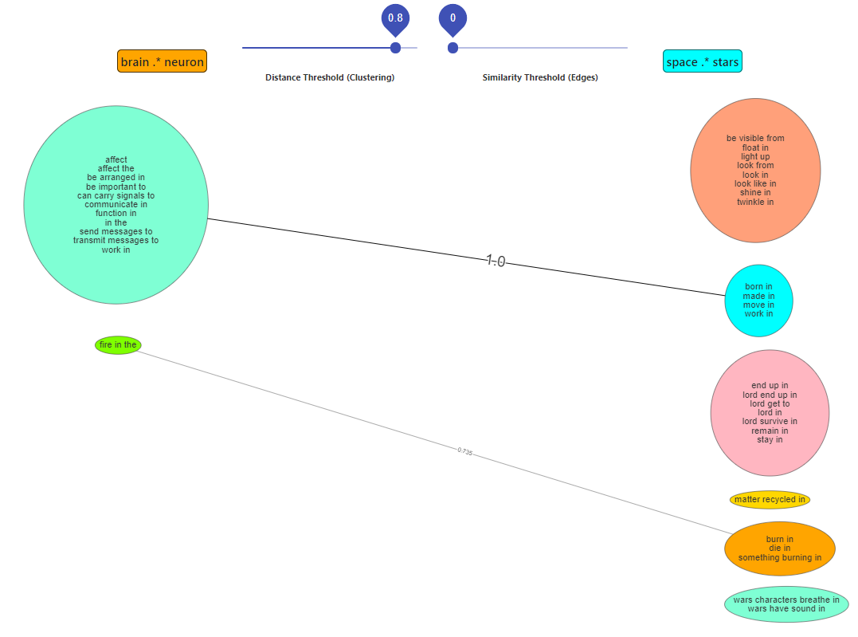

Figure

If I remove stars and leave neurons without a map, it suggests guns:

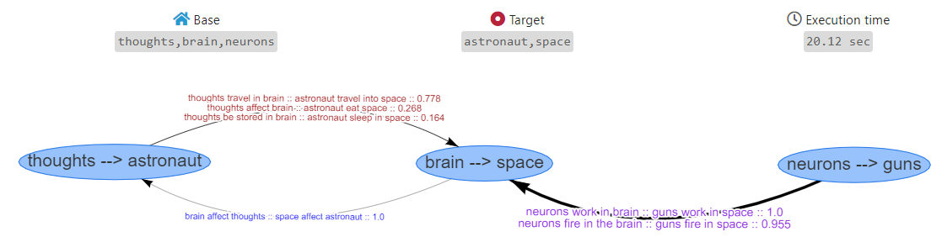

Figure

**Base**: cars, road, wheels

**Target**: boats, river, sail

What I expected?

* cars 🡪 boats
* road 🡪 river
* wheels 🡪 sail

- cars drive on the road like boats cruising in the river.

- cars travel by wheels like boats travel by sail.

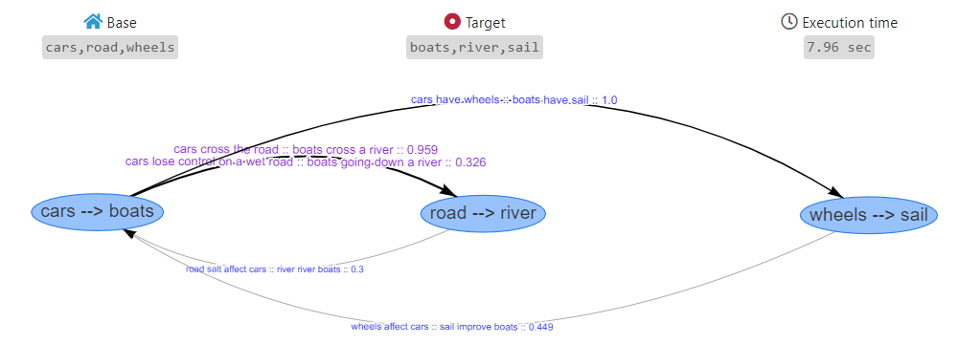

Figure

If I remove the sail, it suggests steering wheel:

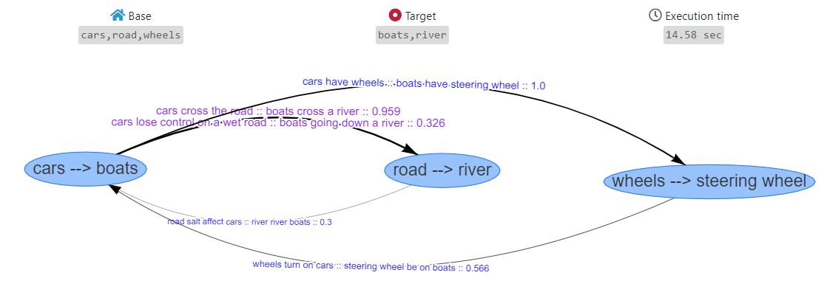

Figure

By the way, in that case steering wheel have score of 1+0.566 = 1.566, and sails (which is also a suggestion) have score of 1+0.449 = 1.449. Not bad…

**Base**: sunscreen, sun, summer

**Target**: umbrella, rain, winter

What I expected?

* sunscreen 🡪 umbrella
* sun 🡪 rain
* summer 🡪 winter

- sunscreen protect as from the sun as the umbrella protect as from the rain.

- sun is stronger and more common in the summer like the rain more common in the winter

If you remember we didn't understand why there are no relation between winter and rain, or winter and umbrella. Well, I found that I had bug in the three-words-question of google autosuggests, it related to 'why does it' and 'how does it'. I fix it, so it better now.

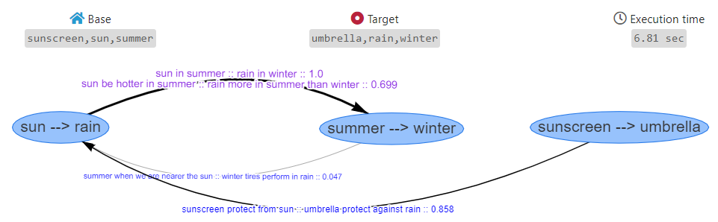

Figure

rain .* winter after the fix:

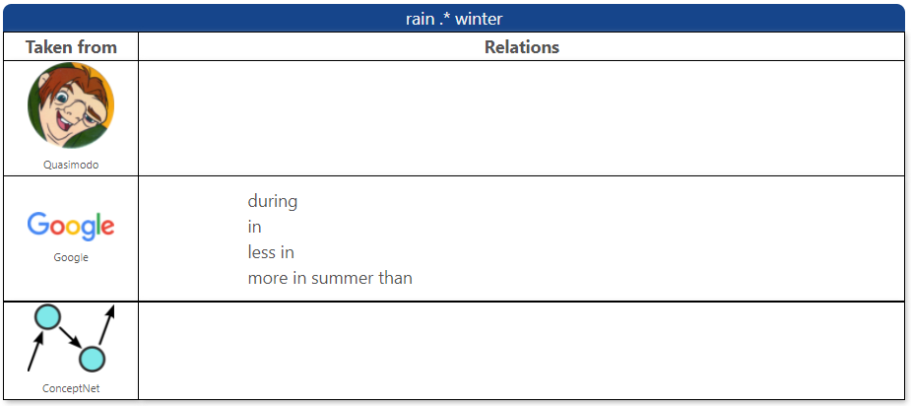

Figure

**Base**: student, homework, university

**Target**: citizen, duties, country

What I expected?

* student 🡪 citizen
* homework 🡪 duties
* university 🡪 country

- student should do homework as the citizen have duties.

- student is a part of the university as the citizen us a part of the country.

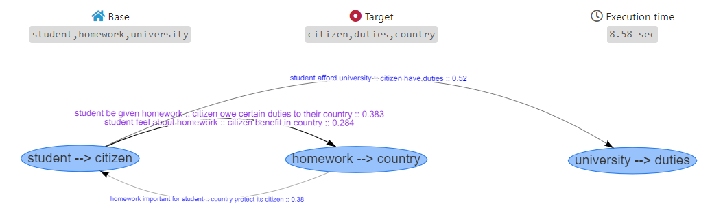

Figure

In the first iteration, it found that (student:homework, citizen:country) is stronger than (student:homework, citizen:duties).

For the first mapping (student:homework, citizen:country):

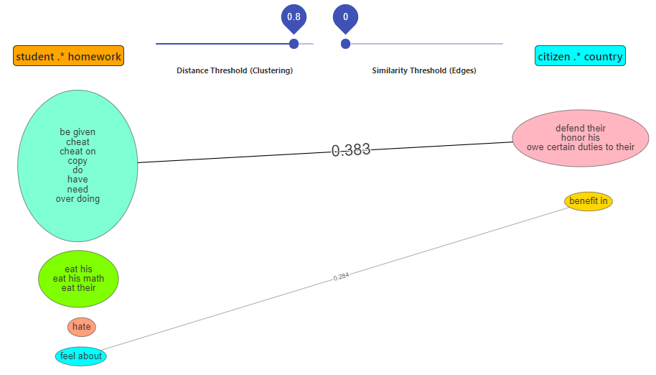

Figure

And for the second direction:

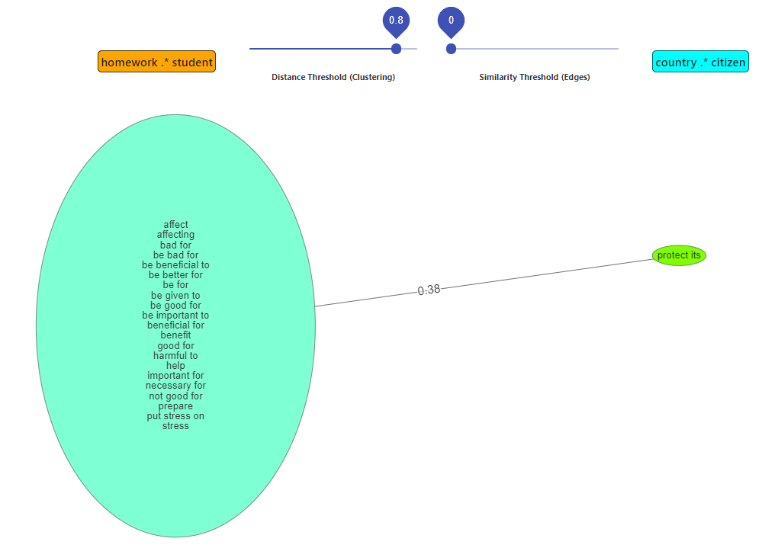

Figure

So the total of both directions: 0.667+0.38 = 1.047

And for the expected mapping (student:homework, citizen:duties):

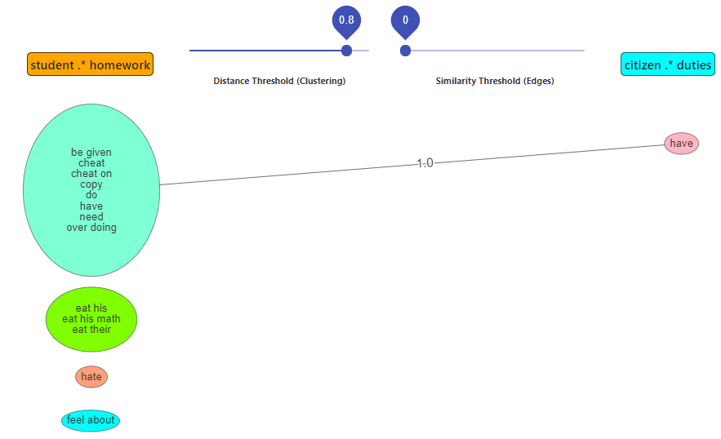

Figure

The second direction has score of 0.

So this is 1+0 = 1 for that mapping .

< 1.047

TODOs:

* show not just the best suggest, also the top 5.
* In the first iteration of the greedy algorithm, go with the top *CONST* matches, not just the best one.
* Maybe extend the previous bullet for each iteration (maybe it can be % of the total options in the current iteration).
* I don't think it cause problems (in the meanwhile), but the clustering is not always look good.

Notes:

* When I wrote first direction and then second direction, it's because we count both directions (earth:sun, electrons:nucleus) and (sun:earth, nucleus:electrons) counts together.