⚠ BEFORE SUBMISSION: open items (TAG requirements; updated 2026-10-01). Delete this list before submitting.
- Title page (not written yet): the author names and their affiliations (institution, department, city, country); the corresponding author’s e-mail and ORCID (ORCID is mandatory); and the Acknowledgments, which TAG places on the title page, with the funding organizations written in full (including Equinom Ltd., which lent the NIR instrument). The same author names, affiliation and e-mail also go into the title block of every Online Resource file, where they are placeholders now; the files are then rebuilt.
- Author contribution statement (not written yet): one short line per author, using initials. TAG prints it before the Acknowledgments, and it is also entered in the submission system.
- Statements and Declarations (not written yet; they go after the References): TAG returns a manuscript that lacks any of them. Needed: Funding (agencies and grant numbers); Competing interests; Author contributions; Data availability; Ethics approval (not applicable to this study). The Data availability text is already drafted and names Online Resource 1 for the genotype BLUPs; it still needs the Zenodo DOI of the MorexV3 SNP calls and the GitHub link (with its Zenodo archive) of the analysis code (comment 234).
- References that still need attention (each marked by a Word comment): Friedman and Atsmon 1988 and Holland et al. 2003 could not be checked, because no PDF was available (comments 102, 401, 257, 501); the page numbers of Keeling et al. 1993 need confirming (502); two citations only partly support their sentences, which were kept as written (104, 428); and the source of the soil variables is not described in the cited paper (216).
- Online Resources (supplementary): done. The 13 files are built, numbered in the order they are first cited, cited in the text, and captioned in the last section (“Supplementary Information”). Left to do: put the author names, affiliation and e-mail into the files (item 1); at submission, upload the 13 files and enter each one’s caption in the submission system; and decide whether the extra, uncited supplement of raw-phenotype checks should join the supplement (it would then need a number and a citation in the text).
- Other open comments (each marked by a Word comment).
- Cover letter (not written yet): give the accession number of the raw reads (ENA PRJEB79623); state any restriction on sharing the seeds of the accessions (the same statement belongs at the end of the Materials and methods); and suggest reviewers who are independent of the authors, from different countries, with institutional e-mail addresses.
- Final Word file: 10-pt Times Roman; automatic page numbering; no field functions. The four figures are embedded in the text and are also uploaded as separate TIFF files, Fig1 to Fig4 (600 dpi, 174 mm wide). Before submitting, delete this list and every remaining Word comment.
- (Optional) Figure accessibility: TAG recommends patterns or symbols in addition to colour, but Figs. 2–4 tell loci and haplotype groups apart by colour alone.
Genome-wide association and haplotype analysis identify candidate genes for grain nutritional quality in wild barley (Hordeum spontaneum)

Key message
Genome-wide association and haplotype analysis in 290 wild barley accessions link a starch–fiber trade-off to shared loci and identify high-fiber wild haplotypes absent from elite malting cultivars.

Abstract
Wild barley (Hordeum spontaneum), the progenitor of cultivated barley, retains genetic diversity that was reduced in cultivated germplasm through domestication and breeding, including variation in grain nutritional quality. Here, 290 wild barley accessions sampled across the environmental gradients of Israel were grown in a common garden over three seasons and phenotyped for grain protein, starch, β-glucan and fiber by near-infrared spectroscopy. Starch had the highest broad-sense heritability of the four traits, and β-glucan the largest genotype-by-season component. Starch was negatively correlated with fiber and β-glucan, and these traits followed opposite gradients of soil texture and precipitation at the sites of origin, suggesting a carbon-allocation trade-off between storage starch and cell-wall components, whereas protein varied largely independently. Genome-wide association mapping with 7.1 million single-nucleotide polymorphisms identified 36 loci, most of them carried by rare alleles, and the number of loci did not follow heritability. Haplotype analysis of the 55 genes within these loci, followed by functional annotation, pointed to a glycerol-3-phosphate acyltransferase (GPAT6) and a glycoside hydrolase family 17 glucanase (GH17) for fiber, and to a plastid phosphate transporter (PHT4;3) for starch. The tightest fiber–starch co-localization, on chromosome 7H, resolved to a GDSL esterase/lipase gene, whose haplotype, defined by variants in its putative promoter, was associated with higher fiber and lower starch. The high-fiber wild haplotypes of GPAT6 and the GDSL gene were absent from five elite malting cultivars, providing targets for improving the nutritional value of cultivated barley.
Keywords Wild barley · Crop wild relatives · Grain nutritional quality · β-glucan · Genome-wide association · Haplotype analysis

Introduction
Climate change and population growth are intensifying pressure on the global food supply, making food security an urgent priority (Godfray et al. 2010). For decades, crop breeding has targeted yield, often at the expense of grain nutritional quality and of the diversity available for further improvement (Dempewolf et al. 2017). Higher grain yield is also frequently associated with lower grain protein concentration, partly because carbohydrate and dry-matter accumulation can outpace nitrogen accumulation during grain filling (Simmonds 1995; Bogard et al. 2010). Dietary risks remain major contributors to the global burden of disease (GBD 2019 Risk Factors Collaborators 2020). Improving the nutritional quality of cereal grains is therefore an important breeding target.
Crop wild relatives (CWR) are a rich reservoir of beneficial alleles for improving disease resistance, abiotic-stress tolerance and yield in major crops, yet their potential for improving nutritional value remains largely untapped (Dempewolf et al. 2017). A principal obstacle is linkage drag, whereby an introgressed wild allele carries linked deleterious variants that degrade agronomic performance (Hübner and Kantar 2021; Huang et al. 2023). High-resolution mapping mitigates this by pinpointing quantitative trait loci (QTLs) at fine resolution, so that they can be introgressed while minimizing linkage drag (Hübner and Kantar 2021). The identification of beneficial alleles at high resolution is therefore essential for exploiting CWR in breeding.
Barley (Hordeum vulgare) was domesticated in the Fertile Crescent about 10,000 years ago and is now the fourth most important cereal worldwide (Badr et al. 2000; Farag et al. 2022). Its wild progenitor, H. vulgare ssp. spontaneum (hereafter H. spontaneum), is distributed across a wide range of environments in the Fertile Crescent and adjacent regions (Harlan and Zohary 1966). Wild barley is characterized by broad genetic and phenotypic variation and has been used successfully in breeding for disease resistance and for drought and salt tolerance (Nevo and Chen 2010). The grain is dominated by starch, with protein, dietary fiber and the soluble fiber β-glucan as the other major components (Farag et al. 2022). Crucially, wild barley grain is nutritionally superior to that of cultivated barley, with on average about 50% more protein, 38% less starch and 65% more fiber (Friedman and Atsmon 1988), making wild barley a potential genetic resource for improving grain quality in cultivated barley.
Advances in genomics now allow the genetic basis of target traits to be identified at high resolution. Genome-wide association studies (GWAS) are widely used to link genetic to phenotypic variation and have identified trait-associated loci and candidate genes in barley and many other crops (Alqudah et al. 2020). An associated single-nucleotide polymorphism (SNP), however, rarely identifies the causal gene, because an associated locus often spans several genes in linkage disequilibrium; analyzing the haplotypes of the genes within a locus can help resolve an association to candidate genes (Marsh et al. 2023). To dissect the genetic basis of grain nutritional traits in wild barley, we analyzed a collection of wild barley sampled across a wide range of environments in Israel, under a design that decouples environmental from geographic distance. This collection has been characterized genetically and phenotypically and used to study local adaptation (Potapenko et al. 2026b) and genome-size variation (Potapenko et al. 2026a), making it suitable for identifying candidate genes for key nutritional traits.
We hypothesized that the nutritional composition of wild barley grain is shaped by ecological constraints, so heritable variation is expected among populations from contrasting environments. To test this hypothesis, we (i) characterized the variation in grain nutritional traits among wild barley populations representing the different ecotypes of Israel; (ii) examined the correlations of these traits with the environmental gradients of the sites of origin and with plant morphology and phenology; (iii) identified loci and candidate genes associated with the nutritional traits by genome-wide association and haplotype analysis; and (iv) examined whether the wild haplotypes associated with these traits are present in elite cultivars.

Materials and methods

Plant material and genotyping
We used a collection of 300 wild barley (Hordeum spontaneum) accessions sampled across Israel under a design that decouples environmental from geographic distance, as described in detail by Potapenko et al. (2026b). Briefly, the sampling area was divided into six regions, three corresponding to the northern, coastal and desert ecotypes of wild barley and three intermediate zones between them, and in each region five sites were selected to represent its climate and soil (Online Resource 1). At each of the 30 sites, spikes were collected from ten plants at least 10 m apart, and each accession was derived from one plant through three rounds of single-seed descent and selfing.
Genomic DNA was extracted from a single seedling of each accession with a cetyltrimethylammonium bromide (CTAB) protocol, and NEBNext libraries were sequenced on an Illumina NovaSeq 6000 (2 × 150 bp), targeting a coverage of at least 5× (Potapenko et al. 2026b). The raw reads (European Nucleotide Archive, PRJEB79623) were quality-checked and trimmed as described by Potapenko et al. (2026b). Cleaned reads were aligned to the barley cv. Morex reference genome assembly v3 (MorexV3; Mascher et al. 2021) with BWA-MEM2 v2.2.1 under default parameters (Vasimuddin et al. 2019), and duplicate reads were marked with Picard MarkDuplicates v3.4.0 (Broad Institute 2019). Variants were called with GATK v4.6.2.0 following the best-practices workflow (McKenna et al. 2010; Van der Auwera and O’Connor 2020). For each accession, a GVCF file was produced with HaplotypeCaller (ploidy 2) and condensed with ReblockGVCF; all accessions were then genotyped jointly with GenomicsDBImport and GenotypeGVCFs, with at most two alternate alleles per site. To reduce the computational load of the large genome, calling was run separately in non-overlapping 60-Mb intervals.
Variants were filtered with bcftools v1.13 (Danecek et al. 2021) and VCFtools v0.1.15 (Danecek et al. 2011). Only biallelic single-nucleotide polymorphisms (SNPs) were kept, and SNPs were removed when QualByDepth < 5, MappingQuality < 45, FisherStrand > 60, StrandOddsRatio > 3, MappingQualityRankSum < −2.5, QUAL < 140, or total site read depth was below 900 or above 1,800. Heterozygous genotypes and genotypes supported by fewer than three reads were set to missing, and SNPs with a minor allele frequency (MAF) below 0.05 or more than 30% missing data were removed. Applied to all 300 accessions, these filters retained 7,110,996 SNPs. The ten accessions of site 04 (Hachola) were then removed because of an error in the sampling site; the SNPs were not re-filtered, so all analyses used the same 7,110,996 SNPs in 290 accessions.

Common-garden experiment and phenotyping
The accessions were grown in a common-garden experiment over three growing seasons (2019–20, 2020–21 and 2021–22) in an insect-proof net-house in the Hula Valley, Israel (33°09′08.4″ N 35°37′15.8″ E), in 5-L pots under full irrigation, as described by Potapenko et al. (2026b). Each season was laid out as a randomized complete block design with one plant per accession in each block: four blocks in 2019–20 and 2020–21, and five in 2021–22.
Six morphological and phenological traits were recorded as described by Potapenko et al. (2026b): flowering time (days from sowing to heading), plant height (length of the tallest tiller), spike length, number of tillers, grain weight and number of grains per spike. Flowering time, plant height and spike length were recorded in all three seasons, number of tillers in 2019–20 and 2020–21, grain weight in 2019–20 and 2021–22, and number of grains per spike in 2019–20 only. Four nutritional traits (protein, starch, β-glucan and fiber) were measured by near-infrared spectroscopy, as described below.
At the end of each season, five spikes per plant were bagged and oven-dried at 35 °C for 30 days. The dried spikes were threshed by hand in 2019–20 and with a Haldrup LT-21 thresher in 2020–21 and 2021–22, and the grain was cleaned with a South Dakota seed blower (Seedburo Equipment Company) and stored for nutritional analysis.

Grain composition by near-infrared spectroscopy

The protein, starch, β-glucan and fiber contents (%) of the cleaned grain of each plant were measured non-destructively with a DA 7250 near-infrared (NIR) analyzer (Perten Instruments). To calibrate the instrument for wild barley, we chose one accession at random from each of the 30 sampling sites. Their grain was scanned five times and then milled with an IKA A11 analytical mill and sieved through a 50-mesh screen for laboratory analysis. Starch and β-glucan were determined with the Megazyme Total Starch and Mixed-Linkage β-Glucan assay kits (Megazyme), with the protocols adapted to small samples; each accession was assayed in four subsamples of about 200 mg, and their mean was used. Total protein was determined by the Kjeldahl method (nitrogen × 6.25) in three subsamples of about 200 mg of ground grain at the Analytical Biochemistry Laboratory of Tel-Hai Academic College. The manufacturer’s calibration for cultivated barley was then adjusted to the laboratory values for protein and starch, and a new β-glucan calibration was built from the kit values and added to it. Fiber had no laboratory reference and was predicted with the cultivated-barley calibration. The calibration was validated by Pearson correlation of the NIR predictions with the laboratory values (Online Resource 2).

Phenotypic data analysis
All phenotypic analyses were performed in R v4.1.2 (R Core Team 2021). Figures were drawn in R with ggplot2 v4.0.1 (Wickham 2016), patchwork v1.3.2 (Pedersen 2025) and base graphics. Block 4 of the 2019–20 season was excluded because its β-glucan values correlated poorly with those of the other blocks (Pearson r = 0.27–0.34, compared with 0.61–0.64 among blocks 1–3; Online Resource 2). The nutritional-trait data thus comprised 3,164 plants of the 290 accessions. Each trait was centered within season by subtracting the season mean. Missing values were then excluded, and values more than three standard deviations from the mean of the centered values, pooled over the three seasons, were removed as outliers.
To estimate the genetic value of each accession, we fitted a linear mixed model for each of the ten traits (the four nutritional and six morphological and phenological traits) in lme4 v1.1.35.3 (Bates et al. 2015), with genotype and season-by-block as random effects. The genotype best linear unbiased predictions (BLUPs) of this model were used as the phenotypes in all downstream analyses (Online Resource 1).
To estimate broad-sense heritability (H²) and the components of phenotypic variance, we added a genotype-by-season random effect to this model. The variance was partitioned into genetic (V_{G}), environmental (V_{E}; season-by-block), genotype-by-season (V_{G×E}) and residual (V_{R}) components, and H² was computed following Holland et al. (2003):
$$H^{2}=\frac{V_{G}}{V_{G}+V_{E}+V_{G×E}+V_{R}}$$
This model was fitted for the four nutritional traits and for flowering time, number of tillers, grain weight and spike length (Fig. 1a; Online Resource 3). To visualize genotype-by-season interaction, we drew reaction norms from the mean of the centered values of each accession in each season (Fig. 1b).
To examine the relationships among traits, we calculated two-sided Pearson correlations between accession BLUPs (n = 290) among the four nutritional traits and between the nutritional traits and flowering time, plant height, grain weight and grain number (Fig. 1c).
To test whether the nutritional traits varied with the environment of the sites of origin, we averaged the BLUPs of the ten accessions of each of the 29 sites for each trait. Ten environmental variables were available for each site: maximum temperature in March, average annual precipitation and elevation from the Israeli Meteorological Service, and seven soil properties measured in a soil sample from each site: pH, electrical conductivity, clay, silt, sand, organic carbon and total nitrogen (Potapenko et al. 2026a). Two pairs of variables were strongly correlated across sites (|r| > 0.8), elevation with March temperature and silt with sand, and elevation and silt were removed (Online Resource 1). The site means were then correlated with the eight remaining variables by two-sided Pearson correlation (Fig. 1d), with Spearman correlation as a sensitivity analysis.

Genome-wide association
To identify genomic regions associated with the nutritional traits, we performed a genome-wide association study (GWAS) for each trait with EMMAX (Kang et al. 2010), using the genotype BLUPs as phenotypes and all 7,110,996 SNPs. Population structure, relatedness and the significance threshold were all derived from one linkage disequilibrium (LD)-pruned set of 111,017 SNPs, obtained with PLINK v1.90b6.4 (Purcell et al. 2007) with a 1,000-kb window, a step of one SNP and an r² threshold of 0.2. Following Potapenko et al. (2026b), the first three principal components of this set (computed in PLINK) were included as fixed covariates, and an identity-by-state kinship matrix from the same set (emmax-kin) as a random effect.
The genome-wide significance threshold was set by a Bonferroni correction at α = 0.10, with the 111,017 pruned SNPs taken as the number of independent tests (P < 9.008 × 10⁻⁷; −log₁₀(P) = 6.0454). For each trait, we drew Manhattan and quantile–quantile plots and calculated the genomic inflation factor (λ_{GC}) (Fig. 2). Allelic effects (β) are given for the minor allele, in the units of the trait (%).
Genome-wide LD decay was estimated from the pairwise r² of all SNP pairs within 2.5 Mb, computed in PLINK, averaged in 1-kb distance bins and smoothed with a LOESS curve weighted by the number of pairs per bin (Online Resource 4).

Loci and candidate genes
To define loci, we grouped the significant SNPs of each trait by LD clumping in PLINK (Purcell et al. 2007). Only significant SNPs could serve as lead SNPs, and any SNP within 2 Mb of a lead SNP and in LD with it (r² ≥ 0.5) joined its locus, regardless of its P value. Each locus was then trimmed to a continuous block around its lead SNP: moving outward on each side, it ended at the first gap of more than 50 kb between consecutive member SNPs. Significant SNPs left outside every locus then served as lead SNPs in further rounds of clumping, until every significant SNP lay within a locus, giving 36 non-overlapping loci (Online Resource 5).
To identify candidate genes, we intersected the interval of each locus, from its first to its last member SNP, with the MorexV3 high-confidence gene annotation (Mascher et al. 2021) from Ensembl Plants release 62 (Yates et al. 2026) using bedtools intersect v2.30.0 (Quinlan and Hall 2010). Every gene overlapping a locus interval was taken as a candidate gene (Online Resource 6).

Haplotype analysis
To test haplotype–trait associations, we defined the haplotypes of each candidate gene with crosshap v1.4.0 (Marsh et al. 2023), which groups SNPs into marker groups by their LD and defines haplotypes by the marker-group alleles that each accession carries. For each gene, the SNPs within the gene and 1 kb on either side were extracted with bcftools v1.13 (Danecek et al. 2021). The LD matrix (r², PLINK; Purcell et al. 2007) was computed from imputed genotypes, whereas haplotypes were assigned from the observed genotypes. Missing genotypes (18.2%) were imputed with the LEA R package v3.6.0 (Frichot and François 2015) from sNMF ancestry estimates with K = 3, the number of genetic clusters in this collection (Potapenko et al. 2026b), using the run with the lowest cross-entropy of ten.
All genes were analyzed with the same crosshap settings: a DBSCAN clustering radius (ε) of 0.6, a minimum marker-group size (MGmin) of two SNPs and a minimum haplotype size (minHap) of nine accessions, with all other settings at their defaults. MGmin = 2 allowed genes with few SNPs to be tested, and ε = 0.6 was chosen without reference to the phenotypes, as the value that balanced the number of testable genes against the proportion of accessions assigned to haplotype groups (Online Resource 7).
For each gene, the BLUPs of the trait for which the gene was identified were compared among haplotype groups with a Kruskal–Wallis test (Kruskal and Wallis 1952). Accessions not assigned to a haplotype group were excluded. Genes with fewer than two haplotype groups could not be tested; they were left out of the multiple-testing correction and are listed with the reason (Online Resource 6). P values were corrected by the Benjamini–Hochberg procedure within each trait (Benjamini and Hochberg 1995), and genes with q ≤ 0.05 were considered significant. Two effect sizes were calculated: the Kruskal–Wallis η², the proportion of the variance in trait ranks explained by haplotype group (Tomczak and Tomczak 2014), and the difference between the highest and the lowest group mean, divided by the standard deviation of the trait among the tested accessions. To show which groups differed, each haplotype group was compared with the largest group of its gene by a two-sided Wilcoxon rank-sum test (Wilcoxon 1945), with Holm correction within each gene (Holm 1979; Fig. 3).

Functional annotation and choice of candidate genes
Only 3 of the 55 candidate genes had a functional description in the MorexV3 annotation. We therefore annotated the 23 genes with significant haplotype associations from the protein sequence of their longest isoform in the MorexV3 high-confidence proteome (Mascher et al. 2021). Each protein was first searched against UniProtKB/Swiss-Prot release 2026_03 (UniProt Consortium 2025) by BLASTP in DIAMOND v2.0.14 (Buchfink et al. 2021), and its best hit was accepted when the e-value was ≤ 10⁻⁵, the hit covered ≥ 50% of the query at ≥ 30% identity, and the hit was not described as uncharacterized, hypothetical, predicted or of unknown function. Protein domains and Gene Ontology terms were then assigned with InterProScan v5.78-109.0 (Jones et al. 2014). Proteins without a result from either source were searched with BLASTP (BLAST+ v2.12.0; Camacho et al. 2009) against the NCBI non-redundant protein database, restricted to green plants (Viridiplantae; accessed 9 September 2026), with the same criteria. Each gene took its annotation from the first of these sources that gave one, in the order Swiss-Prot, InterPro and nr (Online Resource 6).
Among the 23 significant genes, we selected as candidates the genes with a documented or plausible role, based on their protein function and the literature, in the biosynthesis, transport or regulation of the corresponding grain component. The q values and effect sizes were not used in this choice.
To relate the β-glucan loci to the known genes of (1,3;1,4)-β-glucan synthesis and hydrolysis, we located ten canonical genes in MorexV3: the synthases HvCslF3, HvCslF4, HvCslF6, HvCslF7, HvCslF8, HvCslF9, HvCslF10 and HvCslH1, and the endohydrolases HvGlb1 and HvGlb2. Because their published positions refer to genetic maps or earlier genome assemblies, they were mapped from their reference protein sequences. Each protein was searched against the MorexV3 genome with tBLASTn (e-value ≤ 10⁻¹⁰) and against the high-confidence proteome with BLASTP (BLAST+ v2.12.0), and its MorexV3 ortholog was taken as the protein hit with the highest identity. All ten orthologs (≥ 97% identity) were reciprocal best hits, and their genome and proteome positions agreed. The distance of each gene to the nearest β-glucan lead SNP on the same chromosome was measured from the nearest edge of the gene (Online Resource 8).
To search for a candidate gene at the shared fiber and starch loci on chromosome 7H, we examined the nearest annotated gene, HORVU.MOREX.r3.7HG0729030. It was annotated as described above, including the SignalP and Phobius predictions of InterProScan. Each SNP from 1 kb downstream to 3 kb upstream of the gene was then positioned relative to its annotated transcription start site. LD among the significant SNPs was taken from the r² matrix of imputed genotypes used for the haplotype analysis. At the crosshap settings used for all candidate genes, none of the significant SNPs of this gene was included in a marker group, and the gene was therefore analyzed with MGmin = 3 and ε = 0.9, at which the three significant SNPs were included in the marker group that defined the haplotypes (Online Resource 9). As a single pre-specified gene, it was tested without multiple-testing correction, and its two haplotype groups were also compared by a two-sided Wilcoxon rank-sum test (Fig. 4).

Comparison with elite cultivars
To compare the wild haplotypes with modern cultivars, we retrieved the genotypes of elite cultivars in the same gene windows (gene ± 1 kb) from the unimputed MorexV3 SNP calls of the barley pangenome panel (Jayakodi et al. 2024) in DivBrowse (König et al. 2023). Only sites with the same position and the same reference and alternate alleles in both call sets were compared (Online Resource 10). Of the 136 spring elite lines of the panel, 91 were called at ≥ 85% of the compared sites of the three genes together, and among them we chose five widely grown spring malting cultivars released between 2012 and 2018: Avalon, KWS Irina, Odyssey, Laureate and LG Diablo. Their names were verified in their EBI BioSamples records (Online Resource 10).
For each wild haplotype group, a consensus genotype was taken at each site as the majority allele among the accessions of the group, ignoring missing calls, with ties resolved to the reference allele (Fig. 3d–f). The cultivars were compared with these consensus genotypes only; they were not included in the haplotype analysis or assigned to haplotype groups. For the 7H gene (Fig. 4c), the same five cultivars and procedure were used without a new call-rate screen.

Geographic origin of allele and haplotype carriers
To test whether the carriers of associated alleles and haplotypes came from particular regions, we assigned each accession to its sampling site and to one of the six regions of the sampling design. The minor- and major-allele carriers of each of the 36 lead SNPs were compared, as was each haplotype group of the four presented genes (Figs. 3, 4) with the other groups of its gene; accessions with a missing call or without a haplotype group were excluded. Enrichment was measured as the difference between the two sets in the proportion of desert accessions and tested by permuting the region labels among the 29 sites 10,000 times, keeping the accessions of each site together (two-sided); P values were corrected by the Benjamini–Hochberg procedure (Online Resources 11, 12). To separate the allelic effect from geographic origin, each minor-allele carrier was also compared with the major-allele carriers of its own site: we calculated the proportion of carriers whose BLUP differed from the mean of these site-mates in the direction of the allelic effect.

Data and material availability
The raw sequencing reads of the 300 accessions are available from the European Nucleotide Archive under project PRJEB79623 (Potapenko et al. 2026b); the sample alias of each accession is listed in Online Resource 1. [material-sharing statement]

Use of generative artificial intelligence
Generative artificial intelligence tools, Claude Opus and Claude Sonnet (Anthropic; used through Claude Code) and ChatGPT with GPT-5 and GPT-5.5 (OpenAI), were used between February and October 2026 to (i) discuss analysis strategies and the interpretation of results; (ii) write, debug and document the R, Python and shell scripts of the analysis; (iii) check the consistency of the manuscript with the code and its outputs; and (iv) draft and revise the manuscript text. All analytical decisions and interpretations were made by the authors, all code and its outputs were checked by the authors, and all text was reviewed and edited by the authors, who take full responsibility for the content of this publication.

Results

Characterization of wild barley grain nutritional value traits
The four nutritional traits were quantified in 290 H. spontaneum accessions across three growing seasons, and for each trait genotype BLUPs were used to estimate accession-level genotypic values while accounting for season and block effects. Partitioning the phenotypic variance into genetic, season-and-block, genotype-by-season (G×E), and residual components (Fig. 1a) showed that starch had the highest broad-sense heritability (H² = 0.474; Online Resource 3), roughly twice that of the other nutritional traits. The genotype-by-season interaction was small to moderate for all four traits (4.5–15.2%), and β-glucan combined the largest G×E component (15.2%) with the smallest genetic fraction, indicating a strong genotype-specific response across the three growing seasons. Among morphological traits, flowering time had the highest heritability (H² = 0.747) and tiller number the lowest (H² < 0.001), indicating the respective genetic control for these traits. To further explore these trends, reaction norms were generated per genotype across seasons (Fig. 1b). They were consistent with the heritability estimates and showed substantial variation among accessions in their response to season, indicating a notable G×E component for all four traits.
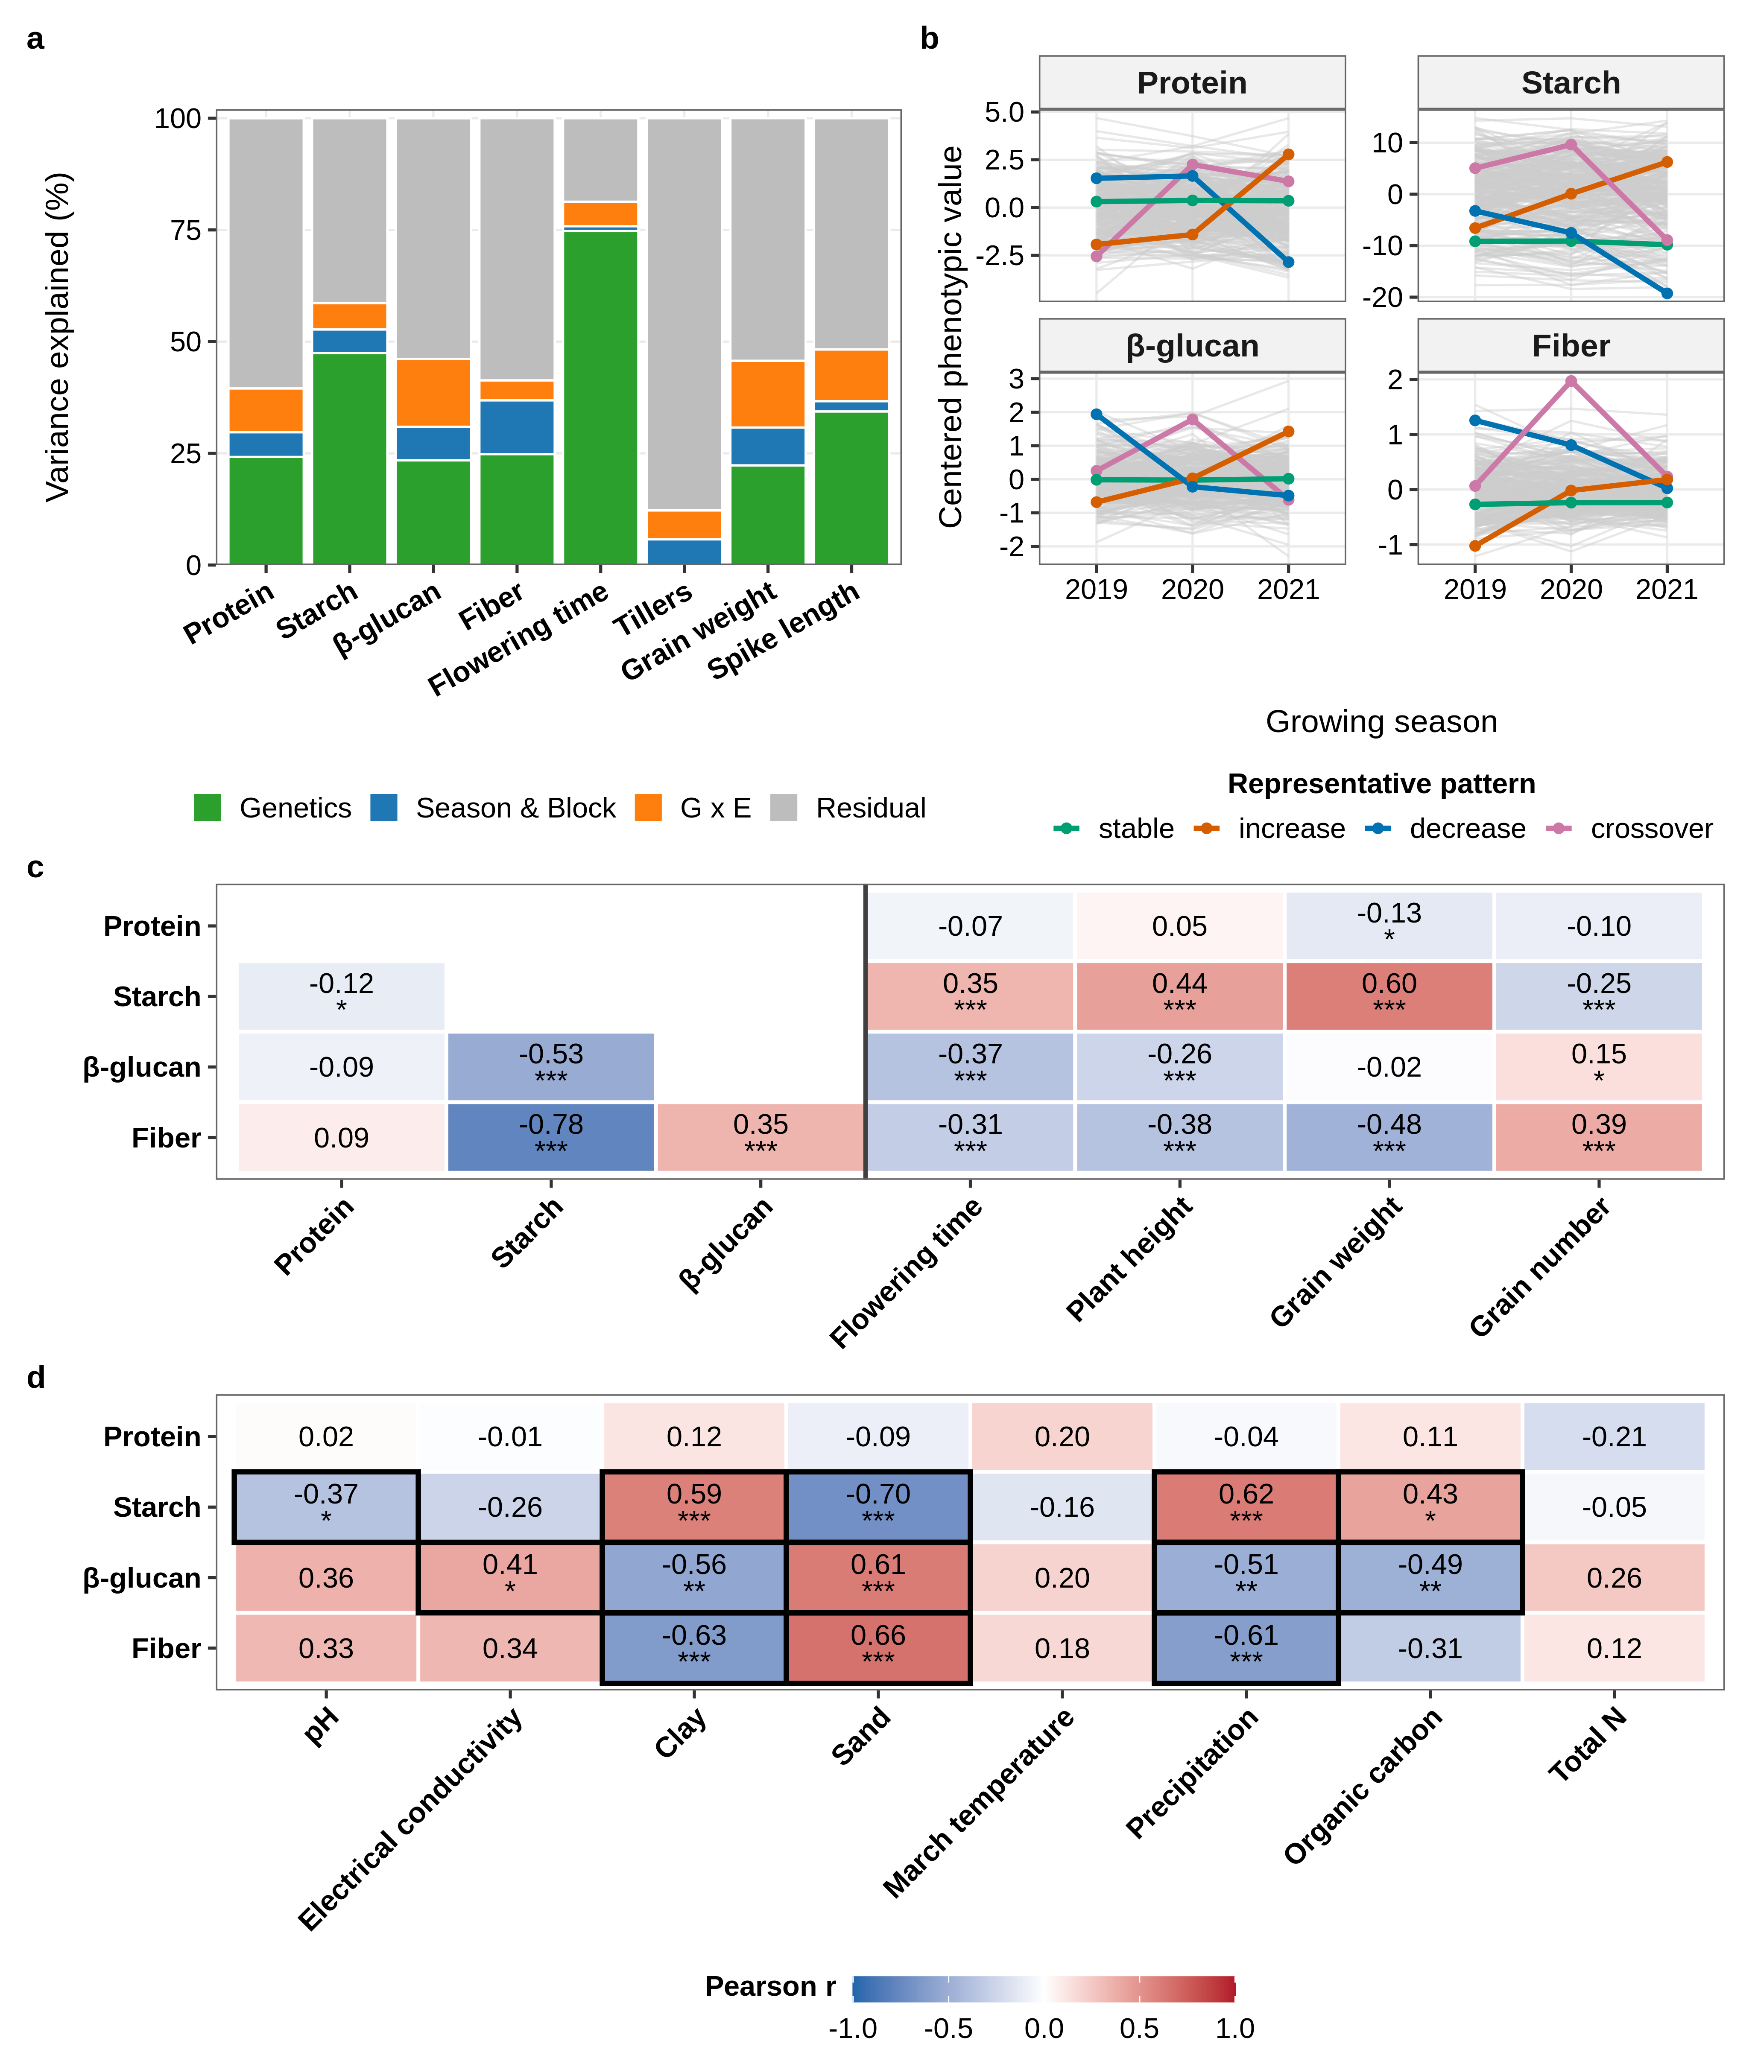
Fig. 1 Genetic and ecological architecture of grain nutritional traits. a Variance partitioning of four nutritional and four morphological traits into genetic, season-and-block, genotype-by-season (G×E) and residual components. b Reaction norms of each accession across the three seasons (labeled by their first year) for the four nutritional traits; gray lines, all accessions; colored lines, the four highlighted accessions per trait: the most stable, the strongest increase and the strongest decrease from 2019–20 to 2021–22, and the strongest crossover. c Pearson correlations among the four nutritional traits (lower triangle) and between them and four morphological traits, from accession BLUPs (n = 290). d Pearson correlations between the nutritional traits and eight environmental variables across the 29 sampling sites, from site-mean BLUPs; outlined cells, P < 0.05. Significance (c, d), two-sided tests without correction for multiple testing: *P < 0.05, **P < 0.01, ***P < 0.001
Among the nutritional traits, starch was strongly negatively correlated with fiber (r = −0.78; Fig. 1c) and β-glucan (r = −0.53), while fiber and β-glucan were positively correlated (r = 0.35; all P < 0.001). Thus, genotypes with higher starch tended to have lower fiber and β-glucan. Protein was poorly correlated with other traits, and significant negative correlation was obtained only for protein-starch (r = −0.12, P < 0.05). Among the morphological and phenological traits, starch was strongly correlated with grain weight, plant height, and flowering time, while fiber showed the exact opposite pattern. Protein was also weakly negatively correlated with grain weight (r = −0.13, P < 0.05). Overall, β-glucan and protein displayed weaker, mostly negative correlations, linking grain composition directly to whole-plant resource allocation and phenology (Fig. 1c).
To examine whether variation in grain nutritional traits followed the environmental gradient of the collection sites, site-mean nutritional-trait BLUPs were correlated with eight environmental variables (Fig. 1d). Starch was positively correlated with clay, precipitation, and organic carbon, and negatively correlated with sand and pH. Fiber showed the opposite pattern for clay, sand, and precipitation, while β-glucan was positively correlated with sand and electrical conductivity and negatively correlated with clay, precipitation, and organic carbon. Protein was not significantly correlated with any of the measured environmental variables. Plotting the accession BLUPs across the 29 sites ordered by ecological region showed a matching descriptive pattern (Online Resource 13): northern-derived genotypes generally had higher starch, whereas desert-derived genotypes tended to have lower starch and higher fiber and β-glucan, and protein showed no clear directional trend. Together, these associations linked the contrasting patterns of starch versus fiber and β-glucan to gradients in soil texture and precipitation, consistent with the broader geographic pattern observed across the collection sites.

Identification of nutritional QTLs and candidate genes
To identify the genomic regions associated with grain nutritional traits, genome-wide association was performed for each trait using the genotype BLUPs as the phenotypic input, the first three principal components as fixed covariates to correct for population structure, and a kinship matrix as a random effect to correct for relatedness among the 290 accessions, testing 7,110,996 SNPs (Fig. 2). The genomic inflation factor was close to unity for all four traits (λ_{GC} = 0.975–1.013; Fig. 2), indicating adequate control of population structure and of genome-wide false-positive inflation.
Overall, 52 SNPs exceeded the genome-wide threshold and resolved into 36 loci, each defined as the lead SNP together with the contiguous block of SNPs in linkage disequilibrium with it (Fig. 2; Online Resource 5). Fiber was the most mappable trait, with 24 significant SNPs in 18 loci, followed by β-glucan (20 SNPs, 11 loci), starch (6 SNPs, 5 loci) and protein (2 SNPs, 2 loci). Interestingly, the number of loci did not follow heritability: starch, the most heritable nutritional trait (H² = 0.474; Online Resource 3), yielded only five loci, whereas fiber, with about half its heritability (H² = 0.248), yielded more than three times as many.
The strongest association in the study was a β-glucan peak on chromosome 2H (2H:41,996,626; −log₁₀(P) = 7.60), and the densest β-glucan signal was a cluster of ten significant SNPs on chromosome 4H (4H:34,825,152–35,062,236), which the 50-kb gap rule split into two adjacent loci. The strongest fiber and starch peaks were both located on the distal arm of chromosome 7H (7H:573,606,306 and 7H:573,606,460; −log₁₀(P) = 7.25 and 6.44, respectively), whereas both protein loci were located on chromosome 3H, the stronger at 3H:106,623,911 (−log₁₀(P) = 6.43). Fiber loci were concentrated on chromosome 1H, which carried six of the 18 fiber loci, five of them in two clusters (329.7–330.7 Mb and 440.0–440.6 Mb). Locus size varied widely, from a single SNP (four loci) to 1.73 Mb, but most loci were small, with a median span of 93.5 kb.
Most lead SNPs carried rare alleles, with a minor allele frequency (MAF) below 0.10 at 25 of the 36 loci (median MAF = 0.068; Online Resource 5). Only two lead SNPs, both associated with starch, carried a common minor allele (MAF = 0.42 at 3H:530,660,057 and 6H:525,776,080). For β-glucan, fiber and starch, the direction of the allelic effects was consistent across loci. At every β-glucan and fiber locus the minor allele was associated with higher trait values (allelic effects of 0.15–0.36% and 0.12–0.25%, respectively), whereas at every starch locus it was associated with lower starch (−1.31 to −2.69%). The two protein loci showed opposite effects (−0.40% at 3H:106,623,911 and 0.68% at 3H:159,799,839).
To examine whether the negative relationship between starch and fiber has a genomic counterpart, the positions of the loci were compared across traits. Fiber and starch loci co-localized in three genomic regions. On chromosome 7H (573.6 Mb), the fiber locus was contained within the starch locus, and the two lead SNPs were only 154 bp apart. On chromosome 1H, four loci fell within 1.02 Mb (329.7–330.7 Mb): a starch locus flanked by two fiber loci, 121 kb and 58 kb away, and a third fiber locus a further 532 kb beyond the first of them. On chromosome 3H (544.0–546.5 Mb), the widest fiber locus was followed 595 kb downstream by a starch locus. In contrast, none of the β-glucan loci overlapped or neighbored a locus of another trait (the closest, on chromosome 3H, lay 6.0 Mb away), although β-glucan was phenotypically correlated with both starch and fiber (Fig. 1c).
To search for potential candidate genes, the interval of each locus, defined by its LD span, was screened for annotated genes in the MorexV3 reference genome. Together, the 36 loci covered 7.91 Mb and contained 55 candidate genes at 15 loci, whereas the remaining 21 loci contained no annotated gene. These included the four loci that consisted of the lead SNP alone, with no other SNP in linkage disequilibrium with it. Fiber contributed most of the candidate genes (32 genes at six loci), followed by starch (10 genes at three loci), β-glucan (seven genes at four loci) and protein (six genes at two loci). Notably, the three most significant β-glucan loci, on chromosomes 2H, 4H and 3H, contained no annotated gene. None of the lead SNPs was located within a gene body.
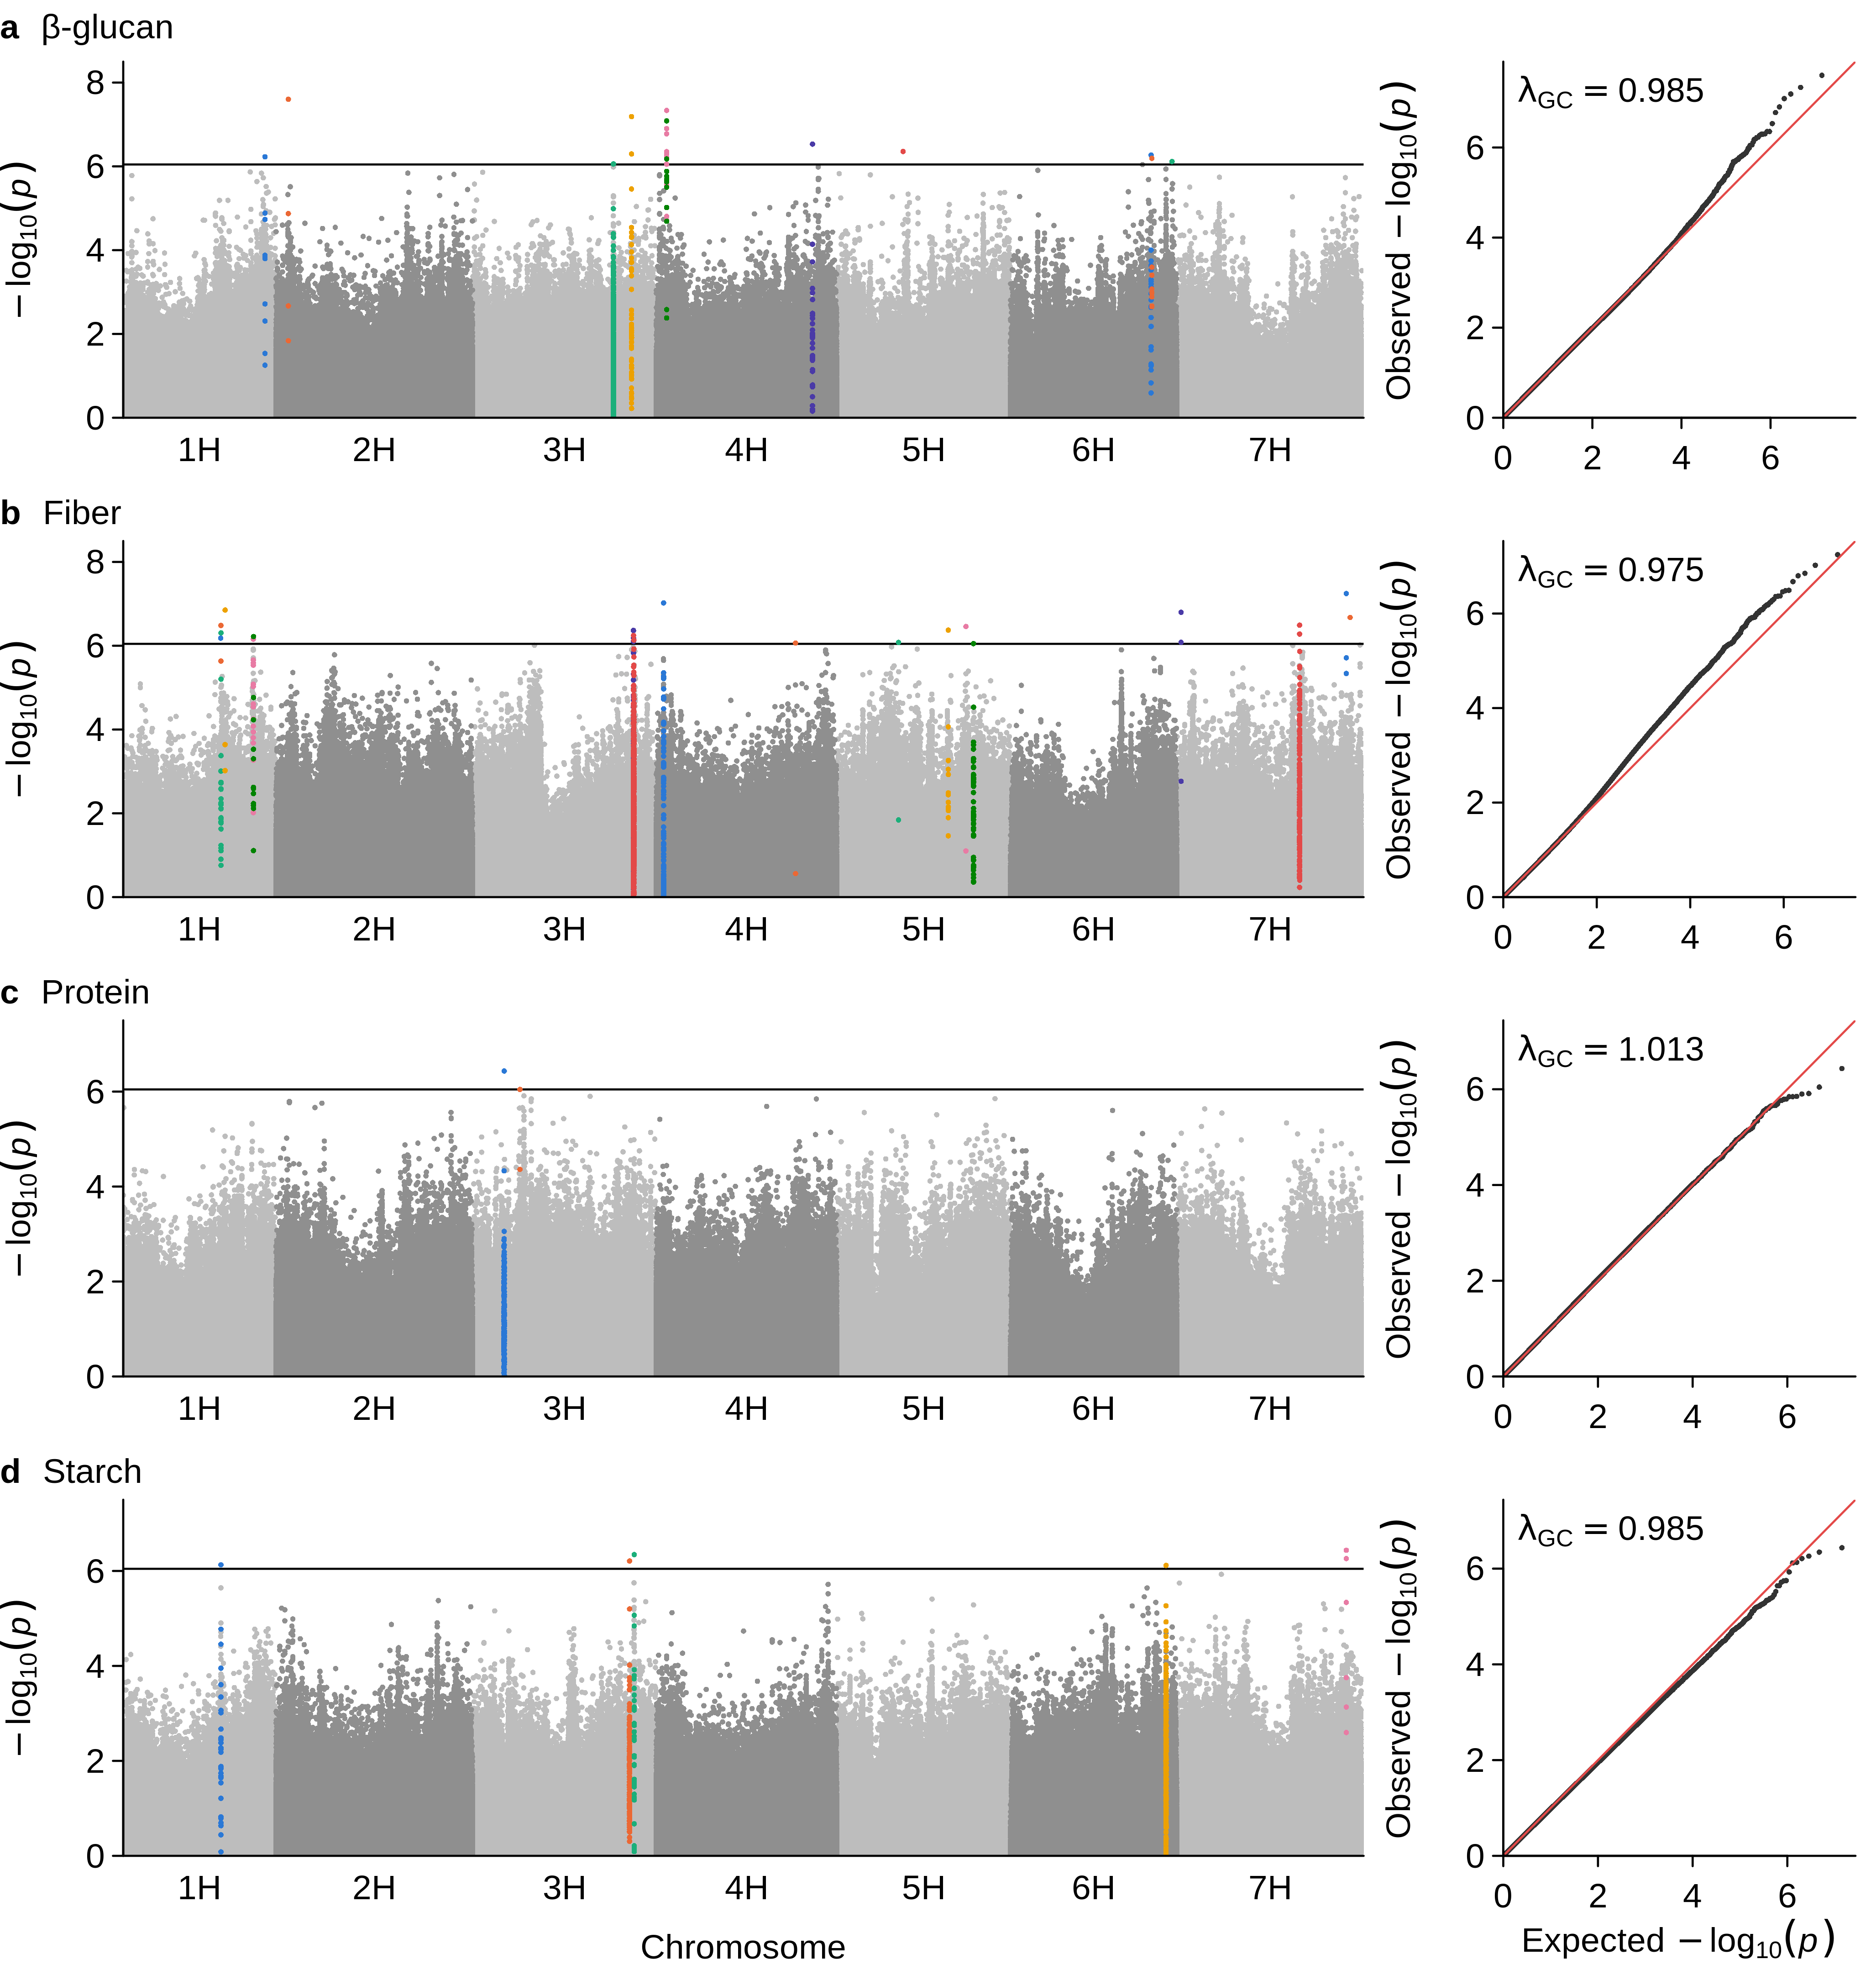
Fig. 2 Genome-wide association mapping of grain nutritional traits in 290 H. spontaneum accessions. Manhattan plots (left) and quantile–quantile plots (right) for a β-glucan, b fiber, c protein and d starch (7,110,996 SNPs). In the Manhattan plots, the SNPs of the 36 loci are colored by locus (adjacent loci in different colors) over alternating gray chromosomes; the horizontal line marks the Bonferroni threshold (α = 0.10; −log₁₀(P) = 6.0454). In the quantile–quantile plots, the red line marks the expectation under the null hypothesis; λ_{GC}, genomic inflation factor

Haplotype analysis and candidate gene resolution
Candidate genes were further evaluated by haplotype analysis to identify phenotypic divergence between accessions carrying contrasting alleles across haplotype groups. Gene-level haplotype analysis tested whether variation across each gene was associated with the corresponding trait (Kruskal–Wallis, Benjamini–Hochberg correction within each trait, q ≤ 0.05) and quantified the direction and magnitude of differences among haplotype groups, information not provided by the single-SNP tests. Of the 55 candidate genes, 30 could be tested and 23 were significant, distributed over 12 of the 36 loci (Online Resource 6). The remaining 25 genes carried no SNPs, too few SNPs, or SNPs too weakly linked to define haplotypes. Within traits, all six testable β-glucan genes and all five testable starch genes were significant, against 12 of 19 for fiber, whereas none of the six protein genes could be tested.
A single locus, the 1.73 Mb fiber locus on chromosome 3H, contained seven of the 12 significant fiber genes. The 23 genes were functionally annotated, and a biological-relevance screen kept only those with a documented or plausible role in the biosynthesis, transport or regulation of the corresponding grain component. The three genes with the clearest such role were two for fiber and one for starch, and none for β-glucan (Online Resource 6). Notably, these did not include the two most significant genes: the first (HORVU.MOREX.r3.6HG0619810, starch, q = 5.5 × 10⁻¹¹) returned no functional call from Swiss-Prot, InterPro or NCBI nr, and the second (HORVU.MOREX.r3.3HG0301210, fiber, q = 1.1 × 10⁻⁹) carried a transposase-derived domain.
The first of the two fiber genes, the glycerol-3-phosphate 2-O-acyltransferase GPAT6 (HORVU.MOREX.r3.3HG0301300), resolved into three haplotype groups that differed in grain fiber (q = 5.3 × 10⁻⁶, η² = 0.208; Online Resources 6, 9; Fig. 3a). It belongs to the land-plant GPAT4/6/8 clade, whose members are bifunctional acyltransferase–phosphatases that produce sn-2 monoacylglycerol, the committed precursor of cutin (Yang et al. 2010; Petit et al. 2016). Cutin and suberin, such as those of the pericarp and testa, are counted among the constituents of dietary fiber (AACC 2001).
The second, the glucan endo-1,3-β-glucosidase GH17 (HORVU.MOREX.r3.5HG0487060), resolved into five haplotype groups that differed in grain fiber (q = 7.5 × 10⁻⁵, η² = 0.222; Online Resources 6, 9; Fig. 3b). It carries the glycoside hydrolase family 17 catalytic domain together with an X8 carbohydrate-binding module. Barley’s own (1,3;1,4)-β-D-glucan endohydrolases EI and EII belong to this family (Houston et al. 2014), and mixed-linkage β-glucan is an important component of grain dietary fiber (Hrmova et al. 2024). This gene, on 5H, is an uncharacterized member of the family rather than either endohydrolase, which map to 1H and 7H.
For starch, the plastid-localized anion/phosphate transporter PHT4;3 (HORVU.MOREX.r3.3HG0301710), an ortholog of rice PHT4;3, resolved into four haplotype groups that differed in grain starch (q = 3.8 × 10⁻⁴, η² = 0.078; Online Resources 6, 9; Fig. 3c). Phosphate is the allosteric inhibitor of ADP-glucose pyrophosphorylase, which catalyzes the committed step of starch synthesis (Irigoyen et al. 2011), so the rate at which phosphate crosses the plastid envelope can constrain starch accumulation. Consistent with this role, loss of the related plastidic transporter PHT4;2 alters starch accumulation in Arabidopsis (Irigoyen et al. 2011).
To ask which of these haplotypes are present in cultivated barley, we compared five European spring malting cultivars released between 2012 and 2018 with the wild haplotype groups at the same three genes (Fig. 3d–f; Online Resource 10). At GPAT6, the five cultivars matched the two low-fiber haplotype groups at 95–98% and 88–91% of called sites but the high-fiber group at only 39–45%, so the high-fiber wild haplotype is essentially absent from these lines. The cultivars, like the two low-fiber groups, carried the reference (Morex) allele at only 12–14% of these sites, against 65% in the high-fiber group. At GH17 and PHT4;3, by contrast, all five cultivars carried the reference allele at every called site.
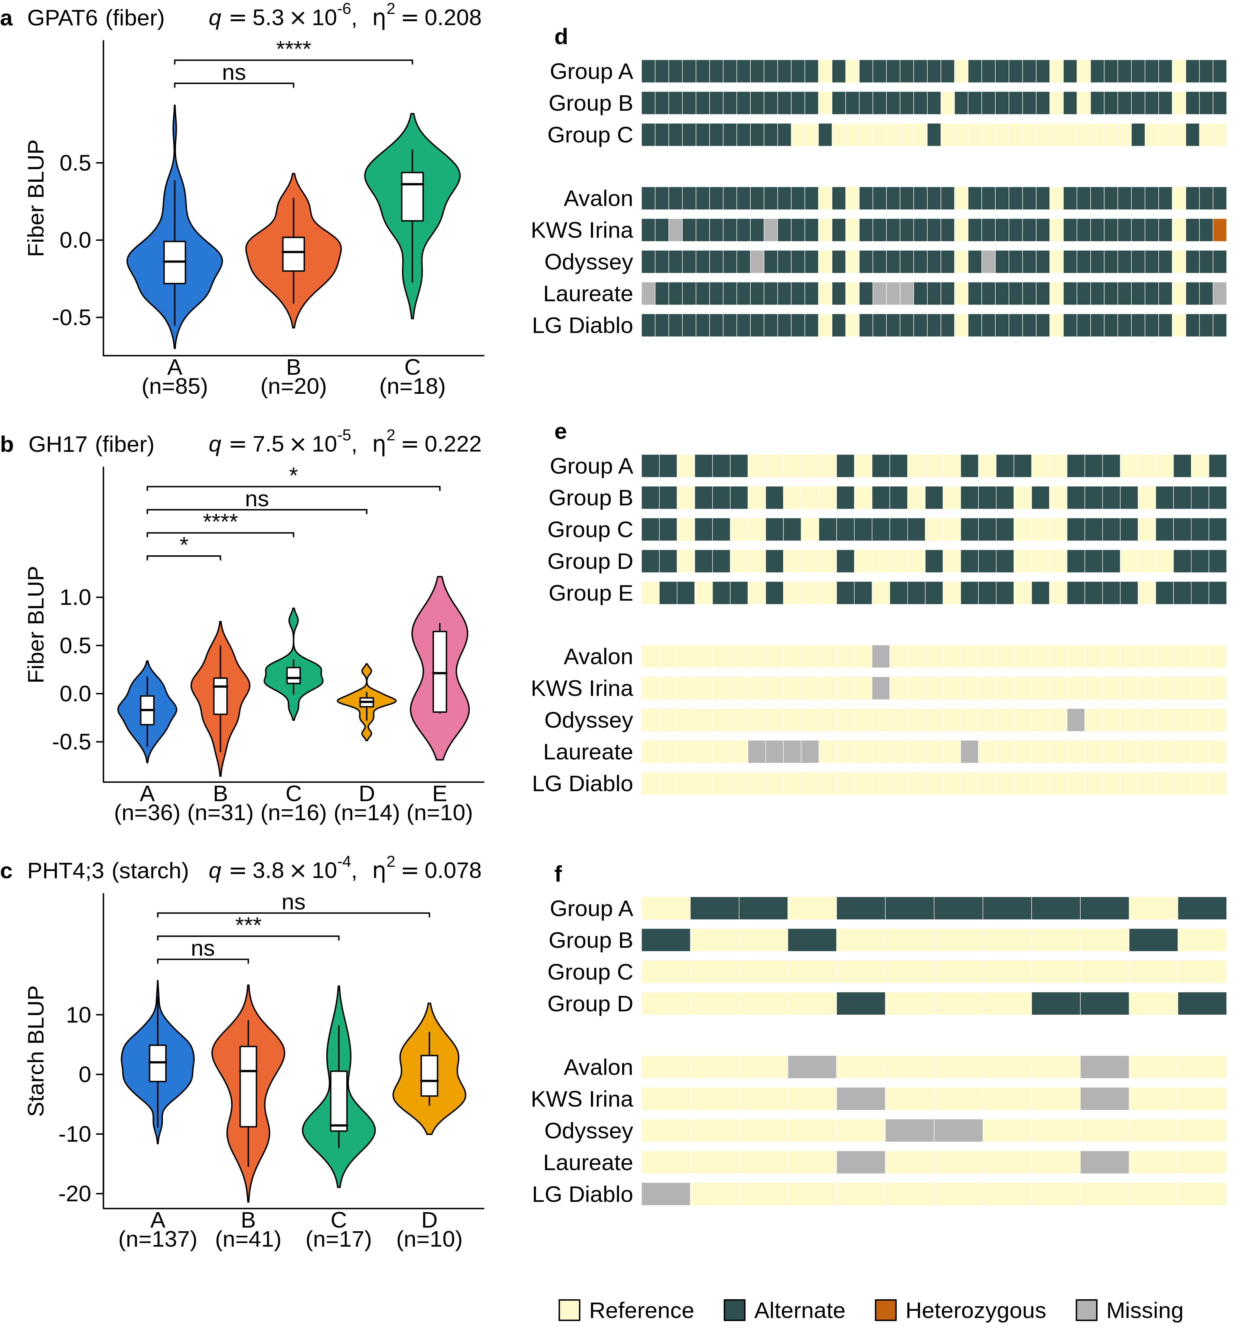
Fig. 3 Haplotype structure of the three candidate genes carried forward, and the genotypes of five elite malting cultivars at these genes. a–c Grain-trait BLUPs by wild haplotype group for a GPAT6 (HORVU.MOREX.r3.3HG0301300), fiber, b GH17 (HORVU.MOREX.r3.5HG0487060), fiber and c PHT4;3 (HORVU.MOREX.r3.3HG0301710), starch; violins with boxplots, group size below each. Above each panel, the Benjamini–Hochberg q and η² of the gene-level Kruskal–Wallis test; brackets, Wilcoxon comparisons of each group against the largest, Holm-adjusted (****P ≤ 10⁻⁴, ***P ≤ 10⁻³, **P ≤ 0.01, *P ≤ 0.05; ns, not significant). d–f Genotypes at the same genes: one row per haplotype-group consensus, then one row per cultivar; columns are the SNPs shared by the two call sets, in genomic order

A shared fiber and starch signal on chromosome 7H
To search for a candidate gene at the tightest of the three fiber–starch co-localizations, the region around the two 7H loci was examined (Fig. 2b, d). Both loci were too narrow to contain a gene, spanning 185 bp (fiber) and 1.56 kb (starch). A single gene, HORVU.MOREX.r3.7HG0729030, lay immediately beside them, within 732 bp of both lead SNPs and 554 bp beyond the edge of the starch locus. The nearest other annotated gene was 112 kb away. The gene encodes a GDSL esterase/lipase predicted to be secreted, annotated at the family level, without a characterized ortholog. Members of this family act on ester bonds in the plant cell wall and cuticle. In rice, the GDSL esterase DARX1 removes acetyl groups from arabinoxylan, the major hemicellulose of rice, and in tomato, GDSL1 is required for cutin deposition in the fruit cuticle (Girard et al. 2012; Zhang et al. 2019).
Three SNPs in this region exceeded the genome-wide threshold: the fiber lead SNP, the starch lead SNP and a second starch SNP (7H:573,606,491). All three lay in the putative promoter region of the gene, 578–763 bp upstream of its annotated transcription start site (the gene is on the minus strand), and they were in linkage disequilibrium with one another (r² = 0.73–0.94). In contrast, none of the six SNPs within the gene body was associated with either trait (−log₁₀(P) ≤ 1.59).
In the haplotype analysis, the gene resolved into two haplotype groups over 246 of the 290 accessions, with the same grouping for both traits (Fig. 4; Online Resource 9). The haplotypes were defined by a single marker group of four SNPs: the three significant SNPs and a fourth in linkage disequilibrium with them (7H:573,606,282; r² = 0.44–0.54). The minority haplotype B comprised exactly the 34 accessions carrying the minor allele at both lead SNPs. It had higher fiber (P = 2.1 × 10⁻³, η² = 0.035, 0.54 SD; Fig. 4a) and lower starch (P = 1.1 × 10⁻³, η² = 0.040, 0.56 SD; Fig. 4b) than the major haplotype A (n = 212). Thus, a single haplotype at this gene was associated with both traits in opposite directions, matching the negative phenotypic correlation between fiber and starch (Fig. 1c). At the four SNPs that defined the haplotypes, the five elite malting cultivars carried the alleles of the low-fiber, high-starch haplotype A at every called site, and none carried those of the high-fiber, low-starch haplotype B (Fig. 4c).
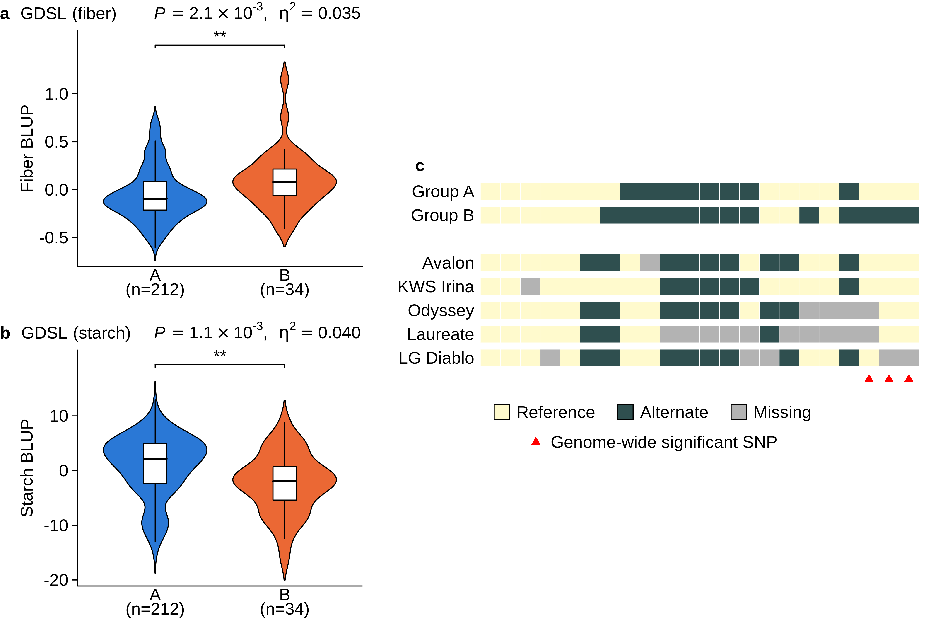
Fig. 4 Haplotype structure of the GDSL esterase/lipase HORVU.MOREX.r3.7HG0729030, and the genotypes of five elite malting cultivars at this gene. a, b Grain-trait BLUPs by wild haplotype group for a fiber and b starch; violins with boxplots, group size below each. Above each panel, the Kruskal–Wallis P and η²; brackets, Wilcoxon comparison of the two groups (**P ≤ 0.01). c Genotypes at the same gene: one row per haplotype-group consensus, then one row per cultivar; columns are the SNPs shared by the two call sets, in genomic order; red triangles, the three genome-wide significant SNPs

Discussion

Ecological differentiation of grain composition
Previous studies of Israeli wild barley showed that population structure, flowering time and growth traits are organized along gradients of temperature and precipitation (Hübner et al. 2009, 2013). The present study extends this ecological differentiation to grain nutritional traits. Because the comparisons were based on genotype BLUPs from common-garden experiments, the regional patterns reflect heritable differences among source populations rather than immediate plastic responses to the environments in which the accessions were collected. The contrast between the starch-rich grain of northern genotypes and the fiber- and β-glucan-rich grain of desert genotypes followed soil texture and precipitation at the sites of origin (Fig. 1d; Online Resource 13), placing the carbohydrate axis on the environmental gradient of the collection.
Physiological studies provide a plausible explanation for the direction of this pattern. Heat and drought during grain filling shorten the filling period, reduce the activity of starch-synthetic enzymes, among them the heat-sensitive soluble starch synthase (Keeling et al. 1993), and decrease starch deposition and final grain weight (Savin and Nicolas 1996). β-glucan, in turn, combined higher values in desert genotypes with the largest genotype-by-environment component of the four traits. Temperature is known to affect the content, solubility, viscosity and molecular weight of barley β-glucan, with the direction and magnitude of the response depending on genotype, stress intensity and timing: higher growth temperatures can increase soluble β-glucan in some genotype–environment combinations, whereas severe short-term heat stress reduces it and promotes its degradation (Anker-Nilssen et al. 2008). Thus, the large G×E observed for β-glucan is consistent with previous studies. Taken together, the nutritional traits were not distributed randomly across the collection but were tightly associated with the environmental conditions of the source sites.

A shared carbon-allocation axis for starch, fiber and β-glucan
Wild barley grain composition reveals two partly distinct biological dimensions: an independent protein axis, and a coordinated carbohydrate axis defining an inverse relationship between storage starch and the cell-wall polysaccharides, fiber and β-glucan. This trade-off was consistently observed across genotypes and along the north-to-desert gradient (Fig. 1c, d; Online Resource 13), indicating that grain composition reflects the competitive allocation of a common sucrose supply within the developing endosperm. This mechanism is supported by functional evidence showing that endosperm-specific overexpression of HvCslF6 increases β-glucan accumulation while reducing starch content (Lim et al. 2020), demonstrating that these components are governed by interconnected physiological and genetic systems. The carbohydrate axis further integrates with a broader whole-plant resource-allocation strategy linked to plant architecture and phenology: larger, later-flowering genotypes with heavier grains prioritize storage starch, whereas smaller, faster-developing plants distribute resources toward higher grain numbers and structural cell-wall material. While domestication and breeding have historically shifted cultivated barley toward the starch-rich end of this axis, with higher starch and lower protein and fiber, wild barley remains a potential source of genetic variation for enriching the crop in fiber and β-glucan (Friedman and Atsmon 1988).
The trade-off also had a genomic counterpart. Fiber and starch loci co-localized in three regions, which resolved to a single gene on chromosome 7H, to two genes on 3H and to no gene with a known role in either trait on 1H. At 7H, a single haplotype of the gene carried both effects, higher fiber and lower starch of similar magnitude. With the two lead SNPs only 154 bp apart and no other annotated gene within 112 kb, this pattern is more simply explained by one causal variant expressed through two correlated traits than by two linked genes. Moreover, the carriers of the minor alleles at this locus, and of the haplotype carrying both effects, came from sites across the environmental gradient of the collection, so this shared signal cannot be explained as a geographic artifact of the accessions’ origin. The gene encodes a GDSL esterase/lipase rather than a starch enzyme, so its link to starch is more likely compositional than mechanistic, as a shift in the cell-wall fraction changes the share of starch in the grain in the opposite direction. At 3H, the two genes were a cutin-biosynthetic acyltransferase (GPAT6) for fiber and a plastid phosphate transporter (PHT4;3) for starch. Thus, the carbon-allocation axis was visible at every level the data could resolve.
In contrast, protein was not correlated with any of the measured environmental variables, including total soil nitrogen and organic carbon at the source sites, and only weakly and negatively with grain weight (Fig. 1c, d). This pattern suggests that grain protein is governed by processes other than those organizing carbohydrate composition. A negative relationship between grain yield or grain weight and grain protein concentration is well documented (Simmonds 1995) and can be explained by a dilution effect: carbohydrates accumulate faster than nitrogen during grain filling, so protein becomes a smaller proportion of total grain mass (Bogard et al. 2010). Differences between wild and cultivated barley in dry-matter accumulation, nitrogen allocation and nitrogen harvest index further suggested that grain protein depends on the balance between carbon deposition and nitrogen acquisition rather than on direct competition with starch alone (Corke et al. 1989). This separation has a practical implication: the strong starch–fiber trade-off may not constrain protein, so increasing fiber or β-glucan need not cause a reduction in protein. At the genomic level, none of the protein candidate genes could be tested, so the genetic control of protein remains unresolved in this panel.

Genetic architecture of grain composition
Trait heritability poorly predicted genome-wide association mapping power. Starch, the most heritable nutritional trait, yielded only five loci, whereas protein, β-glucan and fiber, each with about half its heritability and near-identical to one another, yielded two, 11 and 18 loci, respectively. This contrast emphasizes that mapping success depends on components of the genetic architecture such as the number of alleles, their frequencies and effect sizes, and linkage disequilibrium, rather than on total genetic variation alone.
Most associations rested on rare alleles, and at every fiber, β-glucan and starch locus the minor allele shifted grain composition in the direction of the phenotypic correlations, toward higher fiber and β-glucan and lower starch. This consistency may partly reflect where the carriers came from: at most fiber and β-glucan loci, they originated mainly from desert and coast–desert sites, the populations that already produce low-starch, fiber- and β-glucan-rich grain (Online Resources 11, 12). Such regional enrichment is expected if these alleles contributed to local adaptation, and does not by itself indicate an artifact. The carriers also came from several desert sites rather than a single one, and at most loci they differed from non-carriers of their own site in the direction of the allelic effect, supporting a genetic effect beyond geographic origin. However, correction for population structure is less effective for rare alleles shared by related accessions, so a contribution of common ancestry cannot be fully excluded. Plausible gene functions further support individual loci. For the candidate genes, however, the allelic effect is harder to separate from geographic origin: the haplotypes associated with high fiber at GPAT6 and GH17 came mainly from several desert populations, and the high-starch haplotype of PHT4;3 was nearly absent from them. The 7H locus and its GDSL esterase/lipase, whose carriers and haplotypes were not concentrated in the desert, therefore provide the clearest case.
β-glucan produced some of the strongest associations of the study, yet none of its loci lay near the canonical mixed-linkage glucan pathway. The nearest of the ten canonical synthases and endohydrolases, HvGlb1, lay 83.5 Mb from any β-glucan lead SNP (Online Resource 8), and no SNP on chromosome 7H, which carries HvCslF6 and HvGlb2, was significantly associated with β-glucan (Fig. 2a). The absence of a signal at HvCslF6, the major synthase of grain β-glucan (Houston et al. 2014), is consistent with the unusual conservation of this gene. A previous study of 1,336 barley accessions, 288 of them wild, found only three coding SNPs segregating in HvCslF6, none of them associated with grain β-glucan content. The authors suggested that this conservation reflects the indispensable role of the gene in β-glucan synthesis (Garcia-Gimenez et al. 2019). A gene can thus be essential for a trait and still show no association, because association requires segregating functional variation. This outcome is common rather than exceptional: other association studies also failed to detect HvCslF6 (Houston et al. 2014; Geng et al. 2021). A panel of European spring barley did detect its region (Shu and Rasmussen 2014), indicating that its detection depends on the population. The β-glucan loci identified here, all located away from these genes, therefore point to sources of variation in wild barley that remain to be characterized.

From associated loci to candidate genes
Ranking genes by the significance of their haplotype test was a poor guide to biological candidacy. The genes with the strongest haplotype associations were often the least interpretable, unannotated or derived from mobile elements, whereas the genes with a clear route to the trait ranked lower. Because genes within a locus share one linkage-disequilibrium block, their significance largely reflects linkage with the lead signal rather than their own function. Candidate genes were therefore selected in three steps: the genome-wide association identified the locus, the haplotype test retained the genes whose variation was associated with the trait, and biological relevance chose among these genes. The first two steps can also miss genuine candidates. The definition of loci delimits each association by linkage disequilibrium with its lead SNP, so a gene lying just outside a narrow locus is never considered. The GDSL esterase/lipase at 7H illustrates this: it lay beside two of the strongest signals of the study and was found only by examining the region directly. The haplotype analysis requires sufficient variation within a gene to define haplotype groups, so a gene that could not be tested is not a gene without effect. Likewise, one fixed grouping setting for all genes can leave the associated SNPs of a sparse gene ungrouped, so a real association can be missed even in a gene that was tested. This was also the case at the same gene, whose associated SNPs were grouped only at a different setting (see Materials and methods). The three genes carried forward are therefore those that passed both filters, not a complete list of the genes underlying these traits.
Each candidate gene connects its trait to a specific process in the developing grain. The acyltransferase GPAT6 suggests that cutin deposition in the pericarp and testa contributes to the insoluble fiber fraction, consistent with the central role of GPAT6 in fruit cutin biosynthesis in tomato (Petit et al. 2016). The glucanase GH17 suggests that the hydrolysis of cell-wall glucans contributes to grain fiber, consistent with the role of its family, which includes barley’s own (1,3;1,4)-β-glucan endohydrolases, in degrading mixed-linkage glucan (Hrmova et al. 2024). The phosphate transporter PHT4;3 suggests that plastid phosphate homeostasis contributes to the metabolic conditions required for starch accumulation, consistent with the impaired grain filling reported in rice phosphate-transporter mutants (Ma et al. 2021). The GDSL esterase/lipase at 7H suggests that the modification of cell-wall esters contributes to grain fiber, consistent with the roles of this family in arabinoxylan deacetylation and cutin deposition (Girard et al. 2012; Zhang et al. 2019). Its associated SNPs were confined to the putative promoter, while variants within the gene body showed no association, pointing to regulatory rather than coding variation. These four genes therefore identify distinct biological pathways for future investigation: cutin deposition, glucan hydrolysis, plastid phosphate transport and cell-wall ester modification.

Wild alleles for cultivated barley
The five elite cultivars carried nearly identical genotypes at GPAT6, GH17 and PHT4;3, as expected in modern germplasm. At GH17 and PHT4;3, the cultivars carried the reference allele at every called site. Since the reference genome, Morex, is itself an elite cultivar, their match with the wild groups at these genes should be interpreted with caution: at PHT4;3 the cultivars appeared identical to the low-starch group C at the shared sites (Fig. 3f), most likely because both carry the reference allele, whereas at GH17 they matched none of the wild groups (Fig. 3e). In contrast, GPAT6 and the GDSL esterase/lipase, two independent loci, provided a clear result. At both genes the cultivars carried non-reference alleles at many sites, so their genotypes do not simply reflect the reference genome, and the high-fiber wild haplotype was absent from all five cultivars. At GPAT6, this haplotype came from three desert and two coast–desert populations rather than from a single site (Online Resources 11, 12). These haplotypes may therefore represent wild variation for increasing fiber in cultivated barley.

Conclusions
Grain composition in wild barley is organized around carbon allocation involving starch, fiber and β-glucan, alongside a distinct protein axis governed by carbon and nitrogen balance. By applying genome-wide association and haplotype analysis to ecologically diverse populations, this research identified heritable variation and specific genetic architectures for these traits. Trait associations varied widely among traits and did not follow heritability; starch, the most heritable nutritional trait, mapped to few loci, whereas fiber was distributed across the most. Most associations rested on rare alleles, and β-glucan produced the strongest of them yet contributed no candidate gene. The starch–fiber trade-off recurred in the genome, most clearly at the shared 7H locus and at the neighboring fiber and starch loci on 3H, and four candidate genes link grain composition to cutin deposition, glucan hydrolysis, plastid phosphate transport and cell-wall ester modification.
These defined loci, together with the high-fiber wild haplotypes absent from the elite cultivars examined, provide precise targets for improving cultivated barley nutrition while minimizing the linkage drag commonly associated with wild germplasm introgression (Hübner and Kantar 2021). Previous research successfully transferred beneficial wild alleles to increase β-amylase activity and yield (Xu et al. 2018), yet the simultaneous transfer of undesirable traits remains a persistent challenge. Refining broad genetic associations into a focused set of biologically plausible targets simplifies the monitoring of transferred genomic segments. Future breeding efforts must validate these haplotypes in elite cultivars, replicate their effects in independent populations, and conduct functional tests to assess their overall agronomic impact.

References
AACC (2001) The definition of dietary fiber. Cereal Foods World 46:112–126. https://www.cerealsgrains.org/resources/definitions/Documents/DietaryFiber/DFDef.pdf
Alqudah AM, Sallam A, Baenziger PS, Börner A (2020) GWAS: fast-forwarding gene identification and characterization in temperate cereals: lessons from barley – a review. J Adv Res 22:119–135. https://doi.org/10.1016/j.jare.2019.10.013
Anker-Nilssen K, Sahlstrøm S, Knutsen SH, Holtekjølen AK, Uhlen AK (2008) Influence of growth temperature on content, viscosity and relative molecular weight of water-soluble β-glucans in barley (Hordeum vulgare L.). J Cereal Sci 48:670–677. https://doi.org/10.1016/j.jcs.2008.02.009
Badr A, Müller K, Schäfer-Pregl R, El Rabey H, Effgen S, Ibrahim HH, Pozzi C, Rohde W, Salamini F (2000) On the origin and domestication history of barley (Hordeum vulgare). Mol Biol Evol 17:499–510. https://doi.org/10.1093/oxfordjournals.molbev.a026330
Bates D, Mächler M, Bolker B, Walker S (2015) Fitting linear mixed-effects models using lme4. J Stat Softw 67:1–48. https://doi.org/10.18637/jss.v067.i01
Benjamini Y, Hochberg Y (1995) Controlling the false discovery rate: a practical and powerful approach to multiple testing. J R Stat Soc Ser B Methodol 57:289–300. https://doi.org/10.1111/j.2517-6161.1995.tb02031.x
Bogard M, Allard V, Brancourt-Hulmel M, Heumez E, Machet J-M, Jeuffroy M-H, Gate P, Martre P, Le Gouis J (2010) Deviation from the grain protein concentration–grain yield negative relationship is highly correlated to post-anthesis N uptake in winter wheat. J Exp Bot 61:4303–4312. https://doi.org/10.1093/jxb/erq238
Broad Institute (2019) Picard toolkit. Broad Institute, GitHub repository. https://broadinstitute.github.io/picard/. Accessed 1 October 2026
Buchfink B, Reuter K, Drost H-G (2021) Sensitive protein alignments at tree-of-life scale using DIAMOND. Nat Methods 18:366–368. https://doi.org/10.1038/s41592-021-01101-x
Camacho C, Coulouris G, Avagyan V, Ma N, Papadopoulos J, Bealer K, Madden TL (2009) BLAST+: architecture and applications. BMC Bioinformatics 10:421. https://doi.org/10.1186/1471-2105-10-421
Corke H, Avivi N, Atsmon D (1989) Pre- and post-anthesis accumulation of dry matter and nitrogen in wild barley (Hordeum spontaneum) and in barley cultivars (H. vulgare) differing in final grain size and protein content. Euphytica 40:127–134. https://doi.org/10.1007/BF00023307
Danecek P, Auton A, Abecasis G, Albers CA, Banks E, DePristo MA, Handsaker RE, Lunter G, Marth GT, Sherry ST, McVean G, Durbin R, 1000 Genomes Project Analysis Group (2011) The variant call format and VCFtools. Bioinformatics 27:2156–2158. https://doi.org/10.1093/bioinformatics/btr330
Danecek P, Bonfield JK, Liddle J, Marshall J, Ohan V, Pollard MO, Whitwham A, Keane T, McCarthy SA, Davies RM, Li H (2021) Twelve years of SAMtools and BCFtools. GigaScience 10:giab008. https://doi.org/10.1093/gigascience/giab008
Dempewolf H, Baute G, Anderson J, Kilian B, Smith C, Guarino L (2017) Past and future use of wild relatives in crop breeding. Crop Sci 57:1070–1082. https://doi.org/10.2135/cropsci2016.10.0885
Farag MA, Xiao J, Abdallah HM (2022) Nutritional value of barley cereal and better opportunities for its processing as a value-added food: a comprehensive review. Crit Rev Food Sci Nutr 62:1092–1104. https://doi.org/10.1080/10408398.2020.1835817
Frichot E, François O (2015) LEA: an R package for landscape and ecological association studies. Methods Ecol Evol 6:925–929. https://doi.org/10.1111/2041-210X.12382
Friedman M, Atsmon D (1988) Comparison of grain composition and nutritional quality in wild barley (Hordeum spontaneum) and in a standard cultivar. J Agric Food Chem 36:1167–1172. https://doi.org/10.1021/jf00084a010
Garcia-Gimenez G, Russell J, Aubert MK, Fincher GB, Burton RA, Waugh R, Tucker MR, Houston K (2019) Barley grain (1,3;1,4)-β-glucan content: effects of transcript and sequence variation in genes encoding the corresponding synthase and endohydrolase enzymes. Sci Rep 9:17250. https://doi.org/10.1038/s41598-019-53798-8
GBD 2019 Risk Factors Collaborators (2020) Global burden of 87 risk factors in 204 countries and territories, 1990–2019: a systematic analysis for the Global Burden of Disease Study 2019. Lancet 396:1223–1249. https://doi.org/10.1016/S0140-6736(20)30752-2
Geng L, Li M, Xie S, Wu D, Ye L, Zhang G (2021) Identification of genetic loci and candidate genes related to β-glucan content in barley grain by genome-wide association study in International Barley Core Selected Collection. Mol Breed 41:6. https://doi.org/10.1007/s11032-020-01199-5
Girard A-L, Mounet F, Lemaire-Chamley M, Gaillard C, Elmorjani K, Vivancos J, Runavot J-L, Quemener B, Petit J, Germain V, Rothan C, Marion D, Bakan B (2012) Tomato GDSL1 is required for cutin deposition in the fruit cuticle. Plant Cell 24:3119–3134. https://doi.org/10.1105/tpc.112.101055
Godfray HCJ, Beddington JR, Crute IR, Haddad L, Lawrence D, Muir JF, Pretty J, Robinson S, Thomas SM, Toulmin C (2010) Food security: the challenge of feeding 9 billion people. Science 327:812–818. https://doi.org/10.1126/science.1185383
Harlan JR, Zohary D (1966) Distribution of wild wheats and barley. Science 153:1074–1080. https://doi.org/10.1126/science.153.3740.1074
Holland JB, Nyquist WE, Cervantes-Martínez CT (2003) Estimating and interpreting heritability for plant breeding: an update. In: Janick J (ed) Plant breeding reviews, vol 22. Wiley, New York, pp 9–112. https://doi.org/10.1002/9780470650202.ch2
Holm S (1979) A simple sequentially rejective multiple test procedure. Scand J Stat 6:65–70
Houston K, Russell J, Schreiber M, Halpin C, Oakey H, Washington JM, Booth A, Shirley N, Burton RA, Fincher GB, Waugh R (2014) A genome wide association scan for (1,3;1,4)-β-glucan content in the grain of contemporary 2-row spring and winter barleys. BMC Genomics 15:907. https://doi.org/10.1186/1471-2164-15-907
Hrmova M, Zimmer J, Bulone V, Fincher GB (2024) Enzymes in 3D: synthesis, remodelling, and hydrolysis of cell wall (1,3;1,4)-β-glucans. Plant Physiol 194:33–50. https://doi.org/10.1093/plphys/kiad415
Huang K, Jahani M, Gouzy J et al (2023) The genomics of linkage drag in inbred lines of sunflower. Proc Natl Acad Sci USA 120:e2205783119. https://doi.org/10.1073/pnas.2205783119
Hübner S, Kantar MB (2021) Tapping diversity from the wild: from sampling to implementation. Front Plant Sci 12:626565. https://doi.org/10.3389/fpls.2021.626565
Hübner S, Höffken M, Oren E, Haseneyer G, Stein N, Graner A, Schmid K, Fridman E (2009) Strong correlation of wild barley (Hordeum spontaneum) population structure with temperature and precipitation variation. Mol Ecol 18:1523–1536. https://doi.org/10.1111/j.1365-294X.2009.04106.x
Hübner S, Bdolach E, Ein-Gedy S, Schmid KJ, Korol A, Fridman E (2013) Phenotypic landscapes: phenological patterns in wild and cultivated barley. J Evol Biol 26:163–174. https://doi.org/10.1111/jeb.12043
Irigoyen S, Karlsson PM, Kuruvilla J, Spetea C, Versaw WK (2011) The sink-specific plastidic phosphate transporter PHT4;2 influences starch accumulation and leaf size in Arabidopsis. Plant Physiol 157:1765–1777. https://doi.org/10.1104/pp.111.181925
Jayakodi M, Lu Q, Pidon H et al (2024) Structural variation in the pangenome of wild and domesticated barley. Nature 636:654–662. https://doi.org/10.1038/s41586-024-08187-1
Jones P, Binns D, Chang H-Y et al (2014) InterProScan 5: genome-scale protein function classification. Bioinformatics 30:1236–1240. https://doi.org/10.1093/bioinformatics/btu031
Kang HM, Sul JH, Service SK, Zaitlen NA, Kong S-Y, Freimer NB, Sabatti C, Eskin E (2010) Variance component model to account for sample structure in genome-wide association studies. Nat Genet 42:348–354. https://doi.org/10.1038/ng.548
Keeling PL, Bacon PJ, Holt DC (1993) Elevated temperature reduces starch deposition in wheat endosperm by reducing the activity of soluble starch synthase. Planta 191:342–348. https://doi.org/10.1007/BF00195691
König P, Beier S, Mascher M, Stein N, Lange M, Scholz U (2023) DivBrowse—interactive visualization and exploratory data analysis of variant call matrices. GigaScience 12:giad025. https://doi.org/10.1093/gigascience/giad025
Kruskal WH, Wallis WA (1952) Use of ranks in one-criterion variance analysis. J Am Stat Assoc 47:583–621. https://doi.org/10.1080/01621459.1952.10483441
Lim WL, Collins HM, Byrt CS, Lahnstein J, Shirley NJ, Aubert MK, Tucker MR, Peukert M, Matros A, Burton RA (2020) Overexpression of HvCslF6 in barley grain alters carbohydrate partitioning plus transfer tissue and endosperm development. J Exp Bot 71:138–153. https://doi.org/10.1093/jxb/erz407
Ma B, Zhang L, Gao Q, Wang J, Li X, Wang H, Liu Y, Lin H, Liu J, Wang X, Li Q, Deng Y, Tang W, Luan S, He Z (2021) A plasma membrane transporter coordinates phosphate reallocation and grain filling in cereals. Nat Genet 53:906–915. https://doi.org/10.1038/s41588-021-00855-6
Marsh JI, Petereit J, Johnston BA, Bayer PE, Tay Fernandez CG, Al-Mamun HA, Batley J, Edwards D (2023) crosshap: R package for local haplotype visualization for trait association analysis. Bioinformatics 39:btad518. https://doi.org/10.1093/bioinformatics/btad518
Mascher M, Wicker T, Jenkins J et al (2021) Long-read sequence assembly: a technical evaluation in barley. Plant Cell 33:1888–1906. https://doi.org/10.1093/plcell/koab077
McKenna A, Hanna M, Banks E, Sivachenko A, Cibulskis K, Kernytsky A, Garimella K, Altshuler D, Gabriel S, Daly M, DePristo MA (2010) The Genome Analysis Toolkit: a MapReduce framework for analyzing next-generation DNA sequencing data. Genome Res 20:1297–1303. https://doi.org/10.1101/gr.107524.110
Nevo E, Chen G (2010) Drought and salt tolerances in wild relatives for wheat and barley improvement. Plant Cell Environ 33:670–685. https://doi.org/10.1111/j.1365-3040.2009.02107.x
Pedersen TL (2025) patchwork: the composer of plots. R package version 1.3.2. https://doi.org/10.32614/CRAN.package.patchwork
Petit J, Bres C, Mauxion J-P, Wong Jun Tai F, Martin LBB, Fich EA, Joubès J, Rose JKC, Domergue F, Rothan C (2016) The glycerol-3-phosphate acyltransferase GPAT6 from tomato plays a central role in fruit cutin biosynthesis. Plant Physiol 171:894–913. https://doi.org/10.1104/pp.16.00409
Potapenko E, Shermeister B, Mandel T, Hübner S (2026a) Intraspecific genome size variation is attributed to adaptive silencing of transposable elements in Hordeum species. Mol Biol Evol 43:msag051. https://doi.org/10.1093/molbev/msag051
Potapenko E, Schwarts D, Mandel T, Ashkenazy N, Fuerst D, Atsmon G, Snir S, Korol AB, Kantar MB, Bar-Massada A, Hübner S (2026b) Haplotype blocks are associated with rapid local adaptation to environmental shifts in wild barley. Mol Ecol 35:e70540. https://doi.org/10.1111/mec.70540
Purcell S, Neale B, Todd-Brown K, Thomas L, Ferreira MAR, Bender D, Maller J, Sklar P, de Bakker PIW, Daly MJ, Sham PC (2007) PLINK: a tool set for whole-genome association and population-based linkage analyses. Am J Hum Genet 81:559–575. https://doi.org/10.1086/519795
Quinlan AR, Hall IM (2010) BEDTools: a flexible suite of utilities for comparing genomic features. Bioinformatics 26:841–842. https://doi.org/10.1093/bioinformatics/btq033
R Core Team (2021) R: a language and environment for statistical computing. R Foundation for Statistical Computing, Vienna. https://www.R-project.org/
Savin R, Nicolas ME (1996) Effects of short periods of drought and high temperature on grain growth and starch accumulation of two malting barley cultivars. Aust J Plant Physiol 23:201–210. https://doi.org/10.1071/PP9960201
Shu X, Rasmussen SK (2014) Quantification of amylose, amylopectin, and β-glucan in search for genes controlling the three major quality traits in barley by genome-wide association studies. Front Plant Sci 5:197. https://doi.org/10.3389/fpls.2014.00197
Simmonds NW (1995) The relation between yield and protein in cereal grain. J Sci Food Agric 67:309–315. https://doi.org/10.1002/jsfa.2740670306
Tomczak M, Tomczak E (2014) The need to report effect size estimates revisited. An overview of some recommended measures of effect size. Trends Sport Sci 21:19–25
UniProt Consortium (2025) UniProt: the Universal Protein Knowledgebase in 2025. Nucleic Acids Res 53:D609–D617. https://doi.org/10.1093/nar/gkae1010
Van der Auwera GA, O’Connor BD (2020) Genomics in the cloud: using Docker, GATK, and WDL in Terra. O’Reilly Media, Sebastopol
Vasimuddin M, Misra S, Li H, Aluru S (2019) Efficient architecture-aware acceleration of BWA-MEM for multicore systems. In: 2019 IEEE International Parallel and Distributed Processing Symposium (IPDPS), Rio de Janeiro, Brazil, pp 314–324. https://doi.org/10.1109/IPDPS.2019.00041
Wickham H (2016) ggplot2: elegant graphics for data analysis. Springer, New York. https://doi.org/10.1007/978-3-319-24277-4
Wilcoxon F (1945) Individual comparisons by ranking methods. Biometrics Bull 1:80–83. https://doi.org/10.2307/3001968
Xu Y, Zhang X-Q, Harasymow S, Westcott S, Zhang W, Li C (2018) Molecular marker-assisted backcrossing breeding: an example to transfer a thermostable β-amylase gene from wild barley. Mol Breed 38:63. https://doi.org/10.1007/s11032-018-0828-8
Yang W, Pollard M, Li-Beisson Y, Beisson F, Feig M, Ohlrogge J (2010) A distinct type of glycerol-3-phosphate acyltransferase with sn-2 preference and phosphatase activity producing 2-monoacylglycerol. Proc Natl Acad Sci USA 107:12040–12045. https://doi.org/10.1073/pnas.0914149107
Yates AD, Austine-Orimoloye O, Azov AG et al (2026) Ensembl 2026. Nucleic Acids Res 54:D1053–D1060. https://doi.org/10.1093/nar/gkaf1239
Zhang L, Gao C, Mentink-Vigier F, Tang L, Zhang D, Wang S, Cao S, Xu Z, Liu X, Wang T, Zhou Y, Zhang B (2019) Arabinosyl deacetylase modulates the arabinoxylan acetylation profile and secondary wall formation. Plant Cell 31:1113–1126. https://doi.org/10.1105/tpc.18.00894

Supplementary Information
Online Resource 1 Sampling sites (ecological region, coordinates and environmental variables), the 290 accessions (European Nucleotide Archive identifiers, site and genotype BLUPs of the ten traits) and the correlations among the environmental variables
Online Resource 2 Validation of the near-infrared calibration against laboratory values, and Pearson correlations between the blocks of the 2019–20 season for the four nutritional traits
Online Resource 3 Variance components and broad-sense heritability of the four nutritional and four morphological and phenological traits
Online Resource 4 Decay of linkage disequilibrium with physical distance across the genome (a) and per chromosome (b)
Online Resource 5 The 36 loci of the genome-wide association analysis and the 52 genome-wide significant SNPs
Online Resource 6 The 55 candidate genes: position, haplotype tests, functional annotation and the three genes carried forward
Online Resource 7 Number of testable genes and proportion of accessions assigned to haplotype groups at five values of the crosshap clustering radius (ε)
Online Resource 8 The ten canonical (1,3;1,4)-β-glucan synthase and endohydrolase genes located on MorexV3, and their distances to the β-glucan lead SNPs
Online Resource 9 crosshap haplotype plots of GPAT6, GH17, PHT4;3 and the GDSL esterase/lipase gene
Online Resource 10 Elite cultivars: selection and call rates, and the SNP sites compared between the wild and elite call sets
Online Resource 11 Geographic origin of the carriers of the lead-SNP alleles and of the haplotype groups of the four presented genes: tests of desert enrichment and regional distribution, and comparison with site-mates
Online Resource 12 Geographic origin (Fig. S1) and desert enrichment (Fig. S2) of the lead-SNP allele carriers and haplotype groups
Online Resource 13 Genotype BLUPs of the four nutritional traits across the 29 sampling sites, by ecological region

