Genome-wide association and haplotype analysis identify candidate genes for grain nutritional quality in wild barley (Hordeum spontaneum)
Theoretical and Applied Genetics
[AUTHOR NAMES]
Corresponding author: [CORRESPONDING AUTHOR], [AFFILIATION: institution, department, city, country]; e-mail: [E-MAIL]

Raw phenotype checks: figures
Descriptive checks of the raw phenotypic data of the common-garden experiment (three seasons, 2019–20 to 2021–22): the four nutritional traits by season and by block, correlations between seasons, between traits and between blocks, and the distributions of the raw values and of the genotype BLUPs. Analysis panel: 290 accessions (site 04 and the cultivated checks removed); block 4 of 2019–20 removed except in the figure “Nutritional traits by block”. Values before centering within season and before the ±3 SD outlier rule of the analyses (values centered within season, pooled over seasons, kept within the mean ± 3 SD). The tables are in the accompanying Excel file.
Nutritional traits by season
Nutritional traits by block
Correlations between seasons
Correlations between traits
Correlations between blocks
Distributions of raw values
Distributions of genotype BLUPs

Nutritional traits by season
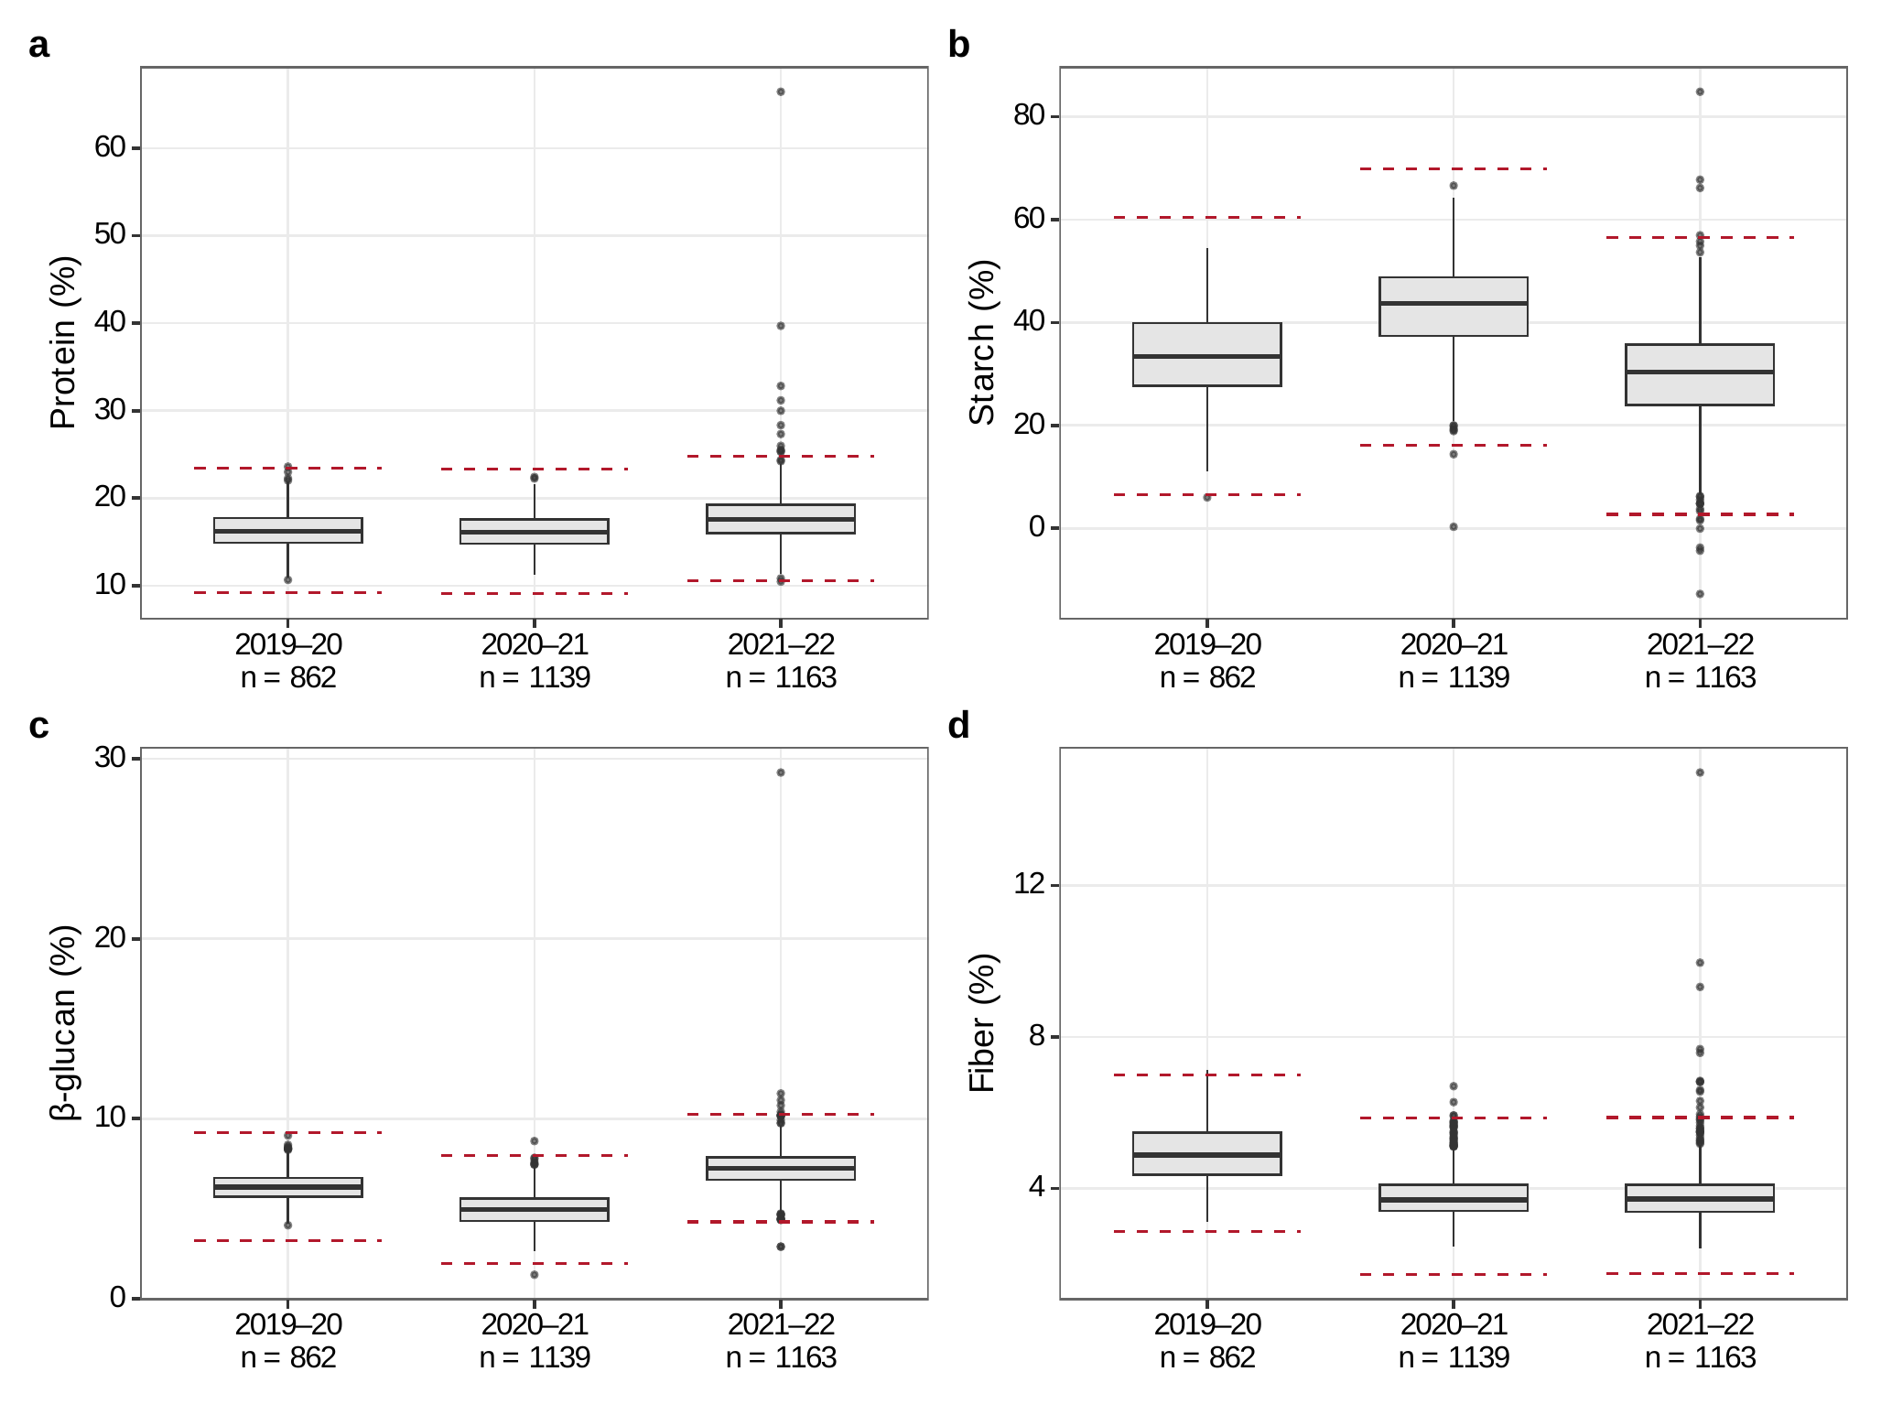
Nutritional traits by season. Raw values of the four nutritional traits (% of grain, near-infrared spectroscopy) by season: a protein, b starch, c β-glucan, d fiber. Boxes, median and interquartile range; whiskers, 1.5 × the interquartile range; points, values beyond the whiskers; n, plants. Dashed lines, the limits of the ±3 SD outlier rule

Nutritional traits by block
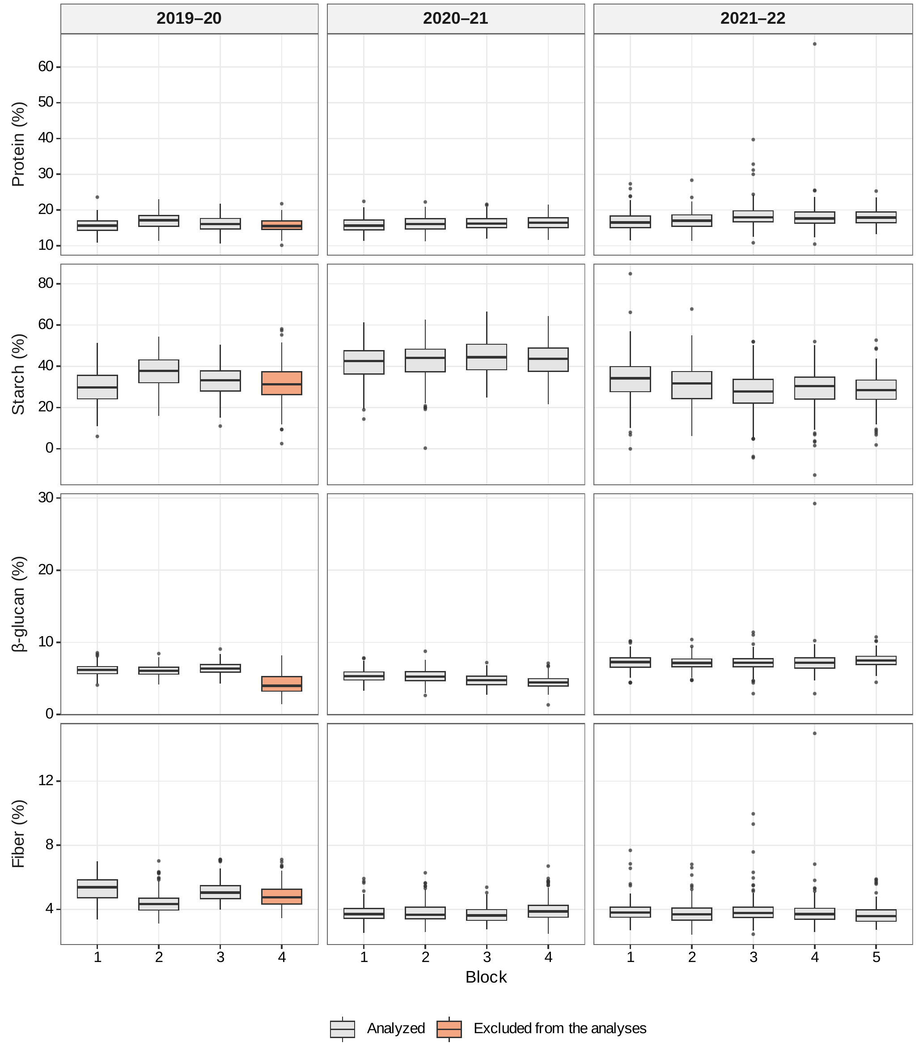
Nutritional traits by block. Raw values of the four nutritional traits by block within each season (rows, traits; columns, seasons). Block 4 of 2019–20 (shaded) was excluded from the analyses because its β-glucan values correlated poorly with those of the other blocks (figure “Correlations between blocks”). Boxes as in the figure “Nutritional traits by season”

Correlations between seasons
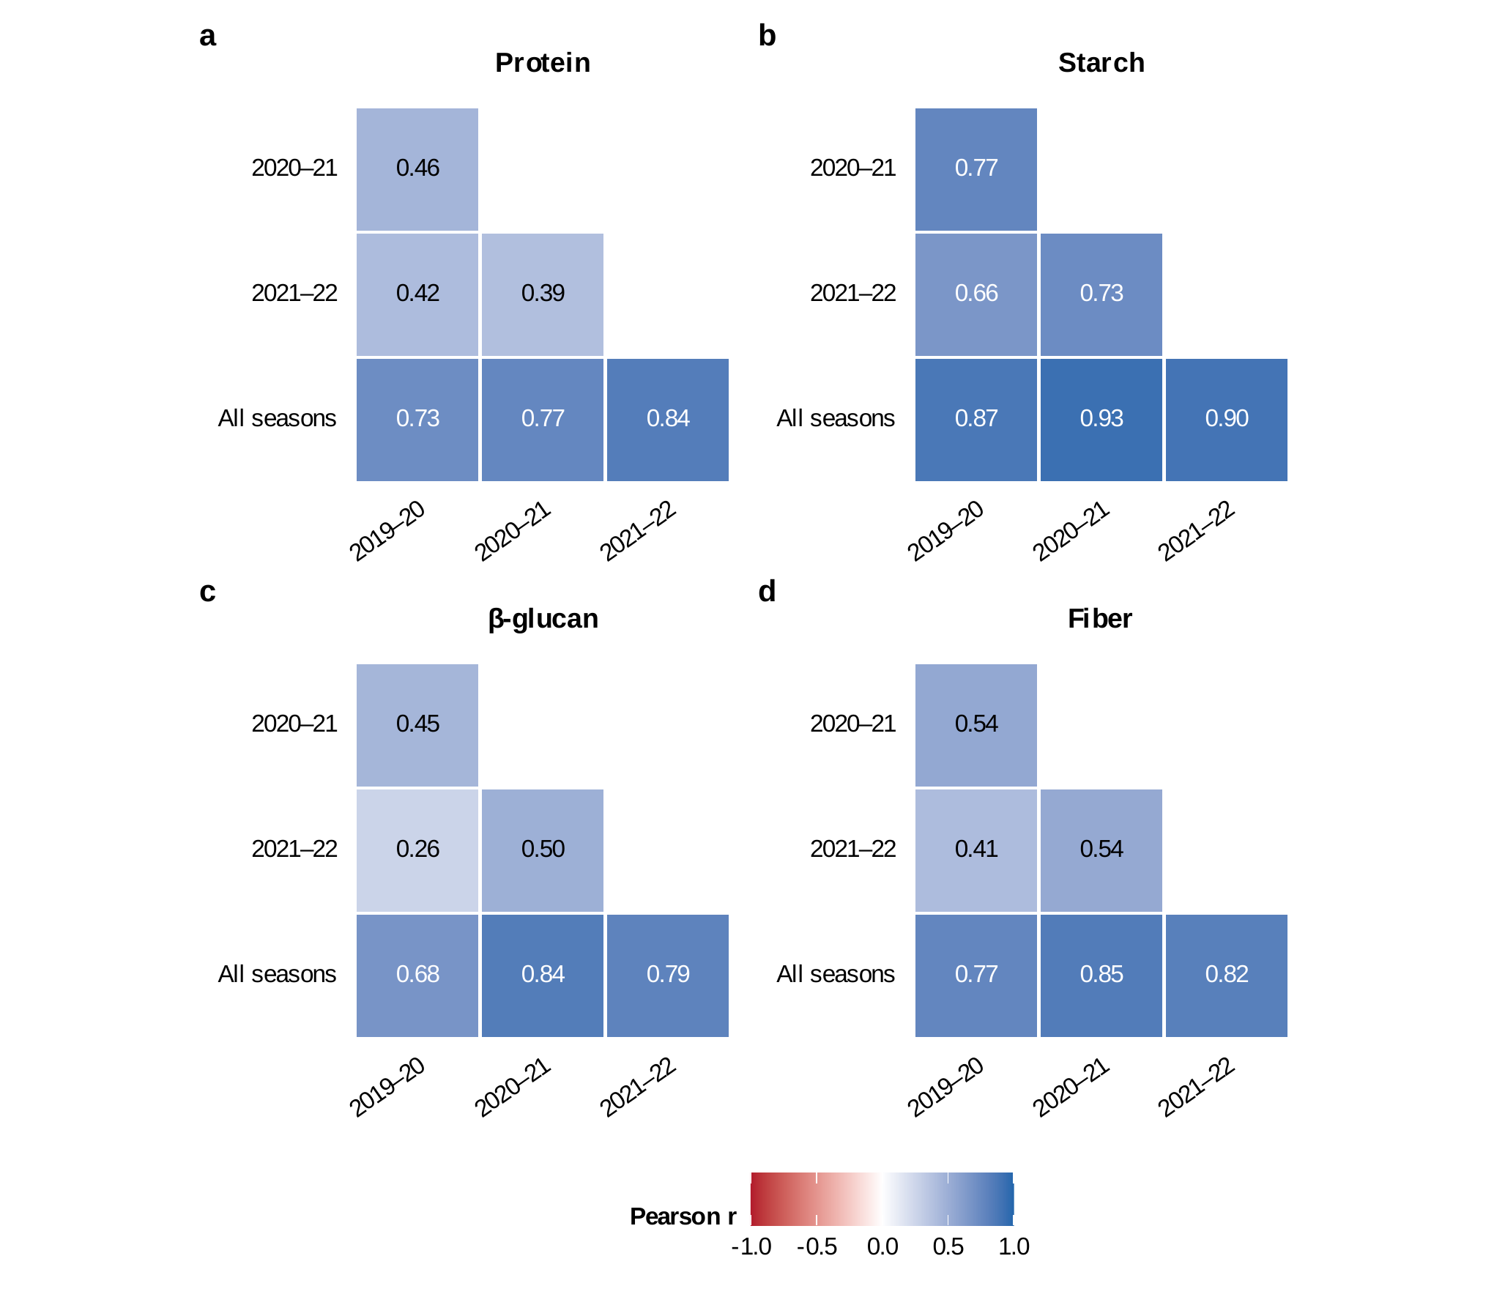
Correlations between seasons. Pearson correlations of accession means between seasons, per nutritional trait: a protein, b starch, c β-glucan, d fiber. For each season, the accession means of the raw values in that season; all seasons, the accession means of the values centered within season. Accessions with values in both members of a pair (285–290)

Correlations between traits
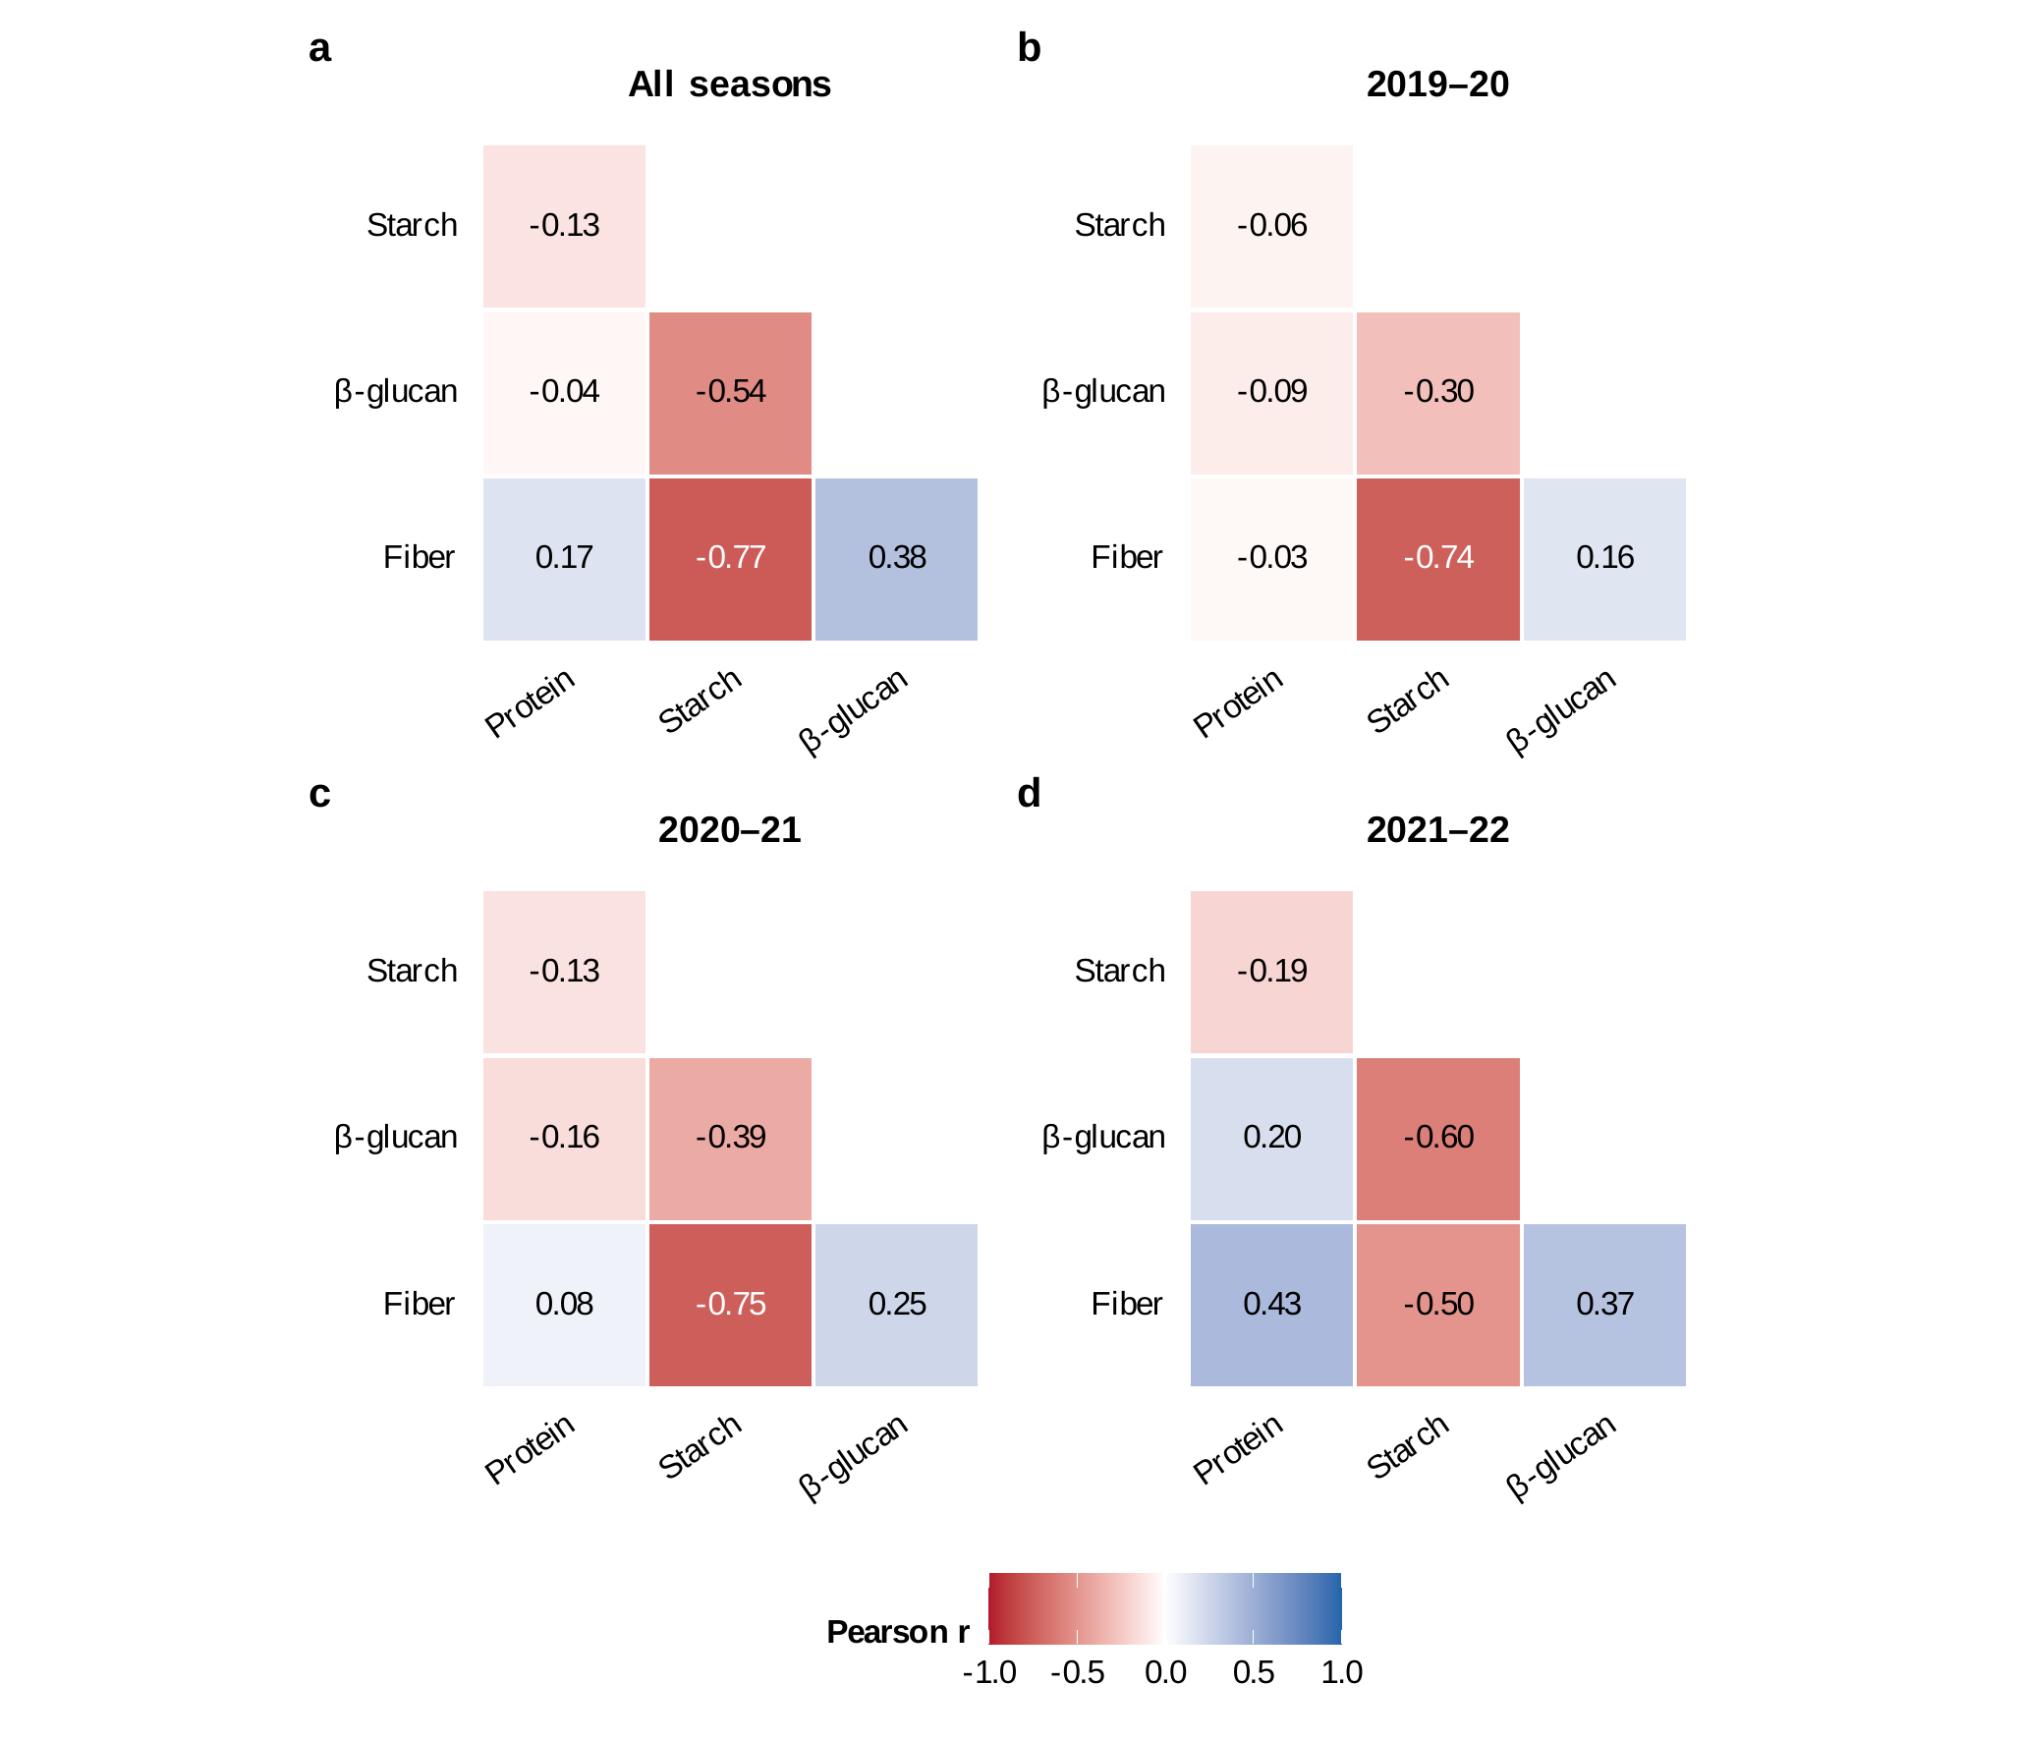
Correlations between traits. Pearson correlations between the four nutritional traits, from accession means: a over all seasons (values centered within season; 290 accessions), b–d within each season (raw values; 287–290 accessions)

Correlations between blocks
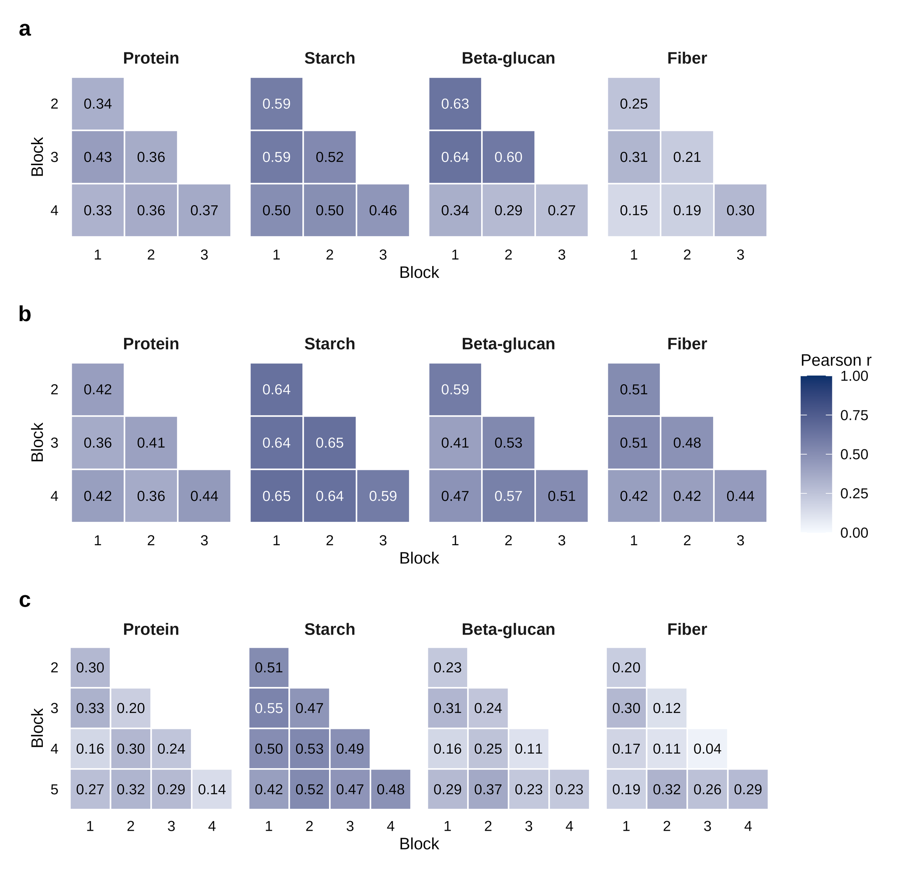
Correlations between blocks. Pearson correlations between blocks within each season for the four nutritional traits (raw values; block 4 of 2019–20 included): a 2019–20, b 2020–21, c 2021–22. Each pair of blocks over the accessions with values in both (171–288)

Distributions of raw values
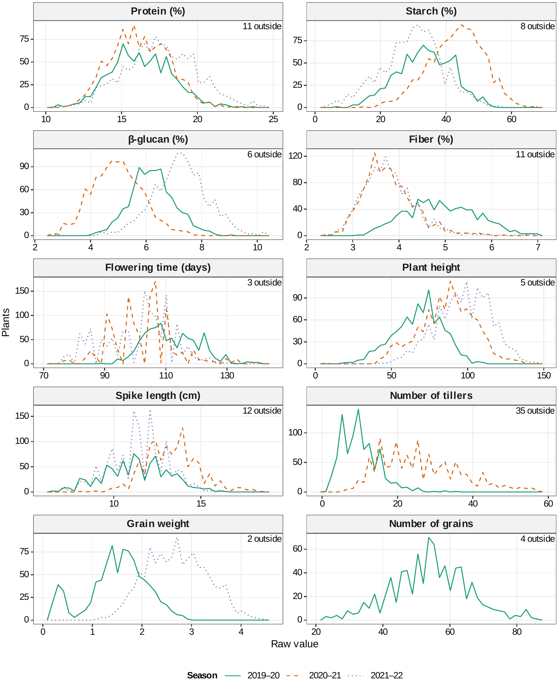
Distributions of raw values. Distributions of the raw values of the four nutritional and the six morphological and phenological traits, by season (frequency polygons, 40 bins). The x axis spans the widest ±3 SD limits of the three seasons; each panel gives the number of values outside it. Number of tillers was recorded in 2019–20 and 2020–21, grain weight in 2019–20 and 2021–22, and number of grains in 2019–20 only

Distributions of genotype BLUPs
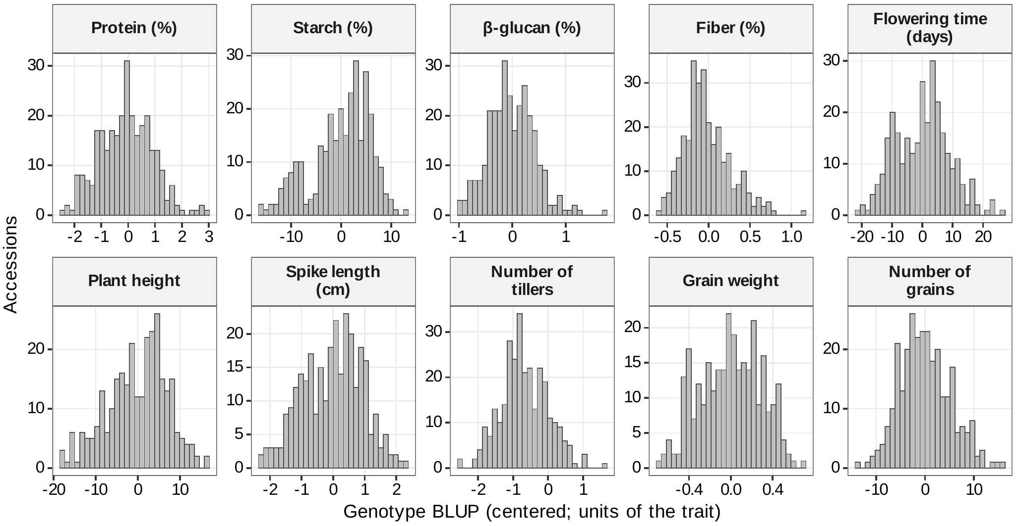
Distributions of genotype BLUPs. Distributions of the genotype BLUPs (centered; units of the trait) of the ten traits, the phenotypes of all analyses (290 accessions)

