Genome-wide association and haplotype analysis identify candidate genes for grain nutritional quality in wild barley (Hordeum spontaneum)
Theoretical and Applied Genetics
[AUTHOR NAMES]
Corresponding author: [CORRESPONDING AUTHOR], [AFFILIATION: institution, department, city, country]; e-mail: [E-MAIL]

Supplementary Figures
Supplementary Figures S1–S5 of the manuscript, numbered in the order in which they are first cited, each followed by its legend. The tables (Tables S1–S22) are in the Excel file Supplementary_Tables.xlsx.
Fig. S1 Decay of linkage disequilibrium with physical distance across the genome (a) and per chromosome (b)
Fig. S2 crosshap haplotype plots of GPAT6, GH17, PHT4;3 and the GDSL esterase/lipase gene
Fig. S3 Geographic origin of the accessions carrying the lead-SNP alleles and the haplotypes of the four candidate genes
Fig. S4 Desert enrichment of the lead-SNP alleles and the haplotypes of the four candidate genes
Fig. S5 Genotype BLUPs of the four nutritional traits across the 29 sampling sites, by ecological region

Fig. S1
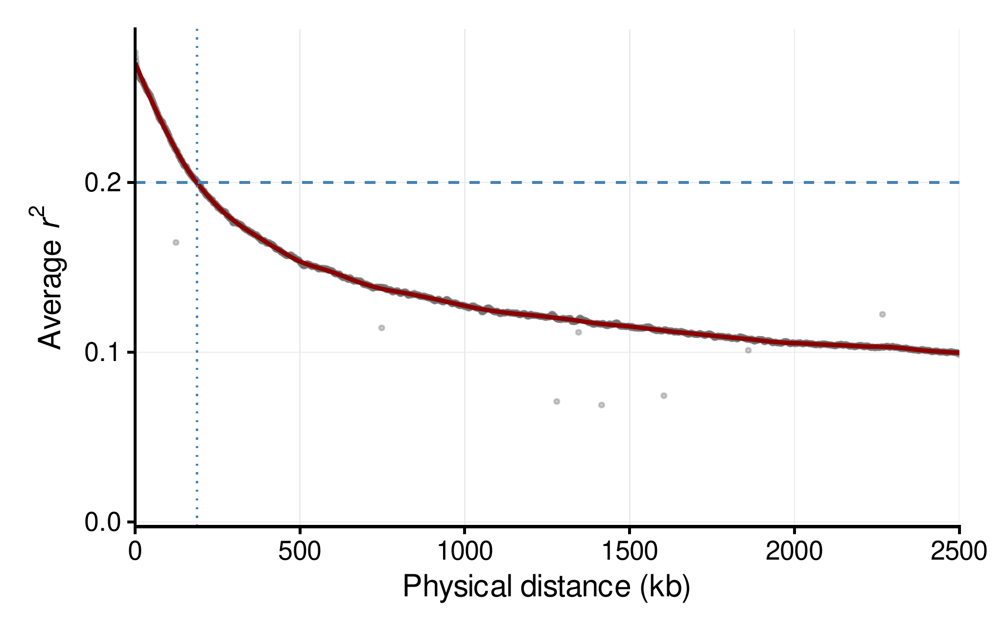
a Genome-wide LD decay
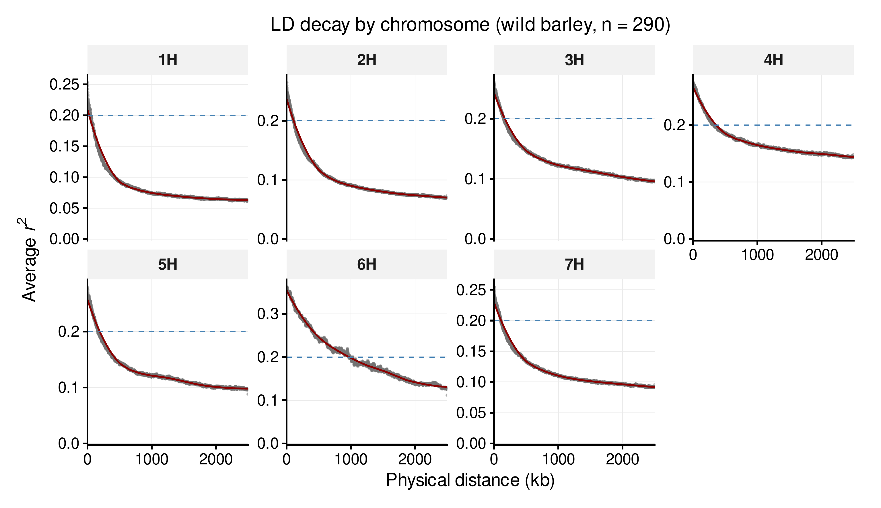
b LD decay per chromosome
Fig. S1 Decay of linkage disequilibrium (LD) with physical distance in the 290 wild barley accessions: a across the genome; b per chromosome. The r² of every pair of the 7,110,996 SNPs within 2.5 Mb (pairs with r² ≥ 0.001) was computed in PLINK v1.90, averaged in 1-kb distance bins (gray points) and smoothed with a LOESS curve (span 0.10) weighted by the number of pairs per bin (red line). Dashed line, r² = 0.2; dotted line in a, the distance at which the smoothed genome-wide r² falls to 0.2 (about 188 kb)

Fig. S2
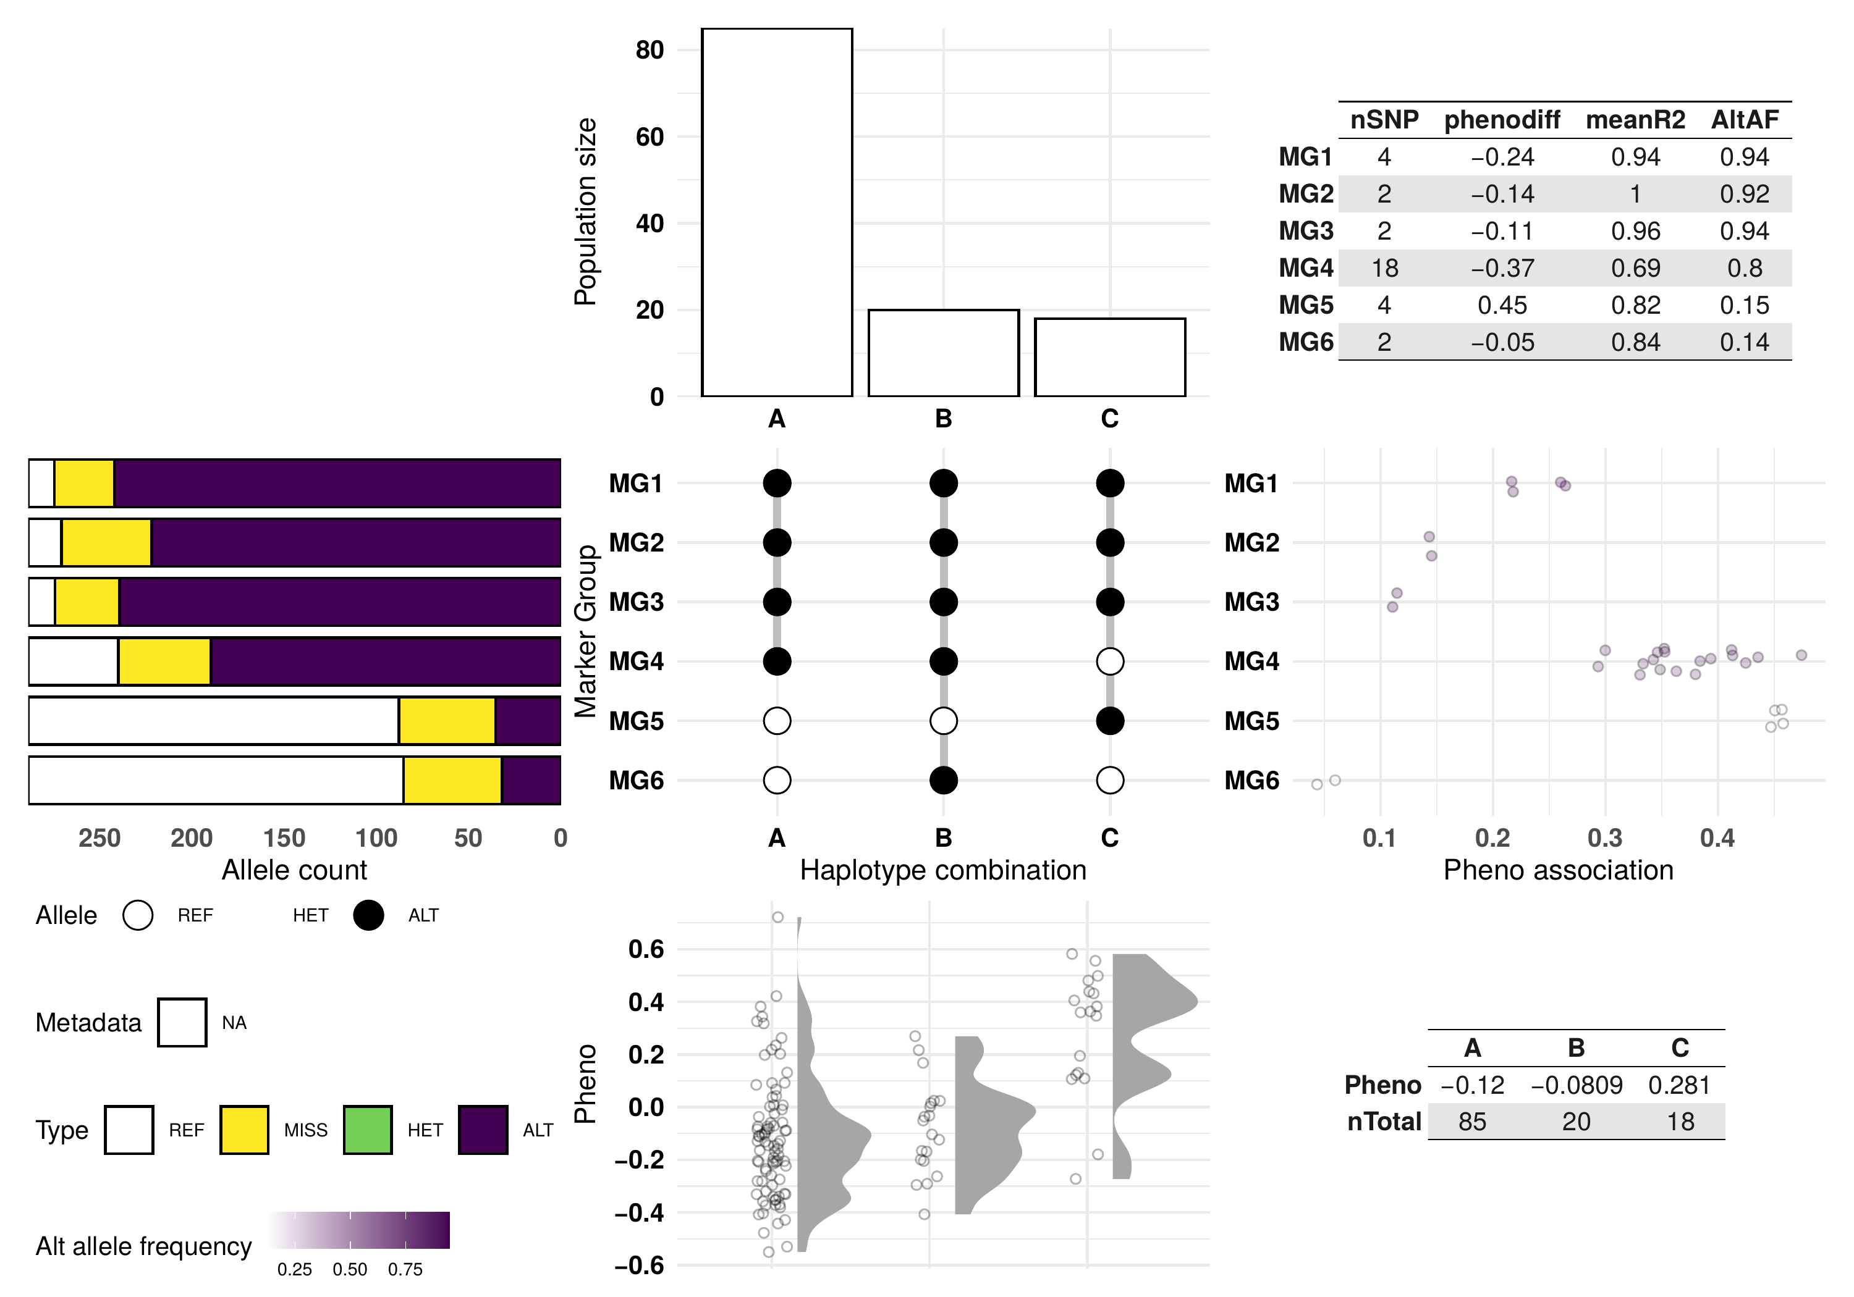
a GPAT6 (HORVU.MOREX.r3.3HG0301300), fiber; ε = 0.6, MGmin = 2
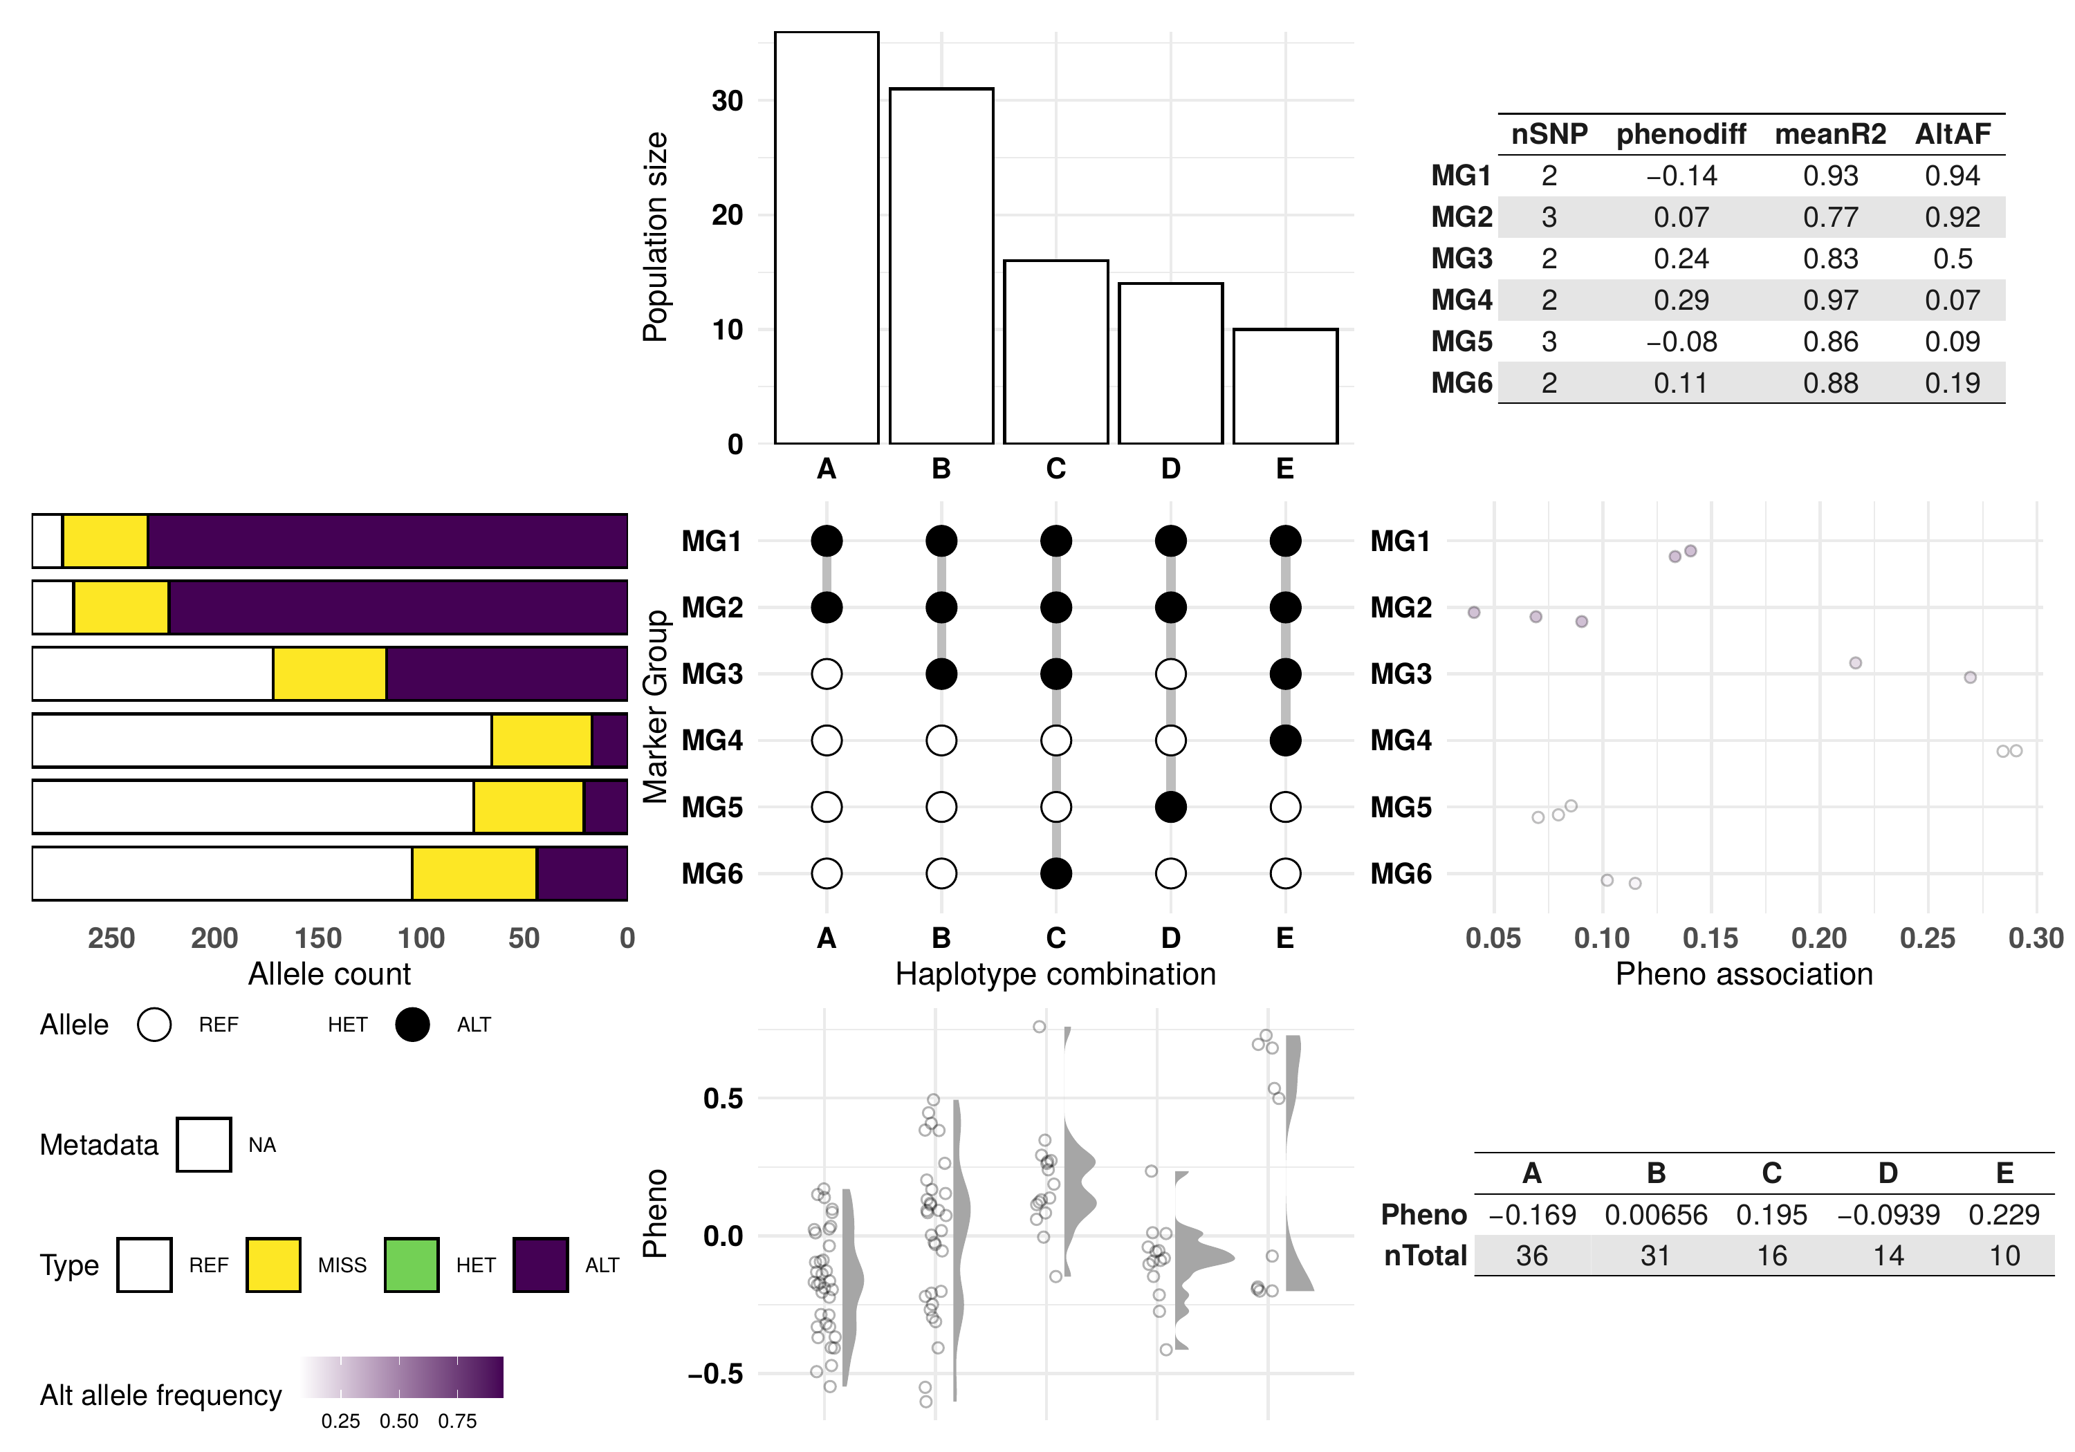
b GH17 (HORVU.MOREX.r3.5HG0487060), fiber; ε = 0.6, MGmin = 2
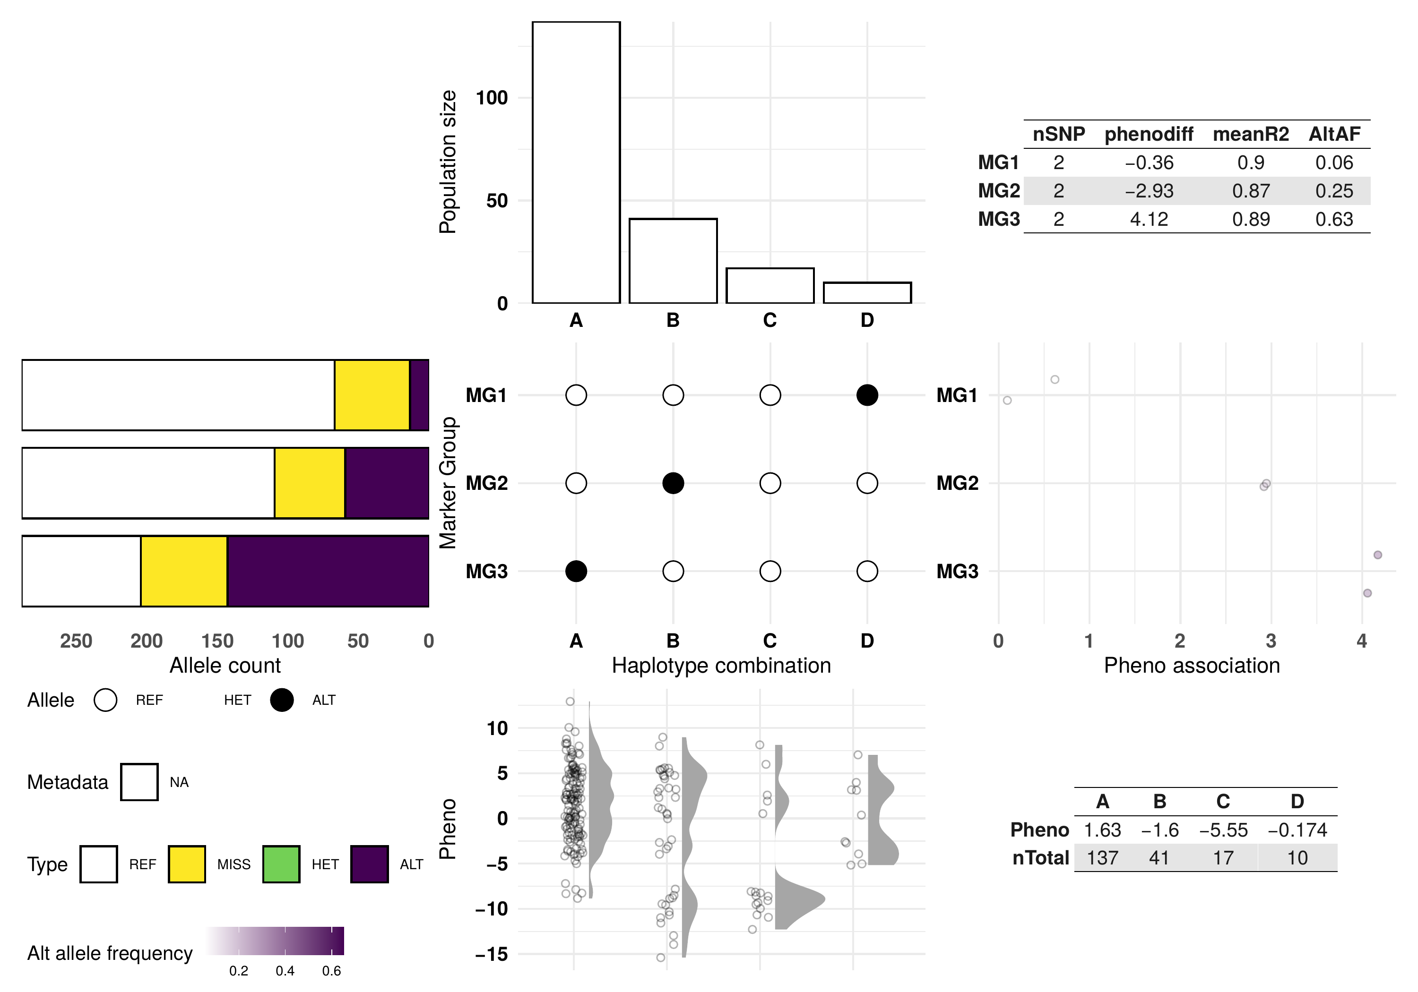
c PHT4;3 (HORVU.MOREX.r3.3HG0301710), starch; ε = 0.6, MGmin = 2
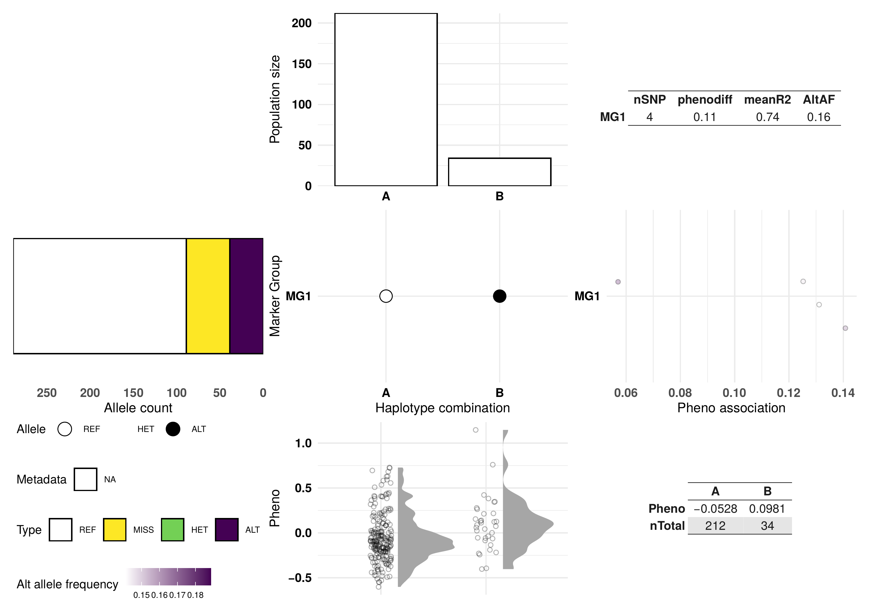
d GDSL esterase/lipase (HORVU.MOREX.r3.7HG0729030), fiber; ε = 0.9, MGmin = 3
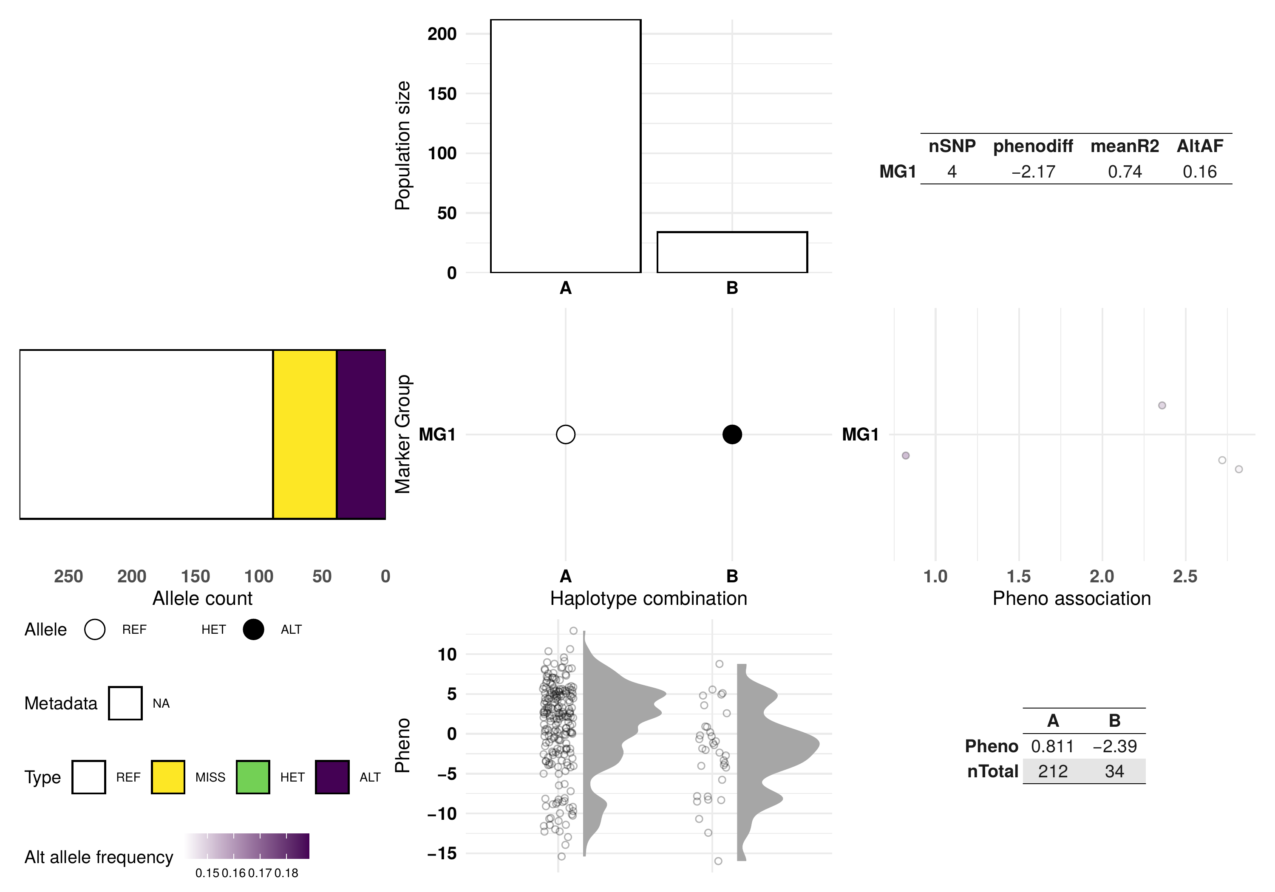
e GDSL esterase/lipase (HORVU.MOREX.r3.7HG0729030), starch; ε = 0.9, MGmin = 3
Fig. S2 Haplotypes of the four presented genes, as plotted by crosshap v1.4.0 at the settings used in the analysis (SNPs within the gene ± 1 kb): a GPAT6 (HORVU.MOREX.r3.3HG0301300), fiber; b GH17 (HORVU.MOREX.r3.5HG0487060), fiber; c PHT4;3 (HORVU.MOREX.r3.3HG0301710), starch (ε = 0.6, MGmin = 2); the GDSL esterase/lipase gene HORVU.MOREX.r3.7HG0729030, d fiber and e starch (ε = 0.9, MGmin = 3; the same haplotypes for both traits)
In each plot: top, the number of accessions in each haplotype group (A, B, …); center, the marker-group (MG) alleles that define each haplotype (open circle, reference allele; filled circle, alternate allele); left, the genotype counts of the SNPs of each marker group (reference, missing, heterozygous, alternate); right, the absolute difference in the trait between alternate- and reference-allele carriers at each SNP of the marker group (Pheno association), shaded by alternate-allele frequency; bottom, the genotype BLUPs of the trait (% of grain) in each haplotype group. Tables: for each marker group, its number of SNPs (nSNP), phenotypic difference (phenodiff), mean r² (meanR2) and alternate-allele frequency (AltAF); for each haplotype group, its mean BLUP (Pheno) and number of accessions (nTotal). Accessions not assigned to a haplotype group are not shown. The haplotype groups are those of Fig. 3; their tests are in Fig. 3 and Table S10

Fig. S3
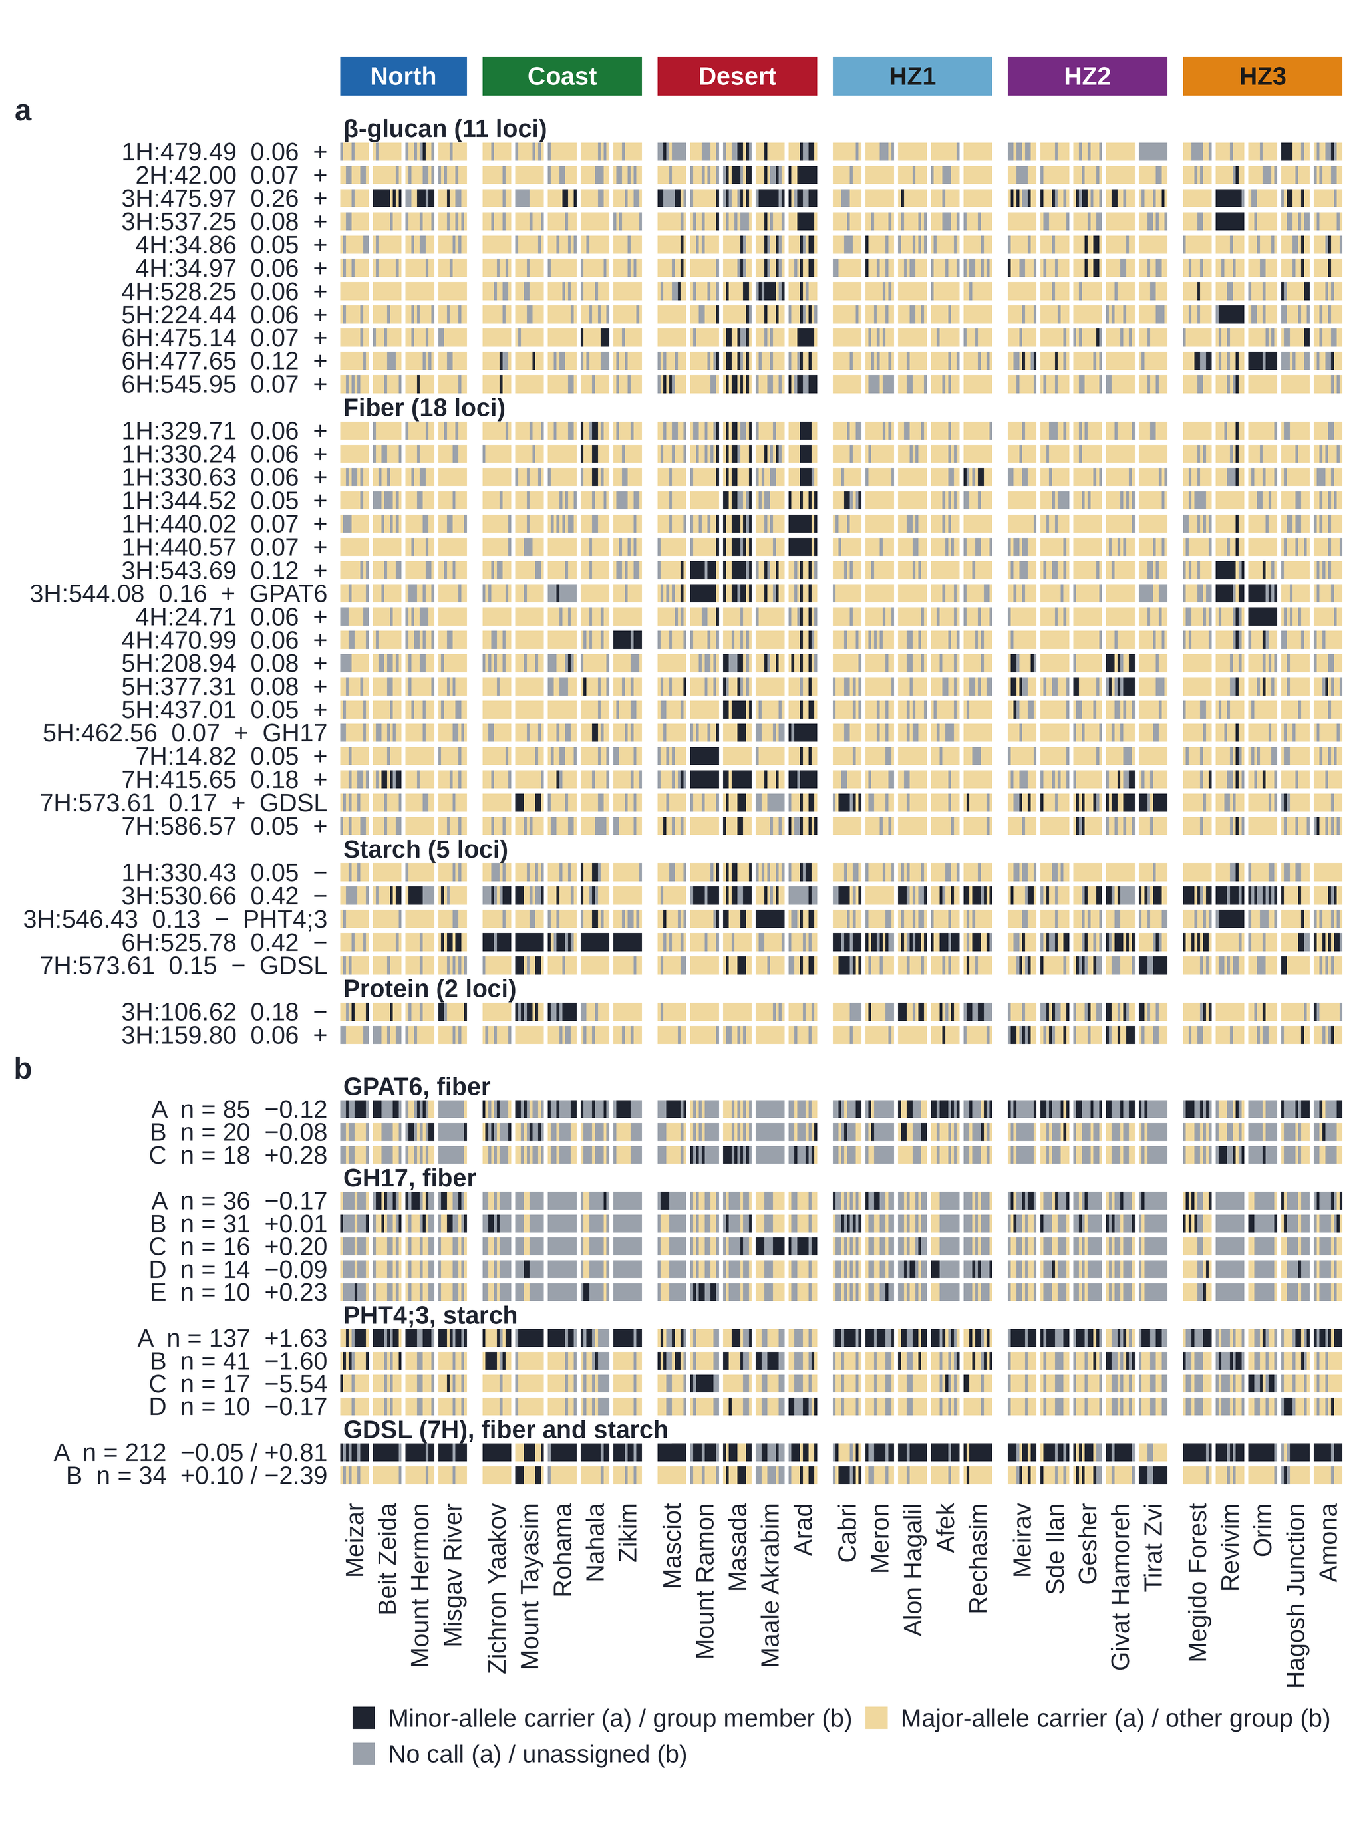
Fig. S3 Geographic origin of the accessions carrying the lead-SNP alleles and the haplotypes of the four candidate genes. a Genotype at the lead SNP of each of the 36 genome-wide significant loci, grouped by trait: minor-allele carrier (black), major-allele carrier (light tan) and missing call (gray). Each row is labeled with the chromosome and position (Mb) of the lead SNP, its minor-allele frequency, the direction of the minor allele's effect on the trait (+, increase; −, decrease) and, where one was carried forward, the candidate gene. b Haplotype groups of the four candidate genes: member of the group (black), member of another group of the same gene (light tan) and accession not assigned to a group (gray). Each row is labeled with the group, its size and its mean genotype BLUP (% of grain; fiber / starch for the GDSL esterase/lipase). Columns are the 290 H. spontaneum accessions, ordered by ecological region (HZ1, North–Coast; HZ2, North–Desert; HZ3, Coast–Desert transitional zones) and by sampling site. The tables behind the figure, and the details of the tests, are in Tables S18–S22

Fig. S4
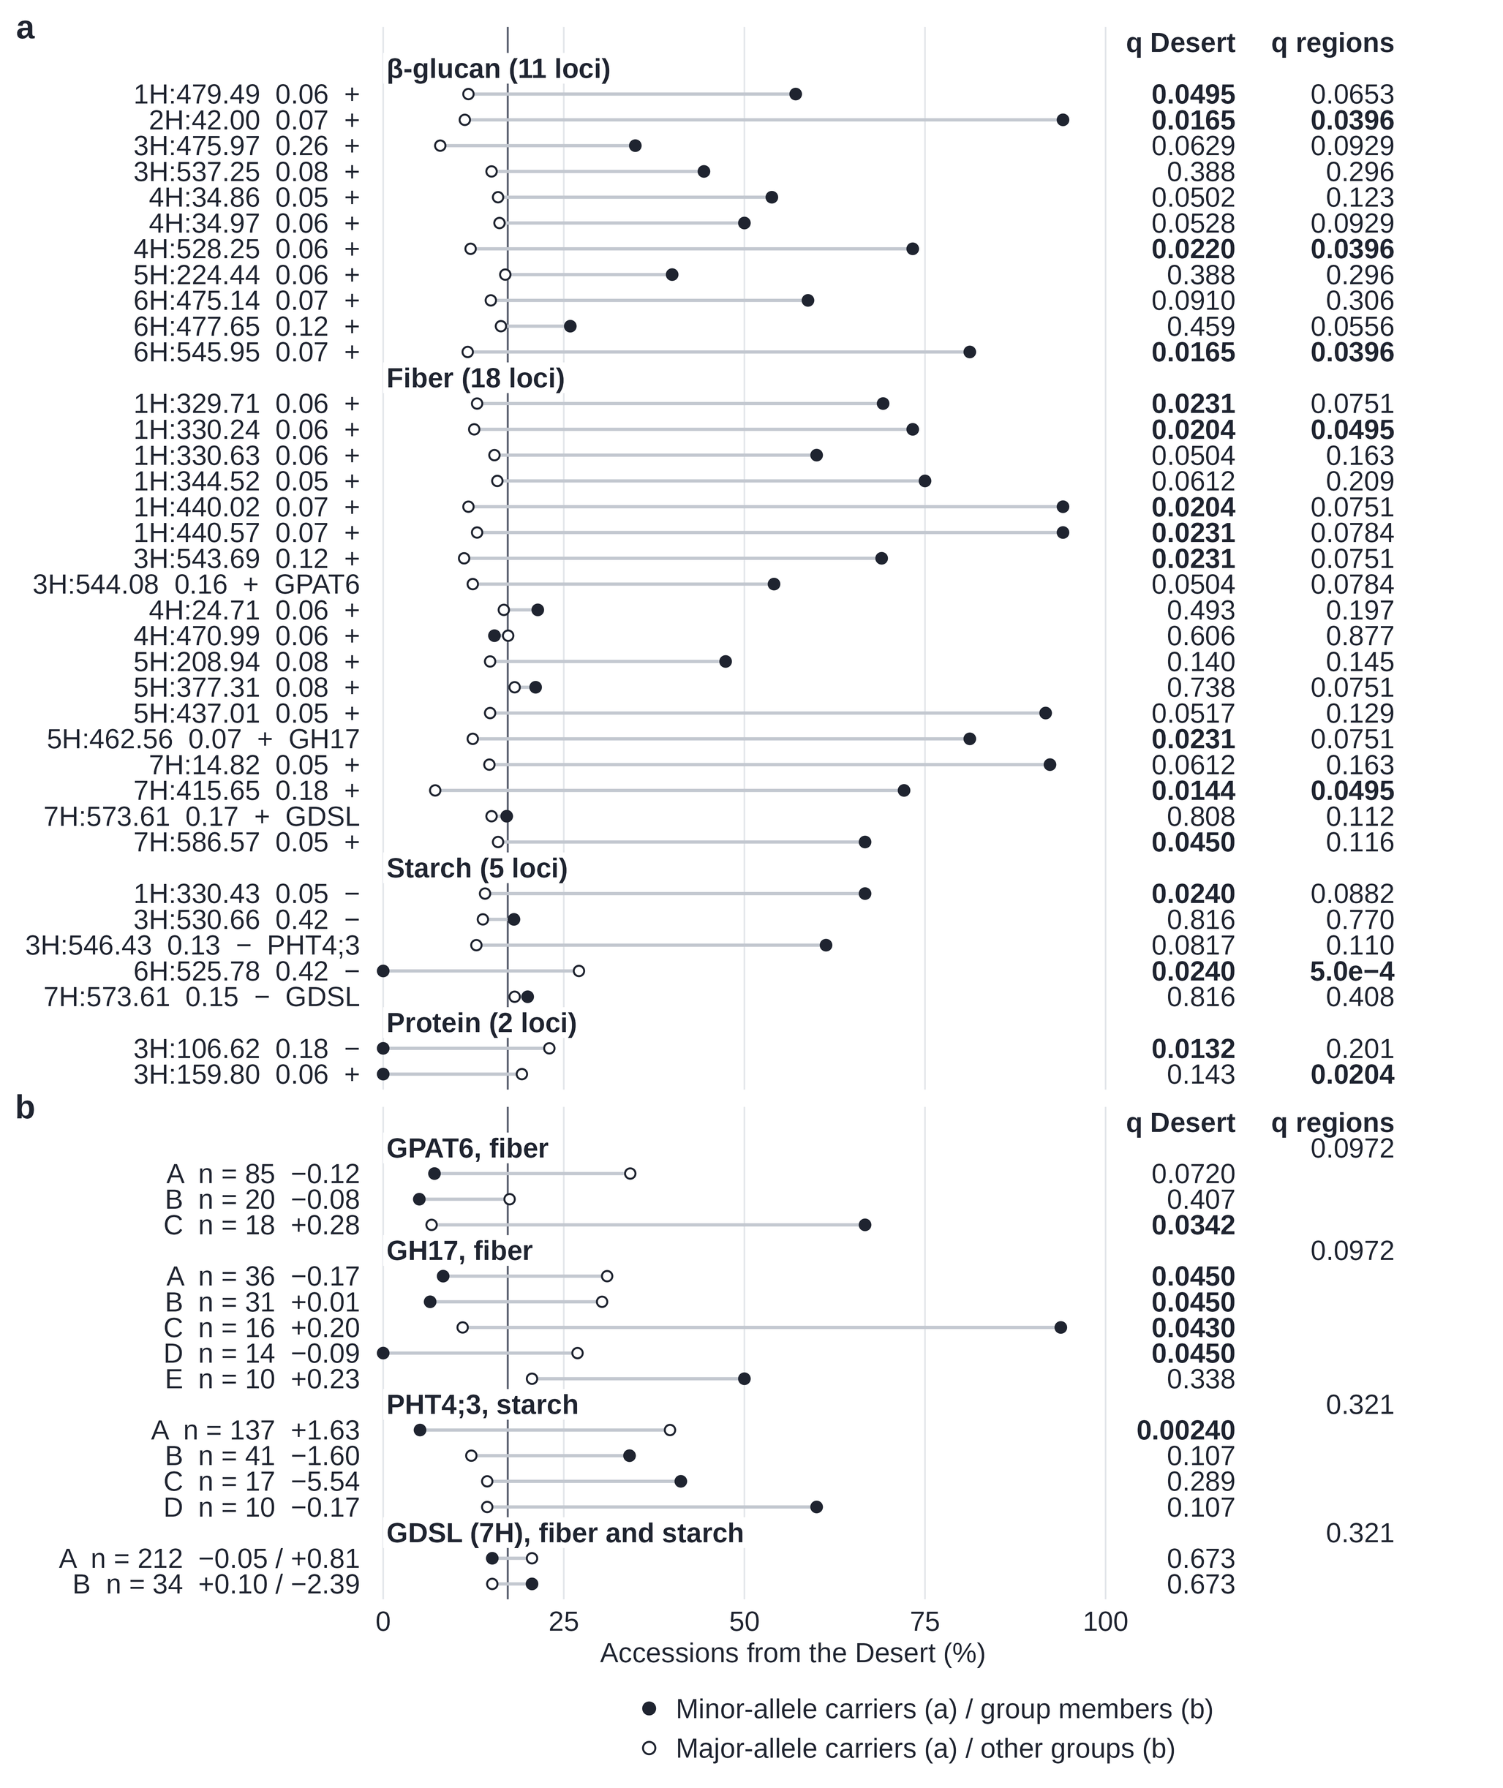
Fig. S4 Desert enrichment of the lead-SNP alleles and the haplotypes of the four candidate genes. a For each lead SNP, the percentage of minor-allele carriers (filled) and of major-allele carriers (open) that originated from desert sites. b For each haplotype group, the percentage of its members (filled) and of the members of the other groups of the same gene (open) that originated from desert sites. The vertical line marks the desert share of the panel (50 of 290 accessions). Right, Benjamini–Hochberg q of two site-permutation tests: Desert, difference in the desert share between the two sets (two-sided); regions, difference in their distribution across the six ecological regions (in b, one test per gene comparing all its groups, shown on the gene row). q was computed within trait in a, within gene for the Desert test in b, and across the four genes for the regions test in b; q ≤ 0.05 in bold. Row labels as in Fig. S3. The tables behind the figure, and the details of the tests, are in Tables S18–S22

Fig. S5
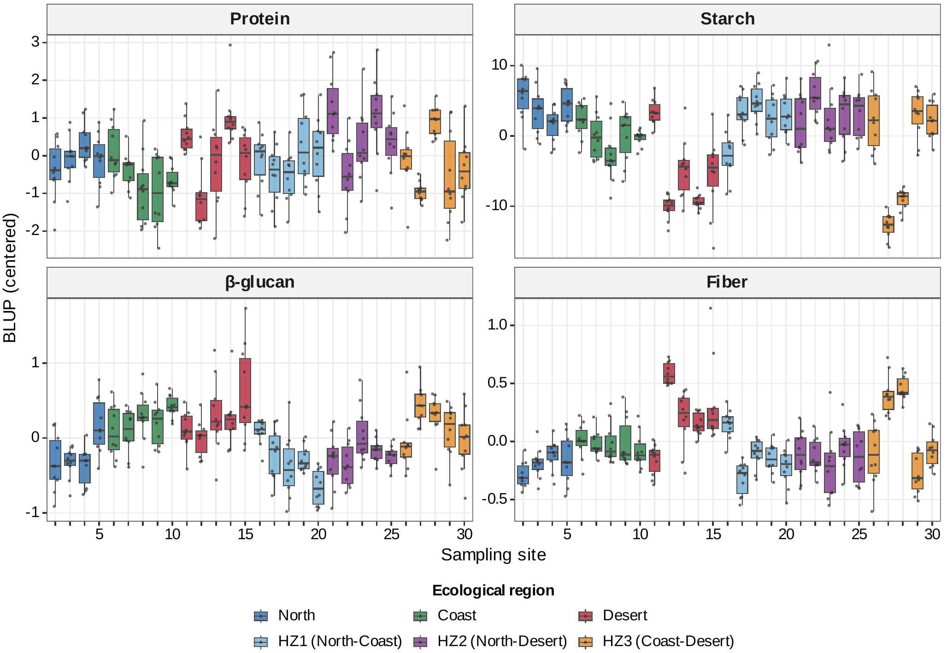
Fig. S5 Genotype BLUPs of the four nutritional traits (centered; % of grain) of the 290 accessions across the 29 sampling sites, ordered and colored by ecological region (HZ1, HZ2 and HZ3, the North–Coast, North–Desert and Coast–Desert intermediate zones). Boxes, median and interquartile range; whiskers, 1.5 × the interquartile range; points, accessions (ten per site). Sites are numbered as in Table S1 (every fifth site labeled; site 4 was not analyzed)

