Results

Characterization of wild barley grain nutritional value traits
The four nutritional traits were quantified in 290 H. spontaneum accessions across three growing seasons, and for each trait genotype BLUPs were used to estimate accession-level genotypic values while accounting for season and block effects. Partitioning the phenotypic variance into genetic, season-and-block, genotype-by-season (G×E), and residual components (Figure 1A) showed that starch had the highest broad-sense heritability (H² = 0.474; Table 1), roughly twice as all other traits. The genotype-by-season interaction was small to moderate for all four traits (4.5% - 15.2%), where β-glucan combined the largest G×E component (15.2%) with the smallest genetic fraction indicating a strong genotype-specific response across the three growing seasons. Among morphological traits flowering time (H² = 0.747) had the highest heritability and tiller number the lowest (H² = 0.031) indicating the respective genetic control for these traits. To further explore these trends, reaction norms were generated per genotype across seasons (Figure 1B). Overall, results were consistent with the heritability with substantial variation between specific genotypes indicating that the genotype X environment signature is notable for all traits.
Trait | H²
Starch | 0.474
Fiber | 0.248
Protein | 0.242
β-glucan | 0.234
Flowering time | 0.747
Spike length | 0.344
Grain weight | 0.223
Tillers | 0.031
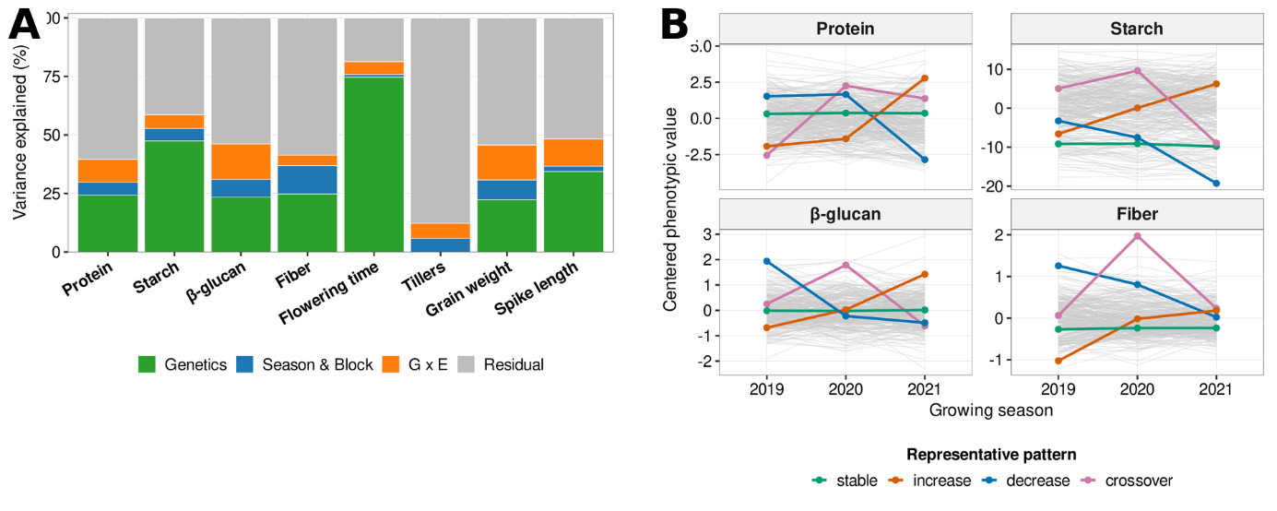
Table 1. Broad-sense heritability (H²) of grain nutritional and morphological traits, estimated from the genotype × environment model as the genetic fraction of total phenotypic variance, for the four nutritional and four morphological traits, ordered by decreasing H².
Figure 1. Genetic architecture of grain nutritional and reference traits. (A) Variance partitioning for four nutritional and four morphological traits into genetic, season + block, genotype × environment, and residual components. (B) Per-genotype reaction norms across the three seasons for the four nutritional traits; grey lines, all accessions; colored lines, four representative trajectories.
To examine whether variation in grain nutritional traits followed the environmental gradient of the collection sites, trait BLUPs were first visualized across the 29 sites ordered by ecological region (Figure 2A). This descriptive pattern suggested that northern-derived genotypes generally had higher starch, whereas desert-derived genotypes tended to have lower starch and higher fiber and β-glucan; protein showed no clear directional trend. Among the nutritional traits, starch was strongly negatively correlated with fiber (r = −0.78; Figure 2B) and β-glucan (r = −0.53), while fiber and β-glucan were positively correlated (r = 0.35; all P < 0.001). Thus, genotypes with higher starch tended to have lower fiber and β-glucan. Protein was poorly correlated with other traits, and significant negative correlation was obtained only for protein-starch (r = -0.12, P < 0.05). Among the morphological and phenological traits, starch was strongly correlated with grain weight, plant height, and flowering time, while fiber showed the exact opposite pattern. Protein was also weakly negatively correlated with grain weight (r = −0.13, P < 0.05). Overall, β-glucan and protein displayed weaker, mostly negative correlations, linking grain composition directly to whole-plant resource allocation and phenology (Figure 2C). To identify which environmental variables of the sites of origin were associated with each trait, site-mean nutritional-trait BLUPs were correlated with eight environmental variables (Figure 2D). Starch was positively correlated with clay, precipitation, and organic carbon, and negatively correlated with sand and pH. Fiber showed the opposite pattern for clay, sand, and precipitation, while β-glucan was positively correlated with sand and electrical conductivity and negatively correlated with clay, precipitation, and organic carbon. Protein was not significantly correlated with any of the measured environmental variables. Together, these associations linked the contrasting patterns of starch versus fiber and β-glucan to gradients in soil texture and precipitation, consistent with the broader geographic pattern observed across the collection sites.

Identification of nutritional QTLs and candidate genes
To identify the genomic regions that are associated with nutritional traits, we used the calculated BLUPs as the phenotypic input in the model, the first three principal components as fixed covariates to correct for population structure, and a kinship matrix as random effect to correct for relatedness (Figure 3B). The genomic inflation factor was calculated for each model indicating adequate control of genome-wide false positive inflation (λ_{GC} > 0.9; Figure 3A).
Twenty-four SNPs (15 significant, 9 marginal) resolved into 20 independent QTLs. Interestingly, highly heritable starch (H² = 0.474) yielded no significant signals, while mildly heritable β-glucan (H² = 0.234) proved most mappable, spanning 11 loci. These included the strongest peak on chromosome 2H (2H:41,996,626) and cluster collapsing four significant SNPs on chromosome 4H (4H:34,825,152 - 34,971,609). Fiber was
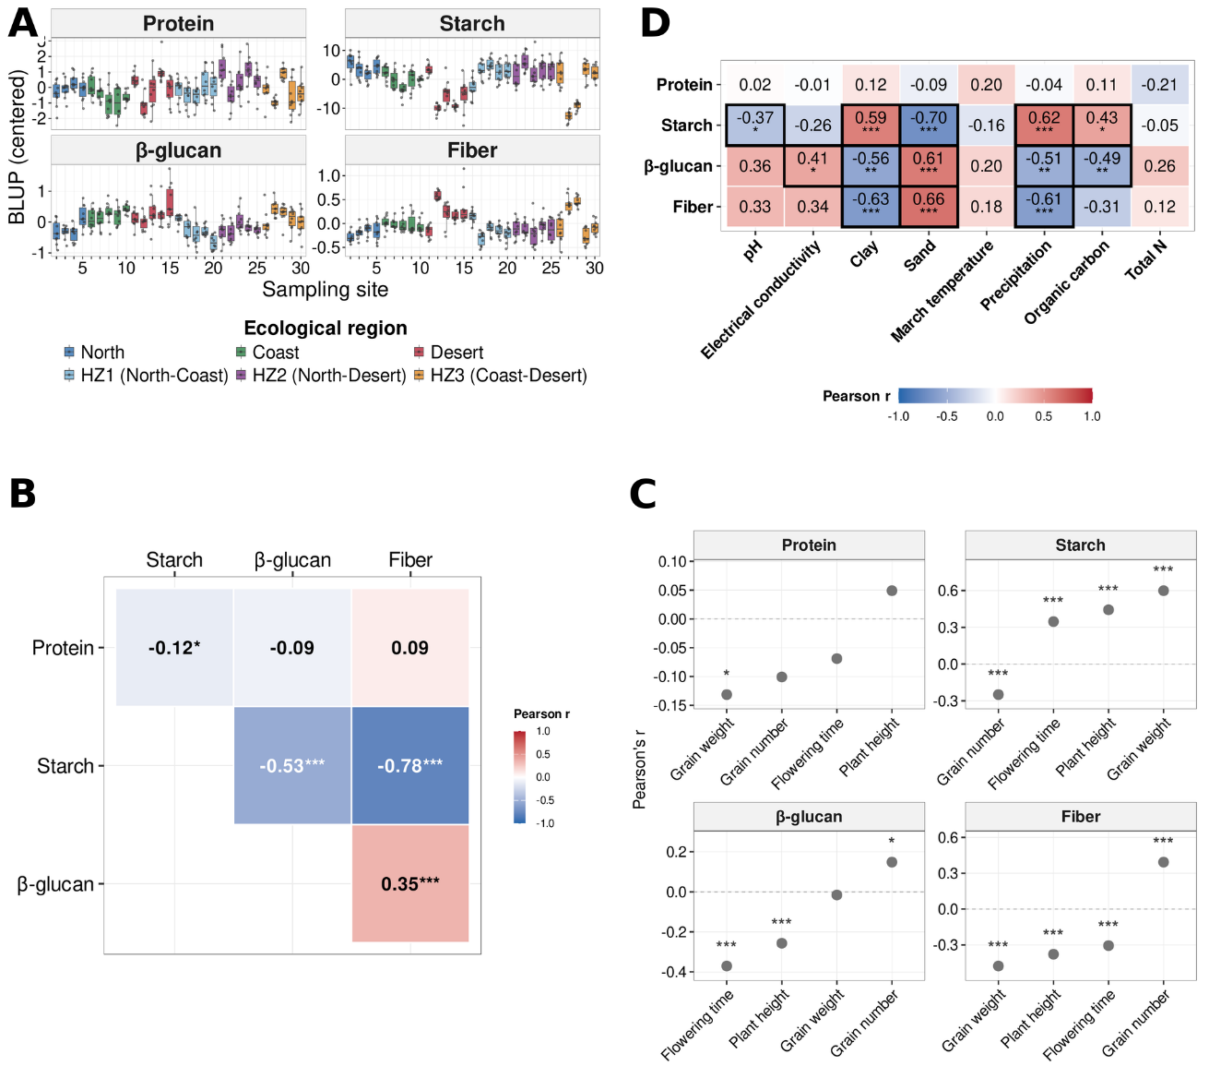
Figure 2. Ecological architecture of grain nutritional traits. (A) Centered trait BLUPs of the four nutritional traits across 29 sampling sites, ordered and coloured by ecological region. (B) Pearson correlations among nutritional-trait BLUPs. (C) Pearson correlations between nutritional- and morphological-trait BLUPs. (D) Pearson correlations between site-mean nutritional-trait BLUPs and eight environmental variables; cells outlined in black are significant at P < 0.05. Significance (B–D): *P < 0.05, **P < 0.01, ***P < 0.001.

associated with four QTLs (1H:344,520,079; 4H:24,707,376; 7H:14,817,657; 7H:573,606,306), whereas protein yielded a single locus on chromosome 3H (3H:106,623,911), and starch produced four marginal loci (3H:546,433,616; 6H:525,776,080; 7H:151,110,354; 7H:573,606,460). Notably, on the distal arm of chromosome 7H, the significant fiber SNP (chr7H:573,606,306) and a marginal starch SNP (Chr7H:573,606,460) co-localized within 154 bp, defining a nine-gene window consistent with shared or linked genetic control driving the negative starch–fiber relationship (Figure 3).
To search for potential candidate genes within the identified QTLs, a region of 200Kb was defined up and downstream of significant SNPs in accordance with the profile of LD decay (r² < 0.2; Figure 3C). Overall 108 candidate genes were identified within the 20 loci: 72 for β-glucan, 18 for fiber, 17 for starch, and one for protein.
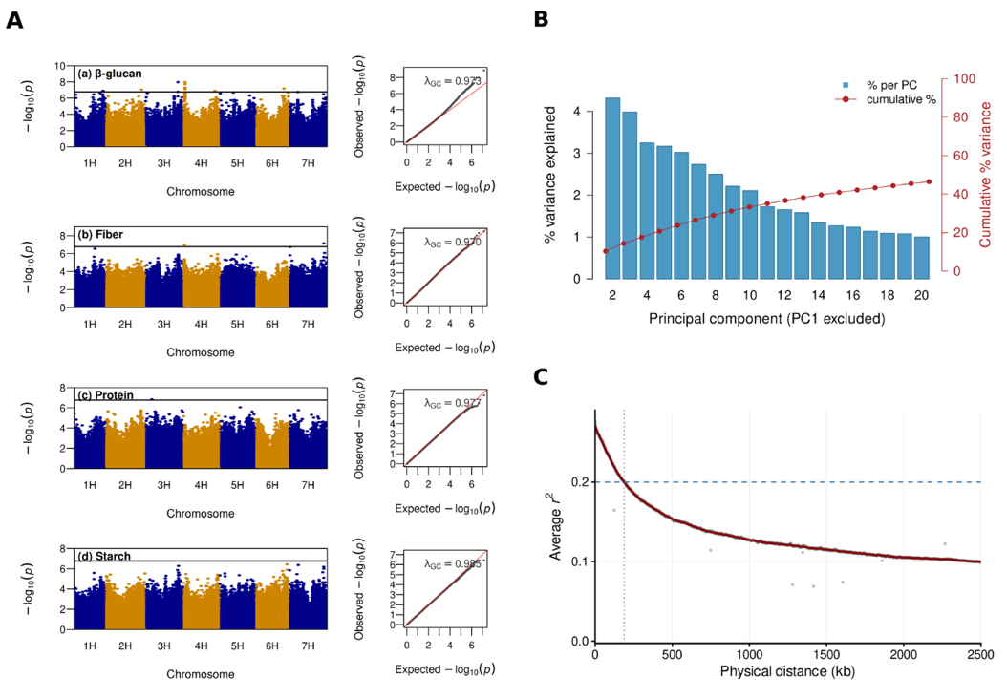
Figure 3. Association mapping, structure correction, and LD diagnostics. (A) Manhattan (left) and QQ (right) plots for the four traits (290 accessions; 7,110,996 SNPs); the line marks the Bonferroni threshold (−log₁₀P = 6.7712), λ_{GC} the genomic inflation factor. (B) PC scree plot (PC1 omitted); bars, % genomic variance per component; line, cumulative %. (C) Genome-wide LD decay (1H–7H); grey points, mean r² in 1-kb bins (0–2.5 Mb); red curve, LOESS fit; dashed line, r² = 0.2, crossed at ~188 kb.

Haplotype analysis of candidate genes for grain nutritional traits
Candidate genes were further evaluated by haplotype analysis to identify phenotypic divergence between accession carrying contrasting alleles across haplotype groups. Gene-level haplotype analysis tested whether variation across each gene was associated with the corresponding trait and quantified the direction and magnitude of differences among haplotype groups, information not provided by the single-SNP tests. We retained 45 of the 108 candidates genes for biological screening where significant phenotypic difference was observed between contrasting alleles (FDR < 0.05). The 45 genes were functionally annotated and a final biological-relevance screen kept only genes with a documented or plausible role in the biosynthesis, transport, or regulation of the corresponding grain component. This process narrowed the genome-wide signal of the four nutritional traits to five biologically plausible candidate genes (Figure 4). The fifth, a 2H pectin methylesterase associated with β-glucan showed only a small haplotype effect and is therefore not presented as a separate panel. Within this shared 7H window, three genes passed the trait-wise FDR filter for both starch and fiber: a probable high-affinity nitrate transporter (7HG0729020), a pentatricopeptide-repeat protein (7HG0729090), and a chloroplastic NifU-like protein (7HG0729100). For each gene, the starch and fiber analyses yielded identical genotype-defined haplotype assignments, and in all three cases the haplotype group with the highest mean fiber had the lowest mean starch. This reciprocal pattern provides locus-level support for shared or tightly linked genetic control of the starch–fiber relationship.
The two starch candidates lie within a single locus on the long arm of 3H (3H:546,433,616), the α-glucan phosphorylase Pho (3HG0301750) resolved into three haplotype groups that differed strongly in grain starch (Kruskal-Wallis P = 6.8 × 10⁻⁹; ε² = 0.18), with one small group carrying distinctly lower starch than the two larger groups. Pho encodes a plastidial α-1,4-glucan phosphorylase that reversibly transfers glucosyl units between glucose-1-phosphate and α-1,4-glucan chains. In developing barley endosperm, HvPho1 is active from the onset of grain development and can generate linear glucans proposed to serve as primers for amylopectin and starch biosynthesis (Cuesta-Seijo et al., 2017). The phosphate/anion transporter PHT (3HG0301710) resolved into four groups and showed the strongest haplotype separation among the genes examined (P = 1.7 × 10⁻¹⁰; ε² = 0.23), with additive effect between haplotypes. PHT4 transporters mediate inorganic-phosphate transport across plastid membranes and maintain plastid phosphate homeostasis, which is closely coupled to carbon partitioning and starch synthesis. Consistent with this role, disruption of the related plastidial transporter PHT4;2 markedly reduces starch accumulation, providing a functional link between PHT4-mediated phosphate transport and starch content (Guo et al., 2008; Irigoyen et al., 2011). Although the shared lead SNP was only marginal at the genome-wide level, the gene-level Kruskal–Wallis associations for both candidates remained significant after trait-wise Bonferroni correction across the tested starch genes.
For the β-glucan and fiber candidates smaller haplotype effects were noticed. Their gene-level associations remained significant across the tested genes. The β-glucan candidate, the AP2/ERF transcription factor (3HG0299440) resolved into two haplotype groups that differed modestly in grain β-glucan (Kruskal–Wallis P = 7.8 × 10⁻³; ε² = 0.03), with the smaller group showing higher β-glucan values than the larger group. AP2/ERF-binding motifs are over-represented in the proximal promoter of HvCslF6, a key synthase of grain mixed-linkage β-glucan, linking this candidate to the transcriptional regulation of β-glucan accumulation (Garcia-Gimenez et al., 2022). The fiber candidate, the BAHD acyltransferase (7HG0642350) resolved into five haplotype groups with a similarly modest separation in grain fiber (P = 4.0 × 10⁻³; ε² = 0.06); among the post-hoc comparisons against the largest haplotype group (A), only the A-versus-B contrast was significant, with group A showing higher fiber values than group B (Holm-adjusted P = 0.040). BAHD acyltransferases modify grass cell walls by transferring hydroxycinnamoyl groups to arabinoxylan, a major fiber polysaccharide, thereby affecting wall structure and digestibility. Experimental suppression of a BAHD acyltransferase reduced arabinoxylan-bound p-coumarate and increased cell-wall digestibility, linking this enzyme family to fiber architecture (Mota et al., 2021).
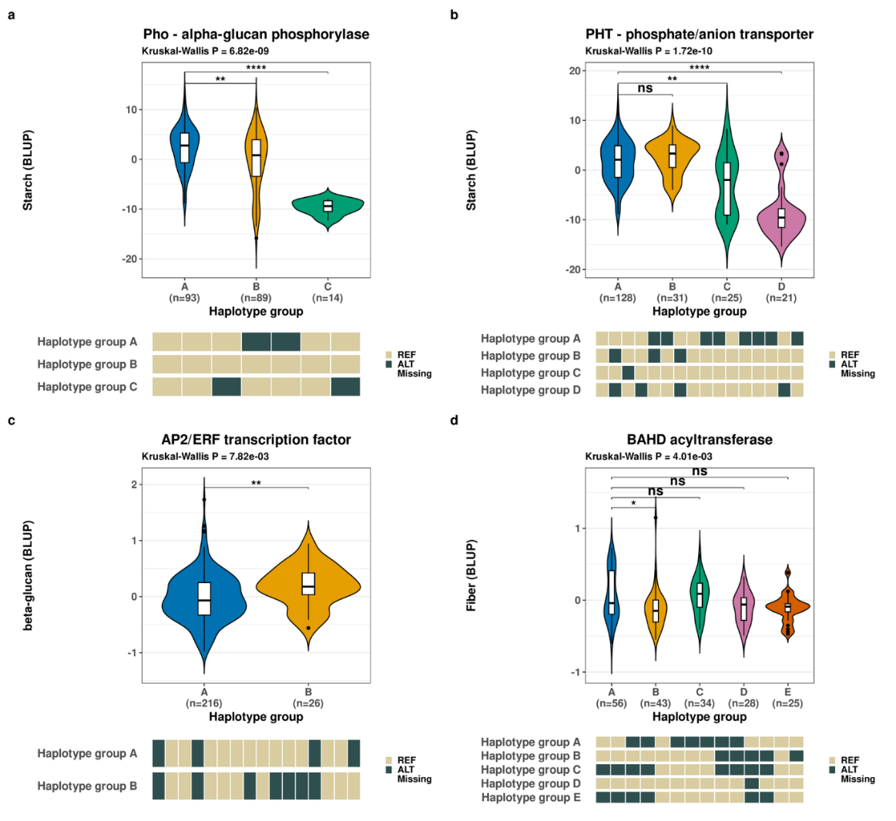
Figure 4. Haplotype structure of the four final candidate genes. Violin/boxplots show trait-BLUP distributions by haplotype group, with genotype strips below: (a) Pho and (b) PHT for starch, (c) AP2/ERF for β-glucan, and (d) BAHD for fiber. The omnibus Kruskal–Wallis P value is shown above each panel. Brackets indicate post-hoc Wilcoxon comparisons of each haplotype group against the largest group, with P values adjusted by Holm independently of the within-gene Holm correction used to select the representative crosshap solution (* P ≤ 0.05, ** P ≤ 0.01, *** P ≤ 0.001, **** P ≤ 10⁻⁴; ns, not significant).

