Assignment 1 – From Q-learning to Deep Q-learning
Submitted by (IDs): 208524413, 208388918

Section 1
- The main problem is that Value Iteration is a model-based dynamic programming algorithm. Its core update step relies on the Bellman optimality equation: $V_{\left\{k+1\right\}}\left(s\right) ← max_{a} \sum_{s'}{(s' | s, a)}[R(s, a, s') +γV_{k}(s')]$. This update explicitly requires full knowledge of the environment's dynamics, specifically the state transition probability function $P(s' | s, a)$ and the reward function $R(s, a, s')$. In a model-free setting, these functions are unknown. The agent cannot compute the expectation (the summation over $s'$) because it doesn't know the probability of landing in any next state $s'$ from a given state-action pair $(s,a)$.
- Model-free methods resolve this problem by replacing Value Iteration's explicit expectation calculation with experience sampling. Instead of requiring the full transition model $P(s'|s, a)$ to compute the weighted sum $Σ_{s^{'}}P\left(…\right)⋅V(s')$, the agent interacts with the environment. By executing action $A$ in state $S$, it observes a single sampled outcome: $(R, S')$. This tuple is used to form a TD Target, such as $R +γ⋅max_{a'}Q(S', a')$ in Q-learning. This target is a bootstrapped estimate of the true Q-value, as it's built from the immediate reward $R$ plus the current estimate of the next state's value. The agent then computes the TD Error (the temporal difference between this new target and its old estimate). This error is then used to update the original value. This entire process learns directly from experienced $(S, A, R, S')$ tuples, without using the unknown $P$ and $R$ functions.
- The main difference is that Q-learning is off-policy while SARSA is on-policy. We can see that in their different TD target calculations. Q-learning uses the target $R+γ⋅max_{a'}Q(S', a')$, meaning it updates $Q(S,A)$ by assuming the optimal, greedy action will be taken from the next state $S'$, regardless of what action the agent's exploration policy actually selects next. In contrast, SARSA uses the target $R+γ⋅Q(S', A')$, incorporating the actual next action $A'$ that the current behavior policy (e.g., $ϵ$-greedy) selected. This means Q-learning directly learns the optimal Q*-values (the value of behaving greedily), whereas SARSA learns the Q-values for the specific, and potentially exploratory, policy it is currently executing.
- Acting purely greedily locks the agent into a purely exploitative strategy from the very beginning. The core problem is that the Q-values are initialized arbitrarily and are therefore highly inaccurate. A greedy agent will repeatedly choose the action that looks best based on these flawed initial estimates, potentially getting stuck in a local optimum and converging to a suboptimal policy. It will never sample (and thus never learn the true value of) actions that initially appear worse, even if they are part of the true optimal path. Decaying $ϵ$-greedy addresses this exploration-exploitation trade-off. The decaying of $ϵ$ promotes high exploration early on when Q-value estimates are unreliable, and then gradually shifts the agent toward exploitation (acting greedily on its now more accurate estimates) as the Q-values begin to converge, maximizing the likelihood of finding the true optimal policy.
Report:
Top 5 Configurations (sorted by average reward)
α | γ | ε decay
0.100 | 0.95 | 0.777 ± 0.042
0.050 | 0.99 | 0.767 ± 0.029
0.300 | 0.99 | 0.763 ± 0.031
0.050 | 0.99 | 0.753 ± 0.029
0.100 | 0.99 | 0.750 ± 0.036

The FrozenLake-v1 environment is a 4×4 grid world with slippery ice surfaces where actions succeed with only 1/3 probability - otherwise the agent slides perpendicular to the intended direction. The goal is to navigate from start (top-left) to goal (bottom-right) while avoiding holes. A grid search was performed over 36 configurations (3 trials each, 10,000 episodes per trial) to identify optimal hyperparameters. Search Space:
$$Learning Rate \left(α\right): \left[0.05, 0.1, 0.2, 0.3\right], Discount Factor \left(γ\right): \left[0.9, 0.95, 0.99\right]$$
$$Epsilon Decay: [0.999, 0.9995, 0.9998], Fixed: ε_start=1.0, ε_min=0.01.$$

The top configuration chosen:
$$α=0.100, γ=0.95, ε_decay=0.999$$
Initially, after 500 episodes (Figure 2), the state-values, $\$V(s)\$$, are still very small and diffuse. Consequently, a clear, optimal policy has not yet emerged from the Q-table, as the agent has not gathered enough information to distinguish valuable states. After 2000 episodes (Figure 3), the Q-table begins to show convergence. As seen in the colormap, value has clearly propagated backward from the goal state, and a preliminary policy is forming. Finally, after 10,000 episodes (Figure 4), the policy appears to have converged. This final policy shows significant variations from the 2000-episode policy (e.g., at the starting State 0 and State 2). This indicates that the agent was still in a crucial learning phase at 2000 episodes, and the additional training was essential to refine its strategy to an optimal path.
The agent's performance and learning trend over the 10,000 episodes are captured in Figure 1. The training plots illustrate the agent's progress. While the top Reward per Episode plot shows noisy, binary (0/1) rewards due to exploration and stochasticity, the bottom Average Steps to Goal plot provides the clearest evidence of learning. This 100-episode rolling average shows the agent initially failing (averaging the max 100 steps) until a significant "elbow" occurs close to episode 4000. After this, the average steps decrease and stabilize. This convergence is confirmed by the data: an analysis of the final 1,000 entries in (episodes 9,001-10,000) shows the agent's raw success rate stabilized at 65.1%, and its raw average steps stabilized at $\sim 37.2$.

Section 2
- The replay buffer (class name utils.ReplayBuffer in our code) is a buffer that collect past “experiences” the model had in the shape of ('state', 'action', 'reward', 'next_state', 'done') and is collecting the interactions of the agent with it’s environment. During training will fill this buffer and sample a batch from it randomly on which we infer from the model and preform backpropagation to update $θ$. Why random sample? To avoid “catastrophic forget” a situation where the model “forgets” how to handle states it saw and trained on in the past in favor of newer experiences. Sampling a random batch feeds the model with relevant, yet “not-too-recent” experiences to train on with every batch, without focusing on a specific area of experiences collected only in the past few steps.
- We use a “target network” (another network instance in our Agent.__init__) in order to deliver “steady” Q-values to the model at every step, and to not create a situation of “unachievable future”. This stability allows the model to chase a target it can reach, rather than have its target change every update step. The size of C is another hyperparameter (“target_update_freq” in our code) that should balance the frequency of these updates. C too small – unachievable target, C too big – very large gaps between Q values and reality in the training process.
DQN Implementation:
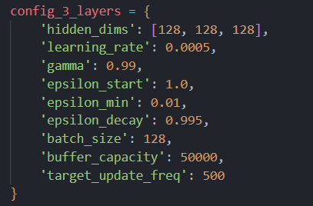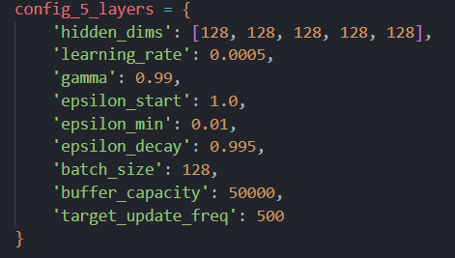
A few hyperparameters emerged as more important in our trials.
- The dimension of the hidden layers (size-128 layer) reduced the number of episodes until reaching the target by $\frac{1}{2}$ compared to a size-64 layer.
- We are balancing exploration vs. exploitation using the epsilon attribute, that specifies the ratio of steps in which we’ll choose a random action rather than the greedy-best action. We aspired to reach the minimum exploration rate after $\sim 500$ episodes, to ensure the agent is not too-random, which will hurt its training.

We observed that the rewards plot behaved with relative instability, unlike networks trained for static classification tasks. This is assumed to be the result of the changing target during training. These instabilities were reduced using a:
- (Very) low learning rate – reduced the convergence time by $\frac{1}{2}$ , compared to a standard $1e^{-3}$ LR. It affected the rewards plot, making it steadier.
- A relatively stable target network (less frequently updated, with $C = 100$)
- A larger buffer (increased from an initial of 10,000 to have more memory of past episodes).
The rest of the hyperparameters were found to be less important to the coverage of the network (batch size, gamma). The two networks we tried have similar parameters otherwise (to compare the effect of the dimensionality increase specifically), with equal size hidden linear layers, MSE as loss criteria, Adam optimizer and ReLU as activation function in the linear layer.
Our 3-layer agent reached its goal of $reward≥475 for 100 consecutive episodes$ after fewer episodes than the 5-layer model, which led us to conclude that this task might be relatively simple, and a bigger network might be an overkill, despite the helpful increase in the size of the hidden layers.
- 3-layer model: Episode 2281: 100-episode average = 475.91 ≥ 475.0. ($243≤reward_{episode}≤500$ in the last 100 episodes).
- 5-layer model: Episode 3308: 100-episode average = 477.85 ≥ 475.0. ($13≤reward_{episode}≤500$ in the last 100 episodes).
- Both agents reached a reward of 500 when used on a new test case (10 episodes) using the function test_agent.
The rewards over the episodes appear in Figures 5-6, with Figure 7 showing a visual comparison of the 2 final agents.

Section 3
Looking to improve our agent, we introduced a new class in our code “DoubleDeepQLearningAgent(DeepQLearningAgent)” that inherits directly from the agent in section 2. This agent applies 2 additional (optional - configurable) improvements:
- A DDQN agent, built with 2 separate networks (“QNetwork”, identical to Section 2, with the same optimizer, activation and loss criterion), implementing the following algorithm learnt in class:
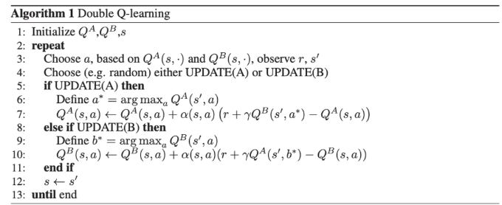
This method is meant to mitigate overestimated Q-values set at early stages of the training process, using a second Q-function. Each Q-function is updated using a q-value from the other Q-function, meaning that extreme experiences that has the potential to skew the network are mitigated. Each network (Q-function) serves as an independent assessor of the other network. Empirically, this has the potential for faster convergence.
- A priority buffer that samples past experiences using a TD error-based priority. The buffer will reintroduce the agent with samples it predicted poorly more frequently, which will give it a stronger cue to correct them, and possibly converge faster, while ensuring balance with the data distribution. The priority buffer is handled with a few additional hyperparameters:

Alpha (α) - Priority Exponent (default: 0.6)
Controls how much prioritization to use when sampling from the buffer.
- α = 0: Uniform sampling (no prioritization) - all experiences equally likely
- α = 1: Full prioritization - experiences sampled purely based on TD error
- α = 0.6: Balanced approach (recommended)
Formula: $priority = {\left(\left|TD_{error}\right|+ ε\right)}^{α}$

Beta (β) - Importance Sampling Correction (default: 0.4)
Controls how much to correct for the bias introduced by prioritized sampling using importance sampling weights. Prioritized sampling changes the distribution of data, which can bias learning. Importance sampling weights compensate for this by giving less weight to frequently sampled experiences.
- β = 0: No correction (biased updates)
- β = 1: Full correction (unbiased updates)
- β starts low (0.4) and increases to 1.0 during training
Formula: $weight =\frac{{\left(N * P\left(i\right)\right)}^{-β}}{max_{weight}}$

Beta Increment (default: 0.001)
How much to increase β after each sampling step. Why?
- Early training: Network is changing rapidly, bias matters less → use lower β (0.4)
- Late training: Network converging, bias matters more → use higher β (→1.0)

Reference: Schaul et al. (2015) - Prioritized Experience Replay
In order to conduct a fair comparison, we trained the enhanced model with the same hyperparameters we used for the 3-layer DQN model + the new parameters:
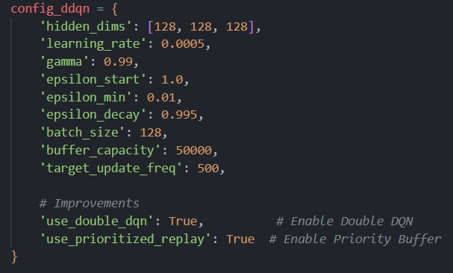
From the beginning of it’s training the model showed greater stability, with an almost steady increase in the avg rewards, unlike the previous 3-layer model. At an avg reward of $±400$ the agent started experiencing some difficulties, but still, it reached its target quicker, converging after 1536 episodes, which is 67% of the episodes it took its sibling model to reach the same performance.
DDQN 3-layer model + priority buffer: Episode 1536: 100-episode average = 475.18 ≥ 475.0 ($137≤reward_{episode}≤500$ in the last 100 episodes).
In the testing environment, the model reached very high results as well:
Mean Reward (= Length): 498.90 ± 3.30
The loss and avg reward plots are available in Figure 8, with Figure 9 comparing this agent to the 3-layer DQN agent.

Appendix

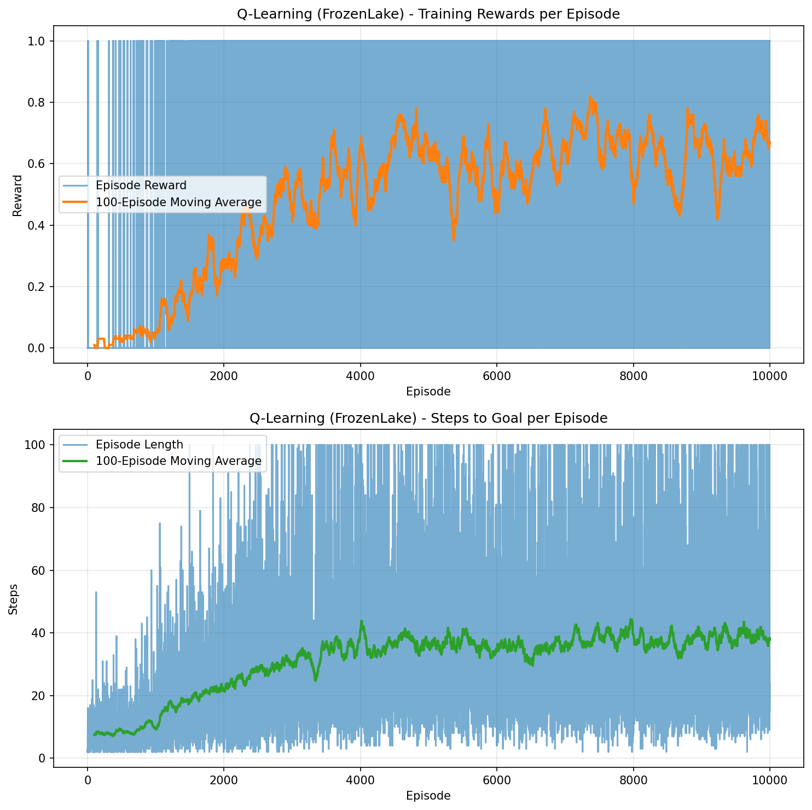
Figure 1

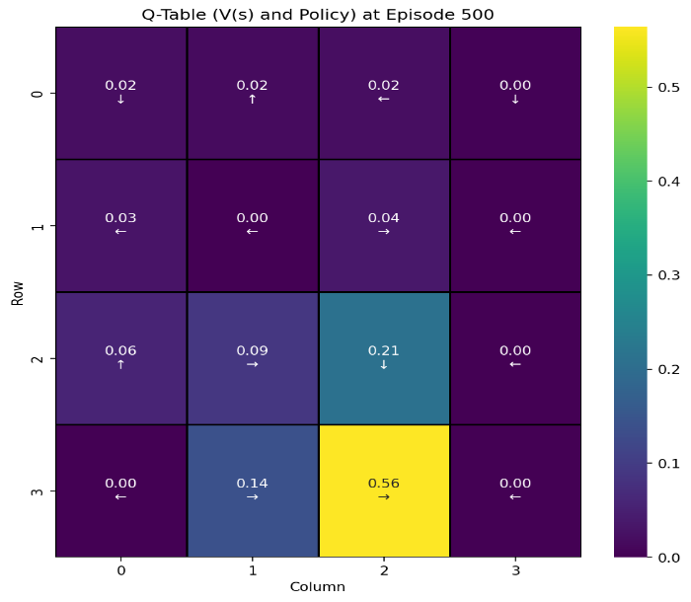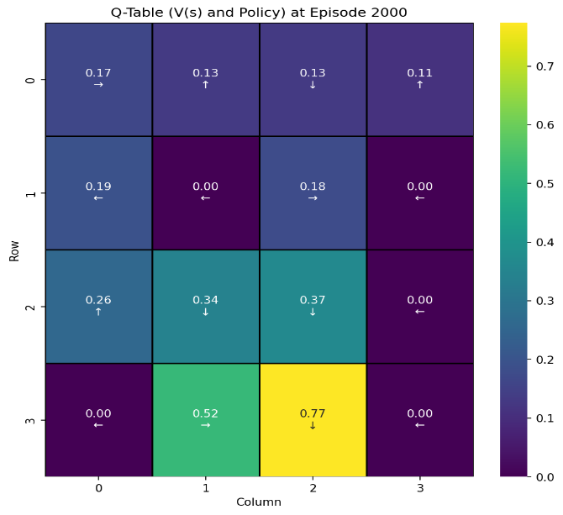
Figure 2 Figure 3

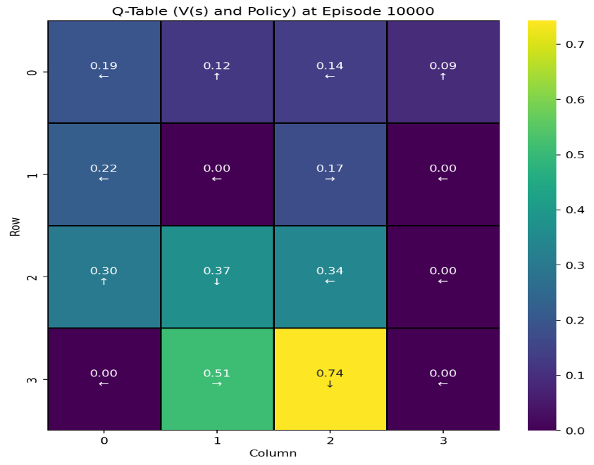
Figure 4

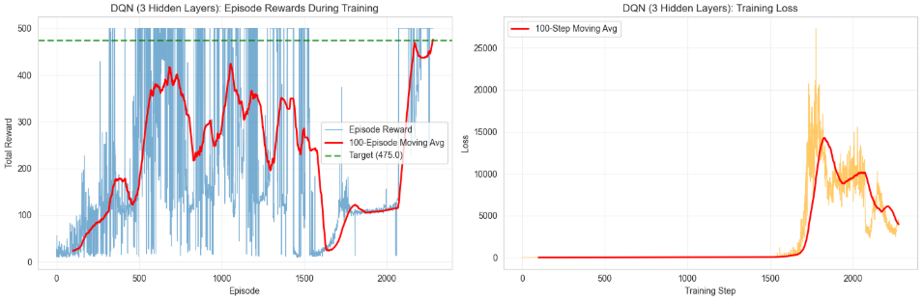
Figure 5 – A spike in the loss after episode 1500, followed by a steady decrease of it, and a sharp increase in the rewards of the model, finally reaching its goal at 2200+.
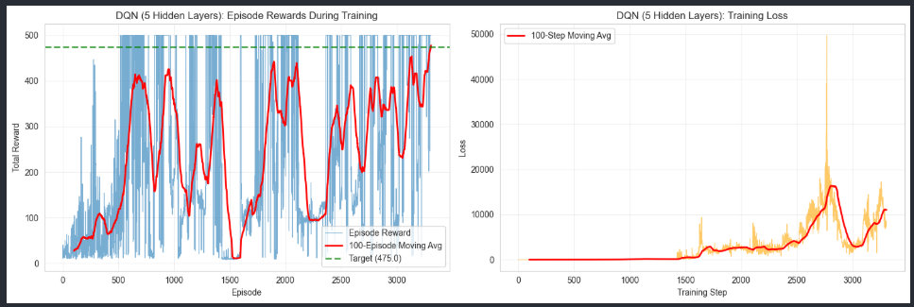
Figure 6 – A sharper spike in loss with a general increase in rewards, but more significant instabilities.
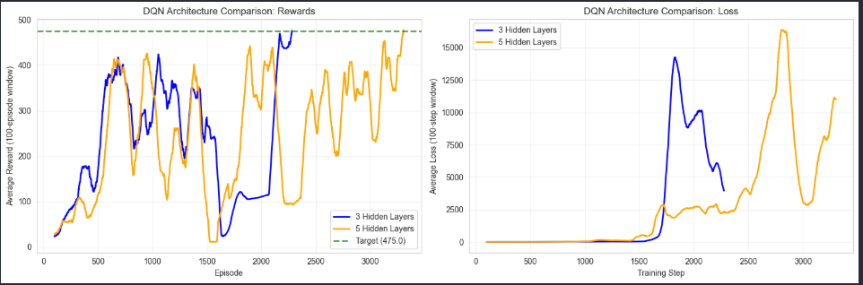
Figure 7 – 3-layer vs. 5-layer DQN performance comparison.
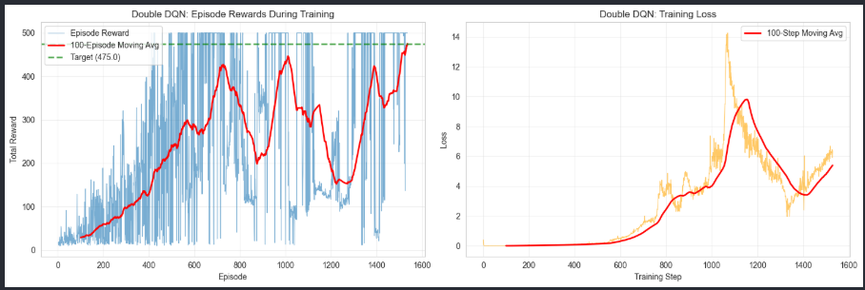
Figure 8 – 3-layer DDQN model with priority buffer, showing a much lower loss then the prior models, and a quicker, steadier increase in the avg rewards.
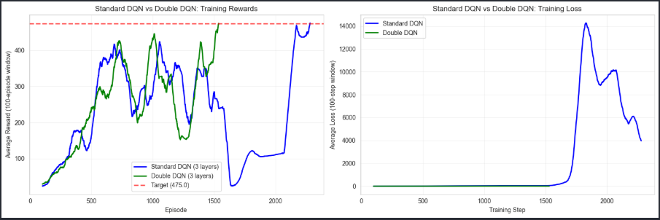
Figure 9 – 3-layer DDQN model with priority buffer compared to the regular 3-layer DQN model, reaching its target sooner with significantly lower loss.

