Assignment 2 – Policy Gradient Methods
Submitted by (IDs): 208524413, 208388918

Section 1 – Monte-Carlo Policy Gradient (REINFORCE)
- What does the value of the advantage estimate reflect? Why is it better to follow the gradient computed with the advantage estimate instead of just the return itself?
The advantage estimate reflects how much better (or worse) a specific action $a_{t}$ was compared to the average expected performance in that state. Instead of looking at the absolute reward, it measures the relative value of the chosen action against a baseline (usually the value function $V(s)$).
Using the advantage significantly reduces the variance of the gradient estimation without introducing bias. Raw returns $R_{t}$ can be very noisy or strictly positive, which can make the gradient updates unstable or inefficient. Centering the signal around zero stabilizes the learning process and leads to faster convergence.
- The reduction of the baseline does not introduce bias to the expectation of the gradient since: $Ε_{π_{θ}}\left[∇logπ_{θ}\left(a_{t} | s_{t}\right)b\left(s_{t}\right)\right]=0.$What is the prerequisite condition for that equation to be true? Prove the equation.
The prerequisite is that the baseline must not depend on the action $a_{t}$. It can be a function of the state $s_{t}$ or a constant, but it must be independent of the action taken at that time step.
Proof using the log-derivative identity: $∇_{θ}logπ_{θ}\left(a | s_{t}\right)=\frac{∇_{θ}π_{θ}(a|s_{t})}{π_{θ}(a|s_{t})}$.
$$E_{π_{θ}} \left[∇_{θ} log π_{θ}\left(a_{t} | s_{t}\right) b\left(s_{t}\right)\right]=\sum_{a∈A}{π_{θ}\left(a | s_{t}\right)∇_{θ}log π_{θ}(a|s_{t}) b(s_{t})}=\sum_{a∈A}{π_{θ}\left(a | s_{t}\right)∇_{θ}log π_{θ}(a|s_{t}) b(s_{t})}=\sum_{a∈A}{π_{θ}\left(a | s_{t}\right)\frac{∇_{θ}π_{θ}(a|s_{t})}{π_{θ}(a|s_{t})}b(s_{t})}=\sum_{a ∈ A}{∇_{θ} π_{θ}\left(a | s_{t}\right) b\left(s_{t}\right)=}=b\left(s_{t}\right)\sum_{a ∈ A}{∇_{θ} π_{θ}\left(a | s_{t}\right)}=b\left(s_{t}\right)∇_{θ}\sum_{a ∈ A}{π_{θ}\left(a | s_{t}\right)}=b\left(s_{t}\right)∇_{θ}\left(1\right)=b\left(s_{t}\right)⋅0 =0$$

- Evaluate both algorithms and compare the results (please refer also to convergence time, as well as performance and other things).
REINFORCE:
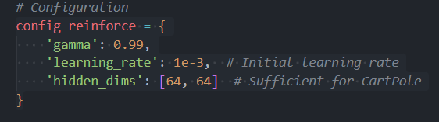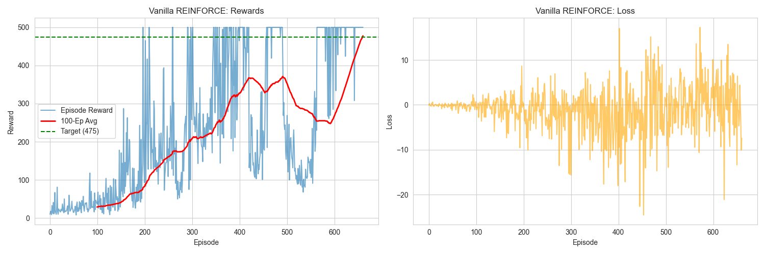

From the Vanilla REINFORCE: Rewards plot, learning progresses gradually with a long warm-up phase. Up to roughly episode 150, rewards remain low, mostly below 100, indicating slow early learning. Between episodes $\sim 150$ and $\sim 400$, the agent begins to frequently reach higher rewards, but performance remains unstable, with sharp drops even after near-optimal episodes.
The 100-episode moving average increases steadily and crosses the target reward line (475) at episode 661, reaching a final average reward of 477.65. This confirms successful convergence, but only after a prolonged training period. Training this model took $1.5 minutes$on a CPU. A key observation from the plot is that even after convergence, individual episode rewards continue to fluctuate heavily, with multiple drops well below 200. This indicates that while the expected policy performance is high, the policy itself remains noisy.

Variance and Stability
The reward plot shows extreme variance throughout training. Episodes frequently alternate between near-maximum reward (500) and very low reward values. This is a textbook manifestation of vanilla REINFORCE’s high-variance gradient estimates, since updates depend on full episode returns with no baseline subtraction.
The Vanilla REINFORCE: Loss plot reinforces this interpretation. The loss oscillates tightly around zero early on, then exhibits increasing amplitude over time, with large positive and negative spikes (down to roughly −25 and up to +15). This widening spread reflects unstable policy gradient updates as returns increase. Importantly, there is no clear downward trend or stabilization in loss magnitude, indicating persistent noise rather than convergence in the optimization objective.
REINFORCE + baseline:
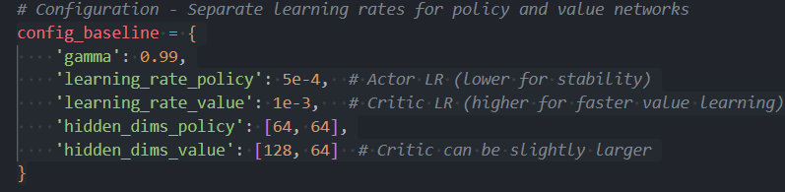
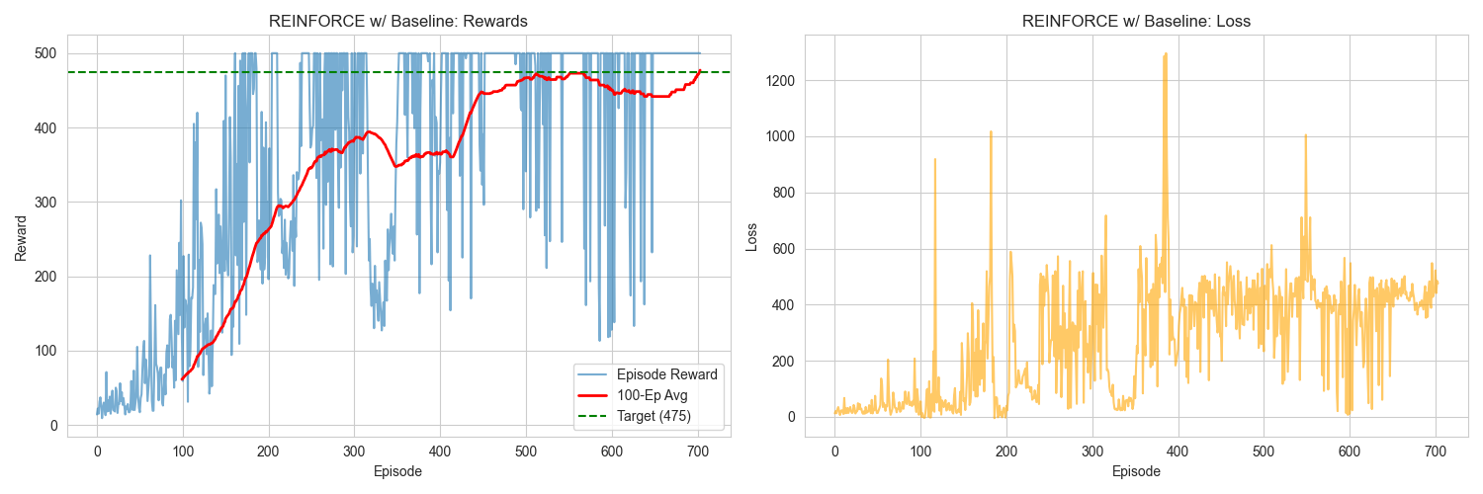
The REINFORCE w/ Baseline: Rewards plot shows a markedly different learning profile. Early learning is faster and more structured, with the agent reaching rewards above 300 by around episode 200. By episodes $\sim 250-300$, near-optimal episodes ($reward ≈ 500$) occur frequently.
The 100-episode moving average stabilizes close to the target line much earlier than in vanilla REINFORCE, although it crosses the target threshold slightly later, at episode 704, with a final average reward of 477.09. Training this model took $\sim 4.5 minutes$ on a CPU. This is significantly longer than the time it took to train the vanilla model.
Crucially, after convergence, the moving average remains stable, and although individual episodes still fluctuate, the frequency and depth of reward collapses are visibly reduced compared to vanilla REINFORCE.
Variance Reduction and Loss Behavior
The reward plot shows reduced variance relative to vanilla REINFORCE. While suboptimal episodes still occur, long streaks of high-reward episodes dominate the later training phase. This reflects the effect of subtracting a learned value baseline, which reduces gradient variance without biasing the policy update.
The REINFORCE w/ Baseline: Loss plot differs fundamentally in scale and structure. Loss values are consistently positive and significantly larger, often in the range of 300–500, with occasional spikes above 1000. This behavior is expected, as the plotted loss now reflects both actor and critic learning dynamics.
Despite the larger magnitude and occasional spikes, the loss curve shows a stable band rather than symmetric oscillation around zero, indicating more consistent gradient directionality. Importantly, these spikes do not correspond to collapses in reward, suggesting that the policy is robust to critic noise.
SUMMARY:
Both algorithms successfully solve the CartPole task and achieve comparable final performance. However, the plots clearly show that REINFORCE with baseline provides significantly better training stability, lower reward variance, and earlier entry into high-performance regimes. Vanilla REINFORCE converges slightly earlier by the moving-average criterion but does so with persistent instability and inefficient learning dynamics.
It is important to note that training the baseline was more resource consuming (time), due to the 2 NNs and slight architectural modifications.

Section 2 – Advantage Actor-Critic
- Why is using the TD-error of the value function for the update of the policy network parameters is practically the same as using the advantage estimate (of equation 1 ${\hat{A}}_{t}={\hat{Q}}_{w}\left(s_{t},a_{t}\right)-{\hat{V}}_{v}\left(s_{t}\right)$)? Prove. The TD-error $δ$ serves as an unbiased sample estimate of the Advantage function. By definition, the Q-value is the expected immediate reward plus the discounted value of the next state. If we substitute this one-step approximation into the Advantage equation, we arrive at the definition of the TD-error.
Proof:
The definition of the Advantage function is: $A\left(s_{t}, a_{t}\right)=Q\left(s_{t}, a_{t}\right)-V\left(s_{t}\right)$.
The definition of the TD-error $δ_{t}$ is: $δ_{t}=R_{t+1}+γ V\left(s_{t+1}\right)-V\left(s_{t}\right)$.
Taking the expectation of the TD-error given the current state $s_{t}$ and action $a_{t}$: $E\left[δ_{t} | s_{t},a_{t}\right]=E\left[R_{t+1}+γV\left(s_{t+1}\right) | s_{t},a_{t}\right]-V\left(s_{t}\right)$.
From the Bellman equation, we know that $Q\left(s_{t},a_{t}\right)=E\left[R_{t+1}+γV\left(s_{t+1}\right) | s_{t},a_{t}\right]$. Substituting this back in: $E\left[δ_{t} | s_{t},a_{t}\right]=Q\left(s_{t},a_{t}\right)-V\left(s_{t}\right)=A\left(s_{t},a_{t}\right)$.
- Explain which function is the actor and which is the critic of the model and what is the role of each one.
In the Actor-Critic architecture, the actor is represented by the policy function $π\left(a | s;θ\right)$. Its primary role is to interact with the environment by selecting actions based on the current state, with the goal of learning the optimal policy parameters $θ$ that maximize expected reward. The critic is represented by the value function $\hat{v}\left(s;w\right)$ (or sometimes the Q-function). Its role is to evaluate the actions taken by the actor by estimating the value of states. This evaluation provides the feedback (TD-error) to critique the actor's performance, which helps reduce variance and stabilizes the policy gradient updates.

