Assignment 3 – Transfer and Meta Learning
Submitted by: Omri Haller (208524413), Shahar Oded (208388918)
** Code files are submitted as a structured project. To run, open the repo in in an IDE, install requirements.txt in your VENV, navigate to the mainColab.ipynb file and run all cells. Modules will be loaded.

Section 1 – Training Individual Networks (Actor-Critic)

1.1. Architecture and Unified Interface
To enable seamless transfer learning in later sections (fine tuning and progressive networks), we designed a unified architecture that allows a single network structure to interact with multiple environments (CartPole, Acrobot and MountainCar) despite their differing state and action spaces.
- Base Algorithm: We utilized an on-policy Actor-Critic algorithm. The actor (policy) and critic (value) share the same feature extraction backbone (MLP) but have separate output heads, or distinct networks depending on the specific run configuration.
- Network Structure: A Multi-Layer Perceptron (MLP) was used with hidden layers of size [128]. ReLU activations were used between layers.
- Unified State Space ($D_{in}=6$): The input dimension was fixed to 6 (the size of the Acrobot state space). For environments with smaller observation spaces, we applied zero-padding:
  - CartPole ($4 ->6$): The 4-dimensional state is padded with 2 zeros.
  - MountainCar ($2 ->6$): The 2-dimensional state is padded with 4 zeros.
- Unified Action Space ($D_{out}=5$): The output dimension was fixed to 5 (the resolution of the MountainCar discretization – see in the next section). For environments with fewer actions, we applied logit masking:
  - Masking Mechanism: A binary mask sets the logits of invalid actions to $-∞$before the softmax step, ensuring the agent assigns them zero probability.
  - CartPole (2 valid): Actions 0-1 are valid; 2-4 are masked.
  - Acrobot (3 valid): Actions 0-2 are valid; 3-4 are masked.

1.2. Environment-Specific Adjustments
- CartPole-v1 (Retrained): Although solved in assignment 2, the agent was retrained using the padded architecture to establish a baseline compatible with the progressive network source pool.
- Acrobot-v1: Trained using the native 6-dim state space and 3-action subset.
- MountainCarContinuous-v0:
  - Discretization: The continuous action space $[-1, 1]$ was discretized into 5 bins: $\{-1.0, -0.5, 0.0, 0.5, 1.0\}$. This allowed us to treat the task as a discrete task, like the other 2.
  - Reward Shaping: In MountainCar, the agent see a positive reward only upon reaching to the top of the hill. With this difficulty, our agent never “accidently” reached the top, so it never reached a positive prize, resulting in lack of ability finish the game, and converging to a local maximum, which is staying in place. To address the sparse reward problem, we implemented a MountainCarRewardShaping wrapper. This added dense rewards for maintaining velocity and reaching new height milestones, significantly stabilizing convergence.
  - Target Criteria: Since we modified the original rewards of the problem, we could no longer halt our agent when reaching the benchmark goal (which is based on a reward score). Instead, we benchmarked the agents on the ratio of solved games they had over the last 100 episodes and defined the stopping criteria at 95%. This definition became the stopping criteria of all agents. But what is a solved game?
    - CartPole: $Reward=500$
    - Acrobat: $Reward≥ -100$
    - MountainCar: $episode length<999$ (finished the game in less than the max time).

1.3. Results
The agents trained with (almost) the same set of hyperparameters (MountainCar is the only task where we had to increase the enthropy). This set represents the shared configurations that worked for all tasks, not necessarily the best for each. This configuration is relatively simple, as these were the smaller networks that converged faster. All hyperparameters appear in Table 1.
All 3 tasks converged. The training plots for rewards and diagnosis appear in Plot 1.
Summary: {'gym_id': 'CartPole-v1', 'episodes': 741, 'steps': 160199, 'seconds': 508.38}
Summary: {'gym_id': 'Acrobot-v1', 'episodes': 405, 'steps': 39550, 'seconds': 67.0}
Summary: {'gym_id': 'MountainCarContinuous-v0', 'episodes': 215, 'steps': 162533, 'seconds': 562.95}
- Convergence vs. Complexity: While CartPole-v1 required the highest number of episodes to converge, indicating it was the most unstable policy to learn, MountainCarContinuous-v0 was computationally the most expensive. It required the most wall time and interaction steps.
- Impact of Reward Shaping: The low episode count for MountainCar is a direct result of the MountainCarRewardShaping wrapper. The dense reward signal allowed the agent to improve its policy with fewer updates (episodes). However, the high step count reflects the physical nature of the task: the agent must spend many steps swinging back and forth to build momentum, resulting in long episode durations (~750 steps/episode) compared to the rapid failures/successes of CartPole.
- Unified Interface Efficiency: The implementation of state-padding (mapping 2D or 4D states to a 6D vector) and action-masking introduced negligible computational overhead. All tasks converged within reasonable timeframes, validating that a single, unified network architecture can effectively learn tasks with disjoint state-action spaces.
- Stability:
  - Critic Loss: As expected in Actor-Critic methods, the critic loss was noisy throughout training. This is due to the non-stationary target (the value function $V(s)$ changes as the policy $π$improves).
  - Reward Volatility: CartPole exhibited the most instability in reward accumulation, likely due to the "catastrophic forgetting" phenomenon common in policy gradients where a large update pushes the agent into a region of the parameter space where it can no longer balance the pole. Acrobot, by contrast, showed the smoothest optimization curve.

Section 2 – Fine-Tuning Agents between Tasks

2.1. Methodology
In this section, we investigated whether representations learned in a source task could accelerate learning in a target task (Transfer Learning). We performed two experiments:
- Acrobot-v1 $→$CartPole-v1
- CartPole-v1 $→$MountainCarContinuous-v0
Initialization: The target agent's hidden layers ("trunks") were initialized with the weights from the fully trained source agent.
Re-initialization: The output heads (Actor and Critic last layers) were re-initialized randomly, as the specific action-value mappings from the source are not valid for the target. At first, we tried initiating only the Actor, hoping the learnt features in the critic will assist the learning process, but this attempt took significantly longer to converge, so we ended up initiating both.
Hyper-parameters: We treated the fine-tuning task similarly to the original training assignment attempting 2 variations of hyper parameters (see Table 1):
- Same as Section 1
- Reducing $\frac{LR_{Actor}}{10},\frac{LR_{Critic}}{10}$ to avoid fast forgetting of the already learnt features from the previous task, as commonly done for fine tuning tasks. This attempt was not successful, resulting in a model that failed to converge after $×3 episodes$.

2.2. Results
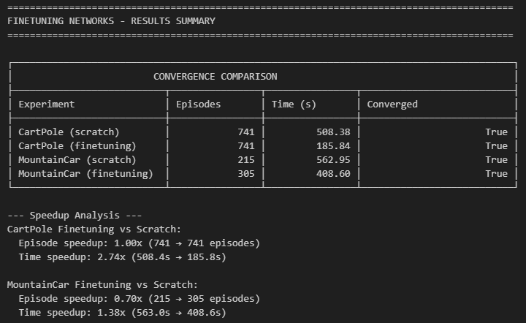
While our primary objective was to accelerate agent training by leveraging transferable features, the results revealed a trade-off between sample efficiency and computational speed. We observed neutral to negative transfer in terms of episode counts - CartPole showed no improvement ($×1.00 speedup$), while MountainCar actually required more episodes to converge ($×0.70$) - suggesting that the pre-trained features were not immediately transferable and likely required an initial 'unlearning' phase. However, this initialization proved computationally efficient, yielding substantial wall-clock time speedups of $×2.74$ for CartPole and $×1.38$ for MountainCar, which indicates that the computational toll of fine-tuning was lighter than training from scratch. Qualitatively, the reward trajectories (see Plot 2) for the fine-tuned agents appeared cleaner than the baselines; they exhibited a characteristic slow start as the agents adjusted their representations, followed by a smooth, stable ascent once they successfully adapted to the new task dynamics.

Section 3 – Progressive Transfer Learning

3.1. Methodology
In this section, we implemented a Progressive Neural Network (PNN) to transfer knowledge from multiple source domains to a target domain without catastrophic forgetting. We focused on two transfer scenarios:
- Sources: {Acrobot, MountainCar} $→$Target: CartPole
- Sources: {CartPole, Acrobot} $→$Target: MountainCar
Instead of fine-tuning weights (which alters the original knowledge), PNNs freeze the source networks and add a new, randomly initialized "column" for the target task.
- Frozen Columns: We loaded the fully trained Actor-Critic agents from Section 1 and explicitly froze their parameters ($requires_grad=False$).
- Active Column: We instantiated a fresh Agent for the target task.
- Lateral Connections: We established lateral connections between the hidden layers of the Source columns and the Target column. Since our base architecture utilizes a single hidden layer ($h=128$), the features from all source hidden layers were concatenated with the target's hidden features before being passed to the final Actor/Critic heads.
To support disjoint state spaces (e.g., CartPole's 4D input vs. Acrobot's 6D input) within a single graph, we utilized the ProgressiveWrapper class:
- Input Handling: We maintained the zero-padding strategy from Section 1. Each column (Source or Target) receives an input vector padded to match its specific training expectation.
- Lateral Adapters: To prevent "Negative Transfer" (where irrelevant source features confuse the target), we implemented learnable Lateral Adapters . These are small sub-networks ($Linear→ ReLU$) placed on the lateral connections. They act as filters, projecting the source features ($128d$) into the target's feature space ($128d$) before fusion.
- Feature Fusion: The final input to the decision head became a concatenated vector of size 384 $({128}_{target}+ {128}_{source} + {128}_{source2}).$
Training these, we encountered the “Loud Neighbor” problem, where the pretrained weights from the source networks “overwhelm” the new agent. We solved that using a “silent initialization” for the adapters, where their weights are initiated with a gain of $1e^{-4}$, but that alone was not enough, and we also had to add a Layer Normalization to the fused features before the output head, to ensure the contributions from the fresh and frozen columns are on the same scale.
The rest of the hyperparameters we used were used in previous sections, also specified in the appendix.

3.2. Results
We compared the performance of Progressive Networks against the "training from scratch" baselines established in Section 1.
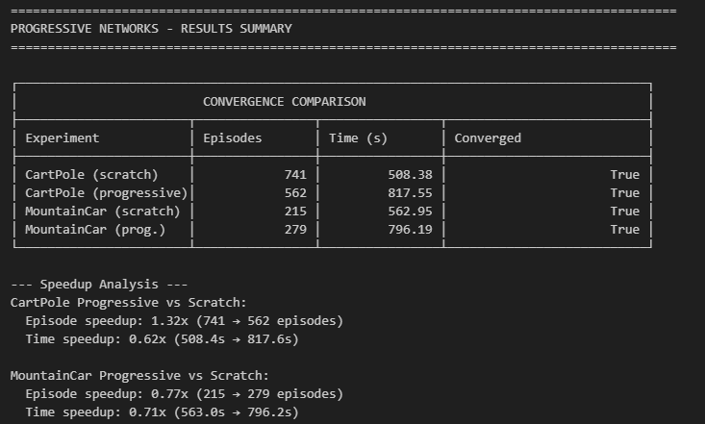
Analysis:
- CartPole (Positive Transfer - "Jumpstart" Effect): The progressive agent demonstrated a significant "Jumpstart". As seen in the reward plots (see Plot 3), the progressive agent (right) reached near-max rewards (~450) by Episode 150, whereas the baseline (left) struggled in the low-reward regime until Episode 300. Although the agent required additional fine-tuning episodes to stabilize the 100-episode moving average (meeting the strict convergence criteria), the initial acquisition of the skill was drastically faster (1.32x reduction in episodes).
- MountainCar (Negative Transfer): Transfer to MountainCar was less successful. The progressive agent required more episodes (279 vs. 215) to converge. This suggests Negative Transfer: the kinematic features learned in CartPole (balancing) and Acrobot (swing-up) likely interfered with the specific momentum-building strategy required for MountainCar, causing the agent to waste exploration time "unlearning" irrelevant priors.
- Computational Overhead (Time vs. Episodes): Despite the reduction in training episodes for CartPole, the Wall-Clock Time increased in both experiments (Speedup < 1.0). This is the expected trade-off of the architecture: the Progressive Network must run forward passes for three distinct networks (Target + 2 Frozen Sources) at every timestep. The computational overhead of these extra floating-point operations outweighed the gain from fewer training episodes.
Conclusion The Progressive Network successfully stabilized and converged for both tasks. It proved highly effective for CartPole, providing a strong initial performance boost, but suffered from negative transfer and computational overhead in the MountainCar task.

Appendix
Table 1: Hyper Parameters attempted + final.
Algorithm | Parameter | Search Space Tested | Final Value
Actor-Critic | Architecture | $$\{\left[128,128\right],\left[64,64\right],\left[128,64\right] ,\left[128\right]\}$$  (2 layers vs. 1 layer) | $$\left[128\right]$$
Actor-Critic | Policy LR | $$\{1e^{-3},5e^{-4}, 1e^{-4}\}$$ | $$5e^{-4}$$
Actor-Critic | Value LR | $$\{1e^{-3},5e^{-4}\}$$ | $$1e^{-3}$$
Actor-Critic | LR Schedule | Decay vs. Constant | Constant
Actor-Critic | Entropy | $$\{0.001, 0.01, 0.1\}$$ | $0.01$ (MountainCar with 0.1)
Actor-Critic | Gradient Clipping | $$\{None, 0.5, 1.0\}$$ | $$None$$
Fine-Tuning Actor-Critic | Architecture | $$\{\left[128\right]\}$$ | $$\left[128\right]$$
Fine-Tuning Actor-Critic | Policy LR | $$\{5e^{-4},5e^{-5}\}$$ | $$5e^{-4}$$
Fine-Tuning Actor-Critic | Value LR | $$\{1e^{-3},1e^{-4}\}$$ | $$1e^{-3}$$
Fine-Tuning Actor-Critic | LR Schedule | Constant | Constant
Fine-Tuning Actor-Critic | Entropy | 0.01 | $0.01$ (MountainCar with 0.1)
Fine-Tuning Actor-Critic | Gradient Clipping | {None} | None
Fine-Tuning Actor-Critic | Head Weights Init | {Actor & Critic, Just Actor} | Actor & Critic
Progressive Actor-Critic | Architecture | $$\{\left[128\right]\}$$ | $$\left[128\right]$$
Progressive Actor-Critic | Policy LR | $$\{5e^{-4}\}$$ | $$5e^{-4}$$
Progressive Actor-Critic | Value LR | $$\{1e^{-3}\}$$ | $$1e^{-3}$$
Progressive Actor-Critic | LR Schedule | Constant | Constant
Progressive Actor-Critic | Entropy | 0.01 | $0.01$ (MountainCar with 0.1)
Progressive Actor-Critic | Gradient Clipping | {None} | None
Progressive Actor-Critic | “Silent Initialization” | {True, False} | True
Progressive Actor-Critic | Layer Norm | {True, False} | True
Progressive Actor-Critic | Adapter Layer dim | $$\{[32], None\}$$ | $$[32]$$
** Attempts to increase the architecture showed lesser results, with the simple 1-hidden layer being the best solution.
** Gradient clipping, despite seeming like a good solution caused as catastrophic forget immediately.
** Base parameters remained the working parameters from task to task, with additional enhancement as required.

Plot 1: Training plot for section 1, showing the reward and diagnosis for the 3 agents.
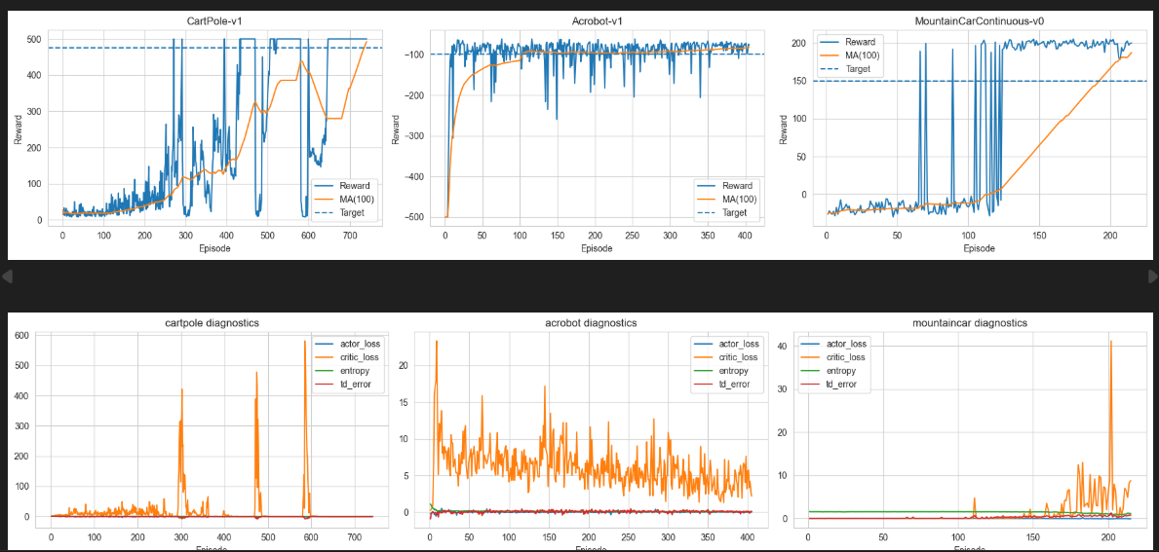

Plot 2: Reward plot comparison between the original agent on the 2 tasks and the fine-tuned agent.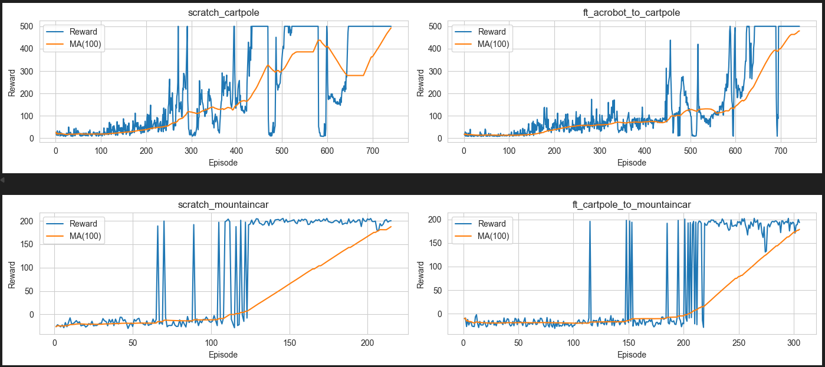

Plot 3: Reward plot comparison between the original agent on the 2 tasks and the fine-tuned agent.
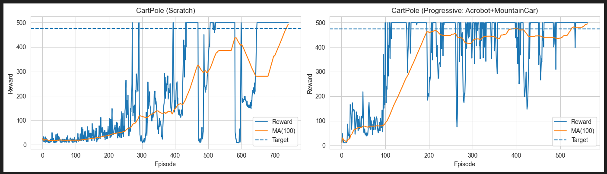
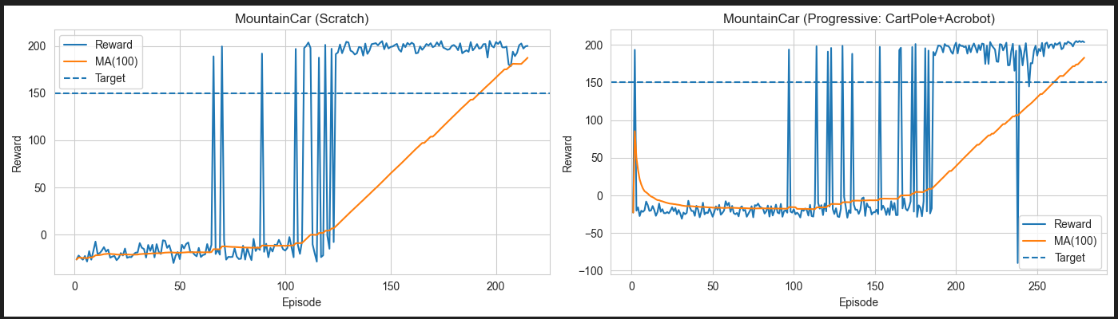

Plot 4: Diagnosis of the Progressive agent training.
