Technical Report: Web Page Summarization Framework
This report outlines the development of a high-performance web page summarization, optimized to balance quality, latency, and cost.
1. Core Requirements and Strategy
The objective was to build two distinct summarization strategies: Fast (low latency) and Advanced (high quality). The solution was required to be:
- Multilingual: Supporting diverse web content.
- Production-Ready: Feasible for millions of daily requests.
- Length-Constrained: Ensuring summaries do not exceed 1.5k characters.
I assumed the provided baseline summaries were for comparison only and established a Gold Standard dataset by re-summarizing the same pages using GPT-5.2. This flagship model was used to generate high-quality reference summaries to serve as the ground truth for quality evaluation and training.
2. Model Distillation and Selection Phase
To bridge the gap between flagship quality and production costs, I implemented a Model Distillation pipeline. I fine-tuned smaller models (GPT-4.1-mini and GPT-4.1-nano) using the Gold Standard dataset to replicate the "Teacher" logic at a fraction of the cost and latency ($<100\$$). Distillation was effective:
- FT GPT-4.1-mini (distilled): ~99% of teacher quality; cost ↓64% (≈1.78× better than base); closes 87% of the quality gap to the teacher.
- FT GPT-4.1-nano (distilled): ~94% of teacher quality; cost ↓91% (≈1.68× better than base); closes 60% of the gap while staying very fast.
Model Selection Benchmark (final method)
I conducted a benchmarking phase on a $\sim 100 items$validation subset, selected to balance evaluation costs while remaining statistically representative. This subset primarily included samples under 250k tokens to ensure context window remain within bounds. To enhance performance across all models, an $O(N)$ input cleanup was done on the Summarizer agent’s input which helped in reducing costs, latency and quality. Benchmarking added $<23\$$to the cost.
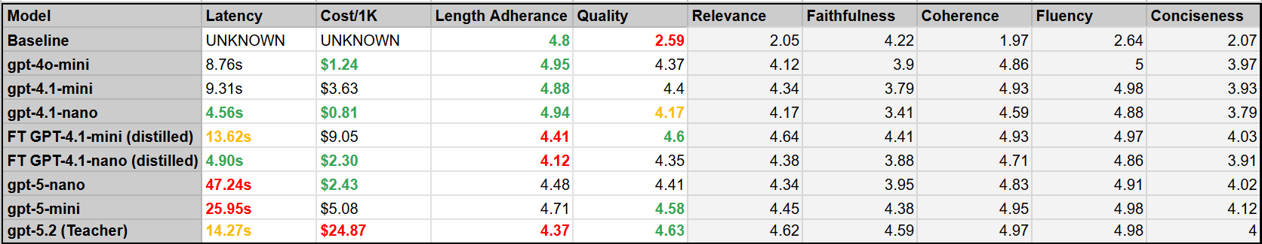
My Selection:
FT GPT-4.1-nano (distilled) for a good quality, low cost, very fast model and FT GPT-4.1-mini (distilled) for close to gold-standard quality at medium latency and significantly lower cost.
The downside: During selection, I identified that the teacher model performed lousily on the length limitation, and that student models could inherit that bias from it. To mitigate this, the training data split specifically enforced both character and token limits, so that fine tuning will push the model towards the correct length in an efficient manner. This pattern was further handled by a retry loop on the Summarizer that re-generated the output in case of length violation, but it’s important to note that the retry mechanism adds significant latency and cost. The benchmark encompasses up to 3 retries. More retries will increase length adherence across all models but might also change the latency / cost score board.
3. Evaluation Methodology: LLM-as-a-Judge
I developed a custom SummarizationJudge using G-Eval methodology on GPT-5.2. The judge utilizes Structured Outputs for deterministic scoring across five dimensions: Relevance, Faithfulness, Coherence, Fluency, and Conciseness. These metrics were selected to balance information density and grounding - critical for a search agent - against the trade-offs of cost and length compliance. Accuracy is prioritized by using the flagship model for this "one-time" benchmarking expense , while a programmatic linear penalization scale (1500–2000 characters) enforces the strict character limits required for production feasibility.
4. Production Challenges Beyond Benchmarking
Context Outliers: For production feasibility, I implemented an optional strategy to use a map-reduce mechanism to split-summarize-concatenate long context window. This strategy is optional in the class given that it will increase the processing costs and possibly latency (due to rate limits, despite parallelism). If not activated – an error will be prompted, and the request will be skipped.
5. Limitations / Future Ideas
- Judge Validation: The G-Eval framework relies on LLM reasoning and has not been validated against human annotators for internal scoring variance. This kind of validation is important, as the judge might prefer outputs that would resemble outputs it would generate (self-preference-bias), despite the structured scoring method.
- Judge Cost: The cost can be reduced by up to $50\%$ if the benchmarking requests are handled in batch jobs, but this was not very feasible under the time constraints of the home task.
- Output Length: Models’ adherence to it (on a character level) was not perfect. While this can possibly be improved using better prompts and/ or extending the implemented retry mechanism, such modifications have cost and latency implications and should be considered.
- Possible Latency Improvement: To maximize production throughput, significant latency gains could be achieved via request parallelism, though this was excluded from benchmarking to avoid API rate-limit skew. Further efficiency could be realized through more aggressive semantic-based input reduction. Finally, transitioning to open-weights models would unlock additional performance tiers through local inference and quantization (e.g., 4-bit/8-bit precision). These techniques, which require direct access to model weights unavailable in managed API ecosystems, are essential for optimizing hardware utilization and reducing per-request costs at the scale of millions of daily requests.

