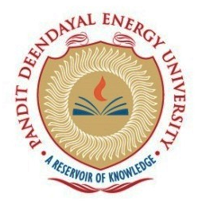

**SCHOOL OF TECHNOLOGY**

**PANDIT DEENDAYAL ENERGY UNIVERSITY**

**GANDHINAGAR, GUJARAT**

**CERTIFICATE**

This is to certify that Mr. / Miss **Harsh Shah** **_**

Enrolment No. **21BCP359** of **3rd Semester** degree course in **Computer Science & Engineering** has satisfactorily prepared and presenter his / her Term Work in **Data Structures & Algorithms Lab (20CP201P)** within four walls of the laboratory of this Institute during **July 2022** to **November 2022**

**Date of Submission:**

**Dr Aditya Shastri**

**Assistant Professor**