Computer Science & Engineering

**LAB MANUAL (2022-23)**

Digital Electronics and Computer Organization Lab

(20CP203P)

**SCHOOL OF TECHNOLOGY**

**PANDIT DEENDAYAL ENERGY UNIVERSITY GANDHINAGAR, GUJARAT, INDIA**

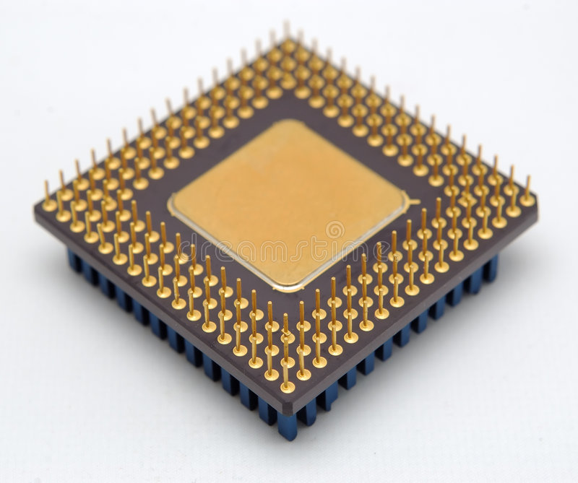

**Student Name: _Harsh Shah_**

**Enrollment No.: 21BCP359 Course with Semester: B.Tech (3rd) CSE**

**Division: 6**

**Group: G11**

**Course Coordinator: Dr. Hiren Thakkar**

**Course Instructor: Dr. Tanmay Bhowmik**



**SCHOOL OF TECHNOLOGY**

**PANDIT DEENDAYAL ENERGY UNIVERSITY GANDHINAGAR, GUJARAT, INDIA**

**CERTIFICATE**

This is to certify that Mr. /Miss **Harsh Shah** Enrolment no**. 21BCP359**  of

**3rd Semester** degree course in **Computer Science and Engineering** has satisfactorily prepared and presented his Term Work in **Digital Electronics and Computer Organization Lab (20CP203P)** within four walls of the laboratory of this Institute during **July-2022** to **November-2022**.

**Date of Submission:** 20-11-2022

**Dr. Tanmay Bhowmik**

**Assistant Professor**

**Dept. of CSE**



**SCHOOL OF TECHNOLOGY**

**PANDIT DEENDAYAL ENERGY UNIVERSITY GANDHINAGAR, GUJARAT, INDIA**

**INDEX**

|  |  |  |  |  |
| --- | --- | --- | --- | --- |
| **Sr. No.** | **Name of Experiment** | **Pg. No.** | **Date** | **Sign** |
| **1** | Basic GATE operations | 1 | 02/08/2022 |  |
| **2** | Introduction to Verilog | 7 | 16/08/2022 |  |
| **3** | Implementation of Structural & Behavioral  Verilog Code | 10 | 23/08/2022 |  |
| **4** | Design a Half Adder, and Full Adder using Half Adder | 16 | 30/08/2022 |  |
| **5** | Design a Half Subtractor, Full Subtractor using Half Subtractors | 19 | 06/09/2022 |  |
| **6** | Designing of Multiplexer, Demultiplexer, Decoder, Encoder | 23 | 13/09/2022 |  |
| **7** | Application of Decoder, Recap of Logisim | 28 | 04/10/2022 |  |
| **8** | Sequential Circuits: Latch and SR flip flop | 31 | 11/10/2022 |  |
| **9** | Flip flops (JK, D, T) | 34 | 18/10/2022 |  |
| **10** | Flip flops Conversion | 39 | 01/11/2022 |  |