* **Program 1**

**// Install JDK**

public class one {

public static void main(String[] args) {

System.out.println("\nCODING IS FUN, ENJOY IT!\n");

}

}

**--> Output:**



* **Program 2**

**// Generate first n Prime Number**

import java.util.Scanner;

public class two{

public static void main (String[]args){

Scanner sc = new Scanner(System.in);

int count = 0, n = 0, i = 1, j = 1;

System.out.print("Enter number of prime numbers to be printed: ");

int a = sc.nextInt();

while (n < a)

{

j = 1;

count = 0;

while (j <= i)

{

if (i % j == 0)

count++;

j++;

}

if (count == 2)

{

System.out.printf ("%d ", i);

n++;

}

i++;

}

}

}  
**--> Output:**



* **Program 3**

**// Arithmetic, Comparison, Bitwise Operations**

import java.util.Scanner;

public class three {

public static void main(String[] args) {

Scanner sc = new Scanner(System.in);

//Performing all arithmetic, comparision, logical and bitwise operations

System.out.print("Enter first number: ");

int a = sc.nextInt();

System.out.print("Enter second number: ");

int b = sc.nextInt();

//Arithmetic Operations

System.out.println("\nAddition: " + (a + b));

System.out.println("Multiplication: " + (a * b));

System.out.println("Subtraction: " + (a - b));

System.out.println("Division: " + (a / b));

System.out.println("Modulus: " + (a % b));

System.out.println("Exponation: " + (a ^ b));

//Comparision Operations

System.out.println("\nGreater than: " + (a > b));

System.out.println("Greater than or equals to: " + (a >= b));

System.out.println("Less than: " + (a < b));

System.out.println("Less than or equals to: " + (a <= b));

System.out.println("Equals to: " + (a == b));

System.out.println("Not equals to: " + (a != b));

//Bitwise Operations

System.out.println("\na&b = " + (a & b));

System.out.println("a|b = " + (a | b));

System.out.println("a^b = " + (a ^ b));

System.out.println("~a = " + ~a);

}

}

**--> Output:**

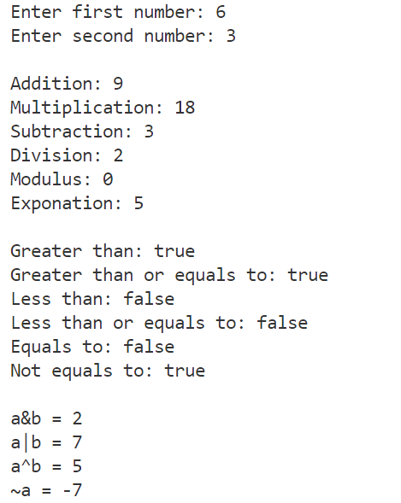

* **Program 4**

**// Calculating Grade & SPI**

import java.util.Scanner;

public class four {

public static void main(String[] args) {

Scanner sc = new Scanner(System.in);

//Calculating grade, gradepoints and SPI

String grade1, grade2;

int gradepoints1, gradepoints2;

//Inputing marks and credits of first subject

System.out.print("\nEnter marks of first subject: ");

int m1 = sc.nextInt();

System.out.print("Enter credits of first subject: ");

int c1 = sc.nextInt();

//Inputing marks and credits of second subject

System.out.print("\nEnter marks of second subject: ");

int m2 = sc.nextInt();

System.out.print("Enter credits of second subject: ");

int c2 = sc.nextInt();

//Calculating grades of first subject

if(m1 >= 80){

grade1 = "O";

}

else if(m1 >= 70){

grade1 = "A+";

}

else if(m1 >= 60){

grade1 = "A";

}

else if(m1 >= 55){

grade1 = "B+";

}

else if(m1 >= 50){

grade1 = "B";

}

else if(m1 >= 45){

grade1 = "C";

}

else if(m1 >= 40){

grade1 = "P";

}

else {

grade1 = "F";

}

//Calculating grades of second subject

if(m2 >= 80){

grade2 = "O";

}

else if(m2 >= 70){

grade2 = "A+";

}

else if(m2 >= 60){

grade2 = "A";

}

else if(m2 >= 55){

grade2 = "B+";

}

else if(m2 >= 50){

grade2 = "B";

}

else if(m2 >= 45){

grade2 = "C";

}

else if(m2 >= 40){

grade2 = "P";

}

else {

grade2 = "F";

}

//Calculating gradepoints of first subject

switch(grade1){

case "O":

gradepoints1 = 10;

break;

case "A+":

gradepoints1 = 9;

break;

case "A":

gradepoints1 = 8;

break;

case "B+":

gradepoints1 = 7;

break;

case "B":

gradepoints1 = 6;

break;

case "C":

gradepoints1 = 5;

break;

case "P":

gradepoints1 = 4;

break;

default:

gradepoints1 = 0;

break;

}

//Calculating gradepoints of second subject

switch(grade2){

case "O":

gradepoints2 = 10;

break;

case "A+":

gradepoints2 = 9;

break;

case "A":

gradepoints2 = 8;

break;

case "B+":

gradepoints2 = 7;

break;

case "B":

gradepoints2 = 6;

break;

case "C":

gradepoints2 = 5;

break;

case "P":

gradepoints2 = 4;

break;

default:

gradepoints2 = 0;

break;

}

//Calculating SPI

float spi = (float)((c1 * gradepoints1) + (c2 * gradepoints2)) / (c1 + c2); System.out.println("\nGrade of first subject is " + grade1);

System.out.println("Gradepoint of first subject is " + gradepoints1);

System.out.println("Grade of second subject is " + grade2);

System.out.println("Gradepoint of second subject is " + gradepoints2);

System.out.println("SPI is " + spi);

}

}

**--> Output:**

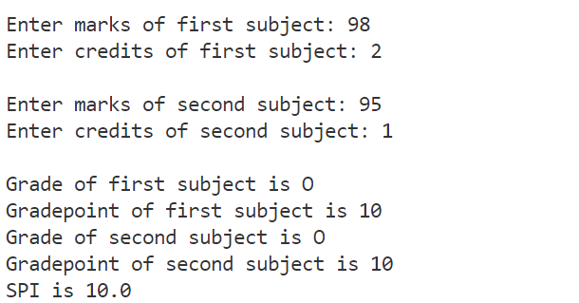

* **Program 5**

**// Maximum of Three**

import java.util.Scanner;

public class five {

public static void main(String[] args) {

Scanner sc = new Scanner(System.in);

//Finding maximum of three numbers

System.out.print("Enter first number: ");

int a = sc.nextInt();

System.out.print("Enter second number: ");

int b = sc.nextInt();

System.out.print("Enter third number: ");

int c = sc.nextInt();

if(a > b){

if(a > c){

System.out.println(a + " is the greatest number");

}

else{

System.out.println(c + " is the greatest number");

}

}

else{

if(c > b){

System.out.println(c + " is the greatest number");

}

else{

System.out.println(b + " is the greatest number");

}

}

}

}

**--> Output:**

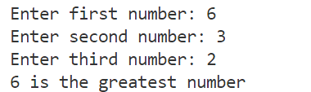

* **Program 6**

**// Checking number of Consonants & Vowels**

import java.util.Scanner;

public class six {

public static void main(String[] args) {

Scanner sc = new Scanner(System.in);

//Counting vowels and consonants in a line

System.out.print("Enter a string: ");

String s = sc.nextLine();

int vowel = 0;

int space = 0;

for(int i = 0; i < s.length(); i ++){

char letter = s.charAt(i);

if(letter == 'a' || letter == 'e' || letter == 'i' || letter == 'o' || letter == 'u'){

vowel = vowel + 1;

}

else if(letter == ' '){

space ++;

}

}

int conso = s.length() - vowel - space;

System.out.println("Number of vowels are " + vowel);

System.out.println("Number of consonants are " + conso);  
 }

}

**--> Output:**

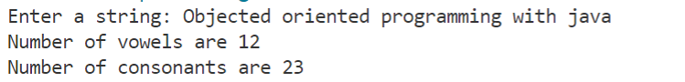

* **Program 7**

**// Number of words that start with capital letter**

import java.util.Scanner;

public class seven {

public static void main(String[] args) {

Scanner sc = new Scanner(System.in);

//Counting number of words that start with capital letters

System.out.print("Enter a sentence: ");

String line = sc.nextLine();

int word = 0;

char firstletter = line.charAt(0);

if(firstletter >= 65 && firstletter <= 90){

word ++;

}

for(int i = 0; i < line.length(); i ++){

char letter = line.charAt(i);

if(letter == ' '){

char first = line.charAt(i + 1);

if(first >= 65 && first <= 90){

word ++;

}

}

}

System.out.println("Total words starting with capital letters are " + word);

}

}

**--> Output:**



* **Program 8**

import java.util.Scanner;

public class CountVowels {

public static void main(String[] args) {

Scanner sc = new Scanner(System.in);

String x = "yes";

while (x.equals("yes")){

System.out.print("Enter a sentence: ");

String str = sc.nextLine();

String s = str.toLowerCase();

int n = s.length();

int a=0, e=0, i=0, o=0, u=0;

for (int j=0;j<n;j++){

char letter = s.charAt(j);

if(letter == 'a' ){

a++;

}

if(letter == 'e' ){

e++;

}

if(letter == 'i' ){

i++;

}

if(letter == 'o' ){

o++;

}

if(letter == 'u' ){

u++;

}

}

System.out.println("Number of 'a': " + a);

System.out.println("Number of 'e': " + e);

System.out.println("Number of 'i': " + i);

System.out.println("Number of 'o': " + o);

System.out.println("Number of 'u': " + u);

System.out.println("Do you want to continue?");

x = sc.nextLine();

}

System.out.println("Thankyou! for your Time");

sc.close();

}

}

**--> Output:**

