* **Program 9**

**// String in Pyramid form**

import java.util.*;

class Pyramid{

public static void main(String[] m){

char c;

int i,j;

Scanner in= new Scanner(System.in);

String s;

System.out.println("Enter A string : ");

s=in.next();

int k,d;

for(i=0;i<s.length();i++){

for(k=0;k<s.length()-i;k++) {

System.out.print(" ");

}

for(j=0;j<=i;j++){

c=s.charAt(j);

System.out.print(c+" ");

}

System.out.println(" ");

}

}

}

**--> Output:**

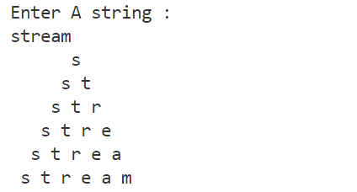

* **Program 10**

**// Diamond Pattern**

import java.util.Scanner;

public class Diamond {

public static void main(String[] args) {

Scanner sc = new Scanner(System.in);

int n = sc.nextInt();

for (int i=1; i<=n; i++){

for (int j=n-i; j>0; j--){

System.out.print(" ");

}

for (int k=1; k<=i; k++){

System.out.print("* ");

}

System.out.println();

}

for (int i=1; i<=n; i++){

for (int k=1; k<=i; k++){

System.out.print(" ");

}

for (int j=n-i; j>0; j--){

System.out.print("* ");

}

System.out.println();

}

sc.close();

}

}

**--> Output:**

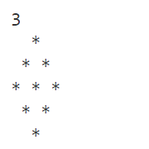

* **Program 11**

**// Passing by value**

import java.util.Scanner;

class CallByValue {

static void swap(int a, int b){

int c = a;

a=b;

b=c;

}

public static void main(String[] args) {

Scanner sc = new Scanner(System.in);

int a = sc.nextInt();

int b = sc.nextInt();

System.out.println("Values before: "+a+", "+b);

swap(a,b);

System.out.println("Values after: "+a+", "+b);

}

}

**--> Output:**

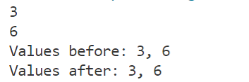

**// Passing By Reference**

import java.util.Scanner;

class Test{

int a, b;

void swap(Test t){

int c = a;

a = b;

b = c;

}

}

public class CallByReference {

public static void main(String[] args) {

Scanner sc = new Scanner(System.in);

Test t = new Test();

t.a = sc.nextInt();

t.b = sc.nextInt();

// t.a = 5;

// t.b = 6;

System.out.println("Values before: "+t.a+", "+t.b);

t.swap(t);

System.out.println("Values after: "+t.a+", "+t.b);

}

}

**--> Output:**

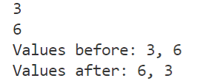

**// Returning value**

import java.util.Scanner;

class CallByValue {

static void swap(int a, int b){

int c = a;

a=b;

b=c;

}

public static void main(String[] args) {

Scanner sc = new Scanner(System.in);

int a = sc.nextInt();

int b = sc.nextInt();

System.out.println("Values before: "+a+", "+b);

swap(a,b);

System.out.println("Values after: "+a+", "+b);

}

}

**--> Output:**



**// Returning Object**

import java.util.Scanner;

class Test{

int a;

Test(int i){

a = i;

}

Test incr(){

Test t = new Test(a + 10);

return t;

}

}

class Main

{

public static void main(String[] args) {

Scanner input = new Scanner(System.in);

int n = input.nextInt();

Test t1 = new Test(n);

Test t2;

t2 = t1.incr();

System.out.println("Value before: "+t1.a);

System.out.println("Value after: "+t2.a);

}

}

**--> Output:**

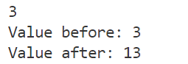

* **Program 12**

**// Area of various Geometric Figures using Method Overloading**

public class AreaMethOverload{

public static void findArea(int l){

System.out.println("Area of Square is :"+ (l*l));

}

public static void findArea(int l, int b){

System.out.println("Area of Rectangle is :"+ (l*b));

}

public static void findArea(int l, int b, int h){

System.out.println("Area of Trapezoid is :"+ (0.5*(l+b)*h));

}

public static void main(String[] args) {

findArea(5);

findArea(5,6);

findArea(5,6,7);

}

}

**--> Output:**

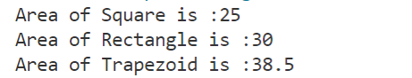

* **Program 13**

**// Scientific Calculator using Math Function**

import java.util.Scanner;

import java.lang.Math;

public class Calculator {

public static void main(String[] args) {

Scanner sc = new Scanner(System.in);

System.out.println("(+) Addition\n(-) Subtraction\n(*) Multiplication\n(/) Division\n(%) Remainder\n(^) Square\n(s) Square root");

System.out.print("\nEnter your Choice: ");

String n = sc.nextLine();

System.out.print("Enter two numbers: ");

int a = sc.nextInt();

int b = sc.nextInt();

if (n=="+"){

System.out.println("Addition: "+ Math.addExact(a,b));

}

else if (n=="-"){

System.out.println("Subtraction: "+ Math.subtractExact(a,b));

}

else if (n=="*"){

System.out.println("Multiplication: "+ Math.multiplyExact(a,b));

}

else if (n=="/"){

System.out.println("Division: "+ Math.floorDiv(a,b));

}

else if (n=="%"){

System.out.println("Modulus: "+ (a%b));

}

else if (n=="s"){

System.out.println("Square root: "+ (Math.sqrt(a)));

}

else if (n=="^"){

System.out.println("Square root: "+ (Math.pow(a,2)));

}

sc.close();

}

}

**--> Output:**

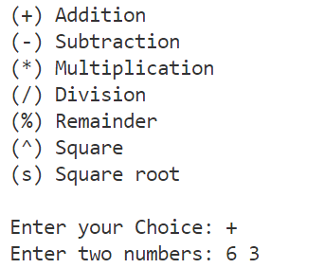



* **Program 14**

**// Sorting Array**

import java.util.Scanner;

public class SortArray {

public static void main(String[] args) {

int n, temp;

Scanner sc = new Scanner(System.in);

// Taking input of array

System.out.print("Enter no. of elements you want in array: ");

n = sc.nextInt();

int a[] = new int[n];

System.out.println("Enter all the elements:");

for (int i = 0; i < n; i++)

{

a[i] = sc.nextInt();

}

**// Sorting loop**

for (int i = 0; i < n; i++)

{

for (int j = i + 1; j < n; j++)

{

if (a[i] > a[j])

{

temp = a[i];

a[i] = a[j];

a[j] = temp;

}

}

}

**// Printing the array**

System.out.print("Ascending Order: ");

for (int i = 0; i < n - 1; i++)

{

System.out.print(a[i] + ", ");

}

System.out.print(a[n - 1]);

}

}

**--> Output:**

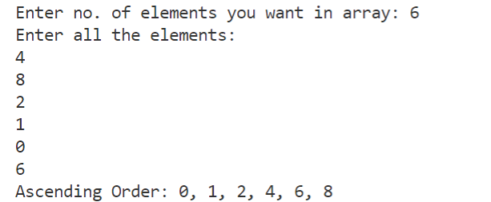

* **Program 15**

**// Multiplication of Matrices**

import java.util.Arrays;

import java.util.Scanner;

public class MatrixMultiply {

public static void main(String[] args) {

Scanner sc = new Scanner(System.in);

int i,j,k;

**// Taking dimensions of Arrays**

System.out.print("Enter no. of rows of 1st array: ");

int row1 = sc.nextInt();

System.out.print("Enter no. of columns of 1st array: ");

int col1 = sc.nextInt();

System.out.print("Enter no. of rows of 1st array: ");

int row2 = sc.nextInt();

System.out.print("Enter no. of columns of 1st array: ");

int col2 = sc.nextInt();

if (col1==row2){

**// First Array**

System.out.println("\nEnter elements of 1st array");

int a[][] = new int[row1][col1];

for (i=0; i<row1; i++){

for (j=0; j<col1; j++){

System.out.printf("Enter element[%d][%d] : ",i,j);

a[i][j] = sc.nextInt();

}

}

System.out.println("1st Array: "+Arrays.deepToString(a));

**// Second Array**

System.out.println("\nEnter elements of 2nd array");

int b[][] = new int[row2][col2];

for (i=0; i<row2; i++){

for (j=0; j<col2; j++){

System.out.printf("Enter element[%d][%d] : ",i,j);

b[i][j] = sc.nextInt();

}

}

System.out.println("2nd Array: "+Arrays.deepToString(a));

**// Multiplying Array**

int c[][] = new int[row1][col2];

for (i = 0; i < row1; i++) {

for (j = 0; j < col2; j++) {

for (k = 0; k < row2; k++){

c[i][j] += a[i][k] * b[k][j];

}

}

}

System.out.print("\nThe Multiplied array is ");

System.out.println(Arrays.deepToString(c));

}

else{

System.out.println("\nArrays can't be multiplied!!");

}

}

}

**--> Output:**

