**Machine Learning Experiment 10**

**Title: Write a python program to implement K-Means clustering Algorithm.**

**Objective:** The objective of this lab assignment is to implement the K-Means clustering algorithm from scratch in Python and gain a deep understanding of how the algorithm works.

**Tasks:**

**Make dataset**

import numpy as np

import matplotlib.pyplot as plt

from sklearn.datasets import make_blobs

X, y = make_blobs(n_samples=300, centers=4, random_state=42, cluster_std=1.0)

plt.scatter(X[:, 0], X[:, 1], s=50, c='gray')

plt.title('Generated Dataset')

plt.show()

**1. Implement the K-Means clustering algorithm from scratch in Python**

**Code:**

class KMeans:

def __init__(self, k, max_iters=100):

self.k = k

self.max_iters = max_iters

self.centroids = None

def initialize_centroids(self, X):

np.random.seed(42)

random_indices = np.random.permutation(X.shape[0])

centroids = X[random_indices[:self.k]]

return centroids

def assign_clusters(self, X, centroids):

distances = np.linalg.norm(X[:, np.newaxis] - centroids, axis=2)

return np.argmin(distances, axis=1)

def update_centroids(self, X, labels):

new_centroids = np.array([X[labels == i].mean(axis=0) for i in range(self.k)])

return new_centroids

def fit(self, X):

self.centroids = self.initialize_centroids(X)

for i in range(self.max_iters):

labels = self.assign_clusters(X, self.centroids)

new_centroids = self.update_centroids(X, labels)

if np.all(self.centroids == new_centroids):

break

self.centroids = new_centroids

return self.centroids, labels

def inertia(self, X, labels):

return np.sum((X - self.centroids[labels]) ** 2)

**2. Visualize the dataset and plot the initial centroids.**

**Code:**

kmeans = KMeans(k=4)

initial_centroids = kmeans.initialize_centroids(X)

centroids, labels = kmeans.fit(X)

plt.scatter(X[:, 0], X[:, 1], s=50, c='gray', label='Data Points')

plt.scatter(initial_centroids[:, 0], initial_centroids[:, 1], s=200, c='red', marker='X', label='Initial Centroids')

plt.title('Initial Random Centroids')

plt.legend()

plt.show()

**Output:**

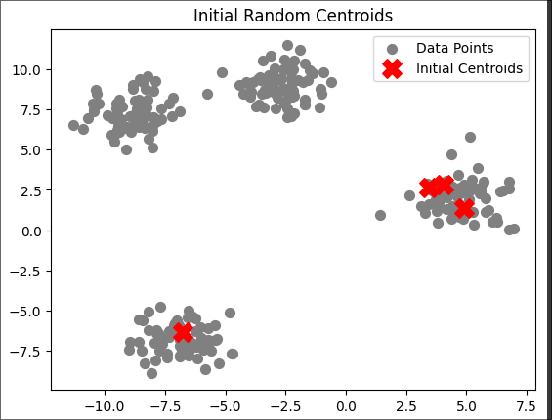

**3. Implement a method to calculate the sum of squared distances (inertia) for different values of K. Use this to determine an appropriate K for your dataset.**

**Code:**

plt.scatter(X[:, 0], X[:, 1], c=labels, s=50, cmap='viridis', label='Data Points')

plt.scatter(centroids[:, 0], centroids[:, 1], s=200, c='blue', marker='X', label='Final Centroids')

plt.title('K-Means Clustering with Final Centroids')

plt.legend()

plt.show()

inertia_values = []

K_values = range(1, 11)

for k in K_values:

kmeans = KMeans(k=k)

centroids, labels = kmeans.fit(X)

inertia = kmeans.inertia(X, labels)

inertia_values.append(inertia)

plt.plot(K_values, inertia_values, marker='o')

plt.title('Elbow Method for Optimal K')

plt.xlabel('Number of clusters (K)')

plt.ylabel('Inertia (Sum of Squared Distances)')

plt.xticks(K_values)

plt.grid()

plt.show()

for k, inertia in zip(K_values, inertia_values):

print(f"K = {k}, Inertia = {inertia:.2f}")

optimal_k = K_values[np.argmin(inertia_values)]

print(f"The optimal K is: {optimal_k}")

kmeans_optimal = KMeans(k=optimal_k)

centroids_optimal, labels_optimal = kmeans_optimal.fit(X)

plt.scatter(X[:, 0], X[:, 1], c=labels_optimal, s=50, cmap='viridis', label='Data Points')

plt.scatter(centroids_optimal[:, 0], centroids_optimal[:, 1], s=200, c='blue', marker='X', label='Final Centroids')

plt.title(f'K-Means Clustering with Optimal K = {optimal_k}')

plt.legend()

plt.show()

**Output:**

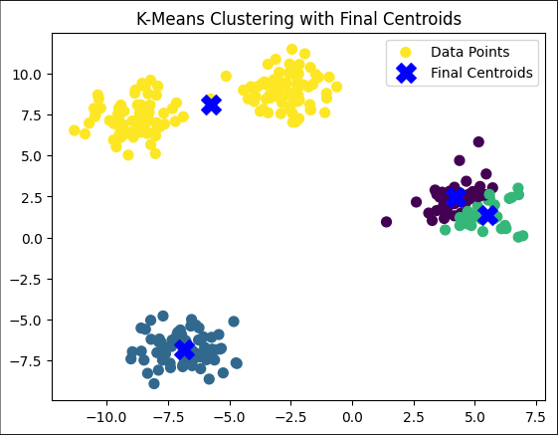 *Clusters = 5*

*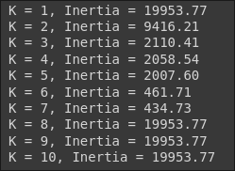 Sum of squared errors for different values of K*

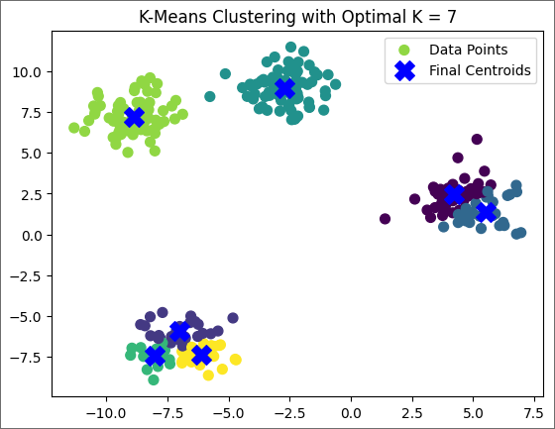 *Least sum of squares for K = 7*