





Prepared By – Shahbaz Akhtar

Code Refactoring and Bug Report Analysis

On

**Note taking Application**

**About Me**

I am an MBA graduate with highly passionate in learning new techniques evolving around. I have worked in corporate as well as business sector.

And with my gained experience I have learnt about the inconsistency in the fields and how to deal around with it. With the development in the AI world, it really motivated me to pursue the Data Science course. With the tons of information available, it is helpful in generating the insights for better decision making. The world is dependent on data driven approach, and its shaping the society. I have worked in so many projects with Python enabled, Sql, and Tableau. I am dedicated to give my contributions towards this field. commendable to embrace it.



**Agenda**

* **Project Description**
* **Bugs Identification**
* **Approach to Resolve**
* **Fixing the bugs**
* **Modifications**

**Tools and Tech Stack**

* **Microsoft Visual Studio code**
* **Python**
* **Flask**
* **HTML**



**Project Description**

To Refactor the existing codebase and ensure the proper functioning of the Note Taking Application. Identifying allbugs during the debugging process. Ensuring to fix the existing codebase inorder to make the application work.

**Bugs Identification**

Initially, From the index() route, Flask application is attempting to handle only POST requests, and it attempts to retrieve the note from the request arguments using request.args.get("note") which typically send data in the request body, not in the query string.

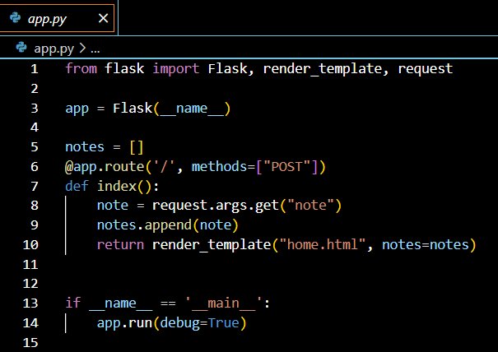



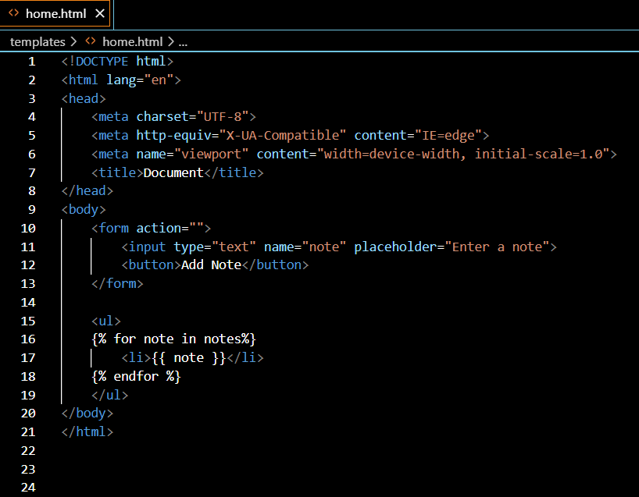

The issue with the HTML code is that the form's action attribute is empty, which means it will default to submitting the form to the current URL without any query parameters. Therefore, accessing the note using request.args.get("note") results in None.

**Approach to Resolve**

After debugging, the approach to resolve the bug involves modifying the Flask route to handle GET request. And updating the form action of html code with action and method.



**Fixing the bugs**

Changing the route decorator of index funtion to handle GET requests (methods=["GET"]).

Also, specifying the method attribute of the form element to "POST" to ensure that the form data is sent as a POST request( <form action="/" method="POST">).

**Modifications**

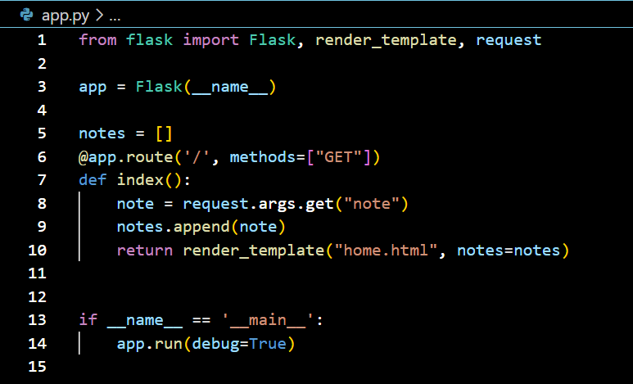



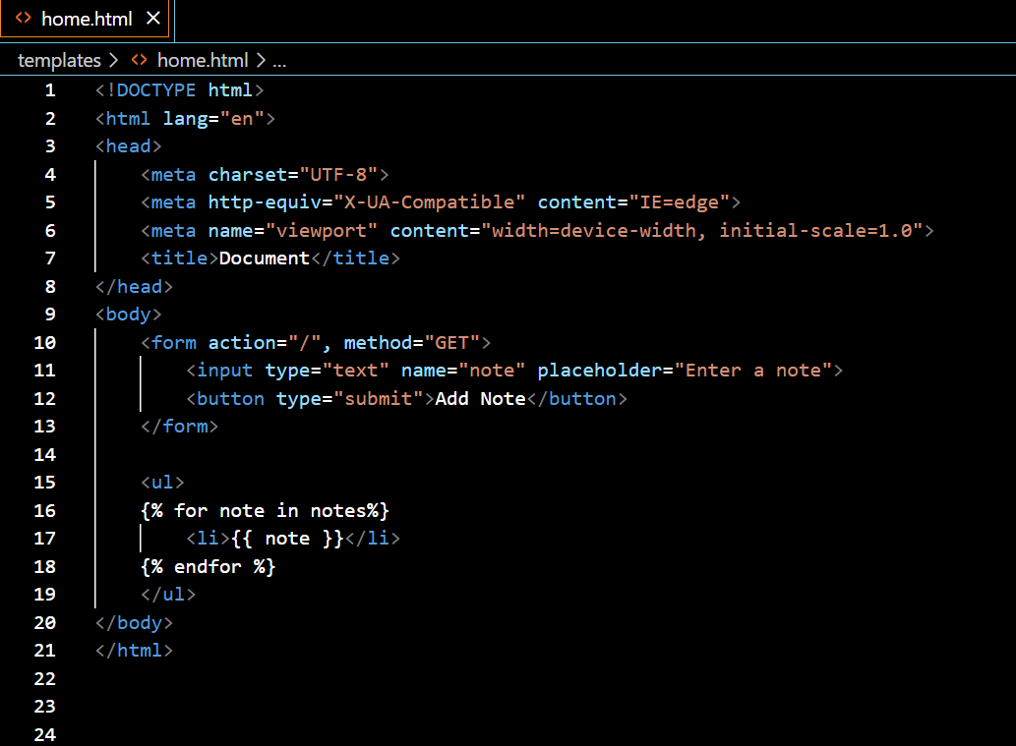

Verification

After implementing the changes, the application was able to correctly handle

With GET requests. When submitting the form, the note was added to

the list of notes without encountering any errors.



Final Output

 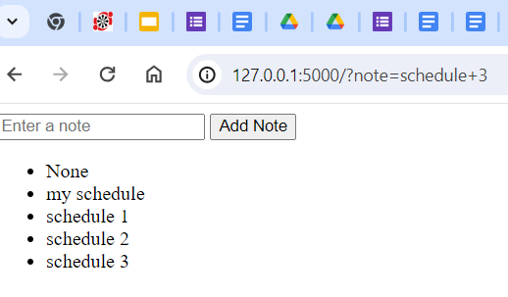

Conclusion

By updating the Flask route to handle GET requests and updating the empty form action with action and method. form data for POST requests, the bug was been successfully resolved, and the application now functions as intended. The improvements has contributed to an efficient user experience