Building application with BUN
Application with separate Projects structure
- Create Project Folder:
- Make a single root folder: mkdir my-fullstack-app
- Enter it: cd my-fullstack-app
- ⚛️ Set Up React Client:
- Run bun create vite client -- --template react-ts to create the /client folder.
- cd client
- bun install (to install React's dependencies)
- cd .. (to go back to the root)
- 🚀 Set Up Express Server:
- Make the server folder: mkdir server
- cd server & Initialize a Bun project: bun init -y
- Add Express: bun add express @types/express
- Replace index.ts with your Express server code, listening on port 3001.
- Add a dev script to server/package.json: "dev": "bun --watch index.ts"
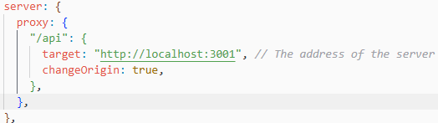
- cd .. (to go back to the root)
- 🔌 Connect Client to Server:
- Open client/vite.config.ts.
- Add a server.proxy object to forward any requests from /api to your backend server (http://localhost:3001).
- 💻 Fetch Data in React:
- Open client/src/App.tsx.
- Use a useEffect hook to fetch('/api/hello').
- Store the JSON response in a state variable and display the message.
- 🏃 Run the Full Application:
- In Terminal 1: cd server then bun dev.
- In Terminal 2: cd client then bun dev.
- Open http://localhost:5173 in your browser to see the final result.

Application with Managed Monorepo
The main goal is to have a single root package.json that manages the entire project, allowing you to install all dependencies from one place and easily share code.
- Initialize the Root:
- In the project's root folder (my-fullstack-app), create a new package.json file by running$bun init -y$.
- Define the Workspaces:
- Edit this new root package.json to tell Bun where your individual projects (the "workspaces") are.
- It's a common practice to put all apps in an apps folder.
- File: /package.json (Root)
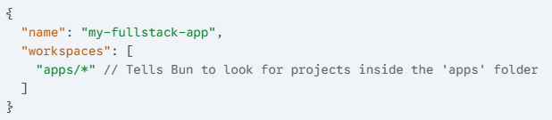
- Organize Your Folders:
- Create a new folder in the root named apps.
- Move your existing client and server folders inside the apps folder.
- The structure will now be: my-fullstack-app/apps/client and my-fullstack-app/apps/server.
- Install All Dependencies (Hoisting):
- Delete the individual node_modules folders from inside apps/client and apps/server.
- Go back to the root folder (my-fullstack-app).
- Run bun install.
- Bun will now read the package.json from client and server, find all their dependencies, and install them into a single node_modules folder at the root. This is called hoisting.
- Create Root-Level Scripts:
- (Optional, but highly recommended) Add scripts to your root package.json to run both projects at once.
- File: /package.json (Root)
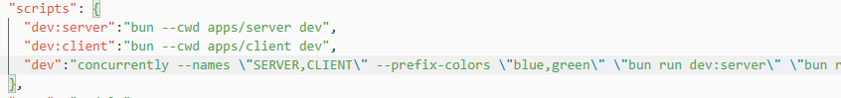
Now, you can just run bun dev from the root, and it will start both your client and server.
The Key Benefits of This Change
- Single Install: You only ever need to run bun install from the root.
- Centralized Dependencies: All node_modules are in one place, saving space and preventing version conflicts.
- Shared Code: You can easily add a packages/shared-types folder and import code from it into both your client and server.
- One Command to Run: You can start your entire application with a single bun dev command.

Now push Monorepo to GitHub and perform cleanup.

