**Missing Content  
  
Page -> Mobile App Development Services**

**Section 2  
  
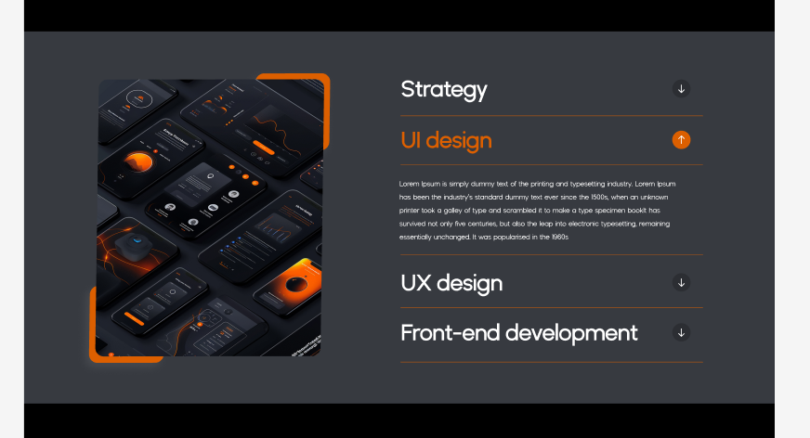**

**Page -> No Code / Low Code  
  
Section 3  
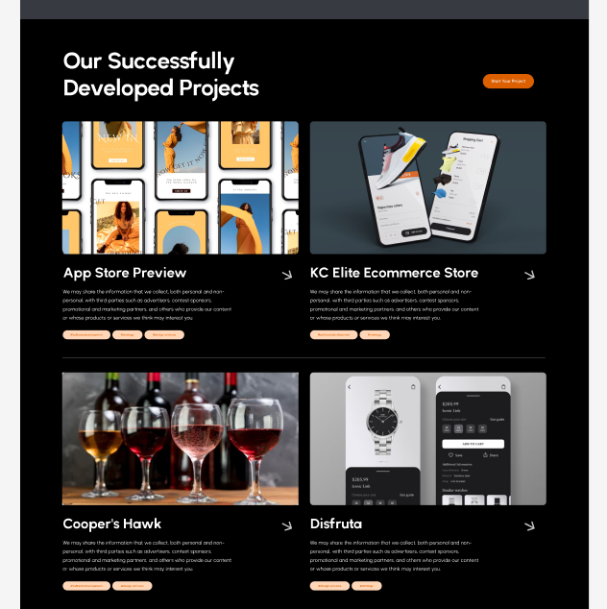**

**Page -> AI DEVELOPMENT  
Section -4  
  
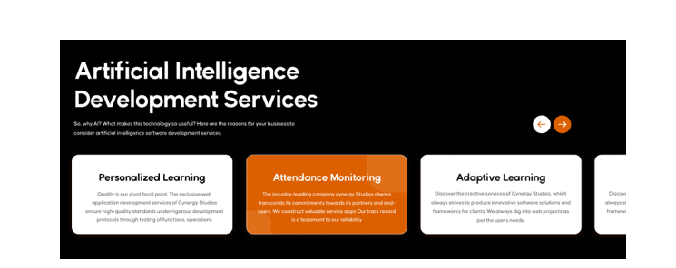  
  
We need 5 sliders content , but currently there are only 3 sliders content**

**Page -> IOS APP DESIGN**

**Section - 2  
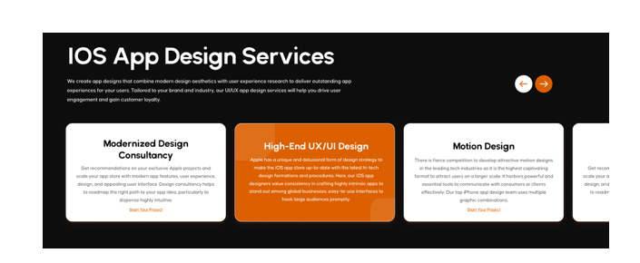  
  
We need 5 sliders content , but currently there are only 4 sliders content**