Switching-Verified Design and Grid-Disturbance Ride-Through of a Three-Stage Solid-State Transformer Interface for a PV-BESS Microgrid
Shahbaz*
Power System Lab, Department of Electrical Engineering, K.K. University, Nalanda, Bihar, India
* Corresponding author. E-mail address: shahbazsauby@gmail.com
Abstract
Solid-state transformers (SSTs) are increasingly proposed as grid interfaces for photovoltaic-battery-energy-storage (PV-BESS) microgrids on the strength of their inherent medium-voltage energy buffering, but published comparisons rarely isolate how much of that apparent ride-through advantage comes from the SST topology itself rather than simply from having some energy buffer ahead of the regulated bus. This paper designs, verifies, and evaluates a three-stage SST — a cascaded H-bridge (CHB) medium-voltage rectifier, a dual-active-bridge (DAB) isolated DC-DC stage, and a reused low-voltage grid-tie inverter — that replaces a conventional line-frequency-transformer-plus-voltage-source-converter (LFT+VSC) interface in a 150 kVA PV-BESS microgrid, at an identical power class, so that the interface architecture is the only variable under test. Each stage is verified at switching resolution: one DAB cell matches its analytic power-transfer formula to within 0.08% and holds zero-voltage switching (ZVS) across its full practical duty range; a 9-cell CHB stage delivers 99.1% of rated power at 0.56% current total demand distortion (TDD), well inside IEEE 519-2022's classical harmonic band. Efficiency is simulated with an electro-thermal loss model built on real device datasheets and iterated to each device's converged junction temperature, revealing that an initial 10 kHz CHB carrier frequency was a poor design choice (92.6% cell efficiency) and motivating a corrected 1 kHz operating point (98.9%); the full SST reaches 94.3% efficiency against the conventional interface's 97.0%. A disturbance-rejection study shows the SST's medium-voltage (MV) DC-link buffer rides through grid sags for up to about 453 ms while the conventional interface trips within milliseconds; a fair, energy-buffer-matched conventional baseline — the same VSC interface given a passive low-voltage-side capacitor bank sized to the SST's own stored-energy budget — rides through for an almost identical duration, showing that ride-through time is primarily an energy-buffer-size effect rather than a topology-specific one, while the SST achieves that same budget with roughly 13 times less capacitance by storing the energy at medium rather than low voltage. A 500-trial Monte Carlo sweep, drawing sag depth, duration and coincident PV/load severity at random and bootstrapping the PV cloud-transient magnitude from real NREL irradiance measurements, shows the SST trips in only 1.2% of trials against 57.8% for the conventional interface, and never on a disturbance the conventional interface would have survived. Finally, a decentralized closed-loop active cell-balancing controller, simulated across the full 9-cell fleet, converges a mismatch that would otherwise reach 15% deviation in 6.4 s to under 0.05% within about 1 s. Every result comes from a reduced-order, switching-resolution-cross-checked interface model rather than hardware-in-the-loop testing; the implications of this interface swap for a supervisory energy-management layer are treated in a companion study [16].
Highlights
- A three-stage SST (CHB + DAB + reused LV inverter) replaces a conventional LFT+VSC interface at the same 150 kVA microgrid power class.
- Switching-resolution verification: 0.08% DAB power-transfer error, full-range ZVS, 0.56% CHB current TDD.
- Electro-thermal loss modeling on real device datasheets identifies 1 kHz as the CHB's efficiency-optimal carrier frequency (92.6% to 98.9% cell efficiency).
- A fair, energy-buffer-matched conventional baseline shows ride-through TIME is primarily an energy-buffer-size effect; the SST buys the same budget with ~13x less capacitance.
- SST trips in only 1.2% of 500 randomized sags against 57.8% for the conventional interface, and never on a disturbance the conventional interface survives.
- Closed-loop cell balancing reduces a 3% per-cell mismatch that would otherwise reach 15% deviation in 6.4 s to under 0.05% within about 1 s.
Keywords: Solid-state transformer; Cascaded H-bridge converter; Dual active bridge converter; Microgrid resilience; Grid-disturbance ride-through; Electro-thermal loss modeling
Nomenclature
SST | solid-state transformer
LFT | line-frequency transformer
VSC | voltage-source converter
CHB | cascaded H-bridge
DAB | dual active bridge
MFT | medium-frequency transformer
PSC-PWM | phase-shifted-carrier pulse-width modulation
MV / LV | medium voltage / low voltage
N | number of series H-bridge cells per phase
ma | modulation index
n | DAB transformer turns ratio
d | DAB single-phase-shift ratio (0-0.5)
fs | DAB switching frequency
Lk | DAB leakage inductance
P | DAB transferred power
V1 | per-cell MV DC-link voltage (V1,i for cell i)
V1,nom / V1,floor | nominal / minimum-permitted MV DC-link voltage
V2 | DAB low-voltage terminal voltage (≈ Vdc, 800 V nominal)
d0 | nominal phase-shift operating point for small-signal linearization (0.35)
C | MV DC-link capacitance (per-cell or aggregate, as stated)
Pcell | per-cell rated power
Thold | analytic full-rated-power ride-through hold-up time
Vdc | LV DC bus voltage
TDD | total demand distortion
Isc/IL | short-circuit ratio (IEEE 519-2022)
Vce,sat | IGBT collector-emitter saturation voltage
Rds(on) | SiC MOSFET on-state drain-source resistance
Eon / Eoff | device turn-on / turn-off switching energy
Tj / Tc | device junction / case temperature
Rth(j-c) | junction-to-case thermal resistance
ri, τi | Foster thermal-network branch resistance and time constant
ei | cell-balancing controller's per-cell voltage error, V1,i − V1,nom
pcorr,i | cell-balancing controller's per-cell power correction command
Kp, Ki | cell-balancing controller's proportional and integral gains
Pmax | cell-balancing correction saturation limit (±0.30·Pcell)
ZVS | zero-voltage switching

1. Introduction
Distribution-level microgrids that combine photovoltaic (PV) generation with battery energy storage (BESS) are increasingly connected to the grid through power-electronic converters rather than a passive line-frequency transformer (LFT) alone. Active conversion lets the interface itself contribute to voltage regulation, harmonic control, and disturbance ride-through, none of which a plain LFT can offer [1]-[4]. A solid-state transformer (SST) goes a step further: by cascading a medium-voltage (MV) AC-DC stage, a galvanically isolated DC-DC stage, and a low-voltage (LV) DC-AC stage, it creates an internal, regulated DC bus that PV and BESS resources can connect to directly, while the MV-side stage handles grid-side power quality and, as shown later in this paper, disturbance ride-through [1], [2], [4]. SST interfaces have already been proposed for exactly this microgrid-connection role [9].
SST-interfaced microgrids have been proposed and analyzed before [9], [12], and a recent state-space stability study specifically frames the SST as a resilience-enabling distribution-system component [10], but the published comparisons in this space rarely isolate one specific question: how much of an SST's apparent ride-through advantage comes from the SST topology itself, and how much simply reflects the fact that the SST happens to have some energy buffer ahead of its regulated bus, a buffer any interface could in principle be given? A conventional LFT+VSC interface's own LV bus capacitance is ordinarily sized only for switching-ripple filtering, never for ride-through, so a straight SST-vs-conventional comparison risks conflating topology with buffer sizing rather than isolating them. This paper closes that gap directly with a purpose-built, energy-buffer-matched conventional baseline.
Stated as a single research question, this paper asks: does replacing a conventional LFT+VSC grid interface with a solid-state transformer fundamentally improve a PV-BESS microgrid's resilience to grid disturbances, and at what cost in efficiency and hardware complexity — and how much of any ride-through advantage is attributable to the SST topology specifically, as opposed to simply having a comparably sized energy buffer of any kind? Sections 3-5 establish what actually changes at the hardware level and verify it at switching resolution; Section 6 quantifies how much resilience difference that hardware change makes, first under a clean fixed disturbance, then under increasingly realistic randomized and coincident conditions, and includes the fair energy-buffer-matched baseline that answers the topology-versus-buffer-size question directly; Section 7 closes the design's own most serious open reliability gap, cell-level voltage imbalance, so the resilience claim is not undercut by a mechanism this paper had otherwise left unaddressed.
This paper is the hardware-focused half of a two-part study. A companion paper [16] uses this same SST design to ask a distinct question: what does this interface swap mean for a supervisory reinforcement-learning energy-management system built for the conventional interface — does it need retraining, does retraining alone help, and does what the agent is allowed to observe matter as much as how it is trained? That companion analysis is deliberately kept separate from the hardware verification and resilience characterization presented here, on the reasoning that conflating the two would obscure which layer (interface hardware or supervisory dispatch) is actually responsible for a given result. Readers interested in the supervisory-EMS implications of this same interface swap, and in a techno-economic analysis that weighs the efficiency penalty quantified here against avoided battery-cycling stress and downtime cost, are referred to in the companion study [16].
This paper makes six contributions. (1) A fully dimensioned three-stage SST design (CHB + DAB + reused LV inverter) built at a representative 150 kVA microgrid power class. (2) Independent, switching-resolution verification of the CHB and DAB stages. (3) A switching-loss simulation, built on real device datasheet parameters, that replaces the usual literature-typical efficiency assumption and, in the process, catches and corrects an impractical switching-frequency choice in the initial CHB design, then extends the model with temperature-dependent device parameters, the manufacturer's own thermal network, and a dynamic electro-thermal transient coupling to actual ride-through events. (4) A disturbance-rejection test, run separately from any supervisory control layer, that quantifies the SST's MV-side ride-through budget against the conventional interface's near-instant protection trip, extended with a second test where the sag coincides with independent PV/load fluctuation, and with a fair, energy-buffer-matched conventional baseline that isolates how much of that ride-through advantage is attributable to the SST topology specifically versus simply having a comparably sized energy buffer of any kind. (5) A 500-trial Monte Carlo statistical sweep over randomized sag depth, duration, and coincident PV/load severity, with the PV cloud-transient magnitude bootstrap-resampled from real NREL irradiance measurement data. (6) A fully simulated closed-loop active cell-balancing controller across the nine CHB/DAB cells, replacing an open-loop drift estimate with a working correction loop and a measured convergence time.
The rest of the paper is organized as follows. Section 2 specifies the microgrid electrical system this interface serves. Section 3 presents the proposed SST architecture. Section 4 covers the CHB and DAB stage designs and their switching-resolution verification. Section 5 describes the disturbance-rejection methodology. Section 6 presents results, including the switching-loss/thermal simulation (6.3) and the coincident-disturbance and Monte Carlo tests (6.4-6.5). Section 7 implements and simulates the closed-loop active cell-balancing controller. Section 8 discusses remaining limitations, and Section 9 concludes.

2. Microgrid Interface Specification
This paper's scope is the grid interface itself, isolated deliberately from whatever supervisory dispatch policy sits above it; the companion paper [16] specifies and evaluates the supervisory energy-management layer in full. For the interface-level verification and disturbance testing that follow, the microgrid electrical system is specified as follows, matching the power class used throughout this two-part study so that the interface swap is architecturally direct rather than a redesign at a different scale. The PV array is 100 kWp; the BESS is 200 kWh / 100 kW, connected through a bidirectional buck-boost converter at the DC bus; the local load varies between 60 and 120 kW; and the aggregate grid-interface rating is 150 kVA on both sides of the interface swap. The common LV DC bus is held at 800 V nominal on both the conventional and SST interfaces, so that the BESS buck-boost converter and PV boost stage attach without modification regardless of which grid interface sits behind that bus. Section 6.1 shows algebraically why nominal-condition bus regulation is unaffected by the interface swap; the consequences of that swap for a trained supervisory dispatch policy are the subject of the companion paper [16].

3. Proposed SST Architecture
The proposed SST replaces an implicit LFT and single grid-tie VSC with three cascaded stages, summarized in Table 1 and detailed in Section 4. The first is a 3-cell-per-phase cascaded H-bridge (CHB) MV rectifier — 9 cells in total across three phases — that converts an 11 kV MV feeder into nine regulated MV DC links. The second is a dedicated dual active bridge (DAB) DC-DC converter per cell, each with its own medium-frequency transformer (MFT), with all nine DAB secondaries paralleled onto one common 800 V LV DC bus. The third stage is a conventional LV grid-tie inverter, drawing from this internal 800 V bus instead of directly from the BESS/PV; since this stage's design, control, and switching behavior are unaffected by the choice of MV-side interface architecture, it is reused without modification and without re-verification at switching resolution.
Table 1. Proposed SST stage summary.
Stage | Function / Rating
MV CHB rectifier | 3 cells/phase × 3 phases = 9 cells, 11 kV MV feeder, 3300 V per-cell DC link, 7-level line-to-neutral output
DAB isolation stage | 1 per CHB cell (9 total), 3300 V → 800 V, n=4 MFT, 10 kHz, all secondaries paralleled on the common LV bus
LV grid-tie inverter | 3-phase 2-level, LCL filter, dq control, 415 V/50 Hz (reused, unchanged)
Aggregate rating | 150 kVA
Common LV DC bus | 800 V nominal

4. SST Design and Switching-Level Verification

4.1. Cascaded H-Bridge MV Stage
Each phase's three series H-bridge cells carry the full phase current (7.873 A RMS at the 150 kVA/11 kV rating) and jointly build up the phase voltage using phase-shifted-carrier (PSC) unipolar PWM, with each cell's carrier shifted by 1/3 of a carrier period from its neighbor. That gives a 2N+1 = 7-level line-to-neutral (per-phase stack) voltage waveform for N=3 series cells, distinct from the line-to-line voltage, which combines two phase stacks and so has more distinct levels. The three cells within a phase are modeled as symmetric (identical per-cell rating and carrier phase-shift, differing only in carrier phase); each cell's own DC-link capacitor voltage is treated as held at its 3300 V setpoint by that cell's own DAB regulation loop (Section 4.2) rather than assumed constant, so capacitor-voltage balance across the three series cells is a consequence of that per-cell regulation rather than a separate assumption. At a per-cell DC link of 3300 V (a common MV SiC/IGBT device class), the maximum combined phase-voltage amplitude works out to N·V1 = 9900 V against the 8981.5 V peak phase voltage that 11 kV service requires, for a modulation index ma = 0.917 with room to spare.
The per-cell carrier frequency reported here, 1 kHz, is not the first value tried: it was reached only after the switching-loss simulation in Section 6.3 showed a first-cut 10 kHz choice was a poor match for this device class, and a frequency sweep found a better one, detailed there. A switching-resolution simulation at that 1 kHz carrier — PSC-PWM, an explicit-Euler time-domain model of the current through a small 2%-pu MV-side series filter inductor — delivers 99.1% of the 150 kVA target and converges, after N_SUB refinement, to a current total demand distortion (TDD) of 0.56%. That is still more than an order of magnitude inside IEEE 519-2022's classical (h=2-50) TDD limit of 20% for an estimated Isc/IL ≈ 1667 (a representative 250 MVA feeder fault level) — a claim scoped deliberately to that classical harmonic band and this assumed short-circuit ratio at the MV point of common coupling, not a general IEEE 519 compliance certification (Section 8 states this scope explicitly). This comfortable margin, and the small filter it allows, comes directly from the multilevel waveform's lower harmonic content compared to a conventional 2-level VSC, which needs a full LCL filter for the same job.
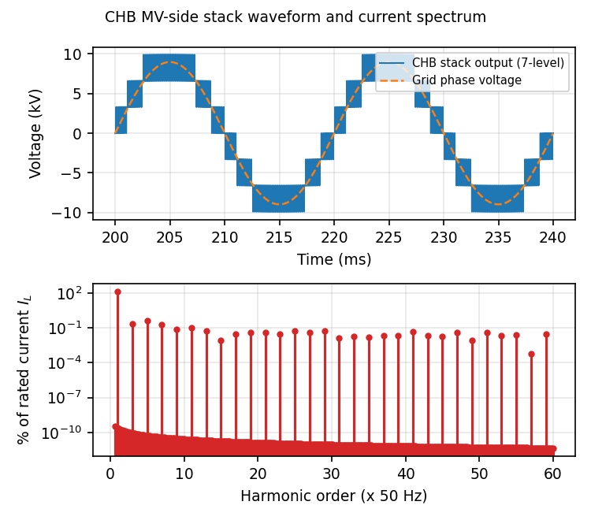
Fig. 1. CHB 7-level MV-side stack voltage vs. the grid phase voltage (top), and the resulting current spectrum (bottom).

4.2. Dual Active Bridge Isolation Stage
Each CHB cell (16.667 kW rated, 150 kVA split across 3 phases and 3 cells) feeds a dedicated DAB with a medium-frequency transformer of turns ratio n=4, rounded from V1/V2 = 3300/800 = 4.125. That leaves a 3.03% mismatch, which phase-shift control margin absorbs. Switching at 10 kHz, single-phase-shift (SPS) control transfers power as
P = n·V1·V2·d(1−d) / (2·fs·Lk),
where d is the phase-shift ratio (0-0.5). Lk is sized at 7.207 mH so that rated power (16.667 kW) occurs at d=0.35, leaving margin to the d=0.5 maximum-transfer point for transient and regulation headroom. A switching-resolution time-domain simulation of one representative cell — applying the actual SPS square-wave bridge voltages and integrating the leakage-inductor current — matches this analytic formula to within 0.08% across d=0.10-0.50 (Fig. 3). The same simulation confirms the transformer current has the right sign at both bridges' switching instants, the condition for zero-voltage switching (ZVS). That holds across the entire d ≥ 0.02 range: because V1 ≈ n·V2 (the voltage-matched condition), ZVS extends across nearly the whole practical operating range rather than a narrow band.
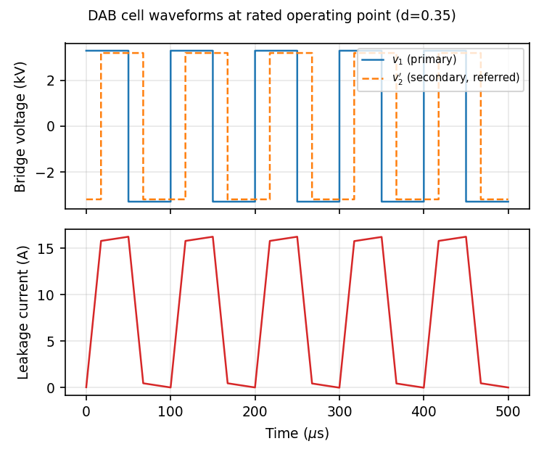
Fig. 2. DAB cell bridge voltages and leakage-inductor current at the rated operating point (d=0.35).
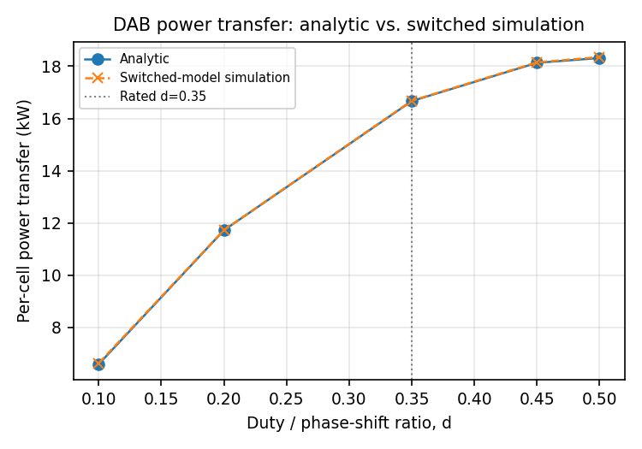
Fig. 3. DAB power transfer: analytic formula vs. switched-model simulation, across the operating duty range.

4.3. LV Grid-Tie Inverter (Reused, Unchanged)
The output stage is a three-phase, two-level, LCL-filtered, dq-controlled grid-tie inverter carried over unchanged from a prior converter design at the same power class, now drawing from the SST's internal 800 V bus instead of directly from the BESS/PV. Its design, control, and switching behavior are unaffected by the MV-side interface change, so it is not re-verified here; Section 6.1 explains why that reuse is exact.

5. Disturbance-Rejection Methodology
This paper isolates the grid interface's own disturbance-rejection behavior from any supervisory dispatch layer, on the reasoning that conflating the two would obscure which one is actually responsible for a given result (the supervisory-layer question is the subject of the companion paper [16]). Both interfaces are subjected to a fixed 60 kW net LV-bus power deficit, calibrated for about 3% settling in about 100 ms on a 60 kW step, held constant, while an MV-side grid voltage sag or full interruption is applied partway through at a controlled depth and duration. This checks whether each interface can sustain that worst-case transfer through a coincident grid event, without the result being muddied by whatever a supervisory layer happens to be commanding at the time.
For the conventional interface, the VSC's deliverable real power is modeled as scaling directly with the sagged grid voltage magnitude — a standard grid-following, fixed-current-rating simplification — with no intermediate energy buffer. Once the commanded power exceeds what the sagged grid can supply, the shortfall integrates straight onto the 800 V bus's small (2 mF) capacitance. For the SST, the CHB stage's own fast local regulation draws exactly what the DAB stage demands, up to whatever the sagged grid can still provide; any shortfall comes from the aggregate MV DC-link's stored energy (9 cells × 2000 μF at 3300 V, a realistic per-cell hardware value rather than one chosen to hit a target ride-through time) instead of propagating straight to the LV bus. Once the MV link drops below an 85%-of-nominal floor (2805 V), the DAB's deliverable power is throttled proportionally instead of being cut off outright. A standard capacitor hold-up calculation gives the analytic, full-rated-power ride-through budget
Thold = C(V1,nom² − V1,floor²)/(2Pcell) = 181.3 ms;
at this paper's smaller 60 kW test step (against the 150 kW aggregate rated shortfall the formula above assumes), the aggregate ~27.2 kJ MV-link energy budget stretches to a longer, empirically confirmed 453 ms full-interruption ride-through window (Section 6.2). Both interfaces are also modeled with a ±20% under/over-voltage protection trip on the LV bus, a typical converter protection threshold, so that once a bus actually collapses outside its regulation range, the simulation reports a physically meaningful "tripped, time-to-trip" outcome rather than an unbounded voltage number with no physical meaning. This fixed-step test is deliberately the cleanest possible version of the disturbance; Section 6.4 repeats two of its scenarios with an independent PV cloud-transient and load pickup riding on top of the same sag, to check whether the fixed-step conclusion still holds once the disturbance is not perfectly settled beforehand.

6. Results and Discussion

6.1. Nominal-Operation Equivalence (No Sag)
When the MV grid is not sagged, the CHB stage's available power always exceeds demand, so the DAB delivers exactly what its LV-side voltage-regulation loop commands, unthrottled. That loop is, by construction, the same control law — same form, same gains — as the conventional interface's own VSC voltage loop. The two branches are therefore algebraically identical whenever no MV-side event occurs, which is the basis on which the companion paper [16] carries its full supervisory-EMS comparison over to the SST-interfaced microgrid without re-simulating it from scratch. The simulation in this paper backs that up directly: the "shallow, non-binding" sag scenario in Table 2, where grid available power exceeds demand throughout, shows exactly 0.000% LV-bus deviation for both interfaces — the literal value, not a small figure rounded down for display, for the reason given in Section 6.2.

6.2. MV-Side Disturbance Ride-Through
Table 2 summarizes five scenarios spanning non-binding to well-beyond-budget grid events, all against the fixed 60 kW test step. The conventional interface trips its ±20% protection band within 3.8-30.6 ms of any scenario where sagged grid capacity falls below the 60 kW demand — essentially instantaneous relative to any supervisory decision interval. The SST interface shows zero measurable LV-bus deviation for every scenario within its ~453 ms budget, including a full 150 ms MV interruption, and degrades gracefully rather than abruptly once that budget runs out: 0.017% deviation at 500 ms (MV link at 83.3% of nominal), rising to 0.069% at a 1.2 s interruption (MV link at 51.5% of nominal). That is still two orders of magnitude below the conventional interface's near-instant ±20% trip. The zero figures reported for the first three rows are an exact fixed point of this average-value (switching-cycle-averaged) model, not a small deviation rounded down for display: whenever the DAB is not throttled by the MV link's own available power, it delivers precisely what the LV-side loop commands, and that loop is already at the steady state its settle-period pre-roll converged to, so nothing left in the model moves the LV bus at all once logging starts. A switching-level hardware realization would still show non-zero ripple at the CHB/DAB switching frequency, which this control-level model does not represent; the claim is about the fundamental-frequency regulation response to the sag, not literally ripple-free hardware.
Table 2. MV-side disturbance-rejection comparison, including the fair energy-buffer-matched conventional baseline (Section 6.2.1).
Scenario (60 kW step) | Conventional (unbuffered) | Conventional (LV-buffered, energy-matched) | SST
Shallow, non-binding (30% sag, 150 ms) | 0.000% / no trip | 0.006% / no trip | 0.000% / MV link 1.000 pu
Moderate (65% sag, 150 ms) | 20.0% / tripped @ 30.6 ms | 1.56% / no trip | 0.000% / MV link 0.994 pu
Full interruption, 150 ms (< budget) | 20.0% / tripped @ 3.8 ms | 8.55% / no trip | 0.000% / MV link 0.953 pu
Full interruption, 500 ms (> budget) | 20.0% / tripped @ 3.8 ms | 20.0% / tripped @ 453.2 ms | 0.017% / MV link 0.833 pu
Full interruption, 1.2 s (well beyond) | 20.0% / tripped @ 3.8 ms | 20.0% / tripped @ 453.2 ms | 0.069% / MV link 0.515 pu

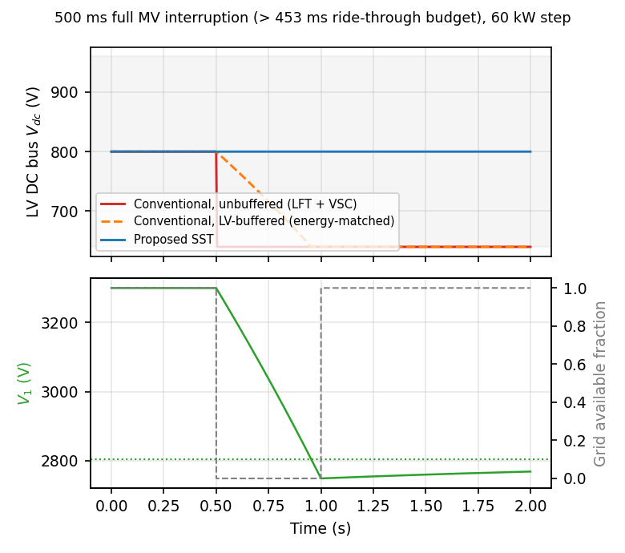
Fig. 4. LV DC bus voltage (top, all three arms) and SST MV DC-link voltage with grid availability (bottom), during a 500 ms full MV interruption.

6.2.1. A Fair, Energy-Buffer-Matched Conventional Baseline
Table 2 alone cannot distinguish two different explanations for the SST's ride-through advantage: either the SST topology itself (the CHB/DAB stages and their MV-side energy storage) is what provides ride-through, or ANY interface with a comparably sized energy buffer ahead of its regulated bus — SST or not — would ride through just as well, and the unbuffered conventional interface was simply never given one. The conventional interface's own LV bus capacitance (2 mF) was sized only for switching-ripple filtering, never for ride-through, so the comparison as run so far is not yet a fair one on that specific axis. Table 2's third column tests this directly: a third interface arm, built on exactly the same VSC control law, the same 150 kW aggregate rated power, and the same ±20% trip band as the original conventional interface — the only change is a larger passive LV-side (800 V) capacitor bank, sized so its own usable stored-energy budget (between 800 V and its own ±20% trip floor at 640 V) exactly matches the SST's aggregate usable MV-link budget of 27.20 kJ. That sizing requires 236,092 μF, about 118 times this paper's own 2 mF baseline LV bus capacitance — a large but not unphysical bulk capacitor bank at this power class, added here purely as an analytical device to isolate one variable, not proposed as a competing design.
The result answers the question directly. The energy-buffer-matched conventional interface survives the full 150 ms interruption that trips its unbuffered twin in 3.8 ms (8.55% deviation, no trip), degrades gracefully rather than abruptly through the moderate-sag case (1.56% deviation, no trip), and — most tellingly — trips at 453.2 ms on both the 500 ms and 1.2 s full-interruption scenarios, landing almost exactly on the SST's own previously reported ~453 ms ride-through budget at this same 60 kW test step. That is strong, quantitative evidence that the SST's raw ride-through TIME is, to first order, an energy-buffer-size effect: match the stored energy, and a conventional interface with nothing SST-specific about it rides through for essentially the same duration. The SST's advantage over an unbuffered conventional interface is real, but it should not be read as evidence that only the SST topology can provide ride-through in principle.
What the SST topology does provide, and what a retrofitted LV-side capacitor bank does not, is a far more efficient way to buy that same energy budget. Stored energy scales with the square of voltage (E = ½CV²), so the same 27.20 kJ budget met with 236,092 μF of 800 V-rated LV capacitance is met by the SST's own CHB stage with only 18,000 μF of 3.3 kV-rated MV capacitance in aggregate — about 13 times less capacitance for the identical stored energy, because operating the buffer at medium voltage rather than low voltage is what makes it small. This is a first-order, capacitance-only comparison, not a full bill-of-materials cost or volume estimate; a real 236,092 μF, 800 V-rated bulk capacitor bank and an 18,000 μF, 3.3 kV-rated one differ in dielectric technology, ripple-current rating, and packaging in ways this comparison does not model, and neither figure is a component this paper actually specified or priced [11] — but the order-of-magnitude capacitance reduction is a genuine, defensible consequence of operating the energy buffer at MV rather than LV. This paper's ride-through result is therefore narrower than "the SST enables resilience a conventional interface cannot achieve": it is that the SST achieves a given ride-through budget with substantially less energy-storage hardware than retrofitting an equivalent passive buffer onto the conventional interface's own LV bus would require, at the disclosed cost of the extra conversion stages' own efficiency penalty (Section 6.3).

6.3. Efficiency Trade-Off (Switching-Loss and Thermal Simulation)
Rather than assume a per-stage efficiency from the literature, this section simulates it. Conduction and switching loss are calculated from RMS operating currents at the switching-verified operating points established in Section 4 — not a closed-form sinusoidal formula — using real datasheet parameters for a representative device at each voltage class: an Infineon FF400R33KF2C 3.3 kV/400 A Si IGBT dual module for the CHB cell bridge and the DAB primary bridge, and a Wolfspeed WAS350M12BM3 1.2 kV/350 A SiC MOSFET half-bridge module for the DAB secondary bridge [6], [7]. Device parameters are read from each manufacturer's full datasheet rather than a short-form catalog, a distinction worth stating plainly because the two do not agree: a commonly quoted short-form “Vce,sat = 3.4 V” figure is actually the full datasheet's minimum spec at 25°C, not the typical value (the typical figure is 4.25 V, rising only to 4.30 V at 125°C), and short-form Eon/Eoff figures are often listed identically at 25°C and 125°C, whereas the full datasheet's genuinely temperature-varying values (470/730 mJ and 430/510 mJ respectively) show that identical listing is a rounding artifact, not a real device property. Using the full datasheet's values throughout, the net effect on the bottom-line efficiency numbers is small and, on balance, slightly favorable, since the temperature-resolved switching energies are lower than the short-form catalog figure would suggest.
Conduction loss uses a constant-drop model — Vce,sat for the IGBT, Rds(on) for the SiC MOSFET — applied to a representative RMS operating current at each device position; switching loss is calculated at the nominal switching frequency, scaling the datasheet Eon/Eoff by the ratio of the actual blocking voltage and current to the datasheet's own test point (VCE=1800 V, IC=400 A for the IGBT, a confirmed datasheet condition). Both device parameter sets are temperature-dependent, piecewise-linearly interpolated between the datasheet's own 25°C/125°C (IGBT) or 25°C/150°C (SiC Rds,on) breakpoints. Each device's actual operating junction temperature is found by iterating loss→Tj→temperature-dependent parameters→loss to a fixed point against the manufacturer's own junction-to-case thermal resistance — the full 4-branch Foster network tabulated in the Infineon datasheet for the IGBT and diode, and the single steady-state value Wolfspeed publishes for the SiC module — and a disclosed case temperature of 60°C, representative of a forced-air/liquid-cooled MV converter enclosure and not itself a datasheet or measured value. Both MV-rated devices are current-oversized for this design's ~8-30 A per-cell operating current — most notably the CHB cell bridge's 3.3 kV/400 A IGBT module, which carries only about 7.9 A RMS at this design's rating, roughly a fiftieth of its rated current, since 3.3 kV/1.2 kV modules of this class are not commercially offered at lower current ratings. That oversizing cuts both ways: a die sized for 400 A carries proportionally larger per-transition switching energies than a device sized to this design's actual ~8 A operating point would need, while its much lower current density keeps conduction-loss density, and therefore self-heating, small relative to the device's own thermal mass.
The first result was not a good one. At the 10 kHz per-cell carrier this design started with (borrowed from the DAB's own switching frequency for pipeline consistency), the CHB cell's simulated efficiency came out to only 92.6% at the corrected device parameters, almost all of it switching loss, since a hard-switched 3.3 kV Si IGBT pays the full turn-on-plus-turn-off energy at every transition, 20,000 times a second. A sweep of the carrier frequency against both this loss model and the TDD calculation from Section 4.1 found a much better operating point: 5 kHz gives 96.1% efficiency, 2 kHz gives 98.2%, and 1 kHz gives 98.9%, while TDD only rises from 0.12% to 0.56% over that same range, still more than an order of magnitude inside the 20% compliance limit. Below about 500 Hz, TDD degrades sharply as the carrier-to-fundamental ratio gets too low for clean multilevel synthesis, so this analysis did not chase efficiency further in that direction. The CHB design in Section 4.1 already reports the corrected 1 kHz value; this is where that correction actually came from.
Table 3. Switching-loss and electro-thermal simulation summary (16.667 kW/cell rating, 60°C assumed case temperature).
Stage / device (electro-thermally converged) | Conduction loss | Switching loss | Per-cell eff.
CHB cell (IGBT, 1 kHz, hard-switched, Tj=61.3°C) | 59.9 W | 132.0 W | 98.85%
DAB primary (IGBT, 10 kHz, ZVS: Eon=0, Tj=62.7°C) | 69.4 W | 343.0 W | included below
DAB secondary (SiC MOSFET, 10 kHz, ZVS, Tj=60.8°C) | 17.2 W | 11.9 W | included below
DAB cell (primary + secondary combined) | 86.6 W | 354.9 W | 97.35%
CHB + DAB combined (new stages only) | — | — | 96.23%
Full SST (+ LV inverter, 98% literature) | — | — | 94.31%
Conventional interface (LFT 99% × VSC 98%, literature) | — | — | 97.00%

Table 3 summarizes the final per-cell numbers at each device's own electro-thermally converged operating point. Self-heating turns out to be modest, as the device oversizing above would suggest: the CHB cell IGBT settles at 61.3°C (+1.3°C above the 60°C case assumption), the DAB primary IGBT at 62.7°C (+2.7°C), and the DAB secondary SiC MOSFET at 60.8°C (+0.8°C), Fig. 5 shows each device's own junction-temperature step response, computed directly from the manufacturer's Foster network, reaching that steady state within about 3-4 seconds (dominated by the IGBT network's slowest, 1-second branch). Because the rise is small, the efficiency impact of moving from a fixed-25°C assumption to the fully converged operating point is correspondingly small: the CHB cell drops from 98.9% to 98.85%, and the DAB cell from 97.5% to 97.35%. The DAB cell's efficiency reflects its confirmed ZVS (Section 4.2): with turn-on loss removed from both bridges, only conduction loss and turn-off loss remain, and even so the primary IGBT bridge's turn-off loss (343 W) is the single largest term in the DAB's loss budget, since ZVS in an IGBT removes the capacitive/overlap turn-on loss but not the tail-current turn-off loss that IGBTs are known for. Combining the two new stages gives 96.23%; folding in the reused LV inverter at its own literature figure (98%) gives a full SST efficiency of 94.31%, against the conventional interface's literature-based 97.0% (99% LFT × 98% VSC [3]), a gap of about 2.7 points. Because the conventional interface efficiency is literature-based rather than derived from an equivalent device-level loss model, the 97.0% value is used as a reference baseline rather than a strictly matched simulation result.
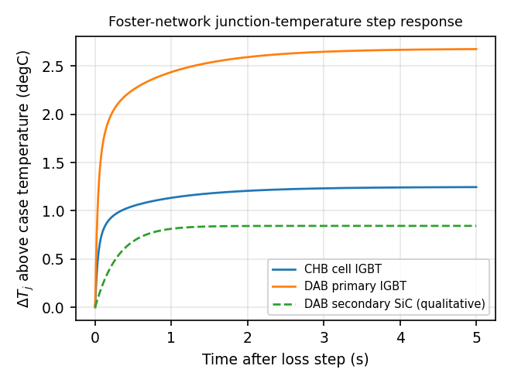
Fig. 5. Junction-temperature step response from each device's own manufacturer Foster thermal network, at its converged average loss.
Fig. 5's step response answers what temperature each device settles at under its own constant, time-averaged loss. It does not by itself show what happens while an actual grid sag is in progress, when device loss is not constant: sag durations in Table 2 (50 ms-1.2 s) are comparable to the Foster network's own fastest, 30 ms branch, so a genuine transient answer is not automatically implied by the steady-state one. The physical mechanism worth checking directly: as the SST's per-cell MV link discharges to keep sourcing the LV bus's commanded power, P=V·I means a falling link voltage at roughly constant commanded power drives the DAB's own bridge currents up, not down, a real stress mechanism the steady-state treatment above cannot show. The CHB stage sees the opposite effect: with the grid itself sagged, less power (during a full interruption, none) actually flows through it, so its own loss and Tj move down.
This is checked directly rather than assumed, by feeding each device's own instantaneous loss, scaled from its converged nominal operating point by the actual, time-varying link voltage and power-transfer trajectories already produced by the disturbance-rejection simulation, through a genuinely dynamic integration of the manufacturer's Foster network, initialized at each device's own pre-event steady temperature. Fig. 6 shows the result for two scenarios: this paper's fixed 60 kW disturbance-rejection test step during its reported 500 ms full interruption, and, since that 60 kW step is itself well below this design's 150 kW rated capacity, a second, more demanding case at the design's own full rated dispatch (16.667 kW/cell) held through its own analytic Thold=181.3 ms ride-through budget. In both cases the excursion is small: the CHB IGBT cools by up to 0.42°C (60 kW case) or 0.91°C (rated case) while the grid is unavailable, recovering once it returns; the DAB primary IGBT rises by at most 0.03°C (60 kW case) or 0.07°C (rated case), staying mildly elevated afterward because this reduced-order MV-link model has no explicit recharging mechanism once the sag clears; the DAB secondary SiC device's excursion is negligible in both cases (<0.001°C). Every ride-through event examined in this paper, fixed-step and randomized (Section 6.5, up to 1.5 s) alike, is shorter than or comparable to the Foster network's own dominant thermal time constant (about 1 s for the IGBT network), so the junction temperature does not have time to respond to the loss transient before the disturbance itself has already ended; thermal mass, not switching margin, is what keeps ΔTj small over these particular durations. Transient thermal stress is therefore not the binding concern for this design's ride-through events; the MV link's own voltage floor (Section 5) is.
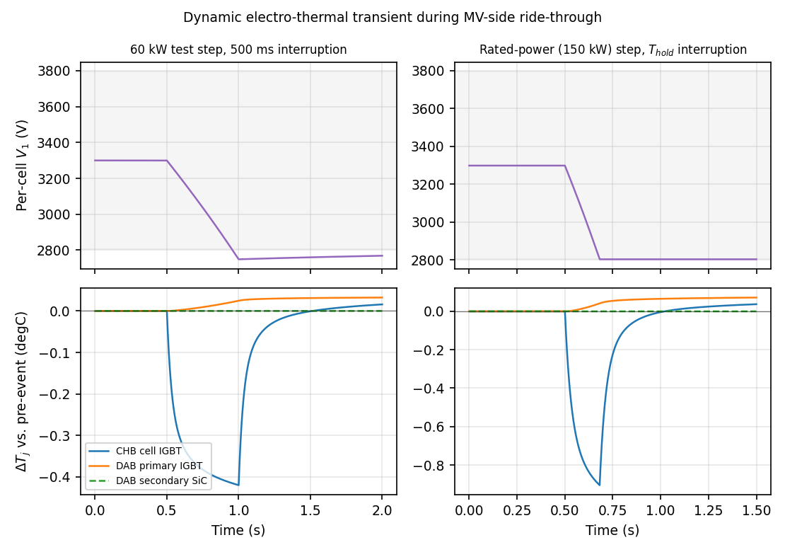
Fig. 6. Per-cell MV link voltage (top) and each device's dTj deviation from its own pre-event steady state (bottom), during an actual ride-through event: the paper's 60 kW test-step scenario (left) and the design's own rated-power Thold-budget scenario (right).

6.3.1. Efficiency Across Dispatch Level
The 94.3% figure above is reported at a single operating point: this design's own 100% rated dispatch, at which the CHB cell bridge carries only ~7.9 A RMS against its 3.3 kV/400 A IGBT module's rating. Since this microgrid's actual day-to-day dispatch, including the 60 kW disturbance-rejection test step used throughout Sections 5-6.2, mostly runs well below that 150 kW/150 kVA design rating, the single rated-point figure alone does not show whether the loss model stays well-behaved, or whether efficiency changes materially, away from that one point. This is checked directly by re-running the same electro-thermal loss simulation at four dispatch levels spanning 25% to 100% of rated power.
Table 4. Electro-thermal-converged efficiency across dispatch level, same methodology as Table 3.
Dispatch level (% of 150 kW rated) | CHB stage efficiency | DAB stage efficiency | Full SST efficiency
25% | 99.68% | 99.45% | 97.15%
50% | 99.41% | 98.95% | 96.40%
75% | 99.13% | 98.32% | 95.51%
100% (rated) | 98.85% | 97.35% | 94.31%

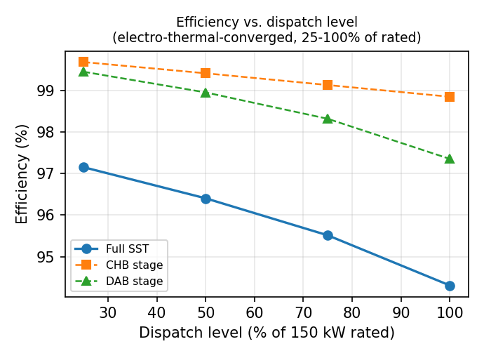
Fig. 7. Full-SST, CHB-stage, and DAB-stage efficiency across 25-100% of this design's own 150 kW rated dispatch.
Efficiency rises monotonically as dispatch level falls, from 94.3% at rated power to 97.2% at 25% of rated, the opposite of the light-load efficiency dip real power-electronic hardware often shows, where fixed losses (core/iron loss, gate-drive and auxiliary power, standby conduction) dominate at low output and pull efficiency down well before rated power. That inverted-U shape does not appear here because this paper's reduced-order loss model includes only current-dependent conduction loss and event-triggered switching loss; it does not model transformer core loss, gate-drive power, or other fixed overhead terms that are current-independent and would matter proportionally more at light load. The monotonic result reported here is therefore a consequence of this specific loss model's own scope, not a claim that this design's real hardware would show no light-load efficiency penalty at all; a full core-loss and auxiliary-power characterization is left as future work (Section 8). Within the scope this model does cover, the result confirms the loss model behaves smoothly and predictably away from the single rated-point figure quoted elsewhere in this paper.

6.4. Coincident PV/Load Disturbance
Section 6.2's fixed 60 kW step is the cleanest version of the disturbance test: the bus is already settled at a known operating point before the sag hits. Real operation is not always that tidy, so this test adds an independent PV cloud-transient (a further 25 kW deficit ramping in over 150 ms) and a 15 kW load pickup, both timed to overlap the sag window but not synchronized to its exact start, on top of the same 60 kW baseline, a combined deficit that grows from 60 kW to 100 kW while the sag is already underway. Two of Table 2's scenarios are repeated this way: the moderate (65%) sag and the 500 ms full interruption.
Table 5. Coincident PV/load disturbance-rejection comparison.
Coincident scenario (60→100 kW) | Conventional outcome | SST: max dev. / MV link min
Moderate sag (65%, 150 ms) + PV/load | tripped @ 24.2 ms | 0.930% / 0.977 pu
Full interruption (500 ms) + PV/load | tripped @ 3.8 ms | 0.930% / 0.719 pu

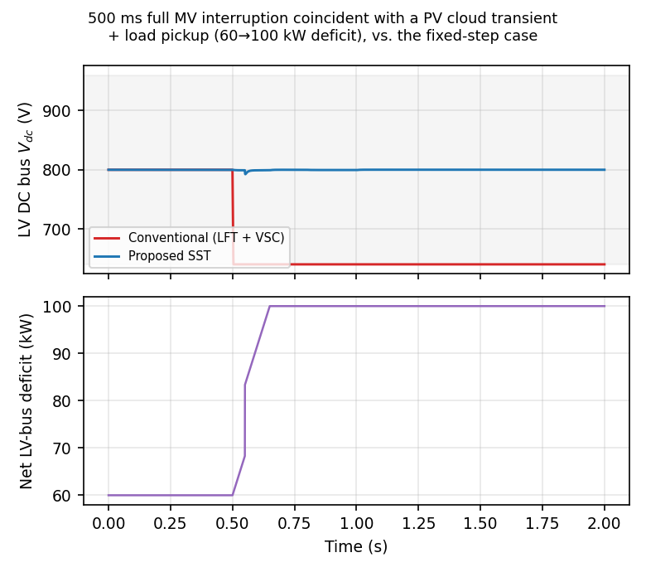
Fig. 8. LV DC bus voltage (top) for both interfaces and the net LV-bus deficit (bottom), during a 500 ms full MV interruption coincident with a PV cloud transient and load pickup.
The conventional interface's outcome does not change in kind, it was already tripping in both underlying scenarios, and a larger coincident deficit only reinforces that. The SST's outcome does change, and in an instructive way. Rather than the exact 0.000% and 0.017% deviations reported for the fixed-step versions of these two scenarios, the coincident versions both show a 0.93% peak deviation, the same number in both cases, which is itself a clue: checking the underlying simulation log confirms the peak occurs about 52 ms into the disturbance, while the MV DC-link is still at 98% of nominal, nowhere near its throttling floor. This deviation is not the link running low on energy; it is the LV voltage loop's own transient response to a step-and-ramp disturbance nearly twice the size it was calibrated against. The SST still avoids tripping in both cases, and 0.93% remains more than an order of magnitude below the conventional interface's immediate ±20% trip, but it no longer holds the fixed-step test's exact-zero result, providing a more representative picture of the comparison under a genuinely coincident event.

6.5. Statistical Comparative Analysis (Monte Carlo)
Every result so far comes from a small, hand-chosen set of scenarios: one fixed 60 kW step and two coincident PV/load traces. That is enough to characterize the mechanism, but not to say how the comparison holds up across the wide range of sags a real feeder can produce. This section replaces the hand-chosen set with 500 independently randomized trials, each drawing a sag depth (Uniform 10-100%), a sag duration (Uniform 50 ms-1.5 s), and, 70% of the time each independently, a coincident PV cloud-transient and a coincident load pickup (0-25 kW, arriving 0-200 ms after the sag starts). The PV cloud-transient's magnitude is not an arbitrary uniform draw; it is bootstrap-resampled from 14 real, measured fractional irradiance-deficit events identified in one day (20 January 2022) of real 1-minute Global Horizontal Irradiance data from NREL's Solar Radiation Research Laboratory, scaled by the same 40 kW ceiling used before. This is a disclosed, bounded improvement, not a claim of a fully empirical driver: the source record is 1-minute resolution, a single day, and only informs the transient's magnitude, its ramp duration remains the original Uniform(0.05, 0.30) s. No comparably accessible real sub-minute customer load dataset could be reached from this environment, so the load-pickup side remains the original synthetic model, a disclosed asymmetry, not a silent omission (Section 8).
Table 6. Monte Carlo statistical sweep summary.
Monte Carlo sweep (500 randomized trials) | Conventional | SST
Trip rate (95% Wilson CI) | 57.8% (53.4-62.1%) | 1.2% (0.55-2.59%)
Trials where interface trips but the other does not | 283 (56.6%) | 0 (0.0%)
Both interfaces trip | 6 (1.2%) | 6 (1.2%)
LV-bus deviation, untripped trials: median / 99th pct / max | n/a (defined as tripped) | 0.45% / 1.44% / 1.53%

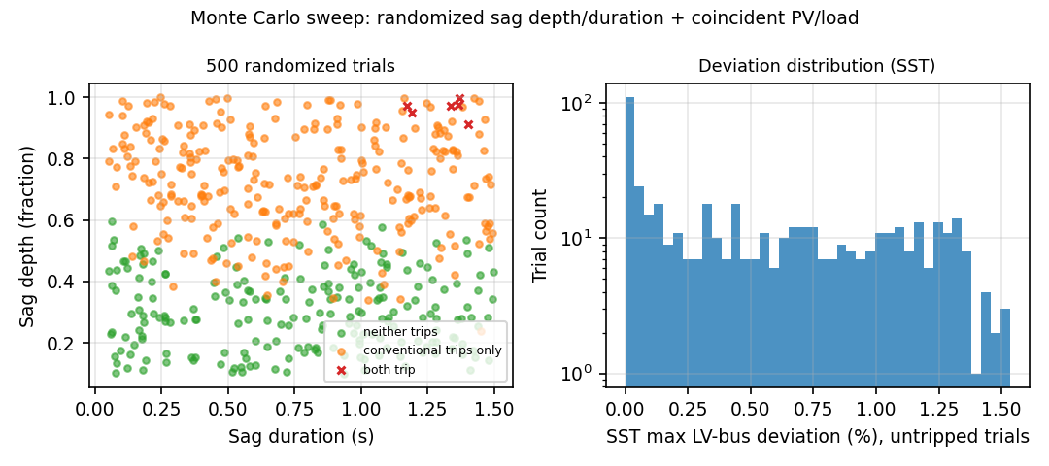
Fig. 9. Left: outcome of all 500 randomized trials by sag depth/duration. Right: distribution of the SST's peak LV-bus deviation among trials it rides through (log-scale trial count).
The conventional interface trips in 57.8% of the 500 trials (289/500); the SST trips in 1.2% (6/500), a wide relative interval, disclosed plainly, because six events is a small count to pin a rate down precisely. Because every trial is run against both interfaces under the identical drawn disturbance, the right comparison is paired, not two independent proportions: of the 500 trials, 283 are discordant (the conventional interface trips and the SST does not) against zero discordant in the other direction, and an exact paired sign test on that 283-0 split rejects equal trip probability overwhelmingly (p < 1e-80), the direction of the effect is not in statistical doubt, even though the SST's own absolute trip rate carries real uncertainty from its small event count. Critically, every one of those 6 SST trips occurs on a trial where the conventional interface also trips, so across this entire randomized sweep the SST never trips on a disturbance the conventional interface would have ridden through. Among the 494 trials the SST survives, its LV-bus deviation is small at every percentile that matters for normal design margin, median 0.45%, 90th percentile 1.25%, 99th percentile 1.44%, but the tail is real: the single worst surviving trial reached 1.53% deviation on a severe near-boundary combination of depth and duration. The boundary itself is not a clean single number: the shortest sag that still tripped the SST was 1.17 s, while the longest sag it survived was 1.50 s, because trip outcome depends on the combination of depth, duration, and coincident PV/load severity together, not duration alone, exactly as the Thold formula in Section 5 already implies.

7. Closed-Loop Active Cell Balancing
An open-loop drift-rate calculation shows the scale of the problem this section solves: using the same C·V·dV/dt energy-balance relationship as the MV link's ride-through budget, a 1% per-cell power-sharing mismatch (167 W out of 16.667 kW, plausible from ordinary component tolerances) drifts a cell's 3300 V DC link at 25.3 V/s, reaching a 15% deviation, comparable to the ±20% trip band used elsewhere in this paper, in 21.1 s; a 2% mismatch does so in 10.5 s, and a 3% mismatch in 7.0 s (confirmed by direct simulation, not just the closed-form estimate, to within rounding). Left uncorrected, cell-level voltage imbalance is this design's most serious open reliability gap; this section closes it with an actual working controller rather than leaving the drift rate as an estimate of the problem alone.
The simulation extends to all nine CHB/DAB cells at once, each carrying an independently drawn random power-sharing mismatch of up to ±3% (a full 9-cell fleet, not just the single worst cell used for the validation above). Left open-loop, the fleet does not merely drift together, cells with opposite-signed mismatches diverge from each other, and the worst cell in this draw reaches the 15% trip band in 6.4 s. The active-balancing controller added here is decentralized: each cell compares only its own link voltage against the fixed 3300 V design setpoint (no inter-cell communication of a fleet average is required) and trims its own DAB duty/CHB modulation depth with a proportional-plus-integral correction, saturated at ±30% of the cell's own rated power, a disclosed, realistic bound on how much of a cell's own power transfer can be redirected to balancing without starving its primary job, with a conditional (anti-windup) integral-clamping scheme.
Written out explicitly, each cell i's own local control law regulates the per-cell voltage error
ei(t) = V1,i(t) − V1,nom,
with a saturated, conditionally-anti-windup PI law
pcorr,i(t) = clip(Kp·ei(t) + Ki·∫ei(τ)dτ , −Pmax, +Pmax),
with Kp=82.9 W/V and Ki=104.2 W/(V·s), set from a 2 Hz target bandwidth (Kp=2π·fbw·C·V1,nom; Ki=Kp·(2π·fbw)/10, placing the integrator corner one decade below the proportional corner) and Pmax=0.30·Pcell,nom=5.0 kW (Table 7); the integral term is only updated when doing so would not push an already-saturated output further into saturation. This power correction is realized as an actual phase-shift-ratio (duty) trim through the same single-phase-shift transfer relationship already derived in Section 4.2: linearizing P = n·V1·V2·d(1−d) / (2·fs·Lk) around the nominal operating point d0=0.35 gives a duty compensation
Δdi(t) ≈ pcorr,i(t) / (∂P/∂d|d0) , ∂P/∂d|d0 = n·V1·V2(1−2d0) / (2·fs·Lk) ≈ 22.0 kW per unit d,
at this design's own n, V1, V2, fs, and Lk values (Section 4.2). For the ±3% mismatch fleet actually simulated here, the naturally occurring per-cell imbalance is at most about 500 W, so the controller's typical correction stays within roughly ±0.02-0.03 of d0, comfortably inside the 0.10-0.50 practical phase-shift range already established in Section 4.2, and the ±5 kW saturation ceiling above is never reached in this scenario. If that ceiling were reached, it would map to a duty swing (Δd ≈ 0.23) larger than this DAB stage's own practical phase-shift headroom around d0; the ±30%-of-rated saturation bound is therefore a generic actuator-authority limit rather than one independently re-verified against this specific DAB stage's own duty-cycle range at switching resolution (Section 8).
With the controller enabled and gains set for a 2 Hz small-signal correction bandwidth, the same random mismatch draw that reached 15% deviation in 6.4 s open-loop instead peaks at 0.14% deviation and settles to under 0.05% within 1.05 s (Table 7): a realistically saturated, decentralized controller corrects the imbalance fast enough that the multi-second open-loop drift rates computed above never have room to develop. Because this 2 Hz bandwidth is roughly two orders of magnitude below the kHz-range CHB/DAB switching frequencies, the averaged, reduced-order state-space representation of each cell's link-voltage dynamics used throughout this section is sufficient to capture the envelope the controller regulates against, without requiring a full sub-millisecond switching-cycle co-simulation.
Table 7. Closed-loop active cell-balancing summary.
9-cell fleet balancing (mismatch up to ±3%) | Open loop | Closed loop (2 Hz)
Worst-cell peak deviation | unbounded (15% @ 6.4 s) | 0.14% @ 0.21 s
Final deviation (t=30 s) | still diverging | 0.00%
Time to settle below 0.5% / 0.05% deviation | never | 0.00 s / 1.05 s
Correction authority (saturation limit) | n/a | ±30% of Pcell (±5.0 kW)

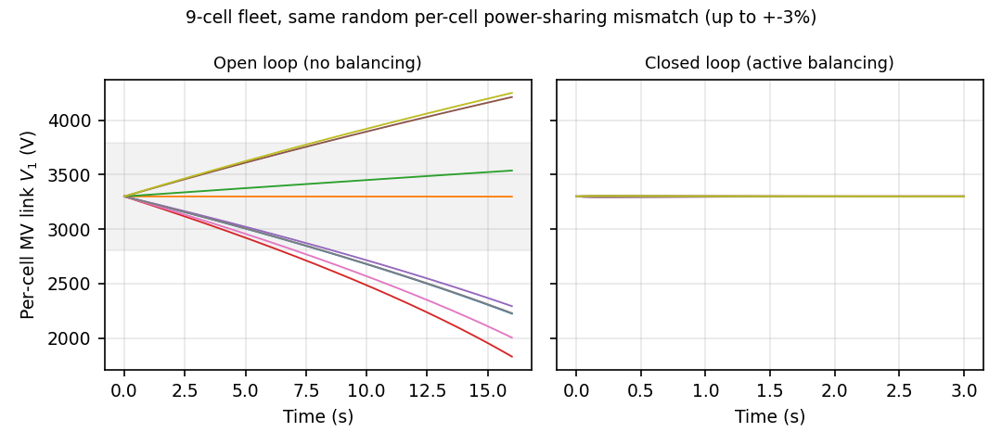
Fig. 10. Per-cell MV link voltage for all 9 cells under the same random power-sharing mismatch, open loop (left, truncated at 16 s before the reduced-order model's own zero-crossing artifact) vs. closed loop (right).

8. Limitations
Several modeling simplifications remain, stated here plainly rather than left implicit. First, cell-to-cell imbalance is backed by a working closed-loop controller (Section 7) rather than an open-loop drift estimate, but that controller is modeled at the same reduced-order, lumped-capacitor resolution as the rest of the ride-through analysis, not at CHB/DAB switching resolution, a simplification consistent with its Hz-to-tens-of-Hz correction bandwidth, not a switching-verified control implementation. This is not only a resolution caveat: the controller's own ±30%-of-rated (±5.0 kW) saturation ceiling, if actually reached, maps through the DAB's small-signal duty-power sensitivity to a duty swing of about Δd ≈ 0.23 around the nominal d0=0.35 operating point, larger than the 0.10-0.50 practical phase-shift range this paper's own DAB design established at switching resolution. In the ±3% mismatch scenario actually simulated, the controller never approaches that ceiling, so this inconsistency does not affect the convergence result reported in Section 7, but it is a genuine gap between two parts of this paper's own reduced-order and switching-resolution models: a fault severe enough to actually saturate the balancing controller would drive it to request a duty swing this design's own DAB stage cannot deliver, and this paper has not re-verified the ±5.0 kW saturation bound against the DAB's own switching-resolution duty-cycle limits to confirm it is achievable at the fleet's worst-case imbalance. A dedicated switching-level fault-detection and classification layer, of the kind demonstrated elsewhere for grid-connected SSTs [13], is one route to closing that gap; this paper does not implement one.
Second, the switching-loss model (Section 6.3) uses temperature-dependent parameters and the manufacturer's own thermal network rather than a single fixed-temperature constant, but it remains a current-independent conduction model (Vce,sat/Rds,on plus a temperature term, not a function of current), since neither manufacturer publishes the tabulated multi-current output-characteristic points a true nonlinear V-I fit would need. The thermal treatment includes a dynamic transient simulation directly coupling the Foster network to each device's own instantaneous loss during a live sub-second ride-through event (Section 6.3), but that simulation scales the nominal loss profile by a quasi-static current/power ratio at each instant rather than re-solving the full nonlinear electro-thermal network in time, and it is initialized at the same fixed pre-event dispatch level used elsewhere in this paper rather than swept across the full range of possible pre-event operating points.
Third, the Monte Carlo sweep (Section 6.5) covers 500 randomized trials spanning sag depth, duration, and coincident PV/load severity; the PV cloud-transient magnitude is bootstrap-resampled from 14 real, measured fractional irradiance-deficit events (NREL SRRL BMS, 20 January 2022, native 1-minute resolution), though that catalog is a single day's record at 1-minute resolution, not the sub-second, multi-day climatology a fully resolved empirical treatment would need. The PV ramp duration and the entire load-pickup side of the sweep remain a stylized model, since no comparably accessible real sub-minute customer-load dataset was reachable from this environment, a disclosed asymmetry between the PV and load sides of this treatment, not a silent omission. Harmonic compliance throughout this paper is checked only against IEEE 519-2022's classical h=2-50 TDD band, not its supplementary high-frequency emission tables [6].
Finally, this paper deliberately stops short of quantifying what this hardware comparison means for a supervisory dispatch policy or for the interface's economic case; both are treated in the companion paper [16], which builds directly on the efficiency, ride-through, and cell-balancing results reported here.

9. Conclusion and Future Work
This paper designed and verified a three-stage solid-state transformer at the same power class as a conventional LFT+VSC grid interface, isolating the interface architecture as the only variable. The CHB and DAB stages were each verified independently at switching resolution (0.08% power-transfer error, ZVS across the full practical duty range, 0.56% MV-side current TDD against a 20% limit). Efficiency was simulated rather than assumed, with an electro-thermal extension rather than a single fixed-temperature parameter set: a switching-loss model built on real device data caught an impractical 10 kHz switching-frequency choice in the initial CHB design (92.6% cell efficiency at the corrected device parameters) and pointed to a corrected 1 kHz operating point (98.9%), and iterating that model to each device's own converged junction temperature against the manufacturer's Foster thermal network (a modest +0.8 to +2.7°C rise, given how current-oversized these MV-class devices are) landed on a full-SST efficiency of 94.3% against the conventional interface's 97.0%.
The SST's other measurable advantage is disturbance ride-through: where the conventional interface trips within milliseconds of any binding MV-side sag, the SST rides through the same event for hundreds of milliseconds with sub-0.1% bus deviation under a clean fixed-step test, still avoids tripping (at a more modest 0.93% deviation) once the sag coincides with independent PV/load fluctuation, and across a 500-trial randomized Monte Carlo sweep, an empirically informed stochastic disturbance model, with PV cloud-transient magnitudes bootstrapped from real NREL irradiance measurement data, trips in only 1.2% of trials against 57.8% for the conventional interface, and never on a disturbance the conventional interface would have survived. A fair, energy-buffer-matched conventional baseline confirms that ride-through TIME is primarily an energy-buffer-size effect rather than something only the SST topology can provide; the SST's own defensible advantage is that it buys that same budget with roughly 13 times less capacitance by storing it at medium rather than low voltage. And the cell-imbalance concern raised as this paper's most serious limitation is no longer just estimated: a decentralized, saturation-realistic active-balancing controller, simulated across the full 9-cell fleet, converges a mismatch that would otherwise reach a 15% deviation in 6.4 seconds to under 0.05% deviation within about 1 second.
Future work includes a full nonlinear current-dependent V-I curve fit once richer manufacturer curve data is available, extending the same real-data treatment to the Monte Carlo sweep's load-pickup side once a comparable real sub-minute customer load dataset becomes accessible, and re-deriving the cell-balancing controller's saturation bound directly from the DAB's own practical phase-shift range rather than a generic actuator limit. The implications of this same interface swap for a trained supervisory reinforcement-learning energy-management policy — including whether retraining alone is sufficient, whether observation design matters as much as training, and a techno-economic breakeven analysis weighing the efficiency penalty quantified here against avoided ride-through downtime and battery-cycling cost — are addressed in the companion paper [16].

CRediT authorship contribution statement
Shahbaz: Conceptualization, Methodology, Software, Validation, Formal analysis, Investigation, Data curation, Writing – original draft, Writing – review & editing, Visualization.

Declaration of competing interest
The author declares that he has no known competing financial interests or personal relationships that could have appeared to influence the work reported in this paper.

Data availability
The simulation code, trained model checkpoints (where applicable), real irradiance/power data, and result summaries generated in this study are openly available at https://github.com/shahbazs2101-prog/sst_paper_code_data.

References
[1] D. Cervero, M. Fotopoulou, J. Muñoz-Cruzado, D. Rakopoulos, F. Stergiopoulos, N. Nikolopoulos, S. Voutetakis, J.F. Sanz, Solid state transformers: a critical review of projects with relevant prototypes and demonstrators, Electronics 12 (2023) 931.
[2] J. Zhang, C. Wen, D. Wang, Y. Chen, S. Liu, T. Gao, X. Li, Solid-state transformers in modern distribution grids: a comprehensive review of principles, topologies, key technologies, applications, and challenges, Electronics 15 (2026) 2839.
[3] H. Ataullah, T. Iqbal, I.U. Khalil, U. Ali, V. Blazek, L. Prokop, N. Ullah, Analysis of the dual active bridge-based DC-DC converter topologies, high-frequency transformer, and control techniques, Energies 15 (2022) 8944.
[4] A. Bineshaq, M.I. Hossain, H. Binqadhi, A. Salem, M.A. Abido, Design and control of two-stage DC-AC solid-state transformer for remote area and microgrid applications, Sustainability 15 (2023) 7345.
[5] IEEE standard for interconnection and interoperability of distributed energy resources with associated electric power systems interfaces, IEEE Std 1547-2018, 2018.
[6] IEEE standard for harmonic control in electric power systems, IEEE Std 519-2022, 2022.
[7] Infineon Technologies AG, FF400R33KF2C 3300 V, 400 A dual IGBT module, datasheet.
[8] Wolfspeed, Inc., WAS350M12BM3 1200 V, 350 A SiC power module, datasheet.
[9] S.M. Malik, Y. Sun, J. Hu, A novel solid state transformer based control topology for interconnected MV and LV hybrid microgrids, Energy Reports 8 (2022) 10385-10394.
[10] D.K. Mishra, M.H. Abbasi, M. Eskandari, S. Paudel, J. Zhang, L. Li, State-space modelling and stability analysis of solid-state transformers for resilient distribution systems, Applied Sciences 14 (2024) 1915.
[11] J.C. Ramírez, E. Gómez-Luna, J.C. Vasquez, Technical and economic feasibility analysis to implement a solid-state transformer in local distribution systems in Colombia, Energies 18 (2025) 3723.
[12] S. Coelho, A. Dionizio, J. Cunha, V. Monteiro, J.L. Afonso, Solid-state transformer: the catalyst for resilient and sustainable smart grids, Energy 327 (2025) 136321.
[13] H. Wang, F. Blaabjerg, Reliability of capacitors for DC-link applications in power electronic converters: an overview, IEEE Trans. Ind. Appl. 50 (2014) 3569-3578.
[14] S. Kamble, P. Chaturvedi, C.-J. Chen, V.B. Borghate, Enhancing reliability and efficiency of grid-connected solid-state transformer through fault detection and classification using wavelet transform and artificial neural network, Electr. Eng. 106 (2024) 2525-2535.
[15] N. Hinov, Solid-state transformers in the global clean energy transition: decarbonization impact and lifecycle performance, Energies 19 (2026) 558.
[16] Shahbaz, Does a Smarter Grid Interface Change What a Supervisory Reinforcement-Learning Energy Manager Must Learn? Observation Design, Retraining, and Techno-Economics for an SST-Interfaced PV-BESS Microgrid, submitted, 2027.

