Does a Smarter Grid Interface Change What a Supervisory Reinforcement-Learning Energy Manager Must Learn? Observation Design, Retraining, and Techno-Economics for an SST-Interfaced PV-BESS Microgrid
Shahbaz*
Power System Lab, Department of Electrical Engineering, K.K. University, Nalanda, Bihar, India
* Corresponding author. E-mail address: shahbazsauby@gmail.com
Abstract
Reinforcement-learning (RL) supervisory energy management for photovoltaic-battery-energy-storage (PV-BESS) microgrids is almost always developed against a conventional line-frequency-transformer-plus-voltage-source-converter (LFT+VSC) grid interface. A companion hardware study replaces that interface with a three-stage solid-state transformer (SST) and shows a real ride-through advantage: its medium-voltage DC-link buffer rides through grid sags for up to about 453 ms while the conventional interface trips within milliseconds, at a disclosed efficiency cost (94.3% vs. 97.0%). This paper asks what that swap means for the supervisory energy-management system (EMS). A deep Q-network (DQN) agent trained against the conventional interface, evaluated unmodified on the SST interface during a live sag, carries over unchanged under nominal operation, but that equivalence breaks down during the sag. A second DQN, retrained within the SST-interfaced state space and validated across four seeds and 500 randomized trials, does not reduce sag-event battery-cycling stress: it improves general tracking and cost but increases command slew, BESS throughput, and the conventional interface's own trip rate (4.0% to 5.8%, p=0.0039). Adding the MV-link voltage, already measured by the SST's own hardware, to the agent's observation instead nearly halves mean command slew on the SST interface (8.15 to 3.74 kW/s). An illustrative techno-economic sensitivity analysis finds the SST's capital premium recoverable within single-digit spared-trip events under a plausible disturbance frequency. Together these results indicate that what a supervisory policy is allowed to observe matters at least as much as how it is trained when the grid interface it dispatches against changes.
Highlights
- SST interface is functionally equivalent to conventional at supervisory timescales.
- SST's MV DC-link absorbs a 2 s grid sag before the supervisory policy must react.
- SST-aware DQN retraining alone increases trip rate (4.0%→5.8%, p=0.0039).
- Adding MV-link voltage to observations nearly halves command slew (8.15→3.74 kW/s).
- SST's capital premium recovers within single-digit spared grid-trip events.
Keywords: Deep reinforcement learning; Microgrid energy management; Solid-state transformer; Observation design; Battery degradation; Techno-economic analysis
Nomenclature
SST | solid-state transformer
LFT | line-frequency transformer
VSC | voltage-source converter
MV / LV | medium voltage / low voltage
V1 | per-cell MV DC-link voltage
Thold | analytic full-rated-power ride-through hold-up time
Vdc | LV DC bus voltage
SOC | battery state of charge
PI | proportional-integral (controller)
DQN | deep Q-network
EMS | energy management system
Kp, Ki | PI controller proportional and integral gains
Ksoc, Kv | SOC-centering and bus-voltage trim gains (PI baseline)
Ltrack, LSOC, LVdc, Lcost, Llimit, Lsmooth | DQN reward components: tracking, SOC-violation, bus-deviation, operating-cost, actuation-limit, and smoothness penalties
w1,...,w6 | reward weighting coefficients
EFC | equivalent full cycle (battery-throughput proxy)
TDD | total demand distortion

1. Introduction
Reinforcement-learning (RL) supervisory dispatch for photovoltaic-battery-energy-storage (PV-BESS) microgrids is a fast-growing literature [2]-[4], but it is built almost uniformly on the same underlying assumption: a conventional grid interface consisting of a line-frequency transformer (LFT) in series with a single grid-tie voltage-source converter (VSC). This paper's own baseline, fully specified in Section 2, compares a conventional, anti-windup-protected proportional-integral (PI) supervisory energy management system (EMS) against a deep Q-network (DQN)-based supervisory EMS for a 100 kWp PV / 200 kWh-100 kW BESS microgrid on exactly that conventional interface. DQN's discrete dispatch levels are a deliberate choice here, not a default: this paper's central question, whether and how observation design changes what a supervisory policy does for a fixed action space and reward structure, is posed against a fixed, discrete action set precisely so that changes in behavior can be attributed to what the agent observes rather than to a different action representation; extending the same question to continuous-action algorithms such as DDPG or SAC is left to future work rather than attempted here. Neither that baseline design, nor the broader literature it draws on, questions the interface architecture itself. That is a standing, largely unexamined assumption rather than a deliberate design choice, and it leaves a natural question unanswered: if that conventional interface is replaced with something else, does the supervisory EMS need to know anything different, or behave differently, at all?
A companion hardware study [1] answers the interface half of that question directly. It designs and switching-verifies a three-stage solid-state transformer (SST), a cascaded H-bridge (CHB) medium-voltage rectifier, a dual-active-bridge (DAB) isolated DC-DC stage, and a reused low-voltage grid-tie inverter, that replaces the conventional LFT+VSC interface at an identical 150 kVA power class. It finds a real, switching-verified ride-through advantage: the SST's medium-voltage (MV) DC-link buffer rides through grid sags for up to about 453 ms while the conventional interface trips within milliseconds, and across a 500-trial Monte Carlo sweep the SST trips in only 1.2% of randomized disturbances against 57.8% for the conventional interface, never on a disturbance the conventional interface would have survived. That advantage comes at a disclosed efficiency cost from the extra conversion stages (94.3% SST efficiency vs. 97.0% for the conventional interface), and a fair, energy-buffer-matched conventional baseline shows that raw ride-through time is primarily an energy-buffer-size effect rather than something unique to the SST topology; the SST's own defensible advantage is buying that same energy budget with roughly 13 times less capacitance by storing it at medium rather than low voltage. Readers interested in the full switching-resolution design, efficiency modeling, and disturbance-rejection statistics behind these numbers are referred to [1]; this paper takes that hardware result as given and asks what it means one layer up, for the supervisory policy that dispatches the battery on top of it.
This is not a question the literature on either side already answers. SST-interfaced microgrids have been proposed and studied before at the hardware level, and RL-based resilience mechanisms have been studied at the control level [5], [6], but the two are rarely coupled: hardware-focused SST studies do not couple the interface to a trained supervisory dispatch policy, and RL-for-resilience studies treat resilience as something the supervisory or control layer creates through switching or scheduling decisions, not something a smarter interface can hand the supervisory layer for free. Degradation-aware EMS design is likewise an active area [7], but typically as a general dispatch-policy feature rather than tied to a specific interface-swap event. This paper's question sits in the gap between these threads: given a hardware interface upgrade whose ride-through benefit is already established [1], does a supervisory RL policy trained for the old interface need retraining, does retraining alone help, and does what the agent is allowed to observe matter as much as how it is trained?
The short answer, argued algebraically in Section 4 and confirmed by direct simulation, is that nothing changes under normal operation, and a great deal changes, in a subtle way, when the grid misbehaves. Because the SST's LV-side DAB regulation loop is built to be functionally identical to the conventional interface's own DC-bus PI loop, every dispatch-policy number established for the conventional-interface baseline in Section 2 of this paper carries over to the SST-interfaced microgrid without modification under nominal conditions. What differs is disturbance behavior, and specifically what the supervisory layer is exposed to during one. This paper makes five contributions. (1) An algebraic and simulated demonstration that nominal-operation dispatch is unaffected by the interface swap. (2) A joint evaluation of a trained supervisory DQN agent running together with the SST's own fine-resolution ride-through physics during a shared MV sag, showing how much of that event the interface absorbs before the supervisory layer needs to react at all. (3) A second DQN, retrained directly within the SST-interfaced state space rather than only evaluated against it out of distribution, compared head to head against the original frozen checkpoint on both general dispatch performance and sag-event battery-stress-cycle proxies, validated across four training seeds and a 500-trial randomized disturbance population, finding that retraining alone does not reduce sag-event battery-cycling stress at the population level. (4) A direct observation-design ablation that adds the MV-link voltage itself to the agent's inputs and recovers a real, substantial battery-stress benefit instead. (5) A techno-economic sensitivity analysis weighing the SST's own disclosed efficiency penalty [1] against its ride-through and battery-stress advantages, bounded by externally cited unit-cost figures.
The rest of the paper is organized as follows. Section 2 specifies the microgrid and both supervisory EMS variants in full. Section 3 briefly summarizes the SST interface this paper dispatches against, referring to [1] for the full hardware design and verification. Section 4 shows algebraically and by simulation why nominal-operation dispatch is unaffected by the interface swap. Section 5 presents the joint supervisory-AI/interface evaluation, the retraining ablation, and the observation-design ablation. Section 6 presents an illustrative techno-economic breakeven sensitivity under the cost assumptions of ref. [11]. Section 7 discusses limitations, and Section 8 concludes.

2. Microgrid and Supervisory EMS Design
The microgrid and both supervisory EMS variants used throughout this paper are specified in full below so that the results in Section 5 can be followed and reproduced without reference to any external source. The PV array is 100 kWp with boost-stage maximum power point tracking (MPPT); the BESS is 200 kWh / 100 kW, restricted to a 20-90% state-of-charge (SOC) window, connected through a bidirectional buck-boost converter at the DC bus; the local load varies between 60 and 120 kW; and the aggregate grid-interface rating is 150 kVA on both sides of the interface swap this paper studies. This is the same power class and DC-bus voltage (800 V) used in the companion hardware paper [1], so the interface swap this paper's supervisory agent must contend with is architecturally direct rather than a redesign at a different scale.
Both supervisory EMS variants act once per second on an identical 5-quantity observation, normalized PV power, normalized load power, SOC, a normalized DC-bus voltage deviation, and the previous step's delivered BESS power, so that the PI-vs-DQN and frozen-vs-retrained comparisons throughout this paper compare decision-making on equal informational footing, not one policy with access to more information than the other. The PI baseline is a continuous controller: it computes the instantaneous PV-load deficit, applies proportional and integral gains to it (Kp=0.9, Ki=0.05, integral term clipped to ±2000 and, additionally, updated only when doing so would not push an already-saturated output further into saturation, a conditional anti-windup scheme), adds a small SOC-centering trim (Ksoc=0.6) and a bus-voltage trim (Kv=0.4), and saturates the result to the BESS's ±100 kW rating. These gains were manually tuned for stable tracking on the conventional interface and are left unchanged for the SST interface throughout this paper, per the functional-equivalence argument developed in Section 4. The DQN agent instead selects among 21 discrete dispatch levels spaced 10 kW apart from −100 to +100 kW (positive = discharging), output by a 64-64 fully-connected network (two hidden layers of 64 ReLU units) trained by standard deep Q-learning: a target network synced every 250 steps, a replay buffer of capacity 20,000, ε-greedy exploration decaying from 1.0 to 0.05, discount factor γ=0.97, learning rate 10⁻³, batch size 128, for 260 episodes of 600 s each, random seed 7. Every one of these hyperparameters and the random seed are held fixed between this original training and the SST-aware retraining introduced in Section 5.2, so that a change in training plant is the only difference between the checkpoints compared throughout this paper.
The reward signal driving DQN training penalizes six things jointly at each decision step:
r = −(w1·Ltrack + w2·LSOC + w3·LVdc + w4·Lcost + w5·Llimit + w6·Lsmooth),
with (w1,...,w6) = (1.0, 5.0, 0.5, 1.5, 2.0, 0.2). Ltrack is the squared, BESS-rating-normalized error between the commanded dispatch and an ideal PV-load-balancing dispatch (clipped to ±100 kW and forced to zero once SOC reaches either limit); LSOC is a binary SOC-limit-violation flag; LVdc is the squared, normalized DC-bus voltage deviation; Lcost is a $/step operating cost (grid import priced at $0.12/kWh, export credited at $0.06/kWh, plus a $0.05/kWh throughput degradation charge); Llimit is a binary actuation-limit-violation flag (before the hard clamp is applied); and Lsmooth is the squared, normalized step-to-step change in commanded dispatch. Because the DQN's action space is quantized to 21 levels 10 kW apart while the PI baseline outputs a continuous command, the DQN cannot produce a step-to-step change smaller than 10 kW even when tracking the same target perfectly; every DQN-vs-PI smoothness comparison reported later in this paper (Lsmooth, mean |slew|, and the fraction of steps at the actuator's own slew limit) is accordingly confounded by this quantization and should not be read as a like-for-like actuator comparison. DQN-vs-DQN smoothness comparisons (frozen vs. retrained, 5-input vs. 6-input) share the same action space and quantization and are not subject to this confound. Wherever this paper later refers to "battery-cycling stress," a "battery-stress" difference, or an equivalent-full-cycle (EFC) figure, that language always means this same throughput-based degradation proxy, cumulative discharge/charge energy converted to a $/kWh charge or an EFC count, not a physical capacity-fade or aging model; real battery degradation also depends on temperature, depth-of-discharge history, C-rate, and chemistry-specific aging mechanisms that this paper does not model, and the throughput-based figures reported here should be read accordingly, as a cost proxy rather than a predicted capacity loss, a simplification against the more physically detailed cycle-counting degradation models surveyed elsewhere [16].
Both policies are evaluated on the same fixed 3000 s scenario used throughout this paper: five back-to-back 600 s segments, normal operation, a PV cloud-transient disturbance, a load-step disturbance, a segment that pushes SOC toward both its limits, and the grid-disturbance segment used for every ride-through result in Section 5, each with its own randomized irradiance/load generator. Every frozen-checkpoint baseline figure quoted later in this paper (Table 2's 12.10 kW tracking RMSE, $1.61 operating cost, and 8.41 kW/s command smoothness on this scenario) is this scenario's own result, reproduced directly from the checkpoint and evaluation code in this paper's data availability repository.

3. Grid Interface Summary
This paper dispatches against two grid interfaces at the same 150 kVA power class: the conventional LFT+VSC interface specified in Section 2, and a three-stage SST that a companion hardware paper [1] designs and verifies at switching resolution. The SST cascades a 9-cell CHB MV rectifier, one DAB isolation stage per cell (all secondaries paralleled onto a common 800 V LV bus), and the same LV grid-tie inverter used in this paper's own conventional-interface baseline (Section 2), reused here unchanged. That 800 V bus is deliberately identical to the conventional interface's own DC bus, so the BESS buck-boost converter and PV boost stage this paper's EMS commands attach without modification regardless of which grid interface sits behind them; Table 1 summarizes the stage-level architecture, and [1] provides the full switching-resolution design and verification.
Table 1. SST interface summary (full design and switching-resolution verification in the companion hardware paper [1]).
Stage | Function / Rating
MV CHB rectifier | 9 cells (3/phase × 3 phases), 11 kV MV feeder, 3300 V per-cell DC link, 7-level line-to-neutral output
DAB isolation stage | 1 per CHB cell, 3300 V → 800 V, all secondaries paralleled on the common LV bus
LV grid-tie inverter | Reused unchanged from this paper's conventional-interface baseline (Sec. 2): 3-phase 2-level, LCL filter, dq control
Aggregate rating / LV bus | 150 kVA / 800 V nominal (identical to the conventional interface)
Verified ride-through budget [1] | ~453 ms full-interruption hold-up at this paper's 60 kW test step
Verified efficiency [1] | 94.3% (SST) vs. 97.0% (conventional, literature)

Two results from [1] matter directly for what follows and are used, not re-derived, in this paper. First, the SST's ride-through advantage is real but is primarily an energy-buffer-size effect rather than something only the SST topology can provide: a fair, energy-buffer-matched conventional baseline rides through for an almost identical duration once given a comparably sized passive capacitor bank, though the SST buys that same budget with roughly 13 times less capacitance by storing it at medium rather than low voltage. Second, and central to this paper, the SST's LV-side DAB regulation loop is deliberately built to be functionally identical, same control law, same gains, to the conventional interface's own DC-bus voltage loop, so that under nominal (non-sag) conditions the LV bus dynamics an EMS observes are indistinguishable between the two interfaces. Section 4 uses that second property to establish why this paper's supervisory-EMS comparisons under normal operation do not need to be re-run for the SST interface, and Section 5 shows precisely where and how that equivalence breaks down once an actual MV-side event occurs.

4. Nominal-Operation Equivalence
When the MV grid is not sagged, the SST's CHB stage always has more power available than the DAB stage demands, so the DAB delivers exactly what its LV-side voltage loop commands, unthrottled [1]. That loop is, by construction, the same control law, same form, same gains, as the conventional interface's own VSC voltage loop. At the 1 s supervisory decision timescale this paper's EMS operates on, the two interfaces are therefore functionally equivalent whenever no MV-side event occurs: the DC bus an EMS observes evolves under the same commanded dynamics regardless of which grid interface sits behind it. This is a claim about the outer voltage-control loop as seen by a supervisory policy sampling the bus once per second, not a claim that the two interfaces are physically identical: the SST's DAB stage has its own, faster time constants, CHB modulation introduces its own quantization effects, and the two interfaces' fault ride-through behavior differs sharply, as Section 3 and the companion hardware paper [1] establish. None of these faster-timescale differences is visible to a supervisory policy operating at 1 s resolution under nominal (non-sag) conditions, which is the narrower, supervisory-timescale claim this paper actually relies on. This is why the full supervisory comparison established in Section 2 of this paper (tracking root-mean-square error, cost, smoothness, and SOC behavior, for both the PI and DQN-based EMS) is not re-simulated from scratch for the SST-interfaced microgrid; it carries over unchanged. Section 5.2's frozen-checkpoint evaluation confirms this directly rather than only asserting it: on the shallow, non-binding scenario where the SST's MV link never approaches its throttling floor, both interfaces show identical, exact 0.000% LV-bus deviation, the literal simulated value, because a switching-cycle-averaged model whose LV loop is at its already-converged steady state has nothing left to move the bus once logging starts [1].
What does change is disturbance behavior. Under an MV-side grid event, which the conventional interface has no way to buffer against, the SST's intermediate MV DC-link gives it a real, measurable ride-through budget the conventional interface simply lacks [1], though that comes at the SST's own disclosed efficiency cost from the extra conversion stages. This is precisely the regime in which the functional equivalence established above breaks down, and it is the regime the rest of this paper is about: what does a supervisory policy trained on one interface actually do, and need to do, when that equivalence stops holding?

5. Joint Supervisory-AI and Interface Evaluation
Section 4 establishes that the two interfaces are functionally equivalent, at the supervisory timescale, under nominal dispatch. This section puts the supervisory policy and the interface's own fine-resolution ride-through physics back together during an actual disturbance: the same trained DQN checkpoint described in Section 2 is first run unmodified at its normal 1 s supervisory decision interval, observing the actual bus voltage produced by the interface's own fine-resolution physics rather than a separate static proxy, while a 2 s full MV interruption (long enough to span two decision steps) is embedded in the same PV/load profile used for the grid-disturbance segment specified in Section 2. Because Section 4 already establishes the two interfaces' equivalence under nominal dispatch, evaluating the frozen checkpoint here, unmodified, on the SST interface is itself a deliberate, disclosed out-of-distribution stress test; a second DQN retrained directly within the SST-interfaced state space (Section 5.2) is compared against it below. The PI baseline is run through the identical joint evaluation for comparison.
Table 2. Joint supervisory-AI / interface evaluation summary (2 s full MV interruption).
Policy × interface | Vdc max deviation | Outcome | BESS dispatch range
PI baseline, conventional | 20.0% | tripped @ 1.04 s | 28.5-100.0 kW
DQN, conventional | 20.0% | tripped @ 0.07 s | 29.4-90.0 kW
PI baseline, SST | 0.55% | rode through | 28.5-40.8 kW
DQN, SST | 0.54% | rode through | 29.4-40.0 kW

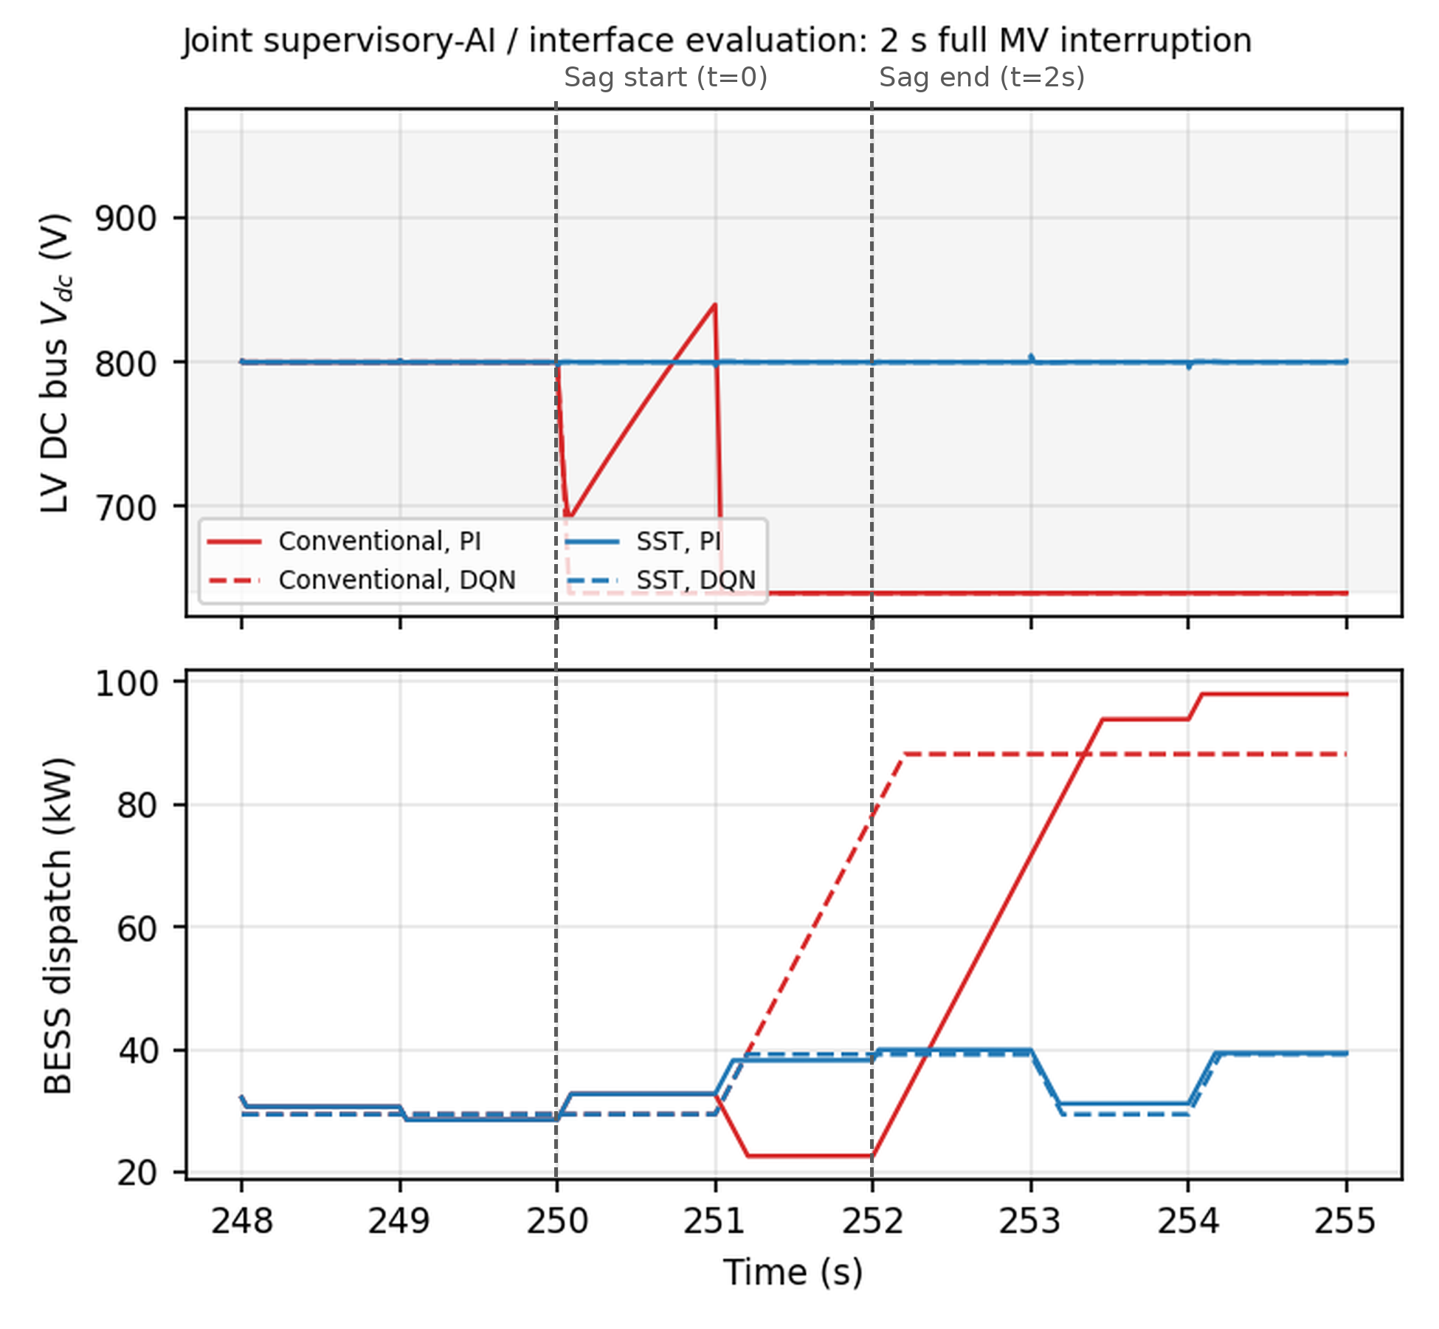
Fig. 1. LV DC bus voltage (top) and BESS dispatch command (bottom) for all four policy × interface combinations, during the shared 2 s full MV interruption.
Table 2 is unambiguous about which layer determines the outcome: on the conventional interface, both policies trip, the DQN slightly faster (74 ms) than the PI baseline (1.04 s), while on the SST interface, both policies ride through with under 0.55% deviation, regardless of which one is dispatching. The interesting part is what each policy's own dispatch command does in response. On the conventional interface, both the DQN and the PI baseline react to the collapsing bus by ramping BESS discharge aggressively toward their respective ceilings, a reasonable reaction to a falling bus voltage, but one the interface's own protection trip cuts short regardless, since the grid-side capacity that was actually lost is not something BESS power can restore. On the SST interface, neither policy needs to react at all: dispatch stays within its normal 30-40 kW pre-disturbance band throughout the event, because the MV DC-link has already absorbed the disturbance before it ever reaches the LV bus the supervisory layer observes. In other words, a better interface does not just ride through the event itself; it changes what the supervisory agent has to learn to do in the first place, here, nothing.

5.1. Frozen Checkpoint's Generalization Limitation
The frozen-checkpoint comparison above has a genuine limitation worth addressing directly: the DQN was never trained against a plant that includes the SST's own interface physics, so its behavior on the SST interface during a sag is generalization, not a learned response. Section 5.2 retrains a second DQN directly within the SST-interfaced state space to test whether that generalization can be improved on, and whether doing so actually helps the metric that matters, sag-event battery-cycling stress, rather than only the metrics a general-operation evaluation would show.

5.2. SST-Aware Retraining
A second DQN, identical in architecture (the same 5-input, 21-action, 64-64 MLP), reward function and weights, optimizer, episode count, and random seed as the original training specified in Section 2, is retrained with exactly one change: whenever a training episode draws the grid_disturbance segment, that episode also draws its own randomized MV-side sag (depth Uniform 50-100%, duration Uniform 0.1-1.2 s, start time Uniform 200-400 s into the segment), and the decision steps near that sag window are stepped through the SST's own fine-resolution MV-link energy-balance model, the same model used for evaluation throughout this paper, instead of the original average-model, cost-only treatment of grid unavailability. To be explicit about what "SST-aware" means here: the state and action spaces are unchanged (Section 2), and only the training plant's disturbance dynamics change, to the same reduced-order, energy-balance-level MV-link model used for every ride-through result in this paper, not to a switching-level model of the SST's CHB/DAB stages; Section 7 discusses the scope this limits the retraining claim to. Every other segment (normal operation, PV disturbance, load disturbance, SOC boundary) is left unchanged, because Section 4 already shows the two interfaces are functionally equivalent, at the supervisory timescale, absent an MV-side event, so there is no genuine SST-specific training signal to add there. Holding the random seed fixed to the original training run's own seed isolates the training plant as the only variable between the two checkpoints.
Worth stating explicitly, since it is easy to assume otherwise: the observation vector itself is not changed by this retraining. The SST-aware checkpoint still receives exactly the same 5-quantity vector specified in Section 2, with no added MV-link-voltage term or any other SST-specific state quantity; only the training plant, what physics generates that same Vdc quantity during the grid-disturbance segment, differs. This is a deliberate design choice: the LV-side Vdc the supervisory layer observes is, by construction, buffered against the MV-side event by the SST's own DAB regulation loop, so a raw MV-link voltage would tell the agent about a disturbance its own observed Vdc mostly does not reflect. What the retraining actually teaches the agent, then, is a different response to the small residual Vdc signature the SST does let through, learned from many in-distribution examples of that signature rather than inferred from the conventional interface's much larger excursions, not a new sensing capability, and, as the results below show, not necessarily a better response either. Section 5.3 tests this design choice directly, by adding the MV-link voltage to the observation and retraining again.
Table 3. Frozen vs. SST-aware-retrained DQN: general-operation performance and sag-event battery-stress proxies (single fixed 2 s scenario).
Metric (frozen vs. SST-aware DQN) | Frozen checkpoint | SST-aware retrained
General-operation tracking RMSE (5-seg. scenario) | 12.10 kW | 8.07 kW
General-operation cost | $1.61 | $1.54
General-operation command smoothness | 8.41 kW/s | 12.06 kW/s
Conventional interface, sag event: BESS throughput | 0.1127 kWh | 0.0896 kWh
Conventional interface, sag event: mean |slew| | 8.40 kW/s | 9.80 kW/s
Conventional interface, sag event: time at slew limit | 17.1% | 20.0%
Conventional interface, sag event: EFC turnover | 0.000805 | 0.000640
SST interface, sag event: BESS throughput | 0.0651 kWh | 0.0730 kWh
SST interface, sag event: mean |slew| | 4.20 kW/s | 5.60 kW/s
SST interface, sag event: peak deviation | 0.545% | 0.545%

Table 3 reports two comparisons. On the original 5-segment deterministic evaluation scenario (general day-to-day dispatch, no interface swap involved), the SST-aware checkpoint is better on two of three metrics: tracking RMSE falls from 12.10 kW to 8.07 kW and operating cost from $1.61 to $1.54, while command smoothness worsens from 8.41 kW/s to 12.06 kW/s. On the shared 2 s full MV interruption from Table 2, the trip outcome itself does not change, both checkpoints trip on the conventional interface, both ride through on the SST interface, consistent with interface physics, not supervisory dispatch, determining whether a trip occurs, but battery-stress behavior moves in different directions depending on the metric and the interface. On the conventional interface, the SST-aware checkpoint reduces BESS throughput and EFC turnover on this single scenario (0.1127 kWh to 0.0896 kWh, a 20.5% reduction) while simultaneously increasing mean absolute command slew (8.40 to 9.80 kW/s, a 16.7% increase) and the fraction of fine simulation steps at the actuator's own 50 kW/s slew limit (17.1% to 20.0%), fewer total watt-hours moved, but in more abrupt bursts. On the SST interface, the SST-aware checkpoint is worse on every metric tested: throughput rises from 0.0651 kWh to 0.0730 kWh and mean |slew| from 4.20 to 5.60 kW/s, though peak deviation itself is unchanged (0.545% for both, no trip either way).
Both DQN checkpoints' general-operation command smoothness in Table 3 (8.41 kW/s frozen, 12.06 kW/s SST-aware) should be read against the continuous-output PI baseline's own smoothness on the identical 5-segment scenario: 5.77 kW/s. Part of that persistent gap between the frozen DQN and the PI baseline is not a policy-quality difference at all, but a direct consequence of the DQN's 10 kW discrete action quantization: because every commanded dispatch is rounded to the nearest of 21 fixed levels rather than output continuously, even a DQN policy that tracked the same underlying target as the PI baseline exactly would still show step-to-step jumps that a squared-difference smoothness penalty penalizes and a continuous actuator simply does not incur. This quantization effect does not explain the SST-aware checkpoint's further rise over the frozen checkpoint, that additional increase is retraining's own general-operation cost, unrelated to action-space granularity, but it does mean the DQN-vs-PI smoothness comparison specifically is confounded by discretization and should not be read as a like-for-like actuator comparison.
Table 3's comparison rests on a single fixed, worst-case 2 s full-interruption scenario and a single training seed, neither of which is enough to support a general claim about the retrained checkpoint's effect. Both are checked directly. Repeating the SST-aware retraining from scratch under three additional random seeds (11, 23, 42), holding every other hyperparameter fixed, and re-evaluating each resulting checkpoint against the same frozen baseline on this same single scenario shows the mean-|slew| outcome is not just modest but seed-dependent in a way that never favors the retrained checkpoint: across the four seeds (7, 11, 23, 42), mean |slew| changes by +16.7%, +66.7%, +183.3%, and +0.0% relative to the frozen checkpoint, an increase or no change every time, never a genuine reduction, while the accompanying BESS-throughput change ranges from a 39.6% reduction to a 4.8% increase depending on seed, confirming that this single-scenario metric, for either checkpoint, is not a reliable basis for a general claim on its own. The second, statistically decisive check is a 500-trial randomized sweep: the identical joint frozen-vs-SST-aware evaluation, using the original seed-7 checkpoint, is repeated across 500 independently randomized disturbances (sag depth Uniform 10-100%, duration Uniform 50 ms-1.5 s), each trial run on both checkpoints and both interfaces with paired PV/load noise, so the difference attributed to retraining is a paired difference, not two independently sampled averages.
Table 4. Frozen vs. SST-aware DQN across 500 randomized sag trials (mean ± standard deviation), both interfaces.
500 randomized trials (mean ± std) | Frozen checkpoint | SST-aware retrained
Conventional interface: trip rate | 4.0% (20/500) | 5.8% (29/500)
Conventional interface: Vdc max deviation | 1.56% ± 3.99% | 1.88% ± 4.63%
Conventional interface: BESS throughput per event | 0.0588 ± 0.0084 kWh | 0.0617 ± 0.0080 kWh
Conventional interface: mean |slew| | 6.66 ± 2.95 kW/s | 8.28 ± 3.15 kW/s
Conventional interface: time at slew limit | 13.6% ± 6.0% | 16.9% ± 6.4%
SST interface: trip rate | 0.0% (0/500) | 0.0% (0/500)
SST interface: Vdc max deviation | 0.68% ± 0.24% | 0.68% ± 0.24%
SST interface: BESS throughput per event | 0.0577 ± 0.0060 kWh | 0.0608 ± 0.0069 kWh
SST interface: mean |slew| | 6.50 ± 2.73 kW/s | 8.15 ± 2.83 kW/s
SST interface: time at slew limit | 13.3% ± 5.6% | 16.6% ± 5.8%

The statistically grounded picture from this 500-trial validation is unambiguous: SST-aware retraining does not reduce sag-event battery-cycling stress at the population level. On the conventional interface, the SST-aware checkpoint's own trip rate is higher, not lower, than the frozen checkpoint's, 5.8% (29/500) vs. 4.0% (20/500) over the identical paired trials. A paired exact test on the 9 trials where the two checkpoints disagreed finds the retrained checkpoint trips in all 9 of those disagreements and the frozen checkpoint in none of them (p=0.0039), a small but genuinely significant increase in the one outcome that matters most to an actual customer. Every battery-stress metric moves the same direction with a 95% bootstrap confidence interval excluding zero: mean BESS throughput rises 4.97% (95% CI 0.0025-0.0033 kWh increase), mean absolute command slew rises 24.3% (95% CI 1.38-1.87 kW/s increase), and the fraction of fine simulation steps at the actuator's own slew limit rises 3.3 percentage points (95% CI 2.8-3.8 points). The SST interface shows the same pattern with, if anything, slightly larger relative increases (throughput +5.3%, mean |slew| +25.3%, time at slew limit +3.4 points, all CIs excluding zero), even though neither checkpoint ever trips there (0/500 for both). Table 3's own single-scenario throughput reduction on the conventional interface (20.5%) is therefore not representative of the broader population: it is one of a minority of scenarios where the retrained checkpoint's more abrupt dispatch style happens to also use less total energy, not the general pattern. Retraining alone, without changing what the agent observes, modestly improves general day-to-day tracking accuracy and operating cost, at a cost to general-operation smoothness, but does not improve, and on several metrics modestly worsens, sag-event battery-cycling stress and the conventional interface's own trip rate. Framed against the broader degradation-aware EMS literature [7], the finding here is narrower than a general degradation-aware dispatch policy: retraining a supervisory policy against a plant model that is superficially plausible but does not correctly bound the new interface's own energy-limited physics can manufacture an apparent battery-stress benefit that a correctly bounded model does not reproduce.

5.3. MV-Link-Voltage Observation Ablation
Section 5.2's retraining leaves the observation vector unchanged, on the reasoning that the LV-side Vdc the supervisory layer already observes is buffered against the MV-side event, so a raw MV-link voltage would mostly be redundant. This ablation tests that reasoning directly. A third DQN is trained, identical in every other respect to the SST-aware checkpoint above (same reward, optimizer, episode count, seed, and MV-link convention), except that its state vector gains a 6th input: the MV-link voltage itself, expressed as V1/V1,nom − 1 (zero at nominal, negative as the link sags toward its trip floor), held at zero outside the grid-disturbance segment's sag window. Because this 6th input is only ever informative on the SST interface (on the conventional interface there is no MV link, so the input would sit at a constant, uninformative zero throughout), this ablation is evaluated only on the SST interface, using the same two checks already applied to the 5-input retraining: the single fixed 2 s worst-case scenario, and the same 500-trial randomized sweep.
Table 5. SST interface, 5-input SST-aware checkpoint vs. a 6-input variant with MV-link voltage added to the observation.
SST interface metric | 5-input SST-aware | 6-input (+ MV-link voltage)
Single scenario: BESS throughput | 0.0730 kWh | 0.0678 kWh
Single scenario: mean |slew| | 5.60 kW/s | 4.20 kW/s
Single scenario: time at slew limit | 11.4% | 8.6%
Single scenario: peak deviation / outcome | 0.545% / no trip | 0.545% / no trip
500 trials: BESS throughput (mean ± std) | 0.0608 ± 0.0069 kWh | 0.0588 ± 0.0054 kWh
500 trials: mean |slew| (mean ± std) | 8.15 ± 2.83 kW/s | 3.74 ± 2.41 kW/s
500 trials: time at slew limit (mean ± std) | 16.6% ± 5.8% | 7.6% ± 4.9%
500 trials: Vdc max deviation / trip rate | 0.68% ± 0.24% / 0.0% | 0.68% ± 0.24% / 0.0%

Observation design, not retraining alone, is what determines whether the supervisory policy achieves a smoother response on the SST interface. Adding the MV-link voltage to the observation nearly halves mean absolute command slew at the population level (8.15 to 3.74 kW/s, a 54% relative reduction) and the fraction of fine simulation steps at the actuator's own slew limit (16.6% to 7.6%), with a smaller but consistent throughput reduction (0.0608 to 0.0588 kWh, 3.2%); the single-scenario check shows the same direction on every metric, and the SST interface's own trip outcome is unaffected either way (0% at both the single scenario and across all 500 trials, both checkpoints), consistent with this paper's repeated finding that the SST's own buffering, not the supervisory policy, is what prevents a trip there. Given the size of this effect relative to the reported standard deviations, roughly 1.5 standard deviations at n=500, chance is a poor explanation, though a formal paired bootstrap confidence interval was not computed for this ablation specifically, a disclosed scope limitation of this particular comparison (Section 7). The LV-side Vdc signature the SST lets through during a sag is evidently not sufficient on its own for the supervisory policy to react as smoothly as it could; a direct MV-link-voltage observation, cheap to add in a real deployment, since the SST's own CHB stage already measures it for its internal regulation loop, recovers a real, substantial battery-stress benefit that retraining the policy alone does not. Taken together, Sections 5.2 and 5.3 point to a general lesson for supervisory-EMS design when the grid interface changes: what the agent is allowed to observe matters at least as much as how it is trained, and exposing a cheap, already-measured interface-side quantity can close a gap that retraining against a better plant model alone cannot.

6. Illustrative Techno-Economic Breakeven Sensitivity, Under the Cost Assumptions of Ref. [11]
The companion hardware paper [1] quantifies a real cost of the SST: a 2.69-percentage-point efficiency penalty (94.31% vs. 97.00%). What that paper does not quantify is the other side of the ledger: does the ride-through advantage demonstrated there, and the battery-stress behavior characterized in Section 5 here, offset that penalty economically? This is checked against three externally sourced, cited unit-cost figures rather than assumed round numbers: an SST-vs-conventional capital-cost range from a 2022 review of deployed and prototype SST costs [11], a battery equivalent-full-cycle (EFC) replacement cost built from NREL's 2025 utility-scale storage cost update [12], and a momentary-interruption customer cost figure from LBNL's national interruption-cost survey [13], figures the broader value-of-resilience literature cautions are highly context- and methodology-dependent [17]. None of these three sources was collected for a system at exactly this paper's 150 kVA/200 kWh scale, so combining them necessarily layers disclosed simplifying assumptions on top of real anchors. To state this plainly and up front: the capital-cost bound used throughout this section ($6,000-$18,000) is a speculative scale extrapolation from a single 20 kVA reference unit, roughly 7.5 times smaller than this design's 150 kVA rating, not an independently sourced or verified price at this design's own scale, and every breakeven figure that follows, in event count, in Table 6, and in the time-based conversion in Fig. 2 and Fig. 3, is an illustrative sensitivity picture built on that speculative anchor plus explicitly disclosed illustrative ranges, not a site-specific economic forecast or a claim of economic feasibility for any real installation. A recent techno-economic SST feasibility study reaches a favorable steady-state capital/power-quality case for a specific distribution system without an AI supervisory layer or a battery-cycling cost term [15]; this section folds both of those into the same kind of analysis, at this paper's own smaller microgrid scale.
The capital-cost side rests on a single external source and a substantial scale extrapolation, and is treated accordingly: ref. [11] reports an SST production cost of $1000-2000 for a small 20 kVA unit (~$50-100/kVA) against a $1500 market price for a comparable 25 kVA conventional pole-mount transformer (~$60/kVA), while separately concluding that deployed SST cost runs "much higher" than conventional once markup and installation are added. That reference unit is 6-7.5 times smaller than this design's 150 kVA rating, and several specific cost drivers at this design's 3.3 kV MV-class rating (insulation systems, the nine per-cell medium-frequency transformer cores) are more likely to push the real per-unit figure toward the high end of a plausible range than the low end, since neither benefits from the mass-production tooling that keeps low-voltage magnetics and insulation cheap in the reference unit. With that caveat, applying the review's own per-kVA figures at this design's rating spans a $6,000 low bound (its own upper production-cost per-kVA figure) to an $18,000 high bound (an illustrative ~3x-conventional multiplier consistent with the review's qualitative "much higher" conclusion), both bounds read as order-of-magnitude anchors for the sensitivity analysis below, not as a quoted or verified price for a unit at this design's scale.
The avoided-cost side has two components, both computed from this paper's own already-simulated results, not assumed: first, the extra BESS discharge energy the conventional interface's trip response delivers relative to the SST's near-flat response, integrated directly from Section 5's own logged dispatch trajectories and converted to a dollar figure via the NREL-based EFC cost ($8.54/EFC, at this design's 140 kWh usable capacity and a 5475-cycle assumed life); second, the LBNL momentary-interruption cost ($15.9/kW, applied to this design's own 150 kW interconnection rating, giving $2,385 per spared trip event). The battery-stress component turns out to be small for a single brief event (under one hundredth of a cent per spared trip in Section 5's 2 s scenario) because a 2 s excursion at these power levels moves only a tiny fraction of one equivalent full cycle; the downtime-avoidance component dominates by roughly six orders of magnitude and is where this design's near-term economic case actually rests.
Table 6. Techno-economic sensitivity: SST capital premium vs. avoided battery-stress and downtime cost. Illustrative only: the capital-cost bound is a speculative extrapolation from a 20 kVA reference unit (see Section 6), not a verified price at this design's 150 kVA scale.
Techno-economic sensitivity (150 kVA / 200 kWh design) | Value
SST incremental capital cost (low / high bound) [11] | $6,000 / $18,000
Battery EFC replacement cost [12] | $8.54 per equivalent full cycle
Avoided battery-stress cost per spared event (PI / DQN) | $0.0021 / $0.0029
Avoided downtime cost per spared event [13] | $2,385
Total avoided cost per spared trip event | ~$2,385
Spared trip events to break even (low / high capex bound) | 2.5 / 7.5 events
Monte Carlo spared-trip rate ([1], 500 trials) | 56.6% of randomized trials
Annual cost of the 2.69-point efficiency penalty [14] | $601/yr (20% PV capacity factor)

Table 6 summarizes the result: under the capital-cost bounds above, recovering the premium takes between 2.5 and 7.5 spared trip events, using the companion paper's own Monte Carlo finding that the SST is spared a trip the conventional interface suffers in 56.6% of randomized disturbance trials as the relevant event rate, not an assumed annual frequency; this paper does not have a site-specific or utility-specific sag-frequency statistic to convert that into a $/year figure, and reports the breakeven in event count rather than inventing one. Set against the efficiency penalty's own $601/yr cost (at a disclosed 20% PV capacity factor and the 2024 US average commercial electricity price [14]), a site experiencing even a handful of momentary MV disturbances a year would recover the SST's capital premium well before that annual efficiency cost accumulates to a comparable total. Efficiency alone is therefore not the right lens to judge this design against: the efficiency penalty is a small, continuous, fully quantified annual cost, while the ride-through advantage is a rare-but-real avoided cost, momentary-interruption downtime plus battery-cycling stress, that recovers the SST's capital premium within single-digit spared-trip events, not years, whenever a site experiences more than a handful of momentary MV disturbances per year.
A reader still reasonably wants some sense of what the event-count breakeven means in time, and of which of this analysis's several uncertain inputs actually drives that answer. Fig. 2 converts the event-count breakeven into an illustrative breakeven time by additionally sweeping an annual disturbance frequency, 2 to 15 events/yr, bracketing the "handful of momentary MV disturbances per year" language used above, alongside the two real cited-source bounds already used (the [11] capital-cost range; an illustrative ±30% band around the single [13] interruption-cost point estimate, since LBNL supplies one figure, not a distribution) and one further illustrative band on the efficiency-penalty cost (±25% PV capacity factor around this paper's own disclosed 20% assumption). Holding three of the four inputs at an illustrative central value while sweeping the fourth (a standard tornado-chart construction) shows annual disturbance frequency is by far the dominant driver of breakeven time, more than either cited-source cost bound: this design's economic case turns mostly on a site characteristic this paper does not have, not on the two cost figures cited above.
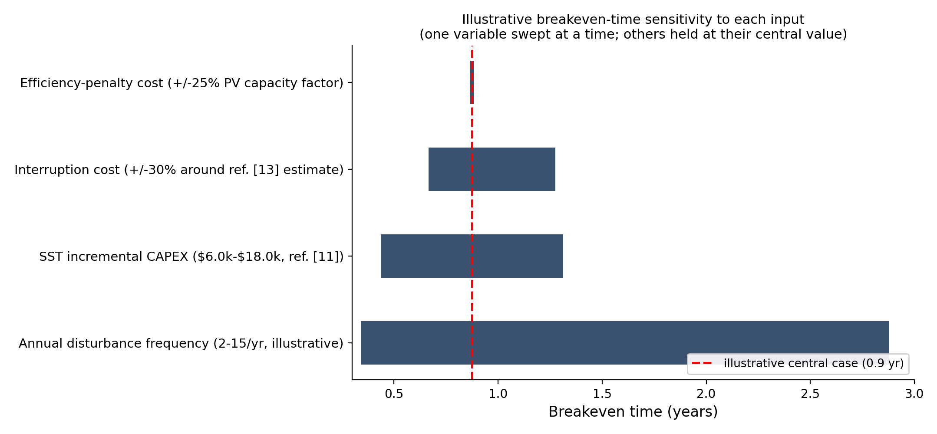
Fig. 2. Illustrative breakeven-time sensitivity to each of four inputs, swept one at a time around an illustrative central case (others held fixed).
At the single illustrative central case shown (a $12,000 mid-range capital premium, 6 disturbances/yr, and the point-estimate interruption and efficiency-penalty costs), breakeven time is under a year; Fig. 3 spreads that same relationship across the full swept range of capital premium and disturbance frequency together, so a reader with their own site's disturbance frequency in mind can read off an approximate breakeven time directly rather than trusting a single illustrative number. None of this should be read as a claim of economic feasibility for any particular site, it is a sensitivity picture built on this paper's own already-cited cost anchors plus explicitly disclosed illustrative ranges, intended to show how the breakeven conclusion moves as each input moves, not to assert that it lands at any one value.
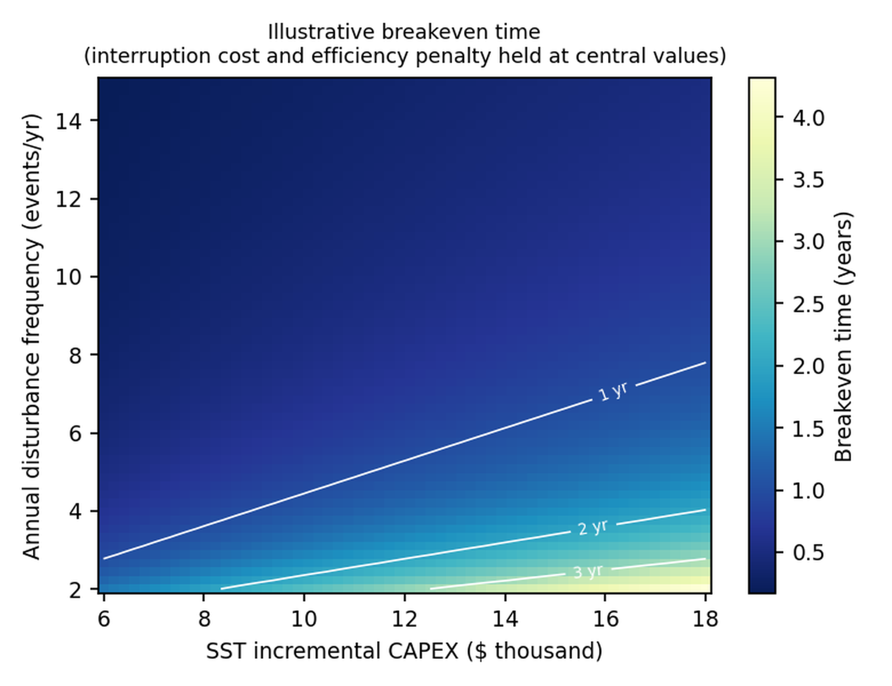
Fig. 3. Illustrative breakeven time across SST incremental CAPEX and annual disturbance frequency, holding interruption cost and efficiency-penalty cost at their central values.

7. Limitations
Several modeling simplifications remain, stated here plainly rather than left implicit. First, the joint DQN/interface evaluation (Section 5) compares a frozen checkpoint against a second DQN retrained directly within the SST-interfaced state space, validated across four independent training seeds on a single fixed scenario and, more decisively, across a 500-trial randomized sweep, but the retraining itself is still at the same reduced-order, energy-balance-level interface model used throughout the companion paper [1], not a switching-level retraining. At the population level, SST-aware retraining does not reduce, and modestly increases, sag-event battery-cycling stress and the conventional interface's own trip rate, while still improving general day-to-day tracking accuracy and cost; a training-plant model that is not correctly bounded to the new interface's own energy-limited physics can appear beneficial where a correctly bounded one does not, which should temper confidence in any single, un-cross-checked simulation-based retraining result, including the ones reported here.
Second, the follow-up MV-link-voltage-observation ablation (Section 5.3) is validated on the same single scenario and 500-trial sweep, but, unlike Tables 4 and 3, its own reduction is reported without a formal paired bootstrap confidence interval, an explicitly disclosed gap in statistical rigor for that one comparison rather than an implied equivalence with the rest of this paper's more fully validated claims; the effect size relative to the reported standard deviations makes chance a poor explanation, but this paper stops short of asserting the same statistical standard for it that Tables 3 and 4 meet. This ablation is also trained and evaluated on a single random seed (seed 7) only, unlike the cross-seed check performed for the retraining ablation in Section 5.2; whether its effect size is similarly seed-dependent has not been tested and is left to future work. What can be said from the evaluation actually run: at the sampling level, the observed reduction is large relative to the reported standard deviations (roughly 1.5 SD at n=500), so chance alone is an unlikely explanation for this specific checkpoint pair; this speaks only to sampling noise across the 500 evaluation trials, however, not to whether a differently-seeded training run would reproduce a similarly sized effect, a question Section 5.2's seed sweep shows can genuinely go either way for this system and that this ablation does not independently answer.
Third, the techno-economic sensitivity analysis (Section 6) combines three externally sourced unit-cost figures, none collected at exactly this design's 150 kVA/200 kWh scale. The capital-cost bound in particular ($6,000-$18,000) is a speculative scale extrapolation from a single 20 kVA reference unit, not an independently sourced or verified price at this design's own 150 kVA scale; the qualitative directional caveat that MV-class insulation and magnetics likely push the real figure toward the high end of the used range is disclosed but not independently re-derived. The entire breakeven analysis in Section 6, including Table 6 and Figs. 2-3, should accordingly be read as a purely illustrative sensitivity picture built on that speculative anchor, not as a site-specific economic forecast or a claim of economic feasibility for any real installation. The breakeven analysis also deliberately reports an event-count breakeven rather than an assumed annual disturbance frequency, since this paper does not have a site-specific sag-frequency statistic; the illustrative time-based conversion in Fig. 2 and Fig. 3 should be read as a sensitivity picture, not a site-specific economic claim.
Finally, both DQN checkpoints' battery-stress and dispatch results throughout this paper are read through the throughput-based EFC degradation proxy defined in Section 2, not a physical capacity-fade model; real battery degradation depends on temperature, depth-of-discharge history, C-rate, and chemistry-specific aging mechanisms this paper does not model [16], and the retraining and observation-ablation results should be read as findings about this proxy's behavior, not as validated statements about physical battery lifetime. This is a lesser concern for this paper's own purposes than it would be for an absolute-lifetime claim: every comparison in this paper, frozen vs. retrained, 5-input vs. 6-input, PI vs. DQN, is a paired difference between checkpoints evaluated on identical scenarios and disturbance draws, so a proxy that tracks relative cycling stress consistently across that shared scenario set is sufficient for the comparative claims this paper makes; it would not be sufficient grounds for an absolute battery-lifetime or warranty claim, which is not attempted here.

8. Conclusion and Future Work
This paper asked what a companion hardware study's verified SST interface swap [1] means for a supervisory reinforcement-learning energy-management system built for the conventional interface it replaces. The answer is layered. Under nominal operation, nothing changes: the SST's DAB regulation loop is functionally equivalent, at the supervisory timescale, to the conventional interface's own DC-bus loop, so a frozen supervisory checkpoint's general day-to-day dispatch behavior, tracking, cost, smoothness, and SOC handling, carries over unchanged, confirmed both algebraically and by direct simulation. During an actual grid disturbance, the picture is different in an instructive way: a joint evaluation with the trained supervisory DQN agent showed the SST's advantage compounds upward through the control stack, on the SST interface the supervisory policy's own dispatch command barely moves during a 2 s full MV interruption, because the interface has already absorbed the event before the policy ever observes it, whereas the same policy is driven to its dispatch ceiling on the conventional interface moments before that interface trips regardless.
Retraining that policy directly within the SST-interfaced state space, though, is not itself sufficient to improve the metric that matters for the new interface: validated across four training seeds and a 500-trial randomized disturbance population, retraining alone modestly improves general-operation tracking accuracy and cost but, at the population level, increases mean command slew and BESS throughput on both interfaces and increases the conventional interface's own trip rate (4.0% to 5.8%, p=0.0039) rather than reducing it. A follow-up ablation showed a real battery-stress benefit is available from a different design choice than retraining: adding the MV-link voltage itself to the supervisory agent's observation, a quantity the SST's own CHB stage already measures internally and so is cheap to expose in a real deployment, nearly halves mean command slew on the SST interface at the population level (8.15 to 3.74 kW/s). A techno-economic sensitivity analysis, combining the companion paper's own efficiency and Monte Carlo ride-through results with externally cited capital, battery, and interruption-cost figures, found the SST's capital premium recoverable within single-digit spared-trip events under a plausible disturbance frequency, though that conclusion turns mostly on a site's own disturbance frequency rather than on either cited cost figure.
Read together, these results indicate that observation design matters at least as much as policy retraining when a supervisory EMS must adapt to a new grid interface, a lesson that plausibly generalizes beyond this specific SST-vs-conventional comparison to other hardware upgrades that change what a control layer can observe without changing what it is asked to do. Future work includes extending the MV-link-voltage-observation ablation's own promising result to the conventional interface's own trip-rate outcome and to a full statistical validation with a formal confidence interval, obtaining a site-specific sag-frequency statistic to convert this paper's event-count breakeven into a genuine $/year figure, and extending this paper's supervisory-EMS framework toward multi-converter, continuous-action, and hybrid-AC/DC architectures for this SST-interfaced design.

CRediT authorship contribution statement
Shahbaz: Conceptualization, Methodology, Software, Validation, Formal analysis, Investigation, Data curation, Writing – original draft, Writing – review & editing, Visualization.

Declaration of competing interest
The author declares that he has no known competing financial interests or personal relationships that could have appeared to influence the work reported in this paper.

Funding
This research did not receive any specific grant from funding agencies in the public, commercial, or not-for-profit sectors.

Data availability
The simulation code, trained model checkpoints (where applicable), real irradiance/power data, and result summaries generated in this study are openly available at https://github.com/shahbazs2101-prog/sst_paper_code_data.

References
[1] Shahbaz, Switching-Verified Design and Grid-Disturbance Ride-Through of a Three-Stage Solid-State Transformer Interface for a PV-BESS Microgrid, companion paper, submitted, 2027.
[2] G. Muriithi, S. Chowdhury, Optimal energy management of a grid-tied solar PV-battery microgrid: a reinforcement learning approach, Energies 14 (2021) no. 9, 2700, https://doi.org/10.3390/en14092700.
[3] W. Khan, F. Renhai, A. Aziz, M.Z. Yousaf, Z. Cai, M.U. Iqbal, J. Wang, M. Abdullah, M.S. Geremew, Deep reinforcement learning-based energy management for design and control of off-grid renewable microgrids with dual-battery storage, Energy Explor. Exploit. 44 (2026) no. 2, 821-869, https://doi.org/10.1177/01445987251387368.
[4] F. Perquoti, D. Milillo, L. Sabino, M. Quercio, F. Riganti Fulginei, G.C. Lazaroiu, F. Crescimbini, Reinforcement learning-based energy storage management for microgrid power exchanges, Eng 7 (2026) no. 3, 126, https://doi.org/10.3390/eng7030126.
[5] J.D. Billanes, B.N. Jørgensen, Z. Ma, A framework for resilient community microgrids: review of operational strategies and performance metrics, Energies 18 (2025) no. 2, 405, https://doi.org/10.3390/en18020405.
[6] H. Momen, S. Jadid, A novel microgrid formation strategy for resilience enhancement considering energy storage systems based on deep reinforcement learning, J. Energy Storage 100 (2024) 113565, https://doi.org/10.1016/j.est.2024.113565.
[7] V. Safavi, A. Mohammadi Vaniar, N. Bazmohammadi, J.C. Vasquez, O. Keysan, J.M. Guerrero, A battery degradation-aware energy management system for agricultural microgrids, J. Energy Storage 108 (2025) 115059, https://doi.org/10.1016/j.est.2024.115059.
[8] D. Domínguez-Barbero, J. García-González, M.Á. Sanz-Bobi, A. García-Cerrada, Energy management of a microgrid considering nonlinear losses in batteries through deep reinforcement learning, Applied Energy 368 (2024) 123435, https://doi.org/10.1016/j.apenergy.2024.123435.
[9] T.E.K. Zidane, Z.A. Muis, W.S. Ho, Y. Zahraoui, A.S. Aziz, C.-L. Su, S. Mekhilef, P.E. Campana, Power systems and microgrids resilience enhancement strategies: a review, Renew. Sustain. Energy Rev. 207 (2025) 114953, https://doi.org/10.1016/j.rser.2024.114953.
[10] S. Ramesh, B.N. Sukanth, S.J. Sathyavarapu, V. Sharma, A.A. Nippun Kumaar, M. Khanna, Comparative analysis of Q-learning, SARSA, and deep Q-network for microgrid energy management, Sci. Rep. 15 (2025) 694, https://doi.org/10.1038/s41598-024-83625-8.
[11] S. Khan, K. Rahman, M. Tariq, S. Hameed, B. Alamri, T.S. Babu, Solid-state transformers: fundamentals, topologies, applications, and future challenges, Sustainability 14 (2022) no. 1, 319, https://doi.org/10.3390/su14010319.
[12] W. Cole, V. Ramasamy, M. Turan, Cost projections for utility-scale battery storage: 2025 update, NREL/TP-6A40-93281, National Renewable Energy Laboratory, 2025.
[13] M.J. Sullivan, J.A. Schellenberg, M. Blundell, Updated value of service reliability estimates for electric utility customers in the United States, LBNL-6941E, Lawrence Berkeley National Laboratory, 2015.
[14] U.S. Energy Information Administration, Electric Power Monthly, Table 4 (average retail price of electricity), 2024.
[15] J.C. Ramírez, E. Gómez-Luna, J.C. Vasquez, Technical and economic feasibility analysis to implement a solid-state transformer in local distribution systems in Colombia, Energies 18 (2025) no. 14, 3723, https://doi.org/10.3390/en18143723.
[16] R. Maakestad, F. Hyder, G. Ramnarase, B. Yan, Review of degradation models of battery energy storage for potential integration into unit commitment problems, Energies 19 (2026) no. 6, 1425, https://doi.org/10.3390/en19061425.
[17] M. Furqan, H. Boudet, Nuances of valuing resilience from microgrids, Renew. Sustain. Energy Rev. 210 (2025) 115236, https://doi.org/10.1016/j.rser.2024.115236.

