Energy-Matched Ride-Through Assessment of a Three-Stage Solid-State Transformer for PV-BESS Microgrids
Shahbaz¹*, Ravi Nath Tripathi²
¹ Power System Lab, Department of Electrical Engineering, K.K. University, Nalanda, Bihar, India
² Department of Electrical and Electronic Engineering, Kyushu Institute of Technology, Kitakyushu, Japan
* Corresponding author. E-mail address: shahbazsauby@gmail.com
Shahbaz ORCID: 0009-0003-3592-4553
Ravi Nath Tripathi: ravi1989tripathi@gmail.com
Running title: Energy matched SST ride through

Abstract
Grid-interface ride-through comparisons can conflate converter architecture with stored-energy sizing and modulation. This study evaluates a 150 kVA, 11 kV/800 V CHB-DAB solid-state transformer (SST) against an energy-matched LFT-VSC interface using analytical checks and an executed coupled averaged model. Nine 2 mF, 3.3 kV links provide 27.20 kJ down to 0.85 pu; both ideal energy-only interfaces give 453.3 ms hold-up at 60 kW. A voltage-dependent DAB limit reduces the analytical 150 kW full-power interval to 112.3 ms, distinct from protection-trip time. MATLAB/Simulink tests couple grid currents, PLL, nine link energies, DAB power actuators and the LV bus. The original SST trips on recovery overcurrent in four of 11 selected cases. A controlled common-mode ablation applies min-max injection before SST phase-command clipping and removes all four additional trips, reducing baseline SST trips from seven to three, equal to the matched conventional count. Remaining trips arise from MV-cell undervoltage in the SST and LV undervoltage in the conventional interface. An identical 20 ms current-reference filter also removes the four trips but delays reactive-current tracking. All 66 coarse/fine-step pairs in the ablation retain trip outcomes and first-cause masks, with trip-time differences at most 12.5 microseconds. Measured one-minute irradiance informs a separate energy sensitivity; coupled disturbances are controlled synthetic inputs. These conditional results identify energy, modulation and protection boundaries without demonstrating architectural superiority, switching-level system validation, hardware efficiency or device-level ZVS.

Highlights
- A three-stage CHB-DAB SST is specified at the same 150 kVA interface rating as a conventional LFT-VSC comparator.
- Ideal switching checks verify seven CHB voltage levels and the DAB analytical power relation.
- A controlled common-mode ablation removes four original SST recovery overcurrent trips in 11 selected cases.
- Matched usable capacitor energy gives equal ideal hold-up when converter power limits remain non-binding.
- Min-max injection and a 20 ms reference filter each reduce SST trips to the matched conventional count.
- Undervoltage failures and delayed reactive-current response define the limits of the tested filter.
Keywords: Solid-state transformer; Cascaded H-bridge converter; Dual active bridge converter; PV-BESS microgrid; Grid-disturbance ride-through; Energy-matched benchmark

Nomenclature
SST solid-state transformer; LFT line-frequency transformer; VSC voltage-source converter; CHB cascaded H-bridge; DAB dual active bridge; PSC-PWM phase-shifted-carrier pulse-width modulation; MV/LV medium/low voltage; Nph series cells per phase (3); Nc total cells (9); ma sinusoidal modulation index; n primary-to-secondary transformer turns ratio (4); d phase displacement normalized to half a switching period, d = 2Δt/Ts = φ/π; fs switching frequency; Lk primary-referred DAB leakage inductance; V1,i MV link voltage of cell i; V2 common LV-bus voltage; Ccell per-cell capacitance; Euse usable stored energy; Pdef net power deficit; P0 nominal per-cell DAB power; ei = V1,i - mean(V1) differential voltage error; pcorr,i outgoing DAB-power correction; Kp, Ki differential PI gains; K(V1,i) DAB power-transfer coefficient; TDD demand distortion in the stated harmonic band; THD current harmonic distortion over the sampled spectrum; ZVS zero-voltage switching.

1. Introduction
Power-electronic interfaces connect renewable resources and battery storage to distribution grids while providing controllable power exchange. A three-stage SST combines an MV AC-DC converter, isolated DC-DC conversion and an LV inverter. Reviews document its topology options, prototypes and implementation challenges [1, 2, 3, 4]. Its internal DC links also provide an energy buffer, whose size must be accounted for when assessing disturbance ride-through.
Applications include interconnected MV/LV microgrids [5], distribution-system resilience [6], insulation-coordinated retrofits [7] and electric-vehicle charging integration [8]. Soft-switching SST research addresses converter losses [9], while feasibility and lifecycle studies evaluate broader implementation trade-offs [10, 11]. These works establish the relevance of active interfaces; the present comparison concerns a narrower question about usable energy and power headroom.
The individual stages this paper builds on each have their own, more mature literature. Multilevel converters were surveyed comprehensively as a maturing medium-voltage technology as early as 2002 [12], and cascaded H-bridge (CHB) converters specifically have since been demonstrated at transmission-class ratings using the same phase-shifted-carrier (PSC) modulation family used in Section 3.1, including a 154 kV, 50 MVAr STATCOM built on a 21-level CHB stack [13]. A separate line of work addresses per-cell voltage balancing under that same PSC modulation, proposing variable-angle carrier shifts to correct imbalance directly in the modulator [14] — the problem Section 5 of this paper instead revisits from the DAB-regulation side, correcting imbalance through each cell's own power flow rather than through the CHB's own switching pattern.
The DAB originates from soft-switched isolated power-conversion research [15]. Single-phase-shift control provides a tractable baseline for relating bridge displacement to transferred power. Broader DAB topology and modulation reviews describe extensions beyond that baseline [16]. Here, ideal switching checks test the analytical power relation; they do not establish device-level ZVS.
Reliability and capacitor lifetime remain relevant because added conversion stages increase component count and control interaction [17, 20]. Complete efficiency and thermal predictions require calibrated device, magnetic, auxiliary and cooling models. Those predictions are outside the present electrical benchmarking study.
State-space studies investigate SST stability and distribution-system resilience [18], while microgrid-control reviews discuss the role of regulated interfaces [19]. A topology comparison must distinguish the usable buffer energy from the conversion dynamics that govern its delivery. Giving one interface substantially more stored energy can produce an apparent ride-through advantage even when both have identical ideal power-regulation capability. Conversely, matched energy does not guarantee matched full-power hold-up if a converter reaches its power limit before the protection floor.
Averaged VSC models and cascaded current/energy control are established tools [24, 25]. Switching implementation, modulation limits and overmodulation have separate validation requirements [26, 27]. DC conversion and regulator design also require explicit operating constraints [28]. These foundations motivate a comparison that holds usable energy constant while retaining architecture-specific voltage and power limits; they do not justify treating equal stored energy as equal dynamic capability.
Coordinated SST regulation has already been studied for MMC-CLLC DC microgrids [32], and CHB phase-power control has been demonstrated under MV voltage imbalance [33]. A recent LLC-based SST preprint examines DC-load faults, current limiting and ramped restoration [34]. These studies concern different converter stages or fault locations. The present contribution is a bounded energy-matched benchmark with disclosed controller implementations and failure causes; neither coordinated control nor smoothed recovery is presented as a new concept. This literature positioning does not establish priority for all energy-matched SST comparisons.
Grid synchronization and current regulation materially affect fault response [29]. Advanced sequence-separating PLLs address conditions beyond a conventional SRF-PLL [30]; this study uses balanced disturbances and makes no corresponding unbalanced-fault claim. Actuator saturation and integrator windup are established control problems [31]. Accordingly, the reference filter examined here is a conventional test intervention, and its value is assessed through matched inputs, unchanged protection and reported trade-offs rather than claimed algorithmic novelty.
The research question is how energy matching changes inferred ride-through benefit, and how DAB headroom, modulation limits and protection can make coupled responses differ even when the usable energy budget is equal.
Section 2 specifies the interfaces. Section 3 defines the switching checks, energy methodology and coupled averaged controls. Section 4 presents energy matching, conditional sensitivity, power headroom, recovery failure, the filter comparison and a controlled common-mode ablation. Section 5 examines differential balancing separately. Sections 6 and 7 discuss limitations and conclusions.

Contributions
The contribution is a reproducible comparison procedure that separates stored-energy sizing from power-delivery and protection constraints. Equal hold-up under the shared ideal energy equation is a conservation check. The executed coupled averaged model then exposes a restoration overcurrent failure that this equation cannot represent. A symmetric current-reference-filter comparison identifies an observed mitigation and its reactive-response trade-off across a disclosed deterministic case set. The filter, PI controllers and PLL are established control elements; no new modulation or robust-stability theorem is claimed. Separate switching and differential-balancing checks provide supporting evidence within their own model boundaries.

2. System Description and SST Architecture
The interface specification includes a 100 kWp PV array, 200 kWh/100 kW BESS, a 60-120 kW local-load range, and a 150 kVA grid interface. Both architectures connect to a nominal 800 V LV bus. The disturbance benchmark fixes net pre-event demand at 60 kW after PV and BESS contributions. BESS reserve is not dispatched dynamically during these tests: no additional battery ride-through service is included. An additional constant-demand sensitivity extends to 150 kW to examine the rated interface boundary.
Fig. 1 lays out the complete system this paper compares: the MV grid feeding the interface under test, the interface's own internal stages, the common 800 V LV DC bus, the PV and BESS resources and the load that all attach to it, and the conventional LFT+VSC baseline evaluated against the same bus and the same power class throughout Sections 4–5.
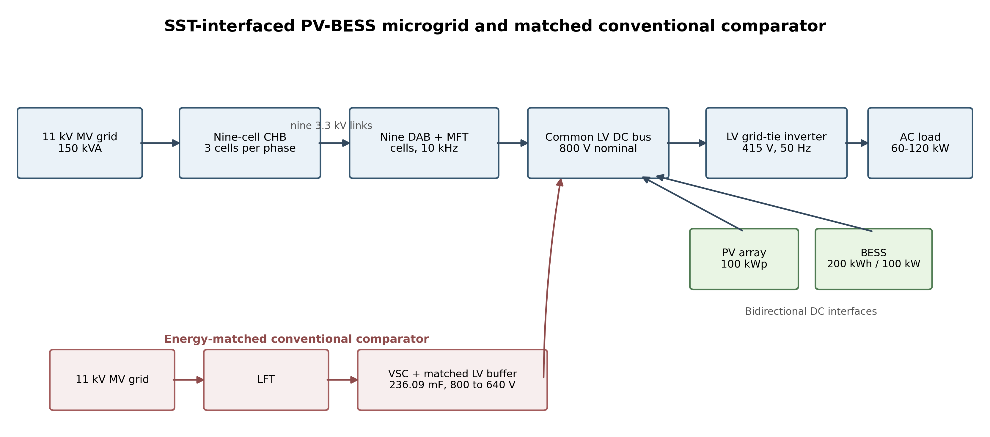
Fig. 1. Overall SST-interfaced PV-BESS microgrid and comparator. The diagram shows the 236.09 mF analytical benchmark; coupled tests use 238.09 mF to include the SST LV capacitor (Section 3.6).
The SST comprises a three-cell-per-phase CHB rectifier (nine links), one DAB per link, and an LV inverter on the common 800 V bus. Table 1 summarizes the specification. Separate ideal switching checks support stage-level equations. An additional coupled averaged CHB-DAB/DC-bus model executes the controllers and protection described in Section 3.6; the LV load is represented by prescribed net power, rather than a switched AC inverter.
Table 1. Proposed SST stage summary.
Stage | Function / Rating
MV CHB rectifier | 3 cells/phase × 3 phases = 9 cells, 11 kV MV feeder, 3300 V per-cell DC link, 7-level line-to-neutral output
DAB isolation stage | 1 per CHB cell (9 total), 3300 V → 800 V, n=4 MFT, 10 kHz, all secondaries paralleled on the common LV bus
LV grid-tie inverter | Specified 800 V/415 V LV inverter; coupled tests execute prescribed net DC-bus power demand, with no dynamic LV inverter states.
Aggregate rating | 150 kVA
Common LV DC bus | 800 V nominal

3. SST Design, Control, and Switching-Level Verification

3.1. Cascaded H-Bridge MV Stage
Each CHB phase comprises three series H-bridge cells. The rated phase current is 7.873 A RMS at 150 kVA and 11 kV line-line. Unipolar modulation compares positive and negative sinusoidal leg references against each cell carrier, allowing cell states -V1, 0 and +V1. The three triangular carriers are displaced by 60° (one-sixth of a carrier period), giving the seven stack-voltage levels -9.9, -6.6, -3.3, 0, 3.3, 6.6 and 9.9 kV. Figure 2 shows the cell arrangement.
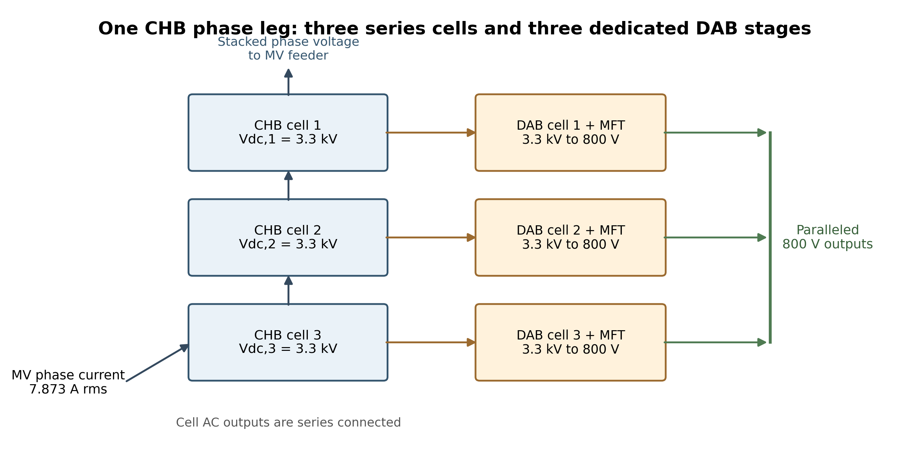
Fig. 2. Functional arrangement of three series CHB cells and dedicated DAB stages in one phase; nine cells in the three-phase specification. This is a block schematic, not a transistor-level circuit.
At 11 kV line-line, the grid phase-voltage peak is 8.981 kV, compared with the 9.9 kV three-cell stack capability. The sinusoidal modulation index is ma = 0.907218. A 6.5 kV IGBT voltage class, represented by the FZ400R65KE3 envelope [22], provides voltage-rating margin above the nominal 3.3 kV links. This rating choice does not establish insulation coordination, switching overshoot, short-circuit protection or a calibrated loss model.
Switching crossings are located on each piecewise-linear triangular-carrier segment, and the series-RL current is propagated analytically between crossings under a sinusoidal grid voltage. Periodic initialization removes startup drift. The series inductance is 51.354 mH and resistance is 0.53778 Ω. A scalar power-angle search sets approximately 150.000 kW aggregate exchange; this is an operating-point construction, not a closed-loop tracking result. RMS harmonic amplitudes use the final 20 ms periodic cycle. Harmonics 2-50 contribute less than 0.001% TDD relative to the rated RMS demand current, while full sampled-spectrum current THD is 7.704%, including switching-frequency content. The small low-order value reflects ideal symmetry and carrier cancellation; it is not IEEE 519 compliance evidence [21]. At fixed power angle, sampling intervals of 1.0, 0.5 and 0.25 μs change power by less than 0.02 W and full-spectrum THD by less than 0.00003 percentage points.
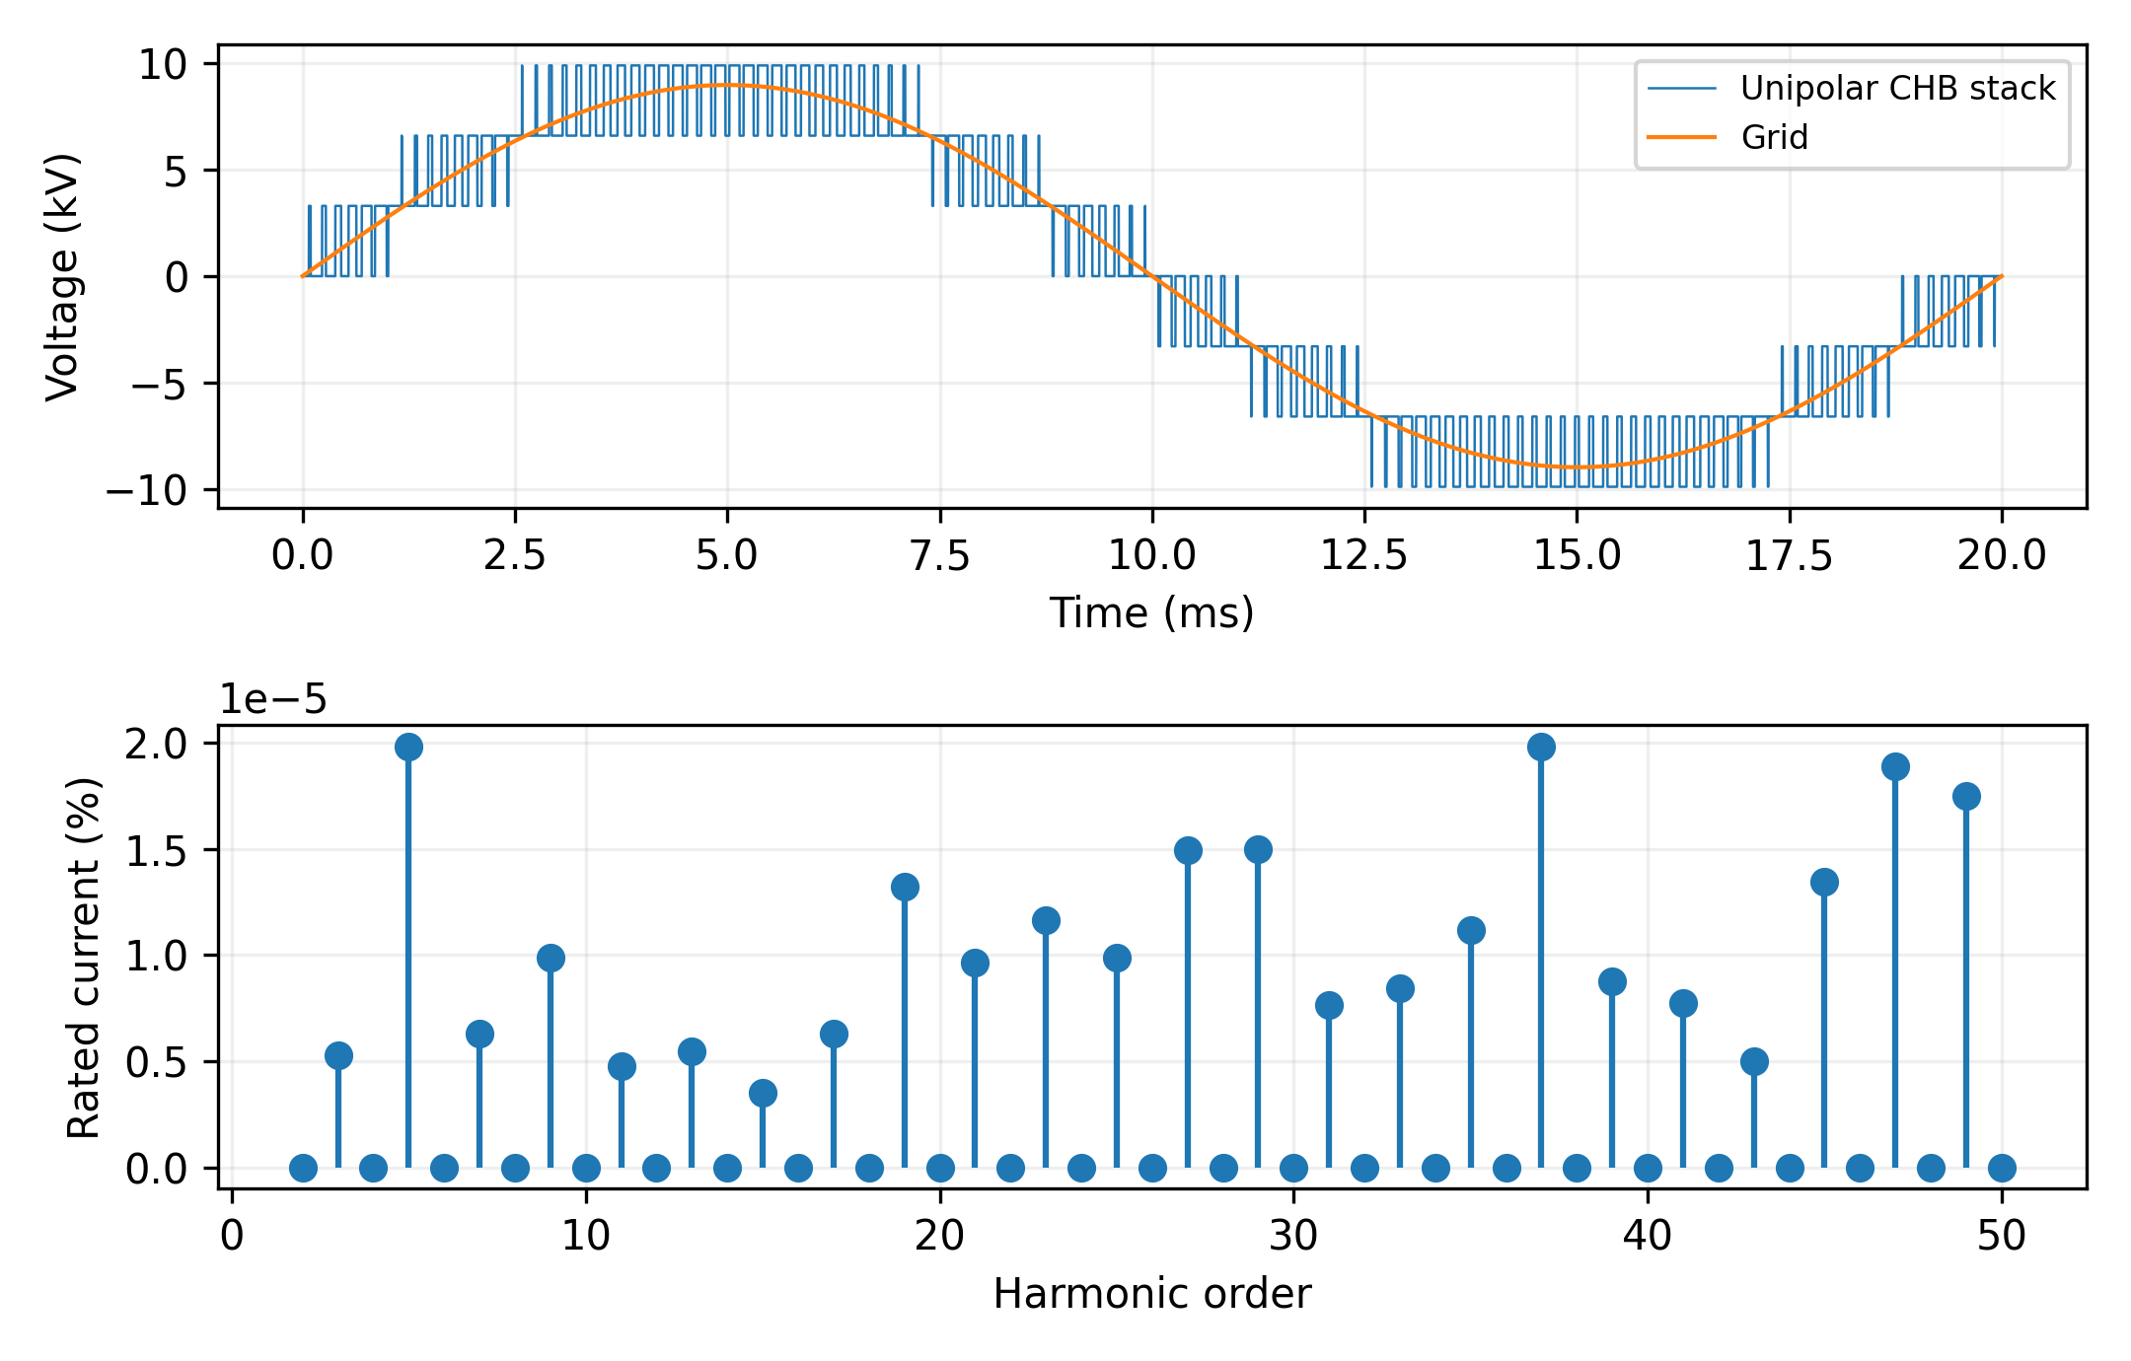
Fig. 3. Ideal unipolar seven-level CHB stack and low-order current spectrum. Higher-frequency switching content is included in the separately reported full-spectrum THD.

3.2. Dual Active Bridge Power Transfer and Leakage Inductance
Fig. 4 shows one DAB cell. The transformer ratio is defined as n=Np/Ns, and leakage inductance is referred to the primary. Each 16.667 kW cell uses n=4, rounded from 3300/800=4.125. The residual voltage mismatch is accommodated by SPS phase shift. Magnetizing inductance, core geometry, winding loss and insulation are outside the ideal power-transfer model and must be established before hardware construction.
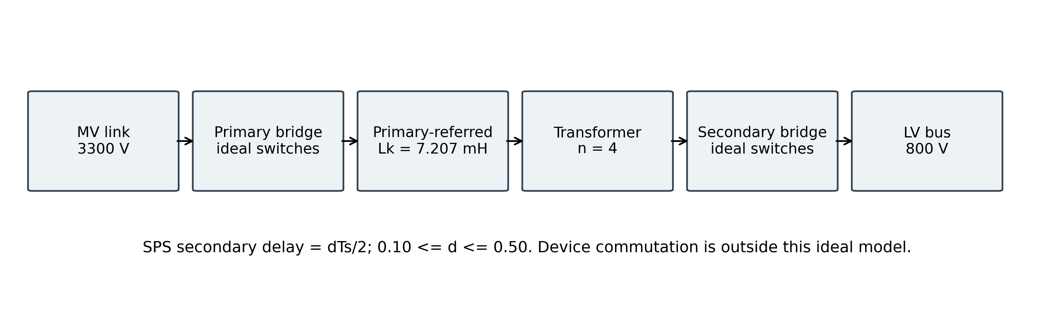
Fig. 4. Functional blocks in one ideal DAB cell; nine are specified in the SST. The bridge switch connections and transformer construction are outside this block schematic.
For positive power flow, the phase displacement is d = φ/π = 2Δt/Ts. The secondary bridge delay is therefore Δt = dTs/2. The evaluated range is 0.10 ≤ d ≤ 0.50. With leakage inductance referred to the primary, ideal single-phase-shift power transfer is
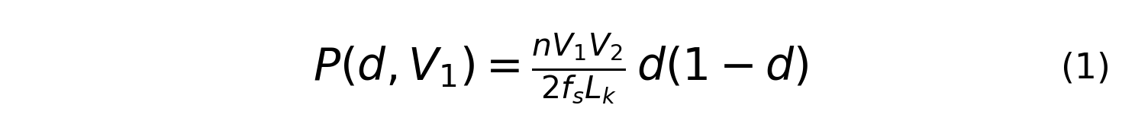
Here n = 4, V1 = 3300 V, V2 = 800 V, fs = 10 kHz and Lk = 7.207 mH. The nominal displacement d0 = 0.35 gives 16.667 kW per cell. The maximum over the evaluated interval occurs at d = 0.50. Lk is an ideal primary-referred energy-transfer inductance; no separate resonant tank is modeled. Its physical implementation, transformer magnetizing branch, winding loss and insulation remain outside this study.
Figure 5 distinguishes the conceptual outer regulation path from the executed switching check. The numerical DAB calculation prescribes d and integrates one periodic ideal leakage-current cycle with a 25 ns step (4000 samples per 100 μs period). It does not simulate a closed-loop LV-bus PI regulator. Dead time and output-capacitance commutation are not included.
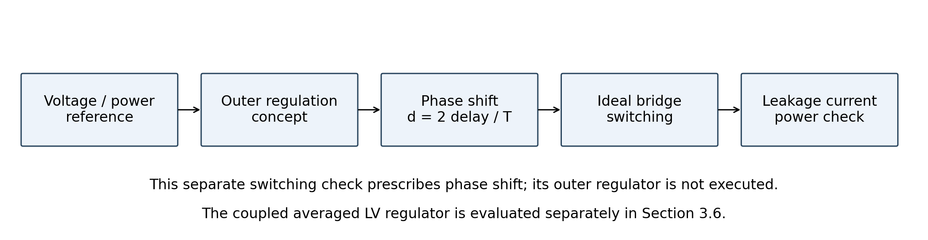
Fig. 5. DAB control concept and separate ideal switching-check boundary; delay is dTs/2. The coupled averaged LV regulator is evaluated separately in Section 3.6.
The one-cell switching-resolution model applies the SPS square-wave bridge voltages and numerically integrates leakage-inductor current. Across d=0.10-0.50, its maximum disagreement with the ideal analytical power relation is 0.177%; the rated-point disagreement is approximately 0.08%. The code also checks current polarity at the switching instants. That polarity is necessary for ZVS, but without nonlinear device output capacitance, commutation charge, dead time, gate resistance, and transformer parasitics it is not sufficient to establish full-range ZVS. The claim is therefore limited to the necessary polarity condition.
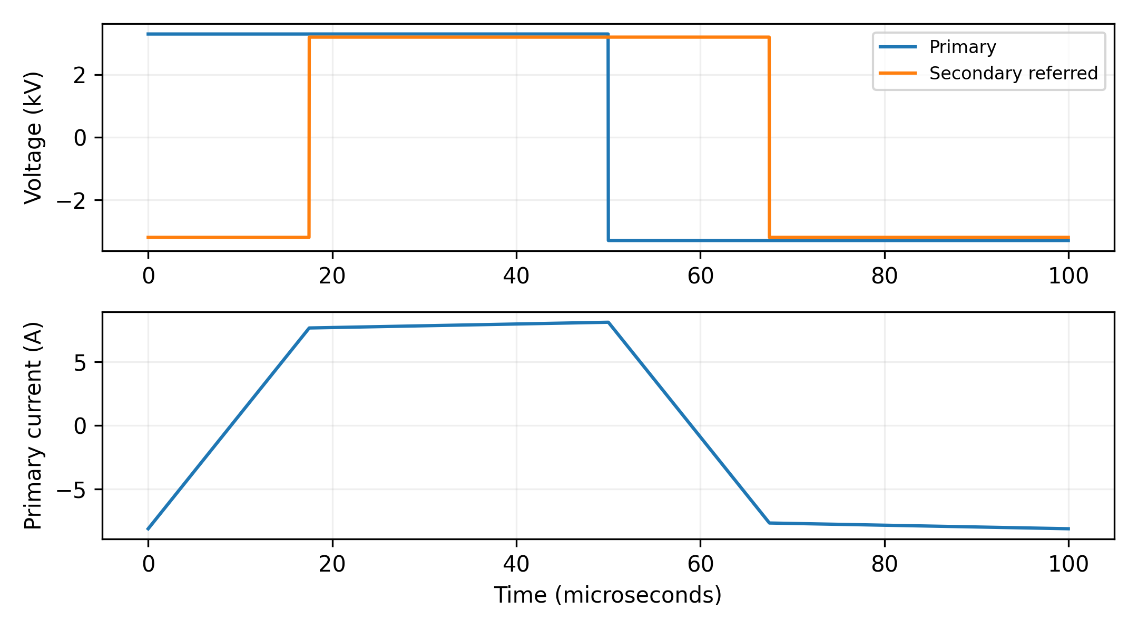
Fig. 6. DAB cell bridge voltages and leakage-inductor current at the rated operating point (d=0.35).
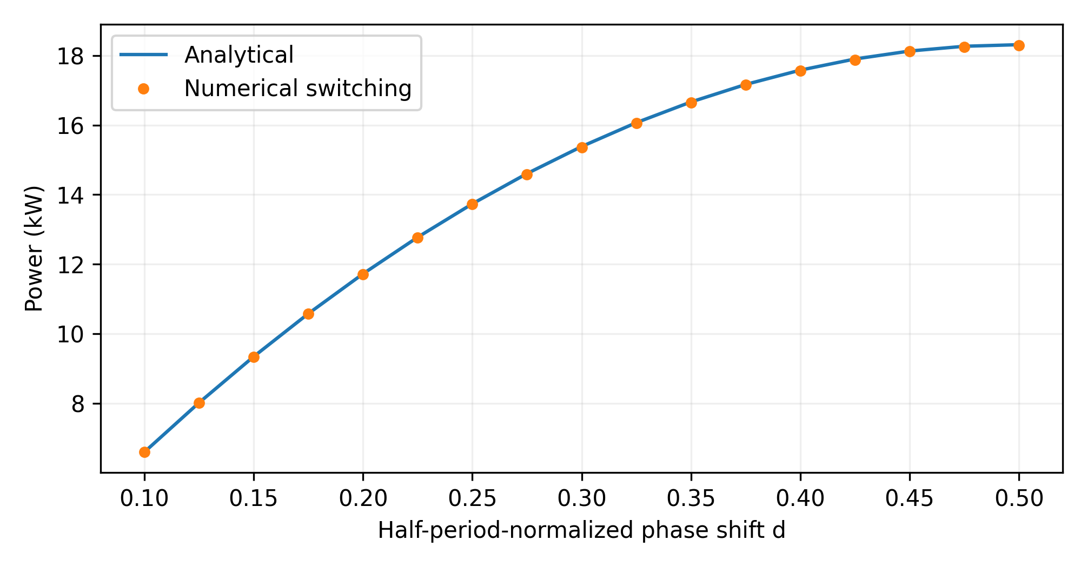
Fig. 7. DAB power transfer: analytic formula vs. switched-model simulation, across the operating duty range.

3.3. LV Grid-Tie Inverter (Reused, Unchanged)
The system specification includes a 150 kVA, 800 V/415 V LV grid-tie inverter. The executed coupled model represents the downstream system by prescribed net power demand at the LV DC bus; it contains no dynamic LV inverter, PV or battery states. The separate CHB and DAB switching checks likewise do not validate this downstream inverter. Conclusions concern the specified grid interface and DC-bus response.

3.4. Simulation Environment and Parameters
Python, NumPy, SciPy and Matplotlib implement the separate CHB switching, DAB periodic-current, algebraic energy and differential-balancing checks. A second model uses MATLAB R2025b and Simulink with a Level-2 MATLAB S-function implementing the coupled averaged equations. This is an equation-based simulation, not a physically wired Simscape circuit. Fixed-step RK4 uses 25 and 12.5 microsecond steps with event boundaries aligned to the grid. The execution archives record MATLAB version, source copies, generated models, CSV/MAT outputs and summaries. Table 2 covers the original checks; Section 3.6 specifies the coupled model.
ChatGPT (OpenAI) assisted manuscript drafting and revision, code development, and numerical auditing. The executed scripts, input data and verification checks are supplied for reproducibility. Responsibility for the final manuscript and its scientific claims remains with the authors.
Table 2. Electrical and numerical settings.
Model or parameter | Value or definition
CHB carrier / displacement | 1 kHz per cell / 60° between carriers
MV series filter | L = 51.354 mH; R = 0.53778 Ω
CHB reference / angle | ma = 0.907218; δ = 0.02003025 rad
CHB sampling / initialization | 0.5 μs base; periodic exact RL propagation
CHB harmonic window | 20 ms; RMS harmonics 2-50; IL = 7.872958 A RMS
DAB switching / integration | 10 kHz; 25 ns; one periodic cycle
DAB parameters | n = 4; Lk = 7.207 mH; d0 = 0.35; d ∈ [0.10, 0.50]
Energy benchmark | 60 kW base deficit; exact constant-event energy integral
Balancing / gains | 1 ms over 8 s; Kp = 82.9 W/V; Ki = 104.2 W/(V s)
Sensitivity seeds | Ride-through: 7, 19, 42; balancing: 7, 19, 42

3.5. Disturbance-Rejection Methodology
For sag depth s, the grid-voltage magnitude is vg = 1 - s pu. The disclosed voltage-support sensitivity assigns iq* = min(1, 2s) pu and id,max = √(1 - iq*²). Active-power capability is Pgrid,max = vg id,max Prated, where Prated = 150 kW at unity power factor. The constant-event deficit is Pdef = max(0, Pdem - Pgrid,max), and its integral is compared with usable capacitor energy. The coefficient 2 is an assumed sensitivity setting, not a national grid-code requirement. All randomized demands remain below the interface rating.
The conventional ripple-capacitor comparator has 2 mF at 800 V and a 0.80 pu lower trip floor. The SST has nine 2 mF links at 3.3 kV and a 0.85 pu MV-link floor. The matched conventional comparator increases its LV capacitance to give the same usable energy over its own stated voltage interval. Voltage floors are architecture-specific; matching concerns the energy available between them. Regulation is ideal while both energy and converter-power constraints remain feasible. Baseline trips occur when required energy reaches the available budget. Section 4.6 separately includes the voltage-dependent DAB power limit.
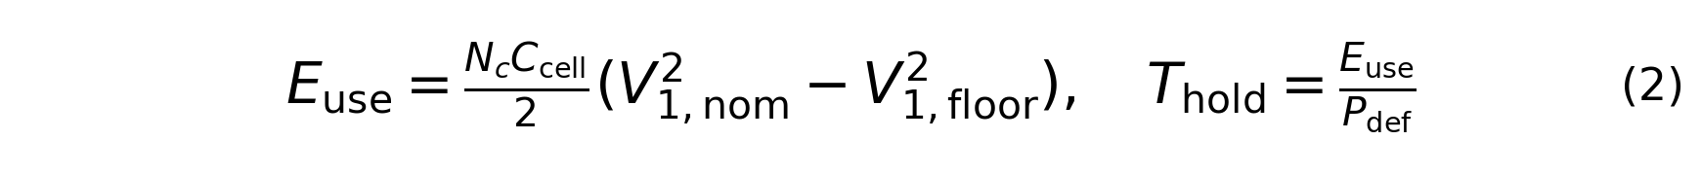
The nominal SST usable energy is 27.1978 kJ. Matching it on the LV bus gives Cmatch = 2Euse/(800² - 640²) = 0.236092 F. At a 60 kW full-interruption deficit, ideal hold-up is 453.296 ms. The 2 mF LV baseline has 230.4 J over its voltage interval, giving only 3.84 ms. These values follow directly from capacitor energy and do not establish topology-specific dynamics.

3.6. Coupled Averaged Model and Executed Controls
The state vector includes three phase currents, nine MV capacitor energies, LV capacitor energy, common-mode and LV PI integrators, PLL states, current PI states and nine DAB actuator powers. The grid-current equation is Lg diabc/dt = vgrid − uconverter − Rg iabc, with Lg = 51.354 mH and Rg = 0.53778 ohm. Phase converter power u_j i_j is shared equally among its three cell links. Cell voltages follow V_i = sqrt(2E_i/Ccell). No actual-current clipping is imposed. Natural phase-power ripple is retained; initial states are nominal algebraic states rather than a solved periodic orbit.
The amplitude-invariant Park transform supplies peak-valued d/q currents. The normalized-q-voltage SRF-PLL uses Kp = 2(0.707)(2π20) and Ki = (2π20)^2; it holds nominal frequency when grid magnitude falls below 0.1 pu. Current PI gains are Kp = Lg(2π100) and Ki = Rg(2π100), with voltage feedforward and cross-coupling compensation. Integral updates freeze during modulation saturation. Desired reactive current is iq* = −min(1,2s) Ipk; the active reference is bounded by sqrt(Ipk² − iq*²). Thus the current circle limits the reference, while protection observes the actual current. Common-mode energy PI gains are 5 s⁻¹ and 10 s⁻², with conditional integration as specified in the archived source.
SST phase commands are bounded by the sum of the three actual cell voltages, followed by neutral/common-mode removal. The conventional arm uses an ideal 11 kV/415 V transformer and an averaged two-level VSC with common-mode injection; its pole limit is VLV(11000/415)/2 when referred to the MV side. Both arms use the same MV-referred RL filter, rating, current-reference law and overcurrent threshold. Transformer loss, leakage beyond this shared filter and switching loss are omitted. The order of common-mode handling and the available converter voltage therefore differ between the implementations. Equal energy, rating and current gains do not make their voltage utilization equivalent. The comparator has not been individually optimized; the observed outcomes compare these specified implementations, rather than establish an inherent architectural ranking. The Stage 6 ablation adds an SST_minmax arm: the common-mode term (max(uabc*) + min(uabc*))/2 is subtracted from the three phase commands before individual phase clipping, followed by neutral removal. Original SST control remains a separate arm. This changes the SST modulation implementation while retaining its physical parameters, regulators, references, energy budget and protection settings; the LFT_matched arm remains unchanged.
The SST LV regulator uses gains 500 W/V and 25000 W/(V s). Its total DAB request is allocated across nine cells with proportional differential correction 82.9 W/V and a bounded allocation that preserves the feasible total. Each cell has ideal SPS capacity nV_iVLV/(8fsLk), forward-only power, and a 0.2 ms first-order actuator; phase shift is recovered by nonlinear SPS inversion. This allocation differs from the separate PI balancing test in Section 5. The energy ledger includes capacitor and grid-filter inductive energy, grid input, delivered demand and Rg i² dissipation. Delivered cell power is algebraically clipped to its instantaneous forward SPS capacity, even while its actuator state is relaxing. This ideal capacity limiter is part of the averaged implementation, rather than a validated hardware current limiter.
Total usable energy in the coupled SST includes the MV links plus the 2 mF LV ripple capacitor: 27.197775 kJ + 0.230400 kJ = 27.428175 kJ. The matched conventional capacitance is therefore 238.0918 mF, rather than the 236.0918 mF used by the earlier MV-only analytical comparison. Protection latches when any SST MV cell reaches 0.85 pu, the LV bus reaches 0.80 pu, or the actual three-phase current norm exceeds 1.25 times its rated norm. After a trip, grid input and delivered load are zero and filter inductive energy dissipates through Rg. The first cause is retained even if a subsequent output sample lies below threshold.
The unfiltered baseline applies the desired d/q reference directly. Filtered variants obey drf/dt = (r* − rf)/τ, with the vector derivative limited to norm Ipk/τ and nominal-current initialization. Both reference components are filtered for the entire run in both architectures. This is not restoration-only filtering. The same plant, PI gains, event inputs and protection are used for baseline, 10 ms and 20 ms comparisons. Filtering can delay reactive support as well as reduce recovery excursions.

4. Results and Discussion

4.1. Nominal-Operation Equivalence (No Sag)
In the ideal energy-only comparison, a non-binding event leaves available grid power above demand, so neither interface draws on its capacitor-energy budget. Equal bus regulation in this case follows from the shared ideal regulation assumption. It is not a demonstrated equivalence of the coupled controllers, switching ripple or hardware losses.

4.2. MV-Side Disturbance Ride-Through
Table 3 summarizes five deterministic events under the disclosed current-circle sensitivity. The 30% sag remains non-binding. At 65% depth, reactive-current priority consumes the current capability and the 150 ms event requires 9.0 kJ, the same deficit energy as a 150 ms interruption. Both exceed the 2 mF budget but remain within 27.20 kJ. Interruptions of 500 ms and 1.2 s require 30 and 72 kJ, so both matched interfaces trip after 453.3 ms.
Table 3. MV-side disturbance-rejection comparison, including the fair energy-buffer-matched conventional baseline (Section 4.2.1).
Scenario (60 kW deficit) | Conventional (2 mF) | Conventional (energy-matched) | SST
30% sag, 150 ms | Ride through | Ride through | Ride through; link 1.000 pu
65% sag, 150 ms | Trip | Ride through | Ride through; link 0.953 pu
Full interruption, 150 ms | Trip | Ride through | Ride through; link 0.953 pu
Full interruption, 500 ms | Trip | Trip at 453.3 ms | Trip at 453.3 ms
Full interruption, 1.2 s | Trip | Trip at 453.3 ms | Trip at 453.3 ms
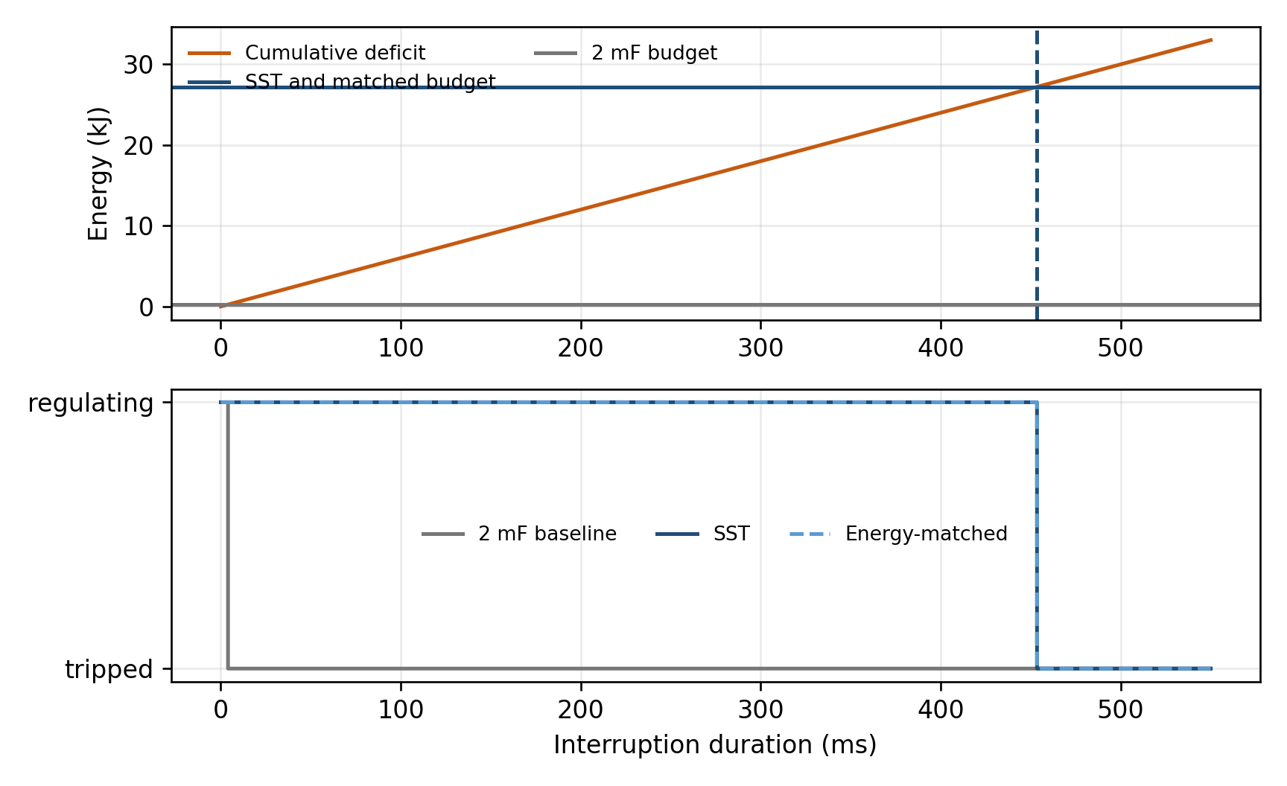
Fig. 8. A 500 ms interruption: cumulative deficit energy, usable-energy budgets and hard trip states.

4.2.1. A Fair, Energy-Buffer-Matched Conventional Baseline
The third arm in Table 3 isolates stored-energy sizing by giving the conventional interface the same 27.20 kJ usable budget as the SST. Its architecture and ideal regulation assumptions are retained, with 236.09 mF on the 800 V bus and a 640 V lower floor. This is about 118 times the 2 mF ripple-capacitor baseline. The capacitor bank is an analytical comparator rather than an optimized competing hardware design; technology-dependent cost, volume, ESR and lifetime are not inferred [20].
Both matched interfaces survive a 150 ms interruption and reach their energy limit at 453.3 ms under a 60 kW deficit. Both therefore trip during the 500 ms and 1.2 s interruptions. This equality is built into the ideal energy model and serves as a consistency check. Additional dynamics are needed to identify topology-specific regulation, protection or recovery differences.
The SST still offers an implementation distinction. Its nine links contain 18 mF of aggregate numerical capacitance at 3.3 kV, whereas the matched LV comparator requires 236.09 mF at 800 V, about 13 times more capacitance. This is not a direct cost, volume, or lifetime comparison: capacitor voltage class, series connection, dielectric technology, ripple current, insulation, and redundancy differ. It is specifically an energy-voltage scaling result.

4.3. Boundary of the Efficiency and Thermal Evidence
The separate electrical checks establish ideal switching waveforms and power consistency. The coupled averaged model additionally tests current regulation, modulation saturation, capacitor dynamics and protection. Neither model includes calibrated full-system semiconductor, magnetic or cooling losses. Figure 9 shows the executed averaged controller and energy paths; the executed coupled implementation is specified explicitly in Section 3.6.
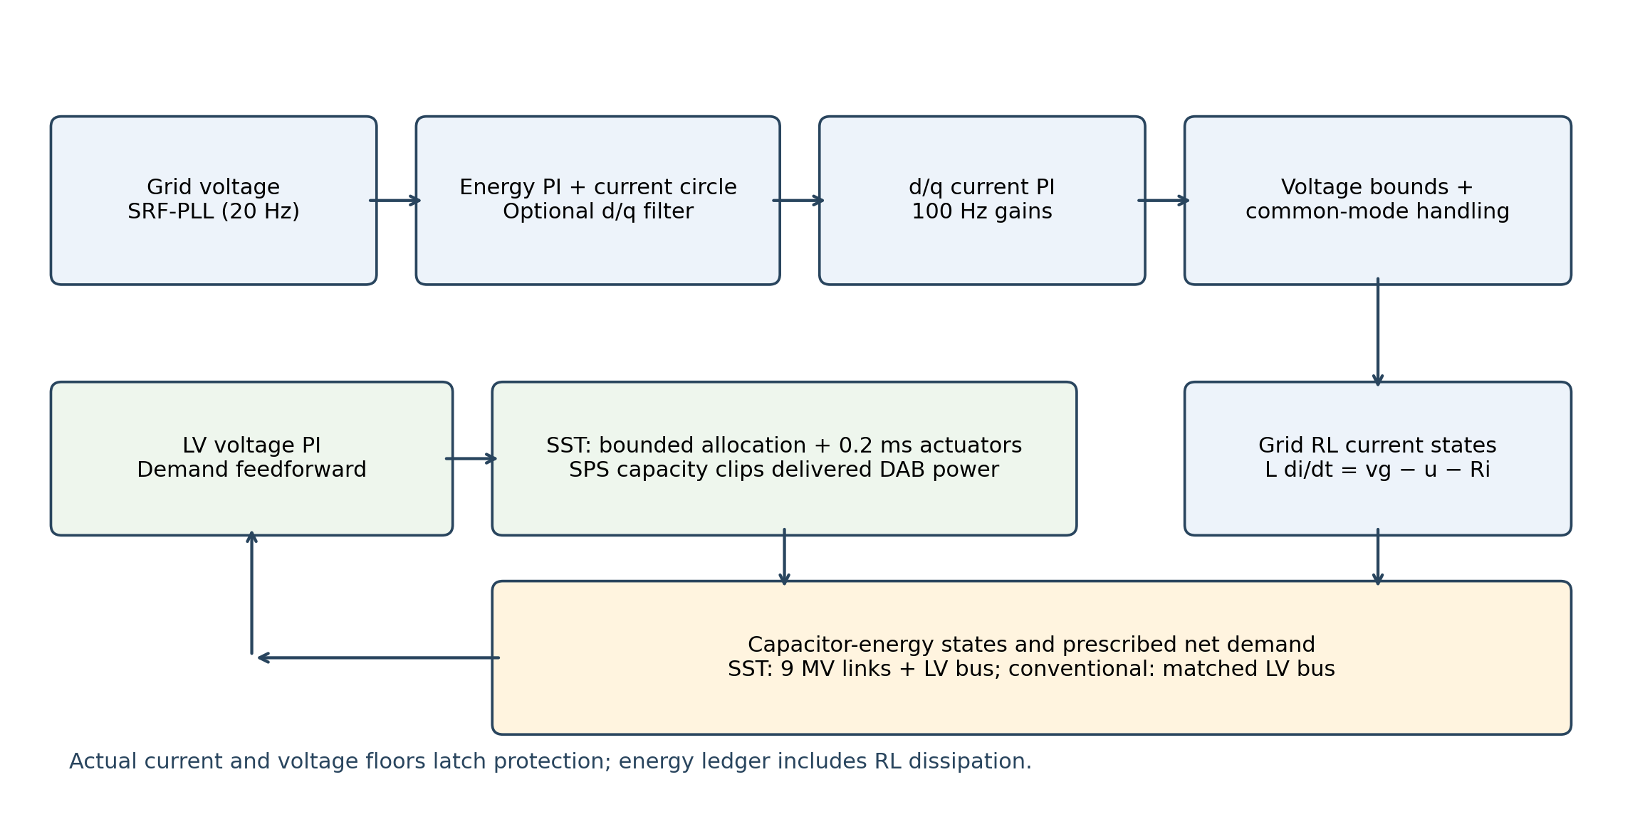
Fig. 9. Signal and energy paths in the executed coupled averaged model. Both interfaces share the PLL, current-reference law and PI gains; their converter-voltage limits and common-mode handling differ. The SST adds nine capacitor-energy states and bounded DAB actuators. No gate-level PWM or downstream LV inverter is executed in this model.

4.4. Irradiance-Informed Coincident-Disturbance Inputs
The supplied 1440-sample GHI CSV is extracted from the user-provided SRRL BMS measurement archive for 20 January 2022 (MIDC query site=BMS, begin=end=20220120) [23]. GHI exactly matches the raw Global CMP22 (vent/cor) channel after clipping negative readings to zero. The archive, download script and MST minute alignment are included and checked. Independent server authentication was unavailable. Event extraction uses a 91-minute rolling maximum smoothed with a 21-sample moving average. Deficit fractions are evaluated only where the envelope exceeds 50 W/m². Runs of at least two consecutive minutes more than 15% below the envelope yield three event magnitudes. The trace supplies magnitude choices for conditional tests; it does not supply sub-second irradiance dynamics or field event probabilities.
Table 4. Provenance label and role of the supplied irradiance trace.
Irradiance item | Specification | Use in this paper
Source | User-supplied BMS archive; 20 January 2022; CMP22 GHI | 1440 samples; raw instrument and time headers included; extraction verified
Resolution | 1 minute | Event magnitude only
Event definition | >=2 min and >15% below local envelope | Three extracted events
Limitation | One day; not sub-second | No field-probability claim
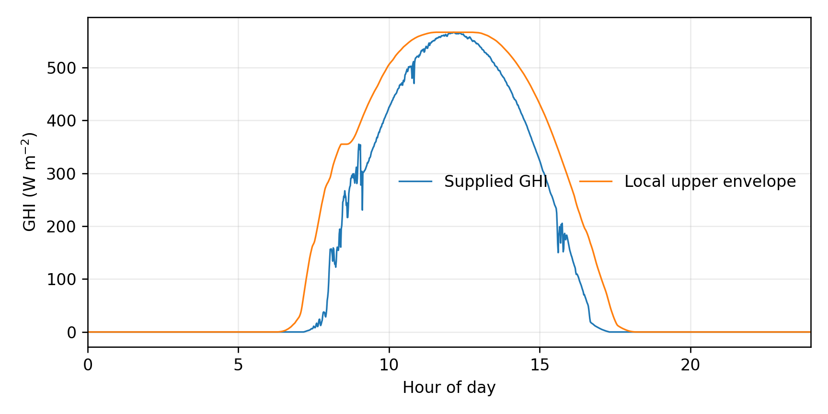
Fig. 10. Supplied GHI trace and local upper envelope used for magnitude extraction.
Coincident PV and load changes are represented as additional demand during a sag. Their contribution enters the same energy-deficit integral as the grid shortfall. Results are therefore interpreted conditionally on the disclosed randomized distributions, not as a field probability of outage.

4.5. Randomized Sensitivity Analysis
Each of 500 paired trials uses sag depth uniform on [0.10, 1.00] and duration uniform on [0.05, 1.50] s. Independently, a PV-deficit addition occurs with probability 0.70 and equals a randomly selected extracted event fraction multiplied by 40 kW. A load addition occurs with probability 0.70 and is uniform from 0 to 25 kW. Both additions persist for the complete sag; they are synthetic coincident-demand steps. Every interface receives identical trial inputs. Seed 7 provides the primary table; seeds 19 and 42 examine sampling sensitivity. These percentages characterize the chosen distributions, not field reliability.
Table 5. Primary randomized sensitivity results for 500 paired trials (seed 7).
Monte Carlo sweep (500 paired trials) | Trip count | Trip rate
Conventional 2 mF | 405 | 81.0%
Proposed SST | 284 | 56.8%
Energy-matched conventional | 284 | 56.8%
SST vs matched outcomes | Identical | Identical
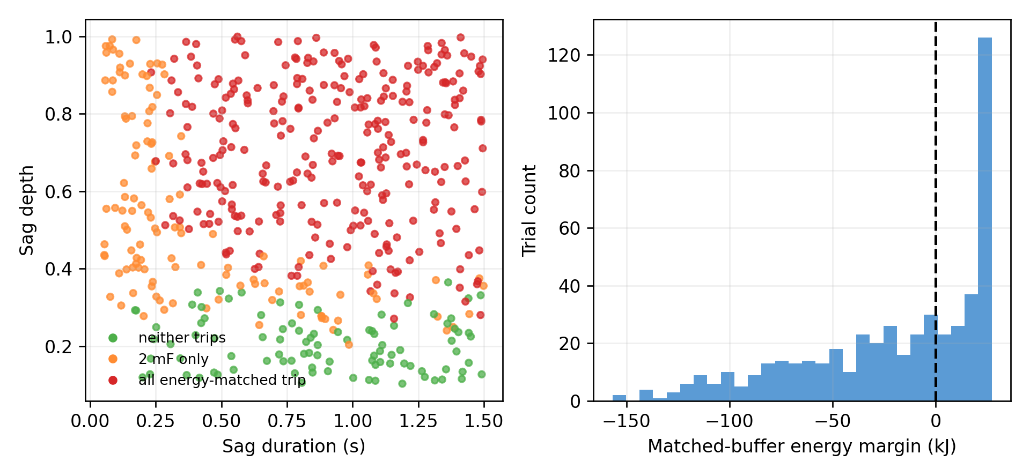
Fig. 11. Primary paired-trial outcomes and matched-buffer energy margins.
For seed 7, the 2 mF comparator trips in 405/500 trials and both matched interfaces trip in 284/500. Seeds 19 and 42 give matched trip rates of 52.8% and 54.8%, respectively; their 2 mF rates are 81.4% and 78.8%. There are zero SST-versus-matched outcome disagreements in every seed because the two energy-only models share the same governing equation. A significance test between these identical deterministic models would not establish independent evidence of equivalence. With seed-7 trial inputs fixed, changing the usable-energy budget from 0.5 to 1.5 times nominal changes the conditional trip rate from 67.4% to 46.8%.

4.6. DAB Power Headroom and Effective Usable Energy
Matched capacitor energy can be delivered only while the conversion stages can support the required power. For an interruption with equal cell voltages, fixed V2 = 800 V and dmax = 0.50, the aggregate DAB maximum is 164.840 kW at V1 = 3300 V and decreases linearly with V1. For constant demand Pdem, the effective lower cell-voltage boundary is
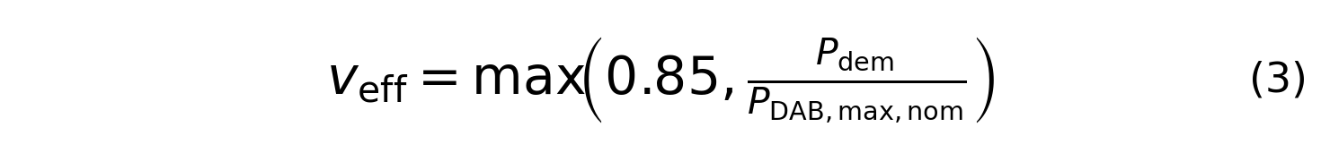
Here veff is normalized by the nominal MV-link voltage. For veff ≤ 1, the full-power interruption hold-up follows from the energy available down to that boundary:
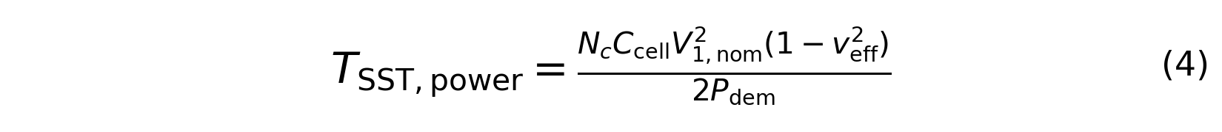
Below approximately 140.114 kW, DAB capability remains sufficient down to the 0.85 pu protection floor. At 150 kW, the effective floor rises to 0.909975 pu, so full-power SST hold-up is 112.349 ms rather than the 181.319 ms energy-only value. The matched LV comparator retains its ideal 150 kW regulation assumption and therefore has the latter value. This conditional result identifies the need to match converter power envelopes as well as usable energy. It is not a simulated controller instability or a hardware trip prediction; unequal cell voltages, losses, common-mode control and output-current constraints could shift the boundary.
Table 6. Constant-interruption sensitivity with the stated DAB power limit.
Deficit (kW) | Effective SST floor (pu) | Matched ideal (ms) | SST with headroom (ms)
60 | 0.8500 | 453.296 | 453.296
90 | 0.8500 | 302.197 | 302.197
120 | 0.8500 | 226.648 | 226.648
140 | 0.8500 | 194.270 | 194.270
150 | 0.9100 | 181.319 | 112.349
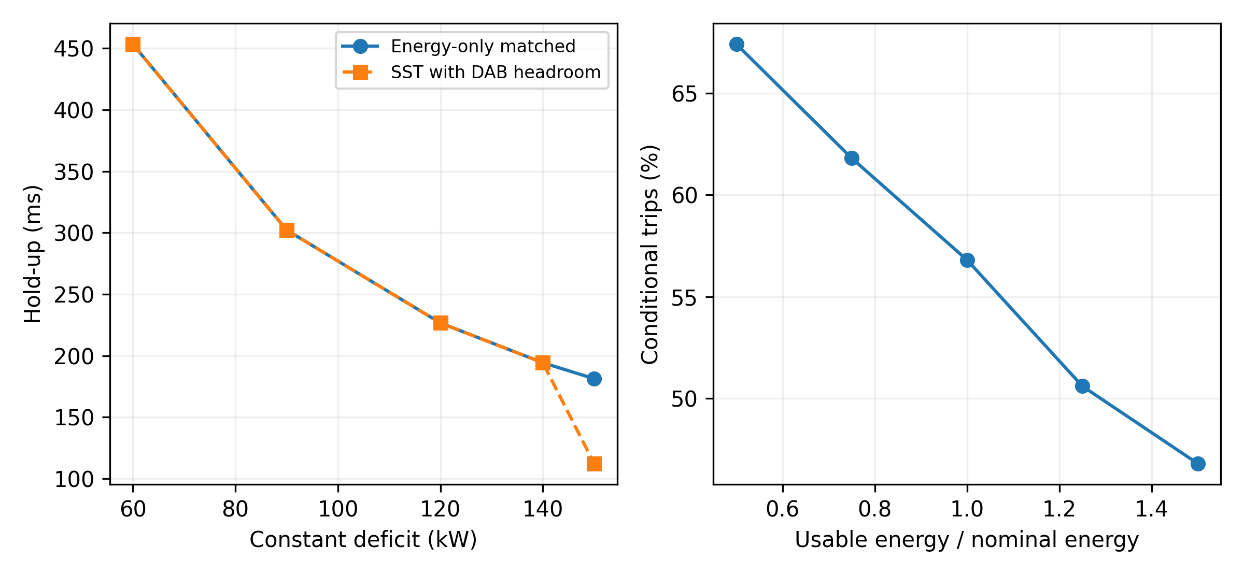
Fig. 12. DAB-headroom interruption limit (left) and fixed-input usable-energy sensitivity (right).

4.7. Coupled Recovery Failure and Symmetric Filter Comparison
The initial coupled stage executes six deterministic events in three architectures at both step sizes (36 runs): nominal operation, a 30% sag for 300 ms, a 150 ms interruption, a coincident event, a persistent 15 degree phase step and a 140 kW interruption for 250 ms. The coincident event starts at 0.4 s with 65% voltage depth for 300 ms and a 20 kW net-demand addition from 0.45 to 0.75 s above the 60 kW base. These are prescribed tests, not measured NREL disturbance waveforms. The high-load test uses 140 kW because 150 kW output plus filter dissipation exceeds the 150 kVA input-current rating. Waveform exports retain every step near restoration and use approximately 1 ms spacing elsewhere; reported summary extrema and integrals are computed before export decimation. Full-step raw MAT files are saved separately by the run script and were not included in the returned archives.
In the fine-step coincident case, the baseline SST trips at 0.706775 s, or 6.775 ms after restoration. Its logged current peak is 1.25173 times rating and its minimum cell voltage remains above the 2805 V protection floor; the retained cause is overcurrent. The energy-matched conventional arm survives, with minimum LV voltage 667.972 V. This separates a recovery/protection limitation from exhaustion of the matched capacitor budget. The 140 kW interruption instead gives an SST trip 194.0625 ms after onset and a matched conventional trip after 195.775 ms; this protection time is distinct from the analytical full-power boundary in Section 4.6.
The next stage repeats the coincident, short-interruption and phase-step cases for both matched architectures, baseline and 10/20 ms filters, at both steps (36 runs). Its unfiltered results reproduce the corresponding original cases. For the coincident SST case, the 10 ms filter survives with peak current 1.237906 times rating, leaving little margin below 1.25. The 20 ms filter survives with peak 1.126685. Minimum conventional LV voltage decreases from 667.972 V to 666.902 V and 666.280 V for the 10 ms and 20 ms variants. SST modulation-saturation fractions increase from 0.000833 to 0.010108 and 0.011862 over the 3 s run. Thus the current improvement does not imply improved performance in every metric. In the anchor-case fine-step export, SST baseline command utilization reaches 1.0431 during the first 6.7 ms after restoration, whereas the matched conventional command remains below 0.875 in that window. Each utilization is normalized by its own implemented voltage limit. These traces are consistent with modulation constraints contributing to recovery difficulty, and motivate the controlled common-mode intervention in Section 4.9.

4.8. Deterministic Exploration and Numerical Verification
The 20 ms variant is then explored against the baseline in 11 selected cases for both matched architectures at both steps (88 runs). Sag depth is fixed at 65%, onset at 0.4 s and stop time at 2 s. Case tuples (base kW, sag seconds, persistent restoration phase degrees) are: 1 (60,0.30,0), 2 (40,0.30,0), 3 (80,0.30,0), 4 (60,0.20,0), 5 (60,0.40,0), 6 (60,0.30,−15), 7 (60,0.30,15), 8 (40,0.20,−15), 9 (40,0.40,15), 10 (80,0.20,15), and 11 (80,0.40,−15). The additional 20 kW demand starts 50 ms after onset and ends 50 ms after restoration. The setting was selected from Section 4.7; this is a subsequent exploratory study, not a preregistered holdout or a full-factorial design.
Table 7 and Fig. 13 summarize the fine-step results. The baseline SST trips in seven cases: overcurrent in cases 1, 6, 7 and 9, and MV undervoltage in cases 3, 5 and 11. The filter removes those four overcurrent trips without introducing a new trip case. Its three remaining SST trips are MV undervoltage; both conventional variants trip on LV undervoltage in those same three cases. The maximum filtered SST current across this set is 1.130009 times rating, in case 7. Counts describe only these selected scenarios and are not probabilities of field failure.
The anchor-case reactive tracking metric integrates |iq − iq*| over the entire sag, using peak-valued Park currents. It increases from 0.032891 A s for the SST baseline to 0.235140 A s for the 20 ms filter. This is a response trade-off, not a grid-code assessment. Aggregating this metric across tripped and surviving cases would confound tracking with post-trip behavior, so no overall mean is used. Figure 13 shows both the recovery-current benefit and the delayed reactive response.
All 44 coarse/fine pairs in the 11-case study retain the same trip outcome; the largest trip-time difference is 12.5 microseconds. The maximum absolute energy-ledger residual across its 88 runs is 0.000183775 J. The preceding stages also retain paired trip outcomes. Archived source snapshots match the supplied stage source, and checks retain finite waveforms, increasing time, latched trip state and zero delivered load after isolation. Refinement and energy conservation establish numerical consistency within these equations; they do not establish physical fidelity or robust stability.
Table 7. Fine-step outcomes in the 11 selected coupled cases.
Architecture / variant | Trips / cases | Overcurrent | Undervoltage
SST / Baseline | 7 / 11 | 4 | 3
SST / 20 ms | 3 / 11 | 0 | 3
Matched LFT / Baseline | 3 / 11 | 0 | 3
Matched LFT / 20 ms | 3 / 11 | 0 | 3
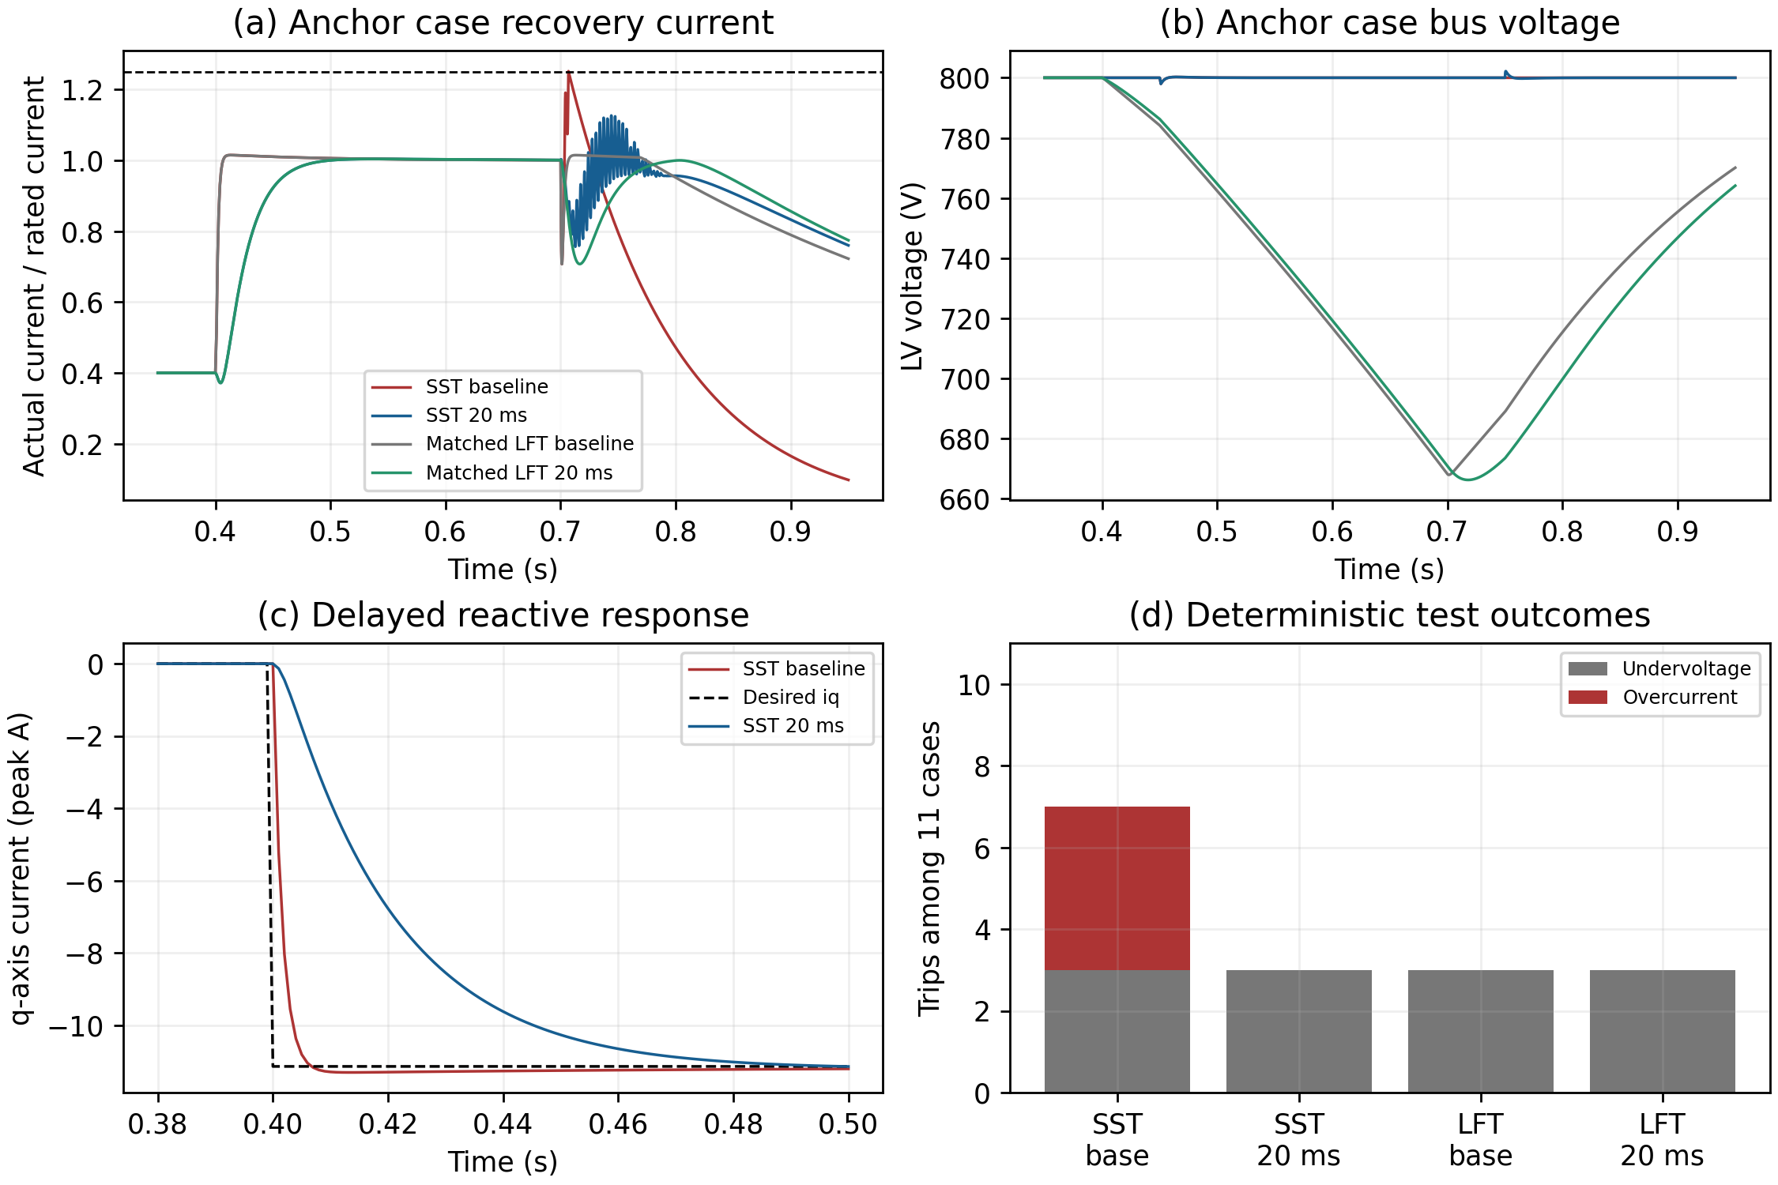
Fig. 13. Coupled anchor-case currents and LV voltage, reactive-response delay, and fine-step trip causes in the 11 selected scenarios. The current threshold is 1.25 times rating; post-trip grid isolation accounts for current decay.

4.9. Controlled Common-Mode Ablation
Stage 6 repeats the 11 cases, baseline and 20 ms reference variants, at 25 and 12.5 microseconds for three arms: original SST, SST_minmax and LFT_matched (132 runs). The original SST and conventional results reproduce the preceding exploration. The SST_minmax arm changes only common-mode injection before phase-command clipping, as defined in Section 3.6. This is a controlled implementation ablation within the averaged equations, not a new converter topology or a new modulation method.
For either time step, baseline trip counts are 7/11 for original SST, 3/11 for SST_minmax and 3/11 for LFT_matched. All three 20 ms variants trip in 3/11 cases. Min-max injection removes the original SST overcurrent trips in cases 1, 6, 7 and 9 without changing the remaining trip-case set. Cases 3, 5 and 11 retain MV-cell undervoltage trips in both SST arms and LV undervoltage trips in the conventional arm. Equal counts do not imply equal failure mechanisms or identical trajectories.
In the fine-step baseline anchor case, original SST trips at 0.706775 s with retained cause mask 4 (overcurrent). Its exported peak current is 1.251730 times rating; SST_minmax and LFT_matched survive with exported peaks of 1.014966. Figure 14 shows the restoration interval. The injected SST avoids the original command saturation in this exported window. The min-max intervention therefore identifies the original common-mode implementation as a contributor to the four additional trips within this model. It does not isolate every mechanism, optimize either architecture, or establish an inherent ride-through advantage. The original filter remains useful as a separate response trade-off, but is not necessary to remove these four trips after the modulation change.
All 66 coarse/fine-step pairs preserve trip/no-trip outcomes and recorded first-cause masks. Maximum trip-time difference is 12.5 microseconds and the largest summary energy residual is 0.000183775 J. All 132 exported CSV/MAT pairs contain finite values and agree within text-export rounding; exported trip transitions match summary times and remain latched. Summary metrics are calculated at the integration step before waveform downsampling. Consequently, exported extrema need not reproduce full-record summary extrema. Full-step raw_results are saved by the supplied execution script and must be retained for reproducibility. A subsequent MATLAB R2025b audit of the locally retained full-step records identifies exactly one passing record for each of the 132 expected run keys, with 80001 samples at 25 microseconds or 160001 samples at 12.5 microseconds. The audit checks finite states, the complete time grid, latched protection, post-trip load isolation, and agreement of recomputed metrics with the execution summary; the largest normalized metric discrepancy is 4.813 × 10⁻¹⁵. SHA-256 hashes identify the audited records. This is a numerical-consistency audit of the executed equations, not independent physical validation.
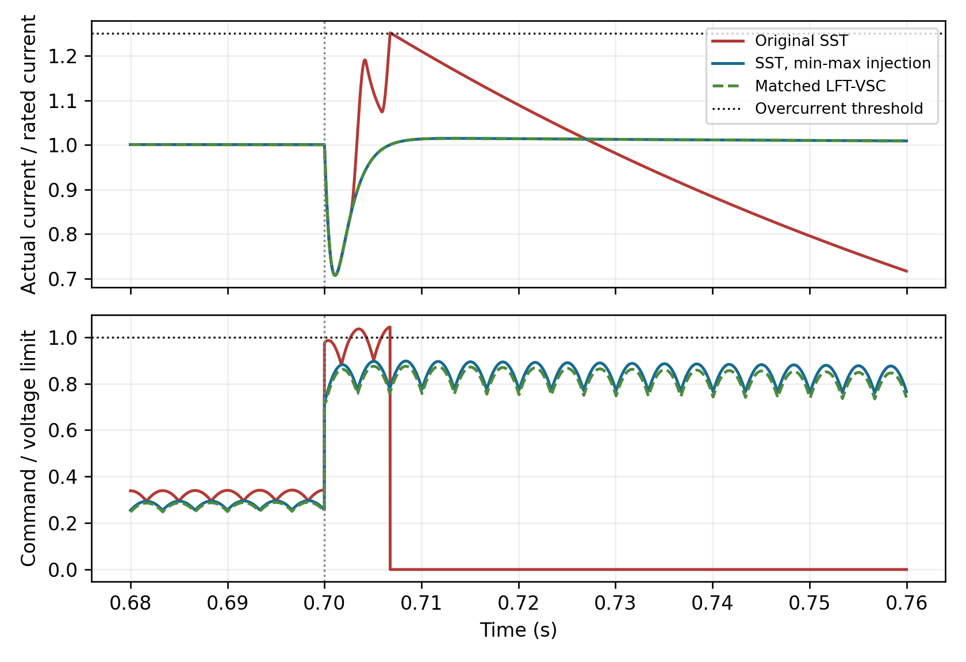
Fig. 14. Stage 6 baseline anchor-case restoration waveforms at 12.5 microseconds. Actual current is normalized by the common rating; command utilization uses each implemented voltage limit. Restoration occurs at 0.7 s. Original SST trips at 0.706775 s; the injected SST and matched conventional arm survive. Post-trip command utilization is zero because the grid is isolated. Curves use the exported waveform records.

5. Zero-Sum Headroom-Limited Cell-Voltage Coordination
The differential balancing model redistributes outgoing DAB power among nine links. The total correction is constrained to zero, separating redistribution from common-mode energy support. The initial energy is ½CcellV1,nom² in every link. Independent uniform power perturbations are drawn within ±3% of nominal cell power, then their mean is removed. The stated percentage applies before centering; the actual centered draw is retained in the supplementary output.
The nominal DAB coefficient is K(V1) = nV1V2/(2fsLk), and P0 = K(V1,nom)d0(1-d0). At each step, cell-specific correction bounds are P(dmin,V1,i) - P0 and P(dmax,V1,i) - P0. At nominal voltage these are -10.074 and +1.648 kW. Positive correction increases outgoing power and discharges a high-voltage link. This sign convention is used consistently in the PI law and energy update.
Figure 15 shows the executed differential controller. Voltage error is measured relative to the instantaneous cell-voltage mean:
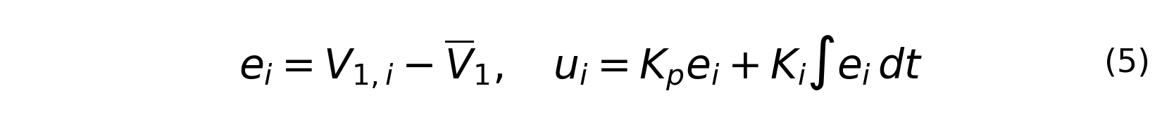
A Euclidean projection imposes both the voltage-dependent box constraints and zero total correction. A bisection search for the projection multiplier λ evaluates
The gains are Kp = 82.9 W/V and Ki = 104.2 W/(V s). Conditional integration freezes an integral increment only when it pushes an active bound further into saturation. The phase shift is obtained from the nonlinear inverse on the increasing-power branch, rather than a linearized displacement correction:
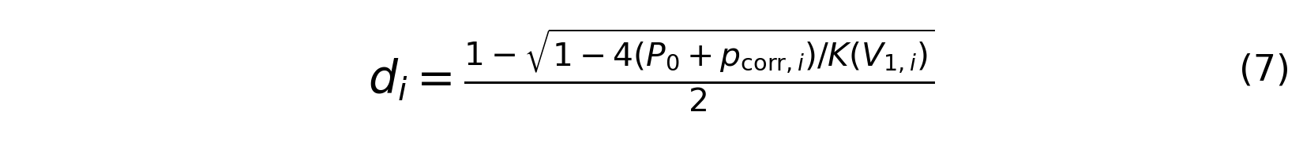
The commanded outgoing power is recomputed from P(di,V1,i), and each cell energy is updated from differential mismatch minus outgoing correction. Aggregate energy is constant under the zero-sum constraints. This PI study isolates differential balancing; it is separate from the coupled model, which uses proportional balancing, common-mode regulators, actuator lag and grid-current dynamics.
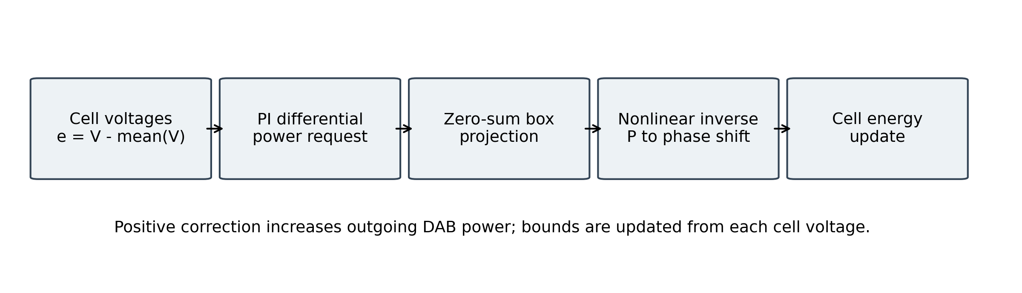
Fig. 15. Differential outgoing-power balancing with voltage-dependent headroom and nonlinear phase-shift inversion.
For seed 19 and the 3% pre-centering mismatch draw, peak deviation is 0.13554%, settling below 0.05% occurs at 1.011 s, and phase shifts stay within 0.33137-0.37243. The maximum aggregate correction residual is below 2 × 10⁻⁹ W. Halving the time step changes peak deviation to 0.13542% and leaves the settling time unchanged. Across seeds 7, 19 and 42, the 3% cases peak between 0.136% and 0.179% and settle within 1.207 s. These are average-model results, not hardware guarantees.
Table 8. Primary differential-balancing results (seed 19).
9-cell balancing item | Result | Implementation
Worst-cell peak deviation | 0.136% | Average-value, seed 19
Settling below 0.05% | 1.011 s | Specific ±3% draw
Differential power sum | <2 × 10⁻⁹ W residual | Bisection box projection
Correction limits | -10.074/+1.648 kW | Nominal bounds; updated with voltage
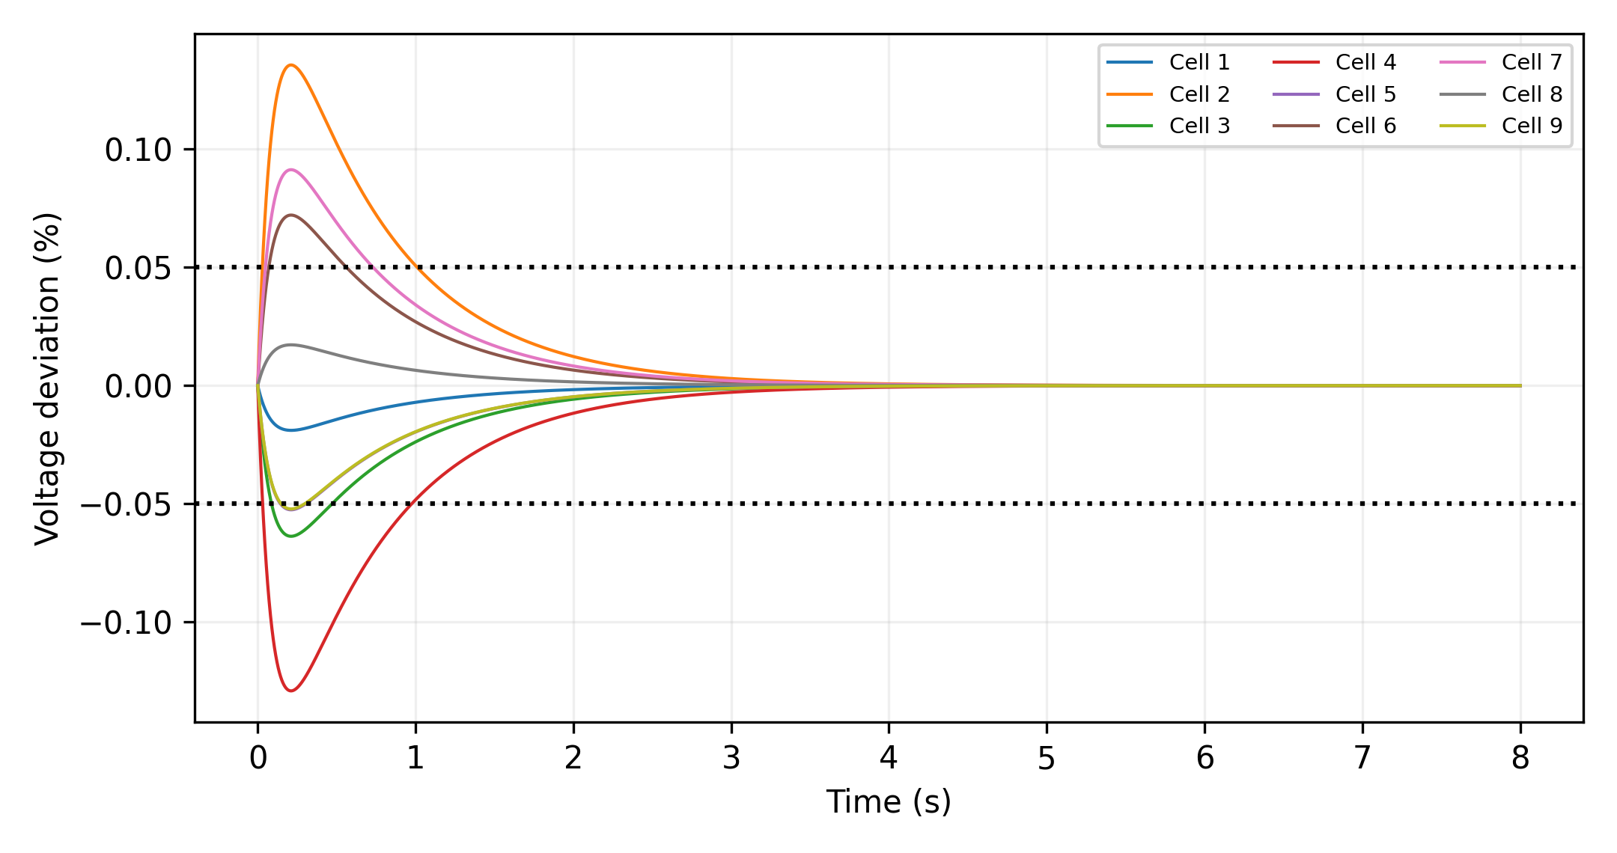
Fig. 16. Nine-cell voltage deviations for the primary 3% mismatch case.
Increasing the pre-centering mismatch range to 10% gives peak deviations of 0.451-0.598% and settling times of 1.860-2.056 s across the three seeds. At 20%, every tested seed reaches dmax = 0.50 and remains saturated for more than 98% of the 8 s trajectory; none settles below 0.05%. Table 9 reports this failure boundary. Persistent imbalance beyond available outgoing-power headroom cannot be removed by increasing PI gain alone.
Table 9. Balancing sensitivity across seeds 7, 19 and 42 (1 ms step).
Pre-centering mismatch | Peak deviation range | Settling-time range | Power-limit outcome
3% | 0.136-0.179% | 1.011-1.207 s | No saturation
10% | 0.451-0.598% | 1.860-2.056 s | No saturation
20% | 2.138-7.136% | Not settled by 8 s | dmax reached; >98% saturation

6. Limitations
The coupled validation is an averaged equation-based model with prescribed balanced grid voltage, an SRF-PLL, an RL filter and ideal conversion stages. It excludes switching ripple, negative sequence, grid-source impedance, measurement noise, digital delay, EMI, device commutation, insulation and hardware protection coordination. The separate CHB switching check sets its nominal exchange by power-angle search and does not validate the coupled controller at switching resolution. Neither harmonic metric establishes standards compliance.
The paper does not report full-system efficiency or a validated junction-temperature trajectory. Complete loss accounting requires nonlinear device data for the selected components, magnetics, filters, capacitors, auxiliaries, cooling, and a matched conventional model. Hardware measurements or a calibrated circuit-level model are required before efficiency or lifetime claims are made.
The supplied one-minute GHI trace is verified against its accompanying raw BMS archive; it supplies event magnitudes for the separate Python energy study. It is not used as the time waveform in the coupled MATLAB tests. Their sag, demand-step and phase-restoration inputs are deliberately synthetic. The 11-case exploration is neither a full factorial design nor a field-probability estimate, and its filter setting was selected after the preceding comparison. Matching energy does not match voltage capability, transformer losses, component cost or control bandwidth. The 20 ms filter acts on both d and q references throughout the run and delays reactive support; no grid-code compliance or general fault-ride-through guarantee follows. The controlled common-mode ablation removes the original four additional SST trips, establishing implementation sensitivity within the stated averaged model. Available phase voltage, energy distribution and the unoptimized comparator still limit architectural attribution. Equal trip counts do not establish equal failure mechanisms. Neither the 11-case exploration nor the reference filter establishes general stability or a grid-code compliance envelope.
The analytical DAB full-power boundary assumes constant LV voltage and equal link voltages; it is distinct from the coupled model protection time. The separate differential PI model and the coupled proportional balancing loop are not interchangeable validation evidence. Persistent saturation in the larger-mismatch study and undervoltage failures in the coupled tests remain reported. BESS reserve dispatch, switched LV dynamics, calibrated losses, thermal lifetime, hardware and HIL verification are outside scope.

7. Conclusion and Future Work
This study specifies a 150 kVA CHB-DAB SST and separates usable capacitor energy from converter power feasibility in ride-through benchmarking. Ideal unipolar modulation produces seven CHB voltage levels, and the separate DAB integration agrees with its analytical power relation within 0.177%. The switching checks establish waveform and ideal power consistency; they do not establish hardware efficiency or device-level ZVS.
Energy matching gives identical ideal hold-up under the shared energy-only equation, but does not guarantee equal coupled recovery. In the original averaged implementation, the anchor SST trips on overcurrent 6.775 ms after sag restoration while its matched conventional comparator survives. The controlled common-mode ablation removes four additional SST overcurrent trips among the 11 selected cases, reducing baseline SST trips from seven to three, equal to the matched conventional count. Remaining SST trips are MV-cell undervoltage, whereas conventional trips are LV undervoltage. The symmetric 20 ms reference filter also removes the four original trips but increases anchor-case reactive-current tracking error. Step refinement preserves every ablation outcome and first-cause mask. These findings support modulation- and protection-aware benchmarking, rather than an inherent SST ride-through advantage. The separate DAB headroom and differential-balancing studies identify additional power-transfer and saturation boundaries.
Further work should assess switching-level coupled behavior, grid impedance and unbalanced disturbances, sensor and digital delays, and restoration-specific strategies that preserve reactive-current response. Additional independent scenarios and parameter variation are needed to establish robustness beyond the selected case set. Calibrated devices, magnetics and losses, followed by experimental validation, are required before interpreting these conditional simulation outcomes as hardware performance.

CRediT authorship contribution statement
Shahbaz: Conceptualization, Methodology, Software, Validation, Formal analysis, Investigation, Data curation, Writing - original draft, Writing - review and editing, Visualization. Ravi Nath Tripathi: Supervision, Methodology review, Validation review, Writing - review and editing.

Declaration of competing interest
The authors declare that they have no known competing financial interests or personal relationships that could have appeared to influence the work reported in this paper.

Funding
This research received no external funding.

Data availability
The supplementary package contains the raw BMS archive and verified GHI extraction, Python source and numerical outputs, and the MATLAB/Simulink coupled source and user-executed archives through the recovery, robustness and executed common-mode ablation stages. Summary tables, waveform CSV/MAT files, model files, executed source snapshots and SHA-256 manifests preserve the simulation provenance. The Python entry point documented in the supplementary README regenerates the separate checks; each MATLAB stage has its own entry point and archived configuration. Controlled coupled disturbances are explicitly distinguished from the measured irradiance trace. The archived coupled CSV/MAT waveform exports are decimated outside the restoration window; summary files retain metrics calculated at the original integration step. Full-step raw outputs can be regenerated with the supplied MATLAB scripts. Stage 6 contains 132 executed runs and the source snapshot used for its common-mode ablation. Its transferred archive contains downsampled waveform records and full-step summary metrics. The supplementary audit includes the original local MATLAB audit report and a separately identified subset of 132 passing full-step records with their SHA-256 hashes. Three full-step anchor records are included for direct inspection. The remaining full-step records are retained by the corresponding author and are available on request; the complete full-step archive is not embedded in the supplementary package. The audit report also contains downsampled exports and a summary MAT file that do not satisfy the full-step schema; these are excluded from the 132-record audit subset.

References
[1] Cervero, D., Fotopoulou, M., Muñoz-Cruzado, J., Rakopoulos, D., Stergiopoulos, F., Nikolopoulos, N., Voutetakis, S., Sanz, J.F.: 'Solid state transformers: a critical review of projects with relevant prototypes and demonstrators', Electronics, 2023, 12, p. 931. doi:10.3390/electronics12040931.
[2] Zhang, J., Wen, C., Wang, D., Chen, Y., Liu, S., Gao, T., Li, X.: 'Solid-state transformers in modern distribution grids: a comprehensive review of principles, topologies, key technologies, applications, and challenges', Electronics, 2026, 15, p. 2839. doi:10.3390/electronics15132839.
[3] De Silva, H.H.H., Jayamaha, D.K.J.S., Lidula, N.W.A.: 'Review on design and control of solid state transformer based microgrids', AIMS Energy, 2019, 7, (6), pp. 901–923. doi:10.3934/energy.2019.6.901.
[4] Agarwala, A., Tahsin, T., Ali, M.F., Sarker, S.K., Abhi, S.H., Das, S.K., Das, P., Hasan, M.M., Tasneem, Z., Islam, M.M., et al.: 'Towards next generation power grid transformer for renewables: technology review', Eng. Rep., 2024, 6, p. e12848. doi:10.1002/eng2.12848.
[5] Malik, S.M., Sun, Y., Hu, J.: 'A novel solid state transformer based control topology for interconnected MV and LV hybrid microgrids', Energy Reports, 2022, 8, pp. 10385–10394. doi:10.1016/j.egyr.2022.08.175.
[6] Coelho, S., Dionizio, A., Cunha, J., Monteiro, V., Afonso, J.L.: 'Solid-state transformer: the catalyst for resilient and sustainable smart grids', Energy, 2025, 327, p. 136321.
[7] Xu, C., Wei, J., Zheng, L., Han, X., Saeedifard, M., Kandula, R.P., Kandasamy, K., Divan, D., Graber, L.: 'Insulation coordination design for grid-connected solid-state transformers', IEEE J. Emerg. Sel. Top. Power Electron., 2022, 10, (4), pp. 3746-3758. doi:10.1109/JESTPE.2021.3125708.
[8] Paudyal, P., Harris, T., Padullaparti, H.V., Bharati, G., Bhavaraju, V.: 'Evaluating EV charging stations operation with medium voltage solid-state transformer: grid performance and value analysis'. Proc. IEEE PES General Meeting, Seattle, USA, 2024, pp. 1-5. doi:10.1109/PESGM51994.2024.10689200.
[9] Zheng, L., Kandula, R.P., Divan, D.: 'Soft-switching solid-state transformer with reduced conduction loss', IEEE Trans. Power Electron., 2021, 36, (5), pp. 5236-5249. doi:10.1109/TPEL.2020.3030795.
[10] Ramírez, J.C., Gómez-Luna, E., Vasquez, J.C.: 'Technical and economic feasibility analysis to implement a solid-state transformer in local distribution systems in Colombia', Energies, 2025, 18, p. 3723. doi:10.3390/en18143723.
[11] Hinov, N.: 'Solid-state transformers in the global clean energy transition: decarbonization impact and lifecycle performance', Energies, 2026, 19, p. 558. doi:10.3390/en19020558.
[12] Rodriguez, J., Lai, J.S., Peng, F.Z.: 'Multilevel inverters: a survey of topologies, controls, and applications', IEEE Trans. Ind. Electron., 2002, 49, (4), pp. 724–738. doi:10.1109/TIE.2002.801052.
[13] Gültekin, B., Gerçek, C.O., Atalik, T., Deniz, M., Biçer, N., Ermis, M., et al.: 'Design and implementation of a 154-kV ±50-Mvar transmission STATCOM based on 21-level cascaded multilevel converter', IEEE Trans. Ind. Appl., 2012, 48, (3), pp. 1030–1045. doi:10.1109/TIA.2012.2190690.
[14] Marquez, A., Leon, J.I., Vazquez, S., Portillo, R., Franquelo, L.G., Freire, E., Kouro, S.: 'Variable-angle phase-shifted PWM for multilevel three-cell cascaded H-bridge converters', IEEE Trans. Ind. Electron., 2017, 64, (5), pp. 3619–3628.
[15] De Doncker, R.W.A.A., Divan, D.M., Kheraluwala, M.H.: 'A three-phase soft-switched high-power-density DC/DC converter for high-power applications', IEEE Trans. Ind. Appl., 1991, 27, (1), pp. 63–73.
[16] Ataullah, H., Iqbal, T., Khalil, I.U., Ali, U., Blazek, V., Prokop, L., Ullah, N.: 'Analysis of the dual active bridge-based DC-DC converter topologies, high-frequency transformer, and control techniques', Energies, 2022, 15, p. 8944. doi:10.3390/en15238944.
[17] Yang, S., Bryant, A., Mawby, P., Xiang, D., Ran, L., Tavner, P.: 'An industry-based survey of reliability in power electronic converters', IEEE Trans. Ind. Appl., 2011, 47, pp. 1441–1451.
[18] Mishra, D.K., Abbasi, M.H., Eskandari, M., Paudel, S., Zhang, J., Li, L.: 'State-space modelling and stability analysis of solid-state transformers for resilient distribution systems', Appl. Sci., 2024, 14, p. 1915. doi:10.3390/app14051915.
[19] Nagasri, D.L.S., Marimuthu, R.: 'Review on advanced control techniques for microgrids', Energy Reports, 2023, 10, pp. 3054-3072. doi:10.1016/j.egyr.2023.09.162.
[20] Wang, H., Blaabjerg, F.: 'Reliability of capacitors for DC-link applications in power electronic converters: an overview', IEEE Trans. Ind. Appl., 2014, 50, pp. 3569–3578. doi:10.1109/TIA.2014.2308357.
[21] 'IEEE standard for harmonic control in electric power systems', IEEE Std 519-2022, 2022.
[22] Infineon Technologies AG: 'FZ400R65KE3 6500 V, 400 A single-switch IGBT module', product information and datasheet.
[23] National Renewable Energy Laboratory: 'Solar Radiation Research Laboratory Baseline Measurement System', MIDC archive, https://midcdmz.nrel.gov/apps/data_api.pl. User-supplied BMS archive and download script; clipped CMP22 extraction verified; query site=BMS, begin=20220120, end=20220120; used for event-magnitude sensitivity.
[24] Yazdani, A., Iravani, R.: Voltage-Sourced Converters in Power Systems: Modeling, Control, and Applications (Wiley, 2010). doi:10.1002/9780470551578.
[25] Teodorescu, R., Liserre, M., Rodriguez, P.: Grid Converters for Photovoltaic and Wind Power Systems (Wiley, 2011). doi:10.1002/9780470667057.
[26] Holmes, D.G., Lipo, T.A.: Pulse Width Modulation for Power Converters: Principles and Practice (Wiley-IEEE Press, 2003). ISBN 9780471208143.
[27] Mohan, N., Undeland, T.M., Robbins, W.P.: Power Electronics: Converters, Applications, and Design (Wiley, 3rd edn., 2003). ISBN 9780471226932.
[28] Erickson, R.W., Maksimovic, D.: Fundamentals of Power Electronics (Springer, 3rd edn., 2020). doi:10.1007/978-3-030-43881-4.
[29] Blaabjerg, F., Teodorescu, R., Liserre, M., Timbus, A.V.: 'Overview of control and grid synchronization for distributed power generation systems', IEEE Trans. Ind. Electron., 2006, 53, (5), pp. 1398–1409. doi:10.1109/TIE.2006.881997.
[30] Rodriguez, P., Pou, J., Bergas, J., Candela, J.I., Burgos, R.P., Boroyevich, D.: 'Decoupled double synchronous reference frame PLL for power converters control', IEEE Trans. Power Electron., 2007, 22, (2), pp. 584–592. doi:10.1109/TPEL.2006.890000.
[31] Astrom, K.J., Rundqwist, L.: 'Integrator windup and how to avoid it'. Proc. American Control Conference, Pittsburgh, USA, 1989, pp. 1693–1698. doi:10.23919/ACC.1989.4790464.
[32] Li, Z., Zheng, T., Wang, Y., Yang, C.: 'A hierarchical coordinative control strategy for solid state transformer based DC microgrids', Appl. Sci., 2020, 10, (19), art. 6853. doi:10.3390/app10196853.
[33] Stynski, S., Grzegorczyk, M., Sobol, C., Kot, R.: 'Current control strategies for a star connected cascaded H-bridge converter operating as MV-AC to MV-DC stage of a solid state transformer', Energies, 2021, 14, (15), art. 4607. doi:10.3390/en14154607.
[34] Wang, H., Zhang, C., Zhang, M., Wang, R., Barbosa, P.: 'Current-limiting control for fault ride-through of LLC-based solid-state transformer in data centers', arXiv preprint 2608.26595, version 2, 2026. doi:10.48550/arXiv.2608.26595.

Figure legends
Fig. 1. Overall SST-interfaced PV-BESS microgrid and comparator. The diagram shows the 236.09 mF analytical benchmark; coupled tests use 238.09 mF to include the SST LV capacitor (Section 3.6).
Fig. 2. Functional arrangement of three series CHB cells and dedicated DAB stages in one phase; nine cells in the three-phase specification. This is a block schematic, not a transistor-level circuit.
Fig. 3. Ideal unipolar seven-level CHB stack and low-order current spectrum. Higher-frequency switching content is included in the separately reported full-spectrum THD.
Fig. 4. Functional blocks in one ideal DAB cell; nine are specified in the SST. The bridge switch connections and transformer construction are outside this block schematic.
Fig. 5. DAB control concept and separate ideal switching-check boundary; delay is dTs/2. The coupled averaged LV regulator is evaluated separately in Section 3.6.
Fig. 6. DAB cell bridge voltages and leakage-inductor current at the rated operating point (d=0.35).
Fig. 7. DAB power transfer: analytic formula vs. switched-model simulation, across the operating duty range.
Fig. 8. A 500 ms interruption: cumulative deficit energy, usable-energy budgets and hard trip states.
Fig. 9. Signal and energy paths in the executed coupled averaged model. Both interfaces share the PLL, current-reference law and PI gains; their converter-voltage limits and common-mode handling differ. The SST adds nine capacitor-energy states and bounded DAB actuators. No gate-level PWM or downstream LV inverter is executed in this model.
Fig. 10. Supplied GHI trace and local upper envelope used for magnitude extraction.
Fig. 11. Primary paired-trial outcomes and matched-buffer energy margins.
Fig. 12. DAB-headroom interruption limit (left) and fixed-input usable-energy sensitivity (right).
Fig. 13. Coupled anchor-case currents and LV voltage, reactive-response delay, and fine-step trip causes in the 11 selected scenarios. The current threshold is 1.25 times rating; post-trip grid isolation accounts for current decay.
Fig. 14. Stage 6 baseline anchor-case restoration waveforms at 12.5 microseconds. Actual current is normalized by the common rating; command utilization uses each implemented voltage limit. Restoration occurs at 0.7 s. Original SST trips at 0.706775 s; the injected SST and matched conventional arm survive. Post-trip command utilization is zero because the grid is isolated. Curves use the exported waveform records.
Fig. 15. Differential outgoing-power balancing with voltage-dependent headroom and nonlinear phase-shift inversion.
Fig. 16. Nine-cell voltage deviations for the primary 3% mismatch case.

