**Task1**

**design a control system for two engines of a type DC motor.-1**

**design a control system for engines of a type servo motor.-2**

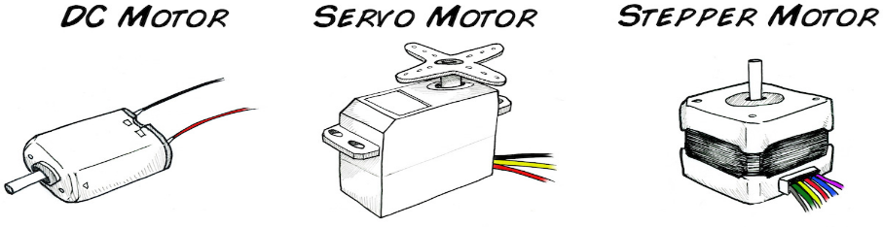First , I want to show you the type of engines it will be working . hare thy have 3 types (DC , Servo , Stepper motors ).

**1-DC motor**

**Used:**

-2 DC motor

- Arduino

- 9v battery

-breadboard mini

And This is how to connecting them:

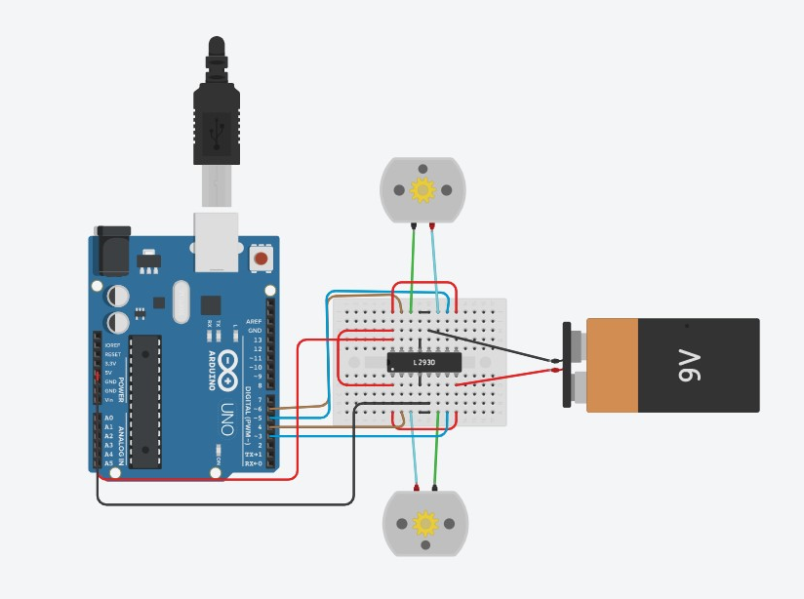

void setup()

{

pinMode(6, OUTPUT);

pinMode(5, OUTPUT);

pinMode(4, OUTPUT);

pinMode(3, OUTPUT);

}

void loop()

{

digitalWrite(6, HIGH);

digitalWrite(5, LOW);

digitalWrite(4, HIGH);

digitalWrite(3, LOW);

{ delay(1000); // Wait for 1000 s

**2- Servo motor**

Used :

2 servo motors -

Battery -

-Arduino

Breadboard small -

