The Islamic University of Gaza.  Programming III Lab.  CSCI 2108. |  | Faculty of Information Technology  Instructor: Aya N. Alharazin
FINAL PROJECT

Gaza Humanitarian Aid Distribution System (GHADS)

Course: Programming III Lab — CSCI 2108
Instructor: Aya N. Alharazin
Student Name: Shahd abo kwaik
Student ID: 220222413

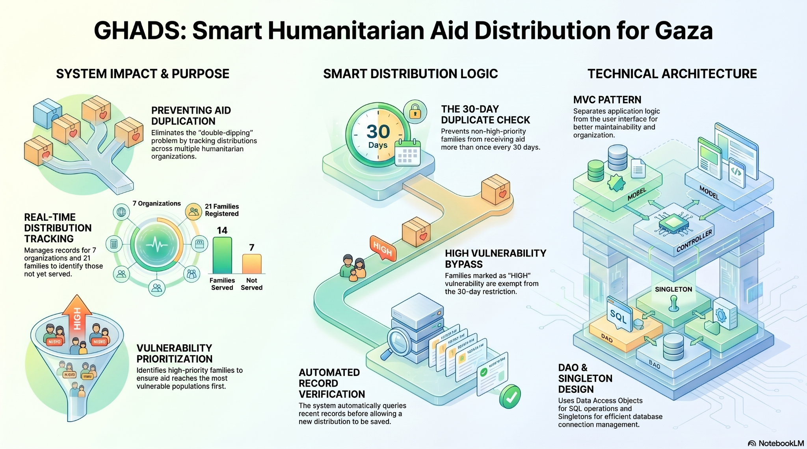System Overview
GHADS (Gaza Humanitarian Aid Distribution System) is a desktop application designed to help humanitarian organizations manage aid distribution activities. The system allows administrators and coordinators to manage organizations, users, families, and aid distribution records in an organized way.
The main problem addressed by GHADS is the duplication of aid distribution and the difficulty of tracking beneficiary families. The system helps ensure fair aid delivery, identifies vulnerable families, and provides useful statistics to support better decision-making.

3. Architecture & Design
The project follows three architecture and design patterns: MVC (Model-View-Controller), DAO (Data Access Object), and Singleton.

MVC (Model – View – Controller)
What is it?
MVC is an architecture pattern that separates the application into three main components: Model, View, and Controller. The Model represents the data and business objects, the View represents the user interface, and the Controller manages user interactions and application logic.
Why did I use it?
I used MVC to keep the project well organized and maintainable. It helped separate the user interface from the application logic and data, making the code easier to understand, modify, and extend.

DAO (Data Access Object)
What is it?
DAO is a design pattern that separates database operations from the rest of the application. It provides dedicated classes to handle data access and SQL queries.
Why did I use it?
I used DAO to keep database-related code separate from the controllers. This improved code organization, reduced duplication, and made database operations easier to manage and maintain.

Singleton Pattern
What is it?
Singleton is a design pattern that ensures only one instance of a class exists during the application lifecycle. In this project, it is used in the DBConnection class to manage the database connection.
Why did I use it?
I used Singleton to provide a single shared database connection throughout the system. This reduces unnecessary connection creation, improves resource management, and centralizes database access.

Duplicate Check Implementation
The duplicate check logic was implemented to prevent repeated aid distribution for the same family within the last 30 days. The rule is that any family whose vulnerability level is not HIGH cannot receive aid again if they already received aid during the previous 30 days. However, families with HIGH vulnerability level are allowed to receive aid even if they received aid recently, because they are considered high-priority cases.
In my project, this logic is implemented in CoordinatorAidDistributionsController.java inside the handleAdd() method before saving a new aid distribution. The system first gets the selected family, organization, coordinator, aid type, and distribution date. Then it checks the family vulnerability level using getVulnerabilityLevel(). If the vulnerability level is not HIGH, the controller calls the getLastAidWithin30Days(familyId) method from AidDistributionDAO.
The getLastAidWithin30Days() method searches the aid_distributions table for the latest aid distribution record for the selected family within the last 30 days. The SQL query uses DATE_SUB(CURDATE(), INTERVAL 30 DAY) to check only recent aid records, orders them by distribution_date in descending order, and returns the most recent record using LIMIT 1.
If a previous aid record is found, the method returns an AidDistribution object containing details such as the organization name, coordinator name, aid type, and distribution date. The controller then rejects the new distribution and displays a clear alert showing the family name, vulnerability level, organization name, and aid date. If no previous record is found, or if the family has HIGH vulnerability, the system creates a new AidDistribution object and saves it using addDistribution(). After a successful save, the system also updates the family’s last_aid_date.

Challenges & Solutions

Challenge 1: Project Complexity and Large Number of Controllers
Challenge:
As the project grew, managing a large number of controllers and screens became challenging. Each module had its own controller, such as user management, family management, organization management, aid distribution, dashboards, and profile management.
Solution:
To keep the project organized, I followed the MVC architecture pattern and separated the functionality into different controllers and FXML screens. This made the code easier to manage, debug, and maintain

Challenge 2: Testing and Debugging
Challenge:
Testing the application was one of the most time-consuming parts of the project. After implementing a new feature, I often had to test multiple screens and functions to ensure that no existing functionality was affected.
Solution:
I performed continuous testing throughout development instead of waiting until the end of the project. After each feature was completed, I tested all related operations and fixed any issues immediately.

Challenge 3: Implementing the Duplicate Aid Check
Challenge:
Implementing the duplicate aid prevention rule required careful handling because some families should be restricted while others should still receive assistance.
Solution:
I implemented a duplicate check mechanism that verifies whether a family has received aid within the last 30 days. Families with HIGH vulnerability are allowed to receive aid, while other families are prevented from receiving duplicate distributions.

Screenshots
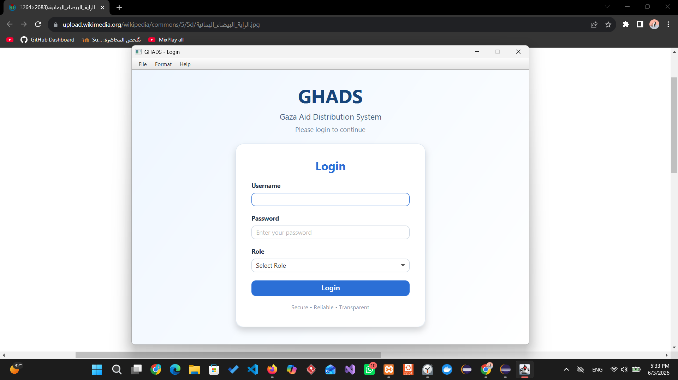
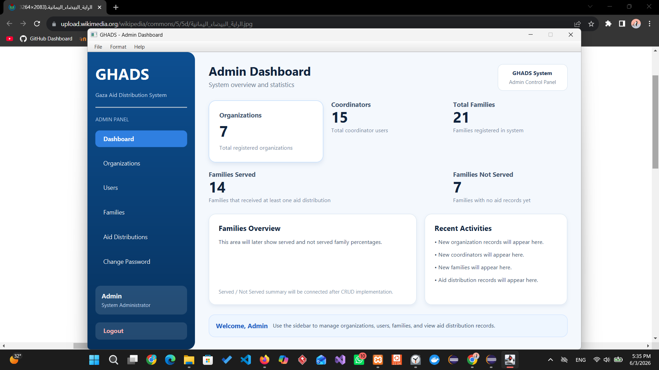
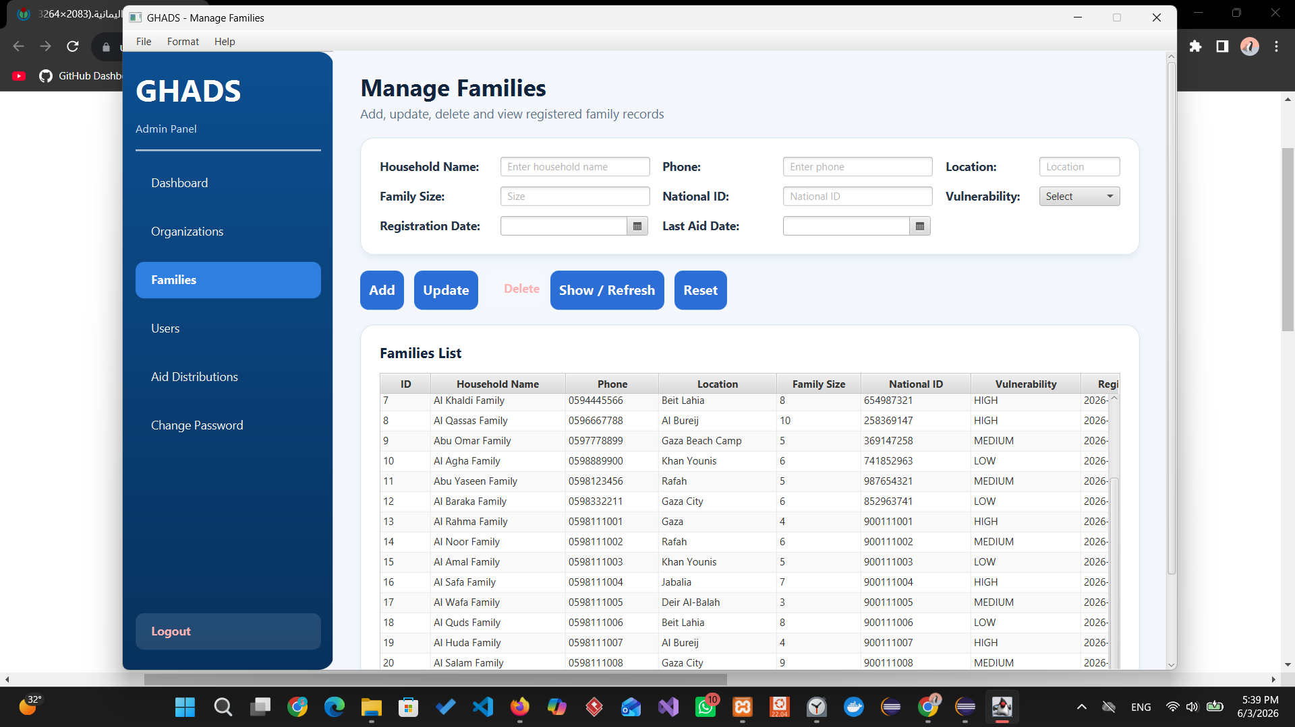
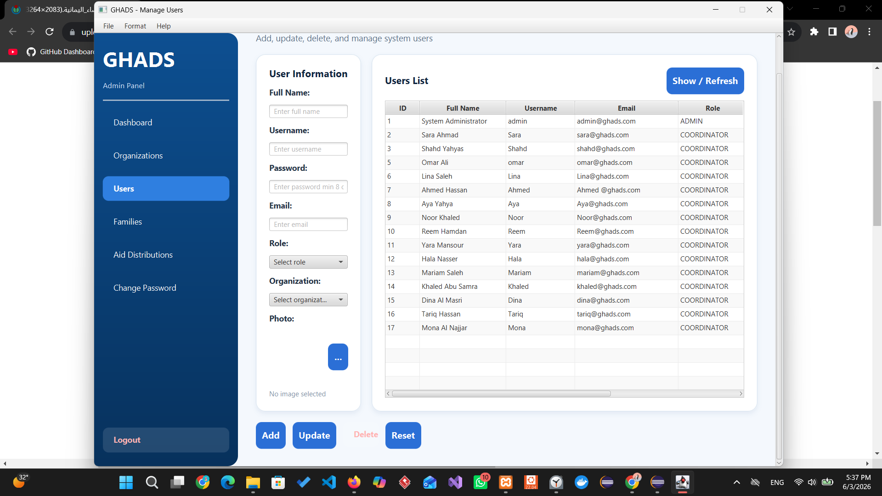
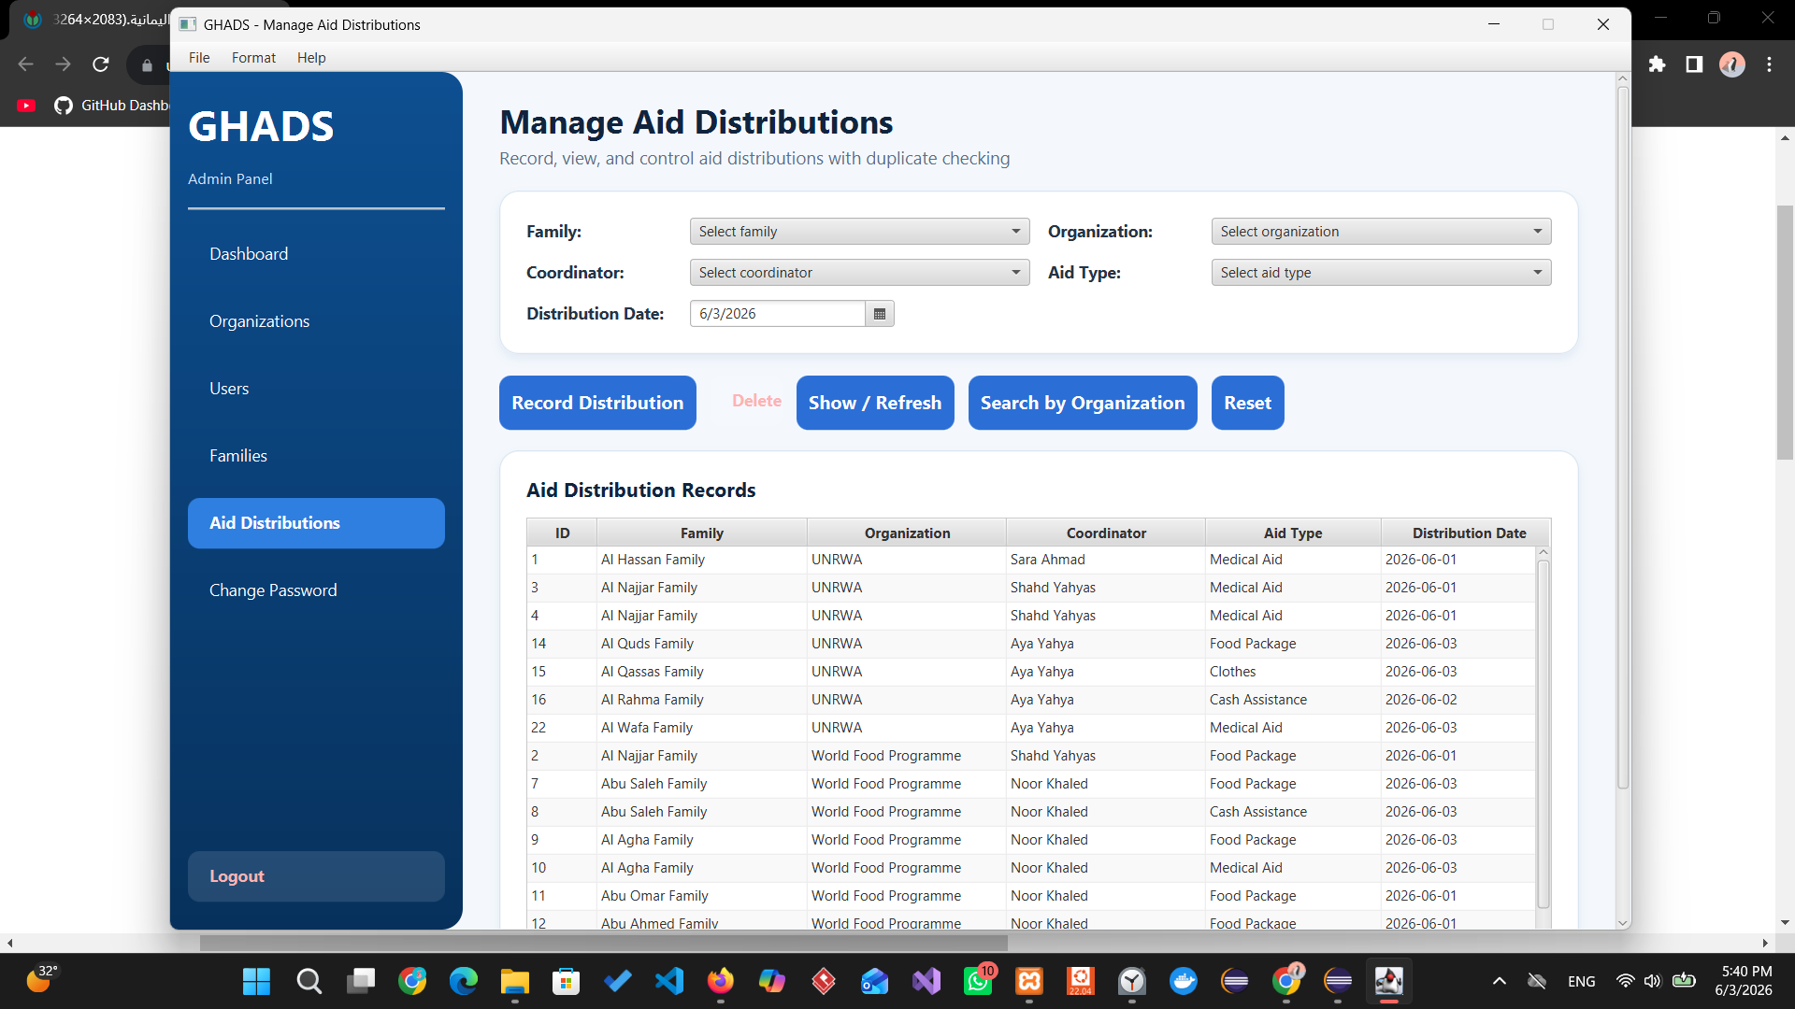
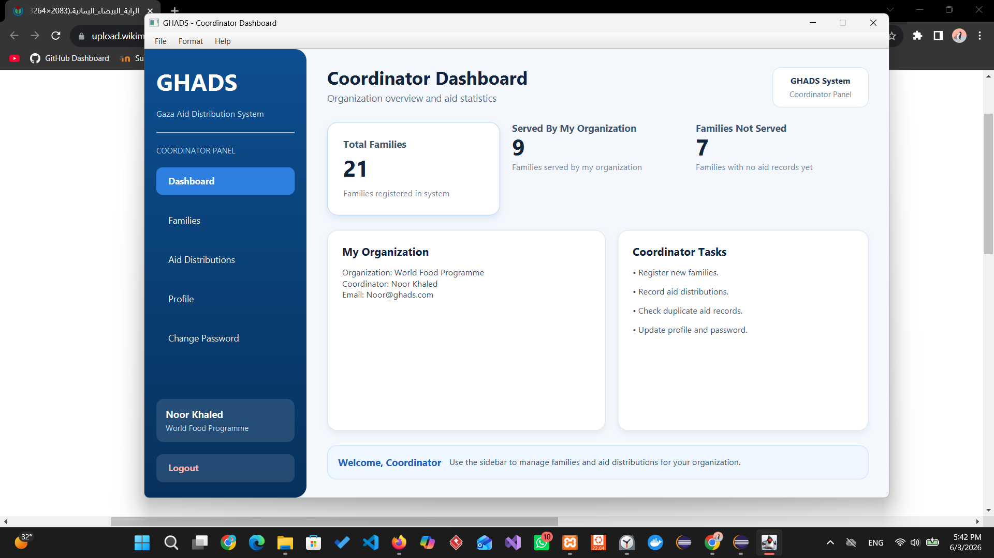
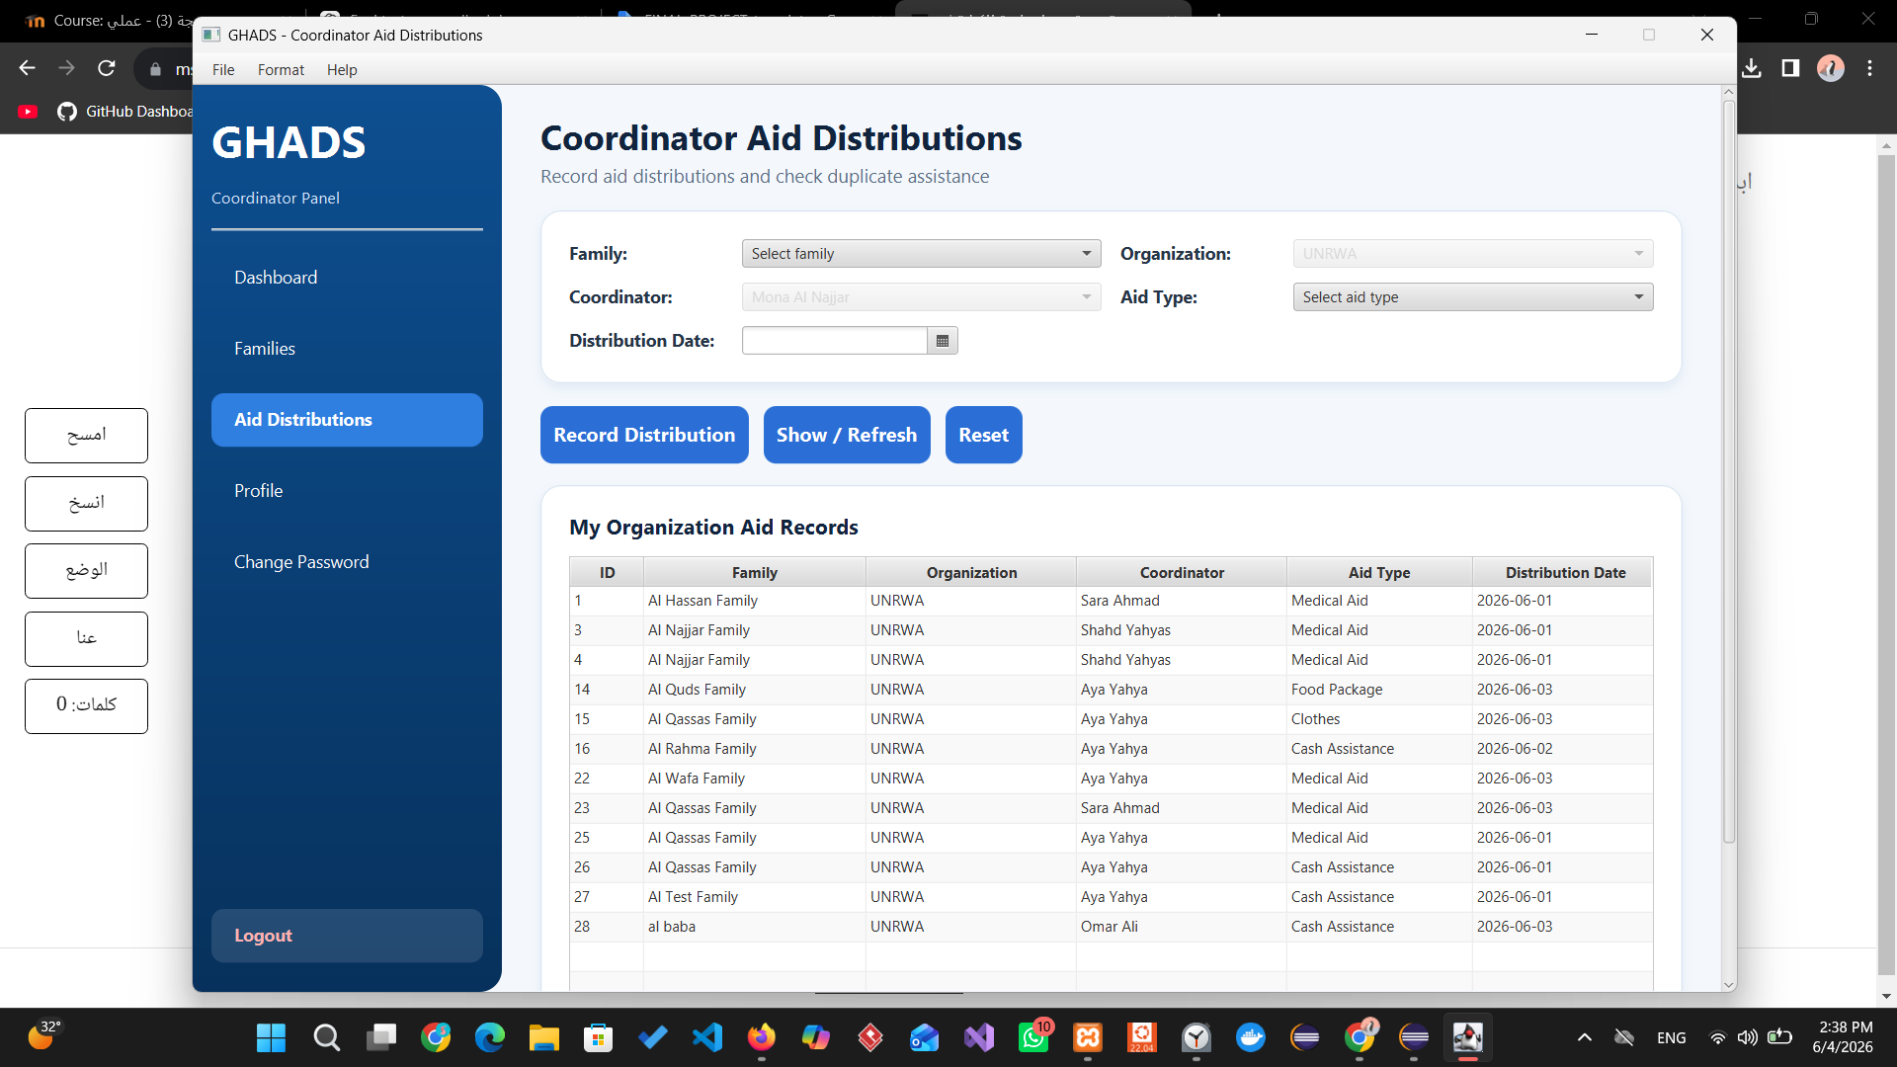
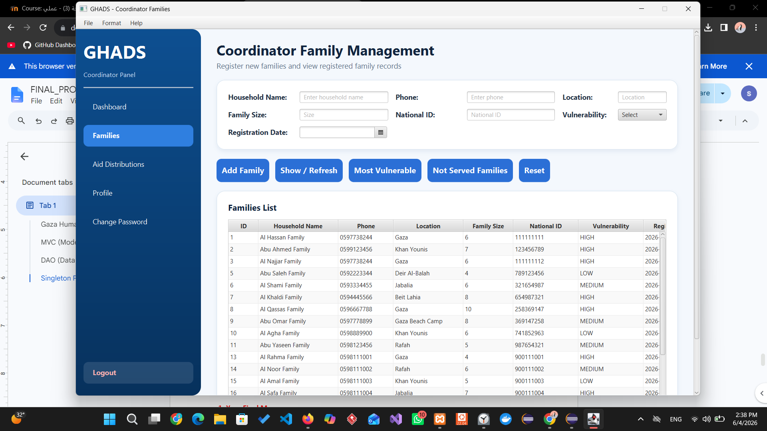
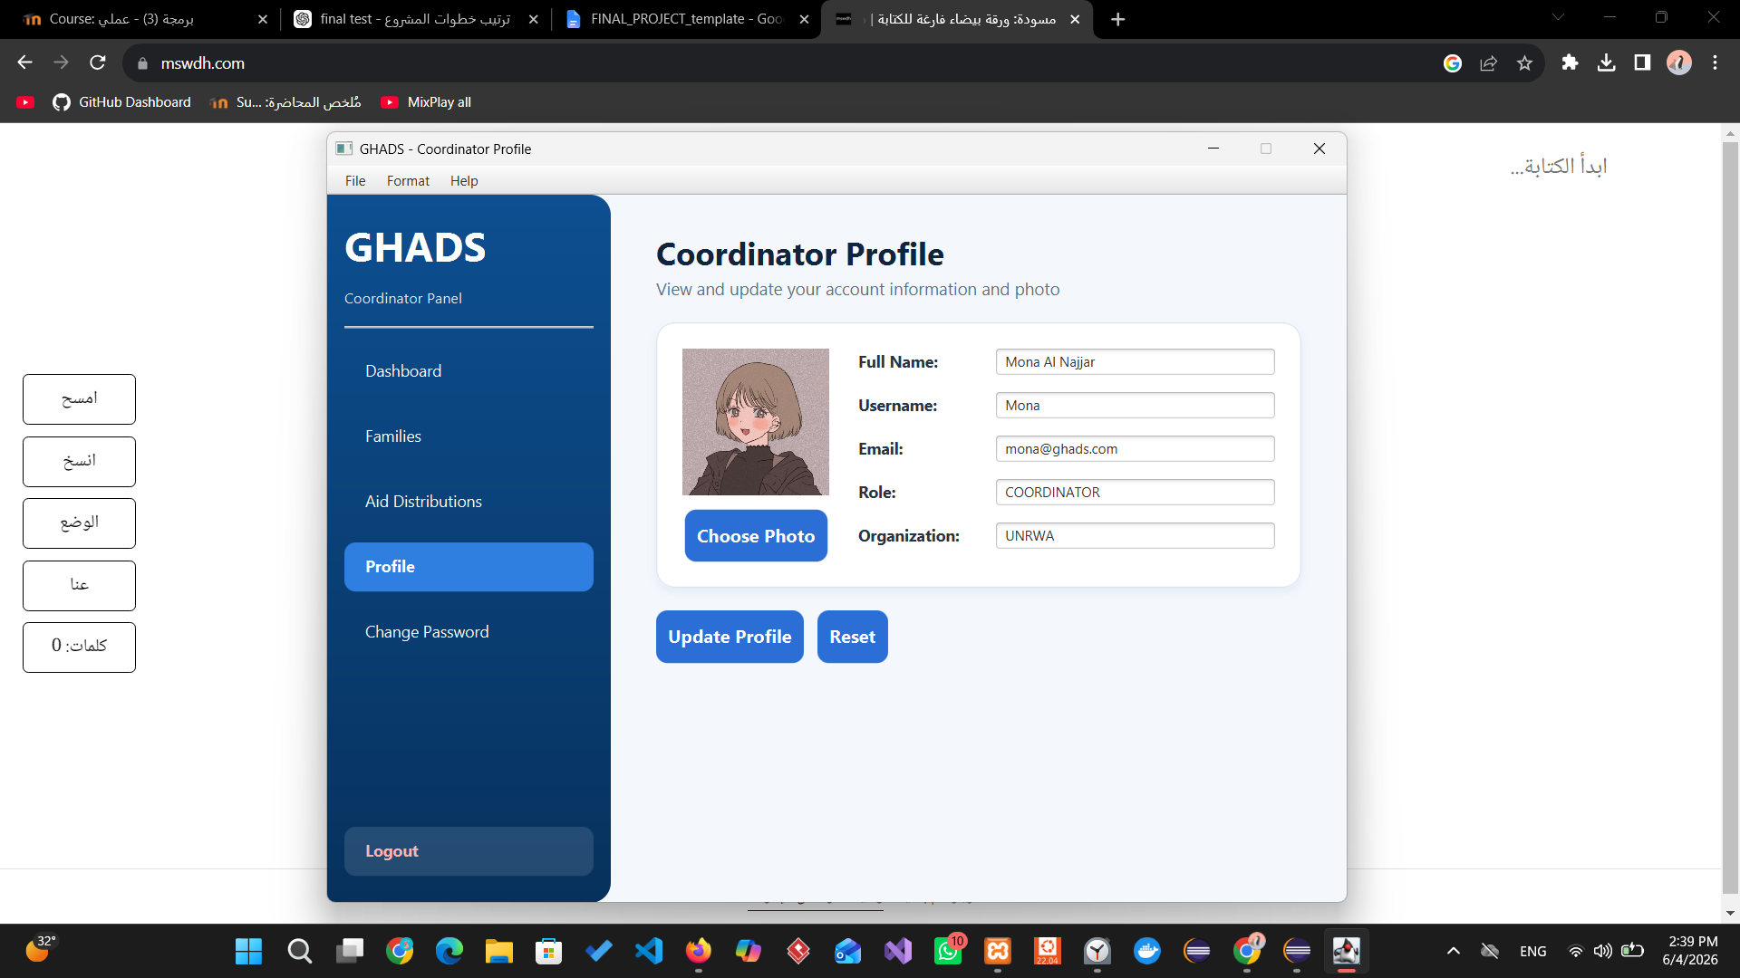

Final Message:
Working on GHADS was an important learning experience for me because it was one of the largest projects I have worked on so far. Beyond programming, I learned the importance of planning before coding, dividing a large project into smaller tasks, and organizing my work in a structured way.
The project taught me patience and problem-solving because I faced many challenges during development and testing. I also learned that continuous testing is an essential part of software development, not just the final step. Overall, the project was both enjoyable and challenging, and it helped me gain more confidence in building complete software applications
My Opinion:
Overall, I enjoyed the course because it allowed me to apply what I learned in a practical project rather than only studying theory. The project helped me understand how different concepts work together in a complete application.
One of the biggest challenges was managing a large project with many screens, controllers, and database operations. Sometimes it was difficult to organize the work and decide where to start. If I could go back to the beginning of the project, I would spend more time planning the project structure and dividing the tasks before starting the implementation.
I think more practical examples and guidance on project planning and application architecture would be helpful for students. In general, the course was useful because it provided hands-on experience and helped me improve both my technical and problem-solving skills.

Links
GitHub Repository | https://github.com/shahd-abo-kwaik/GHADS-Gaza-Humanitarian-Aid-Distribution-System.git
Demo Video | https://youtu.be/tznZCRVHfOg

