An [immediately invoked function expression](https://developer.mozilla.org/en-US/docs/Glossary/IIFE) (IIFE for short) is a JavaScript design pattern that declares an anonymous function and immediately executes it.

Syntax: IIFEs follow a particular syntax as shown below.

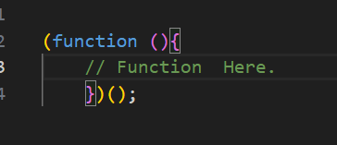

immediately invoked

This type of function is called immediately invoked as these functions are executed as soon as they are mounted to the stack, it requires no explicit call to invoke the function. If we look at the syntax itself we have two pairs of closed parentheses, the first one contains the logic to be executed and the second one is generally what we include when we invoke a function, the second parenthesis is responsible to tell the compiler that the function expression has to be executed immediately.

## We use IIFEs :

IIFEs are useful because they can define local variables that aren't accessible outside the IIFE. For example, IIFEs are often used to execute JavaScript in the browser without polluting global Scope. IIFEs have their own scope i.e. the variables you declare in the Function Expression will not be available outside the function.

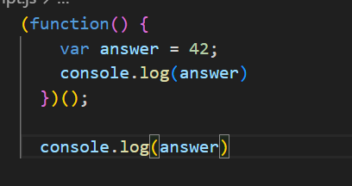

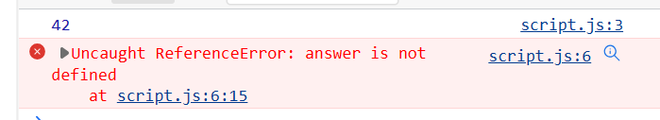

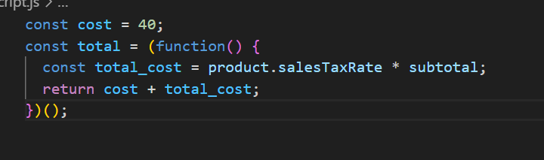

1. IIFEs have their own scope i.e. the variables you declare in the Function Expression will not be available outside the function.
2. Similarly to other functions IIFEs can also be named or anonymous, but even if an IIFE does have a name it is impossible to refer/invoke it.
3. IIFEs can also have parameters

