DEPI – Digital Egypt Pioneers Initiative | Track: Junior Data Analysis
Data Lens
1. Project Planning & Management
DEPI submission item: Project Planning & Management (Project Proposal, Project Plan, Task Assignment & Roles, Risk Assessment & Mitigation Plan, KPIs)
Team member | Role
Shahd Mahmoud Abdelmagid | Team Leader
Eman Ali Mostafa | Member
Malak Hassan Mahmoud | Member
Farah Khaled Fathy | Member
Menna Abdelnasser Ramadan | Member
Mariam Baher Mohsen | Member
Instructor: Noran El Zeky | Lecturer / evaluator

Version 1.0 (draft) | October 2026

1. Project Proposal Summary
Project name: Data Lens – Country Data Comparison Dashboard (World Development Indicators).
Objective: turn the raw, inconsistent World Bank WDI extract (22 countries, 74 indicators, 2000–2025) into a clean, validated data model and an interactive multi-page dashboard that lets users compare countries, including Egypt, across economy, health, education, labor, and infrastructure.

Scope
- In scope: cleaning and standardizing WDI_Data.xlsx; star-schema data model; DAX measures; a dashboard with at least three pages (country overview, country comparison, trends), map, and drill-through; testing; documentation; final presentation; infographic.
- Out of scope: collecting data from sources other than the provided WDI workbook; forecasting or machine-learning models; real-time data refresh; mobile app.
The full proposal (weekly tasks per team member) is in the file Data_Lens_Project_Proposal.docx.

2. Project Plan

Timeline and milestones
Phase | Planned start | Planned end | DEPI deadline | Lead
Project Planning & Management | 01 Oct 2026 | 16 Oct 2026 | 16 Oct 2026 | Shahd
Requirements Gathering | 05 Oct 2026 | 16 Oct 2026 | 16 Oct 2026 | Mariam, Farah
System Analysis & Design | 19 Oct 2026 | 06 Nov 2026 | 06 Nov 2026 | Malak, Menna
Week 1 – Data Understanding & Cleaning | 01 Nov 2026 | 07 Nov 2026 | – | Eman
Week 2 – Data Modeling & DAX | 08 Nov 2026 | 14 Nov 2026 | – | Malak
Week 3 – Dashboard Development | 15 Nov 2026 | 21 Nov 2026 | – | Farah, Menna
Week 4 – Testing & Documentation | 22 Nov 2026 | 28 Nov 2026 | – | Mariam
Implementation complete (source code & execution) | – | 28 Nov 2026 | 30 Nov 2026 | Shahd
Final presentation prep & buffer | 29 Nov 2026 | 04 Dec 2026 | 04 Dec 2026 | Shahd

Note: Dates in the DEPI deadline column come from the Project Documentation Guidelines. The planned start/end dates are the team’s proposed schedule and should be confirmed with the instructor. The final project discussion takes place in Week 21 of the program.
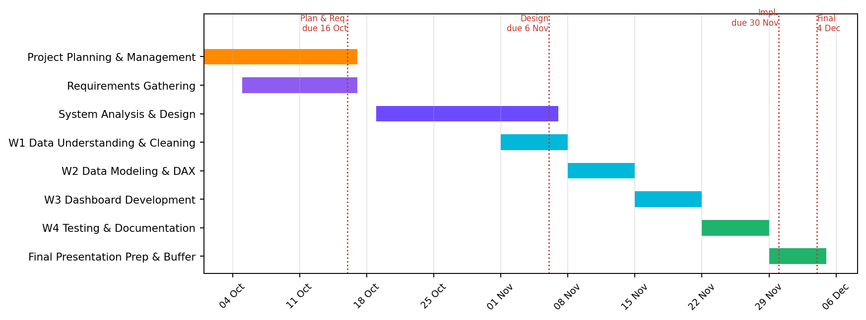
Figure 1 – Gantt chart

Deliverables
# | Deliverable | Owner
1 | Project Proposal, Project Plan, Roles, Risks, KPIs | Shahd
2 | Requirements document (stakeholders, user stories, use cases, FR/NFR) | Mariam, Farah
3 | System Analysis & Design document (diagrams, schema, wireframes) | Malak, Menna
4 | Cleaned dataset + data quality log + list of countries/indicators lacking data | Eman
5 | Power BI data model and DAX measures | Malak
6 | Power BI dashboard (.pbix, 3+ pages, map, drill-through) | Farah, Menna
7 | Test plan, test cases, bug reports | Mariam
8 | User manual and technical documentation | Mariam, Malak
9 | Project infographic and final presentation (PPT/PDF) | Shahd, Mariam
10 | GitHub repository with all files and README | Shahd

Resource allocation
Resource | Type | Use
Team of 6 members | Human | Roles in section 3
Power BI Desktop | Software | Cleaning (Power Query), modeling, DAX, dashboard
Microsoft Excel | Software | Inspecting the source workbook and validating values
GitHub (organization repository) | Platform | Version control and delivery of all project files
WDI_Data.xlsx | Data | Source data: Data sheet and Series - Metadata sheet

3. Task Assignment & Roles
Member | Role | Responsibilities
Shahd Mahmoud Abdelmagid | Team Leader | Coordination, communication with the instructor, task tracking, GitHub uploads, final presentation
Eman Ali Mostafa | Data Cleaning Lead | Power Query cleaning: country names, missing values, duplicates, data quality log
Malak Hassan Mahmoud | Data Modeling & DAX Lead | Star-schema model, relationships, DAX measures
Farah Khaled Fathy | Dashboard Developer | Pages 1–2 (overview and comparison), KPI cards, slicers
Menna Abdelnasser Ramadan | Dashboard Developer / UI-UX | Page 3 (trends), map, drill-through, theme and UI/UX
Mariam Baher Mohsen | QA & Documentation | Test cases and bug reports, user manual, technical documentation, infographic

Note: This split is the team’s working draft and can be adjusted. At the final discussion each member must explain the work they delivered.

4. Risk Assessment & Mitigation Plan
ID | Risk | Likelihood | Impact | Mitigation
R1 | Inconsistent country names (e.g. USA, United States of America, united states) break relationships and totals | High | High | Mapping table in Power Query; test that exactly 22 countries remain
R2 | About 20% of year cells hold ".." (7,521 of 37,675) and a few hold text such as "-" or "295,282.00" | High | Medium | Convert ".." and "-" to null; convert text numbers; show "no data" instead of zero
R3 | Year 2009 is missing from the source columns | Certain | Low | Document it; trends show a gap; YoY measure handles blanks
R4 | Duplicate and empty rows (6 duplicate country–indicator rows, 100 empty rows) | Certain | Medium | Remove duplicates by key; list empty rows in the data quality log
R5 | 6 indicators have no entry in the metadata sheet; 1 indicator has no values at all | Medium | Low | List them as lacking data; exclude from comparison visuals
R6 | The design deadline (6 Nov) overlaps with the start of implementation | Medium | Medium | Start cleaning in parallel; freeze the data model design early
R7 | .pbix is a binary file; two members editing it causes lost work on GitHub | Medium | High | One editor per .pbix at a time; short-lived feature branches; leader merges
R8 | Team member unavailable or unequal workload | Medium | Medium | Weekly check-in; each task has a backup owner
R9 | Power BI Service publishing may need a license | Medium | Low | Deliver the .pbix on GitHub as the primary deliverable; web publishing is optional
R10 | Scope creep (extra pages/indicators) | Medium | Medium | Keep to the agreed 3+ pages; extras only after testing is complete

5. Key Performance Indicators (KPIs)
KPI | Metric | Target | How measured
Data accuracy | Sampled dashboard values equal to source values | 100% of 30 sampled values | Test case TC-D06
Standardization | Distinct country names in the model | 22 | Test case TC-D01
Data completeness handling | ".." or text values left in the Value column | 0 | Test cases TC-D02, TC-D03
Responsiveness | Time for a visual to refresh after a slicer change | ≤ 5 seconds | Test case TC-N01
Quality | Test cases passed | ≥ 95% | Test report
Coverage | Dashboard pages delivered | ≥ 3 | Dashboard review
Schedule | DEPI deadlines met | 4 of 4 | Plan vs. actual dates
Documentation | Required documents uploaded to GitHub | 100% | Checklist in README
Team contribution | Members with a documented deliverable | 6 of 6 | Task board / commit history

Note: KPI targets are proposed by the team and should be confirmed with the instructor.

