DEPI – Digital Egypt Pioneers Initiative | Track: Junior Data Analysis
Data Lens
3. System Analysis & Design
DEPI submission item: System Analysis & Design (problem statement, diagrams, database design, UI/UX, deployment and integration)
Team member | Role
Shahd Mahmoud Abdelmagid | Team Leader
Eman Ali Mostafa | Member
Malak Hassan Mahmoud | Member
Farah Khaled Fathy | Member
Menna Abdelnasser Ramadan | Member
Mariam Baher Mohsen | Member
Instructor: Noran El Zeky | Lecturer / evaluator

Version 1.0 (draft) | October 2026

1. Problem Statement & Objectives
Problem: the WDI workbook covers many countries and indicators but cannot be compared directly. The same country appears under different spellings, many cells hold ".." or text instead of numbers, rows are duplicated or empty, and a year is missing. Comparing countries by hand in Excel is slow and error-prone.
Objectives:
- Clean and standardize the data in a repeatable way.
- Build a star-schema model that supports comparison by country, indicator and year.
- Deliver an interactive dashboard (overview, comparison, trends, map, drill-through).
- Document, test and deliver everything through GitHub by the DEPI deadlines.

2. Use Case Diagram & Descriptions
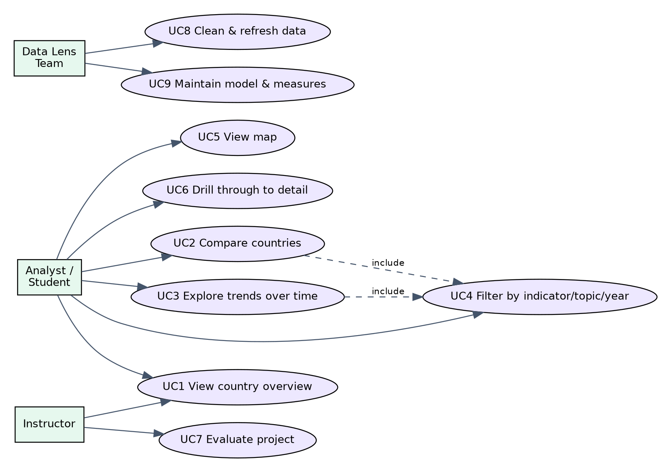
Figure 1 – Use case diagram
Descriptions of UC1–UC9 are given in the Requirements Gathering document (section 4). Functional and non-functional requirements (FR1–FR14, NFR1–NFR8) are stated in the same document.

3. Software Architecture
Architecture style: layered business-intelligence architecture (source → transformation → semantic model → presentation). MVC and microservices do not apply because Data Lens has no web server or APIs; the dashboard runs inside Power BI.
Layer | Component | Responsibility
Source | WDI_Data.xlsx | Raw World Bank data (Data and Series - Metadata sheets)
Transformation | Power Query | Standardize names, handle missing values, remove duplicates, reshape years to rows
Semantic model | Star schema + DAX | Relationships, measures, ranking, comparison logic
Presentation | Power BI report pages | Overview, Comparison, Trends, map, drill-through
Delivery | GitHub | Version control and final deliverables

4. Database Design & Data Modeling
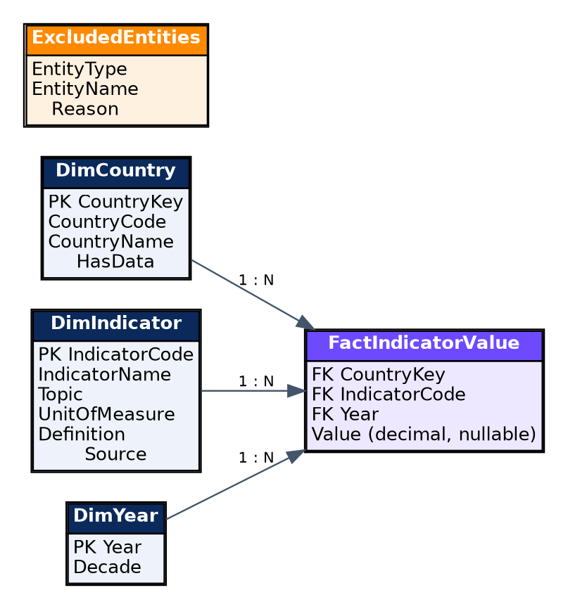
Figure 2 – Entity-Relationship Diagram

Logical and physical schema
Table | Column | Type | Key | Description
DimCountry | CountryKey | Whole number | PK | Surrogate key
 | CountryCode | Text (3) |  | ISO-style code from the source, e.g. EGY
 | CountryName | Text |  | Standardized name
 | HasData | True/False |  | False if the country lacks usable data
DimIndicator | IndicatorCode | Text | PK | Series code, trimmed
 | IndicatorName | Text |  | Trimmed series name
 | Topic | Text |  | From Series - Metadata
 | UnitOfMeasure | Text |  | From Series - Metadata
 | Definition | Text |  | Long definition
 | Source | Text |  | Data source note
DimYear | Year | Whole number | PK | 2000–2025 (2009 has no data)
 | Decade | Text |  | e.g. 2000s
FactIndicatorValue | CountryKey | Whole number | FK | → DimCountry
 | IndicatorCode | Text | FK | → DimIndicator
 | Year | Whole number | FK | → DimYear
 | Value | Decimal (nullable) |  | Null when the source has "..", "-" or no value
ExcludedEntities | EntityType / EntityName / Reason | Text |  | Countries or indicators lacking data

Normalization: the model is in third normal form for the dimensions (each attribute depends only on its key) and uses a fact table at the grain "one value per country, indicator and year". Unpivoting the 25 year columns into rows removes the repeating-column design of the source sheet. The composite key (CountryKey, IndicatorCode, Year) is unique after duplicate removal.

Data cleaning rules
Issue in source | Rule applied
Spelling and case variants of country names | Trim spaces, then map to one standard name (table below)
".." and "-" in year cells | Convert to null
Numbers stored as text, e.g. "295,282.00" | Remove thousands separators and convert to decimal
Duplicate country–indicator rows (6) | Keep one row per key
Empty rows (100) and non-data rows (4: blank rows and source/date notes) | Remove from the fact table; log the empty rows
Year columns named like "2000 [YR2000]" | Extract the 4-digit year, then unpivot
Indicators without metadata (6) | Keep, mark Topic = "Not in metadata", exclude from comparison visuals
Indicator with no values at all (1) | Move to ExcludedEntities

Raw variants found | Standard name
Egypt, Arab Rep. / EGYPT, ARAB REP. / egypt / Egypt | Egypt
USA / United States / united states / United States of America | United States
Korea, Rep. / Korea Rep / South Korea | South Korea
Russian Federation / Russia | Russia
Turkiye / Turkey | Turkey
Names with leading/trailing spaces (Argentina, Australia, France, India, Italy, Nigeria, Saudi Arabia, United Kingdom) | Trimmed name

Note: Standard display names are a team choice; the official WDI names can be kept as an extra column if the instructor prefers them.

5. Data Flow & System Behavior
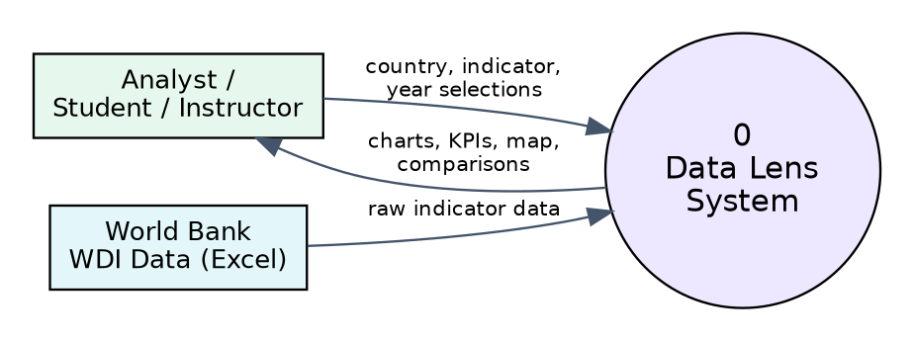
Figure 3 – DFD context level (Level 0)
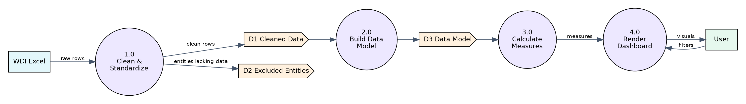
Figure 4 – DFD Level 1
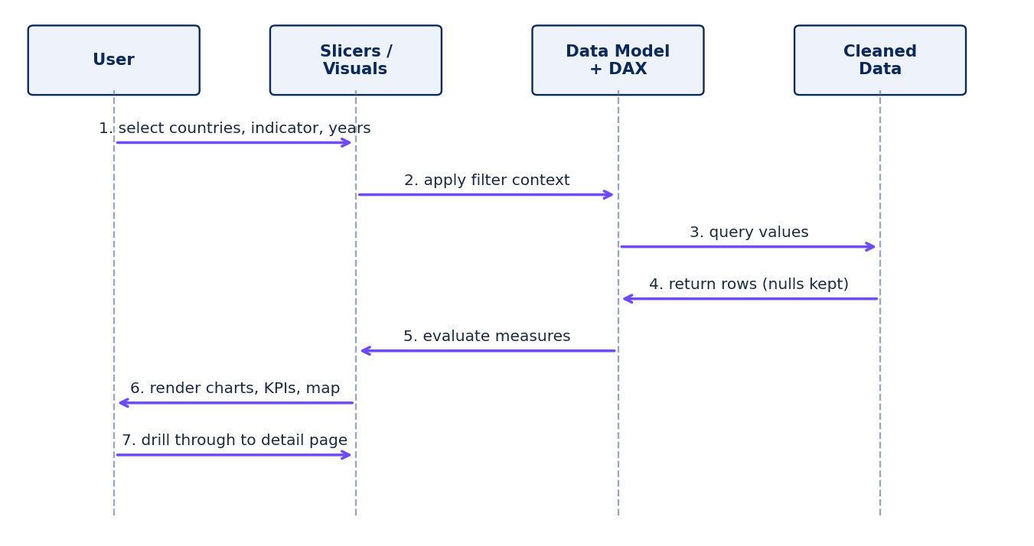
Figure 5 – Sequence diagram: exploring an indicator
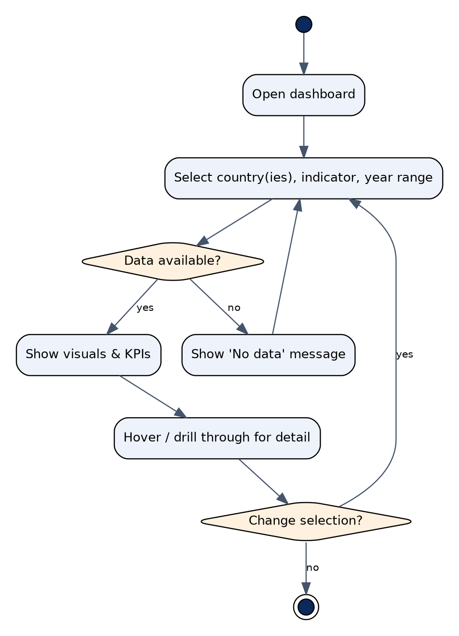
Figure 6 – Activity diagram: user exploration
Figure 7 – State diagram: life cycle of the dataset
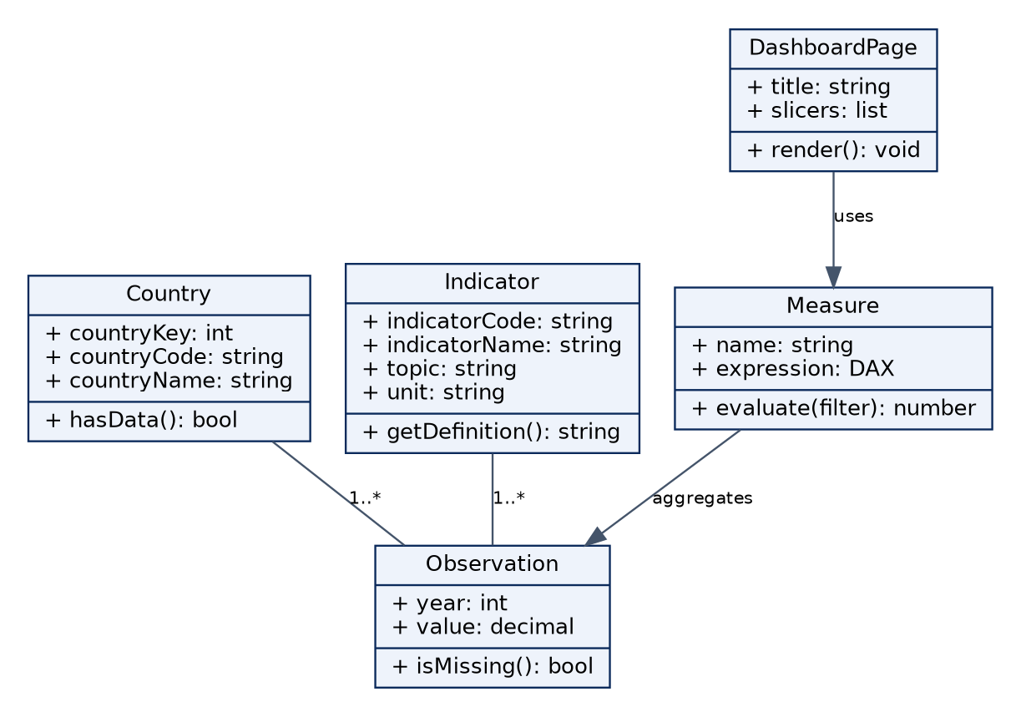
Figure 8 – Class diagram

6. UI/UX Design & Prototyping

Wireframes
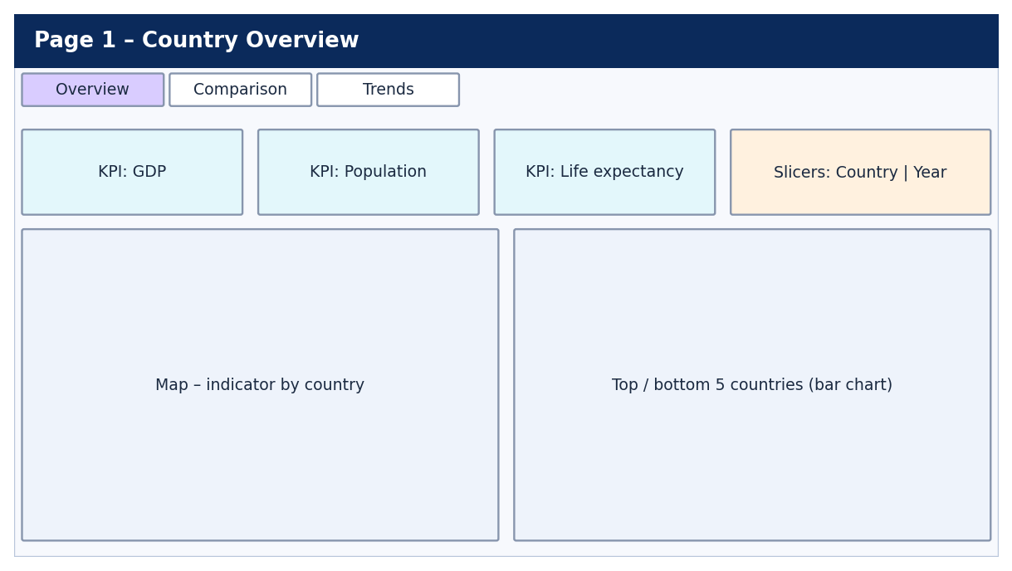
Figure 9 – Wireframe: Overview page
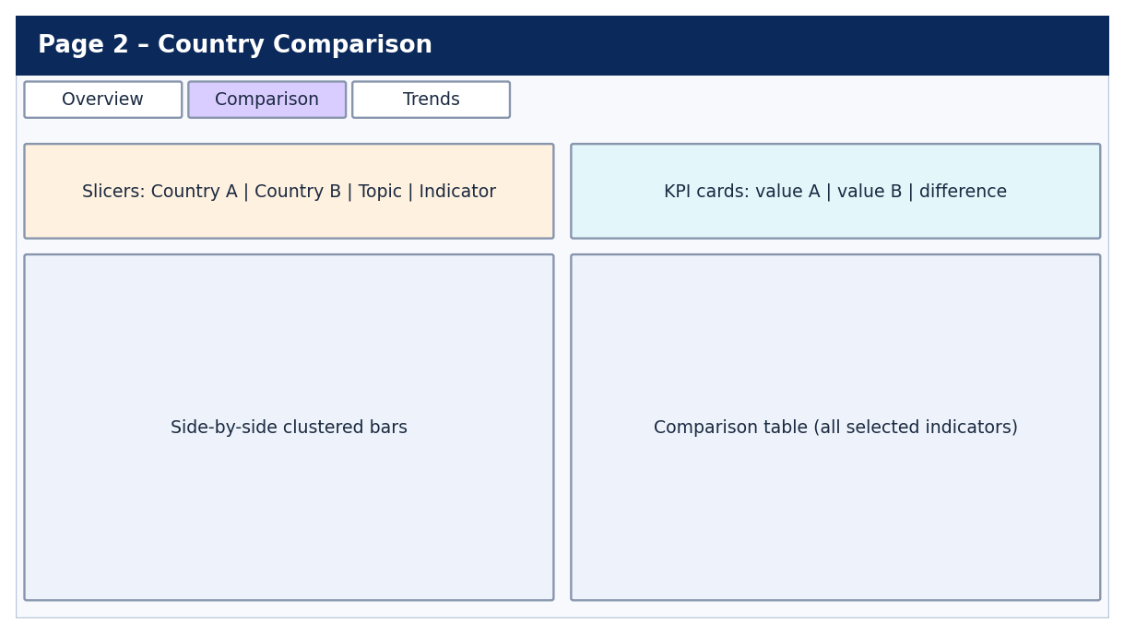
Figure 10 – Wireframe: Comparison page
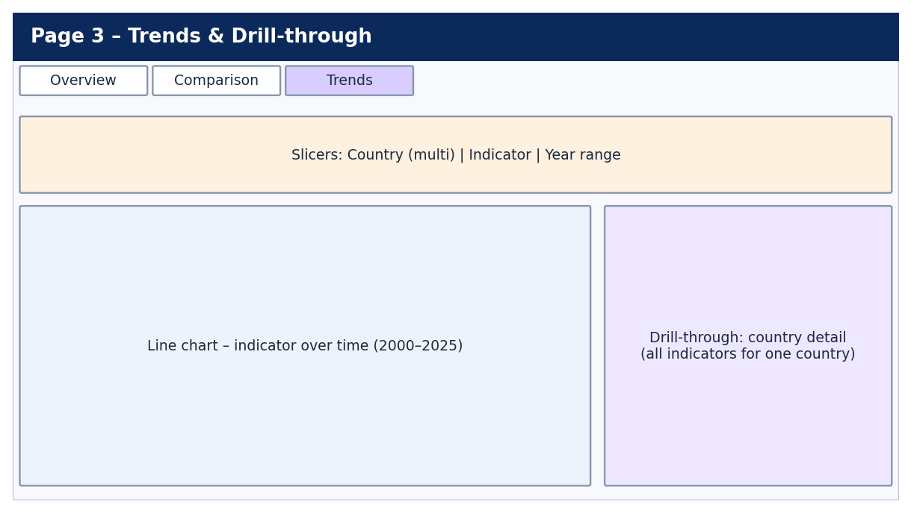
Figure 11 – Wireframe: Trends page with drill-through

UI/UX guidelines
Area | Guideline
Colors | Deep blue (#0B2A5B) for headers and titles, purple (#6D4AFF) for the selected state, cyan (#00B8D9) for highlights, orange (#FF8A00) for warnings such as missing data, green (#1FB36B) for positive change; white or light gray background
Typography | One sans-serif font; page title 24 pt, visual titles 14 pt, labels 11 pt or larger
Layout | Same header, navigation buttons and slicer position on every page; 16:9 canvas
Charts | Bars for comparison, lines for time, map for geography; units in every title; no 3-D
Missing data | Show blank or "No data", never zero
Accessibility | High contrast; color not the only cue (labels and markers); alt text on visuals; tooltips with definition and unit
Interaction | Clear-filters button; visible selected slicer values; drill-through hint text

7. System Deployment & Integration
Part | Technology
Backend / data preparation | Power Query (M) in Power BI Desktop
Frontend / dashboard | Power BI report
Database / model | Power BI in-memory data model (imported from Excel)
Calculations | DAX
Source and delivery | Excel workbook; GitHub

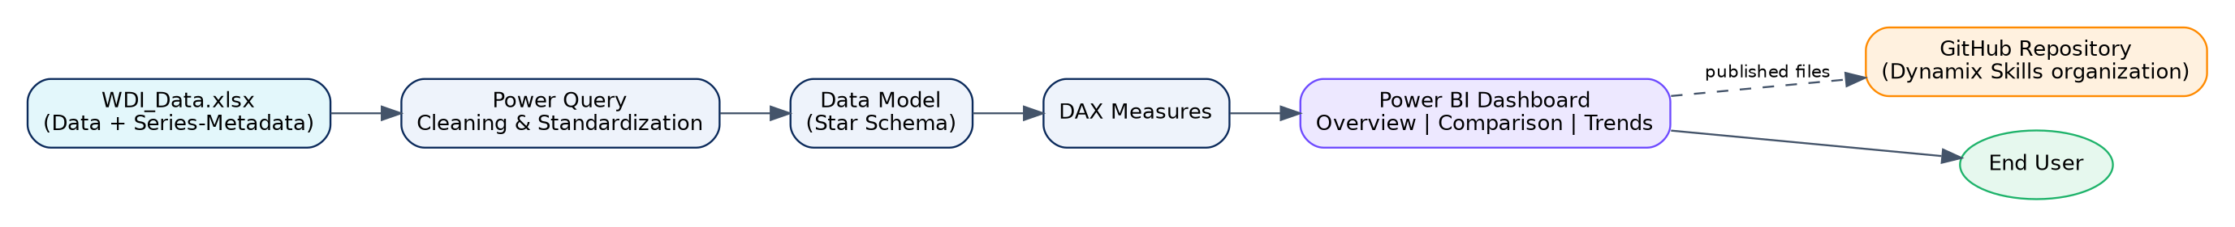
Figure 12 – Component diagram
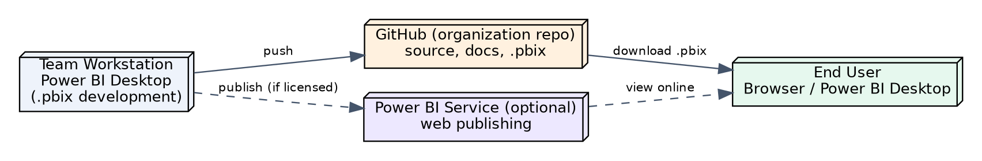
Figure 13 – Deployment diagram

8. Additional Deliverables
- API documentation: not applicable – the system has no APIs.
- Testing & validation: see 04_Testing_and_Quality_Assurance.docx (unit-style data checks, integration checks of the model, user acceptance test).
- Deployment strategy: the .pbix file and all documents are uploaded to the team’s repository in the organization GitHub account (not a personal account). Feature branches are merged by the Team Leader through pull requests. Releases are tagged v0.1 (clean data), v0.5 (model and measures), v1.0 (final). Publishing to the Power BI Service is optional and depends on licensing. Scaling is not a concern because the dataset is small (about 37,000 year cells).

