DEPI · Digital Egypt Pioneers Initiative
Track: Data Analysis
Project Planning & Management
Plan · Roles · Risks · KPIs · Instructor review
Project: DevCompare – Development Indicators Comparison (Egypt, Nigeria, India, Brazil, Türkiye)
Team Leader | Shahd Mahmoud Abdelmagid
Team Members | Malak Hassan Mahmoud  Eman Ali Mostafa  Farah Khaled Fathy  Mariam Baher Mohsen  Menna AbdelNasser Ramadan
Instructor | Nouran Elzeky
Version / Date | v1.0 · 31 October 2026

1. Project Plan
The plan follows the DEPI project steps: Team Formation & Planning (week 5), Instructor Review (week 7), Gathering Requirements (weeks 9–10), Analysis & Design (from week 12), Implementation, Testing, and Release & Final Presentation (week 21).
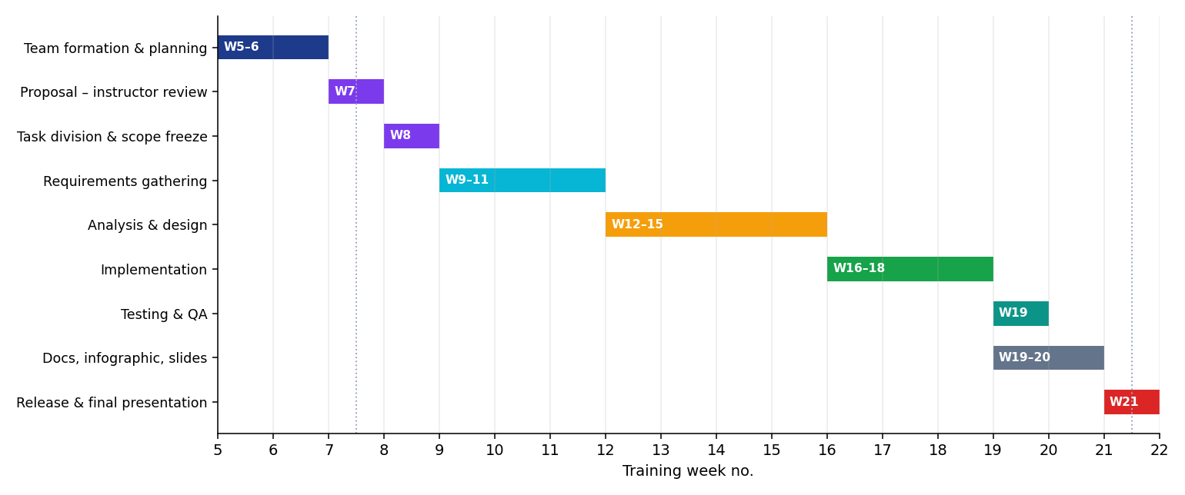
Figure 1 – Project Gantt chart (training weeks)

1.1 Milestones and official deadlines
Item (DEPI Guidelines) | DEPI deadline | Project milestone
Project Planning & Management | 16 Oct 2026 | Proposal, plan, roles, risks, KPIs approved
Requirements Gathering | 16 Oct 2026 | Requirements Specification v1.0
System Analysis & Design | 6 Nov 2026 | Design document with UML, ERD, wireframes
Implementation (Source Code & Execution) | 30 Nov 2026 | Repository with code, README, dashboard
Final Presentation, Testing & Reports | 4 Dec 2026 | Test report, manuals, infographic, presentation

The deadlines above are copied from the DEPI table in the Project Documentation Guidelines (the DEPI column, not the DEPI Industry column). All documents must be uploaded to GitHub, by the Team Leader, to the company organisation repository (not a personal account).

1.2 Deliverables
Phase | Deliverable | Owner
Planning | Project Proposal, Project Plan, Task Assignment, Risk Assessment, KPIs | Shahd, Menna
Requirements | Stakeholder analysis, user stories, use cases, FR / NFR | Mariam, Eman
Design | UML diagrams, ERD, schema, wireframes, UI/UX guidelines, tech stack, deployment | Mariam, Farah
Implementation | Source code, README, tests, processed data, dashboard | Malak, Eman, Farah
Testing | Test plan, test cases, automated tests, bug reports | Menna
Final | User manual, technical documentation, presentation (PPT/PDF), infographic | Menna, Shahd

1.3 Resource allocation
- People: 6 members (within the allowed 4–6) – see Section 2.
- Data: two WDI Excel extracts supplied by the programme (last updated 07/13/2026).
- Software: Python 3.10+, free open-source libraries, a web browser, Git/GitHub (company organisation repository).
- Cost: no paid tools or services.

2. Task Assignment & Roles
Note: the role assignment below is a proposal prepared with the project documents. The team must confirm or adjust it and tell the instructor within the deadline, because the final evaluation depends on each member explaining what they actually did.
Member | Role | Responsibilities
Shahd Mahmoud Abdelmagid | Team Leader · Project Manager | Leads the team and speaks on its behalf; owns the GitHub repository (company organisation account) and uploads all files; plans weeks and milestones; integrates modules; leads the final presentation.
Malak Hassan Mahmoud | Data Engineer | Data ingestion and cleaning (data_loader.py): merging the two WDI extracts, missing-value handling, interpolation rules, data quality report.
Eman Ali Mostafa | Data Analyst | Analytics (analysis.py): ranking, CAGR, correlation, Development Score and forecasting; writes the insights and interpretation.
Farah Khaled Fathy | Dashboard & Visualization Developer | Interactive dashboard (template.html, export_dashboard.py) and static charts (charts.py).
Mariam Baher Mohsen | Systems Analyst & Designer | Requirements gathering, use cases, UML diagrams, ER diagram and schema, UI/UX wireframes and guidelines.
Menna AbdelNasser Ramadan | QA Engineer & Documentation Lead | Test plan, test cases, automated tests, bug reports, user manual, technical documentation and presentation material.

2.1 Responsibility matrix
Activity | Shahd | Malak | Eman | Farah | Mariam | Menna
Planning, GitHub, integration | R | C | C | C | C | C
Data cleaning and merging | A | R | C | I | I | C
Analytics and insights | A | C | R | C | I | C
Dashboard and charts | A | I | C | R | C | C
Requirements, UML, ERD, UI/UX | A | C | C | C | R | I
Testing, user manual, tech doc | A | C | C | C | C | R
Final presentation | R | C | C | C | C | C

R = responsible, A = accountable, C = consulted, I = informed. During the final discussion every member must explain the work they did and what they are responsible for.

3. Risk Assessment & Mitigation Plan
Likelihood (L) and impact (I) are rated Low / Medium / High. Risks R1–R3 already occurred when the data was explored and are therefore recorded together with the action taken.
ID | Risk | L | I | Mitigation / action
R1 | Year 2009 is missing for every country in both extracts | High | Med | Occurred. Internal gaps are linearly interpolated and flagged as not observed; flagged points are excluded from the forecast and from rankings.
R2 | Egypt is missing 2009–2015 (and is absent from the 21-country extract) | High | High | Occurred. Same rule as R1; Egypt has 71.7 % observed cells against ≥ 93 % for the others. Recommended: re-export Egypt from WDI with all years.
R3 | Duplicate rows for Nigeria in both extracts; some indicators empty (internet users for Egypt, exports for Nigeria, domestic credit) | High | Med | Occurred. Files merged with a priority rule; only indicators with data for all five countries are used.
R4 | Misreading the linear forecast as a prediction | Med | Med | Forecast is dashed, labelled indicative, fitted on observed data only, with hold-out error reported; values are clipped at zero.
R5 | Misleading pooled correlations (e.g. life expectancy vs unemployment, +0.78) | Med | Med | Correlations are reported per indicator pair with an explicit caution; no causal claims.
R6 | Scope creep (more countries/indicators) | Med | Med | Countries and indicators live in one configuration file; scope frozen in week 8.
R7 | Member unavailable / uneven workload | Med | High | Each module has an owner and a reviewer; weekly check-in led by the Team Leader.
R8 | GitHub access or wrong account used | Low | High | Team Leader uses the organisation repository invitation, never a personal account.
R9 | Dashboard needs the Chart.js CDN | Low | Med | Version pinned to 4.4.1; for offline use the library file can be saved beside the dashboard.
R10 | Code and documents drift apart | Med | Med | Docs built from the same results files; every change reviewed through pull requests.

4. Key Performance Indicators (KPIs)
Measured values come from the actual project run (pipeline run on 31 Oct 2026). Items marked To verify need a browser-based acceptance test by the team.
KPI | Target | Measured | Status
Countries compared | 5 | 5 | Met
Indicators covered | 18 + 1 derived | 18 + 1 derived | Met
Observed data share (Brazil / India / Nigeria / Türkiye) | ≥ 90 % | 94.9 / 94.7 / 93.1 / 94.7 % | Met
Observed data share (Egypt) | ≥ 90 % | 71.7 % | Not met – source gap 2009–2015, interpolated and flagged
Pipeline run time (load → dashboard) | ≤ 10 s | ≈ 3.7 s | Met
Automated tests passing | 100 % | 18 / 18 (100 %) | Met
Dashboard file size (single file) | ≤ 1 MB | ≈ 83 KB | Met
Dashboard response when changing indicator | ≤ 1 s | Not measured | To verify
Functional requirements covered by a test case | 100 % | See Test Report | Met for pipeline; dashboard cases to verify
All deliverables uploaded to GitHub on time | 100 % | Pending upload | Open

The programme's example KPIs (response time, system uptime, user adoption) were adapted: this is an offline analysis project with a static dashboard, so uptime and adoption are not applicable.

5. Instructor Review Record
This section belongs to the Instructor Review step (week 7). It is left for Nouran Elzeky to complete during the review.
Item | Instructor input
Feedback & Evaluation
Suggested Improvements
Decision (approved / approved with changes / rejected)
Date

Final grading criteria (to be confirmed by the instructor)
The Guidelines state that marks are broken down by documentation, implementation, testing and presentation. The exact weights are not given in the supplied files, so they are left for the instructor.
Criterion | Weight | Evidence in repository
Documentation |  | docs/ folder
Implementation |  | src/, main.py, dashboard/
Testing |  | tests/, Test Report
Presentation |  | Presentation, infographic

