DEPI · Digital Egypt Pioneers Initiative
Track: Data Analysis
Requirements Specification
Stakeholders · User stories · Use cases · FR · NFR
Project: DevCompare – Development Indicators Comparison (Egypt, Nigeria, India, Brazil, Türkiye)
Team Leader | Shahd Mahmoud Abdelmagid
Team Members | Malak Hassan Mahmoud  Eman Ali Mostafa  Farah Khaled Fathy  Mariam Baher Mohsen  Menna AbdelNasser Ramadan
Instructor | Nouran Elzeky
Version / Date | v1.0 · 31 October 2026

1. Introduction
Purpose. This document lists the requirements of DevCompare, a data-analysis project that compares Egypt, Nigeria, India, Brazil and Türkiye (2000–2025) with World Bank WDI data.
Scope. Data preparation, analysis (ranking, growth, correlation, score, forecast), file exports and one interactive dashboard. Out of scope: other countries, live data download, user accounts, a web server, machine-learning models beyond a linear trend.
Sources of requirements. The DEPI Project Documentation Guidelines, the info-graphic template, the two supplied WDI Excel extracts, and the project team.

1.1 Data facts that shape the requirements
- Extract 1: 21 countries, about 70 indicators, 2000–2025 but 2009 is missing.
- Extract 2: Egypt and Nigeria, 2000–2008 and 2016–2025 (2009–2015 missing).
- Egypt is only in extract 2, so Egypt has no values for 2009–2015; Nigeria appears in both files.
- Some indicators are empty for some countries (e.g. internet users for Egypt, exports/imports for Nigeria), so they were not selected.

2. Stakeholder Analysis
Stakeholder | Interest / need | Influence on project | Engagement
Instructor (Nouran Elzeky) | Approves the idea; evaluates documentation, implementation, testing and presentation | High | Review in week 7 and 9; final discussion
DEPI programme management | Standard deliverables on GitHub; best-project selection | High | Deadlines, infographic template
Project team (6 members) | Learn, deliver, explain own work | High | Daily work
Decision makers / viewers | Quick, trustworthy comparison | Medium | Dashboard users
Data analysts / students | Explore trends, reuse the pipeline | Medium | Dashboard and workbook users
World Bank (data provider) | Correct attribution of WDI data | Low | Source cited on the dashboard

3. User Stories & Use Cases

3.1 User stories
Who | I want… | So that… | Requirements
As a decision maker | I want to see which of the five countries leads on each indicator | so that I can compare them quickly. | FR-07, FR-16, FR-17
As a decision maker | I want one overall score per country | so that I get the big picture in seconds. | FR-10, FR-17
As a data analyst | I want to see how an indicator changed from 2000 to 2025 | so that I can describe trends. | FR-13, FR-15
As a data analyst | I want to know which points are interpolated | so that I do not over-trust filled gaps. | FR-04, FR-15
As a data analyst | I want a forecast to 2030 with its error | so that I can discuss likely direction without over-claiming. | FR-11, FR-15
As an instructor | I want the quality of the source data reported | so that I can judge the reliability of the conclusions. | FR-06
As a maintainer | I want to change countries or indicators in one place | so that the project can be reused. | FR-03, NFR-06
As a maintainer | I want to re-run everything with one command | so that results are reproducible. | FR-12, NFR-01
As a mobile user | I want to read the dashboard on my phone | so that I can show it in a meeting. | FR-18

3.2 Use case diagram
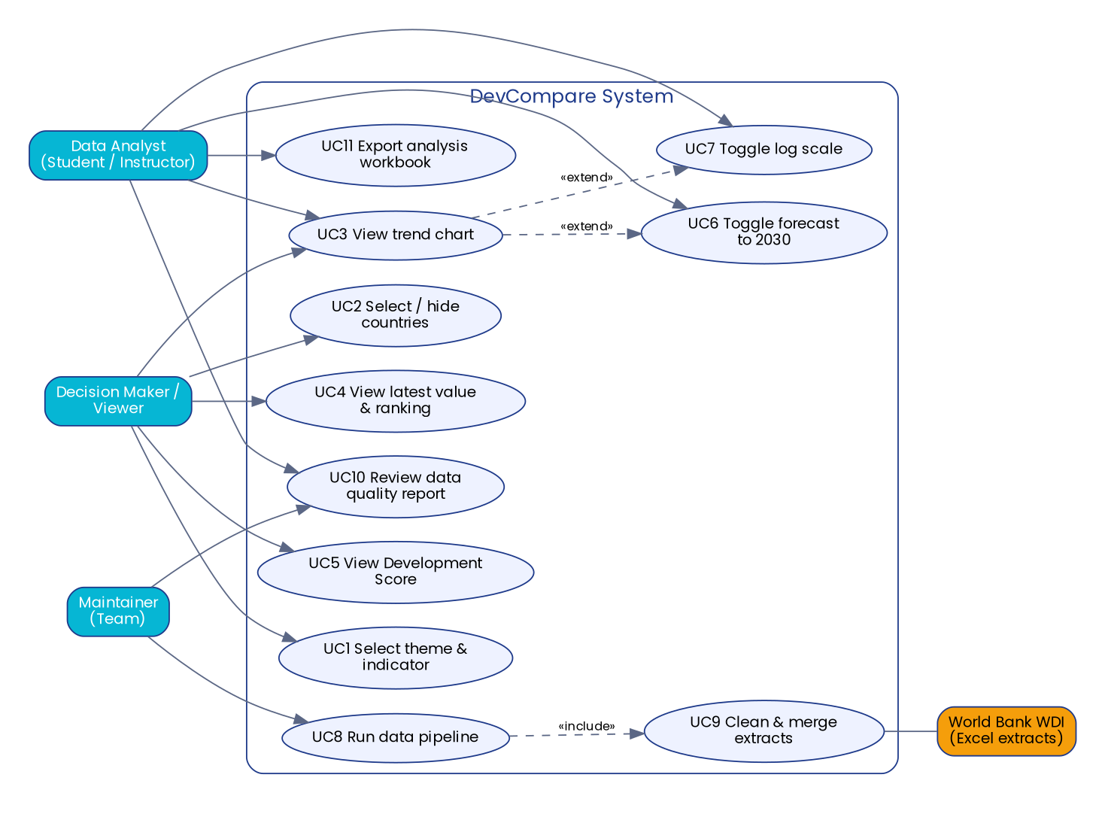
Figure 1 – Use case diagram

3.3 Use case descriptions
ID | Name | Actor | Precondition | Main flow | Postcondition
UC1 | Select theme & indicator | Viewer, Analyst | Dashboard is open | 1. User picks a theme. 2. The indicator list is filtered. 3. User picks an indicator. 4. Charts and table refresh. | Charts show the selected indicator
UC2 | Select / hide countries | Viewer | Dashboard is open | 1. User clicks a country chip. 2. System toggles the country (at least one must remain). | Charts show selected countries only
UC3 | View trend chart | Viewer, Analyst | UC1 done | 1. System draws one line per country 2000–2025. 2. Interpolated points appear hollow. | Trend visible
UC4 | View latest value & ranking | Viewer | UC1 done | 1. System draws a bar chart of the latest observed value. 2. System lists rank per country and the ranking rule. | Rank visible
UC5 | View Development Score | Viewer | Dashboard is open | 1. System shows one KPI card per country, ordered by rank. | Score and rank visible
UC6 | Toggle forecast to 2030 | Analyst | UC3 active | 1. User ticks "Show forecast". 2. System adds dashed lines to 2030 (if a forecast exists). | Forecast visible
UC7 | Toggle log scale | Analyst | UC3 active | 1. User ticks "Log scale". 2. Y axis becomes logarithmic. | Log axis
UC8 | Run data pipeline | Maintainer | Python installed; raw files in data/raw/ | 1. Run python main.py. 2. System loads, cleans, analyses, forecasts and exports. | Files written to data/processed/, outputs/, dashboard/
UC9 | Clean & merge extracts | (included by UC8) | Both extracts present | 1. Read both files. 2. Replace ... 3. Merge with priority. 4. Filter. 5. Interpolate gaps. 6. Add GDP per capita. | Tidy table
UC10 | Review data-quality report | Analyst, Maintainer | UC8 done | 1. Open data_quality_report.csv. 2. Read observed / interpolated / missing % per country. | Quality known
UC11 | Export analysis workbook | Analyst | UC8 done | 1. Open outputs/analysis_results.xlsx (5 sheets). | Workbook available

4. Functional Requirements
Priority follows MoSCoW: Must / Should.
ID | Requirement | Priority | Owner
FR-01 | Load and merge both WDI Excel extracts; the Egypt/Nigeria file has priority when both hold a value. | Must | Malak
FR-02 | Treat the WDI marker .. as a missing value. | Must | Malak
FR-03 | Keep only the five configured countries and the 18 configured indicators. | Must | Malak
FR-04 | Linearly interpolate internal gaps of up to 7 years; never extrapolate; flag interpolated points as not observed. | Must | Malak
FR-05 | Derive GDP per capita = GDP (current US$) ÷ population. | Must | Malak
FR-06 | Produce a data-quality report per country (observed / interpolated / missing %). | Should | Malak
FR-07 | Rank the countries per indicator using the latest observed value, respecting the direction (higher or lower is better). | Must | Eman
FR-08 | Compute the compound annual growth rate (CAGR) of GDP, GDP per capita and population. | Must | Eman
FR-09 | Compute the correlation matrix of the indicators. | Should | Eman
FR-10 | Compute a Development Score (0–100) and rank from six normalised indicators. | Must | Eman
FR-11 | Forecast six indicators to 2030 with a linear trend fitted on observed points only; report hold-out error; never below zero. | Should | Eman
FR-12 | Export the processed CSV, the quality report, a 5-sheet results workbook and static PNG charts. | Must | Malak / Farah
FR-13 | Dashboard: choose a theme and an indicator. | Must | Farah
FR-14 | Dashboard: show/hide each country (at least one must stay visible). | Must | Farah
FR-15 | Dashboard: line chart 2000–2025 with hollow markers for interpolated points, optional forecast to 2030 and optional log scale. | Must | Farah
FR-16 | Dashboard: bar chart of the latest value and a ranking table that states the ranking rule. | Must | Farah
FR-17 | Dashboard: KPI cards showing the Development Score and rank of each country. | Must | Farah
FR-18 | Dashboard: works in light and dark mode and on phone-sized screens. | Should | Farah

5. Non-Functional Requirements
ID | Category | Requirement | How verified
NFR-01 | Performance | The full pipeline runs in ≤ 10 seconds on a normal laptop. | Measured ≈ 3.7 s
NFR-02 | Performance | Dashboard is one self-contained file ≤ 1 MB. | Measured ≈ 83 KB
NFR-03 | Usability | Any indicator is reachable in at most 3 interactions (theme → indicator → country chips). | Acceptance test
NFR-04 | Reliability | Missing data never crashes the pipeline or shows NaN in the dashboard. | Unit test
NFR-05 | Data integrity | Interpolated values are always flagged and never used for forecasting or ranking. | Unit tests
NFR-06 | Maintainability | Countries and indicators are changed only in config.py; modules are separated by responsibility; automated tests exist. | Code review, 18 tests
NFR-07 | Portability | Runs with Python 3.10+; dashboard opens in any modern browser. | Acceptance test
NFR-08 | Security | No personal data, no secrets, no server; the dashboard is a static file. | Review
NFR-09 | Accessibility | Labelled controls, text-based legends and tables, sufficient colour contrast in both modes. | Acceptance test
NFR-10 | Transparency | Source, units, ranking rule and score formula are visible next to the results. | Review

6. Traceability (requirement → test)
Every functional requirement maps to at least one test case in the Test Report (TC identifiers).
Requirement | Test case(s)
FR-01 | TC-01, TC-07
FR-02 | TC-02
FR-03 | TC-03, TC-04
FR-04 | TC-05, TC-06
FR-05 | TC-08
FR-06 | TC-09
FR-07 | TC-11, TC-12
FR-08 | TC-10
FR-09 | TC-17
FR-10 | TC-13
FR-11 | TC-14, TC-15, TC-16
FR-12 | TC-18, UAT-09
FR-13 – FR-18 | TC-18 (dashboard builds) and UAT-01 … UAT-08 (browser acceptance tests)

7. Assumptions & Constraints
- The five countries are Egypt, Nigeria, India, Brazil and Türkiye. Egypt and Nigeria come from the supplied Egypt/Nigeria extract; the other three from the 21-country extract. Changing the list only requires editing `config.py`.
- Only information present in the two extracts is used; no external data.
- Linear forecasting is indicative and is not a prediction.
- The Team Leader uploads the project to the company GitHub organisation repository.

