DEPI · Digital Egypt Pioneers Initiative
Track: Data Analysis
System Analysis & Design
Architecture · Data model · UML · UI/UX · Deployment
Project: DevCompare – Development Indicators Comparison (Egypt, Nigeria, India, Brazil, Türkiye)
Team Leader | Shahd Mahmoud Abdelmagid
Team Members | Malak Hassan Mahmoud  Eman Ali Mostafa  Farah Khaled Fathy  Mariam Baher Mohsen  Menna AbdelNasser Ramadan
Instructor | Nouran Elzeky
Version / Date | v1.0 · 31 October 2026

1. Problem Statement & Objectives
Problem. Development data for different countries is spread over large Excel files with hundreds of rows, text markers for missing values (..) and missing years. Comparing five countries across themes by hand is slow and error-prone, and gaps can silently distort conclusions.
Solution. DevCompare cleans and merges the data, analyses it in a repeatable pipeline, and shows the results in an interactive dashboard that states clearly what is observed, what is interpolated and what is forecast.

Objectives (measurable)
- Compare 5 countries on 18 indicators + 1 derived across 5 themes for 2000–2025.
- Produce rankings, CAGR, correlations, a Development Score and a 2030 trend forecast.
- Run the whole pipeline with one command in ≤ 10 seconds.
- Make every figure traceable: source, unit, ranking rule and data quality are always visible.

1.1 Use case diagram and descriptions
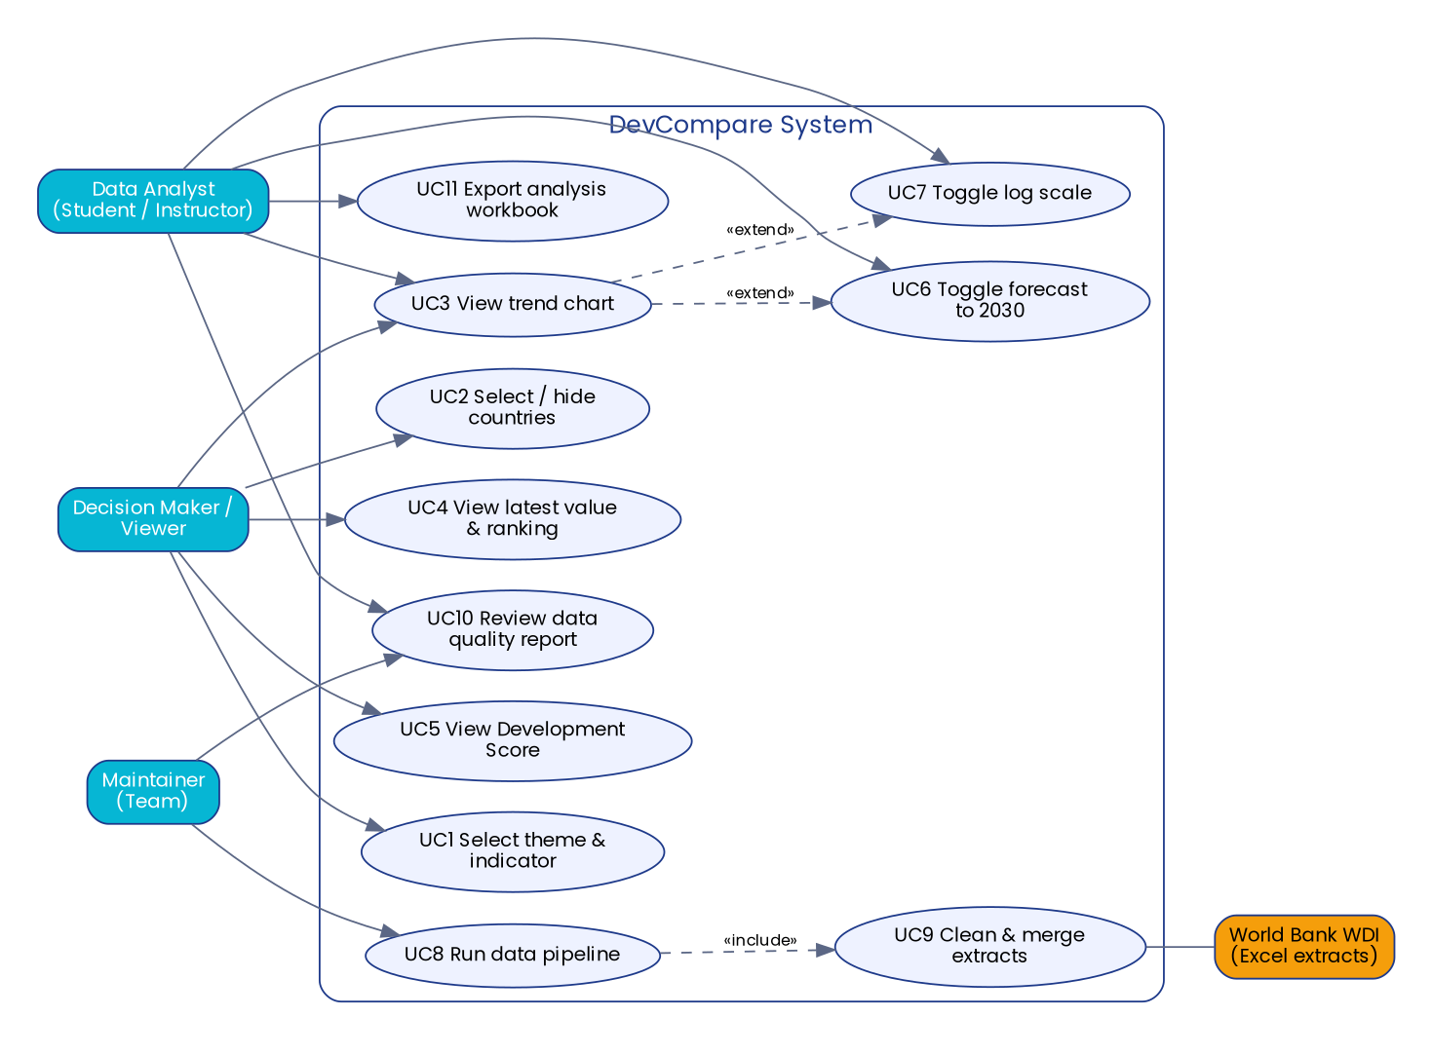
Figure 1 – Use case diagram (descriptions UC1–UC11 are in the Requirements Specification, section 3.3)

1.2 Functional and non-functional requirements
The design covers FR-01 – FR-18 and NFR-01 – NFR-10 defined in the Requirements Specification. The key design-driving constraints are: data gaps must never be hidden (NFR-05), one-command reproducibility (NFR-01), and a static single-file dashboard (NFR-02, NFR-08).

1.3 Software architecture
Architecture style: a layered ETL / analytics pipeline feeding a static client-side dashboard. MVC and microservices were considered and rejected: there is no server, no user input that changes stored data, and no need for independently deployed services.
Layer | Module | Responsibility
Data | data/raw/*.xlsx | Two WDI extracts (read-only)
Processing | src/data_loader.py | Read, merge (priority rule), clean, filter, interpolate, derive GDP per capita, quality report
Analytics | src/analysis.py | Ranking, CAGR, correlation, Development Score, forecast
Output | src/charts.py, main.py | CSV, XLSX and PNG exports
Presentation | src/export_dashboard.py, dashboard/template.html | Embeds results as JSON in one HTML file drawn by Chart.js
Configuration | src/config.py | Countries, indicators, years, forecast horizon

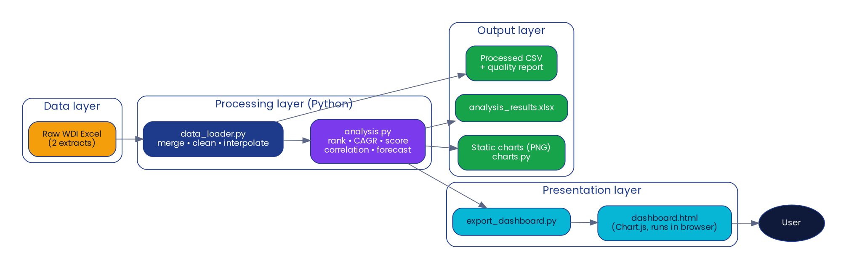
Figure 2 – Layered architecture

2. Database Design & Data Modeling
The project does not use a database server. The data is stored as CSV/XLSX files whose columns follow the schema below, and docs/schema.sql contains an equivalent SQL definition so the files can be loaded into any relational database later.

2.1 ER diagram
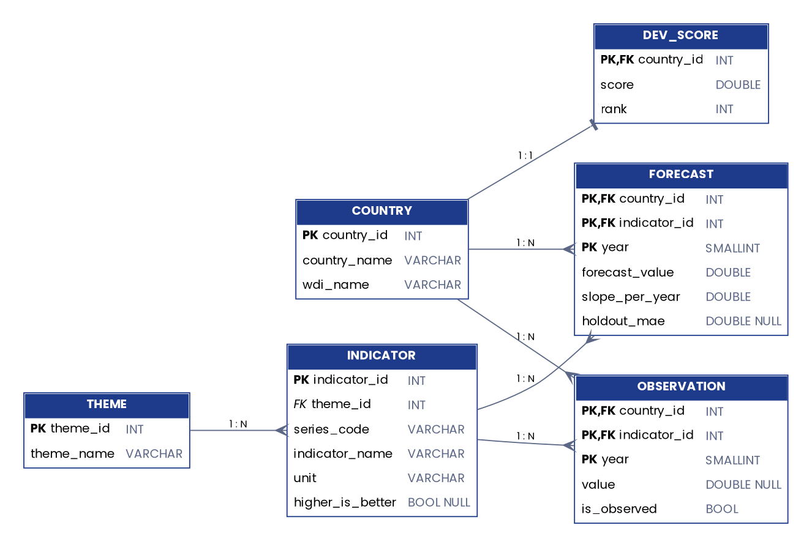
Figure 3 – Entity-relationship diagram

2.2 Logical and physical schema
Table | Columns (PK = primary key, FK = foreign key) | Normalisation / keys
COUNTRY | country_id (PK), country_name, wdi_name (unique) | 3NF; 5 rows
THEME | theme_id (PK), theme_name (unique) | 3NF; 5 rows
INDICATOR | indicator_id (PK), theme_id (FK), series_code (unique), indicator_name, unit, higher_is_better (nullable) | 3NF; 19 rows
OBSERVATION | country_id (PK, FK), indicator_id (PK, FK), year (PK), value (nullable), is_observed | Composite key; one row per country × indicator × year (2,470 rows = 5 × 19 × 26)
FORECAST | country_id, indicator_id, year (composite PK), forecast_value ≥ 0, slope_per_year, holdout_mae | Years 2026–2030
DEV_SCORE | country_id (PK, FK), score 0–100, rank | 1 row per country

File mapping. data/processed/wdi_five_countries_long.csv is the denormalised OBSERVATION table (country, theme, indicator, series code, unit, year, value, observed). outputs/analysis_results.xlsx holds FORECAST, DEV_SCORE and the other analysis sheets.

3. Data Flow & System Behavior

3.1 Data flow diagrams
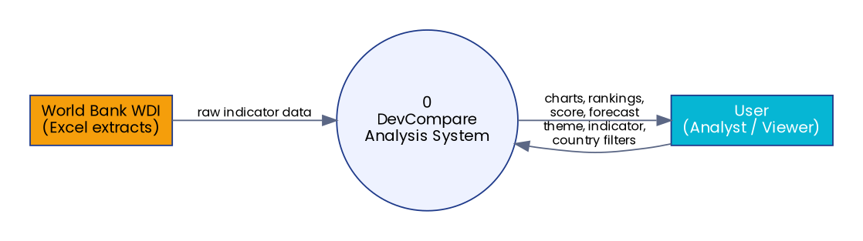
Figure 4 – DFD level 0 (context)
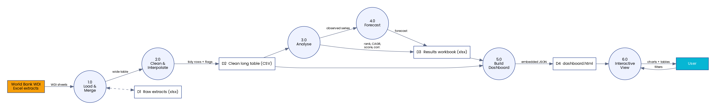
Figure 5 – DFD level 1

3.2 Sequence diagrams
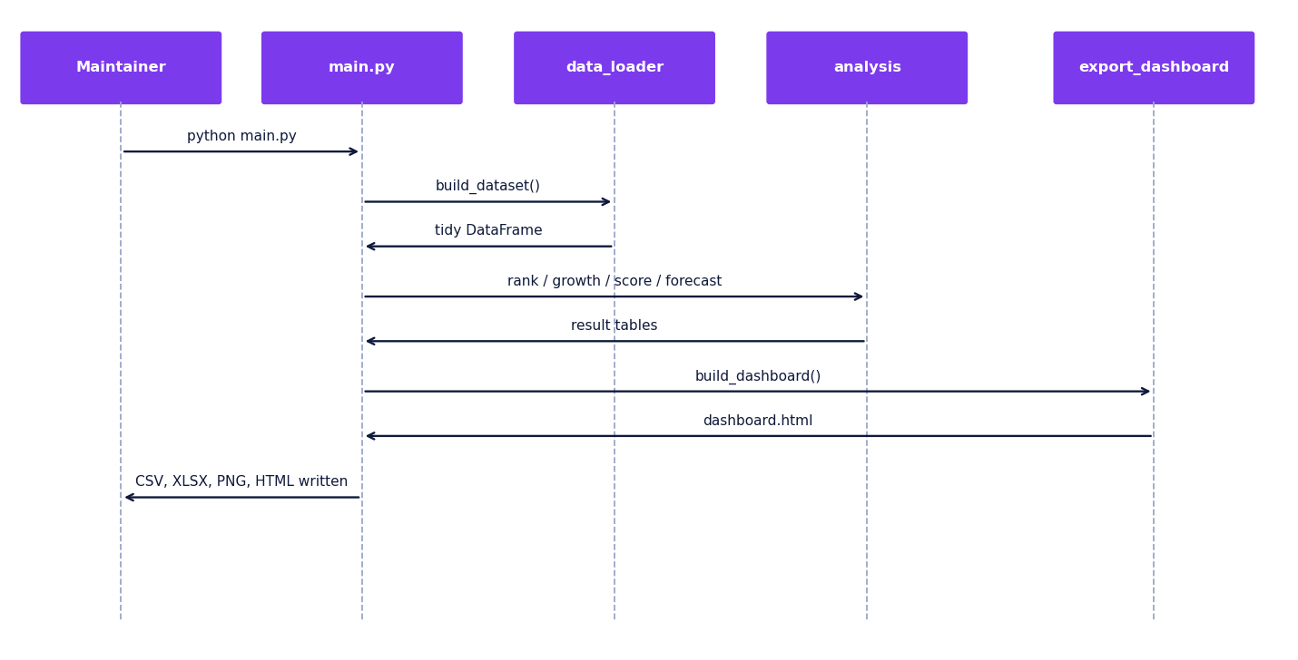
Figure 6 – Sequence: running the pipeline
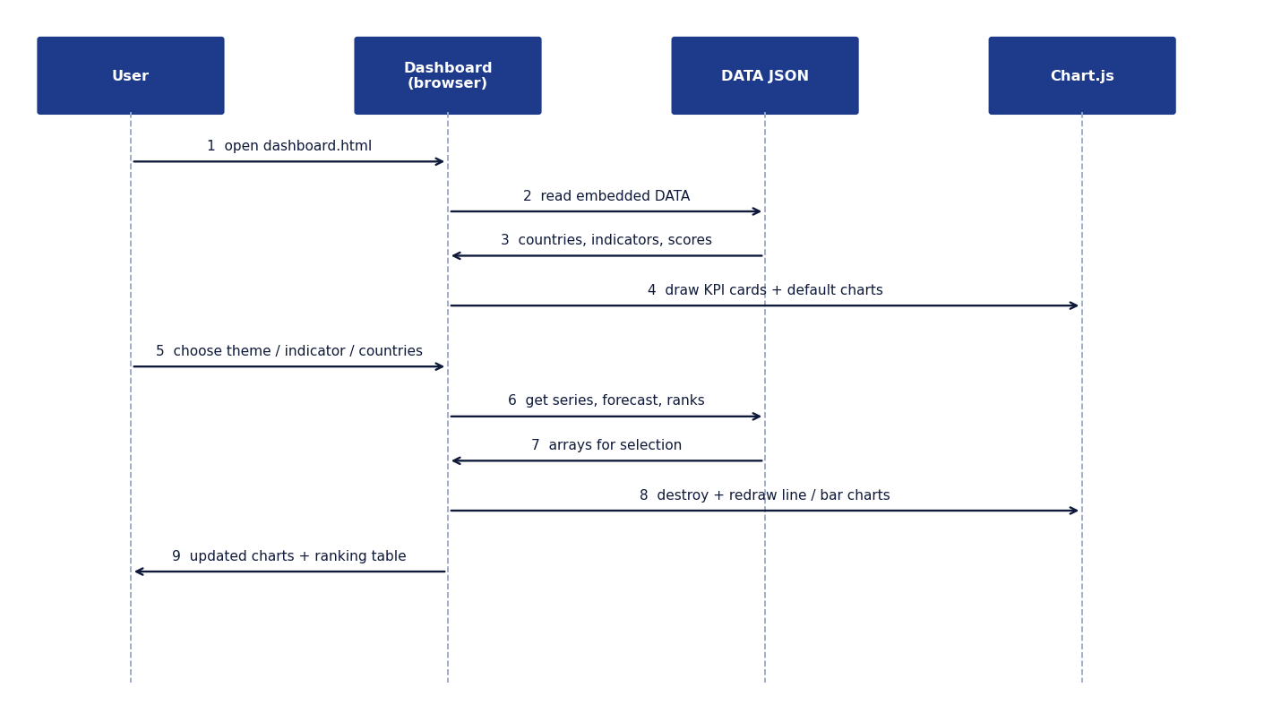
Figure 7 – Sequence: using the dashboard

3.3 Activity diagram
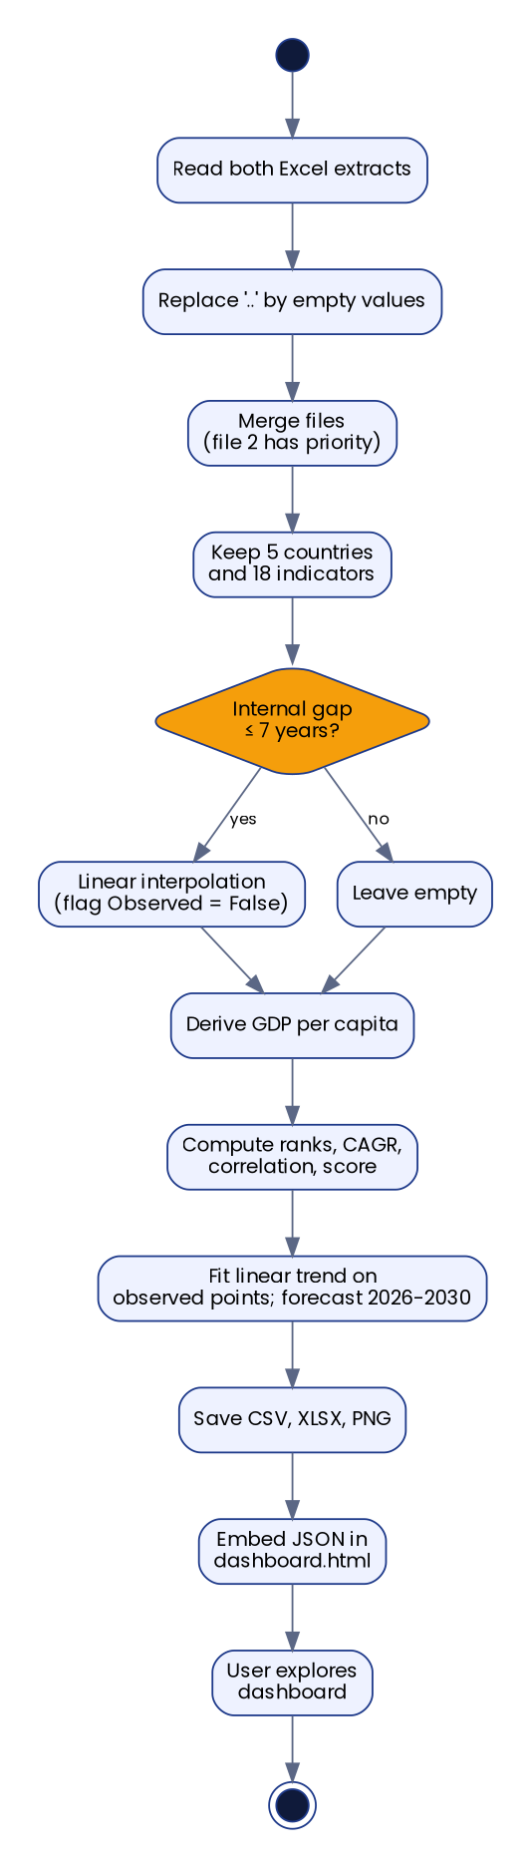
Figure 8 – Activity: from raw files to dashboard

3.4 State diagram
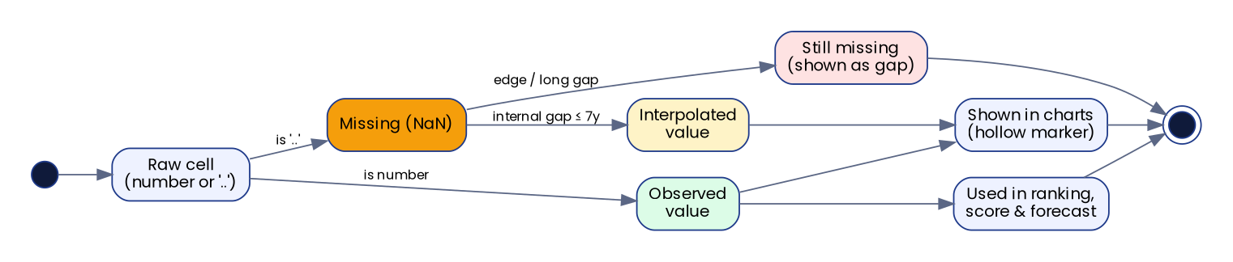
Figure 9 – States of a single data point

3.5 Class diagram
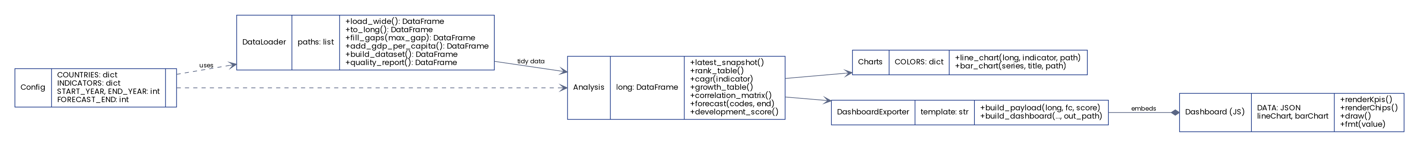
Figure 10 – Modules and their operations (the code is function-based; each box is a module)

4. UI/UX Design & Prototyping

4.1 Wireframes
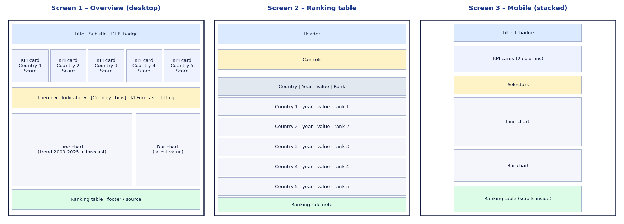
Figure 11 – Wireframes: overview, ranking table, mobile
The final interface is the working dashboard (dashboard/dashboard.html); the wireframes above define its layout: header → KPI cards → controls → charts → ranking table → source note.

4.2 UI/UX guidelines
Topic | Guideline
Colour | Deep blue (primary), purple (secondary), cyan (accent), orange (highlight), green (success) – the DEPI infographic palette. Each country keeps one fixed colour in every chart.
Typography | Inter / Segoe UI / system sans-serif; title 28 px, section headings 15 px, body 13–14 px; tabular numbers in tables.
Layout | Cards with rounded corners and soft shadows; two-column chart area on desktop that stacks on screens < 860 px.
Data honesty | Hollow markers = interpolated; dashed lines = forecast; notes under the charts; source and score formula in the footer.
Themes | Automatic light/dark mode following the device setting.
Accessibility | Every control has a visible label; country chips are real buttons; values are also in a table; colour is never the only carrier of meaning (country names in legend, bars and table).

5. System Deployment & Integration

5.1 Technology stack
Area | Technology | Use
Language | Python 3.10+ | Pipeline, analysis, tests
Data | pandas, NumPy, openpyxl | Read Excel, reshape, clean, write xlsx
Analytics | scikit-learn (LinearRegression) | Linear trend forecast
Charts | matplotlib | Static PNG charts
Frontend | HTML, CSS, JavaScript, Chart.js 4.4.1 | Interactive dashboard
Testing | unittest | 18 automated tests
Version control | Git / GitHub (company organisation) | Source, docs and data

No backend framework, no database server and no AI/LLM services are used.

5.2 Component diagram
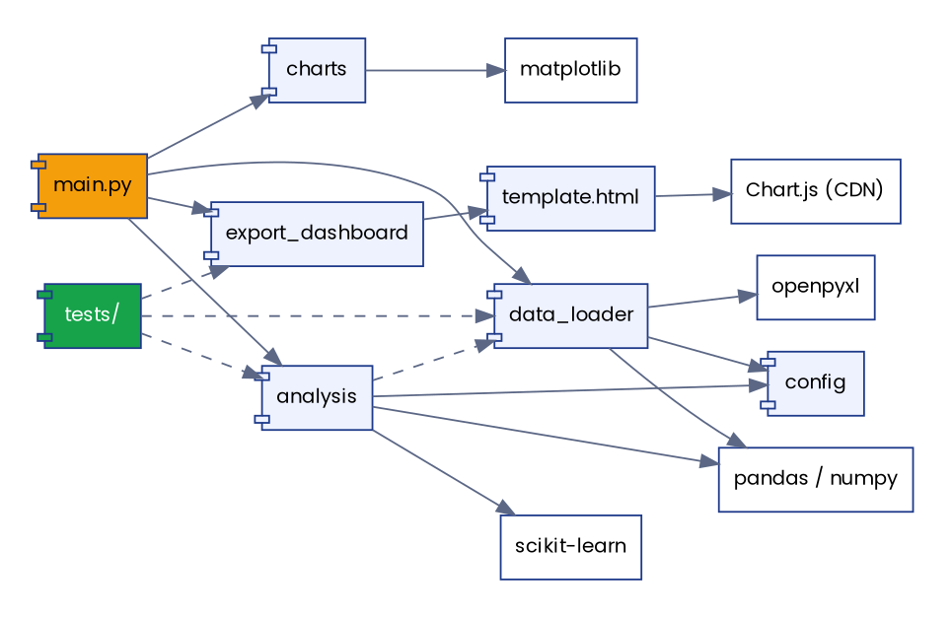
Figure 12 – Component diagram

5.3 Deployment diagram
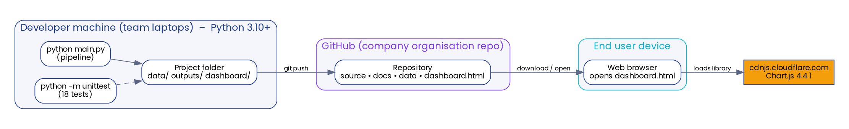
Figure 13 – Deployment diagram

6. Additional Deliverables

6.1 API documentation
The system has no REST API (no server), so there are no endpoints to document. The public Python functions are documented in the Technical Documentation (section 4).

6.2 Testing & validation plan
- Unit tests (tests/test_pipeline.py, 18 tests) for loading, cleaning, interpolation, ranking, CAGR, score, forecast and dashboard export.
- Integration check: python main.py must finish without errors and create all output files.
- User acceptance tests (UAT-01 … UAT-09) executed in a browser; listed in the Test Report.
- Data validation: quality report per country; a hold-out error for each forecast.

6.3 Deployment strategy
- Hosting environment: none required. Team members run the pipeline locally; the dashboard is one HTML file that can be opened from disk, from GitHub, or from any static host.
- Pipeline: pip install -r requirements.txt then python main.py.
- CI/CD: optional. A GitHub Actions workflow could run the 18 tests on every pull request; not configured yet.
- Scaling: the pipeline is vectorised pandas; adding countries or indicators needs only config.py changes. Data above a few hundred MB would call for a database (see docs/schema.sql).

