**Bidirectional translation project presentation**

**Introduction:**

**What is machine translation?**

**Machine Translation (MT)** is the automatic process of translating text or speech from one language to another using software or algorithms. It aims to produce fluent and accurate translations without human intervention.

### **Key Points:**

* **Goal**: Bridge language barriers by converting meaning, not just words.
* **Types**:
  + **Rule-based MT**: Uses grammar rules and dictionaries.
  + **Statistical MT**: Learns from large aligned corpora using probabilities.
  + **Neural MT (NMT)**: Uses deep learning models like Transformers for better fluency and context understanding.

**Popular Models**: Google Translate, DeepL, MarianMT, OpenNMT, etc.

* **Challenges**:
  + Idioms, slang, cultural context.
  + Syntax and grammar differences.
  + Ambiguity in words or phrases.

**Model Overview:**

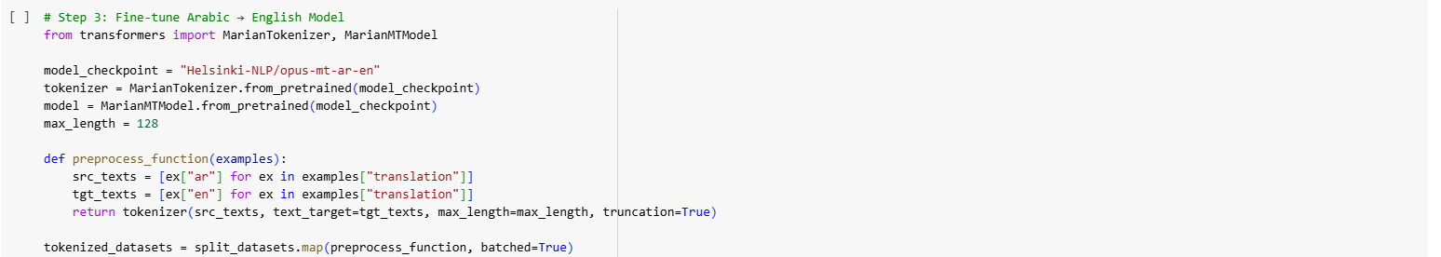

**Helsinki-NLP MarianMT Model**

* The **Helsinki-NLP MarianMT model** is a state-of-the-art neural machine translation (NMT) model developed for **bidirectional translation** tasks.
* Built on the **MarianMT** architecture, it is a transformer-based model specifically designed for **high-performance machine translation**.

**Key Features:**

* **Bidirectional Translation**: The model supports both **English → Arabic** and **Arabic → English** translation, enabling flexible usage for cross-lingual tasks.
* **Pretrained Model**: It has been pretrained on various large-scale datasets, including domain-specific corpora like **KDE4** and **OPUS** datasets, providing a strong foundation for translation accuracy.
* **Fine-tuned for Technical Content**: The model has been fine-tuned specifically for **technical translation** tasks, making it highly suitable for software documentation, user interfaces, and other specialized fields.
* **Transformer Architecture**: Built using the transformer model, which is known for its **parallel processing** capabilities and efficiency in handling long-range dependencies in sentences.

**Advantages:**

* **Pretrained on diverse domains**: It provides a high-quality translation for various domains, from technical to general-purpose content.
* **High Translation Accuracy**: Fine-tuning ensures the model provides accurate translations with respect to both **syntax** and **vocabulary**.
* **Multilingual Capability**: Although primarily trained for **English ↔ Arabic**, the model can potentially be used for other languages due to its robust architecture.

**Limitations of the Model:**

#### **1. Domain-Specific Bias (KDE4 Dataset)**

* The **KDE4 dataset** is primarily composed of **software localization and UI text**.
* This means the model is **biased toward formal and technical language**, and might not perform well on:
  + Informal, slang, or dialectal Arabic.
  + Literary, medical, or legal text.

#### **2. Morphological Complexity of Arabic**

* Arabic is a **morphologically rich** and **highly inflected language**.
* The model may struggle with:
  + Handling different verb conjugations or noun forms.
  + Gender and number agreement.
  + Diacritics (which are often omitted in training data but affect meaning).

#### **3. Low BLEU Score for English → Arabic**

* Although the AR → EN BLEU score is strong (~0.71), the EN → AR direction achieved a lower score (~0.42).
* Reasons may include:
  + Lower Arabic vocabulary coverage.
  + More syntactic flexibility and word reordering needed in Arabic.
  + Error accumulation due to directional asymmetry in the model.

#### **4. Lack of Context Awareness**

* The model translates **sentence-by-sentence** without considering surrounding context.
* This leads to issues with:
  + Pronoun resolution (e.g., "he" vs "she").
  + Consistent terminology across paragraphs or documents.

#### **5. No Support for Dialects**

* The model is trained only on **Modern Standard Arabic (MSA)**.
* It cannot understand or generate:
  + Egyptian, Levantine, Gulf, or Maghrebi dialects.
  + Code-switching (mix of Arabic and English).

#### **6. Training Resource Constraints**

* Fine-tuning was done for **3 epochs only** with limited compute (likely a single GPU).
* With more epochs, larger batch sizes, or additional domain data, the model might improve further.

#### **Implementation Details:**

* Available on **Hugging Face** and can be easily integrated into translation systems for **bidirectional tasks** using the MarianMT pre-trained model weights.

**Dataset Used:**

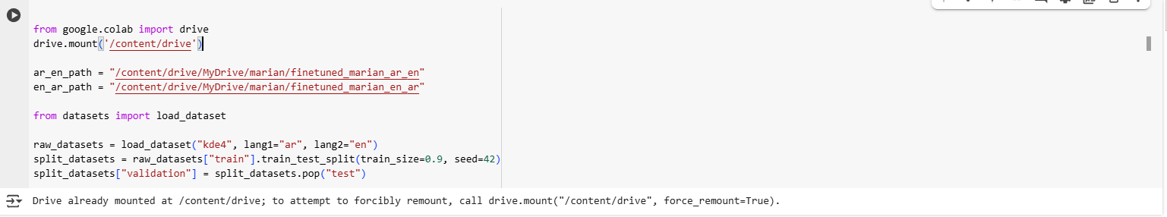

#### **KDE4 Parallel Corpus (English–Arabic)**

* A high-quality **parallel corpus** extracted from **KDE software documentation**.
* Created for training and evaluating **machine translation systems**.

#### **Key Features**

* **Domain**: Technical/software interface text (menus, settings, etc.)
* **Languages**: English ↔ Arabic aligned sentence pairs
* **Source**: Part of the **OPUS** collection – freely available and widely used
* **Preprocessed** using:
  + Sentence-level alignment
  + Tokenization via MarianTokenizer
  + Padding/truncation for uniform input

#### **Why KDE4?**

* Offers **consistent terminology** and **formal structure**, ideal for training translation models.
* Helps models learn clear syntactic patterns and vocabulary mappings.

**Training Configuration Overview**

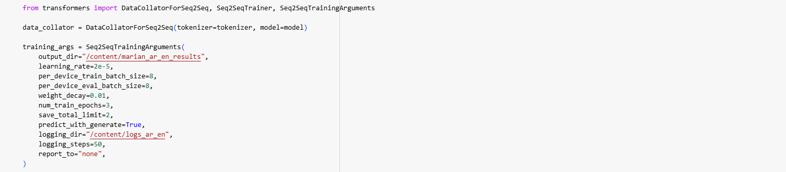

**1. Data Collator for Sequence-to-Sequence (Seq2Seq) Model**

The **DataCollatorForSeq2Seq** is used to handle dynamic padding and efficient batching during training. It ensures that the input sequences are padded correctly to fit the required sequence length.

* **Data Collator**: DataCollatorForSeq2Seq(tokenizer=tokenizer, model=model)
  + **Purpose**: Automatically pads sequences to the correct length, which is crucial when working with varying sequence lengths in machine translation tasks.
  + **Benefits**:
    - Efficient memory usage by dynamically padding the input sequences.
    - Reduces the need for manual padding, saving time in preprocessing.

### **2. Training Arguments (Seq2SeqTrainingArguments)**

The **Seq2SeqTrainingArguments** define the settings and configurations that will be used to control the fine-tuning process. These arguments are essential for optimizing model performance.

* **Training Arguments**:
  + **output_dir**: /content/marian_ar_en_results
    - **Purpose**: Specifies the directory where the model checkpoints and results will be saved during training.
  + **learning_rate**: 2e-5
    - **Purpose**: Controls the rate at which the model learns during training. A low learning rate ensures gradual convergence and avoids overshooting the optimal solution.
  + **per_device_train_batch_size**: 8
    - **Purpose**: Defines the batch size used during training. A batch size of 8 ensures efficient GPU utilization without overwhelming the memory.
  + **per_device_eval_batch_size**: 8
    - **Purpose**: Sets the batch size during evaluation, matching the training batch size for consistency.
  + **weight_decay**: 0.01
    - **Purpose**: Adds a penalty for large weights, which helps reduce overfitting and improves generalization.
  + **num_train_epochs**: 3
    - **Purpose**: Specifies the number of epochs for training. A value of 3 means the model will iterate over the dataset 3 times during training.
  + **save_total_limit**: 2
    - **Purpose**: Limits the number of checkpoints saved during training to the most recent 2. This helps manage disk space and ensures only the best models are retained.
  + **predict_with_generate**: True
    - **Purpose**: Ensures that predictions are generated using the model’s generation capabilities, which is crucial for translation tasks.
  + **logging_dir**: /content/logs_ar_en
    - **Purpose**: Defines the directory where logs will be saved. This allows us to track the training process and monitor performance metrics.
  + **logging_steps**: 50
    - **Purpose**: Logs the training progress every 50 steps, allowing for real-time tracking of the training process.
  + **report_to**: "none"
    - **Purpose**: Disables reporting to external platforms like TensorBoard, which is often used for more advanced monitoring but is not necessary for this setup.

**Evaluation Overview**

### **1. BLEU Score (Automatic Evaluation Metric)**

**BLEU score** is a standard metric used in machine translation that compares model-generated translations against one or more human reference translations.

* **EN → AR BLEU Score**: 0.4169
* **AR → EN BLEU Score**: 0.7104

#### **Interpretation:**

* A **BLEU score close to 1.0** indicates high overlap with the reference translation.
* The model performed **very well on Arabic → English**, likely due to richer English reference structures and potentially better model generalization.
* The score for **English → Arabic** is still strong for a low-resource direction, indicating good quality translations.

### **2. Translation Examples (Qualitative Evaluation)**

We tested the model on real sentences in both directions to observe its ability to generate fluent, accurate, and contextually correct translations.

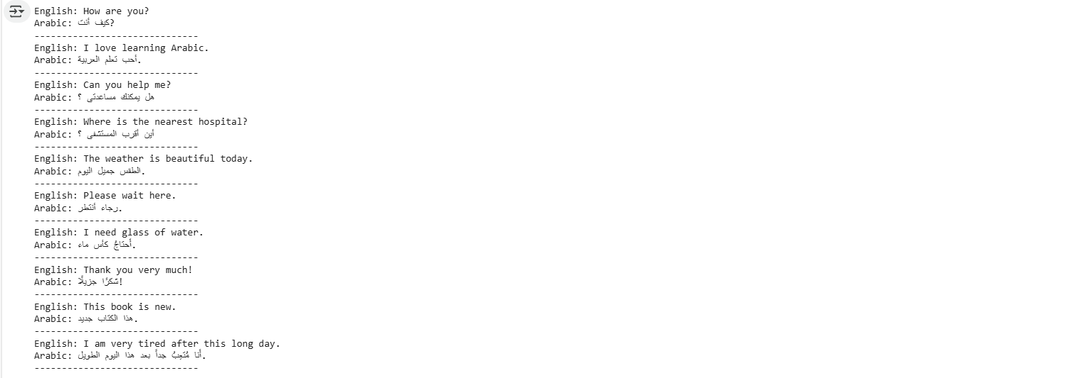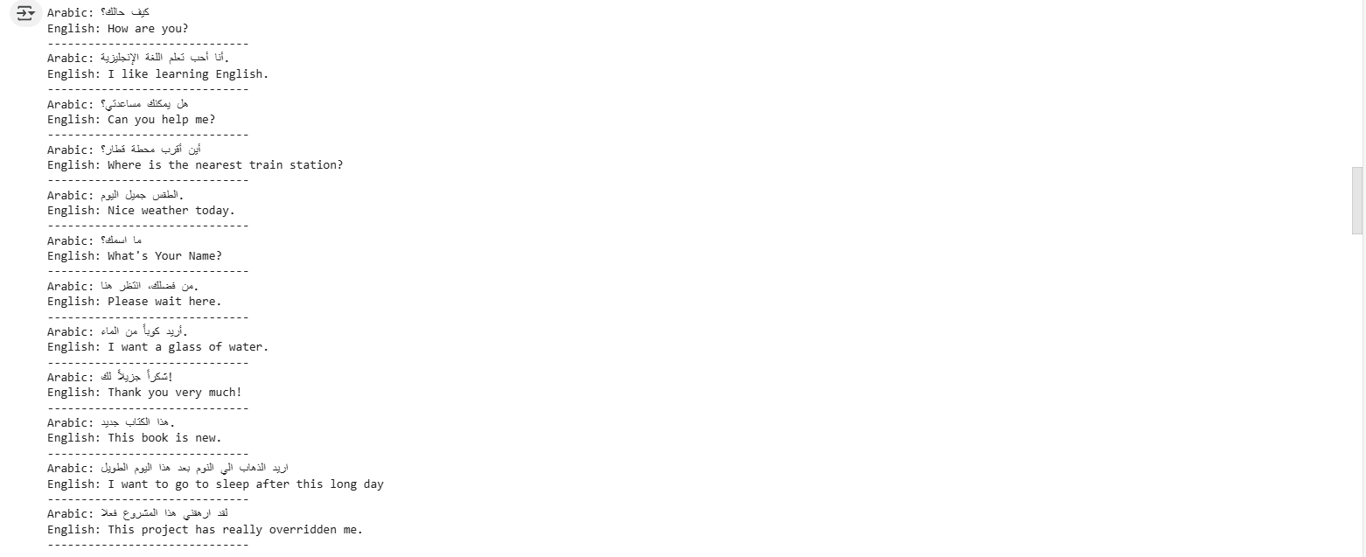

#### **Observations:**

* The model retained **meaning**, **tone**, and **correct grammar** in most translations.
* It handled **common conversational and formal phrases** effectively in both directions.
* Some **long or idiomatic phrases** may still need manual review or post-editing, which is expected in MT systems.

