SICKLEPREDICT · PROTOTYPE EVALUATION

Results Report: Bi-LSTM Risk Stratification of Vaso-Occlusive Crises on a Simulated Wearable Cohort
Prototype version 1.0 · November 2026 · Companion to the SicklePredict Project Proposal (v1.1)
Important: simulated data. All patients, signals and crises in this report were generated by a computer simulation. The pre-crisis physiological signature was written into the simulator as an assumption, so these results show that the data pipeline, model and evaluation work end to end. They are not evidence that the SicklePredict device predicts crises in real patients. That requires the IRB-approved feasibility study described in Section 6.2 of the proposal.

1. Key findings
- On 40 held-out test patients, the proposed model (M5) reached a window-level AUROC of 0.846 (95% CI 0.80–0.90) and an AUPRC of 0.538, against a base rate of 0.022.
- Alerts preceded 33 of 39 crises (85%), with a median warning time of 12 hours (interquartile range 6–20 h).
- The alert burden was 0.13 false alerts per patient-week (34 of 83 alerts); 59% of alerts were followed by a crisis within 24 h.
- Removing the personal baseline (M3) caused the largest loss: AUROC 0.654 and only 21% of crises caught. Restricting to consumer-watch sensors (M4) kept AUROC similar (0.839) but lowered AUPRC to 0.412 and crises caught to 69%.
- The model relied most on the isosbestic 810 nm channel and its transit delay, then electrodermal activity; peripheral temperature added little, because ordinary cold exposure produced the same cooling without a crisis.
- All three proposal hypotheses (sensing specificity, multimodal fusion, personalised modelling) were supported within the simulation, which was built on those assumptions. They remain hypotheses for real-world testing.

2. Purpose and scope
This prototype turns the proposal's machine-learning design (Section 4) into working software before any hardware or patient data exist. It answers three practical questions: can the planned variables be stored and processed as one multivariate time series; can a Bi-LSTM with temporal attention and a per-patient baseline be trained and evaluated rigorously; and what would the outputs clinicians and judges see look like. The same code is meant to be reused unchanged when real wristband data from the Phase 2 pilot replace the simulator.

3. Methods

3.1 Simulated cohort
The simulator generated 200 patients, each wearing the wristband continuously for 60 days, giving 288,000 patient-hours of hourly aggregated data and 234 VOC events (average wear time 91.0%). The inclusion criterion mirrors a feasibility study: at least three VOC episodes in the prior 12 months. Genotype mix (HbSS 68%, HbSβ0 10%, HbSβ+ 10%, HbSC 12%), haemoglobin, HbF and hydroxyurea use follow Saudi patterns, with higher HbF in the Eastern region.
To make the task realistic, the simulator adds circadian rhythm, sleep, physical activity and motion artefacts, daily charging gaps and forgotten wear, device removal during hospital stays, cold exposure, heat and dehydration, emotional stress, intercurrent infections, and "aborted" vasoconstriction episodes that resemble a prodrome but never become a crisis. Each patient expresses the pre-crisis signature through a different mix of pathways (vasoconstrictive, oxygenation, rheological, autonomic) and at a different strength, and some barely express it at all.
Assumed pre-crisis signature. Starting 12 to 48 hours before onset, the simulator ramps up: falling perfusion index (strongest at 810 nm), rising ratio-of-ratios and falling SpO2, longer 810 nm transit delay, rising heart rate and skin conductance, falling HRV and wrist temperature, and reduced activity. This window is the proposal's central hypothesis, not an established fact.

3.2 Model inputs
Sensor group | Hourly variables | Rationale (proposal §3)
Multi-λ PPG | Perfusion index at 520, 660, 940 nm; ratio-of-ratios 660/940; estimated SpO2 | Superficial perfusion and relative deoxygenation
Isosbestic PPG | Perfusion index at 810 nm; microvascular transit delay | Oxygenation-independent blood volume and rheology
Electrodermal | Tonic skin-conductance level; SCR per minute | Sympathetic response to early hypoperfusion
Thermistor | Wrist skin temperature | Peripheral vasoconstriction
Cardiac | Heart rate; RMSSD | Autonomic tone
Activity & context | Steps; signal-quality index; outdoor temperature (phone) | Artefact handling and known triggers
Table 1. Fifteen hourly input channels, plus a device-worn flag and time of day. The full data dictionary is in the database files.

3.3 Prediction task
Every hour, the model reads the previous 24 hours and estimates the probability that a VOC will begin within the next 24 hours. The first 7 days of each patient form the calibration week and are not scored. Hours during a crisis and the 72 hours after it are excluded, because the question is prediction, not recognition of an ongoing crisis.
Personal baseline. For each patient and channel, the median and robust spread are learned from that patient's own calibration week, separately for four six-hour blocks of the day. Each later hour is then expressed as the number of personal standard deviations away from that patient's usual value at that time of day.

3.4 Models compared
Model | Inputs and normalisation | What it tests
M1 Rule-based threshold | Perfusion drop + heart-rate rise, population norms; no learning | Simple consumer-style alert
M2 Random forest (summary features) | 24-h summary features, population norms | Prior-work approach (Ji 2021; Vuong 2023)
M3 Bi-LSTM + attention, population baseline | All sensors, one population-wide normalisation | Value of the personal baseline
M4 Bi-LSTM + attention, consumer sensors only | Personal baseline, consumer-watch channels only (520/660/940 PPG, HR, HRV, steps) | Value of 810 nm, EDA and thermistor
M5 SicklePredict (proposed) | All sensors, personal circadian baseline | The full proposed design
Table 2. Each comparison isolates one of the three contributions claimed in Section 2.3 of the proposal.
Architecture. A bidirectional LSTM (24 units per direction) reads the 24-hour window; a temporal-attention layer weights each hour; a dense layer with dropout produces the logit. Training used weighted cross-entropy, Adam with weight decay, Gaussian input noise, a fresh random sample of negative windows each epoch, and early stopping on validation AUPRC. Scores were Platt-calibrated on validation patients. The network was implemented from scratch in NumPy and its gradients were verified numerically (maximum relative error 1.6 × 10⁻⁷).

3.5 Evaluation
Patients were split before any modelling: 120 for training, 40 for validation and 40 for testing, so no patient contributes to more than one set. The alert threshold (0.317 for M5) was chosen on validation patients by maximising F1, before the test set was scored. An alert fires when risk stays above the threshold for 2 consecutive hours, at most once every 12 hours. A crisis counts as caught when an alert occurred in the 24 hours before onset. Confidence intervals come from 1,000 bootstrap resamples of whole patients.

4. Results

4.1 Discrimination
Model | AUROC (95% CI) | AUPRC | Sens. | Spec. | Crises caught | Median lead (h) | False alerts / pt-wk
M1 Rule-based threshold | 0.584 (0.50–0.66) | 0.032 | 0.65 | 0.46 | 32/39 (82%) | 16.5 | 9.19
M2 Random forest (summary features) | 0.750 (0.68–0.81) | 0.163 | 0.31 | 0.94 | 27/39 (69%) | 14.0 | 1.30
M3 Bi-LSTM + attention, population baseline | 0.654 (0.58–0.73) | 0.042 | 0.09 | 0.98 | 8/39 (21%) | 9.0 | 0.47
M4 Bi-LSTM + attention, consumer sensors only | 0.839 (0.78–0.89) | 0.412 | 0.34 | 0.99 | 27/39 (69%) | 10.0 | 0.15
M5 SicklePredict (proposed) | 0.846 (0.80–0.90) | 0.538 | 0.46 | 1.00 | 33/39 (85%) | 12.0 | 0.13
Table 3. Test-set performance (43,467 hourly windows, 938 positive). Sensitivity and specificity are window-level at each model's validation-chosen threshold.
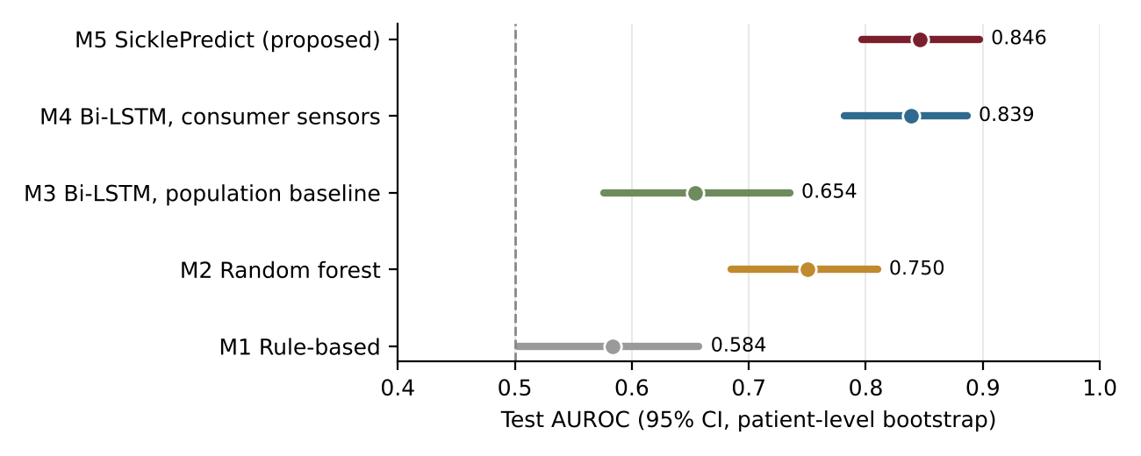
Figure 1. Test AUROC with 95% patient-level bootstrap intervals. Dashed line marks chance.
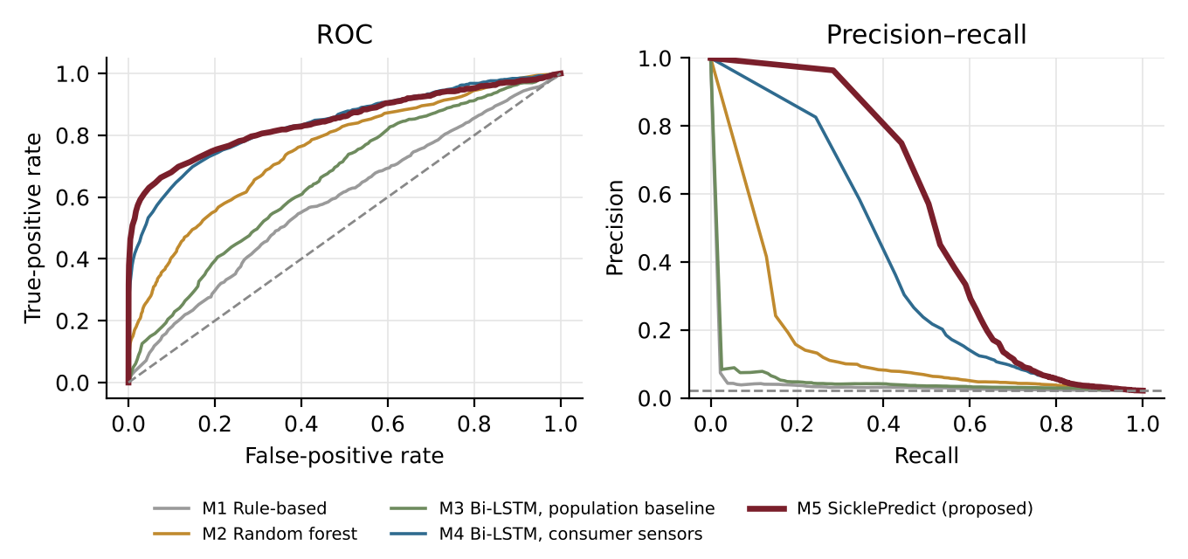
Figure 2. ROC and precision–recall curves on the test patients. The dashed line in the right panel is the base rate (0.022). Because pre-crisis hours are rare, precision–recall separates the models more clearly than ROC.
The rule-based alert was barely better than chance and fired 2,436 alerts, 98% of them false, which would cause severe alarm fatigue. Without personalisation, the Bi-LSTM (M3) lost most of its precision, because differences between patients swamped the changes within each patient. The consumer-sensor model (M4) ranked windows almost as well as M5, but its precision–recall performance and crisis capture were clearly lower.

4.2 Alerting at the crisis level
M5 issued 83 alerts over 259 monitored patient-weeks. Of the 39 evaluable crises, 33 were preceded by an alert, with warning times between 1 and 23 hours (median 12 h). At the clinical level, that would leave time for the preventive steps in Section 5 of the proposal: oral hydration, warmth and tele-consultation. The 6 missed crises are listed in Appendix A; in each, the highest risk in the preceding 24 hours stayed below the alert threshold (range 0.10–0.31).

4.3 Illustrative patient
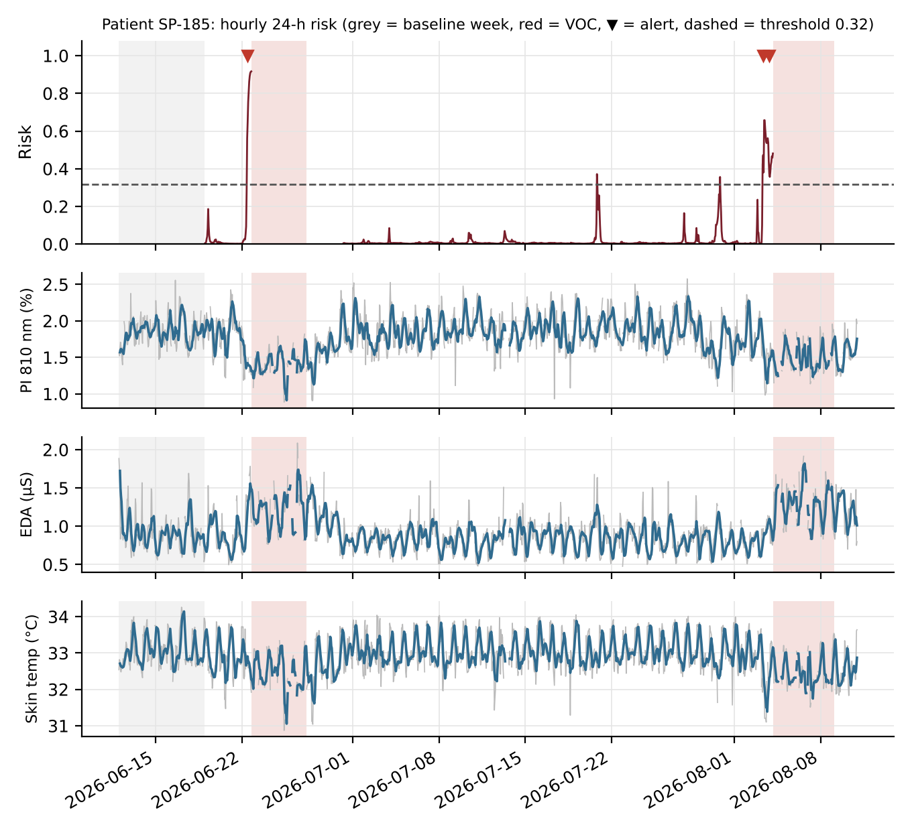
Figure 3. Test patient SP-185 (45-year-old woman, HbSS, on hydroxyurea). Top: hourly risk, alert threshold, alerts (▼) and crises (red). Below: 810 nm perfusion index, skin conductance and wrist temperature (grey = hourly, blue = 6-hour average). Both crises were preceded by alerts, 8 h and 20 h before onset, with no false alerts over 60 days. Two brief spikes above the threshold did not trigger an alert because of the two-hour persistence rule.

4.4 What the model relies on
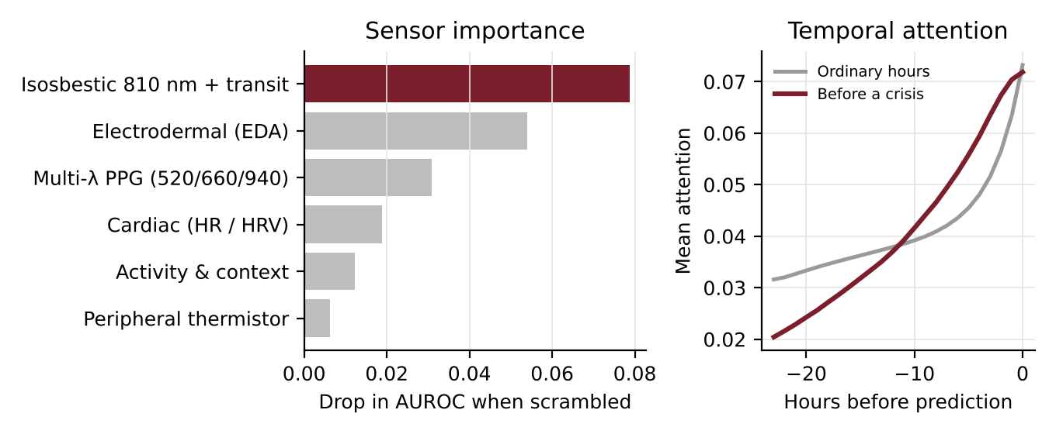
Figure 4. Left: drop in test AUROC when each sensor group is randomly scrambled (permutation importance). Right: mean temporal-attention weight across the 24-hour window.
Scrambling the isosbestic 810 nm group reduced AUROC by 0.079, more than any other group, followed by electrodermal activity (0.054). Among single channels, the 810 nm transit delay (0.057) and tonic skin conductance (0.032) mattered most. Before a crisis, attention shifted toward the most recent hours, which matches the rising prodrome built into the simulator. These importances reflect the simulator's assumptions; in real data they would be findings.

4.5 Consistency across patient groups
Group | Level | Patients | Crises | AUROC | Crises caught
Sex | F | 23 | 20 | 0.832 | 85%
Sex | M | 17 | 19 | 0.861 | 84%
Genotype | HbSC / HbSβ+ | 8 | 9 | 0.880 | 78%
Genotype | HbSS / HbSβ0 | 32 | 30 | 0.833 | 87%
Age | 18–30 | 18 | 25 | 0.877 | 80%
Age | < 18 | 7 | 4 | 0.824 | 100%
Age | > 30 | 15 | 10 | 0.778 | 90%
Therapy | No hydroxyurea | 14 | 19 | 0.840 | 79%
Therapy | On hydroxyurea | 26 | 20 | 0.860 | 90%
Table 4. Performance of M5 by subgroup (proposal §10). Groups are small, so differences are within sampling noise and should not be interpreted as real disparities.

4.6 Calibration
After Platt scaling, predicted risk matched the observed crisis rate across deciles of test hours: in the top decile, mean predicted risk was 0.145 and the observed rate 0.145. The Brier score was 0.013. A calibrated score lets the dashboard show risk as a probability rather than an arbitrary index.

5. Interpretation against the proposal's hypotheses
Proposal claim (§2.3) | Comparison | Result in simulation
Personalised baseline beats a population threshold | M3 vs M5 | AUROC 0.654 → 0.846; crises caught 21% → 85%
Purpose-built sensing and multimodal fusion add value | M4 vs M5 | AUPRC 0.412 → 0.538; crises caught 69% → 85%
Sequence modelling beats engineered summaries | M2 vs M5 | AUROC 0.750 → 0.846; false alerts/pt-wk 1.30 → 0.13
Table 5. Each gap is consistent with the proposal, but the simulator encodes the assumptions behind it, so this shows internal consistency, not external validity.

6. Limitations
- Simulated data. Effect sizes, lead times and channel importances are consequences of the simulator's assumptions. Real physiology may differ in timing, size or direction.
- Small test set. The test set has 40 patients and 39 evaluable crises, so confidence intervals are wide, and subgroup estimates rest on a handful of crises.
- Hourly aggregates. The prototype works on hourly summaries. A real device would sample PPG at tens to hundreds of hertz, and feature extraction and artefact rejection at that level remain a separate engineering workstream (proposal §3.4).
- Label definition. Crisis onset is assumed to be known to the hour. In practice, onset times from patient diaries and ED records are noisy, and home-managed crises are under-reported.
- Single split. Results come from one patient-level split and one training seed. Repeated cross-validation would give more stable estimates.

7. Recommended next steps
- Use the same data schema as the case report form for the Phase 2 pilot, so wristband exports flow straight into this pipeline.
- Pre-register the primary endpoint (crises caught within 24 h at a fixed false-alert budget) and the comparison against a consumer-wearable arm, as Section 6.2 of the proposal recommends.
- Run a sensitivity analysis on the simulator: shorter prodromes, weaker signatures and more cold-exposure confounding, to see how quickly performance degrades and what sample size the pilot needs.
- Add repeated cross-validation, multiple training seeds and a decision-curve analysis before any clinical presentation.

Appendix A. Crises not preceded by an alert
Event | Onset | Care setting | Likely trigger | Peak risk in prior 24 h
SP-055-E2 | 2026-04-03 17:00 | home-managed | none identified | 0.097
SP-055-E3 | 2026-04-26 17:00 | ED visit | cold exposure | 0.229
SP-063-E2 | 2026-04-11 05:00 | ED visit | none identified | 0.308
SP-100-E2 | 2026-03-26 16:00 | ED visit | cold exposure | 0.194
SP-100-E3 | 2026-04-08 03:00 | ED visit | none identified | 0.275
SP-136-E1 | 2026-04-04 00:00 | ED visit | cold exposure | 0.222
Table A1. All 6 missed crises. The alert threshold was 0.317.

Appendix B. Files delivered with the prototype
File or folder | Contents
data/SicklePredict_Synthetic_Database.xlsx | Readable copy: data dictionary, patients, VOC events, sample week
data/sicklepredict.db | Full SQLite database (patients, wearable_hourly, voc_events, data_dictionary)
data/wearable_hourly.csv.gz | All 288,000 hourly records
sicklepredict/ | Source code: simulate, features, bilstm, train, evaluate, predict
outputs/models/ | Trained Bi-LSTM weights and run settings
outputs/dashboard_data/ | Result tables behind this report and the online dashboard
run_all.py | Regenerates the data, retrains all models and rewrites the results

