FACULTY OF ARTIFICIAL INTELLIGENCE ENGINEERING
Syrian Private University
Next-Day Athlete Readiness Prediction from Wearable, Training-Load and Lifestyle Data
Seminar 1 Report: Part One and Chapter 1 (draft for supervisor approval)
Student: [Name]
Supervisor: [Name]
Project type: Semester project
Date: October 2026

Part One: Project Definition and State of the Art

A. Problem Statement and Objectives

A.1 Scientific problem
Coaches and athletes try to balance training load against recovery so that athletes improve without becoming overtrained, ill or injured. In practice, this decision relies on experience, on simple questionnaires and on closed commercial tools. Wearables now record sleep, resting heart rate and activity continuously, and athletes can report how ready they feel each day, but it is not clear how reliably tomorrow's readiness can be predicted from these signals.
Three difficulties make the problem scientifically interesting. First, the target (self-reported readiness) is subjective and noisy, and different athletes use the scale differently. Second, the available public data are small, so a model that looks accurate on a random split may fail on an athlete it has never seen. Third, strong published results often use large models whose cost and opacity limit practical use.

A.2 Goal and objectives
Goal: build and evaluate a lightweight, explainable model that predicts whether an athlete will have a low-readiness day tomorrow, and measure whether personalization improves on a single population model.
- Build a reproducible pipeline that turns the raw PMData files into one row per participant per day.
- Define baselines and a success threshold before training any model.
- Train and compare Ridge regression, XGBoost and LSTM/GRU under leave-one-subject-out evaluation.
- Measure the contribution of sleep, training load and nutrition-related features (ablation).
- Explain predictions with SHAP and study how many days of data a new athlete needs (cold start).
- Deliver a small demo application for decision support.

A.3 Research questions
- Which model is most accurate for next-day low readiness on athletes unseen during training?
- Does a personalized or fine-tuned model outperform one population model?
- How much do sleep, training load and nutrition-related logs each add to the prediction?
- How many days of a new athlete's data are needed before the model becomes useful?

A.4 Users and affected parties
The primary users are coaches and athletes (including amateurs starting a healthy routine) and gyms or clubs that monitor groups. The affected parties are the people whose data are used: the 16 PMData participants, whose data are anonymised and released under a Creative Commons license, and any future app users. The system is decision support, not a medical diagnosis.

B. State of the Art

B.1 Related work (draft)
Public lifelogging data for athletes are scarce. PMData (Thambawita et al., 2020) combines Fitbit signals, wellness and training-load reports from the PMSys app, and food and hydration logs from 16 participants over roughly five months. Because it pairs objective sensor streams with self-reported readiness, fatigue and stress, it is a natural reference dataset for readiness-related prediction.
Recent studies on PMData lean toward language models. Health-LLM (2024) studies large language models for health prediction from wearable sensor data. HealthSLM-Bench (2025) benchmarks small language models on PMData-style tasks (stress, readiness, fatigue and sleep quality) using a 14-day window, and HybridSense-LLM (2026) combines statistical features with language-model reasoning for the same targets. These works establish the tasks and give reference results. According to their abstracts they emphasise model scale and prompting rather than lightweight, interpretable pipelines; this will be checked in the full-text review.
Personalization has been studied for other targets. PerSQ (2022) monitors and improves personalized sleep quality from long-term lifelogs on PMData. PAIR models daily injury risk with athlete-specific embeddings and reports that personalization and temporal alignment improve performance.
Time-series and multimodal approaches complete the picture: a 2022 study predicts soccer players' readiness from self-reported wellness series, a 2026 study forecasts athlete injury with an LSTM and attention and provides explanations, and PART fuses devices, surveys and physical tests in a weighted ensemble for tennis. Together, these studies show that the problem is active, but they leave open the combination of questions that this project targets (Section B.4).

B.2 Comparison table
Work | Year | Data | Target | Method | Relevance
PMData | 2020 | 16 athletes: Fitbit, PMSys, logs | Dataset labels | Dataset paper | Our data; small cohort, self-reported labels
Health-LLM | 2024 | Wearable datasets incl. PMData | Health prediction | LLM prompting / tuning | Strong reference; heavier models
PerSQ | 2022 | PMData lifelogs | Sleep quality | Personalized monitoring | Shows value of personalization
Soccer readiness | 2022 | Soccer players' wellness series | Readiness | Time-series models | Closest method precedent
HealthSLM-Bench | 2025 | PMData tasks | Stress, readiness, fatigue, sleep | Small language models | Task definition; 14-day window
HybridSense-LLM | 2026 | PMData | Stress, readiness, fatigue, sleep | Statistical features + LLM | Latest direct PMData work
PAIR | n/a* | Athlete wearable data | Daily injury risk | Personalized neural model | Personalization helps
LSTM + attention | 2026 | Wearable sensors | Athlete injury | LSTM with attention | Architecture reference
PART (tennis) | n/a* | Devices, surveys, physical tests | Readiness, injury risk | Weighted ensemble | Multi-source fusion
Table 1. Comparison of reviewed works. *Year to be confirmed. Entries come from abstracts and will be verified in the full-text review.

B.3 Coverage matrix
Work | PMData | Readiness / fatigue | Personal-ization | Multi-source | Unseen athletes | Light + explainable
PMData | ● | ● | – | ◐ | – | –
Health-LLM | ● | ● | – | ◐ | – | –
PerSQ | ● | – | ● | ◐ | – | –
Soccer readiness | – | ● | – | – | – | –
HealthSLM-Bench | ● | ● | – | ◐ | – | ◐
HybridSense-LLM | ● | ● | – | ◐ | – | –
PAIR | – | – | ● | ◐ | – | –
LSTM + attention | – | – | – | ◐ | – | ◐
PART (tennis) | – | ◐ | – | ● | – | –
This project | ● | ● | ● | ● | ● | ●
Table 2. Coverage matrix. ● addressed, ◐ partly, – not reported in the abstract.

B.4 Research gap
Existing work either (i) targets PMData with large or hybrid language models, (ii) studies personalization for other targets such as sleep quality or injury risk, or (iii) applies time-series models to other cohorts. In the abstracts reviewed, we did not find a study that systematically compares population, personal and fine-tuned models for next-day readiness on PMData while (a) combining sleep, training-load and nutrition-related features, (b) evaluating strictly on unseen athletes, and (c) reporting calibration and a cold-start analysis with a lightweight, explainable model. This project addresses that gap.

C. Proposed Solution

C.1 Idea
The system converts each athlete's recent history (up to day t) into a feature vector and predicts whether readiness on day t+1 will be low. A day is called low readiness when the self-reported score is 4.5 or below on the 0-10 scale (35% of report-days; provisional until the distribution is finalized). Predictions are accompanied by SHAP explanations that show which factors, such as short sleep or a jump in training load, drove the risk.

C.2 Block diagram
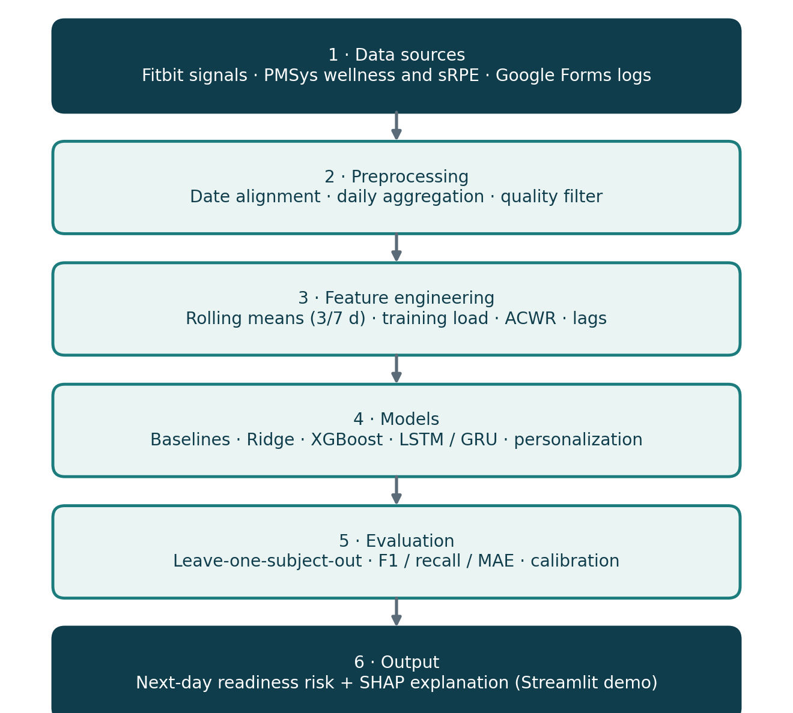
Figure 1. Block diagram of the proposed system.

C.3 Flowchart
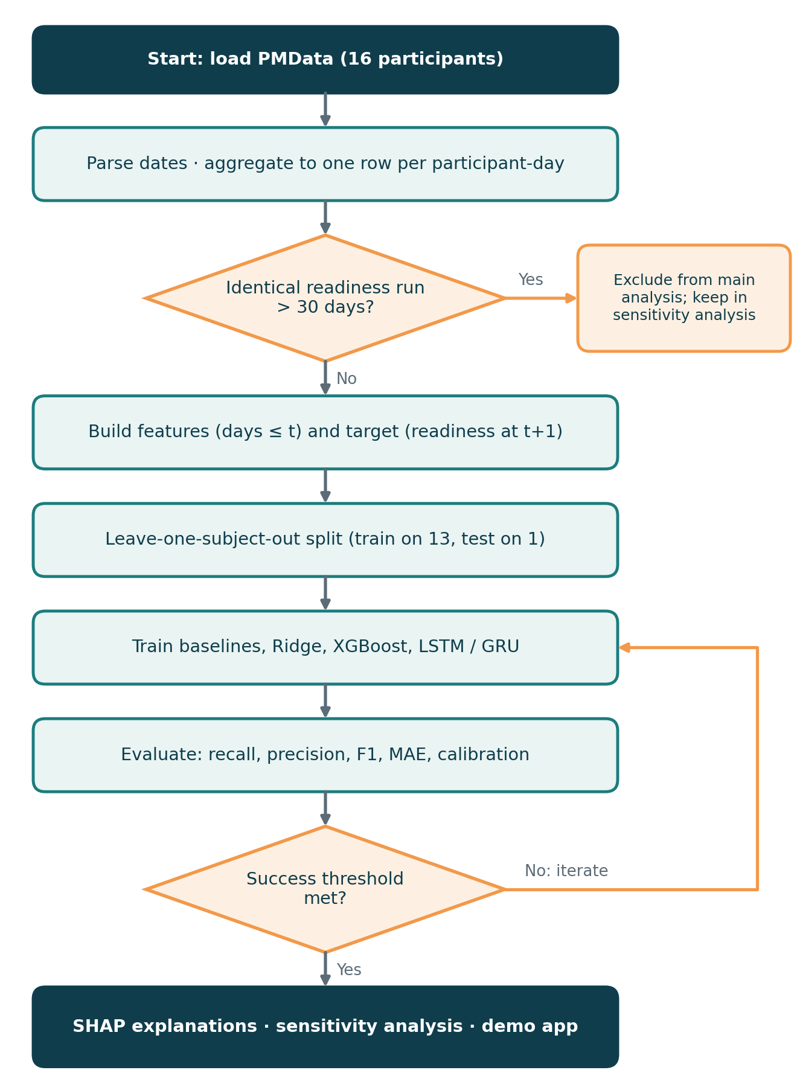
Figure 2. Flowchart of the pipeline, including the quality filter and the iterate loop.

C.4 Approach and models
- Baselines: persistence (tomorrow equals today), majority class, 7-day mean.
- Classical models: Ridge regression and XGBoost on engineered features (3- and 7-day rolling means, training load, acute:chronic load ratio, lags, weekday).
- Sequence models: LSTM/GRU over the last 7-14 days.
- Personalization: population model versus per-athlete model versus population model fine-tuned on the athlete's first days.
- Explainability: SHAP values, plus ablations that remove one feature group at a time.

C.5 Evaluation protocol and success threshold
All features use information up to day t only, and scalers and imputers are fitted on training athletes only. Models are evaluated with leave-one-subject-out (LOSO): each athlete is held out in turn. Metrics are recall, precision and F1 for the low-readiness class, macro-F1 for three classes (low ≤ 4.5, medium 5-6.5, high ≥ 7), MAE for the regression target, AUROC and the Brier score for calibration. Per-athlete results are reported with bootstrap confidence intervals and a Wilcoxon signed-rank test between the best two models.
Success threshold (provisional, refined in week 3): recall ≥ 0.70 at precision ≥ 0.50 for the low-readiness class under pooled LOSO. If this is not met, the project still succeeds if the best model beats persistence by at least 0.05 macro-F1 and a lower MAE, with a documented analysis of why the target is hard to predict.

D. Problem Framing Pack
Row | Answer
Task type | Binary classification: low readiness tomorrow. Secondary: 3-class classification and regression of readiness (0-10).
Input → output | Past 7-14 days of sleep score, resting heart rate, steps, active minutes, training load (sRPE), acute:chronic load ratio, self-reported wellness and hydration/alcohol/weight logs → low-readiness day at t+1.
Users and affected | Users: coaches, athletes, gyms. Affected: the 16 anonymised PMData participants and future app users.
Costlier error | False negative: a missed low-readiness day means the athlete trains at full load while tired, raising the risk of overtraining and injury. A false positive only costs an unnecessary lighter session.
Metric + threshold | Recall ≥ 0.70 at precision ≥ 0.50 on low-readiness days (provisional). Secondary: macro-F1 and MAE against persistence.
Baseline | Persistence, majority class (recall 0 on low days), 7-day mean; published PMData readiness results as external reference.
Test-set size | LOSO over about 14 athletes: roughly 1,250 valid day-pairs and about 440 low-readiness days (estimates, confirmed after the baseline run). At recall 0.70 the 95% interval is about ± 4 points (1.96·√(0.7·0.3/440)).
Table 3. Framing card.

E. Dataset Description and EDA

E.1 PMData
PMData was collected from 16 participants (p01-p16) between November 2019 and March 2020. Each participant has Fitbit Versa 2 data, wellness and training reports from the PMSys app, Google Forms logs and food images. It is released by Simula under a Creative Commons license, so the source and the dataset paper must be cited.
Folder | Files used | Content
pmsys | wellness.csv, srpe.csv (injury.csv unused for now) | Readiness (0-10), fatigue, mood, sleep quality and duration, soreness, stress; session RPE and duration
fitbit | sleep_score.csv; steps, resting_heart_rate and active-minute JSON files | Sleep score components, daily steps, resting heart rate, sedentary / light / moderate / very active minutes
googledocs | reporting.csv | Weight, hydration (glasses) and alcohol logs
food-images | not used in this phase | Meal photos (possible future extension)
overview | participant-overview.xlsx (not used) | Age, height, gender, max heart rate; contains missing and irregular entries
Table 4. Structure of the data and what is used.

E.2 Preprocessing
A single script (build_dataset.py) aggregates each participant to one row per calendar day, from the first to the last wellness report. Dates in day/month/year format are parsed explicitly. Steps and active minutes are summed per day, resting heart rate is averaged (zeros treated as missing), sRPE load is exertion times duration summed per day, and the target readiness_next is the next day's readiness. The output is daily.csv.

E.3 Exploratory data analysis
- 2,211 participant-days; 1,729 days with a readiness report; 1,423 valid pairs (report today and tomorrow). Participants have 68 to 147 reports over 106 to 151 days.
- Class distribution of readiness: low (≤ 4.5) 609 days (35%), medium (5-6.5) 762 days (44%), high (≥ 7) 358 days (21%).
- Completeness: Fitbit active minutes 100%, steps 94%, sleep score 80%, readiness 78%, resting heart rate 72%, hydration and alcohol 64%, weight 52%.
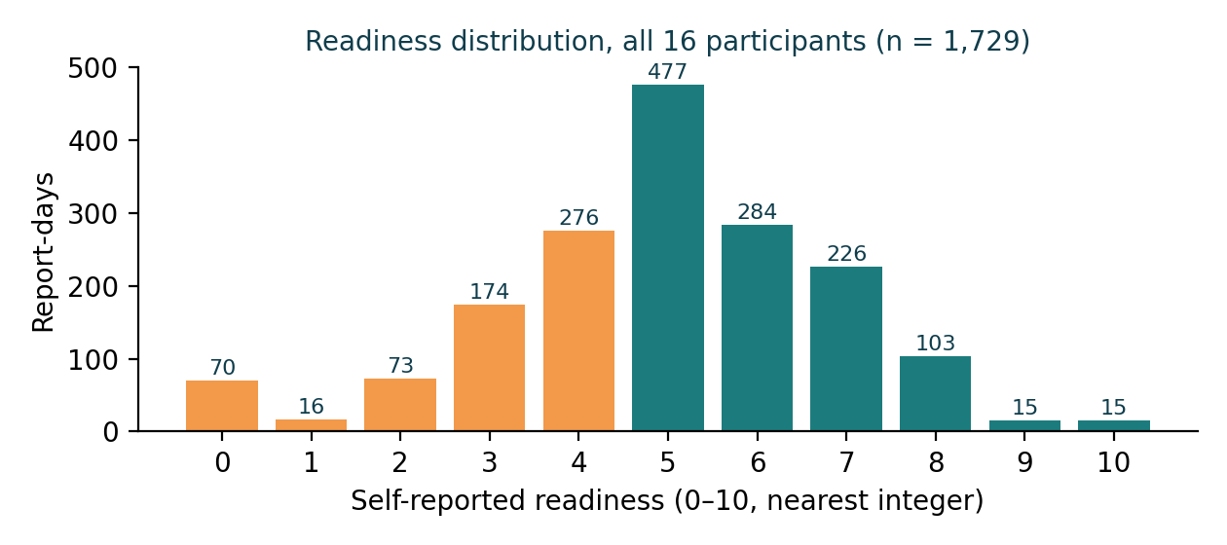
Figure 3. Distribution of self-reported readiness (values rounded to the nearest integer).
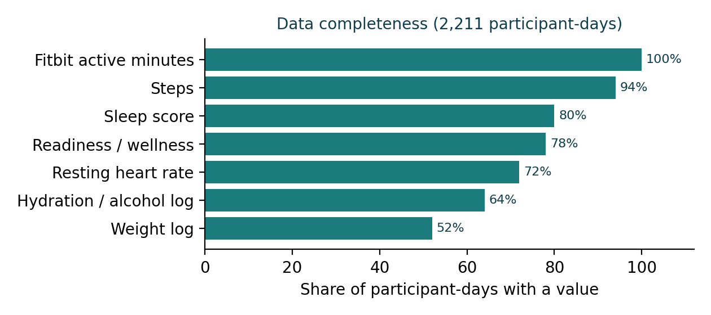
Figure 4. Share of participant-days with a value, by variable.

E.4 Data quality and exclusions
Inspection of readiness series revealed two participants whose self-reports are nearly constant. p03 reports the same value on 95% of days (longest identical run: 47 days). p05 reports 0 on 57 days (mostly consecutive) and then 5 on 70 days (longest run: 46 days), which looks like a default slider value rather than a daily rating. Rule: participants with an identical-value run longer than 30 days are excluded from the main analysis and kept in a sensitivity analysis, so that the effect of the decision is reported. The main analysis therefore uses 14 participants.

E.5 Limitations
- Small cohort (16 athletes, 5 months): results may not generalise.
- Subjective targets, with different scale use per athlete.
- Nutrition information is sparse (hydration, alcohol and weight logs on 52-64% of days), so its effect may be weak.
- Consumer-grade wearable (Fitbit Versa 2); no medical-grade measurements.

E.6 EDA notebook
The EDA notebook reproduces every number in this section from daily.csv and is submitted with the repository (notebooks folder).

Chapter 1: Theoretical Study

1.1 Athlete monitoring and readiness
Readiness describes an athlete's capacity to perform or train well on a given day. In team and individual sports it is commonly tracked with short wellness questionnaires covering fatigue, mood, sleep quality, muscle soreness and stress, scored on ordinal scales. These reports are cheap and sensitive to change, but they are subjective: two athletes may use the same score for different states, which motivates per-athlete modelling and the use of objective signals alongside them.

1.2 Training load and the acute:chronic workload ratio
External load measures what the athlete did, while internal load measures how hard it felt. Session RPE (sRPE) is the product of a session's perceived exertion and its duration, giving an internal load in arbitrary units. The acute:chronic workload ratio (ACWR) divides recent load (typically 7 days) by longer-term load (typically 28 days); values far above 1 indicate a sudden increase in load. ACWR is widely used but debated as a standalone injury predictor, so here it is treated as one feature among many.

1.3 Wearable signals
Consumer wearables record heart rate, steps, activity intensity and sleep. Resting heart rate tends to rise with fatigue and illness, and sleep scores summarise duration, composition and restlessness. These measurements are noisy and sometimes missing, so aggregation to daily values, explicit handling of missing data and robustness checks are required.

1.4 Time-series features and data leakage
Daily records of one athlete form a time series. Rolling means over 3 and 7 days capture trends, lags capture persistence, and weekday captures routine. The central risk is leakage: any feature that uses information from day t+1 or later, or any scaler fitted on test data, makes results look better than they are. Therefore every feature is computed from days up to t, and preprocessing is fitted on training athletes only.

1.5 Models
- Persistence and mean baselines: the minimum a model must beat; readiness is autocorrelated, so persistence is a strong baseline.
- Ridge regression: linear regression with an L2 penalty that shrinks coefficients and stabilises estimates when features are correlated.
- Gradient-boosted trees (XGBoost): an additive ensemble of shallow trees, each fitted to the gradient of the loss, with regularisation. It handles non-linear effects and missing values and works well on small tabular data.
- LSTM and GRU: recurrent networks whose gates control what is remembered over a sequence, avoiding the vanishing-gradient problem of plain RNNs. They can model sequences directly but need more data and are less stable on small cohorts.

1.6 Class imbalance and thresholds
When the positive class (low readiness) is less frequent, accuracy is misleading. We use class weights (the scale_pos_weight parameter in XGBoost), report precision-recall behaviour, and choose the operating threshold on the precision-recall curve, taking care that thresholds are not tuned on the same predictions used for the final claim.

1.7 Evaluation
A random train-test split mixes days of the same athlete in both sets and overestimates generalisation. Leave-one-subject-out evaluation holds out one athlete at a time and is the right test for a system meant to serve new athletes. Metrics: precision, recall and F1 for the positive class; macro-F1 for several classes; MAE for regression; AUROC for ranking quality; and the Brier score and calibration curves to check whether predicted probabilities can be trusted. Because each athlete provides a separate score, results are summarised as mean and spread across athletes, with bootstrap confidence intervals and a paired Wilcoxon signed-rank test. For a proportion such as recall, the 95% interval is approximately 1.96·√(p(1−p)/n), where n is the number of positive cases.

1.8 Explainability
SHAP assigns each feature a contribution to a prediction using Shapley values from cooperative game theory; TreeSHAP computes them efficiently for tree models. Global SHAP summaries show which factors matter overall, and local explanations show why one day was flagged. Explanations must be read as associations in the data, not causal claims.

1.9 Personalization and cold start
A population model learns from many athletes, a personal model from one athlete's own history, and a fine-tuned model starts from the population model and adapts to the athlete. Personal models need enough days of data; the cold-start analysis measures performance as a function of the number of days available for a new athlete.

1.10 Ethics and privacy
PMData is anonymised and released under a Creative Commons license; it is used according to its terms and cited accordingly. Predictions are decision support for coaches and athletes and must not be presented as medical advice.

References (to be verified and completed)
- Thambawita, V., et al. PMData: A Sports Logging Dataset. ACM Multimedia Systems Conference (MMSys), 2020. DOI 10.1145/3339825.3394926. Dataset: datasets.simula.no/pmdata.
- Health-LLM: Large Language Models for Health Prediction via Wearable Sensor Data. arXiv:2401.06866, 2024.
- Monitoring and Improving Personalized Sleep Quality from Long-Term Lifelogs. arXiv:2211.12778, 2022.
- Soccer players' readiness prediction from time-series of self-reported wellness. MDPI Engineering Proceedings 18(1), 37, 2022.
- HealthSLM-Bench: Benchmarking Small Language Models for Mobile and Wearable Healthcare Monitoring. arXiv:2509.07260, 2025.
- HybridSense-LLM (statistical features with LLM reasoning on PMData). Bioengineering, 2026.
- Ozolcer, M. and Bae, S. PAIR: Personalized Neural Modeling for Daily Injury Risk Assessment via Wearable Health Data.
- Athlete Injury Prediction: A Time Series Forecasting Method Based on Wearable Sensor Data and Deep Learning, 2026.
- Multimodal Injury Risk and Performance Prediction in Tennis Using Weighted Ensemble Learning (PART). IEEE Systems, Man, and Cybernetics Magazine.
Note: titles and years come from abstracts and search results and must be checked against the full texts; textbook references for Chapter 1 will be added in the next draft.

