**Backend**

There is a database of 100 million Hostels, PG and Flats; name, Image and location (lat, long).

-- Design an efficient data structure (MySQL, Java Classes) and algorithm (pseudo code)

Which can find nearby hostels and pg records given a location (lat. long).

**CODE:**

- create database backends;

- use backends;

- CREATE TABLE employee (

ID int not null auto_increment primary key,

NAME varchar(60) not null,

ADDRESS varchar(80) not null,

LAT float(10,6) not null,

LNG float(10,6) not null);

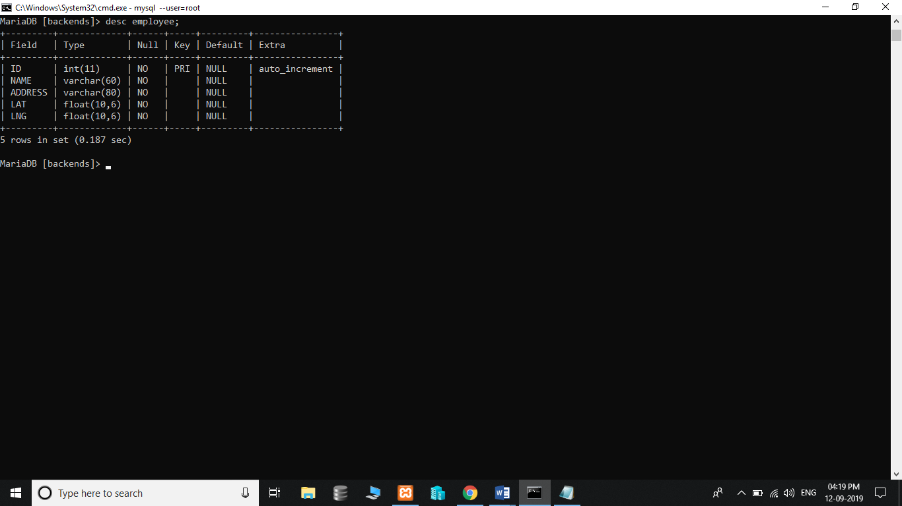\

- INSERT INTO employee (name, address, lat, lng) VALUES ('Frankie Johnnie & Luigo Too','939 W El

Camino Real, Mountain View, CA','37.386339','-122.085823'),

('Amici\'s East Coast' , '790 Castro St, Mountain View, CA','37.38714','-122.083235'),

('Kapp\'s Apartment ','191 Castro St, Mountain View, CA','37.393885','-122.078916'),

('Round : Mountain View','570 N Shoreline Blvd, Mountain View,CA','37.402653'),

('Tony & Alba\'s Pizza & Pasta','619 Escuela Ave, Mountain View, CA','37.394011','-122.095528'),

('Oregano\'s Wood-Fired Pizza','4546 El Camino Real, Los Altos, CA','37.401724','-122.114646');

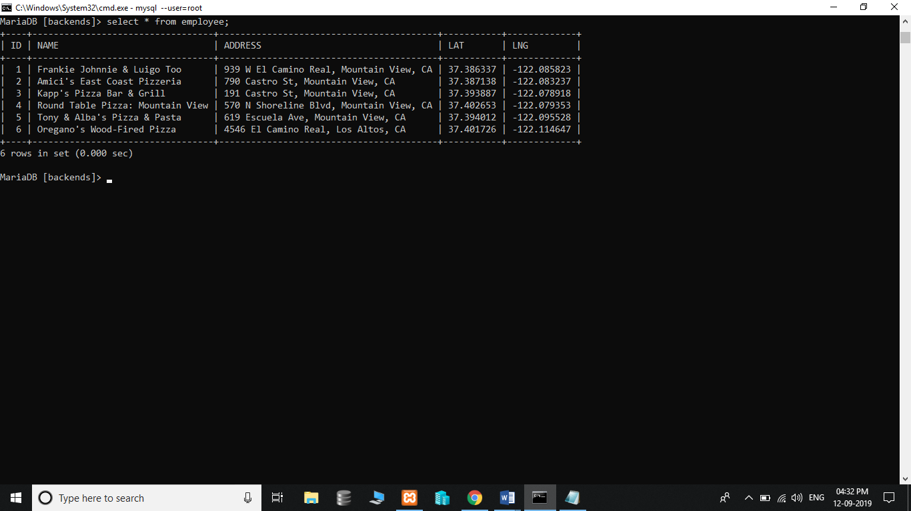

**This one is to find latitudes and longitudes in a distance less than 28 miles.**

* select id, (3959 * acos(cos(radians(37)) * cos(radians(lat)) * cos(radians(lng) - radians(-122)) + sin(radians(37)) * sin(radians(lat)))) as Distance from employee having distance < 28 order by Distance limit 0,20;

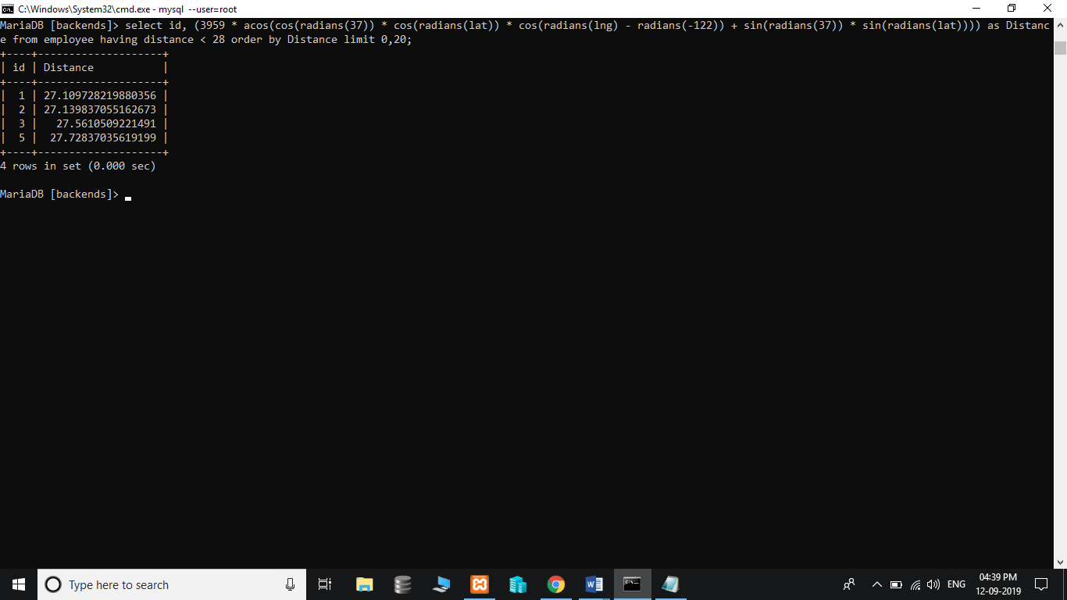

**This one is to find latitudes and longitudes in a distance between 28 and 29 miles.**

* select id, (3959 * acos(cos(radians(37)) * cos(radians(lat)) * cos(radians(lng) - radians(-122)) + sin(radians(37)) * sin(radians(lat)))) as Distance from employee having distance > 28 and distance < 29 order by Distance limit 0,20;

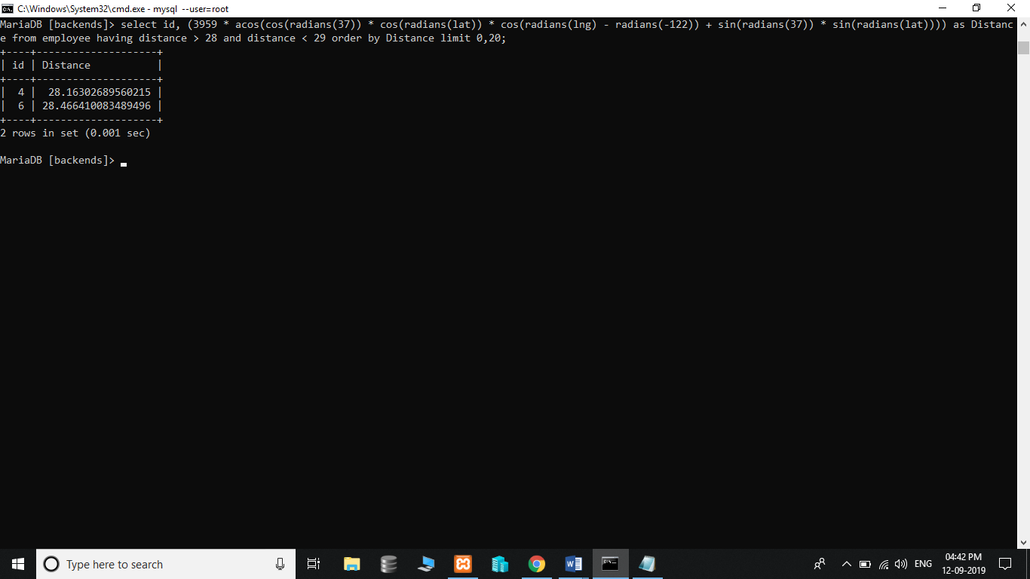

- **Explain your approach**

Firstly I will create database name as backends.

Then creating table containing 5 columns as Id, Name, Address, lat, long.

In which Id will be primary key and auto incremented while inserting new value. And all other will

Be not null.

- **Data Structure (MySQl, NoSQl or any other)**

MySQL

- **Your algorithm - Provide Pseudo Code**

1. Showing latest 5 inserted results.  
   For this, we are using a table in which when every new record comes, we are inserting it into the queue table.
2. Showing the latest 5 results from the user location:  
   For this, we need to aggregate the data and show to the local users every 5 mins and we can serve the same data to all users from that locality for 5 mins.
3. Can search any rented home, hostels, or for pg through lat, long.
4. End.

**- Time and Space Complexity**

**Time complexity** of an algorithm is the amount of time taken by an algorithm to run a function comparing length of the input. In this database we have more time complexity because of 100 million of hostels around the country.

**Space complexity** of an algorithm is the amount of space or memory taken by an algorithm to run a function comparing the length of the input. In this we have less complexity of space because each time the value inserted the id will automatically incremented i.e. space is dynamically associated.

- **How much time did it take to complete the assignment?**

2-3 hrs.

- **Your past project report link/screenshots**

--

- **What are you good at (Don’t limit your answer to Tech only)?**

Programming – C, C++, java

Android, html, CSS, JavaScript, developing.

Sports – cricket, skating.

- **Your expectation out of this Internship?**

Improving skill for future expectations of becoming web and mobile developer.

Improving skill for job perspective.

Help people wherever I could.

- **Answer the following question (Yes/No)**

Familiar with Java? -**YES**

Familiar with MySQl? -**YES**

Familiar with AWS? -**NO**

Familiar with Python? -**NO**

**DEEP SHAH**

**B-tech (CSE)**

**Ganpat University,**

**Ahmedabad**