Maven

Attribute | Value
Owner | Gaurav Jethawa (430707)
Contact Information | GJ00437070@techmahindra.com

Revision History

Author | Date | Version # | Revision Description
Gaurav Jethawa | 29/03/2016 | 1.0 | Initial Draft Version  Maven Continuous Integration

Table of Contents

Continuous Integration 3
Maven 3
Installation 4
Creating Maven Project in Eclipse 6
Creating the Parent Folder 6
Creating Sub Modules 8
Building the Maven Project 10
Maven POM 10
Maven Repository 11
Maven Build Profiles 11
Maven - Jenkins integration 12
Maven – Jfrog Artifactory Setup 12
Developer machine Central Repository Configuration. 14
Troubleshooting 15
References 15

Continuous Integration
- "Continuous integration" refers to a process that builds and tests code on a frequent basis.
- The continuous integration servers constantly monitor source code repositories and as soon as new changes/commits are detected, they initiate a new build cycle. Each check-in gets verified by an automated build. Hence problems or errors are detected in early stages.
- The build cycle actually involves code compilation and, in addition, may involve various tests and code analysis
- Because you’re integrating so frequently, there is significantly less back-tracking to discover where things went wrong, so you can spend more time building features.
- Catch issues fast and nip them in the bud.

Maven
Apache Maven is a software project management based on the concept of a project object model (POM). Maven can manage a project's build, reporting and documentation from a central piece of information.

Ant vs Maven vs Gradle
- Ant doesn't give any guidance on how to structure your project.
- External libraries required by your project are usually checked into version control, because there is no automated mechanism to pull them from a central location.
- Maven provides a standardized project and directory structure, as well as dependency management.
- Projects consisting of multiple modules could define their dependencies on each other
- Gradle build scripts are declarative, readable, and clearly express their intention
- Writing code in Groovy instead of XML, significantly cuts down the size of a build script and is far more readable.

Advantages:
- It maintains the repository of the archives. So does not required to maintain jar archives in local.
- It simplifies the way of your build will work, because every build follows standard procedure.
- All dependencies are downloaded automatically.
Disadvantages:
- Your project pretty much has to be laid out the correct way.

Installation
Step1) Download maven / raise TIM request and extract it to C:\apache-maven-3.3.3
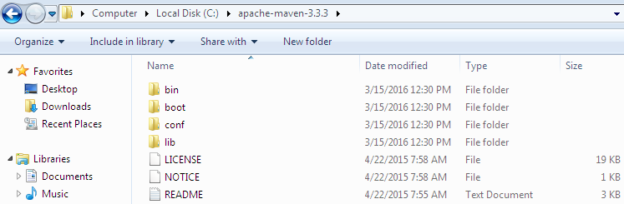

Step2) Configure Eclipse.
Open Eclipse IDE Select Window Preferences
Step3) Click Maven Installations Add
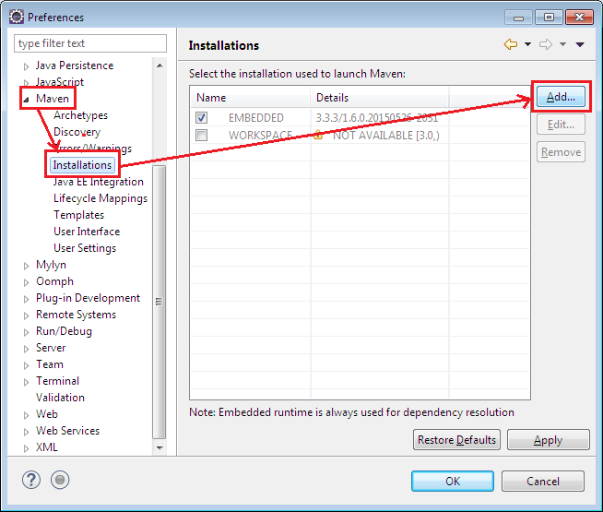
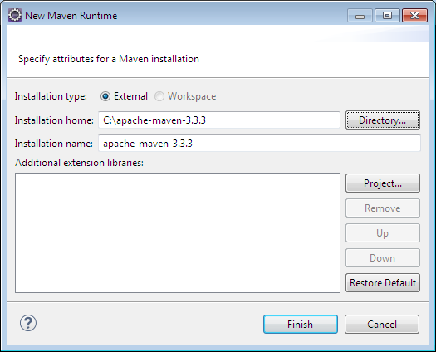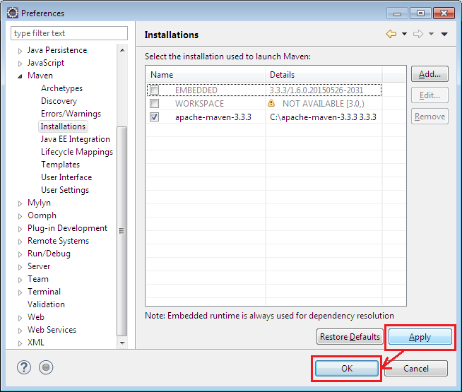

Step4) Set Environment Variable M2_HOME and append it in Path
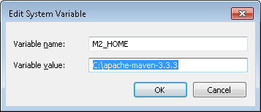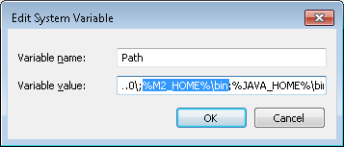
Step5) Configure Central repository on local machines to point it to server machine.
Go to C:\Users\{username}\.m2. Open settings.xml and enter below code.

<settings>
.
.
<mirrors>
<mirror>
<id>central-proxy</id>
<name>Local proxy of central repo</name>
<url>http://10.10.21.172:8081/artifactory/list/CentralReplica path to central loc.
</url>
<mirrorOf>central</mirrorOf>
</mirror>
</mirrors>
.
.
</settings>

Creating Maven Project in Eclipse

Creating the Parent Folder
Step1) Go to Eclipse, Click on File menu -> New -> Maven Project
If Maven project is not listed under the New menu options, click
File -> New -> Other…
In the Select Wizard, Choose Maven Project and click Next.

Step2) In the New Maven Project Window, enable Create a simple project Check box and click Next button.

Step3) In this window give the project name in Group Id, Parent Folder name in Artifact Id. Since it is a parent folder, select packaging as POM and click Finish.

Creating Sub Modules
Step1) Right click on ParentFolder -> New -> Other-> Maven Module
Step2) Enter the Webmodule name in ModuleName Tab. Uncheck Create a simple project check box and click Next
Step3) Verify the details and click Finish

Building the Maven Project
Right click the Maven project Run As and you will find multiple maven goals.
Click Maven clean and install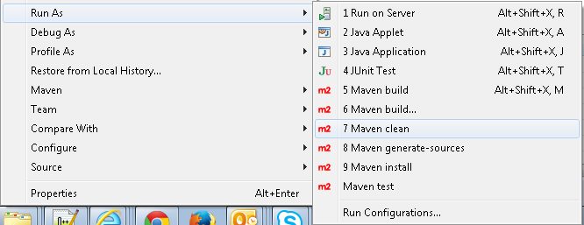

Alternate way:
Open command prompt, navigate to root directory of the project where pom.xml resides and run below command:
mvn clean package install
mvn test

Maven POM
POM Stands for Project Object Model. It Uses XML by Default and describes following things about the project:
- Name and Version
- Artifact Type
- Source Code Locations
- Dependencies
- Plugins
- Profiles (Alternate build configurations)

Maven uniquely identifies a project using GAV:
- groupID: Arbitrary project grouping identifier (no spaces or colons). Usually loosely based on Java package
- artfiactId: Arbitrary name of project (no spaces or colons)
- version: Version of project

Maven Repository
A repository is a place i.e. directory where all the project jars, library jar, plugins or any other project specific artifacts are stored and can be used by Maven easily.
Maven repositories are of three types
- Local Repository: folder location on your machine, keeps your project's all dependencies (library jars, plugin jars etc.). When you run a Maven build, then Maven automatically downloads all the dependency jars into the local repository. Default location (USER_HOME) can be overridden in settings.xml
- Central Repository: provided by Maven community, it contains a large number of commonly used libraries. When Maven does not find any dependency in local repository, it starts searching in central repository using the URL mentioned in configuration file (settings.xml)
- Remote Repository: Remote repositories refer to any other type of repository, accessed by a variety of protocols such as file:// and http://
Maven searches for the dependencies in the following order: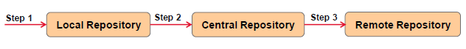

Maven Build Profiles
Build profile is a set of configuration values which can be used to set or override default values of Maven build. Using a build profile, you can customize build for different environments such as Production v/s Development environments
Profiles are specified in pom.xml file. Please refer to the attached POM.xml file above. It has profiles like prod, qa, dev and analyze-test-classes
Profiles modify the POM at build time, and are used to give parameters different target environments.

Maven - Jenkins integration
Refer to the document on Jenkins on how to integrate it with Maven

Maven – Jfrog Artifactory Setup
A Central Artifactory is required when the developers in the team do not have full internet access (to download the required dependencies/artifacts from maven central repository).
The server machine will download all the necessary dependencies and will upload it on a Central Repository hosted by Jfrog Artifactory server. The artifactory url will be exposed so that local developers can point their central repository to this url and download the dependencies.
Artifactory Installation on server:
Step1) Download Zip file from https://www.jfrog.com/open-source/ and extract it to
D:\artifactory-oss-4.7.1

Step2) Go to D:\artifactory-oss-4.7.1\bin and click artifactory.bat

Step3) Make sure the maven project is built on server first to auto download dependencies from central repository. Go to local repository i.e. C:\Users\{username}\.m2\repository.
Create a zip file of the artifacts.

Step4) Navigate to http://localhost:8081/artifactory/webapp/#/home
Login with Admin user details : username : Admin / Password : password

Step5) Go to Build Repositories Local and click New
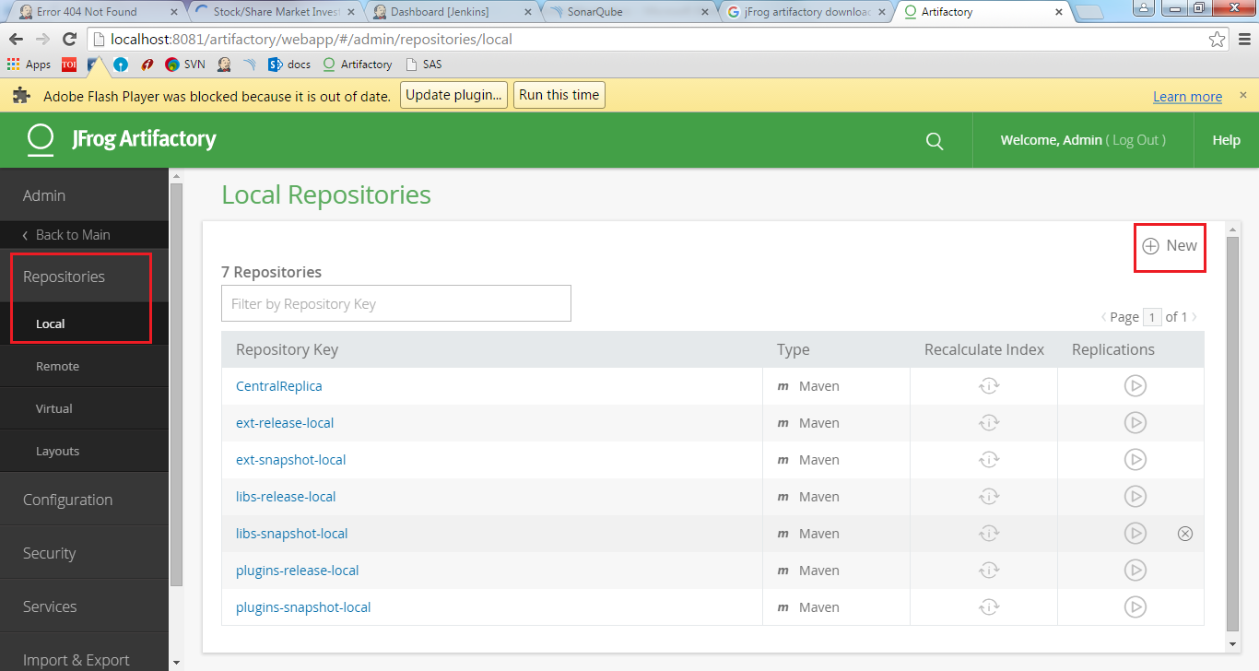
Step6) Select Package type Maven, give repository key and click finish.
Step7) To load the local artifacts on the repository we created, go to Import/Export and click repositories. Go to Import Repository from Zip section and load zip to the repository we created.
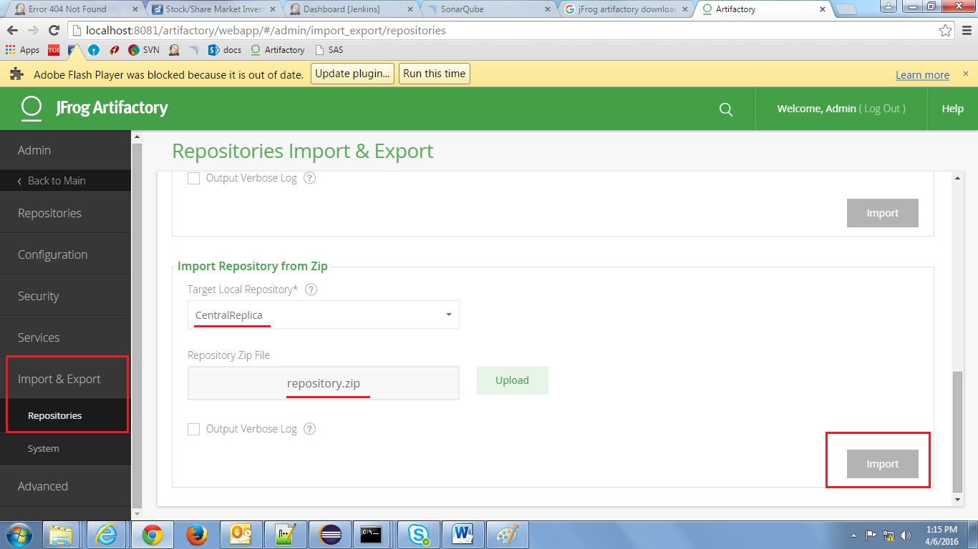

Step8) To get the repository url, go to home page Artifacts right click repository and click NativeBrowser
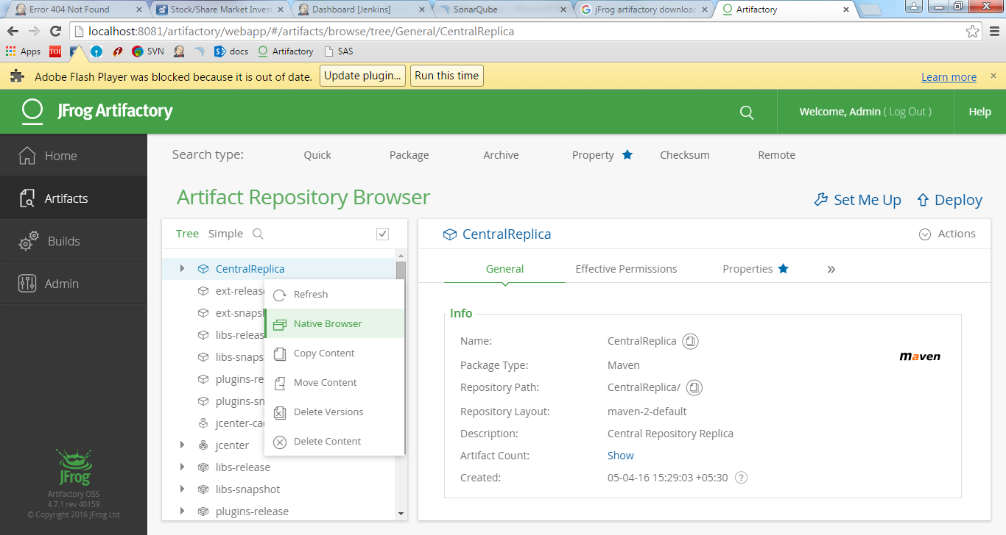

Developer machine Central Repository Configuration.
Step1) Go to C:\Users\{username}\.m2 and update settings.xml with:
<settings>
.
.
<mirrors>
<mirror>
<id>central-proxy</id>
<name>Local proxy of central repo</name>
<url>http://10.10.21.172:8081/artifactory/list/CentralReplica path to central loc.
</url>
<mirrorOf>central</mirrorOf>
</mirror>
</mirrors>
.
.
</settings>

Troubleshooting
1) Compiler Issue. If you face below error:
[ERROR] Failed to execute goal org.apache.maven.plugins:maven-compiler-plugin:3.1:compile (default-compile) on project gs-rest-service: Compilation failure
[ERROR] No compiler is provided in this environment. Perhaps you are running on a JRE rather than a JDK?
Update jdk path in pom.xml file.
<plugin>
<groupId>org.apache.maven.plugins</groupId>
<artifactId>maven-compiler-plugin</artifactId>
<version>3.1</version>
<configuration>
<source>1.8</source>
<target>1.8</target>
<fork>true</fork>
<!-- add this jdk executable path if u face compiler issues while build -->
<executable>C:/Program Files/Java/jdk1.8.0_66/bin/javac.exe</executable>
</configuration>
</plugin>

References
http://maven.apache.org/guides/
http://www.tutorialspoint.com/maven/

