A Vision of an IoT-Based Water Logging System

***Abstract***-

The shipping and logistics industry is a vital component of the Indian economy, contributing approximately **13-14% of the total GDP**. As a key driver of economic growth, any disruptions in this sector can have significant consequences for the nation’s economy. Currently, **roads serve as the primary mode of transportation**, handling **85% of passenger traffic** and **over 60% of goods transportation**.

However, the sector faces numerous challenges, one of the most pressing being **waterlogging in underground tunnels**. This issue poses serious threats to the **safety and efficiency of transportation** in India. Addressing this problem is crucial to ensuring uninterrupted mobility and infrastructure resilience.

To mitigate this challenge, we propose the integration of **modern technologies** such as **Arduino Uno, LCD displays, LEDs, ultrasonic sensors, servos, and pumps**. These innovations can enhance real-time monitoring and response mechanisms, significantly improving transportation safety and efficiency. By leveraging advanced technology, we can develop a **smarter, more reliable transportation system** for the country.

Collaboration among **government agencies, engineers, and technology experts** will be essential in implementing these solutions effectively. Through a collective effort, we can pave the way for a **more resilient and efficient transportation infrastructure in India**.

***Introduction***: -

in urban India, managing waterlogging has become a critical challenge, particularly in subway systems. To address this issue, advanced technological solutions are very important. The introduction of a sensor-based waterlogging system is implemented with ultrasonic sensors representing a significant instrument in the management of such situations. This system offers real-time monitoring of water levels, enabling prompt actions to prevent waterlogging and ensure travellers safely.

1. The core of this system lies in its application of ultrasonic sensors to measure water levels accurately. This sensor boosts the accuracy rate up to 95%, providing precise readings even in bad weather conditions. When combined with an LCD unit positioned at the top, travellers and authorities gain instant

visibility into the current water levels within the subway, promoting informed decision-making and proactive measures to mitigate risks.

1. In addition, the system uses a gate mechanism that opens and closes automatically when the water level is either lower or higher than the prescribed range of water. This equipment enables the proper functioning of subway infrastructure and assures the well-being of travellers.
2. A dedicated kill switch has been integrated to uphold the system's reliability. This switch serves as a failsafe mechanism, allowing operators to manually override the system in case of malfunction or incorrect reading. This proactive approach to system management enhances overall safety and operational efficiency.
3. Furthermore, a high-performance motor pump is integrated into the system to effectively reduce water accumulation within the subway. This motor, boasting an impressive efficiency rate of 80%, swiftly removes excess water, minimising disruptions to subway operations and ensuring a safe and seamless travelling experience for passengers.
4. 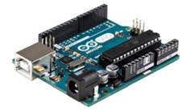In conclusion, the sensor-based waterlogging system represents a paradigm shift in managing water- related challenges in Indian subways. With its advanced sensor technology, intelligent gate mechanism, and fail- safe features, it offers unparalleled accuracy, reliability, and efficiency. As India continues to urbanise, investments in such innovative solutions are crucial to ensuring

Fig.1 Arduino

**Main Part**

**A. Challenges of IoT in Water Management**

**1. Connectivity**

The **battery life of the module** may be **limited**, requiring **regular inspections** to prevent **connectivity failures**. Additionally, **data loss** can occur due to **long wires**, as signals may fade or weaken before reaching their destination. To **ensure stable connectivity**, it is essential to use **low-resistance wiring** and implement **proper signal transmission techniques**.

**2. Hardware Specifications**

To maintain **compatibility with modern technologies**, the **hardware components** must adhere to the latest standards. If a component requires **replacement** and does not conform to the same specifications, it may cause **interoperability issues**, making the system **more complex** and difficult to manage.

# **B. System Devices**

1. **Arduino Uno:**

|  |  |
| --- | --- |
| Micro Controller | ATMega328 |
| Operating Voltage | 5V |
| Voltage (Input) | 7-12V |
| Voltage Limit (Input) | 6-20V |
| Clock Speed | 16MHz |
| SRAM | 99.85 KB |
| EEPROM | 28 KB |
| Flash Memory | 32 B |

1. **Ultrasonic Sensor**

An **ultrasonic sensor** measures the **distance to an object** using **ultrasonic sound waves**. It consists of a **transducer** that emits and receives **ultrasonic pulses**, calculating the **proximity of objects** based on the time it takes for the pulse to return.

In this project, **ultrasonic sensors** are used for **high-precision water level measurement**, achieving an **accuracy rate of up to 95%**. By emitting **ultrasonic pulses** and analysing the reflection time from the **water surface**, these sensors provide **real-time data** on water levels. This capability is crucial for **early flood detection**, enabling authorities to take **proactive measures** to prevent subway flooding.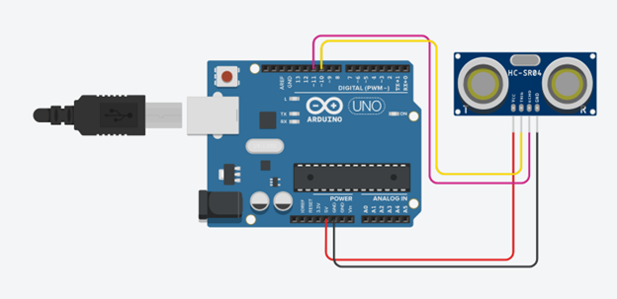

Fig. 2 Ultrasonic Sensor

**3. Servo Motor**

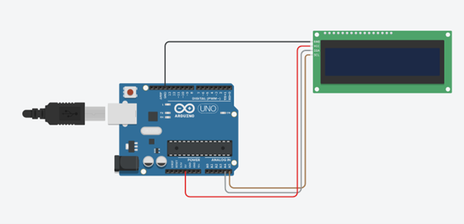A **servo motor** efficiently rotates **mechanical components** with **high precision** and **velocity control**. In this project, the servo motor plays a key role in **controlling barriers**, ensuring **automated movement** in response to detected **water levels**.

**Key Benefits:**

* **Enhances system reliability** and **passenger safety**
* **Provides real-time response** to water accumulation
* **Operates efficiently in harsh conditions** (e.g., monsoons)
* 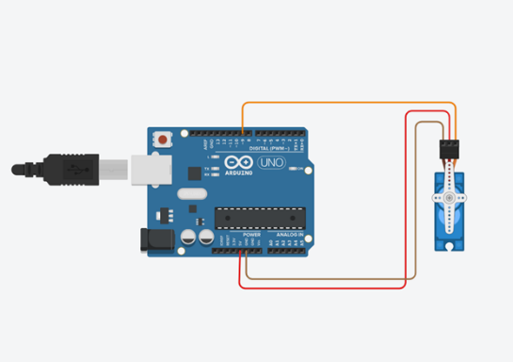**Ensures uninterrupted subway operations**

Fig.3 Arduino with Micro Servo Motor

1. **I2C 20X4 LCD:**

A **20x4 LCD display** is capable of showing **20 characters per line** across **four lines**. Each character is displayed within a **5x7 pixel matrix**. The display contains two registers: **Command** and **Data**, making it compatible with standard **HD44780 controller LCDs**.

In this project, the **LCD provides real-time water level data**, improving the **user experience** within the **sensor-based waterlogging system**. This feature significantly enhances **safety, operational efficiency, and resilience** in subway management, particularly during extreme weather events.  
  
 Fig.4 LCD (Liquid Crystal Display)

### **C. Working Proposal**

Waterlogging in subway systems poses a **serious safety risk**, especially during **heavy rains**. Implementing an **advanced sensor-based system** can help **prevent flooding** and create **safer subway environments**.

**1. Review of Past Studies**

* Examining previous research on **subway waterlogging issues**
* Exploring the effectiveness of **sensor-based flood prevention systems**
* Identifying **gaps in current solutions** and areas for **further research**

**2. System Implementation**

A **sensor-driven flood prevention system** will be developed, integrating the following components:  
**Ultrasonic sensors** to monitor **real-time water levels**  
**Automated barrier system** using **servo motors** to control water inflow  
**LCD display** to provide **real-time updates** to subway staff and passengers  
**Microcontroller (Arduino Uno)** for **centralized system control**  
**Motorized pump** to rapidly **drain excess water**  
**Kill switch** for **emergency shutdown** if needed

**3. Testing and Evaluation**

The system will be **tested in a simulated subway environment** to evaluate:

* **Effectiveness of real-time monitoring**
* **Response speed of automated barriers**
* **Performance of the motorized pump in water drainage**
* **User feedback from subway workers and passenger**

#### **4. Collaboration and Safety Compliance**

To ensure successful implementation, collaboration with **subway officials and engineers** is necessary. The system must comply with **safety regulations** and undergo **rigorous testing** before deployment.

### **D. Expected Outcomes**

**Increased subway safety** by monitoring water levels and responding instantly to flooding risks  
**Reduced disruptions and infrastructure damage** during **heavy rains**

**Enhanced operational efficiency** for subways, leading to a **safer and more reliable commuting experience**

***Future Work***

1. **GSM:**

Integrating GSM module into sensor-based waterlogging systems for Indian subways to send SMS alerts to all nearby devices, including those carried by travellers, is an important step forward for safety during floods. By working on these things, we can make sure that everyone, including travellers’, gets important messages during floods, helping keep everyone safe.

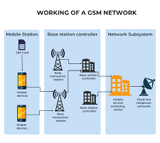

**Fig. 7 GSM Model Working**

1. **GPS:**

Integrating GPS modules into sensor-based waterlogging systems for Indian subways to utilize Google Maps for spreading information to travellers regarding flood hazards, significantly improves travellers’ safety within Indian subways

**conclusion**

The introduction of **sensor based waterlogging systems** in Indian subways is a **big step** in **passenger safety and operational reliability**. By using **ultrasonic sensors, servo motors, 20x4 I2C LCD display, Arduino Uno microcontroller, water pumps and kill switch** we are **upgrading urban infrastructure** with **latest engineering solutions**.

These systems not only **detect water levels in real time** but also **take proactive measures** to prevent flooding, setting a **new standard** for **efficiency and risk management** in subway operations.

Looking forward to: **Improving system performance** for better accuracy and response

**Increasing reliability** for uninterrupted operation in extreme weather **Adapting the system** to **urban transit network demands**

Ultimately this is not just about **reducing disruptions**—it’s about making subway travel **safer, smarter and more reliable for everyone**. This project shows the **power of technology** in **shaping the future of mobility**.

**Reference**

• **"Road Waterlogging Indicator Using Ultrasonic Sensor with GPS System for Vehicle Driving Assistance"**  
*International Journal of Advances in Engineering and Management (IJAEM)*, Volume 4, Issue 11, November 2022.  
This study discusses a system utilizing ESP32 microcontrollers and ultrasonic sensors to measure water levels, transmitting data to a cloud server for real-time analysis and alerting.  
[Link to paper](https://ijaem.net/issue_dcp/Road%20Waterlogging%20Indicator%20Using%20Ultrasonic%20Sensor%20with%20GPS%20System%20for%20Vehicle%20Driving%20Assistance.pdf)​

• **"Design of an Urban Waterlogging Monitoring System Based on the Internet of Things"**  
*International Conference on Intelligent Computing and Internet of Things*, 2018.  
This paper proposes a system combining vehicle networks, sensor technology, and cellular networks to monitor urban waterlogging, aiming to reduce incidents related to property and personal safety.  
[Link to paper](https://link.springer.com/chapter/10.1007/978-3-030-21373-2_25)​

• **"Advanced IoT Solutions to Monitor Vehicular Movement in Flooded Underpass"**  
*International Journal of Electrical and Computer Engineering (IJECE)*, Volume 8, Issue 1, 2021.  
This research presents an IoT-based system that monitors underpass water levels and provides timely warnings to drivers, enhancing safety during heavy rainfall.  
[Link to paper](https://www.academia.edu/45051592/Advanced_IOT_Solutions_to_Monitor_Vehicular_Movement_in_Flooded_Underpass)​

• **"An IoT Based Water-Logging Detection System: A Case Study of Dhaka"**  
*American International University-Bangladesh (AIUB)*, 2019.  
This study details an IoT system employing GPS modules and various sensors to detect and monitor waterlogging, transmitting data for real-time analysis and response.  
[Link to paper](https://dspace.aiub.edu/jspui/bitstream/123456789/32/1/An%20IoT%20Based%20Water-Logging%20Detection%20System.pdf)​

• **"Development and Application of Flood Control and Waterlogging Prevention Intelligent Monitoring System Based on Subway 'One Map'"**  
*ISPRS Annals of the Photogrammetry, Remote Sensing and Spatial Information Sciences*, 2022.  
This paper discusses a monitoring system using intelligent sensing cameras and water level recognition algorithms to manage subway flood control and waterlogging prevention.  
[Link to paper](https://isprs-annals.copernicus.org/articles/X-3-W1-2022/93/2022/)